Supplementary Materials
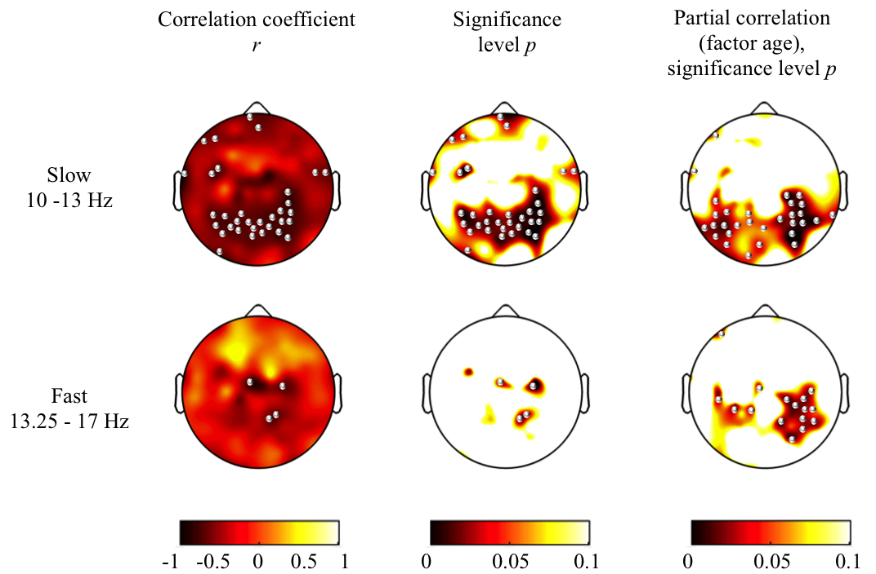
Figure S1. Topographical maps of Pearson correlations between processing speed and slow sigma power (10–13 Hz) and fast sigma power (13.25–17 Hz) for sleep stage N2. Left column: Maps for Pearson correlation coefficients (r); Middle column: Corresponding p-value; Right column: Maps for p-values from partial correlations (factor “age”). Power maps were individually scaled for data range. Significant correlations (p < 0.05, one-tailed) are indicated with bullets. Correlations between processing speed and slow sigma power were found in 34 electrodes (r ranging from −0.6 to −0.9) and in 30 electrodes after controlling for age (r ranging from −0.6 to −0.9). Fast sigma power was correlated with processing speed in 4 electrodees (r ranging from −0.7 to −0.8) and in 16 elecrodes after controlling for age (r ranging from −0.6 to −0.9).
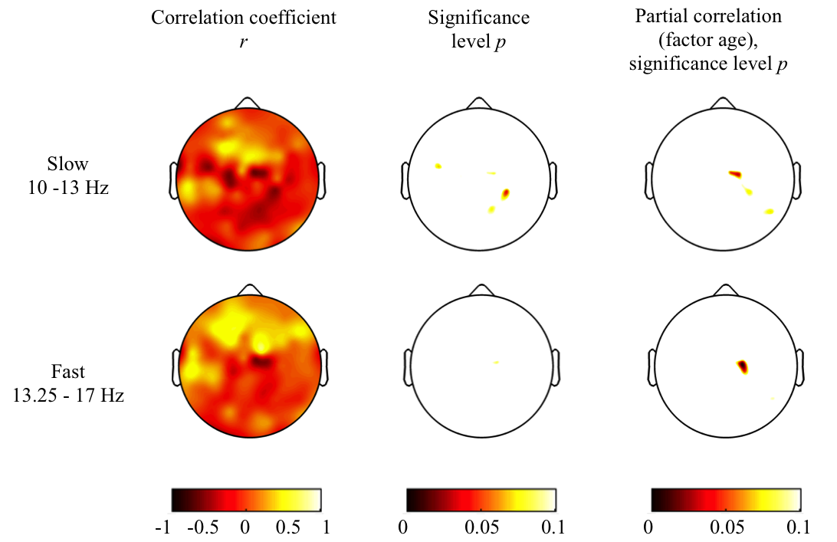
Figure S2. Topographical maps of Pearson correlations between processing speed and slow sigma power (10–13 Hz) and fast sigma power (13.25–17 Hz) for sleep stage N3. Left column: Maps for Pearson correlation coefficients (r); Middle column: Corresponding p-value; Right column: Maps for p-values from partial correlations (factor “age”). Power maps were individually scaled for data range. No significant correlations (p < 0.05,
one-tailed) were found.
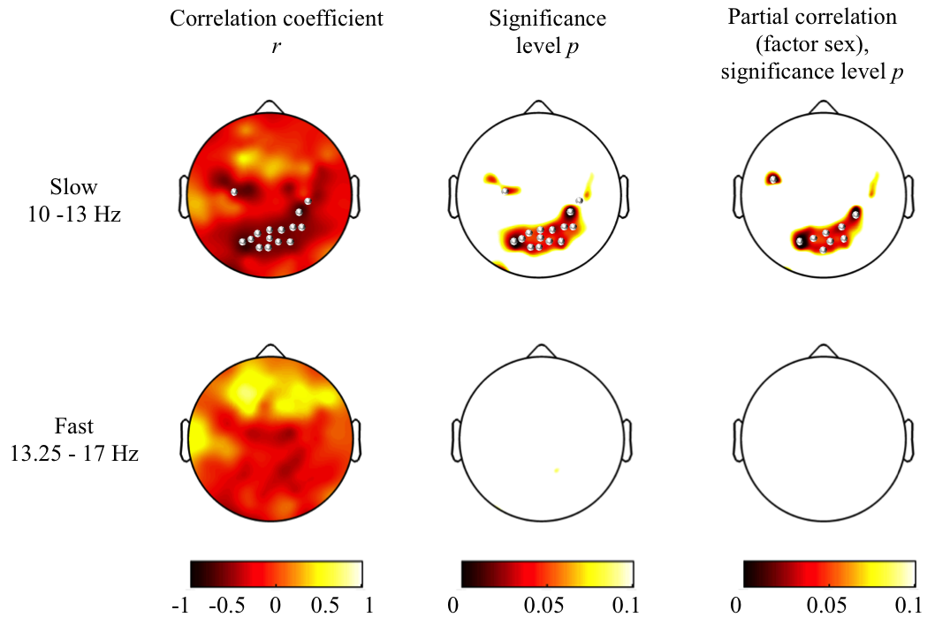
Figure S3. Topographical maps of Pearson correlations between processing speed and slow sigma power (10–13 Hz) and fast sigma power (13.25–17 Hz) for NREM sleep
(N2 and N3). Left column: Maps for Pearson correlation coefficients (r); Middle column: Corresponding p-value; Right column: Maps for p-values from partial correlations (factor “sex”). Power maps were individually scaled for data range. Significant correlations
(p < 0.05, one-tailed) are indicated with bullets. Slow sigma power and processing speed were correlated in 15 electrodes (r ranging from −0.6 to −0.8) and in 9 electrodes after controlling for age (r ranging from −0.6 to −0.9).

