Adolescent Self-reported Executive Function as a Predictor of Subsequent Symptoms of Internalizing Psychopathology

By

Moriah Major

Department of Psychology and Neuroscience

University of Colorado Boulder

Boulder, Colorado 80309

Honors Thesis Defense Date: Monday, November 2nd, 2020

Honors Thesis Advisor: Marie Banich

Defense Committee:

Dr. Marie Banich, Department of Psychology and Neuroscience, Thesis Advisor

Dr. Heidi Day, Department of Psychology and Neuroscience, Honors Council Representative

Dr. Emily Harrington, Department of English, Outside Member

Abstract
Lower levels of executive function have been associated with several domains of internalizing psychopathology. Executive function (EF) is a compilation of cognitive control processes, which enable self-regulation and goal-directed behaviors (Banich, 2009). Such processes play a fundamental role in an individual’s ability to make decisions, evaluate situations, and flexibly assimilate to novel life occurrences. Internalizing psychopathology is an umbrella term that refers to psychopathology syndromes with prominent dimensions of depression, worry, and fear (Banich et al., 2020). Research assessing adult psychopathology has found that adults with major depression and anxiety exhibit decreased levels of executive function in a multitude of behavioral areas. While all of these findings are important, it is not clearly understood if the research findings can be applied to adolescents. This study assesses whether either parent-reported or adolescent self-reported EF at an initial time point can predict subsequent symptoms of internalizing psychopathology, and whether that provides additional information above and beyond prior levels of psychopathology. We have taken a bifactor modeling approach in order to assess the common and unique aspects of internalizing psychopathology symptoms as they relate to adolescent EF (Banich et al., 2020). In addition to the latent variable factor scores, we also included the ASEBA (Achenbach System of Empirically Based Assessment) composite scores in our study as a clinical measurement of psychopathology. We concluded that adolescent self-reported BRIEF GEC scores can predict future common internalizing and low positive affect-specific psychopathology symptoms while accounting for baseline psychopathology.

Introduction
The goal of this thesis is to examine the relationship and directionality between adolescent executive function and symptoms of internalizing psychopathology. Executive function (EF) is a compilation of cognitive control processes, which enable self-regulation and goal-directed behaviors (Banich, 2009). Such processes play a fundamental role in an individual’s ability to make decisions, evaluate situations, and flexibly assimilate to novel life occurrences. Internalizing psychopathology is an umbrella term that refers to psychopathology syndromes with prominent dimensions of depression, worry, and fear (Banich et al., 2020).
Lower levels of executive function have been associated with several domains of psychopathology. Research assessing adult psychopathology has found that adults with major depression exhibit decreased levels of executive function in a multitude of behavioral areas: switching between tasks (Snyder et al., 2015), behavioral inhibition (Murphy et al., 1999), fluid decision making (Murphy et al., 2001), and planning (Beats et al., 1996). In a study completed by Bradbury et al. (2011) adults with anxiety disorders also struggled with cognitive flexibility. In general, most studies have focused on reduced levels of EF in adults with depression and anxiety (Castaneda et al., 2008). While all of these findings are important, it is not clearly understood if the research findings can be applied to adolescents.
Adolescence is a crucial time period of brain development. Several brain regions implicated in executive function undergo significant change (Han et al., 2016). For instance, the dorsal lateral prefrontal cortex (DLPFC) is a brain region linked to impulse inhibition, planning, and understanding the implication of one’s decisions (Giedd, 2004). Several researchers have speculated that greater developed EF allows some adolescents to have more emotional regulation and cognitive flexibility than adolescents with reduced levels of EF (Martel et al., 2007). By extension, researchers have seen evidence that more effective EF might boost adolescents’ ability to employ successful coping skills to combat internalizing difficulties (Martel et al., 2007). Alternatively, another study suggests depression may play a role in reduced EF functions such as inhibition (Bredemeier, 2016).
While some research suggests that reduced EF is a by-product of higher levels of internalizing symptoms, one can also evaluate if reduced EF might be a risk factor for subsequent psychopathology. In a population of children with autism spectrum disorder (ASD) and attention deficit hyperactivity disorder (ADHD), parent-reported EF scores predicted subsequent levels of psychopathology one month later (Lawson et al., 2015). Specifically, children with ASD who possessed greater inflexibility predicted higher levels of anxiety and depression. Children with ADHD possessed greater difficulties controlling inhibition, which predicted subsequent aggression (linked to externalizing psychopathology). In a group of adults with ADHD, lower levels of EF significantly predicted current and lifetime depression as measured by the Structured Clinical Interview for DSM-IV disorders (SCID) (Knouse et al., 2013).
Previous research has focused on assessing adolescent executive function with performance based behavioral tasks that have low ecological validity (Han et al., 2016; Favre et al., 2008). While two such tests, the Wisconsin Card Sorting Task (WCST) and Trail Making Test, assess executive function, they do so in a controlled environment and don’t encapsulate EF processes that are employed in everyday situations. A vital component of EF is being able to flexibly adapt to a situation; however, standardized tests, such as the WCST, explicitly instruct an individual what to do. Therefore, the aforementioned tasks cannot capture the flexible component of EF that is frequently at work. In addition, the research that has measured adolescent EF through behavioral tasks has not found definitive relationships with internalizing psychopathology (Han et al., 2016). For instance, some previous studies comprised of adolescents diagnosed with Major Depressive Disorder (MDD) indicated that they have impaired performance on popular behavioral task measurements of EF, such as the Wisconsin Card Sorting Task (WCST) (Han et al., 2016). Yet conversely, Favre et al. (2008) documented that children and adolescents diagnosed with MDD were not impaired on the WCST or the Trail Making Test.
Alternatively, another means of examining EF is through self-report. One popular measure is the Behavioral Rating Inventory of Executive Function (BRIEF). The BRIEF is a measurement of EF that contains a parent report and youth self-report for children between 11-18 years old (Gioia et al., 2000). The inventory measures several aspects of EF such as emotional control (ex. “I overreact to small problems”), planning (ex. “I don’t think ahead about possible problems”), and shifting (ex. “I have trouble changing from one activity to another”) (Gioia et al., 2000). Lower levels of EF, as measured by the BRIEF, have previously been linked to greater anxiety symptoms in adult women (Abbing et al., 2019). In addition, another study assessing children and adolescents (5-18 years old) found greater EF impairment was associated with depression across parent-reported and self-reported BRIEF scores (Kavanaugh et al., 2019). Finally, in a community sample of youth (aged 13-22 years) self-reported BRIEF scores indicate lower EF is associated with higher levels of depression and anxiety compared to adolescents with normal EF levels (Snyder et al., 2020).
The main focus of this study was to assess whether either parent-reported or adolescent self-reported EF at an initial time point in a nonclinical population could predict subsequent symptoms of internalizing psychopathology, and whether that provides additional information above and beyond prior levels of psychopathology. While most previous research hasn’t used the adolescent and parent reported BRIEF scores to assess internal psychopathology in a nonclinical population, researchers have generally found parent reports to be more reliable in predicting current (Loeber et al., 1990) and subsequent levels of childhood psychopathology (Lawson et al., 2015). Therefore, it was predicted that parent reported BRIEF scores would be more accurate in predicting future adolescent internal psychopathology symptoms than adolescent self-reports.
In addition, we investigated whether there are differences present in parent-adolescent BRIEF score agreement over time. The present study took place over a two year time period, which allowed us to evaluate parent and adolescent BRIEF score agreement at two separate time points. Since adolescent brain development is taking place over the two years, we expected adolescent levels of EF to improve during the study.
Depression and anxiety are known to be highly comorbid (Kessler et al., 2008). Therefore it is unclear which aspects of cognitive control are associated with general overlapping symptoms present in internalizing psychopathology as opposed to specific dimensions of depression (low positive affect, loss of interest) and anxiety (anxious arousal, anxious apprehension) (Banich et al., 2020). Many researchers are now conceptualizing psychopathology as latent dimensions that represent symptoms across a continuum. In this study, we have taken a bifactor modeling approach in order to assess the common and unique aspects of internalizing psychopathology symptoms as they relate to adolescent EF. This bifactor model parses depression and anxiety symptom covariance into a common factor (common internalizing factor), which captures what is similar amongst symptoms across depression and anxiety (e.g., negative affect). In addition, the model parses unique variance that is accounted for by other factors above and beyond this common factor: low positive affect (LPA; symptoms of anhedonic depression, e.g., “I feel that nothing is enjoyable.”), anxious arousal (AA; symptoms of panic, e.g., “ My hands are shaky.”), and anxious apprehension (Worry; e.g., “My worries overwhelm me.”) (Banich et al., 2020).
In addition to the latent variable factor scores, we also included the ASEBA (Achenbach System of Empirically Based Assessment) composite scores in our study as a clinical measurement of psychopathology. The ASEBA checklists are a clinically standardized assessment of child/adolescent social, emotional, and behavioral competencies. To see if our factor scores are detecting clinically relevant features, we examined whether the ASEBA internalizing composite scores significantly correlate with our calculated factor scores. We also anticipate that if our factor scores are specific to internalizing psychopathology they will not have much of a relationship with ASEBA externalizing composite scores.
We hypothesized that adolescent self-reported EF would have a relationship with the common internalizing factor scores given that EF has been previously related to both anxiety and depression. Based on previous neural imaging research with our parent sample that showed alteration in brain regions involved in executive function for those high in low positive affect, we also hypothesized that the specific dimension of low positive affect (LPA) would have a significant relationship with EF (Banich et al., 2020).
Methods
The participants consisted of 27 adolescent females (mean age = 16.94 s.d. = 1.74 ), 26 adolescent males (mean age = 16.88, s.d. = 1.45), and 53 adult women (mean age = 48.6, s.d. = 6.45 ). Individuals were recruited based on their previous participation with the GEM (Genes, Environment, and Mood) study at the University of Denver. The GEM study previously focused on genetics, psychopathology, and emotional processing in conjunction with adolescent development (Hankin et al., 2015). English was the primary language spoken by each participant. All of the participants included in the following analysis completed four visits to the University of Colorado Boulder. The first visit consisted of computer-based behavioral tasks followed by paper questionnaires and a clinical interview. During the second appointment, participants spent approximately 2 hours and 15 minutes being scanned in an MRI. Two years later, all participants returned to complete two more visits that mirrored the protocol previously stated. Each participant over the age of 18 gave informed consent. Adolescent assent and parent permission were also obtained for participants under the age of 18. All participants were treated in accordance to the policies of the University of Colorado Institution Review Board.
Assessment of Executive Function
We used the Behavior Rating Inventory of Executive Function (BRIEF) to assess adolescent EF. Two versions were administered: one to the adolescents under the age of 18 (BRIEF-SR) and one to the parents or adolescents over the age of 18 (BRIEF-A). The BRIEF-SR is composed of 80 multiple choice items while the BRIEF-A is composed of 75 items. For each question, the participant was asked to rate on a 3-point Likert scale ranging from 1 (disagree) to 3 (agree) (Gioia et al., 2015).
Both questionnaires are comprised of eight subscales: Inhibit, Shift, Emotional Control, Initiate, Working Memory, Plan/Organize, Organization of Materials, and Task Monitor. These eight scales comprise two indices: The Behavioral Regulation Index (BRI) and the Metacognition Index (MI). The BRI captures a child’s ability to regulate and monitor behavior effectively. The index is comprised of inhibit, shift, and emotional control scales. The MI consists of initiate, working memory, planning, organization of materials, and monitoring subscales. The MI captures an adolescent’s ability to effectively solve problems with planning and organization efforts. The BRI and MI added together yields the Global Executive Composite score (GEC). Higher scores on all of the BRIEF scales suggest lower levels of executive function (i.e., greater difficulty with executive function). This questionnaire possesses high internal consistency in both clinical and standardized samples with alpha coefficients of .85 and .89 (Gioia et al., 2015). For the purposes of this investigation, we focus on the GEC scores rather than the individual subscales.
Achenbach System of Empirically Based Assessment (ASEBA) Measurements (Achenbach, 1991)
We included the ASEBA in this study to get a clinical measure of symptom levels for adolescent internalizing and externalizing psychopathology.
YSR/ASR
The Youth Self-Report (YSR) and the Adult Self-Report (ASR) were both created by T.M. Achenbach and L.A. Rescorla . The questionnaires assess adaptive functioning problems and substance use. Adolescent participants under the age of 18 were asked to complete the YSR, while adolescent participants in the study over the age of 18 were asked to complete the ASR. Both scales are comprised of 126 items. The inventory generates eight separate subscales: Anxious/Depressed, Withdrawn Depressed, Rule Breaking Behavior, Somatic Complaints, Aggressive Behavior, Social Problems, Thought Problems, and Attention Problems. Participants were asked to use a 3-point Likert scale to report their response. The scale ranges from 0 (not true), 1 (somewhat or sometimes true), or 2(very true or often true). As is suggested by the creators of the ASEBA, we summed the Aggressive Behavior and Rule-Breaking Behavior subscales to get an externalizing composite score. Similarly, an internalizing composite score was calculated by summing the Anxious/Depressed, Withdrawn/depressed, and Somatic Complaints subscales. The additive raw scores from both composite scales were then converted to T-scores. Greater T-score values highlight more frequent or severe symptoms.
Dimensional Assessment of Psychopathology
The following questionnaires were administered to determine the level of symptoms common to depression and anxiety, as well as specific symptoms related to low positive affect (LPA), anxious apprehension (worry) and anxious arousal (AA).
Mood and Anxiety Symptoms Questionnaire (MASQ)
The MASQ is a 39-item self-report scale that was created to assess the comorbidity of anxious and depressive symptoms (Watson et al., 1995). The MASQ consists of two anhedonic depression subscales: low positive affect (LPA) and loss of interest (LI). The LPA subscale is comprised of 14 items e.g., (“Felt like it took extra effort to get started”). While the LI subscale consists of 8 items (“Felt like there wasn’t anything interesting or fun to do”). The anxious arousal subscale (AA) evaluates symptoms of panic (e.g., “Hands were shaky”) (Banich et al., 2020).
Penn State Worry Questionnaire (PSWQ)
The PSWQ is a 16-item questionnaire that has been designed to capture dimensions of pathological worry (e.g., “My worries overwhelm me.”) (Meyer et al.,1990). From this questionnaire, we assessed anxious apprehension. The PSWQ has been found to have decent internal consistency and test-retest reliability (Banich et al., 2020).
Latent variable model
To determine levels of symptoms related to psychopathology in our adolescents, we created scores from a latent variable model as described in Banich et al., (2020, pg 83). As an overview, item parcels were created by averaging the items with the greatest inter-item correlations to generate four parcels per factor. Correlational parceling was then used to combine the most highly correlated items into parcels, which made “mini-scales” and effectively reduced the number of indicators to more manageable numbers, and equally preserved the construct structure. For instance, for each subscale, pairs of items were averaged with the highest correlations, and then averaged 2-item parcels with the highest correlations to form 4-item parcels. For the scales with an odd number of items, single items were averaged with the parcel they correlated highest.
Confirmatory factor analysis was conducted in Mplus using full information maximum likelihood estimation. A bifactor confirmatory factor analysis (CFA) was specified. Bifactor models are an effective statistical technique that captures the co-occurrence of psychopathology by parsing symptom covariance into a common factor, thereby encapsulating what is shared across internalizing psychopathology dimensions. Once those symptoms are accounted for, it also distinguishes unique orthogonal factors that are specific to each symptom dimension.
All parcels were specified to load onto the Common Internalizing factor that captures covariance across all indicators. Additionally, parcels were loaded onto their unique respective factors that represent the remaining covariance in each subscale, after accounting for the common factor. The additional three factors were constrained to be orthogonal to one another since their shared variance was previously captured by the common factor. In a previous model, loss of interest (LI) parcels loaded heavily only on the Common Internalizing factor. In addition, the LI-specific factor did not have a significant variance, which indicated the common factor fully accounted for covariance among the LI parcels. Therefore, LI-specific factor was eliminated and LI parcels solely loaded onto the Common Internalizing factor.
The revised model had good to acceptable fit (CFI = 0.95, RMSEA = 0.067, SRMR = 0.070; X² (90) = 172.28, p < .001). All calculated parcels loaded significantly on their factor(s). Factor scores were saved for further analysis. The factor determinacies (a measure of the degree to which factor scores represent the true latent factors, >0.9 is ideal) were high for Common Internalizing (0.91), LPA-specific (0.92), and AAp-specific (0.91) factors. However, the factor determinacy for Aar-specific factor was lower (0.78). For this reason, results involving Aar-specific factor scores need to be interpreted with caution since the factor scores do not fully capture the latent variable.
Results
The results section is organized by first providing descriptive data with regards to our measures and then according to the questions asked in this study.
A. Descriptive Data
1. Executive Function as Measured by Self- and Parent Report on the BRIEF
The basic data for self-reported executive function are shown in Table 1. Recall, higher BRIEF scores indicate reduced levels of executive function. Since the raw BRIEF scores were normalized into t-scores (i.e. Scores range 0-100), the means in Table 1 indicate the individuals in our study have average levels of executive function.

Table 1
Adolescent and parent-reported BRIEF T-scores for both time points
 | Time Point 1 T-scores |  | Time Point 2 T-scores
Mom Parent-Report | Mean | S.D | Mean | S.D
GEC | 51.64 | 12.69 | 46.69 | 10.25
Adolescent Self-Report | Mean | S.D | Mean | S.D
GEC | 47.39 | 9.61 | 47.18 | 10.15

A 2 by 2 ANOVA with the factors of Rater (Youth, Mom) and Time Point (1, 2) was performed on the BRIEF t-score values. The ANOVA yielded a significant main effect of Time Point (F(1, 52) = 8.50, p = .005) and a significant Time Point by Rater interaction (F(1, 52) = 11.29, p = .001). The interaction indicated that moms rated their adolescent’s EF as being more impaired (i.e., higher BRIEF scores) compared to adolescent self-report scores at Time Point 1 (t(52)= -2.03, p<.05). At Time Point 2 (TP2), BRIEF scores do not significantly differ between the parents and youth (t(52)= 0.33, p > .05)). Also, while parent scores suggest a reduction in EF deficits for their adolescent between Time Point 1 and Time Point 2 t(52)=4.032, p<.005,), there is no difference between the youth ratings of EF at the two time points (t(52)= 0.202, p >.05)
2. Measures of Level of Psychopathology
Table 2 provides information on the sample’s levels of psychopathology as measured by the ASEBA at the two time points. The ASEBA raw scores were normalized into to t-scores (i.e., Score values ranged 0-100). T-scores of 65-69 are considered to be in the borderline clinical range, and scores 70+ are in the clinical range. As such, our sample mainly consists of individuals within the normal range and/or borderline clinical range.
Table 2
Informational Table for Factor scores and ASEBA Composite Scores
 | Time Point One |  | Time Point Two
 | Mean | S.D | Mean | S.D
Internalizing | 49.41 | 9.45 | 51.69 | 12.41
Externalizing | 48.24 | 9.26 | 46.50 | 9.43

A two by two ANOVA with the factors of Scale (Internalizing, Externalizing) and Time Point (1, 2) was performed on the ASEBA t-score values. The ANOVA yielded a significant main effect of Scale (F(1,52) = 6.22, p = .016) and a significant Time by Scale interaction (F(1, 52) = 6.013, p = .018. The interaction indicated that levels of internalizing and externalizing symptoms did not differ at TP1 (t(52) = 0.796, p > .05), but did significantly differ at TP2 (t(52) = 3.28, p = .001) with greater internalizing than externalizing symptoms. In addition, internalizing (t(52) = -1.81, p > .05) and externalizing (t(52) = 1.46, p > .05) scores did not differ between TP1 and TP2.
Factor scores, by their nature, have a mean of 0 and s.d. of 1, so we did not analyze their change over time.

B. Relationship between Measures and associations with Time
To determine whether our factor scores are indeed capturing clinically relevant aspects of symptoms of psychopathology, we ran correlations between the ASEBA clinical scores and the factor scores for both time points (See Table 3). Overall, the pattern was as expected. The factor scores correlate more strongly with the ASEBA internalizing than the ASEBA externalizing scores at both Time Point 1 and 2. However, the common factor also correlates with the externalizing ASEBA scores at Time Point 2 (r=0.34). These correlations suggest factor scores are measuring something specific to symptoms of internalizing psychopathology instead of all the symptoms present in psychopathology.
Table 3
Pearson’s r coefficients for ASEBA and Factor Scores at TP1 and TP2
 | Externalizing TP1 | Internalizing TP1 | Common TP1 | LPA TP1 | AA TP1 | Worry TP1 | Externalizing TP2 | Internalizing TP2 | Common TP2 | LPA TP2 | AA TP2 | Worry TP2
ExternalizingTP1 | 1.00
Internalizing TP1 | 0.37 | 1.00
Common TP1 | 0.17 | 0.70 | 1.00
LPA TP1 | 0.05 | 0.37 | 0.21 | 1.00
AA TP1 | -0.14 | -0.09 | -0.01 | -0.29 | 1.00
Worry TP1 | -0.11 | 0.34 | 0.25 | 0.01 | 0.04 | 1.00
Externalizing TP2 | 0.57 | 0.44 | 0.34 | -0.04 | -0.03 | -0.08 | 1.00
Internalizing TP2 | 0.35 | 0.68 | 0.57 | 0.20 | -0.19 | 0.39 | 0.47 | 1.00
Common TP2 | 0.14 | 0.53 | 0.54 | 0.20 | -0.18 | 0.32 | 0.34 | 0.67 | 1.00
LPA TP2 | 0.17 | 0.39 | 0.16 | 0.62 | -0.04 | 0.11 | 0.11 | 0.17 | 0.12 | 1.00
AA TP2 | -0.01 | -0.18 | -0.28 | -0.15 | 0.20 | -0.06 | 0.21 | 0.00 | 0.00 | -0.29 | 1.00
Worry TP2 | -0.05 | 0.19 | 0.18 | 0.00 | 0.04 | 0.48 | -0.08 | 0.43 | 0.09 | 0.09 | -0.18 | 1.00

** Bolded values represent correlations with a p-value < 0.05.
Abbreviations: Externalizing = Externalizing psychopathology as measured by the ASEBA; Internalizing = Internalizing psychopathology as measured by the ASEBA; Common = Common Internalizing factor score; LPA = Low Positive Affect-specific factor score; AA = Anxious Arousal-specific factor score; Worry = Worry-specific factor score

To examine the relationship of the factor scores over time, we calculated the correlations between the factor scores at Time Point 1 and Time Point 2 (see Table 4).

Table 4
Pearson’s r Correlations between Age and Factor Scores at TP1 and TP2
 | AGE  TP1 | AGE TP2 | Common TP1 | LPA TP1 | AA TP1 | Worry TP1 | Common TP2 | LPA TP2 | AA TP2 | Worry TP2
AGE TP1 | 1.00
AGE TP2 | 0.98 | 1.00
Common  TP1 | -0.06 | -0.06 | 1.00
LPA TP1 | -0.08 | -0.10 | 0.21 | 1.00
AA TP1 | 0.01 | 0.00 | -0.01 | -0.29 | 1.00
Worry TP1 | 0.18 | 0.15 | 0.25 | 0.01 | 0.04 | 1.00
Common TP2 | 0.00 | 0.03 | 0.54 | 0.20 | -0.18 | 0.32 | 1.00
LPA TP2 | -0.02 | -0.09 | 0.16 | 0.62 | -0.04 | 0.11 | 0.12 | 1.00
AA TP2 | -0.03 | 0.00 | -0.28 | -0.15 | 0.20 | -0.06 | 0.00 | -0.29 | 1.00
Worry_TP2 | 0.36 | 0.34 | 0.18 | 0.00 | 0.04 | 0.48 | 0.09 | 0.09 | -0.18 | 1.00
** Bolded values represent correlations with a p-value < 0.05.
Abbreviations: Common = Common Internalizing factor score; LPA = Low Positive Affect-specific factor score; AA = Anxious Arousal-specific factor score; Worry = Worry-specific factor score

We also examined whether age is associated with our factor scores since internalizing psychopathology increases during adolescence (Hankin et al., 2015) (See Table 5). Increasing age seems to only be correlated significantly with increasing levels of the worry-specific factor score at Time Point 2. However, due to this significant correlation, we will include adolescent age in our linear regression models as a covariate. However, we do not anticipate age will play a significant role in predicting psychopathology apart from models featuring the worry-specific factor score.

Table 5
Pearson’s r correlations between the Factor Scores at TP1 and TP2
 | Common TP1 | LPA TP1 | AA TP1 | Worry TP1 | Common TP2 | LPA TP2 | AA TP2 | Worry TP2
Common TP1 | 1
LPA TP1 | 0.21 | 1.00
AA TP1 | -0.01 | -0.29 | 1.00
Worry TP1 | 0.25 | 0.01 | 0.04 | 1.00
Common TP2 | 0.54 | 0.20 | -0.18 | 0.32 | 1.00
LPA TP2 | 0.16 | 0.62 | -0.04 | 0.11 | 0.12 | 1.00
AA TP2 | -0.28 | -0.15 | 0.20 | -0.06 | 0.00 | -0.29 | 1.00
Worry TP2 | 0.18 | 0.00 | 0.04 | 0.48 | 0.09 | 0.09 | -0.18 | 1
** The bolded values represent correlations with a p-value < 0.05.
Abbreviations: Common = Common Internalizing factor score; LPA = Low Positive Affect-specific factor score; AA = Anxious Arousal-specific factor score; Worry = Worry-specific factor score

In Table 5, we take a closer look at how the factor scores correlate amongst themselves at both time points. Common internalizing, LPA-specific, and worry-specific scores from Time Point 1 positively correlate with their respective factor scores at Time Point 2. We would expect the factor scores to be correlated amongst themselves across time, since the same symptoms are being assessed at each time point. As previously mentioned in the methods section, the AA- specific factor score did not have very good reliability. Therefore, the lack of a correlation between AA-specific factor scores from Time Point 1 and AA-specific factor scores from Time Point 2 is not surprising or of concern.
C. Examination of Hypotheses
1. What is the relationship between EF and psychopathology at a GIVEN time point (i.e., at TP1 and TP2)?
We tested this question by running four linear models with the dependent variable (i.e., predicted value) being a factor score from Time Point 1. For each model, factor scores were predicted by parent-reported adolescent BRIEF GEC (TP1) and then separately predicted by the adolescent self-reported BRIEF GEC scores (TP1). All models were controlled for by adolescent age (TP1). Looking at Table 6, parent-reported adolescent EF was entirely unrelated to predicting internalizing psychopathology symptoms at the first time point (ex. Common internalizing: t(50)=0.281, p> 0.05). Conversely, adolescent self-reported BRIEF GEC scores from TP1 could predict common internalizing at TP1 (t(50)=3.25, p< 0.005) and worry-specific symptoms at TP1 (t(50)= 2.64, p < 0.05).
Table 6
Symptoms of Internalizing Psychopathology at TP1 predicted by PR and adolescent BRIEF Scores from TP1 (Linear Regression Models)
Common TP1
 | Youth |  |  |  | Parent
 | Estimate | Std. Error | t value | Pr(>l tl) | Estimate | Std. Error | t value | Pr(>l t l)
BRIEF  TP1 | 0.02 | 0.006 | 3.25 | 0.002 | 1.50 e-03 | 5.33e-03 | 0.281 | 0.78
Age  TP1 | AGE TP1 | -0.000 | 0.003 | -0.08 | 0.93 | 3.54e-03 | -0.013 | 0.99
LPA TP1
 | Youth |  |  |  | Parent
 | Estimate | Std. Error | t value | Pr(>l t l) | Estimate | Std. Error | t value | Pr(>l t l)
BRIEF  TP1 | 0.009 | 0.008 | 1.105 | 0.274 | 0.003 | 0.007 | 0.499 | 0.620
Age  TP1 | -0.000 | 0.004 | -0.055 | 0.956 | 0.000 | 0.004 | 0.071 | 0.944
AA TP1
 | Youth |  |  |  | Parent
 | Estimate | Std. Error | t value | Pr(>l t l) | Estimate | Std. Error | t value | Pr(>l t l)
BRIEF  TP1 | -0.003 | 0.003 | -0.928 | 0.358 | -0.000 | 0.002 | -0.234 | 0.816
Age  TP1 | -0.000 | 0.001 | -0.291 | 0.772 | -0.000 | 0.001 | -0.336 | 0.738
Worry TP1
 | Youth |  |  |  | Parent
 | Estimate | Std. Error | t value | Pr(>l t l) | Estimate | Std. Error | t value | Pr(>l t l)
BRIEF  TP1 | 0.024 | 0.009 | 2.643 | 0.010 | -0.010 | 0.007 | -1.378 | 0.174
Age  TP1 | 0.005 | 0.004 | 1.110 | 0.272 | 0.003 | 0.005 | 0.661 | 0.512
** The bolded values represent correlations with a p-value < 0.05.
Abbreviations: Common = Common Internalizing factor score; LPA = Low Positive Affect-specific factor score; AA = Anxious Arousal-specific factor score; Worry = Worry-specific factor score

We tested if EF has a relationship with symptoms of internalizing psychopathology at Time Point 2 by running the same four linear models for each of the parent and then adolescent self-reported BRIEF scores, mirroring what we ran above for Time Point 1. The dependent variable (i.e., predicted value) was once again a factor score from Time Point 2. In each model, a factor score was predicted by either parent-reported adolescent BRIEF GEC scores (TP2) or adolescent self-reported GEC scores (TP2). All models were controlled for by adolescent age (TP2). Parent-reported EF at TP2 had a trending ability to predict common internalizing symptoms at TP2(t(50) = 1.97, p = 0.054). Otherwise, parent-reported BRIEF GEC scores at TP2 did not predict specific factor symptoms of internalizing psychopathology at TP2 (ex. LPA: t(50) -1.27, p > .05).
Adolescent self-reported BRIEF GEC scores at TP2 predicted common internalizing symptoms at TP2 (see Table 7), similar to the pattern observed for TP1. However, adolescent self-reported BRIEF GEC scores at TP2 could not predict specific factor score symptoms of internalizing psychopathology at Time Point 2, which differs from the results found at Time Point 1.

Table 7
Symptoms of Internalizing Psychopathology at TP2 predicted by PR and adolescent BRIEF Scores from TP2 (Linear Regression Models)

Common TP2
 | Youth |  |  |  | Parent
 | Estimate | Std. Error | t value | Pr(>l t l) | Estimate | Std. Error | t value | Pr(>l t l)
BRIEF TP2 | 0.033 | 0.005 | 5.682 | 7.21e-07 | 0.015 | 0.007 | 1.973 | 0.054
Age  TP2 | -0.000 | 0.003 | -0.060 | 0.952 | 0.004 | 0.004 | 1.1e-09 | 0.250
LPA TP2
 | Youth |  |  |  | Parent
 | Estimate | Std. Error | t value | Pr(>l t l) | Estimate | Std. Error | t value | Pr(>l t l)
BRIEF TP2 | 0.005 | 0.007 | 0.701 | 0.487 | -0.008 | 0.007 | -1.127 | 0.265
Age  TP2 | -0.001 | 0.004 | -0.378 | 0.707 | -0.001 | 0.004 | -0.468 | 0.642
AA TP1
 | Youth |  |  |  | Parent
 | Estimate | Std. Error | t value | Pr(>l t l) | Estimate | Std. Error | t value | Pr(>l t l)
BRIEF TP2 | 0.001 | 0.002 | 0.672 | 0.505 | 0.004 | 0.002 | 1.620 | 0.112
Age  TP2 | -0.000 | 0.001 | -0.352 | 0.726 | 0.000 | 0.001 | 0.076 | 0.940
Worry TP1
 | Youth |  |  |  | Parent
 | Estimate | Std. Error | t value | Pr(>l t l) | Estimate | Std. Error | t value | Pr(>l t l)
BRIEF TP2 | 0.007 | 0.008 | 0.905 | 0.369 | -0.005 | 0.008 | -0.593 | 0.555
Age  TP2 | 0.010 | 0.004 | 2.349 | 0.022 | 0.010 | 0.004 | 2.383 | 0.021
** The bolded values represent correlations with a p-value < 0.05.
Abbreviations: Common = Common Internalizing factor score; LPA = Low Positive Affect-specific factor score; AA = Anxious Arousal-specific factor score; Worry = Worry-specific factor score

2. After accounting for TP1 baseline level of internalizing psychopathology (TP1), are symptoms of internalizing psychopathology at TP2 also predicted by parent or youth self-reported EF (i.e., BRIEF scores)?
We tested this question by running four linear models with the dependent variable (i.e., predicted value) being a factor score from Time Point 2. In each model, a single factor score from Time Point 2 was predicted by the same factor score from Time Point 1, parent-reported adolescent BRIEF GEC scores at Time Point 1 and controlled by adolescent age at Time Point 2. Referencing Table 8, parent-reported BRIEF GEC scores from Time Point 1 did not predict symptoms of internalizing psychopathology at Time Point 2 (ex. Common internalizing: t(50)=0.950, p > .05) above and beyond the level of psychopathology at Time Point 1.
We also ran four linear models with the same components outlined above, but instead of parent-reported BRIEF GEC scores, the dependent variable was predicted by adolescent self-reported BRIEF GEC scores from Time Point 1 controlling for adolescent age from Time Point 2. Again, referencing Table 8, adolescent reported BRIEF GEC scores from Time Point 1 predicted common internalizing psychopathology symptoms at Time Point 2 (t(50) = 4.81, p <.005) above and beyond common internalizing symptoms at Time Point 1. In addition, adolescent reported BRIEF GEC scores predicted LPA-specific symptoms at Time Point 2 t(50) = 2.67, p < .05) above and beyond LPA-specific symptoms at Time Point 1. For both models, adolescent EF predicted future common internalizing and LPA-specific symptoms over and above the respective factor scores from the first time point. The more adolescents report greater problems with executive function at Time Point 1, the higher amount of internalizing psychopathology symptoms observed in the future.
To further examine whether adolescent self-reported EF at TP1 could help to predict level of psychopathology at TP2 above and beyond parent-report EF, we ran two models with common internalizing and LPA-specific symptoms (TP2) as dependent variables, as these were the two aspects of psychopathology at TP2 that were predicted by adolescent self-reported BRIEF scores at TP1. In each model, one of the factor scores from Time Point 2 was predicted by its respective factor score from Time point 1, parent-reported and adolescent self-reported BRIEF GEC scores (TP1) and controlled by adolescent age from Time Point 2. We ran this model to assess if parent-reported and adolescent self-reported BRIEF scores share a common variance that predicts future symptoms of psychopathology or if there is a unique component in adolescent self-reported EF that is associated with future symptoms of psychopathology. Even in these models, adolescent self-reported BRIEF GEC scores were capable of predicting future symptoms of common internalizing (t(48)= 4.7, p < .005) and LPA-specific symptoms (48)= 2.61, p < .05) (see Table 8). Therefore, adolescent self-reported BRIEF scores captures a certain aspect of EF that can predict common internalizing and LPA-specific symptoms at Time Point 2 over and above the level of psychopathology at Time Point 1.

Table 8
Symptoms of Internalizing Psychopathology at TP2 predicted by PR and adolescent BRIEF Scores from TP1 while accounting for baseline Psychopathology
Common TP2
 | Youth |  |  |  | Parent
 | Estimate | Std. Error | t value | Pr(>l t l) | Estimate | Std. Error | t value | Pr(>l t l)
BRIEF  TP1 | 0.022 | 0.006 | 3.451 | 0.001 | 0.005 | 0.005 | 0.985 | 0.330
Common  TP1 | 0.420 | 0.139 | 3.024 | 0.004 | 0.617 | 0.139 | 4.422 | 5.6e-05
Age TP2 | 0.003 | 0.003 | 1.060 | 0.294 | 0.004 | 0.004 | 1.223 | 0.227
 | Both
 | Estimate |  | Std. Error |  | t value |  | Pr(>ltl)
PR BRIEF  TP1 | 0.003 |  | 0.004 |  | 0.772 |  | 0.444
Adol BRIEF  TP1 | 0.022 |  | 0.006 |  | 3.351 |  | 0.001
Common  TP1 | 0.421 |  | 0.139 |  | 3.020 |  | 0.004
Age TP2 | 0.003 |  | 0.003 |  | 1.218 |  | 0.229
LPA TP2
 | Youth |  |  |  | Parent
 | Estimate | Std. Error | t value | Pr(>l t l) | Estimate | Std. Error | t value | Pr(>l t l)
BRIEF  TP1 | 0.014 | 0.006 | 2.399 | 0.020 | 0.000 | 0.004 | 0.150 | 0.882
LPA  TP1 | 0.478 | 0.096 | 4.950 | 9.56e-06 | 0.515 | 0.101 | 5.091 | 5.9e-06
Age TP2 | -0.001 | 0.003 | -0.170 | 0.865 | -0.000 | 0.003 | -0.090 | 0.925
 | Both
 | Estimate |  | Std. Error |  | t value |  | Pr(>ltl)
PR BRIEF  TP1 | -0.002 |  | 0.004 |  | -0.043 |  | 0.966
Adol BRIEF TP1 | 0.014 |  | 0.006 |  | 2.369 |  | 0.022
LPA TP1 | 0.479 |  | 0.097 |  | 4.891 |  | 1.22e-05
Age TP2 | -0.000 |  | 0.003 |  | -0.174 |  | 0.863
AA TP2
 | Youth |  |  |  | Parent
 | Estimate | Std. Error | t value | Pr(>l t l) | Estimate | Std. Error | t value | Pr(>l t l)
BRIEF  TP1 | -0.000 | 0.002 | -0.022 | 0.982 | 0.002 | 0.002 | 1.178 | 0.244
AA TP2 | 0.154 | 0.100 | 1.542 | 0.130 | 0.000 | 0.001 | 0.143 | 0.887
Age TP1 | -0.000 | 0.001 | -0.160 | 0.873 | 0.158 | 0.097 | 1.615 | 0.113
Worry TP2
 | Youth |  |  |  | Parent
 | Estimate | Std. Error | t value | Pr(>l t l) | Estimate | Std. Error | t value | Pr(>l t l)
BRIEF  TP1 | -0.004 | 0.008 | -0.519 | 0.606 | -0.004 | 0.006 | -0.735 | 0.465
Worry TP1 | 0.427 | 0.115 | 3.68 | 0.0005 | 0.389 | 0.110 | 3.529 | 0.0009
Age TP1 | 0.009 | 0.004 | 2.387 | 0.020 | 0.008 | 0.004 | 2.173 | 0.034
** The bolded values represent correlations with a p-value < 0.05.
Abbreviations: Common = Common Internalizing factor score; LPA = Low Positive Affect-specific factor score; AA = Anxious Arousal-specific factor score; Worry = Worry-specific factor score; PR BRIEF = Parent-reported BRIEF scores; Adol BRIEF = Adolescent self-reported BRIEF scores

Figures 1 & 2 are residual scatterplots. In Figure 1, the y-axis captures what is unique to common internalizing symptoms at Time Point 2 and removes the effects it shares with parent-reported BRIEF scores, common internalizing symptoms at Time Point 1 and adolescent age measured at Time Point 2. The x-axis captures what is unique to adolescent BRIEF scores at Time Point 1 and removes the effects it shares with parent-reported BRIEF scores, common internalizing symptoms at Time Point 1, and adolescent age measured at Time Point 2. The resulting residual scatterplot visually shows how the unique variance for adolescent BRIEF self-reported scores at Time Point 1 predicts the unique variance of common internalizing symptoms at Time Point 2.

Figure 1
Residual scatterplot of adolescent BRIEF GEC scores (TP1) predicting common internalizing symptoms at TP2
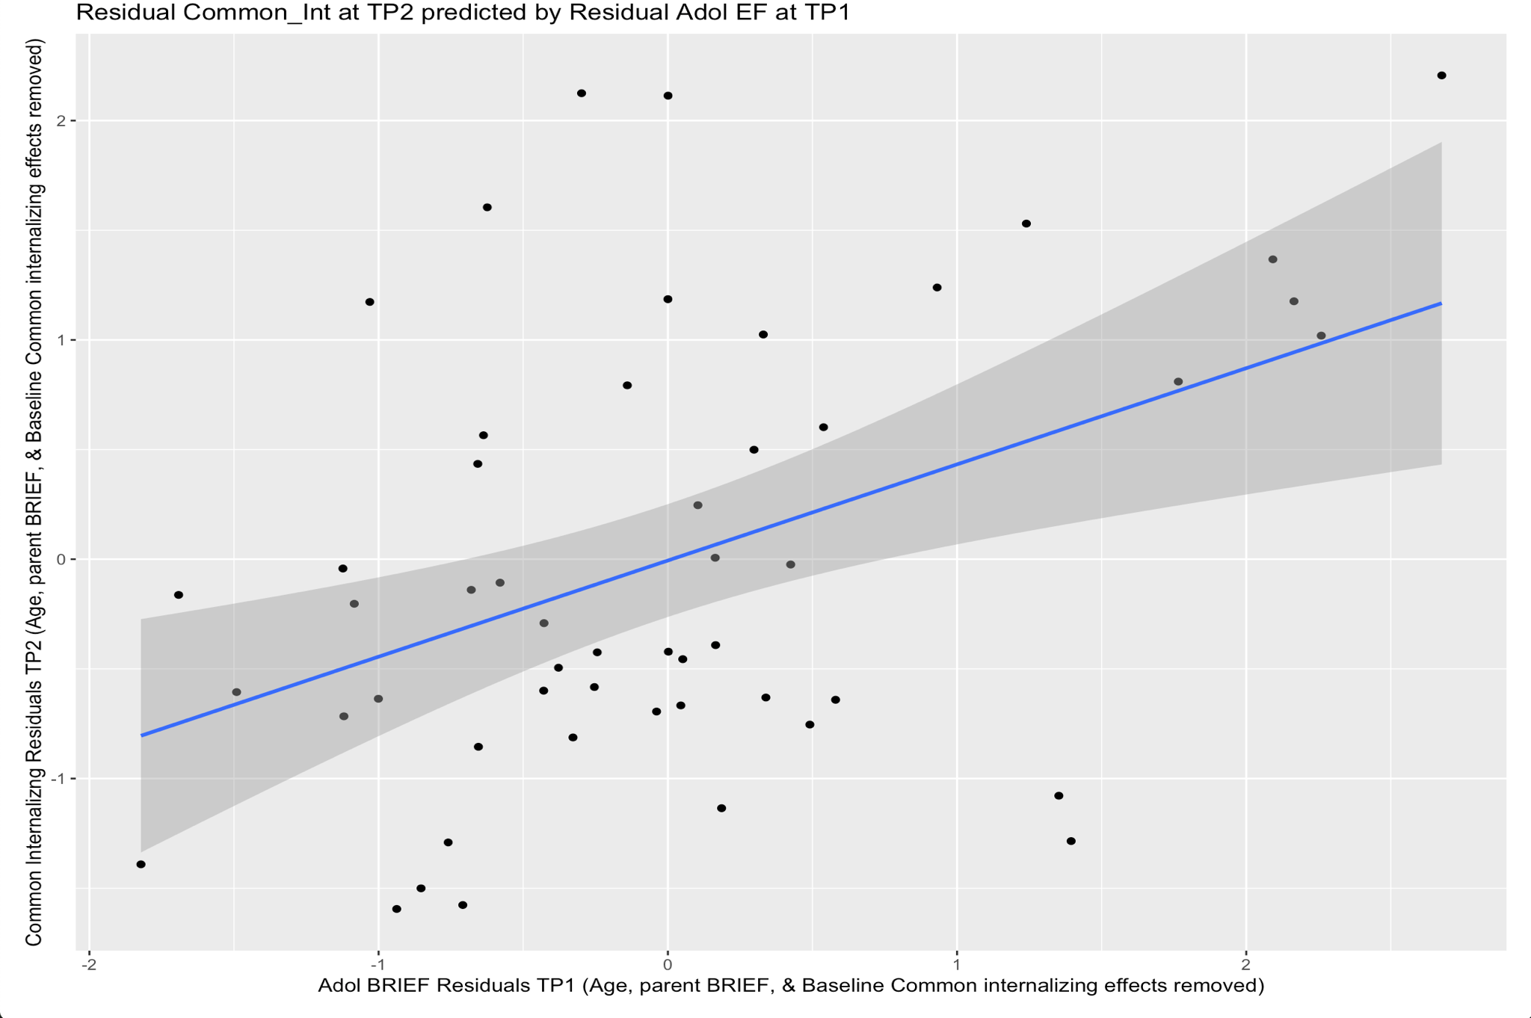
In Figure 2, the y-axis captures what is unique to LPA-specific symptoms at Time Point 2 and removes the effects it shares with parent-reported BRIEF scores, LPA-specific symptoms at Time Point 1, and adolescent age measured at Time Point 2. The x-axis captures what is unique to adolescent BRIEF scores at Time Point 1 and removes the effects it shares with parent-reported BRIEF scores, LPA-specific symptoms at Time Point 1, and adolescent age measured at Time Point 2. The resulting residual scatterplot visually shows how the unique variance for adolescent BRIEF self-reported scores at Time Point 1 predicts the unique variance of LPA-specific symptoms at Time Point 2.

Figure 2
Residual scatterplot of adolescent BRIEF GEC scores (TP1) predicting LPA symptoms at TP2
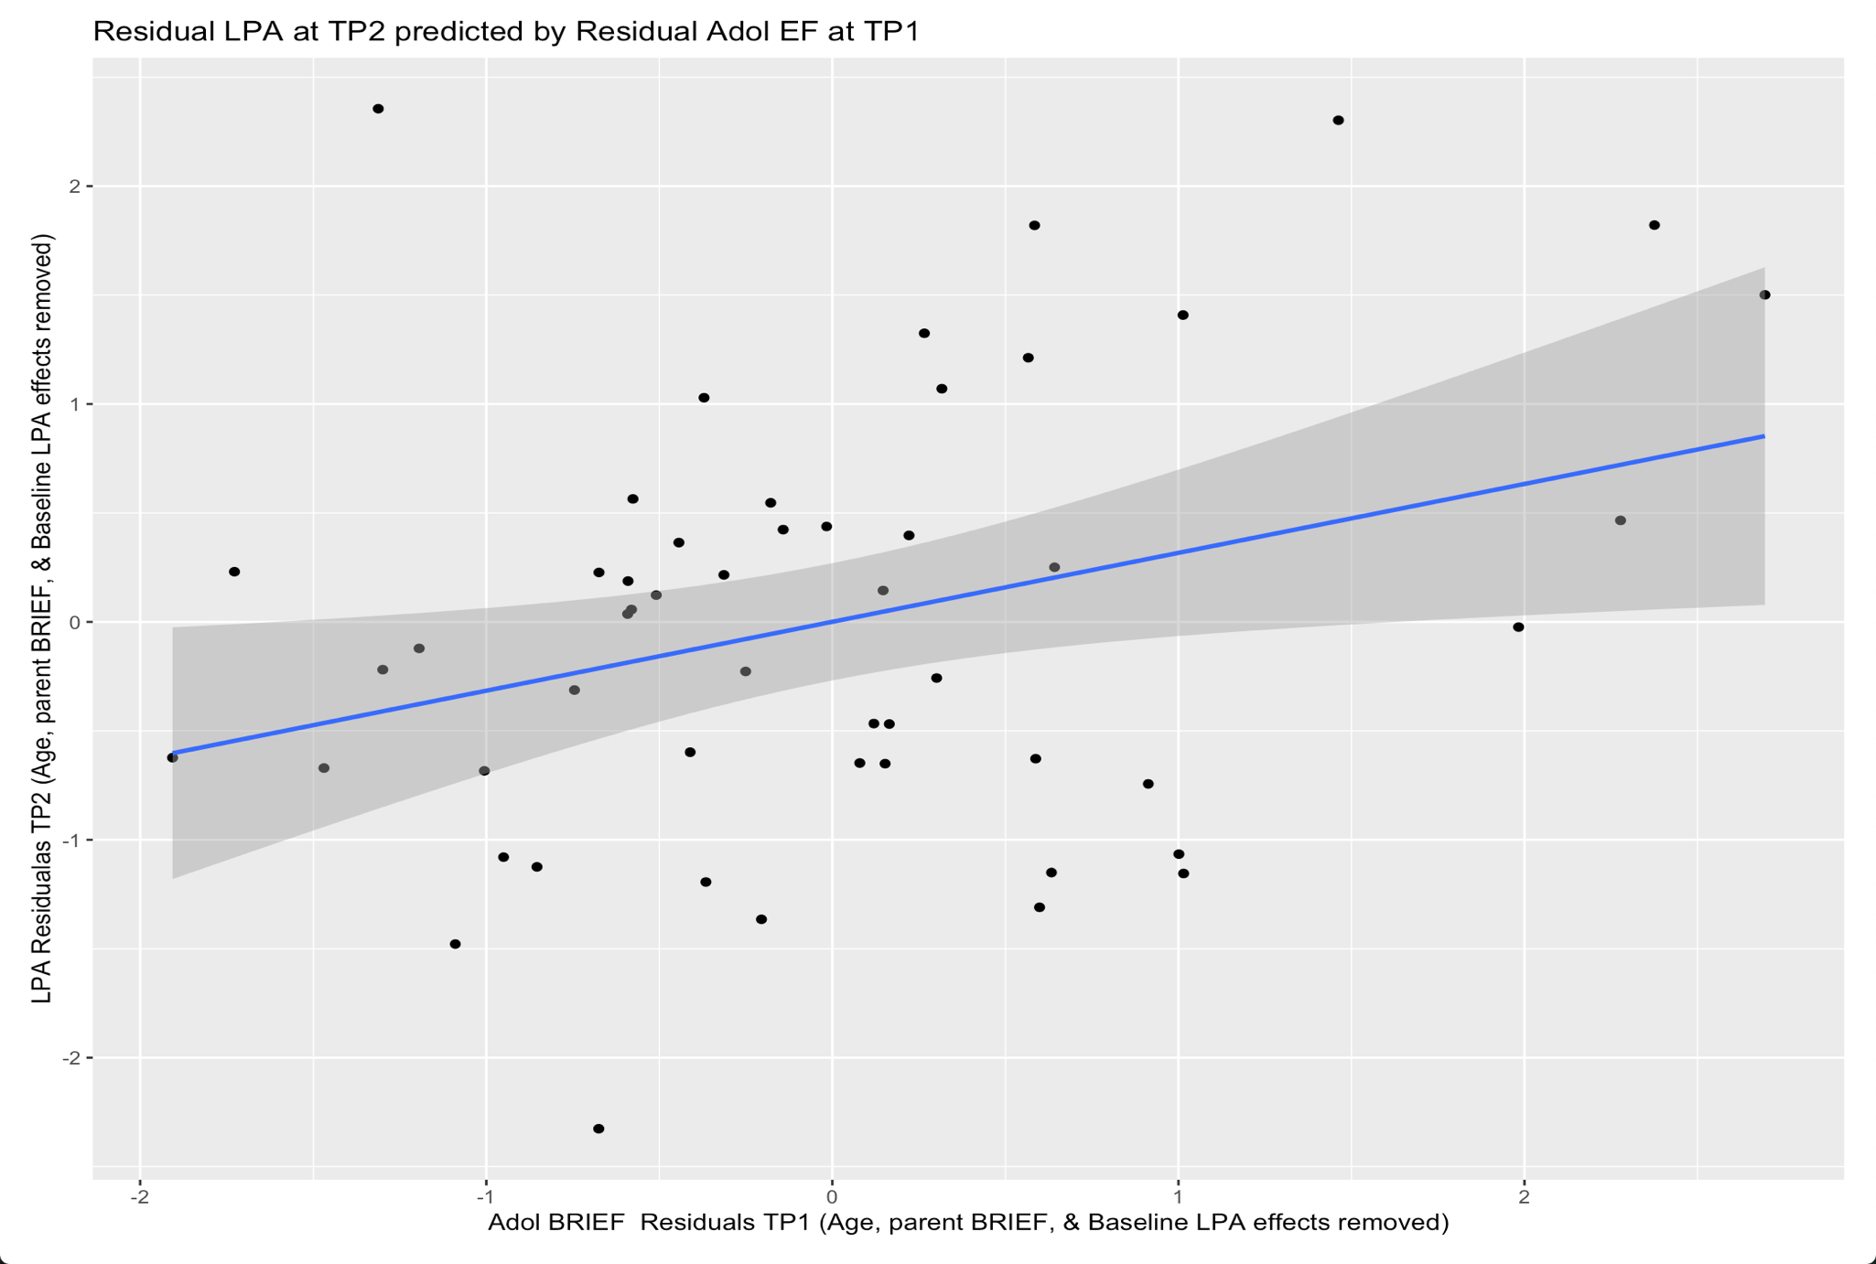

3. After accounting for TP1 baseline level of internalizing psychopathology (TP1), are clinically measured symptoms of psychopathology (i.e., ASEBA scores) at TP2 also predicted by parent or youth self-reported EF (i.e., BRIEF scores)?
We tested this question by running two linear models with the dependent variable (i.e., predicted value) being an ASEBA composite score from Time Point 2. In each model, an ASEBA composite score from Time Point 2 was predicted by the same ASEBA composite score at Time Point 1, parent-reported adolescent BRIEF GEC scores at Time Point 1, adolescent self-reported BRIEF GEC scores and controlled by adolescent age measured at Time Point 2. Referencing Table 9, Parent-reported BRIEF scores were once again unable to predict future psychopathology (t(47) = -1.24, p > .05). In addition, adolescent self-reported EF scores once again predicted subsequent symptoms of internalizing psychopathology above and beyond baseline psychopathology (t(47) = 2.67, p < .05) as measured by the ASEBA. These findings mirror what was evaluated with the factor scores.
Interestingly, subsequent externalizing psychopathology as measured by the ASEBA was predicted by parent-reported BRIEF scores (t(47) =3.19, p < .05) over and above baseline externalizing psychopathology (Table 9). Moreover, adolescent self-reported BRIEF scores were unable to predict future externalizing psychopathology as measured by the ASEBA (t(47) = 1.57, p > .05). Perhaps parent-reported BRIEF scores capture a unique component of adolescent EF that can predict externalizing psychopathology.
Table 9
Internalizing and Externalizing ASEBA composite scores from Time Point 2 predicted by parent and self-reported BRIEF scores, adolescent age (TP2), and baseline psychopathology.
Internalizing TP2
 | Estimate | Std. Error | t value | Pr(>l t l)
Internalizing TP1 | 0.634 | 0.155 | 4.088 | 0.0001
PR BRIEF  TP1 | -0.118 | 0.097 | -1.214 | 0.230
Adol BRIEF  TP1 | 0.408 | 0.153 | 2.670 | 0.010
Age TP2 | 0.098 | 0.065 | 1.498 | 0.140
Externalizing TP2
 | Estimate | Std. Error | t value | Pr(>l t l)
Externalizing TP1 | 0.450 | 0.132 | 3.391 | 0.001
PR BRIEF  TP1 | 0.260 | 0.081 | 3.194 | 0.002
Adol BRIEF  TP1 | 0.201 | 0.127 | 1.578 | 0.121
Age TP2 | 0.054 | 0.055 | 0.987 | 0.328
** The bolded values represent correlations with a p-value < 0.05.
Abbreviations: Common = Common Internalizing factor score; LPA = Low Positive Affect-specific factor score; AA = Anxious Arousal-specific factor score; Worry = Worry-specific factor score; PR BRIEF = Parent-reported BRIEF scores; Adol BRIEF = Adolescent self-reported BRIEF scores
Figures 3 & 4 are residual scatterplots. In Figure 3, the y-axis captures what is unique to ASEBA internalizing symptoms at Time Point 2 and removes the effects it shares with parent-reported BRIEF scores, ASEBA internalizing symptoms at Time Point 1 and adolescent age measured at Time Point 2. The x-axis captures what is unique to adolescent BRIEF scores at Time Point 1 and removes the effects it shares with parent-reported BRIEF scores, ASEBA internalizing symptoms at Time Point 1, and adolescent age measured at Time Point 2. The resulting residual scatterplot visually shows how the unique variance for adolescent BRIEF self-report scores at Time Point 1 predicts the unique variance of ASEBA internalizing symptoms at Time Point 2.
In Figure 4, the y-axis captures what is unique to ASEBA externalizing symptoms at Time Point 2 and removes the effects it shares with adolescent self-reported BRIEF scores, ASEBA externalizing symptoms at Time Point 1 and adolescent age measured at Time Point 2. The x-axis captures what is unique to adolescent parent-reported BRIEF scores at Time Point 1 and removes the effects it shares with adolescent self-reported BRIEF scores, ASEBA externalizing symptoms at Time Point 1, and adolescent age measured at Time Point 2. The resulting residual scatterplot visually shows how the unique variance for adolescent parent-reported BRIEF scores at Time Point 1 predicts the unique variance of ASEBA externalizing symptoms at Time Point 2.

Figure 3
Residual Scatterplot of Internalizing ASEBA at TP2 predicted by Adolescent EF at TP1
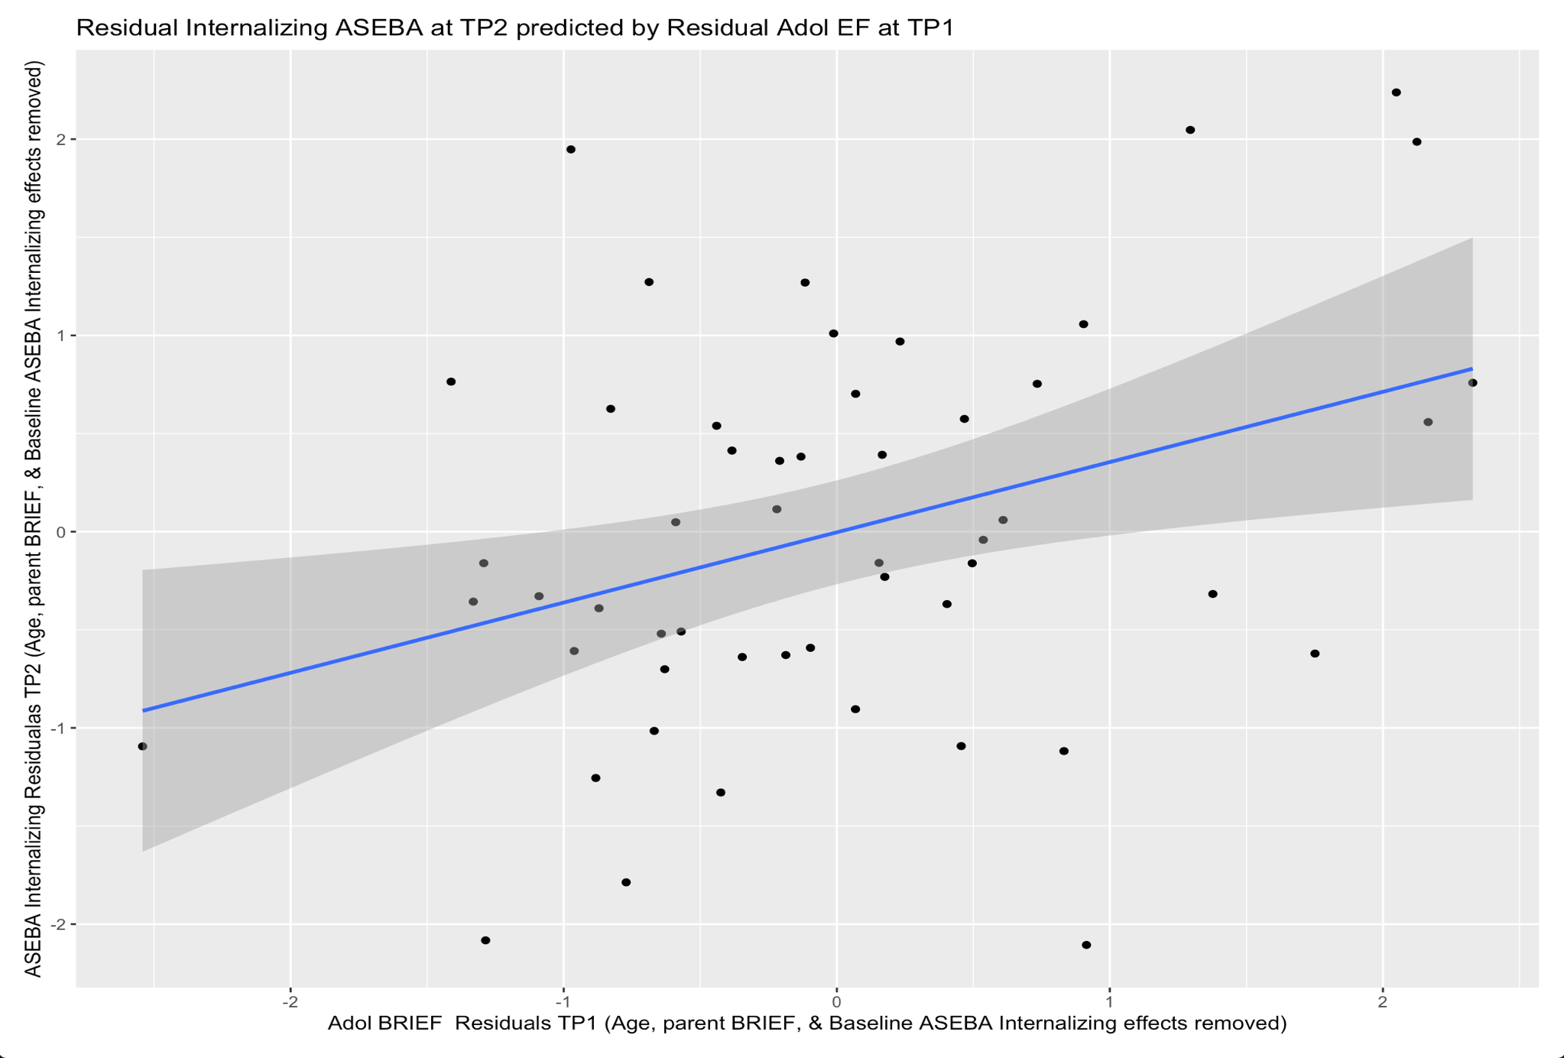
Figure 4
Residual Scatterplot of Externalizing ASEBA at TP2 by Parent-reported EF at TP1
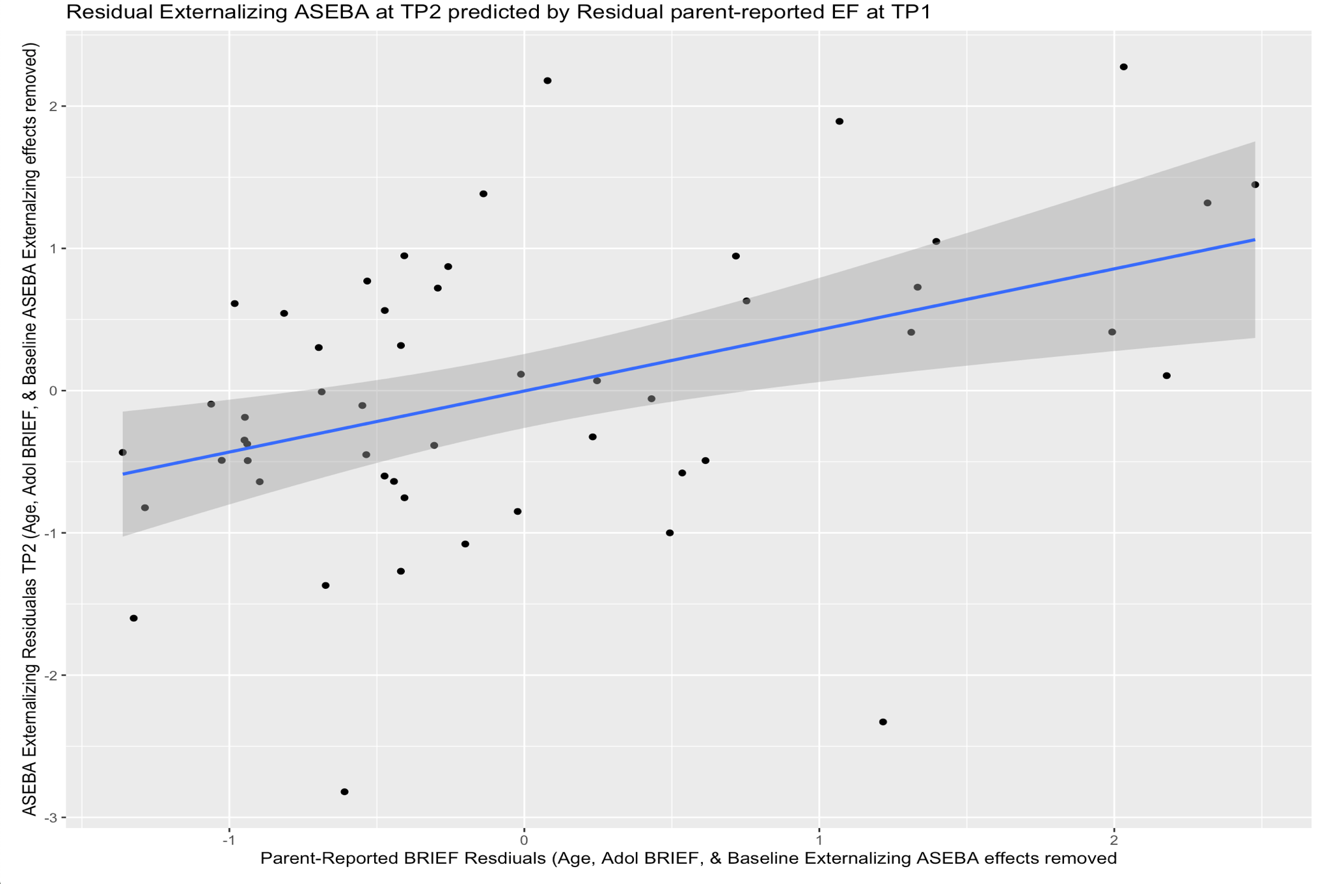

Discussion
In this study, we found youth self-reported EF is predictive of subsequent symptoms of internalizing psychopathology. Part of our goal was to evaluate what aspect(s) of psychopathology could be predicted by adolescent EF. Adolescent self-reported BRIEF GEC scores predict future common internalizing and low positive affect-specific psychopathology symptoms while accounting for baseline psychopathology. Assessing prior psychopathology symptoms is still important in predicting future psychopathology symptoms, however, gauging adolescents’ level of executive function can help predict greater common internalizing and low positive affect-specific psychopathology symptoms later in development.
Common internalizing is known to generally capture symptoms of negative affect present in both depression and anxiety. LPA-specific factor score captures symptoms of anhedonia and the absence of positive emotional experiences (Watson et al., 1995). Both of these factor scores are more focused on “ I feel crummy” statements as opposed to anxious constructs (i.e. I worry about the future). Since executive function is critical for planning, organizing, and goal achievement, perhaps an inability to focus on a goal can lead to greater negative affect as opposed to worry.
While adolescent self-reported EF was effective in predicting future symptoms of internalizing psychopathology above and beyond baseline psychopathology, parent reported EF was not. The above findings deviate from previous research, which discovered that parent assessments are usually more reliable in predicting children’s (5-10 years old) internalizing psychopathology (Loeber et al., 1990). Perhaps the findings in this study diverge from results found by Loeber et al. (1990) due to our older adolescent population. In a study assessing adolescent boys’ (13 years old) temperament and EF to predict future psychopathology, the youth reports were also more accurate than the parent reports (Latzman et al., 2016).
Similarly, adolescent BRIEF scores from TP1 were capable of predicting internalizing psychopathology symptoms at TP2 as measured by the ASEBA. Once again, parent reports from TP1 did not predict adolescent internalizing psychopathology symptoms at TP2. However, we did find that parent-reported EF is more accurate when predicting future externalizing psychopathology symptoms (ASEBA) while accounting for baseline psychopathology symptoms. Conversely, the adolescent self-reported BRIEF scores from TP1 did not significantly predict externalizing psychopathology symptoms at TP2. The BRIEF GEC scores as measured by adolescents and parents seem to have some predictive utility in assessing future adolescent psychopathology symptoms. Specifically, adolescent self-reported EF seems to have a relationship with subsequent symptoms of internalizing psychopathology. Meanwhile, parent-reported EF is better equipped to predict future symptoms of adolescent externalizing psychopathology.
The sample size in this study was relatively small (n=53). However, the sample was large enough to address the questions asked in this study. For instance, our factor scores positively correlated with clinically measured ASEBA internalizing composite scores. The factor scores ability to correlate with the ASEBA internalizing scores demonstrates our factor scores are capturing clinically measured aspects of internalizing psychopathology. In addition, parent-reported BRIEF scores demonstrated adolescent EF improved during the study. Given adolescent brain development, improved adolescent EF is what we would expect over the two year study.
In the future, it will be worth assessing EF with both self-reports and performance based behavioral tasks since these two versions of evaluating EF are not always correlated (Egan et al., 2019). Existing research indicates that self-reports and behavioral tasks assess different psychological constructs (Friedman & Banich, 2019). Behavioral tasks are more robust when examining latent variables of executive function. Individual behavioral tasks are generally less reliable because they are vulnerable to task impurity. Task impurity occurs when a task is measuring more than one isolated construct. For instance, many EF behavioral tasks require control of other brain processes such as sensorimotor functions, so performance on the behavioral task is evaluating more than EF processes (Friedman & Banich, 2019). Alternatively, self-reports focus on assessing solely EF functions that occur in everyday situations. Out of curiosity, I ran linear regression models with latent variables of EF evaluated in my population in a previous study (2-3 years ago) to assess subsequent internalizing psychopathology symptoms. The latent variables of EF could not predict future internalizing psychopathology. Perhaps the latent variables of EF were not predicting subsequent internalizing psychopathology because the behavioral tasks were measured incongruently from the psychopathology measures. Future research will want to explore if behavioral task measurements of EF capture a different aspect of psychopathology symptoms from self-reports.
Conclusion
In this study, we found support for two different ways psychopathology and EF interact with one another. The positive correlations between adolescent EF and common internalizing symptoms of psychopathology at both time points, suggests that as the level of executive function decreases, the level of internalizing psychopathology also increases. With linear regression models, we found lower levels of adolescent self-reported EF can predict subsequent elevated levels of common internalizing and LPA-specific symptoms of internalizing psychopathology compared to adolescents with normal levels of EF. Adolescent EF and symptoms of internalizing psychopathology clearly share a unique relationship. Perhaps one day we will be able to specifically pinpoint which aspects of EF predict subsequent symptoms of internalizing psychopathology. Recognizing certain risk factors of internalizing psychopathology prior to adolescence may be important in preventing the manifestation of internalizing psychopathology symptoms later in development.

References
Abbing, A., de Sonneville, L., Baars, E., Bourne, D., & Swaab, H. (2019). Anxiety
reduction through art therapy in women. Exploring stress regulation and executive functioning as underlying neurocognitive mechanisms. PLoS ONE, 14(12). https://doi.org/10.1371/journal.pone.0225200
Achenbach, T. M., Ivanova, M. Y., Rescorla, L. A., Turner, L. V., & Althoff, R. R.
(2016). Internalizing/Externalizing problems: review and recommendations for clinical and research applications. Journal of the American Academy of Child & Adolescent Psychiatry, 55(8), 647–656. https://doi.org/10.1016/j.jaac.2016.05.012
Banich, M. T. (2009). Executive function: The search for an integrated account.
Current Directions in Psychological Science, 18(2), 89–94. https://doi.org/10.1111/j.1467-8721.2009.01615.x
Banich, M. T., Smith, L. L., Smolker, H. R., Hankin, B. L., Silton, R. L., Heller, W., &
Snyder, H. R. (2020). Common and specific dimensions of internalizing disorders are characterized by unique patterns of brain activity on a task of emotional cognitive control. International Journal of Psychophysiology, 151, 80–93. https://doi.org/10.1016/j.ijpsycho.2020.02.002
Beats, B. C., Sahakian, B. J., & Levy, R. (1996). Cognitive performance in tests
sensitive to frontal lobe dysfunction in the elderly depressed. Psychological Medicine, 26, 591–603. doi:10.1017= S0033291700035662
Bradbury, C., Cassin, S. E., & Rector, N. A. (2011). Obsessive beliefs and neurocognitive
flexibility in obsessive–compulsive disorder. Psychiatry Research, 187, 160–165. doi:10.1016=j.psychres.2010.11.008
Bredemeier, K., Warren, S. L., Berenbaum, H., Miller, G. A., & Heller, W. (2016).
Executive function deficits associated with current and past major depressive symptoms. Journal of affective disorders, 204, 226–233. https://doi.org/10.1016/j.jad.2016.03.070
Castaneda, A. E., Tuulio-Henriksson, A., Marttunen, M., Suvisaari, J., & Lo ̈nnqvist, J.
(2008). A review on cognitive impairments in depressive and anxiety disorders with a focus on young adults. Journal of Affective Disorders, 106, 1–27. doi:10.1016=j.jad.2007.06.006
Egan, K. N., Cohen, L. A., & Limbers, C. (2019). Parent–child agreement on the
Behavior Rating Inventory of Executive Functioning (BRIEF) in a community sample of adolescents. Applied Neuropsychology: Child, 8(3), 264–271. https://doi.org/10.1080/21622965.2018.1438896
Favre, T., Hughes, C., Emslie, G., Stavinoha, P., Kennard, B., & Carmody, T. (2008).
Executive functioning in children and adolescents with major depressive disorder. Child Neuropsychology: A Journal on Normal and Abnormal Development in Childhood and Adolescence, 15, 85–98. doi:10.1080=09297040802577311
Giedd, J. N. (2004). Structural magnetic resonance imaging of the adolescent brain.
Annals of the New York Academy of Sciences, 1021, 77–85. doi:10.1196=annals.1308.009
Gioia, G. A., Isquith, P. K., Guy, S. C., & Kenworthy, L. (2000). Test review behavior
rating inventory of executive function. Child Neuropsychology, 6(3), 235–238. https://doi.org/10.1076/chin.6.3.235.3152
Gioia, G. A., Isquith, P. K., Guy, S. C., & Kenworthy, L. (2015). Behavior rating
inventory of executive function (2nd ed.). Lutz, FL: Psychological Assessment Resources.
Hankin, B.L., Young, J.F., Abela, J.R.Z., Smolen, A., Jenness, J.L., Gulley, L.D., Technow, J. R., Gottlieb, A. B., Cohen, J. R., & Oppenheimer, C. W. (2015). Depression from childhood into late adolescence: influence of gender, development, genetic susceptibility, and peer stress. Journal of Abnormal Psychology 124 (4) 803-816. https://doi.org/10.1037/abn0000089
Han, G., Helm, J., Iucha, C., Zahn-Waxler, C., Hastings, P. D., & Klimes-Dougan, B.
(2016). Are executive functioning deficits concurrently and predictively associated with depressive and anxiety symptoms in adolescents? Journal of Clinical Child & Adolescent Psychology, 45(1), 44–58. https://doi.org/10.1080/15374416.2015.1041592
Kavanaugh, B. C., Cancilliere, M. K., Fryc, A., Tirrell, E., Oliveira, J., Oberman, L. M.,
Wexler, B. E., Carpenter, L. L., & Spirito, A. (2019). Measurement of executive functioning with the National Institute of Health Toolbox and the association to anxiety/depressive symptomatology in childhood/adolescence. Child Neuropsychology, 0(0), 1–16. https://doi.org/10.1080/09297049.2019.1708295
Kessler, R.C., Gruber, M., Hettema, J.M., Hwang, I., Sampson, N., Yonkers, K.A. (2008).
Co-morbid major depression and generalized anxiety disorders in the Nation Comorbidity Survey follow-up. Psychol. Med. 38 (3), 365-374. https://doi.org/10.1017/S0033291707002012.
Knouse, L. E., Barkley, R. A., & Murphy, K. R. (2013). Does executive functioning (EF)
predict depression in clinic-referred adults?: EF tests vs. Rating scales. Journal of Affective Disorders, 145(2), 270–275. https://doi.org/10.1016/j.jad.2012.05.064
Latzman, R. D., Shishido, Y., Latzman, N. E., & Clark, L. A. (2016). Anxious and
depressive symptomatology among male youth: The joint and interactive contribution of temperament and executive functioning. Child Psychiatry & Human Development, 47(6), 925–937. https://doi.org/10.1007/s10578-016-0623-x
Lawson, R. A., Papadakis, A. A., Higginson, C. I., Barnett, J. E., Wills, M. C., Strang, J.
F., Wallace, G. L., & Kenworthy, L. (2015). Everyday executive function impairments predict comorbid psychopathology in autism spectrum and attention deficit hyperactivity disorders. Neuropsychology, 29(3), 445–453. https://doi.org/10.1037/neu0000145
Martel, M., Nikolas, M., & Nigg, J. T. (2007). Executive function in adolescents with
ADHD. Journal of the American Academy of Child & Adolescent Psychiatry, 46, 1437–1444. doi:10.1097=chi. 0b013e31814cf953
Meyer, T.J., Miller, M.L., Metzger, R.L., Borkovec, T.D. (1990). Development and
validation of the Penn State Worry Questionnaire. Behavioral Research and Therapy Journal. 28(6), 487-495. https://doi.org/10.1016/0005-7967(90)90135-6.
Müller, O., Rothenberger, A., Brüni, G. L., Wang, B., & Becker, A. (2018). Questioning
the long-term stability of the additive model in comorbid CTD+ADHD - The transition from childhood to adulthood. PLoS ONE, 13(11). https://doi.org/10.1371/journal.pone.0207522
Murphy, F. C., Rubinsztein, J. S., Michael, A., Rogers, R. D., Robbins, T. W., Paykel, E.
S., & Sahakian, B. J. (2001). Decision-making cognition in mania and depression. Psychological Medicine, 31, 679–693. doi:10.1017=S0033291701003804
Murphy, F. C., Sahakian, B. J., Rubinsztein, J. S., Michael, A., Rogers, R. D., Robbins,
T. W., & Paykel, E. S. (1999). Emotional bias and inhibitory control processes in mania and depression. Psychological Medicine, 29, 1307–1321. doi:10.1017= S0033291799001233
Snyder, H. R., Friedman, N. P., & Hankin, B. L. (2020). Associations between task
performance and self-report measures of cognitive control: Shared versus distinct bbilities. Assessment. https://doi.org/10.1177/1073191120965694
Snyder, H. R., Miyake, A., & Hankin, B. L. (2015). Advancing understanding of
executive function impairments and psychopathology: Bridging the gap between clinical and cognitive approaches. Frontiers in Psychology, 6. https://doi.org/10.3389/fpsyg.2015.00328
Watson, D., Weber, K., Assenheimer, J.S., Clark, L.A., Strauss, M.E., McCormick, R.A.
(1995). Testing a tripartite model: I. evaluating the convergent and discriminant validity of anxiety and depression symptom scales. Journal of Abnormal Psychology, 104(1), 3-14. https://psycnet.apa.org/doi/10.1037/0021-843X.104.1.15

Supplied by Hannah R. Snyder, Ph.D. Assistant Professor, Brandeis University

