Eradication of the Invader:
Interactions Between Arrhenatherum Elatius Management Practices and Soil Nitrogen Cycling

An Honors Thesis by Michelle Tracy Leung
Department of Environmental Studies, University of Colorado Boulder
Defense Date: 5 April 2022

Thesis Advisor:
Dr. Eve-Lyn S. Hinckley, Assistant Professor, Department of Environmental Studies
Defense Committee:
Dr. Eve-Lyn S. Hinckley, Department of Environmental Studies, Dr. Cassandra Brooks, Department of Environmental Studies, Dr. Timothy Seastedt, Department of Ecology and Evolutionary Biology
Table of Contents
Acknowledgments 1
Abstract 2
Introduction 3
Research Questions and Hypotheses 6
Study site 7
Methods 8
Study design 8
Field Methods 9
Laboratory Methods 9
Data Analysis 10
Results 11
Discussion 13
Limitations of the Study 17
Future Research 17
References 19
Tables and Figures 26

Acknowledgments
I would like to thank everyone who has been with me for every part of the step in my honors thesis research from inspiring me to do research, to experiencing field work, working in the lab, and problem solving through the obstacles. Special thanks to my wonderful advisor, Dr. Eve-Lyn Hinckley for giving me the courage to start this entire honors thesis journey, while also being an awesome mentor who inspires me to do research within the environmental field. I would also like to thank Ph.D. student, Hannah Miller, for always being a phone call away for all my incessant questions and distressing situations I was in throughout this process. I would not have been able to continue the research without her optimism and support. Thank you, Wendy Roth for guiding me and her willingness to help troubleshoot the Lachat with me even with the little time that we had; it has been a wonderful learning experience even with all the chemistry we had to do. Thank you Katie Snell for doing the C:N analysis in such short notice. Thank you to Boulder OSMP staff, Ann Lezberg, Lynn Riedel, and Brian Anacker for going out to the field and helping me establish plots and site areas that created the foundation for my research while also answering all my questions about A. elatius. To the entire Environmental Biogeochemistry Group (past and present group members), thank you for your time out in the field and lab, advice, guidance, and support.
The research was funded by a University of Colorado Undergraduate Research Opportunities Program (UROP) fellowship.

Abstract

Due to climate change and other global change drivers, there is an increased risk of invasion in native plant communities as non-native species tend to thrive under increased levels of CO₂ and increased atmospheric nutrient deposition. Invasion of non-native species can cause shifts in ecosystem function due to changes in plant community composition that cause modifications in nutrient cycling, organic matter decomposition, and soil ecology. Currently, the Western United States (U.S.) consists of numerous non-native species in tallgrass prairie ecosystems. As a result, land managers are using several different management technique to eradicate and limit their spread including prescribed burning, mechanical removal, herbicides, and livestock grazing. Boulder Open Space and Mountain Parks (OSMP) in the Colorado Front Range of the Rocky Mountains have been increasing efforts to eliminate the spread of Arrhenatherum elatius (A. elatius), which has persisted in ecosystems of the Front Range for the past 20 years. This honors thesis project investigates how cattle grazing and prescribed fire— common management strategies to limit the growth and spread of A. elatius—interacts with soil nitrogen (N) cycling at Shanahan Ridge, Boulder, Colorado. The data presented include net N cycling processes— mineralization and nitrification – and aboveground vegetation biomass in four different treatment sites: past graze, recent graze, graze + burn, and no management. Graze + burn was associated with lower rates of N cycling processes compared to recent graze and past graze. However, differences among treatments were not statistically significant for soil N cycling measurements (p > 0.05). There were statistical differences in the amount of thatch for graze + burn, past graze, and recent graze (p < 0.05). Overall, these data suggest that the interactions between grazing and soil N cycling rates are perhaps due to complicating factors that differ across the sites. This project provides foundational knowledge regarding how management techniques could be influencing nutrient cycling and A. elatius growth. It will help to inform Boulder OSMP’s management techniques as they relate to control of A. elatius and changes to ecosystem function.

Introduction
Terrestrial ecosystems continue to change due to human activities that are influencing both the climate and the biogeochemical cycles that underlie all life on Earth. Consequences due to climate change include a significant alteration to the distribution of species and the composition of plant and animal communities, including non-native invasive species (Finch et al, 2021). For plant communities, there is an increased risk of invasion with shifts in climate, as non-natives tend to thrive better following disturbances while other invasive species show greater competitiveness from increased levels of CO₂ (Bradley & Wilcove, 2009). With invasion, ecosystem function can shift due to changes in plant community composition that cause modifications in nutrient cycling, organic matter decomposition, and soil ecology (Díaz-Barradas et al, 2015; Hickman et al, 2013). As biological invaders take root in an ecosystem, there is often an eventual decline or extinction of native species due to competition, disease, or depletion of resources, which can impede native restoration efforts (Dukes & Mooney, 2004; Gibbons, 2017; Fehmi, Rasmussen, & Arnold, 2021). With numerous variables influencing shifts between native and non-native vegetation, ecological restoration and management strategies can be difficult to formulate as suppression of one invader could often result in an establishment of another invasive species (Gaskin et al, 2020).
Previous studies have found a strong positive correlation between the level of invasion by particular plant species and availability of soil nutrients, including nitrogen (N). Therefore, the rapid dominance of invasive species suggests that they can take advantage of available resources that were inaccessible to native species; their dominance can cause lower soil moisture, changes to soil microbial communities, and alterations to the frequency of disturbances such as wildfires (Daehler, 2003; Siding, LeJeune, & Seastedt, 2004; Fehmi, Rasmussen, & Arnold, 2021; Molinari & D’ Antonio, 2020; Miniat et al, 2021; Díaz-Barradas et al, 2015). Invasive plants often increase biomass and net primary productivity of ecosystems due to greater soil N availability, altered N fixation rates, higher C:N, and production of litter with higher rates of decomposition (Hickman et al, 2013). These changes cause greater likelihood of increased nutrient concentrations in surface soils (Vanderthoven, Dassonaville, & Meerts, 2005; Liao et al, 2008; Fehmi, Rasmussen, & Arnold, 2021). As a result, there are often changes in the relative proportion of ammonium (NH₄⁺), nitrate (NO₃⁻), and amino acids in the soil due to the non-native plants’ ability to condition the surrounding soil biota (Díaz-Barradas et al, 2015; Suding et al, 2013).
Currently, Western United States (U.S.) grassland ecosystems consist mostly of non-native species, and a return to native species through restoration efforts is challenging, due to compounding global change drivers like shifts in climate and increases in atmospheric nutrient deposition (Want et al, 2017; Stevens et al, 2004 ). As a result, the remaining native prairie ecosystems are drastically dwindling even as their conservation is becoming a priority for land managers across the region (Flatt, 2015). Numerous exotic grasses and Eurasian weeds have dominated Western U.S. grasslands by occupying gaps between native plants, causing, for example, shifts in plant community composition and changes to the water balance (Dukes & Mooney, 2004). Much of the non-native species invading the Intermountain West of the U.S differ in biomass, height, and phenology relative to native species within the area increasing their likelihood of survival. (Litt & Pearson, 2013). Invasive plants can contribute to increases in wildfire frequency across the rangelands of the Western U.S. due to changes from diverse to homogenous grasslands (Chambers & Wisdom, 2009; Runyon/KUNC, 2020). This change influences the region’s albedo resulting into increased evapotranspiration rates that accelerates aridity of the region (Taylor et al, 2013; Chambers & Wisdom, 2009). Changes in the species composition of the regions also influences the overall biogeochemical cycling, which can transform shrublands from carbon (C) sinks to C sources because of low microbial carbon-use efficiency (Chambers & Wisdom, 2009; Masto et al, 2022).
Several management strategies have been used to help mitigate the persistence of invasive plant species across the Western U.S. (Gaskin et al, 2020). Strategies used by land managers can vary in effectiveness depending on timing and frequency which can be difficult to determine (Wilson & Clark, 2001). The main management techniques for non-native plant species include prescribed burning, mechanical removal, herbicides, and grazing (Gaskin et al, 2020; Coon et al, 2020). Prescribed burning has the potential to reduce the invasive population and allow the native population to establish dominance within the community while removing accumulated plant thatch or litter (Keeley, 2006; Emery & Gross, 2005; National Geographic Society, 2019; Molinari & D’ Antonio, 2020). Due to less selectivity, cattle grazing is considered suitable for targeting plant diversity and typically favors grasses and small forbs comparable to other types of livestock grazing (Pykälä, 2003; Stammel, Kiehl, & Pfadenhauer, 2003). Cattle grazing can alter ecosystem N cycling in grassland ecosystems due to several factors, including changes to soil bulk density, soil moisture content, and soil temperature, which drive plant establishment, as well as rates of decomposition and N cycling through removal of aboveground biomass, breaking of thatch (litter) layers, and altering spatial heterogeneity of vegetation (Olsen et al, 2011; Sun et al, 2018; Molinari & D’ Antonio, 2020; Adler, Raff, & Lauenroth, 2001; Renne & Tracy, 2007). Cattle grazing can also influence biogeochemical cycling by releasing nutrients via manure and urine, depositing large amounts of N into the environment for plant uptake (Renne & Tracy, 2007; Steinfeld & Wassenaar, 2007). Although studies have shown that cattle grazing can modify soil N processes, the level of whether the practice increases or decreases rates of N cycling processes is still debated (Zhou et al, 2017).
One strategy in reducing invasive species is a combination of grazing and prescribed burning treatments. This strategy is largely dependent on proper timing of the treatments affecting vegetation cover, biomass, plant density, and seed (Diamond, 2009). The mosaic landscape created by burning and grazing affects invasive plant establishment across the area where the interaction becomes dependent on time and spatial factors (Prescribed-Fire, 2020). Therefore, interactions between grazing and prescribed burning can create a diverse plant community within a grassland ecosystem while leading to increases in soil N availability and changes to other nutrient cycles (Diamond, 2009; Prescribed-Fire, 2020; Weir et al, 2013; Anderson et al, 2006). Weir et al (2013) found that recently burned and grazed areas had higher N availability compared to previously burned and grazed areas.
Tall Oatgrass (Arrhenatherum elatius), a perennial, cool-season bunchgrass, was adapted and introduced in the early 1800s across North America from Europe by humans. It is abundant in lightly grazed or mown grasslands, but rare in pastures (Will & Begg, 1994; U, 2002; Pfitzenmeyer, 1962). A. elatius has become an increasing threat to native tallgrass prairies in the Western U.S., including open space lands adjacent to the Boulder-Denver Metropolitan area, managed by the City of Boulder Open Space and Mountain Parks (OSMP). With dramatic increases in cover across the Colorado Front Range for the past 20 years, A. elatius now occupies 300 acres of land and is expected to increase 30-70 acres per year (IPM in Action: Boulder City and County Battle Invasive Weeds, n.d.; EnviroPlan Partners, 2018). The expansion of A. elatius will impact the diversity and function of grassland and prairie ecosystems that have historically supported important habitats for a wide variety of butterfly and ground-nesting bird species (EnviroPlan Partners, 2018; Pfitzenmeyer, 1962). Boulder OSMP has implemented a few management strategies to reduce A. elatius invasion, but cattle grazing has been the most predominant due to its cost effectiveness at a large scale (A. Lezberg, personal communication, 2021). Under grazing pressures, the population of A. elatius will likely decline but will increase if there is an absence of grazing (Dostálek & Frantik, 2011; Pfitzenmeyer, 1962).
Currently, A. elatius’ overall influence and effect on the functioning of ecosystems within Boulder OSMP is unclear. A recent study highlighted the interactions between the invasive and the soil N cycle. Hinckley at al. (in review) found that net N mineralization was higher in two of three A. elatius -invaded sites in the foothills of the Colorado Front Range. They also observed increases in aboveground biomass with invasion at two of three sites. However, at the third location, Shanahan Ridge, invaded sites showed the opposite effect. Further analysis of the interaction between A. elatius’ invasion and the soil N cycle is informative to guide efforts in eradicating/limiting the spread of the invasive species based on characteristics particular to each invaded site. One next step is to determine whether OSMP's usage of cattle grazing is effectively eradicating and/or limiting the growth of A. elatius. Continual coordination with OSMP, researchers, and collaborators will increase understanding A. elatius in the prairie ecosystems and proper usage of successful management strategies. Therefore, investigating the relationship between cattle grazing and soil N cycling in A. elatius invaded areas will provide useful data, demonstrating how both an invasive species and a management practice interact and the degree to which they are associated with an altered soil N cycle. The outcomes of this investigation have important implications for land managers who seek to restore native grassland communities. To address this knowledge gap, I investigated the following questions and hypotheses:

Research Questions and Hypotheses
Q1: How do soil N cycling rates vary across grazing management practices (grazing, no grazing, and grazing + prescribed burning) in OSMP lands?
H1: Higher soil N cycling rates will be associated with areas where A. elatius is present, and no grazing has occurred because A. elatius will outcompete native plant species within the area. However, these patterns may vary across plots as past evidence indicates that it could be dependent on the surrounding soil and vegetation environment (Hinckley et al, in review). The opposite pattern will be observed in recently grazed areas. Combinations of grazing and prescribed burning could decrease soil N cycling rates as interactions of burning and grazing alter seed success and the aboveground biomass (Diamond, Call, & Devoe, 2012). However, depending on the timing of when each of the treatments was applied, there may not be a direct effect on soil N cycling rates (Emery & Gross, 2005).
Q2: Do soil net N cycling rates differ between managed and unmanaged sites?
H2: Managed sites (graze + burn, past graze, recent graze) will have lower soil N cycling rates due to lower abundance of A. elatius. The unmanaged sites (no management) invaded with A. elatius will show higher soil N cycling rates.
Q3: Do aboveground biomass and A. elatius thatch and litter amounts differ among management treatments?
H3: Recent grazing will result in lower aboveground live vegetation and lower levels of A. elatius thatch biomass than other treatments. The combination of grazing and prescribed burning will also have lower aboveground biomass compared to the past grazed site due to combustion of biomass.

Study site

The study was conducted in the Shanahan Ridge area located within Boulder OSMP lands in Boulder, Colorado (39.9673 ˚N, 105.2586 ˚W, elevation 1676 m). Shanahan Ridge is more broadly a part of the traditional territories of the Arapaho, Cheyenne, and Ute peoples. The climate of this region is semiarid, characterized with extremes throughout the summer and winter. The annual rainfall is about 475 mm and snowfall of about 2017 mm where most of the moisture occurs during the winter and spring months (City of Boulder, 2018; Hogan, 2019). The temperature can be as low as -30℃ to greater than 32℃ in the winter and summer, respectively (City of Boulder, 2018). The region is comprised of savanna and prairie ecosystems; Shanahan Ridge is among the most A. elatius-invaded areas that is actively managed by Boulder OSMP. This region supports high plant and animal diversity and resides next to urban neighborhoods. Thus, the area is used regularly for recreational activities including heavily trafficked trails. The study area includes open woodlands consisting of mostly Ponderosa pines (Pinus ponderosa) with Douglas Fir (Pseudotsuga menziessi) and Common Juniper trees (Juniperus communis) (Mountain & Ridge, 1998). Specifically, the focus of the sampling was within P. ponderosa woodlands at two locations: the Water Tank Grazing Cell and Hardscrabble Grazing Cell (near the Lehigh Connector-North Trailhead; Fig. 1). Outlined by grazing enclosures, OSMP has conducted cattle grazing within the Water Tank Grazing Cell since 2014 during the summer months (A. Lezburg, personal communication, 2021). There are a total of four site across each of the two locations, where each site is characterized by a different management strategy (i.e., “treatment”). The Water Tank Grazing Cell (Fig. 1) contains three treatments: recent graze (2021), past graze (2014-2021) and a third treatment containing grazing that occurred in 2019-2021 along with prescribed burning in 2019 (henceforth, referred to as “graze + burn”). The Hardscrabble Grazing Cell only has one site: no management (Fig. 1) where no grazing has occurred.

Methods

Study design
Four treatments were established near one another (within ~20 m) to decrease the amount of variation among sites. The past graze treatment had grazing activity since 2014 and there has been indication that the site was grazed in 2019-2021 for approximately one month. The recent graze treatment had 55 cattle for 13 days in place during June 2021. Occurrence of grazing was confirmed by Boulder OSMP managers and marked by trampled A. elatius and cattle excrement. As for the graze + burn treatment, grazing occurred during 2019-2021 and was burned in 2019. The boundary of the burn was confirmed by field survey and indication of burned marks on the trees, establishing the extent of the prescribed burning. Lastly, no management techniques have been used in the no management treatment. This site is located next to a residential area and the Shanahan Ridge trailhead. At each of the four sampling sites, I established four 2m x 2m plots. Each plot was chosen to mimic microenvironments, relative A. elatius abundance, slope, similar vegetation cover, and absence of rare plants. The locations of each plot were based on tree canopy cover (e.g., shade and branch cover) and distance from the nearest plot. Specifically, a criterion included having at least two plots directly under tree canopy and two plots not under tree cover but still within tree-dense areas. Areas that included other N-fixing plant species were avoided and A. elatius coverage within the plot was not standardized to capture spatial heterogeneity in the management treatments.

Field Methods
Field sampling occurred during two phenological periods of A. elatius, including: June-July 2021 (peak biomass, “summer”) and Oct-Nov 2021 (plant senescence, “autumn”) for soil N processing rates (net N mineralization and net nitrification) and aboveground vegetation biomass. Within each phenological period, two soil cores (3 cm diameter, 0-10 cm depth) were randomly collected at each plot and placed into plastic bags: one was for immediate lab analysis and the other was returned to its borehole within the plot for in-field incubation (Hart et al, 1994). After approximately a 30-day incubation period, the incubated soil cores were transported to the laboratory at the Institute of Arctic and Alpine Research (INSTAAR) for immediate analysis of ammonium and nitrate concentrations.
Aboveground biomass samples were collected within each plot for each sampling period with gloved hands. The live vegetation was separated by A. elatius and other plant species. Any dead stems, thatch cover, and litter (e.g., small pinecones and needles) were collected separately from live tissues within a quadrat of each plot (henceforth referred to as thatch). The vegetation samples were used to calculate aboveground biomass on an areal basis, leaf tissue C:N ratios, and abundance of A. elatius. Vegetation tissue samples were dried at 60℃ for 48 hr and weighed (mass per unit area). Each sample was cut and mixed into a homogenous subsample of aboveground biomass tissue to be subsamples and pulverized prior to analysis for total C and N. Plant composition was assessed to identify the presence of other plant species and determine the vegetation percent cover for each plot. A total of 64 soil samples and about 96 aboveground vegetation samples were collected across four plots at each treatment during peak A. elatius biomass (summer) and the seasonal transition (autumn).

Laboratory Methods

Soil Analysis for Net Nitrification and Net Mineralization
Once soil samples were returned from the field, roots and rocks was removed by hand. Field-moist soil (g) was extracted in 50 ml of 2M potassium chloride (KCl), shaken for 2 hr, and filtered using Whatman 1 filters. Acid-washed equipment was used and samples were frozen (-18℃) until analysis. The extracted solution was analyzed for NO₃⁻ and NH₄⁺ concentrations with a Lachat QuickChem 7500 Flow Injection Autoanalyzer at the University of Colorado, Boulder. Standards were prepared in 2M KCl matrix. The instrument detection limit for nitrate was 0.01 mg/L - 10 mg/L and any samples above the detection limit was diluted with 2M KCl to ensure accurate values. A calibration coefficient of ≥ 0.995 was achieved for sample analysis and %RSD for each standard was 10%. A continuing calibration verification blank (CCVB) and calibration verification standard was run for every 20 samples to ensure the 10% RSD value. NO₃⁻ was quantitatively reduced to NO₂⁻ as the sample passes through a copperized cadmium column with ensured efficiency of >75% in the instrument. Any samples with indication of air bubbles within the peak levels were re-analyzed and peak baselines were readjusted if needed. The NH₄⁺ analysis on the Lachat reacts with alkaline phenol, then with hypochlorite to form indophenol blue while sodium nitroprusside enhances sensitivity. The absorbance of the instrument is measured at 630nm and is directly proportional to the ammonia concentration within the samples. All reagents for NH₄⁺ analysis was kept at room temperature. The instrument detection limit for NH₄⁺ was 0.02 mg/L- 2 mg/L) and the calibration coefficient and %RSD of all standards were constrained by the same expectation as the NO₃⁻. A subsample of each soil sample was dried at 105℃ for 48 hr and analyzed for gravimetric soil moisture.

Vegetation Analysis for C:N
Vegetation tissue, as well as thatch and litter samples were combusted for total C and N concentrations and stable isotope values (¹³C/¹²C and ¹⁵N/¹⁴N) using the Thermo Finnigan Flash EA 1112 and Delta V Plus Isotope Ratio Mass Spectrometer at the Earth Systems Stable Isotope Lab. Standards used were ethylene diamine tetraacetic acid (EDTA), Glutamic Acid (GLUT), and Acetanilide (ACT). Vegetation samples were weighed between 1-2 mg and packed in tin capsules for elemental analysis. The CO₂ standards range was diluted by 90% to encompass large ranges of C within the vegetation. N₂ was used as the carrier gas for fast mass switching.

Data Analysis
Rates of net N mineralization and net nitrification were calculated by differencing the mass of inorganic N (NH₄⁺ and NO₃⁻ for net N mineralization and NO₃⁻ for net nitrification) in final and initial soil samples and dividing the amount by the incubation period to get mass of N produced per gram of dry soil per day for each of the two sampling periods. Rates and inorganic N pools are reported on an areal basis using bulk density values from Hinckley et al. (in review) at a similar location. R (version 1.4.1717) was used to analyze the resulting data using the packages car, dplyr, ggplot2, and tidyverse. Most of the data violated the assumptions of the parametric test (normality, linearity, and homogeneity) due to small sample sizes causing large variations in the results. Therefore, I used a non-parametric Kruskal-Wallis test to compare differences in rates and amount of inorganic N pools across different treatments. A pairwise Wilcoxon rank sums test was used to determine any significant differences across the different treatments. A two-way ANOVA was used to compare thatch biomass and aboveground C:N across the different treatments as the data met the assumptions of normality of residuals, homoscedasticity, and independence. Calculated p-values were used to determine significance (α < 0.05). Net mineralization rates, net nitrification rates, inorganic N pools, and A. elatius biomass was analyzed using the Kruskal-Wallis test. The data are reported as means and standard deviations in mg m⁻² day⁻¹ and g m⁻² for rates and biomass, respectively.

Results
Patterns emerge when viewing the differences in percent cover of vegetation type among the different treatments. The population of non-A. elatius plants increased between the summer and autumn for graze + burn, past graze, and no management. Most of the treatments had an increase in the population of A. elatius when comparing summer and autumn sampling times except for the no management site (Fig. 2). In the summer period, the highest average percent cover of A. elatius, non-A. elatius, and thatch was in no management (40%), graze + burn (50%), and recent graze (51%), respectively. In the autumn, the highest average percent cover of A. elatius and non-A. elatius was in both graze + burn (26%) and past graze (62%). For thatch, the highest percent cover was in recent graze (63%) (Fig. 2)
Comparing the vegetation biomass of thatch and litter amounts across different treatments, the graze + burn treatment consistently had the highest amount of thatch and litter compared to other treatments at 249.01 ± 96.97 g m⁻² in the summer and 253.28 ± 87.07 g m⁻² in the autumn (Table 2). There was significant differences among thatch biomass values across treatments (F_{(3,24)}= 5.102, p < 0.05). Specifically, the graze + burn treatment was significantly different from the no management and past graze treatments (p < 0.05) (Fig. 3). Thatch biomass also did not show any significant interactions with sampling season (p > 0.05). There was no significant difference in vegetation biomass of A. elatius across different treatments (p > 0.05) (Fig. 5).
Comparison of C:N ratios of aboveground biomass across treatments with data from both seasons together revealed the highest C:N was in the graze + burn treatment (60.0 ± 16.5). The recent graze treatment had the lowest C:N at 42.8 ± 14.4 along with a higher N percentage compared to other treatments (1.20 ± 0.43%N) (Table 1). Only the recent graze and graze + burn treatments were significantly different from one another (p < 0.05). There was also statistical significance found in the interaction between treatment with the seasons. However, there was no statistical significance between mean values from the summer and autumn sampling seasons within treatment (p > 0.05). Additionally, there was not a clear pattern in C:N ratios of aboveground (live) biomass or thatch biomass across the different grazing treatments (Table 4).
Rates of soil N cycling processes – net N mineralization and nitrification – showed consistent patterns across the summer as grazing treatments had higher rates compared to no management (Fig. 5 and Fig. 6). In the summer, the recent graze treatment had the highest rate in net N mineralization at 48.2 ± 17.8 mg m⁻² day⁻¹ while the lowest rate was 18.6 ± 15.3 mg m⁻² day⁻¹ in the no management treatment. During autumn, the past graze treatment had the highest rate in net N mineralization at 6.8 ± 4.7 mg m⁻² day⁻¹. Similar patterns occurred in net nitrification rates across the treatments with past graze treatment having the highest rate in both seasons at rates of 56.0 ± 64.8 and 8.16 ± 4.90 mg m⁻²day⁻¹ during summer and autumn, respectively. On average, there were higher rates of net N mineralization and nitrification in the summer compared to the autumn. Soil N cycling processes across all treatment types were not significantly different among treatments for each sampling season (p > 0.05).
There was no clear pattern across the different treatments (summer and autumn sampling periods) for either soil NH₄⁺ or NO₃⁻ pools (Fig. 7 and Fig. 8). In both sampling seasons, the graze + burn treatment at highest NH₄⁺ pools (274 ± 168 mg m⁻²). For NO₃⁻ pools, the past graze treatment had the highest amount (3260 ± 2162 mg m⁻²) in the summer. On the other hand, the highest soil NO₃⁻ pool in the autumn was the recent graze treatment (329 ± 194 mg m⁻²). The no management treatment consistently had the lowest amount of NH₄⁺ and NO₃⁻ pools during both seasons (Fig. 7 and Fig. 8). On average, there were higher amounts of soil NH₄⁺ and NO₃⁻ pools in the summer compared to the autumn. Across treatments and seasons, results were not statistically significant (p > 0.05).
Soil moisture was also measured as a potentially important explanatory variable for net N cycling rates. The average soil moisture was consistent throughout the different treatments in the summer sampling season ranging on average from ~12-19% (Table 3). In the autumn, there were more differences shown in the soil moisture content with no management having the highest percent at 33.31 ± 46.83% and graze + burn having lower moisture content with 3.50 ± 1.50%.

Discussion
Soil N cycling Across the Grazing Treatments
This study was conducted within Boulder OSMP areas invaded by A. elatius to inform the potential interactions of grazing treatments aimed at eradicating the invasive species and changes the soil N. Along the Colorado Front Range, Shanahan Ridge showed different net N cycling rates in response to invasion of A. elatius that could potentially be due to varying soil environments of the area (Hinckley et al., in review). However, invasive species have been shown to change the surrounding environment by influencing N cycling rates including the potential to double nitrification rates impacting the composition of ammonia-oxidizing bacteria in soil and causing increase input of N in the soil for plant uptake (Hawkes et al, 2005; Hickman et al, 2013). Therefore, I hypothesized that higher soil N cycling processes would be associated with areas where A. elatius was abundant (H1). However, results from this study indicate a complex interaction between grazing and the associated soil N cycle processes – rates of net N mineralization and net nitrification.
Grazing of grassland ecosystems can stimulate net N mineralization due to livestock fecal matter and the decreasing effect livestock have on litter inputs (Liu et al, 2011). Past studies have reported the differing responses of the effect of grazing on net N mineralization. The result from my study shows possible implications of grazing associated with higher rates of net N mineralization. The rate of net N mineralization was slightly higher in the recent graze treatment (48.6 ± 17.8 mg m⁻² day⁻¹) in the summer comparable to the other treatments —past graze (48.2 ± 76.5 mg m⁻² day⁻¹) and graze + burn (38.3 ± 33.0 mg m⁻² day⁻¹) (Fig. 5). The summer samples for recent graze were collected right after the cattle grazed through the site area. Some of the plots within the treatment site had evidence of cattle fecal matter near plots. As a result, cattle fecal matter could potentially explain the higher rates of net N mineralization within the recent graze site. In addition to cattle, the presence of A. elatius was also at its highest at the recent graze treatment site during the summer season (30.32 ± 13.74 mg m⁻² day⁻¹). A meta-analysis of invasive species impacts on the N cycle by Castro-Díez (2014) found that invasive species tend to enhance N mineralization due to increased litter amounts that are beneficial to microorganisms within the existing literature. This suggests that there could be an interaction between grazing and presence of A. elatius that is associated with increased N cycle processes within the soil environment. Although not statistically significant, when comparing the three grazing treatments in the summer, graze + burn indicated lower levels of net N cycling rates (Fig. 6 and Fig. 7). Such results could indicate the combined effect of management treatments during A. elatius peak growing season is associated with lower net N cycling rates. However, there is no statistically significant differences between the treatments, thus, the relationship between grazing and net N cycling rates is inconclusive.
Comparing patterns of net N cycling rates in the summer and autumn sampling period indicate changes to the ecosystem’s N balance dependent on the season. Net N cycling rates in the summer are much higher than rates observed in the autumn (Fig. 6 and Fig. 7). The lower N cycling rates — net N mineralization and nitrification—in the autumn is due to seasonal changes in soil moisture and temperature. As inorganic N is the most bioavailable form in soils produced from the decomposition of organic remains, any changes that affect the rate of decomposition will affect net N cycling rates (Guntiñas et al, 2012). As a result, decreasing temperature and soil moisture, with lower N content litter in most of the treatments of this study, there is a decrease in the rate of net N cycling rates in autumn (Fig 5 and Fig. 6). Measurements of rates during autumn indicate varying results across the sites compared to the summer samples, therefore, no discernable pattern can be observed to fully answer Q1.
I did not observe significant differences when comparing the managed (past graze, recent graze, and graze + burn) and unmanaged (no management) treatments (Q2). Contrary to H2, there was no indication of the no management treatment being associated with higher soil N cycling rates. On the other hand, no management consistently showed the lowest rates of net mineralization and net nitrification rates in the summer (Fig. 6 and Fig. 7). This result could be attributed to the differences in location in which the unmanaged sites and managed sites are situated. The managed sites are more densely populated by P. ponderosa compared to the unmanaged sites. Due to a lower population of P. ponderosa, two of the plots within the unmanaged site (no management) had ~30-40% cover of A. elatius while the other two plots barely had any presence of the invasive plant and were under direct tree cover (Fig. 1). As a result, the negative soil N cycle rates could also be attributed to the presence of non-A. elatius plants and/or indicative of N immobilization occurring (Seagle et al, 1992). Microbial immobilization of N occurs when there are higher levels of C:N reducing the amount of plant available N (Nevins et al, 2020). Although no inventory was taken of the plants found within each of the plots, the lower soil N cycle rates observed in the no management treatment suggests there could be a larger presence of woody species as such plants have higher levels of carbon (Nevins et al, 2020). Contrary to what I hypothesized (H2), the grazing treatments had higher N cycling rates compared to the no management treatment, which could indicate that grazing has a positive influence on the soil N processes. Knapp et al. (1999) also showed similar trends of increased net N mineralization and net nitrification in grazed areas comparable to ungrazed areas in a prairie grassland ecosystem.

Aboveground Biomass Across the Grazing Treatments
I measured the C:N ratios of aboveground biomass vegetation (live) tissue to determine whether there were differences in N amounts across the different treatment types. The recent graze has the lowest C:N of 42.8 ± 14.4 compared to the other treatments. This could be attributed to the effects of grazing that occurred most recently compared to the other treatment sites. As grazing directly adds organic N to the soil through feces and urine, plants can take up more readily available nutrients, causing lower C:N ratio in the short-term (Tang et al, 2020). Studies have shown that grazing can affect the C:N ratios by changing the available N concentration and soil moisture (Medina-Roldán et al, 2012). On the other hand, grazing exclusion can cause increases in plant C:N ratios (Medina-Roldán et al, 2012). Therefore, grazing can have immediate short-term effects on soil N fluxes. Yet determining how long this effect lasts is difficult due to other unpredictable factors such as moisture content and temperature can alter the C:N ratios (Wang et al, 2022).
I collected thatch with litter biomass as it was difficult to separate thatch and the litter by hand in the field. Thatch can affect the growth and development of native species through changes in soil moisture, light and nutrient availability, and as a physical barrier to seed dispersal (Molinari & D’Antonio, 2020). In the results of this study, aboveground thatch biomass indicated some significant differences across the different grazing treatments (Q3). After running a two-way ANOVA statistical test on the aboveground thatch biomass for the combined data from both sampling seasons, there was statistical difference between graze + burn with past graze and graze + burn and no management treatments (Fig. 3) (p < 0.05). However, no statistical differences were found between the sampling seasons (p > 0.05). Contrary to H3, it appears that graze + burn has higher average amount of thatch (251 ± 85.3 g m⁻²) comparable to no management (146 ± 50.8 g m⁻²) and past graze (130 ± 68.4 g m⁻²)(p = 0.00714). The larger amount of thatch biomass found in graze + burn may be attributed to the larger density of P. ponderosa located at that site comparable to past graze and no management (Fig. 1 and Fig. 2). Canopy cover and forest stand density are important variables that affect litter production (Bahru & Ding, 2020). As the lowest amount of A. elatius aboveground biomass was measured in the graze + burn treatment, the thatch biomass collected may encompass more litter than thatch (Table 2). On the other hand, studies have found that prescribed burning is known to reduce standing dead and litter (Boughton et al, 2018). Thus, future studies focused on areas outside of forest cover may be necessary to determine the relationship between thatch biomass and management treatments; the locations used in this study are highly variable in species diversity and can vary among plots within each treatment (A. Lezberg, personal communications).
While soil moisture can directly affect net N cycling processes, the amount of thatch could be affecting the level of soil moisture by holding water at the soil surface (Molinari & D’Antonio, 2020). Soil moisture during the summer sampling season was relatively consistent across all treatments (Table 3). This consistency can be due to the timing of the soil sampling in the summer which was right after a rain event which results in the lack of differences in evaporation or drying time. Therefore, it is insufficient to determine how grazing treatments could be directly associated with the N processing rates. The results of soil moisture in the autumn sampling season reveal some differences. The graze + burn treatment showed less amount of soil moisture but has higher amount of thatch and litter contradicting the effects thatch has on soil moisture. However, thatch could potentially limit infiltration of precipitation into the soil. As a result, higher amounts of thatch may lead to lower amounts of soil moisture content. While the autumn sampling period could reveal potential effects of thatch on moisture, there is a need to increase the sample size to determine whether the trends persist throughout the growing season as well.

Limitations of the Study
Due to time constraints of the study period for this honors thesis, the sample size was small, which likely contributed to large variations within the datasets. If the sample size were increased there would be more certainty in the values calculated by this study with greater statistical power in the patterns resulting from the data. While this study was investigated during two phenological periods of A. elatius, additional analysis in the spring may help increase understanding how the development of A. elatius could be affecting soil N cycling throughout the year. An annual study of A. elatius’ life cycle could indicate certain time periods during which Boulder OSMP could increase frequent implementation of grazing management in the same areas. Frequent implementation may result in higher nutrient availability for plant uptake while eradicating the influence of A. elatius. In addition to time and statistical constraints, there were limitations in selecting site areas due to where certain types of management practices occurred. This made it difficult to ensure exact replication of plot design in each site due to slight differences in terrain, plant composition, and tree cover. Although limitations were present, the dataset provides important initial information on how cattle grazing could be potentially influencing A. elatius growth and soil N cycling in the grasslands of the Colorado Front Range.

Future Research
This study has demonstrated that grazing has short-term effects to the ecosystem and a combination of treatments could contribute to lower levels of net N cycling processes. My research suggests that Boulder OSMP should consider combining management treatments due to indication that the graze + burn is associated with lower net N cycling rates in the summer. However, more research into how grazing is directly affecting N cycling rates is needed to reveal more distinct patterns. Therefore, to understand the lasting effects of grazing into the future of grassland ecosystems, the continual monitoring on grazing practices throughout Boulder OSMP land can help efforts in eradicating A. elatius. Past studies have indicated biological control has been the most cost-effective technique used in managing the spread of non-native species indicating the continual usage of grazers for managing A. elatius will still be effective (Ditomaso et al, 2017). Due to intensive understanding in the interactions between the invasive species with its surrounding environment, research has also indicated the overall effectiveness of combining management techniques (Ditomaso et al, 2017). Expanding research to other combinations of management techniques used by Boulder OSMP will build on the research shown in my thesis research to understand how land managers can adequately make informed decisions in formulating measures to eradicate A. elatius. Such research may be applicable for other regions in the Western U.S grasslands that are also addressing concerns towards the spread of A. elatius. Overall, this research contributes to a broader understanding in the relationship between the invasive species A. elatius and the N cycle.

References
Adler, P., Raff, D., & Lauenroth, W. (2001). The effect of grazing on the spatial heterogeneity of vegetation. Oecologia, 128(4), 465-479.
Anderson, R. H., Fuhlendorf, S. D., & Engle, D. M. (2006). Soil nitrogen availability in tallgrass prairie under the fire–grazing interaction. Rangeland Ecology & Management, 59(6), 625-631.
Bahru, T., & Ding, Y. (2020). Effect of stand density, canopy leaf area index and growth variables on Dendrocalamus brandisii (Munro) Kurz litter production at Simao District of Yunnan Province, southwestern China. Global Ecology and Conservation, 23, e01051.
Batten, K. M., Scow, K. M., & Espeland, E. K. (2008). Soil microbial community associated with an invasive grass differentially impacts native plant performance. Microbial ecology, 55(2), 220-228.
Boughton, E. H., Bohlen, P. J., & Maki, J. H. (2018). Effects of experimental season of prescribed fire and nutrient addition on structure and function of previously grazed grassland. Journal of Plant Ecology, 11(4), 576-584.
Bradley, B. A., & Wilcove, D. S. (2009). When invasive plants disappear: transformative restoration possibilities in the western United States resulting from climate change. Restoration Ecology, 17(5), 715-721.
Callaway, R. M., Thelen, G. C., Rodriguez, A., & Holben, W. E. (2004). Soil biota and exotic plant invasion. Nature, 427(6976), 731-733.
Castro‐Díez, P., Godoy, O., Alonso, A., Gallardo, A., & Saldaña, A. (2014). What explains variation in the impacts of exotic plant invasions on the nitrogen cycle? A meta‐analysis. Ecology letters, 17(1), 1-12.
Chambers, J. C., & Wisdom, M. J. (2009). Priority research and management issues for the imperiled Great Basin of the western United States. Restoration ecology, 17(5), 707-714.
City of Boulder. (2018). City of Boulder Multi-Hazard Mitigation Plan: Comprehensive Update [Data file]. Retrieved from https://bouldercolorado.gov/sites/default/files/2020-11/multi-hazard-mitigation-plan-2018.pdf
Coon, J. J., van Riper, C. J., Morton, L. W., & Miller, J. R. (2020). What drives private landowner decisions? Exploring non-native grass management in the eastern Great Plains. Journal of Environmental Management, 276, 111355.
Daehler, C. C. (2003). Performance comparisons of co-occurring native and alien invasive plants: implications for conservation and restoration. Annual Review of Ecology, Evolution, and Systematics, 34(1), 183-211.
Diamond, J. M. (2009). Effects of targeted grazing and prescribed burning on fire behavior and community dynamics of a cheatgrass (Bromus tectorum)-dominated landscape. Utah State University.
Diamond, J. M., Call, C. A., & Devoe, N. (2012). Effects of targeted grazing and prescribed burning on community and seed dynamics of a downy brome (Bromus tectorum)–dominated landscape. Invasive Plant Science and Management, 5(2), 259-269.
Díaz-Barradas, M. C., Zunzunegui, M., Álvarez-Cansino, L., Esquivias, M. P., Collantes, M. B., & Cipriotti, P. A. (2015). Species-specific effects of the invasive Hieracium pilosella in Magellanic steppe grasslands are driven by nitrogen cycle changes. Plant and soil, 397(1), 175-187.
DiTomaso, J. M., Van Steenwyk, R. A., Nowierski, R. M., Vollmer, J. L., Lane, E., Chilton, E., ... & Dionigi, C. P. (2017). Enhancing the effectiveness of biological control programs of invasive species through a more comprehensive pest management approach. Pest management science, 73(1), 9-13.
Dostálek, J., & Frantík, T. (2011). The impact of different grazing periods in dry grasslands on the expansive grass arrhenatherum elatius L. And on woody species. Environmental Management, 49(4), 855–861.
Dukes, J. S., & Mooney, H. A. (2004). Disruption of ecosystem processes in western North America by invasive species. Revista chilena de historia natural, 77(3), 411-437.
Emery, S. M., & Gross, K. L. (2005). Effects of timing of prescribed fire on the demography of an invasive plant, spotted knapweed Centaurea maculosa. Journal of Applied Ecology, 42(1), 60-69.
EnviroPlan Partners, L. L. C. (2018). Tall Oatgrass Ecological Impact Study. EnviroPlan Partners, LLC. Retrieved from https://enviroplanpartners.com/2018/05/21/tall-oatgrass-ecological-impact-study/ http://files/1738/tall-oatgrass-ecological-impact-study.html
Fehmi, J. S., Rasmussen, C., & Arnold, A. E. (2021). The pioneer effect advantage in plant invasions: site priming of native grasslands by invasive grasses. Ecosphere, 12(9), e03750.
Finch, D. M., Butler, J. L., Runyon, J. B., Fettig, C. J., Kilkenny, F. F., Jose, S., ... & Amelon, S. K. (2021). Effects of climate change on invasive species.
Flatt, C. (2015, October 19). Invasive species threaten Native grasslands in the Pacific Northwest. The World from PRX. https://www.pri.org/stories/2015-10-19/invasive-species-threaten-native-grasslands-pacific-northwest.
Gaskin, J. F., Espeland, E., Johnson, C. D., Larson, D. L., Mangold, J. M., McGee, R. A., ... & Tekiela, D. R. (2020). Managing invasive plants on Great Plains grasslands: A discussion of current challenges. Rangeland Ecology & Management.
Gibbons, S. M., Lekberg, Y., Mummey, D. L., Sangwan, N., Ramsey, P. W., & Gilbert, J. A. (2017). Invasive plants rapidly reshape soil properties in a grassland ecosystem. MSystems, 2(2), e00178-16.
Guntiñas, M. E., Leirós, M. C., Trasar-Cepeda, C., & Gil-Sotres, F. (2012). Effects of moisture and temperature on net soil nitrogen mineralization: A laboratory study. European Journal of Soil Biology, 48, 73-80.
Hart, S. C., Stark, J. M., Davidson, E. A., & Firestone, M. K. (1994). Nitrogen mineralization, immobilization, and nitrification. Methods of Soil Analysis: Part 2 Microbiological and Biochemical Properties, 5, 985-1018.
Hawkes, C. V., Wren, I. F., Herman, D. J., & Firestone, M. K. (2005). Plant invasion alters nitrogen cycling by modifying the soil nitrifying community. Ecology letters, 8(9), 976-985.
Hickman, J. E., Ashton, I. W., Howe, K. M., & Lerdau, M. T. (2013). The native–invasive balance: implications for nutrient cycling in ecosystems. Oecologia, 173(1), 319-328.
Hinckley, E.S., H.R. Miller, A. Lezburg, and B. Anacker. Tall Oatgrass Invasion Accelerates Soil Nitrogen Cycling in Ecosystems of the Colorado Front Range, U.S. Oecologia (In Review).
Hogan, T. (2019). A floristic survey of the Boulder Mountain Park. Journal of the Botanical Research Institute of Texas, 13(1), 279-314.
IPM in Action: Boulder City and County Battle Invasive Weeds (n.d.). Retrieved April 13, 2021, from
http://westernipm.org/index.cfm/ipm-in-the-west/communities/ipm-in-action-boulder-city-and-county-battle-invasive-weeds/
Keeley, J. E. (2006). Fire management impacts on invasive plants in the western United States. Conservation Biology, 20(2), 375-384.
Knapp, A. K., Blair, J. M., Briggs, J. M., Collins, S. L., Hartnett, D. C., Johnson, L. C., & Towne, E. G. (1999). The keystone role of bison in North American tallgrass prairie: Bison increase habitat heterogeneity and alter a broad array of plant, community, and ecosystem processes. BioScience, 49(1), 39-50.
Liao, C., Peng, R., Luo, Y., Zhou, X., Wu, X., Fang, C., ... & Li, B. (2008). Altered ecosystem carbon and nitrogen cycles by plant invasion: a meta‐analysis. New phytologist, 177(3), 706-714.
Litt, A. R., & Pearson, D. E. (2013). Non‐native plants and wildlife in the Intermountain West. Wildlife Society Bulletin, 37(3), 517-526.
Liu, T., Nan, Z., & Hou, F. (2011). Grazing intensity effects on soil nitrogen mineralization in semi-arid grassland on the Loess Plateau of northern China. Nutrient Cycling in Agroecosystems, 91(1), 67-75.
Medina-Roldán, E., Paz-Ferreiro, J., & Bardgett, R. D. (2012). Grazing exclusion affects soil and plant communities, but has no impact on soil carbon storage in an upland grassland. Agriculture, Ecosystems & Environment, 149, 118-123.
Miniat, C. F., Fraterrigo, J. M., Brantley, S. T., Callaham, M. A., Cordell, S., Dukes, J. S., ... & Lovett, G. (2021). Impacts of Invasive Species on Forest and Grassland Ecosystem Processes in the United States. In Invasive Species in Forests and Rangelands of the United States (pp. 41-55). Springer, Cham.
Molinari, N. A., & D’Antonio, C. M. (2020). Where have all the wildflowers gone? The role of exotic grass thatch. Biological Invasions, 22(3), 957-968.
Mountain, F., & Ridge, S. (1998). IN COLORADO PONDEROSA PINE FORESTS. Western Birds, 29, 169-173.
Nasto, M. K., McLeod, M. L., Bullington, L., Lekberg, Y., & Stark, J. M. (2022). The effect of plant invasion on soil microbial carbon‐use efficiency in semi‐arid grasslands of the Rocky Mountain West. Journal of Ecology, 110(2), 479-493.
National Geographic Society. (2019, July 15). Controlled burning. National Geographic Society. https://www.nationalgeographic.org/encyclopedia/controlled-burning/.
Nevins, C. J., Strauss, S. L., & Inglett, P. (2020). An Overview of Key Soil Nitrogen Cycling Transformations: SL471/SS684, 5/2020. EDIS, 2020(3).
Olsen, Y. S., Dausse, A., Garbutt, A., Ford, H., Thomas, D. N., & Jones, D. L. (2011). Cattle grazing drives nitrogen and carbon cycling in a temperate salt marsh. Soil Biology and Biochemistry, 43(3), 531-541.
Pykälä, J. (2003). Effects of restoration with cattle grazing on plant species composition and richness of semi-natural grasslands. Biodiversity & Conservation, 12(11), 2211-2226.
Pfitzenmeyer, C. D. C. (1962). Arrhenatherum Elatius (L. Source: Journal of Ecology (Vol. 50, pp. 235–245).
Prescribed-Fire. (2020, January 21). Influence of fire on Grazing Distribution. Prescribed Fire. https://prescribed-fire.extension.org/influence-of-fire-on-grazing-distribution/.
Renne, I. J., & Tracy, B. F. (2007). Disturbance persistence in managed grasslands: shifts in aboveground community structure and the weed seed bank. Plant Ecology, 190(1), 71-80.
Runyon/KUNC, L. (2020, October 30). In grasslands plagued by invasives and drought, wildfires fuel calls for new solutions. KPBS Public Media. Retrieved March 31, 2022.
Seagle, S. W., McNaughton, S. J., & Ruess, R. W. (1992). Simulated effects of grazing on soil nitrogen and mineralization in contrasting Serengeti grasslands. Ecology, 73(3), 1105-1123.
Stammel, B., Kiehl, K., & Pfadenhauer, J. (2003). Alternative management on fens: Response of vegetation to grazing and mowing. Applied Vegetation Science, 6(2), 245-254.
Steinfeld, H., & Wassenaar, T. (2007). The role of livestock production in carbon and nitrogen cycles. Annu. Rev. Environ. Resour., 32, 271-294.
Stevens, C. J., Dise, N. B., Mountford, J. O., & Gowing, D. J. (2004). Impact of nitrogen deposition on the species richness of grasslands. Science, 303(5665), 1876-1879.
Suding, K. N., LeJeune, K. D., & Seastedt, T. R. (2004). Competitive impacts and responses of an invasive weed: Dependencies on nitrogen and phosphorus availability. Oecologia, 141(3), 526–535.
Suding, K. N., Stanley Harpole, W., Fukami, T., Kulmatiski, A., MacDougall, A. S., Stein, C., & van der Putten, W. H. (2013). Consequences of plant–soil feedbacks in invasion. Journal of Ecology, 101(2), 298-308.
Sun, J., Ma, B., & Lu, X. (2018). Grazing enhances soil nutrient effects: Trade‐offs between aboveground and belowground biomass in alpine grasslands of the Tibetan Plateau. Land Degradation & Development, 29(2), 337-348.
Tang, B., Man, J., & Bai, Y. (2020). Leaf nitrogen acquisition of Leymus chinensis varies with leaf age and land use change in a semiarid grassland. Environmental and Experimental Botany, 175, 104051.
Taylor, M. H., Rollins, K., Kobayashi, M., & Tausch, R. J. (2013). The economics of fuel management: wildfire, invasive plants, and the dynamics of sagebrush rangelands in the western United States. Journal of Environmental Management, 126, 157-173.
U. (2002, January 31). Plant Fact Sheet: TALL OATGRASS Arrhenatherum elatius (L.) [PDF]. USDA NRCS Plant Materials Program.
Vanderhoeven, S., Dassonville, N., & Meerts, P. (2005). Increased topsoil mineral nutrient concentrations under exotic invasive plants in Belgium. In Plant and Soil (Vol. 275, pp. 169–179).
Wang, C., Zhou, J., Liu, J., & Du, D. (2017). Responses of soil N-fixing bacteria communities to invasive species over a gradient of simulated nitrogen deposition. Ecological Engineering, 98, 32-39.
Wang, L., Xu, H., Zhang, H., & Zhang, Y. (2022). Grazing and Mowing Affect the Carbon-to-Nitrogen Ratio of Plants by Changing the Soil Available Nitrogen Content and Soil Moisture on the Meadow Steppe, China. Plants, 11(3), 286.
Weir, J. R., Fuhlendorf, S. D., Engle, D. M., Bidwell, T. G., Cummings, D. C., Elmore, D., ... & Winter, S. L. (2013). Patch burning: integrating fire and grazing to promote heterogeneity.
Wills, B. J., & Begg, J. S. C. (1994). Arrhenatherum elatius (L.) Beauv. - a review, and evaluation of tall oat grass for dryland and hawkweed-affected country in the South Island. Proceedings of the New Zealand Grassland Association, 121–126.
Wilson, M. V., & Clark, D. L. (2001). Controlling invasive Arrhenatherum elatius and promoting native prairie grasses through mowing. Applied Vegetation Science, 4(1), 129-138.
Wu, J., Zhang, X., Shen, Z., Shi, P., Xu, X., & Li, X. (2013). Grazing-exclusion effects on aboveground biomass and water-use efficiency of alpine grasslands on the Northern Tibetan Plateau. Rangeland Ecology & Management, 66(4), 454-461.
Zhang, C., Dong, Q., Chu, H., Shi, J., Li, S., Wang, Y., & Yang, X. (2018). Grassland community composition response to grazing intensity under different grazing regimes. Rangeland Ecology & Management, 71(2), 196-204.
Zhou, G., Zhou, X., He, Y., Shao, J., Hu, Z., Liu, R., ... & Hosseinibai, S. (2017). Grazing intensity significantly affects belowground carbon and nitrogen cycling in grassland ecosystems: A meta‐analysis. Global Change Biology, 23(3), 1167-1179.

Tables and Figures

Table 1: Site locations, soil and vegetation (mean ± SD) characteristics of different management treatments across both study time periods at each plot location. Soil type determined from NRCS survey area Version 17, June 5, 2020. Soil bulk density and pH in reference from Hinckley et at. (in review).
Site | X Coord. (WGS84) | Y Coord. (WGS84) | Altitude (m) | Soil type | Bulk density (g/cm³) | pH | Above Ground Biomass C:N | Above Ground Biomass N (%) | Dominant plant species | A. elatius cover  (%)
Past Graze | -105.2642 | 39.9606 | 1755.348 | Nederland very cobbly sandy loam | 0.98 | 6.17 ± 0.53 | 53.0 ± 18.9 | 0.966 ± 0.320 | Arrhenatherum elatius, Andropogon gerardii | 61 ± 63
Recent Graze | -105.2654 | 39.9906 | 1765.108 | Nederland very cobbly sandy loam | 0.98 | 6.17 ± 0.53 | 42.8 ± 14.4 | 1.20 ± 0.430 | Arrhenatherum elatius, Andropogon gerardii | 23 ± 21
Graze & Burn | -105.2664 | 39.9600 | 1770.799 | Nederland very cobbly sandy loam | 0.98 | 6.17 ± 0.53 | 60.0 ± 16.5 | 0.849 ± 0.225 | Arrhenatherum elatius, Andropogon gerardii | 21 ± 22
No Manage-ment | -105.2597 | 39.9660 | 1742.591 | Nederland very cobbly sandy loam | 0.98 | 6.17 ± 0.53 | 54.1 ± 14.0 | 0.927 ± 0.328 | Arrhenatherum elatius, Andropogon gerardii, | 33 ± 51

Table 2: Vegetation aboveground biomass (mean ± SD) at each treatment site for each sampling season. Vegetation was separated by presence of live A. elatius and non-A. elatius and thatch and litter (pine needles, small pine cones etc.)
 |  | Summer 2021 |  |  | Autumn 2021
Treatment | A. Elatius Aboveground Biomass  (g m⁻²) |  | Non- A. Elatius Aboveground Biomass  (g m⁻²) | Thatch & Litter Aboveground Biomass  (g m⁻²) | A. elatius Aboveground Biomass  (g m⁻²) | Non-A. elatius Aboveground Biomass  (g m⁻²) | Thatch & Litter Aboveground Biomass  (g m⁻²)
Past Graze | 27.42 ± 23.10 |  | 59.30 ± 39.73 | 130.83 ± 69.84 | 28.790 ± 19.65 | 34.57 ± 37.10 | 128.72 ± 77.75
Recent Graze | 30.32 ± 13.74 |  | 31.93 ± 6.99 | 211.01 ± 61.63 | 20.85 ± 2.28 | 13.92 ± 18.72 | 191.51 ± 32.28
Graze + Burn | 20.50 ± 5.32 |  | 25.99 ± 3.11 | 249.01 ± 96.97 | 16.52 ± 11.81 | 30.23 ± 7.42 | 253.28 ± 87.07
No Management | 29.51 ± 17.86 |  | 57.47 ± 20.98 | 155.71 ± 56.77 | 24.10 ± 23.60 | 63.16 ± 33.50 | 135.44 ± 50.20

Table 3: Average soil moisture content (mean ± SD)
Treatment | Summer 2021  (% water) | Fall 2021  (% water)
Past Graze | 12.35 ± 1.81 | 8.87 ± 4.48
Recent Graze | 18.57 ± 3.07 | 10.50 ± 5.05
Graze + Burn | 12.77 ± 1.58 | 3.50 ± 1.50
No Management | 18.01 ± 2.61 | 33.31 ± 46.83

Table 4: C:N ratio (mean ± SD) at each treatment site for each sampling season. Vegetation was separated by presence of live A. elatius and non-A. elatius and thatch and litter (pine needles, small pine cones etc.)
 | Summer 2021 |  |  |  | Autumn 2021
Site |  | A. elatius  C:N | Non- A. elatius  C:N | Thatch & Litter C:N | A. elatius  C:N | Non-A. elatius  C:N | Thatch & Litter  C:N
Past Graze |  | 55.3 ± 23.1 | 34.4 ± 4.4 | 45.3 ± 6.4 | 72.0 ± 7.2 | 78.4 ± 11.3 | 43.7 ± 10.4
Recent Graze |  | 33.2 ± 11.6 | 26.6 ± 5.7 | 45.2 ± 10.5 | 56.9 ± 11.4 | 40.3 ± 8.6 | 53.3± 10.8
Graze + Burn |  | 71.5 ± 30.1 | 25.99 ± 3.11 | 55.3 ± 14.5 | 75.6 ± 13.3 | 57.2 ± 3.5 | 54.7 ± 19.2
No Management |  | 39.9 ± 2.7 | 40.3 ± 8.6 | 57.0 ± 8.8 | 61.8 ± 4.2 | 61.2 ± 16.5 | 60.8 ± 6.8

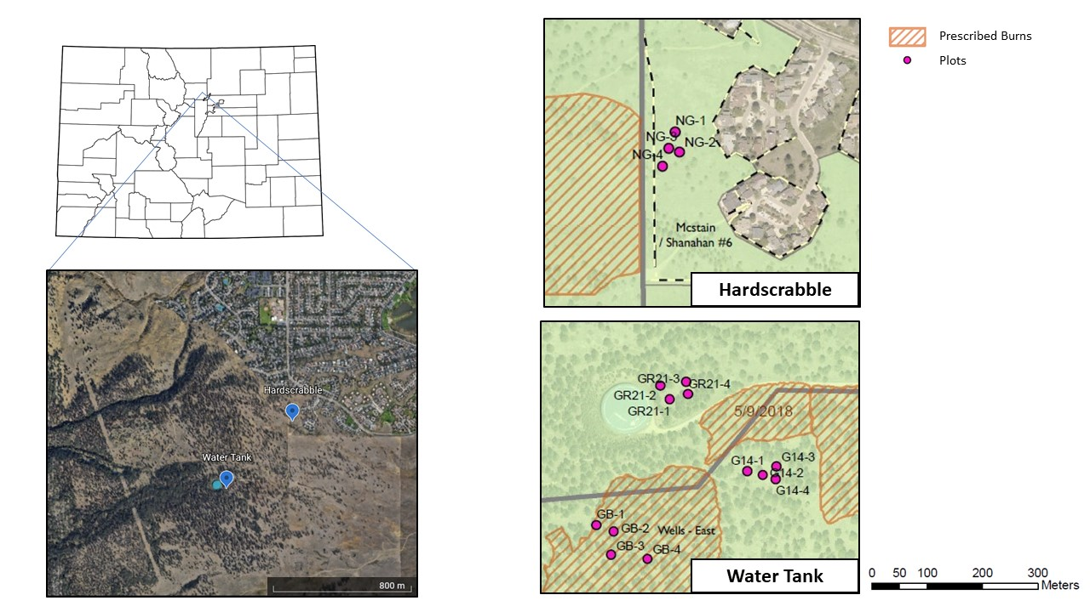

Figure 1: Site map locations of plots. Courtesy of Boulder OSMP.

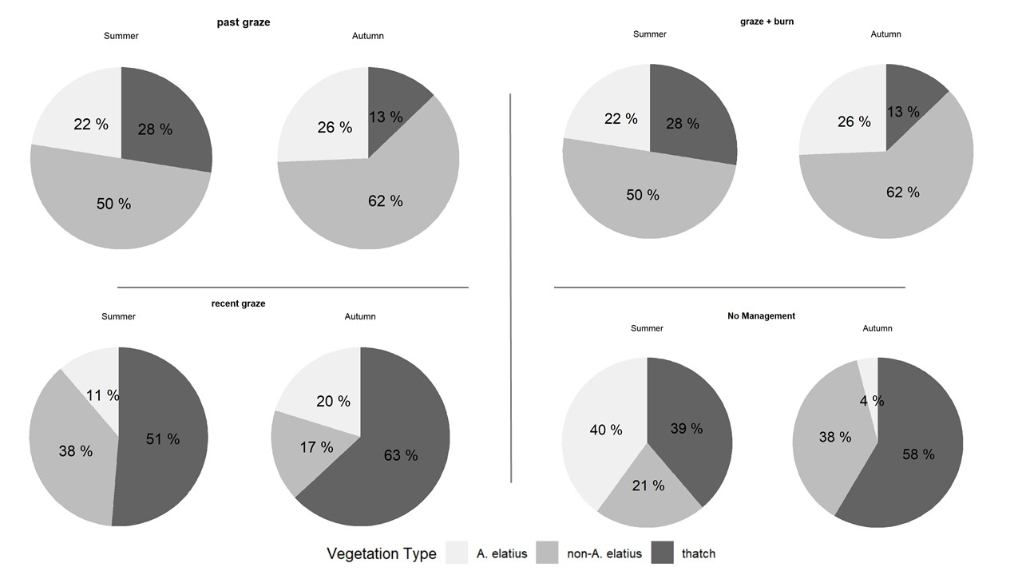

Figure 2: Total percent cover for different vegetation types: A. elatius, Non-A. elatius, and Thatch. Note: Due to difficulty in visually separating thatch, litter, and bareground, thatch represents all of the above rather than just thatch..

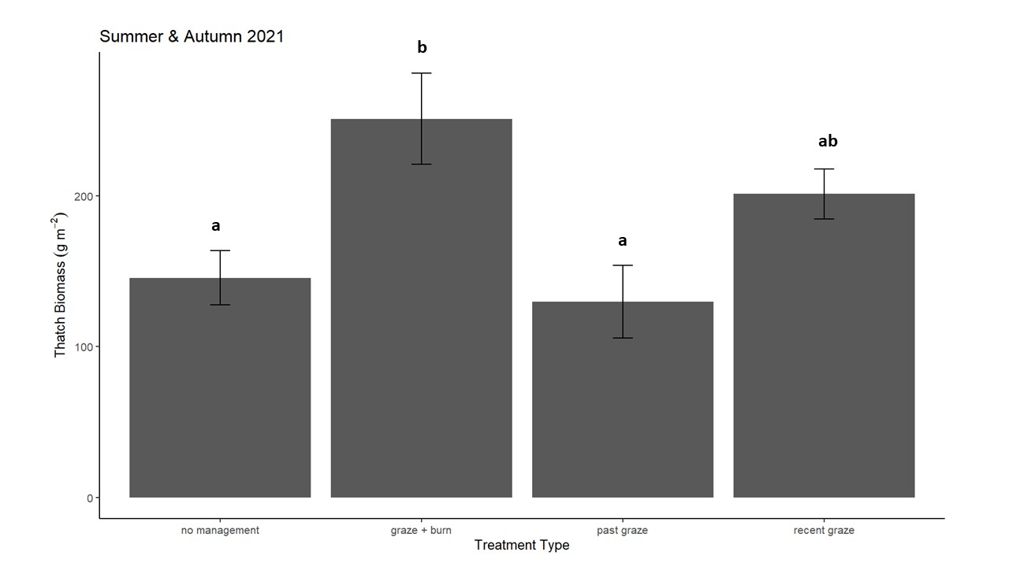

Figure 3: Mean (± SD) aboveground thatch and litter biomass across different management treatments in summer and autumn 2021. The letters indicate statistical significance between treatment types (p < 0.05). No statistical significance was found between summer and autumn sampling seasons (p > 0.05).

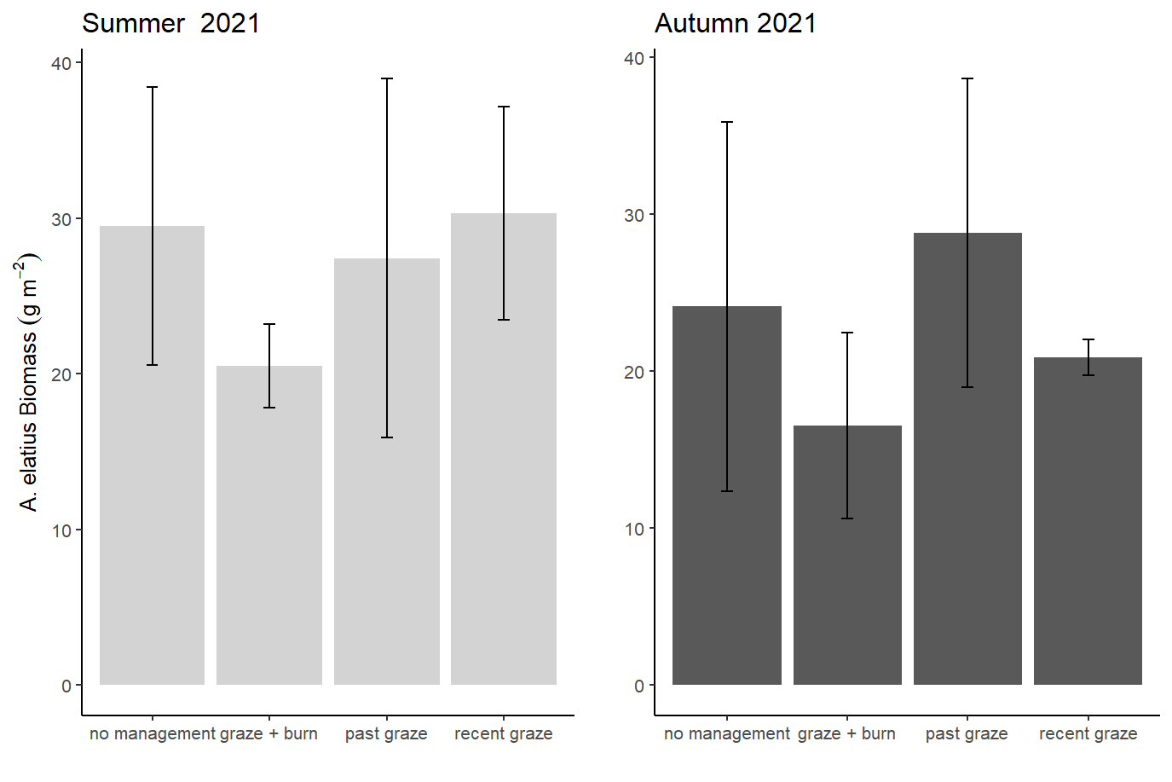
Figure 4: Mean (± SD) aboveground A. elatius biomass across different management treatments in summer and autumn 2021. No significance was found across treatment groups or within the different sampling seasons (p > 0.05).

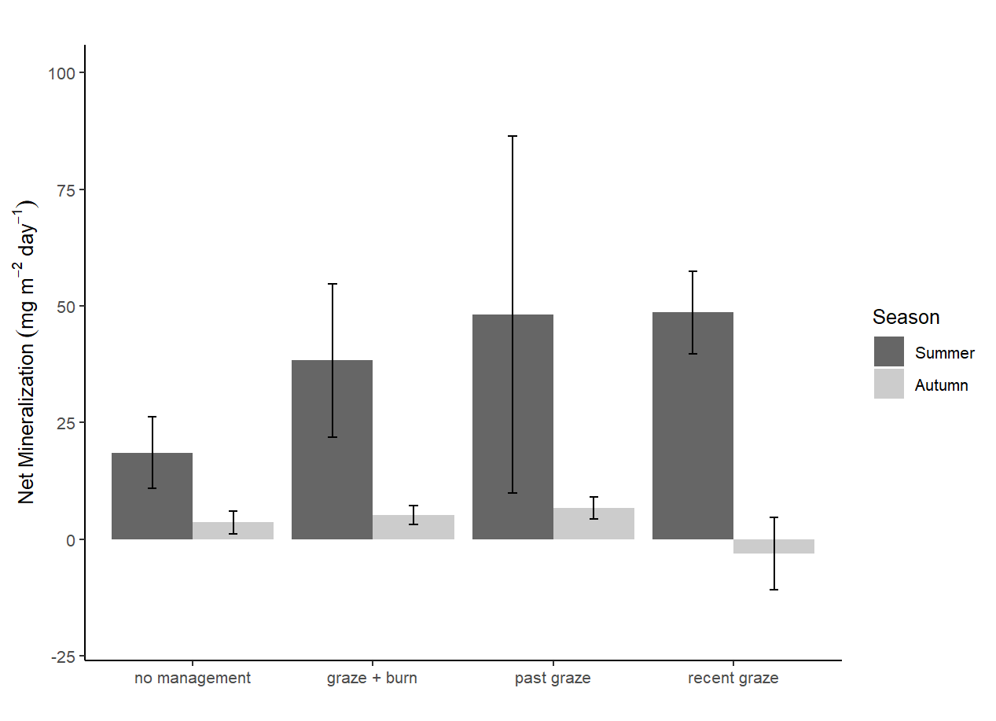
Figure 5: Mean (± SD) net N mineralization rates across treatments for summer and autumn 2021. No statistical significance was found across the different treatments within each sampling season (p > 0.05)

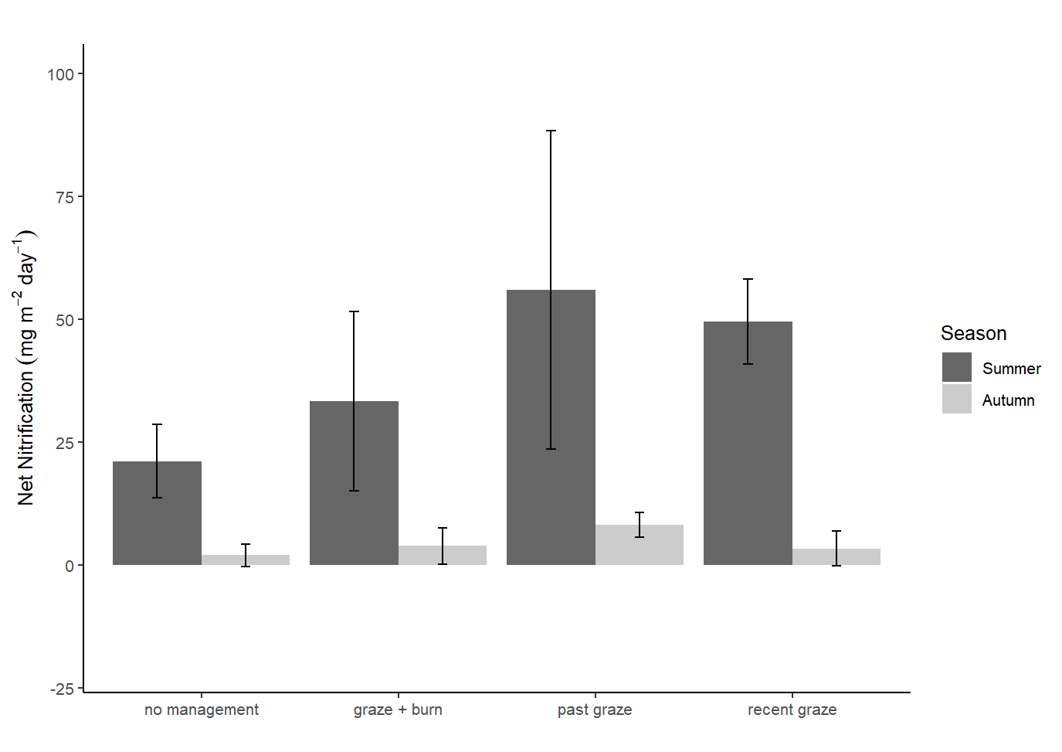
Figure 6: Mean (± SD) net N nitrification rates across treatments for summer and autumn 2021. No significant difference was found across the different treatments within each sampling season (p > 0.05)

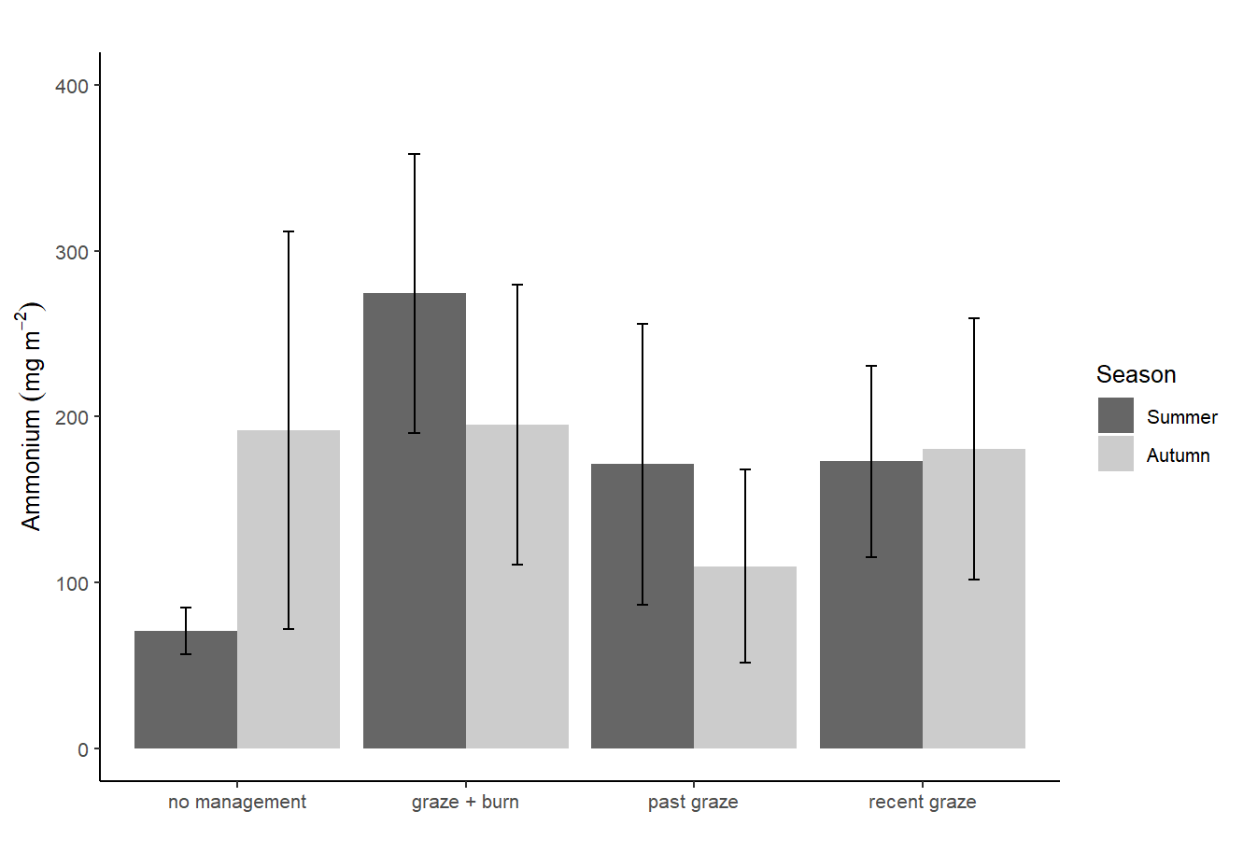
Figure 7: Mean (± SD) ammonium pools across treatments for summer and autumn 2021. No significant difference was found across the different treatments within each sampling season (p > 0.05)

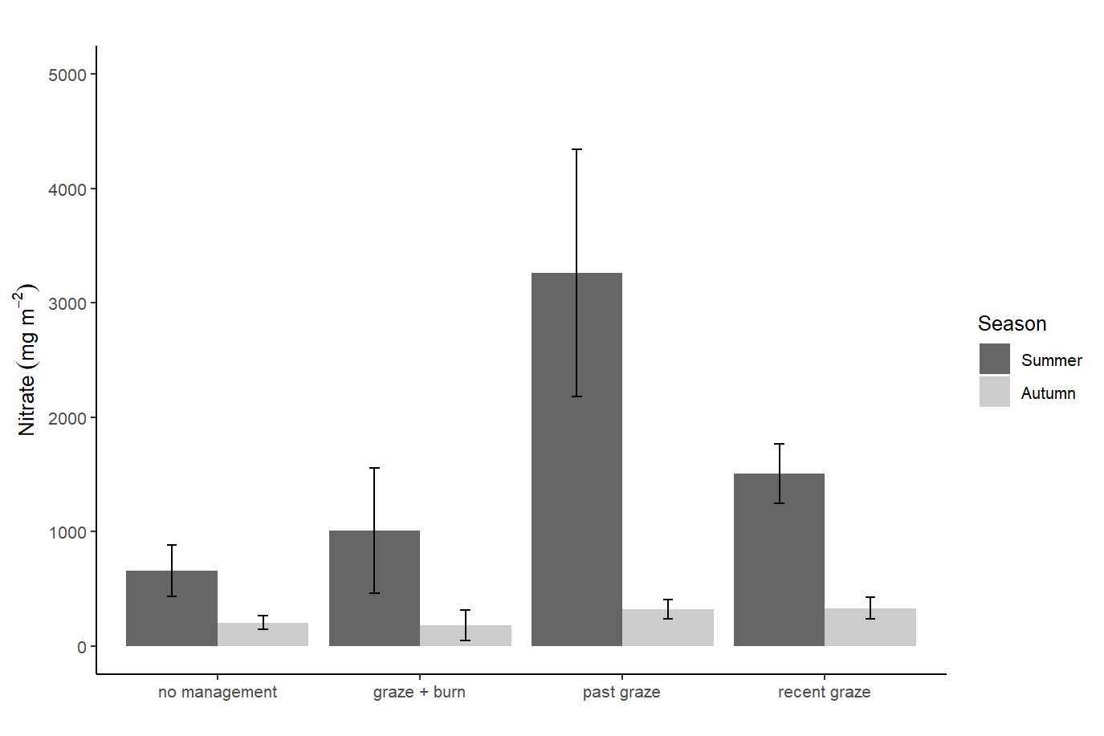
Figure 8: Mean (± SD) nitrate pools across treatments for summer and autumn 2021. No significant difference was found across the different treatments within each sampling season (p > 0.05)

