Figure 1. Sample survey question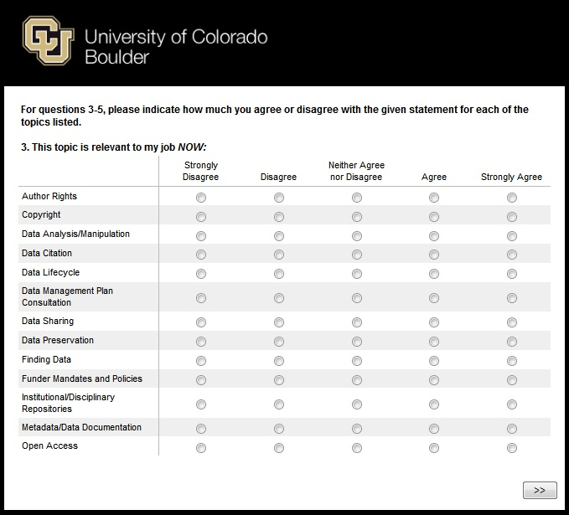
Figure 2. Approach to training needs assessment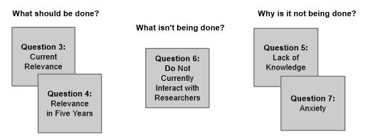
Figure 3: Example overall indicator of training need scoring rubric for “Data Sharing”
Question |  |  |  |  |  |  | Score
Current relevance | Scale | Strongly Disagree (-2) | Disagree (-1) | Neutral (0) | Agree (1) | Strongly Agree (2) | 11
 | # Respondents | 0 | 4 | 0 | 7 | 4
Relevance in near future | Scale | Strongly Disagree (-2) | Disagree (-1) | Neutral (0) | Agree (1) | Strongly Agree (2) | 22
 | # Respondents | 0 | 1 | 4 | 7 | 8
Already doing? | Scale | Yes (-1) | No (1) |  |  |  | 11
 | # Respondents | 4 | 15
Lack of Knowledge | Scale | Strongly Disagree (-2) | Disagree (-1) | Neutral (0) | Agree (1) | Strongly Agree (2) | 2
 | # Respondents | 0 | 7 | 4 | 7 | 1
Anxiety | Scale | Strongly Disagree (-2) | Disagree (-1) | Neutral (0) | Agree (1) | Strongly Agree (2) | 8
 | # Respondents | 0 | 3 | 5 | 11 | 0
Overall Indicator Score: |  |  |  |  |  |  | 54

Figure 4. Overall training prioritization scores

Figure 5. Scores for relevance to participants’ jobs now and in five years

Figure 6. Scores for participants’ lack of knowledge and anxiety levels concerning survey topics
Figure 7. Frequency of topics about which participants currently interact with researchers

