DISCOVERABILITY OF INDUSTRIAL CONTROL SYSTEM HONEYPOTS
by
Clark Mousaw

Undergraduate Honors Thesis

Department of Information Science
University of Colorado Boulder
2021

Committee Members:
Dr. Lecia Barker
Dr. Aaron Hansen
Dr. Stephen Voida

Acknowledgment
The completion of this work would have been impossible without the support and assistance of faculty advisors and staff at the University of Colorado Boulder. I would like to express my utmost gratitude to Dr. Lecia Barker for her unwavering support, mentorship, and encouragement throughout the entirety of my time spent on this work. I would like to give my sincerest thanks to Dr. Aaron Hansen, whose expertise was a privilege to learn from. I also owe thanks to Dr. Stephen Voida, Aaron Botello, Brad Judy, Dr. James Curry, and everyone else that generously provided guidance and offered assistance throughout the year. I am deeply appreciative to all of you for helping me grow as a researcher.

Abstract
Internet connectivity has facilitated a more convenient and efficient way of managing critical infrastructure such as power plants, electrical grids, factory floors, gas meters, and more. Concurrently, internet connectivity of industrial control systems (ICS) that manage critical infrastructure broadens attack vectors for cyber attacks. Honeypots designed to emulate ICS are a valuable tool used to detect and gather information on cyber attacks directed at degrading critical infrastructure, although honeypots are far less useful to security professionals and researchers if they can be correctly identified as a honeypot by attackers. This study originally aimed to investigate the popular ICS honeypot Conpot and the signatures/heuristics that makes Conpot discoverable by automated detection mechanisms. However, repeated freezing exhibited by Conpot prompted the study to shift towards investigating a possible vulnerability within Conpot. This study demonstrates that Conpot can be frozen at will by conducting an Nmap version scan over port TCP 502, preventing Conpot from carrying out its intended function of collecting attack intelligence. Further evaluation is needed to determine the cause of the potential vulnerability and how widespread it could be.

CONTENTS

SECTION

I. Introduction 1

II. Review of Literature 3

ICS/SCADA Systems 3
Attacks on ICS/SCADA Systems 3
ICS/SCADA Discoverability 4
Intelligence Gathering with Honeypots 5
Honeyscore 6
Discoverability of Honeypots 6
Research Gap 7

III. Conpot Discoverability 9

Conpot Signature Identification 9

IV. Methodology and Design 14

Conpot Configurations 15
Network and Host Specifications 17
Conpot Deployment 19

V. Results 23

Freezing Behaviors Exhibited by Conpot 23
Possible Conpot Vulnerability 26
Interpretation of Results 29

VI. Conclusions, Limitations, and Future Work 34

Conclusions 34
Limitations 34
Future Work 35

TABLES

Table

1. Default Conpot template configuration…………………………………...10

2. Designed Conpot configurations………………………………………….15

3. Nmap scan results………………………………………………………....28

FIGURES

Figures

1. Likely Conpot instance indexed by Shodan 11

2. Honeyscore identifying likely Conpot instance 12

3. Honeyscore of a likely Conpot instance 12

4. Conpot 2G deployed in Windows Command Prompt 19

5. Conpot configurations in their respective Docker containers 20

6. Nmap scan results of TCP ports utilized by Conpot 21

7. Conpot 2G web interface 21

8. Logs prior to freezing of Conpot 23

9. Shodan page for Conpot Deployment 2G 24

10. Censys data for port 102 of Conpot 2G 25

11. Replicated freeze logs 26

12. GitHub User 1 logs 30

13. GitHub User 2 logs 30

14. Default Conpot deployed without Modbus 32

15. Well-known signatures broadcasted over TCP port 21 33

SECTION I
Introduction
On February 5th, 2021 an unauthorized attacker remotely accessed a water treatment facility in Oldsmar, Florida. The attacker was able to successfully send a command to increase the levels of sodium hydroxide, commonly known as lye, to the industrial control system (ICS) managing the facility. If the attack was not immediately noticed by the system operator, thousands of residents could have been poisoned [1].
As we become increasingly reliant on ICS and Supervisory Control and Data Acquisition (SCADA), securing the systems that manage our critical infrastructure has never been more imperative. While the security safeguards that protect ICS/SCADA are advancing, numerous and devastating cyber attacks are still being carried out against ICS/SCADA systems. ICS/SCADA honeypots, systems that masquerade as ICS/SCADA systems, are an integral tool for learning about new threats to ICS and creating new safeguards to protect against those threats. One of the most popular ICS honeypots, Conpot, is used around the world to emulate different types of ICS and gain valuable attack intelligence. Conpot’s popularity has undoubtedly led to new knowledge pertaining to ICS/SCADA attack surfaces, but its widespread use has also led to its default configuration values, or “signatures,” being incorporated into frameworks and automated detection mechanisms that are used to differentiate them from authentic ICS/SCADA systems. An easily identified honeypot is far less valuable because it is unlikely that an attacker would interact with a system they knew was being closely monitored for attack intelligence. By deploying a set of Conpots with different variations to the default configuration, this study set out to investigate Conpot’s discoverability by determining which signatures are more likely to lead to detection and the amount of variation from the default template that is required in order to completely avoid automated detection. However, unexpected behaviors and repeated freezing exhibited by Conpot prompted the study to shift towards investigating a possible vulnerability within Conpot. In this study, I demonstrate that Conpot can be frozen at will by conducting an Nmap version scan over port TCP 502. This freezing behavior prevents Conpot from carrying out its intended function of collecting attack intelligence, effectively forfeiting the opportunity to log new attacks directed at ICS/SCADA systems. While clues indicate this potential vulnerability is not isolated to the Conpots deployed during this study, further evaluation is needed to determine the cause of the potential vulnerability and how widespread it could be.
In Section II of this paper, I provide an overview of relevant research pertaining to ICS/SCADA security, the viability of using ICS/SCADA honeypots to collect attack intelligence, and consequences resulting from Conpot being discoverable via automated detection. In Section III, I discuss the concept of Conpot’s discoverability, which is followed by the methodology and design of the experiment in Section IV. I cover the results of the experiment and my interpretation of those results in Section V. Finally, I finish the thesis with conclusions, limitations, and opportunities for future work in Section VI.

SECTION II
Review of Literature

ICS/SCADA Systems
ICS/SCADA systems are widely used to manage critical infrastructure such as electrical grids, power generation, manufacturers, gas meters, and much more. Our way of life has become dependent upon the reliability of these systems, and in turn, we are becoming increasingly reliant on the critical services they provide [2]. ICS/SCADA systems were originally designed to function in an isolated network, inaccessible from outside the physical location of the system. Consequently, the common protocols on which ICS/SCADA systems operate have no built-in security measures. As the demand for remote management and monitoring increased, these insecure protocols were layered into Ethernet and TCP/IP to support long-distance communication. These same protocols are still used today by ICS/SCADA around the world [3].
While internet connectivity has facilitated a more convenient and efficient way of managing critical infrastructure, this connectivity has broadened an attack surface on the services that people depend on every day. While ICS/SCADA systems were designed to be reliable, the severity and number of successful attacks directed at these systems highlights the fact that their original design, and more importantly, the decision to connect these systems to the internet to facilitate remote management, were made without sufficiently considering the risks of an intentional attack [2].

Attacks on ICS/SCADA Systems
Many different historical examples demonstrate the disruptions to critical infrastructure resulting from cyber attacks directed at the ICS/SCADA systems that control them. For example,
- In March of 2019, a global aluminum producer began manually managing operations at many smelting plants around the world after a severe ransomware attack disrupted automated ICS/SCADA operations. Plants and factories in the United States and Norway were temporarily unable to use their systems and were forced to use paper order lists until the threat was neutralized [4].
- In December of 2015, attackers carried out a devastating attack on Ukraine’s electrical utilities, denying power to nearly a quarter-million people for six hours. The attackers were able to carry out this attack completely remotely [5].
- Perhaps one of the most devastating cyber attacks on an ICS/SCADA system was in 2010 when nuclear centrifuges in Iran were severely damaged after being infected with the malicious computer worm Stuxnet, which was specifically designed to target the ICS/SCADA systems controlling the centrifuges. Iran’s nuclear program sustained catastrophic damage from Stuxnet, which caused the centrifuges to spin uncontrollably until many were destroyed [6].

ICS/SCADA Discoverability
The creation of robust port scanning and indexing tools has made discovering ICS/SCADA systems connected to the internet increasingly easier in the last decade. One such tool, a webstie called “Shodan.io,” launched in 2009, is self-described as the search engine for the Internet of Things. Shodan generates terabytes of data every month by actively scanning the entirety of the IPv4 address range and indexing banner information returned by a wide variety of internet-connected devices. The data collected by Shodan is publicly accessible and is often remarkably detailed to such an extent that not only can the exact type of system be easily identified, but critical vulnerabilities to the system can be identified as well. While Shodan is a valuable tool for security professionals and researchers, analysis of underground hacker forums shows Shodan is also is used by attackers to conduct reconnaissance and facilitates various types of devastating cyber attacks [7]. Shodan also maintains a database of indexed data, allowing for the analysis of historical data collected by previous scans [8]. ICS/SCADA systems that are connected to the internet for convenient, remote management are among the myriad of devices scanned daily by Shodan.
Research has shown that the number of ICS/SCADA systems that are connected to the internet is increasing [9]. In an experiment to test the functionality of Shodan, researchers at the Air Force Institute of Technology deployed four programmable logic controllers (PLC) commonly used in ICS/SCADA configurations. Each of the four devices were indexed by Shodan within 19 days [10], demonstrating Shodan’s proficiency in indexing internet-connected devices. Publically accessible ICS/SCADA banner information collected by Shodan is often so detailed that it can be used by malicious attackers to search for especially vulnerable ICS/SCADA devices to exploit. Previous research focused on conducting vulnerability assessments of internet-connected ICS/SCADA systems found that out of over half a million ICS/SCADA devices indexed by Shodan, between 6.45% [11] and 19.59% [12] had vulnerabilities that could be exploited by malicious attackers, indicating that a sizeable portion these systems are not adequately protected from cyber attacks.

Intelligence Gathering with Honeypots
One way to gain intelligence on cyber attacks to valuable systems is by deploying a honeypot. Honeypots are software or devices that emulate valuable and potentially vulnerable systems with the goal of being an attractive target for attackers. When deploying a honeypot, the desired outcome is to not only learn about an attacker but to also learn about potentially unknown vulnerabilities to the system that a honeypot is emulating. Honeypots can be low-interaction, meaning they only simulate simple networking and logging functions. Honeypots can also be high-interaction, meaning that they can contain graphical user interfaces, simulate complex networking and logging functions, and simulate other advanced functions of the system they are emulating. High-interaction honeypots are typically more difficult to deploy and maintain [13].
To gain attack intelligence on vulnerable ICS/SCADA systems, numerous honeypots are available for use that were specifically designed to emulate authentic ICS/SCADA systems. Different types of ICS/SCADA honeypots emulate different types of systems. These systems include automatic tank gauges [14], electrical grids [15], and other general-use ICS/SCADA platforms [16]. Conpot, a general ICS/SCADA honeypot created by the MushMush Foundation, is free, open-source, and the most popular and widely used ICS/SCADA honeypot in use [17]. Conpot is a low-interaction honeypot that is designed to be simple to deploy and maintain [18]. Conpot has templates which can be used to emulate different ICS/SCADA services, but the configuration can also be modified to emulate any desired system. Users can customize various details of the configuration such as the product name, vendor ID, serial number, and other settings. Once deployed, this information is viewable on the internet.

Honeyscore
In addition to performing robust scans of internet-connected devices, Shodan also offers a free service that identifies honeypots called Honeyscore. Honeyscore uses a proprietary algorithm which returns a 0.0 – 0.1 probability value predicting whether or not a system is a honeypot [19]. The effectiveness of Honeyscore has also been studied by researchers, who manually inspected systems they discovered on Shodan that they believed to be instances of Conpot [20]. They found that Honeyscore excelled at finding the systems they believed to be instances of Conpot, but they also found that Honeyscore incorrectly identified some of those systems as real ICS/SCADA systems. This demonstrates that Honeyscore can be fooled into reporting a honeypot as an authentic ICS/SCADA system depending upon the honeypot’s configuration.

Discoverability of Honeypots
An important aspect of deploying and maintaining honeypots is to configure them in a manner that makes them appear to be authentic ICS/SCADA systems. An easily identified honeypot is far less valuable to security professionals and researchers because it is unlikely that an attacker would knowingly interact with a system they knew was being closely monitored for attack intelligence. Honeypots that are detectable can prevent researchers from gaining intelligence on potential attacks. Attackers are not interested in disclosing the vulnerabilities and exploits that they have discovered because system vulnerabilities can be patched shortly after a new exploit has been identified by security researchers, rendering the exploit useless [20,] [21].
Previous research proposed conducting an analysis of signatures or heuristics of popular ICS/SCADA honeypots to identify systems that are honeypots. A study conducted at the Naval Post Graduate School created three heuristics and tested whether or not they could correctly identify systems they believed to be instances of Conpot. The three heuristics used to identify probable instances of Conpot were default configurations and keywords taken from Conpot, specific port configurations typical of Conpot deployments, and instances where the system was deployed via a public cloud service [20].
Other researchers have created systematic frameworks that allowed them to discover instances of GasPot, a honeypot that emulates automatic tank gauges. By searching for default configurations, missing protocol features, unusual behavior exhibited by the system, and identifying the underlying platform on which the system was deployed, researchers were able to identify systems that were likely GasPots [22].

Research Gap
Due to the fact that easily identifiable honeypots are less useful because attackers are less likely to knowingly interact with them, knowing which factors contribute towards the detectability of honeypots is valuable information to researchers and cyber security professionals. Finding ways to hide well-known Conpot signatures used to differentiate Conpots from authentic ICS/SCADA devices has been identified by previous research as an opportunity for future work [18]. If automated tools such as Shodan’s Honeyscore can be used by attackers to identify ICS/SCADA honeypots, then it is vital to learn more about how Honeyscore is detecting ICS/SCADA honeypots and what strategies can be pursued to avoid these detection methods. During an email conversation I had with the author and creator of a framework used to identify GasPots [22], I was informed that performing a reverse-engineering process would be an effective strategy to gain insights into how Shodan identifies ICS/SCADA honeypots.
Another opportunity for future work that has been identified is testing the accuracy of frameworks used to identify Conpot instances [20]. In theory, frameworks used to identify ICS/SCADA honeypots are capable of identifying honeypots with high precision. However, due to the fact that the researchers do not own or control the systems their frameworks assess, they cannot state with 100% certainty if the systems the frameworks identify as honeypots are truly honeypots. The same concept is true with automated detection methods such as Honeyscore.
To further this research area of ICS/SCADA security and investigate the knowledge gaps discussed above, I designed an experiment to not only test the accuracy of Honeyscore’s detection rate, but to also determine how signatures are being used by Honeyscore to calculate probability values. If successful, the results of the experiment would provide valuable insights into Conpot’s discoverability.

SECTION III
Conpot Discoverability

Conpot includes six templates for users to choose from that simulate various types of ICS/SCADA systems and devices. Conpot users can deploy any of the six templates in order to gain attack intelligence on the system that the template is emulating.
- The “default” Conpot template simulates a Siemens S7-200 micro programmable logic controller (PLC).
- The “guardian_ast” template mimics a Veeder-Root Guardian Automated Solids Transfer system, commonly used at gas stations for the monitoring of petroleum holding tanks.
- The “IEC104” template emulates a Siemens S7-300 programmable logic controller used for communicating over the IEC 60870-5-104 transmission protocol.
- The “ipmi” template mimics an Intelligent Platform Management Interface, a set of interface standards used for the management and remote monitoring of ICS/SCADA devices.
- The “kamstrup_382” template simulates a Kamstrup 382 smart meter, used for monitoring the registration of electricity.
- The “proxy” template emulates a proxy feature for Conpot deployments.

Conpot Signature Identification
These templates can be deployed with default configurations, but users are able to modify the configuration details, changing the identifying elements broadcast over the internet. Because Conpot is the most popular and widely used ICS/SCADA honeypot, many of the default configuration elements of various Conpot templates have been identified and have become well-known “signatures” that allow researchers and attackers to easily classify these systems as honeypots. Research has already been conducted into identifying these default signatures and incorporating them into frameworks that can be used to determine if a system is a honeypot [20,] [22]. These default elements have been dubbed by researchers as “fingerprints,” “heuristics,” and “signatures.” The most well-known signatures, “Technodrome” in the PLC name field, “Mouser Factory” in the plant ID field, and “88111222” in the module serial number field, are all default values used in the default Conpot template. When these signatures are being broadcast from a system that appears to be an ICS/SCADA system, the system is likely running a default instance of Conpot. A signature that can be used to identify the guardian_ast Conpot template is the string “STATOIL STATION” in the station name field.

System Name | Facility Name | Serial Number | System Location | Ports
Technodrome | Mouser Factory | 88111222 | Venus | 80, 102, 502, 161, 47808, 623, 21, 69, 44818
Table 1 – Default Conpot template configuration

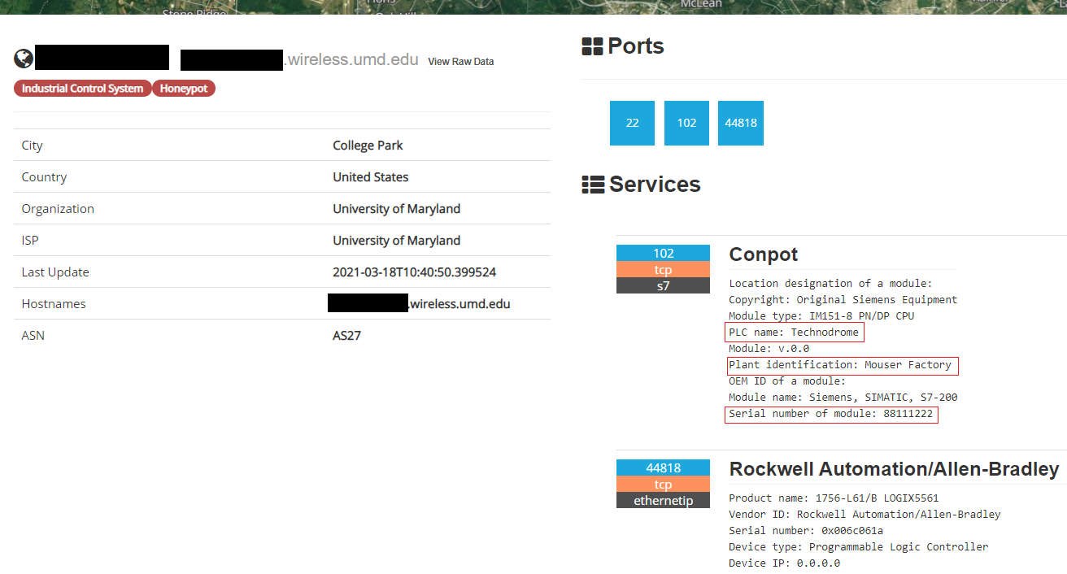
Figure 1 – Likely Conpot instance indexed by Shodan
Figure 1 is a screenshot from Shodan showing what can be assumed is an instance of Conpot. As a result of Conpot’s signatures becoming well-known, indexing services such as Shodan search for these signatures and are able to identify and label these systems as Conpot deployments [23]. Shodan has identified and tagged the system in Figure 1 as a honeypot, likely based upon the well-known Conpot which I have highlighted with red squares. The default Conpot template broadcasts these signatures over TCP port 102, similarly to how an actual Siemens S7-200 micro PLC connected to the internet would broadcast authentic information about itself. TCP 102 is a service commonly utilized by PLC communications for Siemens devices. In the figure above, Shodan automatically labels this system as an instance of Conpot.
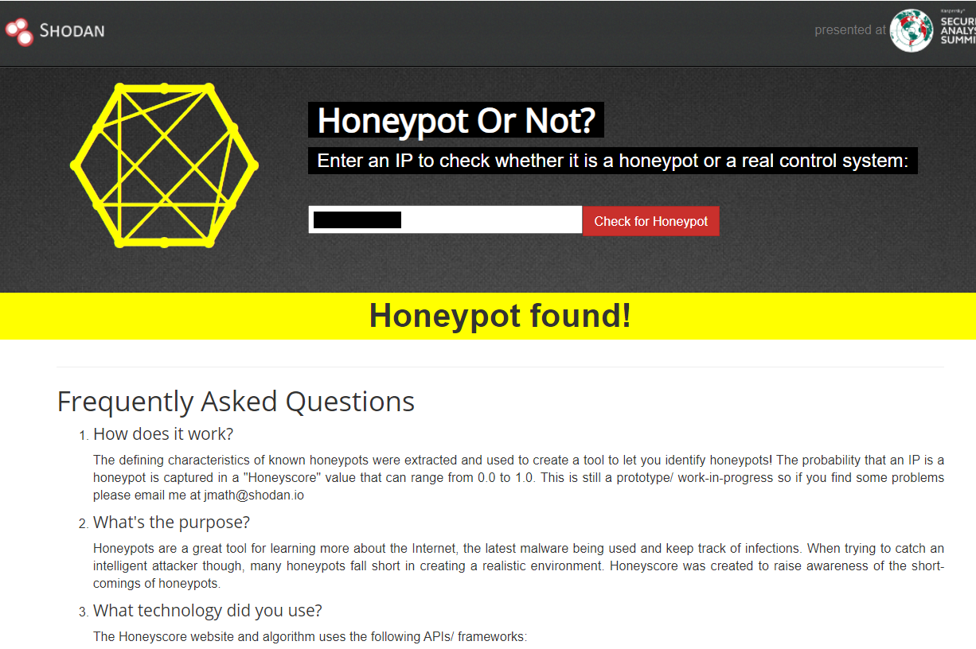
Figure 2 – Honeyscore identifying likely Conpot instance
Figure 2 shows Shodan’s Honeyscore indicating that the device running on the IP address in question is a honeypot. However, to obtain the actual Honeyscore, the 0.0 – 0.1 probability value that a device is a honeypot, Shodan’s command line interface application must be used.
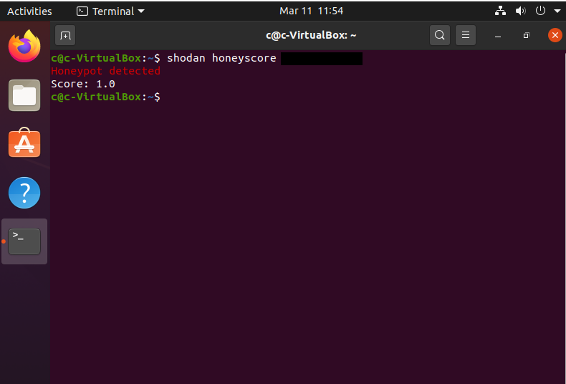
Figure 3 – Honeyscore of likely Conpot instance
When a Honeyscore is requested for this system’s IP, a maximum probability score of 1 is returned, indicating the highest level of confidence that the system is indeed a honeypot. While Honeyscore runs on a proprietary algorithm and the way it detects honeypots is not available for analysis[20], it can be reasonably expected that Shodan will identify a Conpot instance running the default template broadcasting default signatures over TCP 102, assuming Shodan has successfully indexed the signatures.

SECTION IV
Methodology and Design

In order to further investigate the discoverability of Conpot, I designed an experiment to test the extent to which the default Conpot template must be changed to observe a difference in discoverability and the amount of variation from the default template that is required to completely avoid automated detection. For the purpose of this experiment, I measured discoverability on two criteria: Honeyscore probability values, and Shodan identification tags.
The experiment involved deploying a series of Conpots with varying configurations for 20 days to test how the altering of individual signatures would affect discoverability. Deploying Conpots with controlled variations to the default configuration and observing the rates of detection via Honeyscore’s probability scores and Shodan’s honeypot tags would offer the following benefits: 1) it should become clearer whether any of the signatures or data being broadcast are subject to any statistical “weighting” during the calculation of a Conpot’s Honeyscore, 2) determining the amount of variation from the default template that is necessary to observe a change in Honeyscore, and 3) determining the amount of variation from the default template that is required to completely avoid automated detection. In order to produce the desired results that would achieve these benefits, I deployed seven Conpots with varying configurations. I designed these configurations in a way to test for the bare minimum of variation required to observe a change in Honeyscore or detection, such as testing whether or not changing one letter from a default signature results in a variance in Honeyscore, or if programming unique elements in some fields but leaving default elements in other fields results in an observed variance in Honeyscore.

Conpot Configurations
Each of the seven Conpots were variations of the default template that mimics a Siemens S7-200 micro programmable logic controller. I determined this experiment’s configuration changes by altering elements and port configurations that have been identified in past research as signatures that can be used to identify Conpot instances [20,] [22].
Name | IP | System Name | Facility Name | Serial Number | System Location | Ports
2A | 128.138.102.25 | default | default | default | default | default
2B | 128.138.102.26 | Technodiome | default | default | Renus | default
2C | 128.138.102.27 | Technodoome | Mouses Factory | 98111222 | Jenus | default
2D | 128.138.102.28 | default | default | 62659785 | Building 13 | default
2E | 128.138.102.29 | Magnetic Transistor | Dynamic Infrastructure | 65466593 | Platform 9 | default
2F | 128.138.102.31 | default | default | default | default | Default~2
2G | 128.138.102.32 | Synthetic Scrum | Forged Architecture | 87846538 | Tower 20 | Default~2
Table 2 – Designed Conpot configurations
Table 2 lists each configuration designed for this experiment. The custom elements were chosen using a random jargon generator.
- 2A was a completely unchanged, default configuration. I designed this Conpot to act as a control for the experiment; a honeypot that Shodan should have had no issue detecting and labeling as a Conpot instance.
- 2B had two fields where one letter from the default signature was changed— “Technodrome” was changed to “Technodiome” and “Venus” was changed to “Renus.” All other elements contained default values. This deployment was meant to test if a minor change in a limited number of fields would result in an observed change in detection or Honeyscore. If changing a single character from a signature yielded a different Honeyscore, it might imply Shodan is using exact string matches to search for Conpots.
- 2C had each field containing an element where one character was altered from the default element. “Technodrome” was changed to “Technodoome,” “Mouser Factory” was changed to “Mouses Factory,” “88111222” was changed to “98111222,” and “Venus” was changed to “Jenus.” This configuration was intended to determine if a minor change in all fields would result in a different score or detection rate than a minor change in a limited number of fields, such as with Conpot 2B.
- 2D had entirely custom elements in two of the fields, with each of the other fields containing default values. I designed this deployment to test if a complete change in a limited number of fields would result in an observed change in detection or Honeyscore. The results from 2D were also meant to be compared to the results of 2B. If two custom elements lead to a different score or detection rate than elements with two minor changes such as with 2B, it would imply that completely altering a signature is better for avoiding detection than altering single characters of a signature.
- 2E had entirely custom elements in each of the fields but retained the default port configuration. This was intended to determine if a custom value in all fields would result in a different Honeyscore or detection rate than custom elements in a limited number of fields, such as with Conpot 2D.
- 2F used default signatures, but two of the port numbers were varied. 2F was meant to test whether or not changes to default port configuration would affect detection/scoring on an otherwise default Conpot instance. If Conpot 2F yielded the same Honeyscore as Conpot 2A, a default Conpot, then it would imply that changing the port configuration without altering the default signatures does not affect automated detection.
- 2G had every element changed completely, including two port numbers being varied. Configuration 2G was meant to test detection/scoring performance on a deployment with completely unique signatures and a non-default port configuration. 2G was also designed to be compared to 2E. 2G was also designed to determine if any other detection methods were being incorporated by Shodan outside of the controlled variables for this experiment. If 2G was detected as a Conpot or had a Honeyscore high enough to warrant a “honeypot” tag, it would imply that other signatures not part of the controlled variables for the experiment were being used for detection. If this were the case, a new set of Conpots would need to be deployed that included a Conpot with added variance from the default template to determine the extent of variation needed to receive a Honeyscore of 0.0 (i.e. not detected or being classified as an authentic ICS/SCADA system).

Network and Host Specifications
I decided to conduct the experiment on the University of Colorado Boulder campus network. Residential internet service providers (ISP) often filter ports that they determine to be dangerous or obscure, which home users typically do not need. During early test deployments of Conpot on a private home network, the ports required for this experiment did not reliably remain open. Even after setting up port forwarding and firewall exceptions, the residential ISP filtered the required ports, making the data broadcast over those ports unavailable for indexing by Shodan.
Network administrators at the University of Colorado Boulder allocated a dedicated subnet of public IP addresses for this experiment and made boundary firewall exceptions on the campus network for this dedicated subnet. No network ports used by Conpot were being filtered at any time. With the exception of Ports UDP 623 and UDP 69, which were excluded from deployments 2F and 2G but were open for all other deployments, ports TCP 80, TCP 102, TCP 502, UDP 161, UDP 47808, TCP 21, and TCP 44818 remained open throughout the deployment period for each Conpot.
This experiment also required a host device capable of running many virtual machines simultaneously. The host device would need to contain enough RAM and processing power to remain running as intended without any interruption. A PC with a fresh install of Windows 10 Enterprise was allocated for the experiment. The PC physically resided on campus and without firewall or host-based security controls from the campus enabled. The PC used for the experiment had an Intel Core i5-8500 CPU with 8 GB RAM.
I forked the Conpot source code from the main Mushorg GitHub page [24] and create a template to spawn multiple clones. I made the desired changes to the default signatures shown in Table 2 by altering the values in the Conpot configuration files.
Conpot is primarily Python code that can be deployed via many different methods. The Conpot documentation lists the application Docker as one such method [25]. Docker is a virtualization platform that allows for the use of different applications in individual, isolated environments called containers [26]. The experiment required isolated virtual environments, so Docker was used for each of the Conpot deployments. Docker also has the capability to sync with GitHub. This facilitated a streamlined deployment system where Docker would pull each Conpot configuration in Table 2 directly from GitHub repositories, which I could then deploy in individual Docker containers.

Conpot Deployment
I deployed each Conpot into a separate Docker container using Windows command line. Figure 4 shows Conpot configuration 2G being deployed in Docker with the following command:
docker run --rm --detach --name 2G -p 128.138.102.32:80:8800 -p 128.138.102.32:102:10201 -p 128.138.102.32:502:5020 -p 128.138.102.32:161:16100/udp -p 128.138.102.32:47808:47808/udp -p 128.138.102.32:21:2121 -p 128.138.102.32:44818:44818 clarkm1/vhpot2g
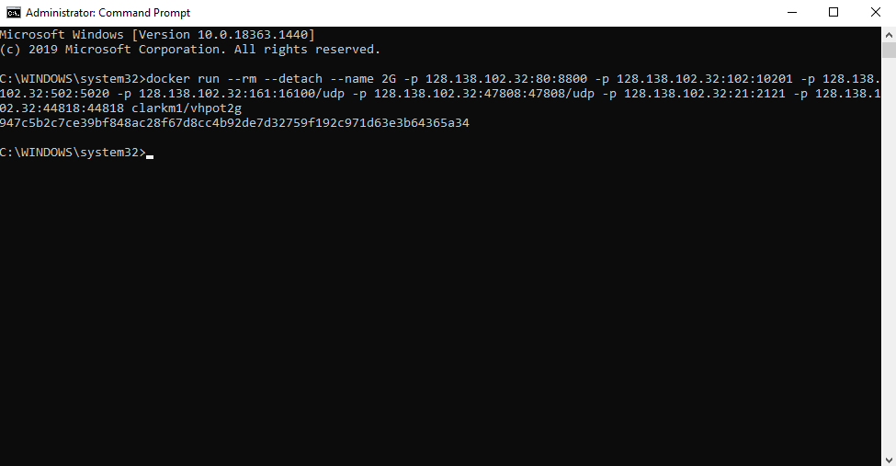
Figure 4 – Conpot 2G deployed in Windows command prompt
I bound each individual Docker container to a specific public IP within the dedicated subnet. Shodan advertises an “on-demand scanning” function where scan results can be displayed via the Shodan CLI on Linux. The on-demand scanning function does not immediately conduct a scan of a specified IP. Rather, the on-demand scanning function returns scan results from the last time Shodan indexed data from that specific IP. This means that if a user were to query Shodan’s CLI, the data returned might have been indexed by Shodan days prior. If I did not assign each of the Conpot deployments to static, unchanging public IP addresses, it could have created confusion regarding which honeypot was being scored and detected. To avoid this potential issue, I assigned each Conpot deployment a static IP that would not change throughout the experiment. Shodan also has an IP history function that indexes historical information for specific IP addresses. It is unknown whether or not historical IP information has any bearing on honeypot detection or Honeyscore. This was another reason dynamic assignment of IPs was not an appropriate method, and why it was more appropriate to have static IPs for this experiment.

Figure 5 - Conpot configurations in their respective Docker containers
Once I deployed each Conpot into their respective Docker container using the Windows command line, I scanned each IP using Nmap to confirm that all desired ports were open and that each Conpot was running as intended.
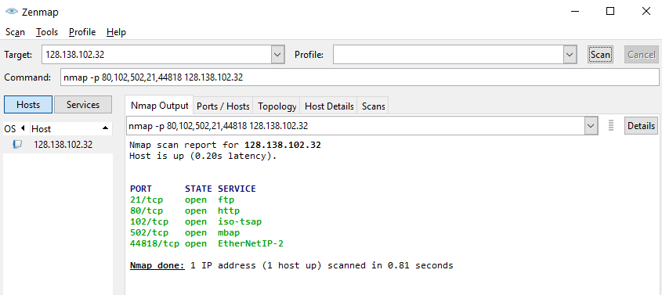
Figure 6 – Nmap scan results of TCP ports utilized by Conpot
Figure 6 demonstrates how each of the TCP ports utilized by the different Conpot configurations were scanned. After confirming that all desired ports were open, I navigated to each Conpot’s IP address using a web browser to ensure that the Conpot was accessible over the internet.
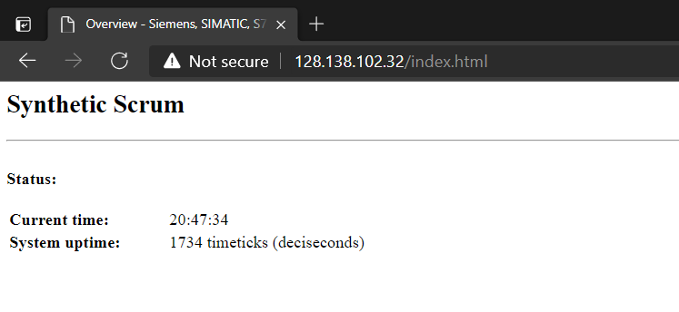Figure 7 – Conpot 2G web interface
Once I conducted the initial checks to ensure that each Conpot was running and externally accessible, I periodically checked Shodan to determine if the results for each IP had been updated. If I were to scan a Conpot immediately after deployment, no results would be returned, so it was necessary to wait for Shodan to index data for the IPs the Conpots were deployed on, which was an unknown amount of time.
While waiting for the Conpots to be scanned, I decided to conduct twice-daily health checks to ensure that the Conpots remained up and running. Many different points of failure could result in the Conpots going offline, such as power interruptions, network interruptions, and memory limits. Perhaps one of the greatest risks resulted from the fact that the Conpots were active honeypots accessible over the internet and masquerading as vulnerable ICS/SCADA systems. Because of the potential risk of an actual attack, it was imperative that I monitor each Conpot for abnormalities. Most importantly, the experiment took place on the University of Colorado Boulder campus network; it was vital that I exercise due diligence by checking the logs and health of each Conpot to monitor for potential risk to the campus network.

SECTION V
Results

Freezing Behaviors Exhibited by Conpot
Approximately 38 hours after deployment, I was surprised to discover that none of the Conpots were accessible via web browser. This was unexpected, as Conpot’s web interface being inaccessible would indicate either a software failure or that the Conpots were potentially attacked. During attempts to navigate to any of the assigned public IP addresses, requests stalled and eventually timed out, preventing access to any of the Conpot installations’ web interfaces. After logging directly into the PC hosting the Conpots and checking Docker to investigate, I noticed that the status of each container was still listed as “running,” with the container homepage appearing identical to Figure 5. This indicated that there was not an issue occurring with the Docker containers, but with the Conpots deployed within them. I checked the logs for each Conpot, and observed an identical error message across each deployment, indicating a common point of failure.
Figure 8 - Logs prior to freezing of Conpot
Figure 8 indicates that the freeze was occurring during Modbus traffic over port TCP 502. After I saved the logs for each Conpot, I restarted each container and conducted initial health checks again to ensure that each Conpot’s web interface was accessible via web browser and all desired ports remained open. I observed the same behavior again two days later: each Conpot would be inaccessible via browser, but still remain “running” in its Docker container. This cycle continued every two to three days.
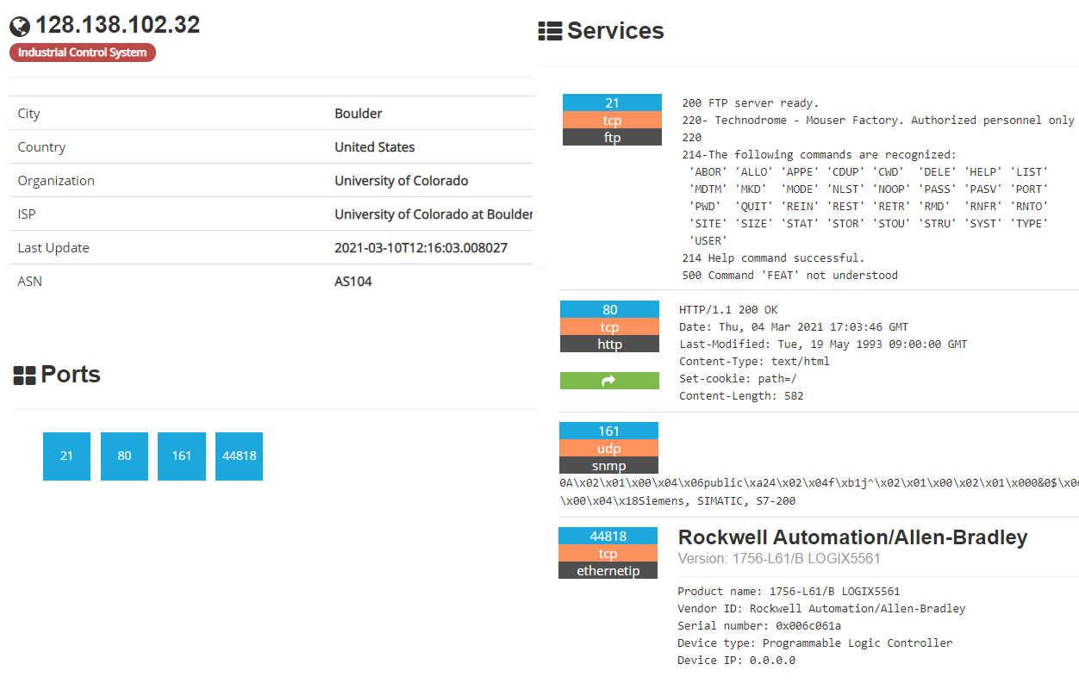Figure 9 - Shodan page for Conpot Deployment 2G
Towards the end of the intended 20-day deployment period, Shodan had indexed data for each of the IP addresses on which the Conpots were deployed. Figure 9 shows a screenshot of Shodan’s web page displaying data that was indexed for Conpot 2G. Surprisingly, Shodan hadn’t indexed all of the ports that were opened for the experiment and therefore had not indexed all of the data being broadcast from the Conpots. Specifically, Shodan never indexed ports TCP 102 or TCP 502 for any of the seven deployments. Additionally, Shodan labeled six out of the seven deployments as legitimate industrial control systems with the exception being Conpot 2A, the unchanged default Conpot deployment. Shodan never labeled any of the Conpots with the “honeypot” tag, and Honeyscore returned a score of 0.0 after I scanned each Conpot’s IP. These results indicated Shodan had classified almost all of the Conpot deployments as authentic ICS and had not discovered that any of the Conpots were, in fact, honeypots.
With Shodan failing to index any data provided over ports TCP 102 or TCP 502, and therefore not indexing any of the configuration changes I made, I searched each Conpot using a different indexing service called Censys. Upon checking Censys for each Conpot’s assigned IP, I observed something interesting: Censys had indexed the data being broadcasted over port TCP 102 for each of the Conpot deployments, and therefore had recorded my changes to the default signatures.
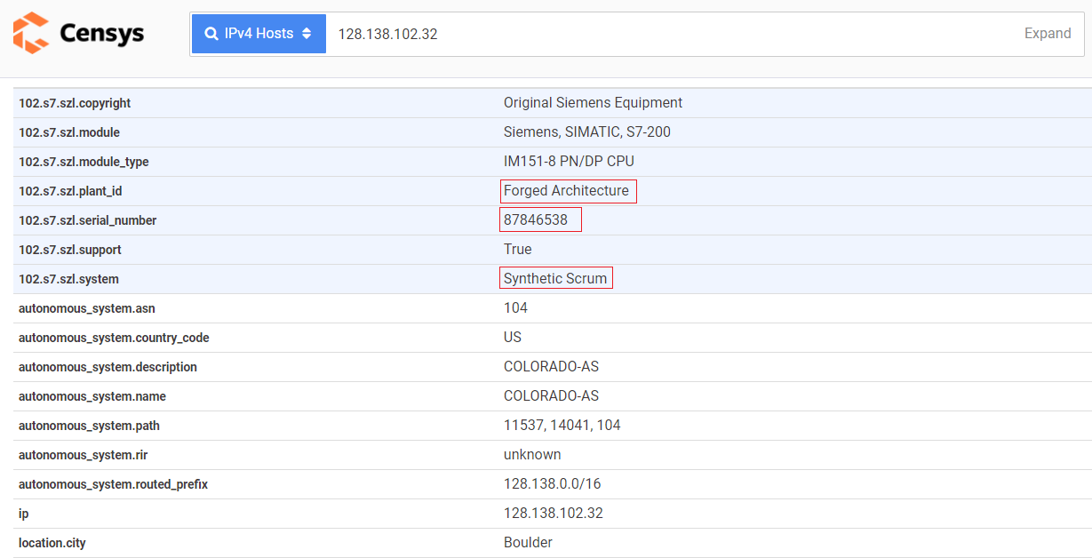
Figure 10 - Censys data for port 102 of Conpot 2G
Figure 10 shows a screenshot of Censys’ web page displaying three of the custom signatures I programmed into Conpot 2G. The fact that Censys was able to index my configuration changes confirmed that the Conpots were indeed broadcasting the custom elements over TCP port 102, as intended. This discovery had two important implications for this study: the first being that Shodan’s failure to index the signatures could not be attributed to the way in which the Conpots were deployed or designed, and the second being that the custom elements I programmed for each Conpot could be indexed despite the repeated freezing.

Possible Conpot Vulnerability
After the deployment period had ended, I scanned the Conpots with various Nmap scan settings over various ports to determine if I could replicate the conditions under which my Conpot instances were freezing during the study. This activity was primarily intended to determine the cause of the freezing and to determine if I could remediate the problem to get the experiment back on track and collect the discoverability and Honeyscore data from Shodan I originally intended to collect. My analysis of the Conpot logs before, during, and after the freezes revealed that the issue was occurring during the processing of incoming Modbus traffic over TCP port 502. However, basic Nmap scans of TCP 502 did not replicate the freeze, nor did I have any expectation of replication due to the fact that I had already conducted basic Nmap scans on the same Conpots as initial health checks shortly after their deployment.
However, when I used Nmap’s aggressive scan feature to scan each of my Conpot deployments over port TCP 502, the previously observed freezing behavior reappears. Within 10 seconds of the aggressive Nmap scan, I observed each Conpot’s web interface becoming inaccessible via web browser, followed by Conpot exhibiting the same freezing behavior observed during the 20-day deployment period.
Figure 11 – Replicated freeze logs
Figure 11 shows Conpot logs after being subject to an aggressive Nmap scan. While the error message generated as a result of the Nmap aggressive scan is different than the error message that I observed during the 20-day deployment period (Figure 8), both errors occurred as a result of incoming Modbus traffic over port TCP 502.
While attempting to rule out potential factors related to the deployment setup that could be causing the freeze, I tested the Conpot build itself to determine if there was an issue with the way that I initially cloned each Conpot, or if the build I had cloned was out of date. To test this hypothesis, I pulled the most recent, default Conpot build directly from Mushorg’s GitHub source code repository using the following command in Windows command line:
I observed the same freezing behavior and the same log error after it was scanned using an Nmap aggressive scan. I concluded that if the most up-to-date Conpot build was experiencing the same freezing behavior as the Conpots that I had cloned for the experiment, the issue was not related to the build or the configuration changes that were made for the purpose of this study.
According to the Nmap documentation, an aggressive scan incorporates 4 distinct scanning functions. Those functions are OS detection (-O), version scanning (-sV), script scanning (-sC) and traceroute (--traceroute) [27]. In order to determine which of these scanning functions was responsible for the Conpots freezing, I scanned each Conpot using the four distinct scanning functions one by one. I scanned each Conpot from the original deployment, in addition to two new deployments. These new deployments were a default version of Conpot pulled from Mushorg named “default,” and another default Conpot without port TCP 502 enabled named “nomod.”

Name | IP | -O | -sV | -sC | --traceroute
2A | 128.138.102.25 | No effect | Freeze observed | No effect | No effect
2B | 128.138.102.26 | No effect | Freeze observed | No effect | No effect
2C | 128.138.102.27 | No effect | Freeze observed | No effect | No effect
2D | 128.138.102.28 | No effect | Freeze observed | No effect | No effect
2E | 128.138.102.29 | No effect | Freeze observed | No effect | No effect
2F | 128.138.102.31 | No effect | Freeze observed | No effect | No effect
2G | 128.138.102.32 | No effect | Freeze observed | No effect | No effect
default | 128.138.102.35 | No effect | Freeze observed | No effect | No effect
nomod | 128.138.102.36 | No effect | No effect | No effect | No effect
Table 3 – Nmap scan results
The functions OS detection (-O), script scanning (-sC), and traceroute (--traceroute) had no effect on the Conpots and I did not observe any freezing behaviors on any of the deployments. However, when I conducted version scanning (-sV) on the Conpots, eight out of nine froze and their logs displayed the “Exception occurred in ModbusServer.handle() at sock.recv(): timed out” error message. This outcome indicated that Nmap version scanning over port TCP 502 could effectively freeze Conpot in a similar manner to the freeze that was observed during the discoverability experiment. The only Conpot that did not crash during the version scan was the default Conpot named nomod that did not have TCP Port 502 enabled.

Interpretation of Results
While I could not collect the originally intended Conpot discoverability data, this study still revealed interesting findings. It appears that a default Conpot template deployed in Docker containers on a Windows PC can be frozen at will using the version scanning feature of Nmap. This freezing behavior prevents Conpot from carrying out its intended function of collecting attack intelligence. If this vulnerability is widespread enough to affect many or all Conpots, and is not simply isolated to the Conpots deployed during this study, it could potentially have serious consequences for ICS/SCADA security. If any Conpot can be frozen and rendered nonfunctional after being targeted by an Nmap scan, Conpot’s use as a practical tool for collecting attack intelligence is called into question. Nmap is not obscure scanning software; it is widely used by researchers, network administrators, security professionals, and attackers alike as a tool for information gathering. It should be assumed that a publically accessible honeypot masquerading as an authentic ICS/SCADA system will be subject to a wide range of intrusive Nmap scans. If a potential attacker were to conduct an Nmap version scan or Nmap aggressive scan of a Conpot emulating an ICS/SCADA system and the Conpot suddenly became unresponsive and inaccessible, the attacker would have no choice but to abandon the target, with the Conpot potentially forfeiting the opportunity to log new attack exploits for ICS/SCADA systems. There is also a high probability that if this bug is a widespread Conpot vulnerability, attackers are already using it to differentiate Conpots from real ICS/SCADA systems.
The log messages associated with the unexpected freeze during the study deployment and the replicated freeze triggered by an Nmap version scan are not identical. The error that I observed during the study deployment reads, “ERROR:conpot.protocols.modbus.slave_db:Function 43 can not be broadcasted.” The error for the replicated freeze reads,“Exception occurred in ModbusServer.handle() at sock.recv(): timed out.” I have shown that Conpot can be frozen using Nmap version scanning, but the cause of the unexpected freezing during the discoverability experiment remains unknown. However, each of these two instances of Conpot freezing occurred during incoming Modbus traffic, demonstrating that there is potentially more than one way to freeze Conpot with Modbus requests over TCP port 502.
While it cannot yet be determined whether or not this bug is an isolated occurrence, clues suggest that it is not isolated:
A GitHub post from February 26, 2019 proposes that an Nmap scan using the “aggressive” scan feature of ports 1 through 1000 will result in Conpot freezing [28]. Upon inspecting the GitHub poster’s logs of their frozen Conpot, the following log event occurs after their Conpot receives incoming Modbus traffic:
Figure 12 - GitHub User 1 logs
A GitHub post from a separate Conpot user on July 19, 2018 states that after using the Nmap version scanning function on Conpot, the user observed slowdowns resulting in Conpot no longer working as intended [29], as reflected in their Conpot logs.
Figure 13 - GitHub User 2 logs
A study from the Naval Post Graduate School discusses their Conpot deployment “abruptly” stopping and being unable to log any additional information after receiving incoming Modbus traffic. The researchers refer to the event as a “mysterious crash”[30]. Their setup was on a laptop running Linux and Conpot was deployed inside Virtual Box, a completely different setup than what I used for my experiment. If the mysterious crash described in this deployment resulted from either of the two Conpot errors that were detailed in this study, it would indicate that this potential vulnerability is not specific to Docker or Windows setups.
In a 2019 study, researchers found 749 likely Conpot instances on Shodan that had been indexed and were broadcasting the default Conpot signature “88111222” [20]. As of March 2021, when I searched for the string “88111222” on Shodan, only 16 devices appear, all deployed by the same organization (the University of Maryland), and Shodan has identified all 16 of these installations as Conpots. While it is possible that this drop-off of indexed Conpots can be attributed to a sharp decrease in usage or popularity, it is also possible that fewer Conpots are being indexed because there are fewer Conpots accessible over the internet. The potential Modbus vulnerability that has been discovered in this study could be a possible explanation for the sharp decrease in Conpots being accessible and subsequently indexed.
It is unknown why Shodan did not index TCP port 102, on which the varying Conpot signatures were broadcasted during this study, but the Censys service was able to index signatures over TCP port 102. It is also unknown why the Conpot that was deployed without Modbus (TCP 502) enabled—the same Conpot that did not freeze after being subject to an Nmap version scan—also did not have port TCP 102 indexed by Shodan. That particular Conpot never experienced any freezing, yet Shodan has not indexed its TCP 102 data or labeled it as a honeypot, to date. This indicates that Shodan’s inability to index the Conpot signatures over port TCP 102 might be completely unrelated to the potential Modbus vulnerability.
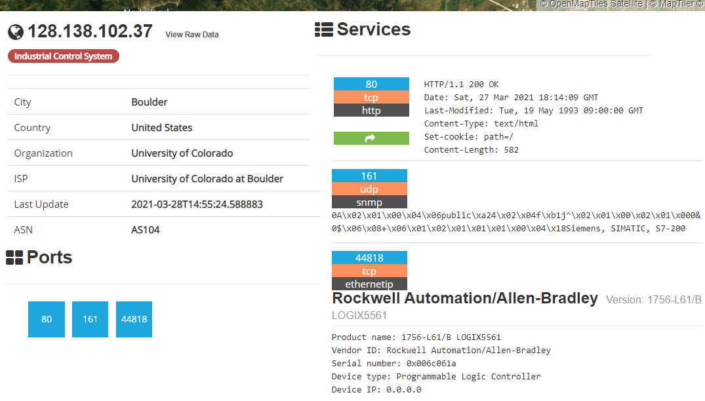Figure 14 – Default Conpot deployed without Modbus
Figure 14 shows Shodan’s indexed data for the Conpot named “nomod” that did not have port TCP 502 enabled.
It appears that Shodan is not searching every port it indexes for well-known signatures to identify instances of Conpot. Each of the Conpots that I deployed for the discoverability experiment were broadcasting two well-known Conpot signatures, “Mouser Factory” and “Technodrome,” over port TCP 21. Those signatures were indexed by Shodan but were apparently not used to determine if the system was an instance of Conpot, as each was assigned a Honeyscore of 0.0.
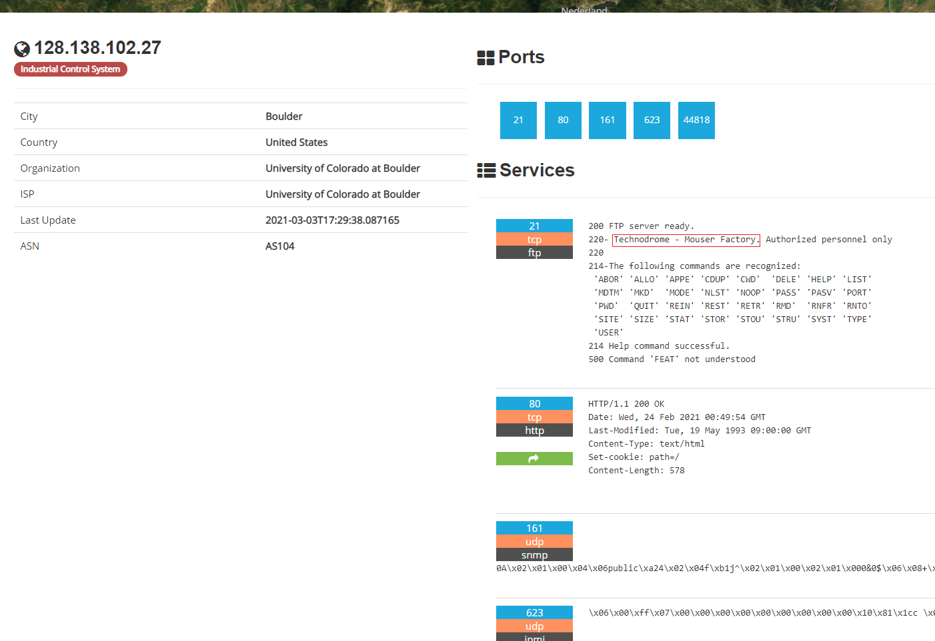
Figure 15 – Well-known signatures broadcasted over TCP 21
Although Shodan labeled six out of the seven Conpots as industrial control systems, none of them were ever labeled as honeypots, and each received a Honeyscore of 0.0. Because the signatures “Mouser Factory” and “Technodrome” are not typically values broadcasted from authentic ICS/SCADA systems, one way that Shodan could theoretically improve their Conpot detection capabilities would be for searching for these well-known signatures over port TCP port 21.

SECTION VI
Conclusions, Limitations, and Future Work

Conclusions
I originally intended for this study to investigate the popular ICS honeypot Conpot and the signatures/heuristics that makes Conpot discoverable via automated detection mechanisms, such as Shodan’s Honeyscore. Unexpected behaviors and consistent freezing exhibited by Conpot changed the direction of the research to focus on investigating a possible Conpot vulnerability.
This study has demonstrated that a default Conpot template emulating a Siemens S7-200 micro programmable logic controller deployed in Docker containers on a Windows PC can be frozen at will by conducting an Nmap version scan over port TCP 502. While this vulnerability may be isolated to the Conpots deployed during this study, I have identified various clues that indicate this vulnerability is not a result of the deployment specifics or design of the experiment. If this vulnerability is widespread enough to affect many or all Conpots and is not simply an isolated occurrence, it could potentially have serious consequences for ICS/SCADA security. Such a vulnerability prevents Conpot from carrying out its intended function of collecting attack intelligence. Additionally, attackers could be already using this vulnerability to differentiate Conpots from real ICS/SCADA systems.
Lastly, data collected from Shodan scans of modified Conpots deployed as part of the vulnerability investigation suggest that Shodan is not searching every port that it indexes for well-known Conpot signatures—another finding with potential implications for ICS/SCADA security analysis.

Limitations
This experiment was limited to testing the discoverability of the “default” Conpot template which mimics a Siemens S7-200 micro programmable logic controller. None of the other five templates that are included with Conpot were tested during the experiment. It is unknown if any other Conpot template is vulnerable to freezing after Nmap version scans or incoming Modbus traffic.
All Conpots were deployed using Docker containers on a Windows 10 computer. While authentic ICS/SCADA systems aren’t typically utilized in virtual environments, deploying honeypots in virtual environments is commonplace. However, virtual environments have the possibility of being detectable. As a result, the data collected for this experiment may have been influenced by the Conpots being deployed in a virtual environment. Any future attempt to replicate the original purpose of the designed experiment—the discoverability of Conpot by automated detection methods—should incorporate Conpots into the experiment that are not deployed in virtual environments in order to test this variable.
Much of the analysis of findings was conducted via inference of available data. Gaining access to Shodan and Censys administrators to ask questions and learn about the way Shodan indexes and searches for signatures would provide far more valuable insight. Shodan administrators were unable to be reached after multiple attempts to contact them.

Future Work
While the original research question for this study was not answered, this study may have created opportunities for future work. Research opportunities based upon the results of this study include: Determining how widespread the Conpot Modbus vulnerability is, discovering the cause for the unexpected freezing observed during the 20-day deployment period, and determining the cause for replicated freezing behaviors triggered by Nmap aggressive scanning or version scanning. Other future tasks include investigating Censys’ ability vs. Shodan’s inability to index data being broadcast over port 102 and determining if variables related to a Conpot’s deployment setup such as type of virtual machine software or operating system influence the prevalence of the vulnerability. Lastly, the original purpose of the designed experiment, the detectability of Conpot by automated detection tools, continues to be an opportunity for future research.

Bibliography

[1] A. V. CNN Jamiel Lynch and Christina Carrega, “Someone tried to poison a Florida city by hacking into the water treatment system, sheriff says,” CNN. https://www.cnn.com/2021/02/08/us/oldsmar-florida-hack-water-poison/index.html (accessed Mar. 28, 2021).
[2] A. Nicholson, S. Webber, S. Dyer, T. Patel, and H. Janicke, “SCADA security in the light of Cyber-Warfare,” Computers & Security, vol. 31, no. 4, pp. 418–436, Jun. 2012, doi: 10.1016/j.cose.2012.02.009.
[3] A. Mirian et al., “An Internet-wide view of ICS devices,” in 2016 14th Annual Conference on Privacy, Security and Trust (PST), Auckland, New Zealand, Dec. 2016, pp. 96–103, doi: 10.1109/PST.2016.7906943.
[4] “Huge aluminium plants hit by ‘severe’ ransomware attack,” BBC News, Mar. 19, 2019.
[5] “How an Entire Nation Became Russia’s Test Lab for Cyberwar,” Wired.
[6] T. M. Chen and S. Abu-Nimeh, “Lessons from Stuxnet,” Computer, vol. 44, no. 4, pp. 91–93, Apr. 2011, doi: 10.1109/MC.2011.115.
[7] M. Bada and I. Pete, “An exploration of the cybercrime ecosystem around Shodan,” in 2020 7th International Conference on Internet of Things: Systems, Management and Security (IOTSMS), Dec. 2020, pp. 1–8, doi: 10.1109/IOTSMS52051.2020.9340224.
[8] M. Patton, E. Gross, R. Chinn, S. Forbis, L. Walker, and H. Chen, “Uninvited Connections: A Study of Vulnerable Devices on the Internet of Things (IoT),” in 2014 IEEE Joint Intelligence and Security Informatics Conference, Sep. 2014, pp. 232–235, doi: 10.1109/JISIC.2014.43.
[9] O. Andreeva, “Industrial Control Systems and their Online Discoverability,” [Online]. Available: https://media.kasperskycontenthub.com/wp-content/uploads/sites/43/2016/07/07190427/KL_REPORT_ICS_Availability_Statistics.pdf.
[10] R. Bodenheim, J. Butts, S. Dunlap, and B. Mullins, “Evaluation of the ability of the Shodan search engine to identify Internet-facing industrial control devices,” International Journal of Critical Infrastructure Protection, vol. 7, no. 2, pp. 114–123, Jun. 2014, doi: 10.1016/j.ijcip.2014.03.001.
[11] S. Samtani, S. Yu, H. Zhu, M. Patton, J. Matherly, and H. Chen, “Identifying SCADA Systems and Their Vulnerabilities on the Internet of Things: A Text-Mining Approach,” IEEE Intelligent Systems, vol. 33, no. 2, pp. 63–73, Mar. 2018, doi: 10.1109/MIS.2018.111145022.
[12] S. Samtani, S. Yu, H. Zhu, M. Patton, and H. Chen, “Identifying SCADA vulnerabilities using passive and active vulnerability assessment techniques,” in 2016 IEEE Conference on Intelligence and Security Informatics (ISI), Sep. 2016, pp. 25–30, doi: 10.1109/ISI.2016.7745438.
[13] D. I. Buza, F. Juhász, G. Miru, M. Félegyházi, and T. Holczer, “CryPLH: Protecting Smart Energy Systems from Targeted Attacks with a PLC Honeypot,” in Smart Grid Security, Cham, 2014, pp. 181–192, doi: 10.1007/978-3-319-10329-7_12.
[14] “The GasPot Experiment: Unexamined Perils in Using Gas-Tank-Monitoring Systems,” p. 24.
[15] @sk4ld, sk4ld/gridpot. 2020.
[16] L. Spitzner, “The Honeynet Project: trapping the hackers,” IEEE Secur. Privacy, vol. 1, no. 2, pp. 15–23, Mar. 2003, doi: 10.1109/MSECP.2003.1193207.
[17] “An experiment in using IMUNES and Conpot to emulate honeypot control networks.” https://ieeexplore.ieee.org/document/7973617 (accessed Mar. 23, 2021).
[18] A. Jicha, M. Patton, and H. Chen, “SCADA honeypots: An in-depth analysis of Conpot,” in 2016 IEEE Conference on Intelligence and Security Informatics (ISI), Sep. 2016, pp. 196–198, doi: 10.1109/ISI.2016.7745468.
[19] N. Rowe, “Creating Effective Industrial-Control-System Honeypots - ProQuest.” https://search.proquest.com/docview/2437943514?pq-origsite=gscholar&fromopenview=true (accessed Oct. 06, 2020).
[20] J. C. Brown, “Identifying Honeypots Simulating Internet-Connected Industrial Control System Devices,” p. 85.
[21] T. Holz and F. Raynal, “Detecting honeypots and other suspicious environments,” in Proceedings from the Sixth Annual IEEE SMC Information Assurance Workshop, Jun. 2005, pp. 29–36, doi: 10.1109/IAW.2005.1495930.
[22] M.-R. Zamiri-Gourabi, A. R. Qalaei, and B. A. Azad, “Gas what?: I can see your GasPots. Studying the fingerprintability of ICS honeypots in the wild,” in Proceedings of the Fifth Annual Industrial Control System Security (ICSS) Workshop, San Juan PR USA, Dec. 2019, pp. 30–37, doi: 10.1145/3372318.3372322.
[23] J. Matherly, “Complete Guide to Shodan,” p. 97.
[24] mushorg/conpot. MushMush, 2021.
[25] “Quick Installation using Docker — Conpot 0.6.0 documentation.” https://conpot.readthedocs.io/en/latest/installation/quick_install.html (accessed Mar. 29, 2021).
[26] “Empowering App Development for Developers | Docker.” https://www.docker.com/ (accessed Mar. 29, 2021).
[27] “Miscellaneous Options | Nmap Network Scanning.” https://nmap.org/book/man-misc-options.html (accessed Mar. 27, 2021).
[28] “Conpot Freeze while Nmap Scann · Issue #437 · mushorg/conpot,” GitHub. https://github.com/mushorg/conpot/issues/437 (accessed Mar. 29, 2021).
[29] “NMAP scan causes a freeze · Issue #384 · mushorg/conpot,” GitHub. https://github.com/mushorg/conpot/issues/384 (accessed Mar. 29, 2021).
[30] D. Hyun, “Collecting Cyberattack Data for Industrial Control Systems using Honeypots.” https://faculty.nps.edu/ncrowe/oldstudents/Hyun_Dahae_ICS_thesis.htm (accessed Oct. 21, 2020).

