Protests in Independent Kazakhstan 1991-2019

By
Ryan Cabana

Committee:
Thesis Advisor: John O’Loughlin, Ph.D.
Honors Council Representative: William Travis, Ph.D.
Outside Reader: Suzanne Magnanini, Ph.D.

Submitted to the Geography Department
University of Colorado-Boulder

April 18th, 2020
Acknowledgements
I have extreme gratitude for John O’Loughlin, through three courses and this undergraduate honors thesis, he has been invaluable in my development as a student. I also owe sincere thanks to Barbara Buttenfield who has similarly helped me in honing my abilities as a student. This gratitude extends to many other members of CU-Boulder Department of Geography’s faculty and staff who have been so devoted and supportive toward their students.
I would feel remiss if I didn’t extend personal thanks to Suzanne Magnanini who not only extending consistent support for my academic pursuits but also introduced me to the exciting world of literature.

Table of Contents
Lists of Maps and Tables 6
List of Figures 7
Introduction 9
Chapter I: Historical Context 13
Geography of Central Asia 13
Emergence of the Kazakhs 16
The Khanate System 17
The Nomadic Economy 20
Legacy of the Nomadic Khanates 21
Tsarist Russia in Kazakhstan 26
Political Change in Soviet Kazakhstan 28
Migration and a Shifting Demographic 30
Kazakhstan in the Soviet Economy 32
Kazakhstan on the Eve of Independence 33
Chapter II: Overview of Contemporary Kazakhstan 36
Nursultan Nazarbayev 36
The Kazakhstani State 38
Kazakhstan’s Geopolitical Strategy 40
Russia 41
China 45
United States 49
Uzbekistan 51
Protests Data: Methods and Presentation 52
Chapter III: Protests in the 1990s 57
Ethnic Tensions (National Politics) 57
Chinese Nuclear Testing (Geopolitical) 59
Economic Challenges of the 1990s 60
Economic Proximity to Russia (Economic) 61
Privatization and Associated Policy (Economic) 65
Worker Desolation (Economic) 68
Chapter IV: Protests in the 2000s 72
The Iraq War and US Engagement in Central Asia (Geopolitical) 72
Protests Against Uzbekistan (Geopolitical) 73
Opposition in Independent Kazakhstan (National Politics) 74
State Action as an Object of Protests (National Politics) 78
Chapter V: Protests in the 2010s 80
The Zhanaozen Massacre 81
Anti-Russia Protests (Geopolitical) 82
Democratic Choice of Kazakhstan: Challenge to the Khan (National Politics) 83
Chapter VI: Overarching Trends in Protests 87
Kazakhstan’s Insecure Resource Economy (Economic) 89
The Tightening Grip of Authoritarianism (National Politics) 92
What Constitutes Protests in Kazakhstan 95
The Head Patron’s Agency in Contributing to Protests 96
Chapter VII: Conclusion & Discussion 99
References 101

List of Maps:
1.1 The Central Asian Republics 14
1.2 Topographic Map of Kazakhstan 15
2.1 Oil Pipelines in Kazakhstan 42
2.2 Oil Pipelines in Kazakhstan and Surrounding States 43
2.3 Belt and Road Initiative Map 47
2.4 Location of Xinjiang Region 48
3.1 The Semipalatinsk Nuclear Testing Site 59
List of Tables:
1.1 Ethnic Composition of Kazakhstan 31
3.1 Ethnic Protests 58
3.2 Anti-Nuclear Protests Against China 60
3.3 Prevalence of Five Keywords in Protest Data 70
4.1 Anti-US Protests 73
4.2 Anti-Uzbek Protests 74
4.3 Opposition Protests per Decade 77
4.4 State Action as an Object of Protests 78
5.1 Anti-Russian Protests 82
6.1 Protests Caused by Authoritarian Action 93
6.2 Forces Behind Protests in Kazakhstan 95
List of Figures:
2.1 Kazakhstan Imports: Russia and China 44
2.2 Kazakhstan Exports: Russia and China 45
2.3 Protests in Kazakhstan: 1991-2019 54
2.4 Total Protests: Volume by Type 54
3.1 Protests in Kazakhstan: 1991-1999 57
3.2 Kazakhstan: Trade with Russia 63
3.3 Kazakhstan Protests: 1991-1999 64
4.1 Kazakhstan Protests: 2000-2009 72
5.1 Kazakhstan Protests: 2010-2019 80
6.1 Protests in Kazakhstan: 1991-2019 87
6.2 Total Protests: Volume by Type 88
6.3 Economic Protests: 1991-2019 89
6.4 Kazakhstan: Real GDP 90
6.5 Global: Annual Crude Oil Prices ($/bbl) 90
6.6 National Politics Protests: 1991-2019 92
6.7 Authoritarian Actions Resulting in Protests 93
6.8 Agency of the Head Patron 96
6.9 Patronal Politics 97
6.10 Economic Development 97

Introduction:
The model of the Western democracy pervades the world as the pinnacle of systems of governance. In contrast to this, the existence of authoritarian states twists the ideas behind democracy to their antithesis. It is easy for an observer to question why a population would seemingly concede certain rights and liberties that are considered sacred to many in developed western societies. An immediate conclusion for some may be the conjuring of an image of a brutally repressive state with extensive security apparatuses that are run by eccentric strongman. The likes of Muammar al-Gaddafi or Kim Jong Un color the imagination with medal-clad dictators who make fantastic claims of their fitness to rule. While regimes that resonate with this imagery have existed, this conceptualization is far too shallow in understanding the reality behind authoritarian regimes. Authoritarian regimes vary widely in their form and function. Most often the regimes that are successful in persisting are those that attempt to remain inconspicuous.
A clear illustration of this can be found in the successor states to the former Union of Soviet Socialist Republics (USSR), spanning the vast area of Central Eurasia. Apart from the stable democracies of the three Baltic republics (Estonia, Latvia, & Lithuania), the twelve remaining states have all experienced varying degrees of authoritarian rule since their independence in 1991. Seemingly existing on a spectrum that spans from stable and orderly to chaotic and unruly.
Among these, the Central Asian state of Kazakhstan has been relatively successful in its path of authoritarian governance. What is unique in Kazakhstan is the high degree of stability and public support the regime has enjoyed throughout its independence period of 29 years. Nevertheless, this placid status quo was broken with the resignation of Kazakhstan’s president of twenty-seven years, Nursultan Nazarbayev, in March of 2019. This sparked a wave of protests that swept through the country’s largest cities. The motivations behind the protests were multiple (anti-government, anti-Chinese, etc.). These distinct protests were connected to one another by the opposition party that organized them all, the Democratic Choice of Kazakhstan. The severity of the protests was surprising regarding the young state’s track record of maintaining a high degree of social stability. What is far more revealing about this contemporary case of unrest is lack of attention that the phenomenon of protests has received in Kazakhstan from both scholars and the media hitherto. This dearth of analysis is damaging to both the understanding of Kazakhstan as a political and social entity as well as the broader comprehension of the dynamics of authoritarian states.
Mention of protests in independent Kazakhstan in the scholarly literature is not altogether absent, more accurately it is incomplete and unconnected. Typically, a few significant instances are briefly mentioned in publications (Olcott 2010) or are in a few cases the focus of journal articles. However, these studies are normally biased toward elite-based interpretations of events, focusing on the role of both regime and opposition members in protests (Radnitz 2010, Peyrouse 2012, Niyazbekov 2018). Outside of this small area of work there are few sources that cover the holistic trends of protest actions in Kazakhstan through the country’s independence period.
This thesis seeks to rectify this paucity of research by flushing out a more comprehensive record of protests in Kazakhstan. Moreover, I employ a multitude of analytics to properly examine the trends that appear within this record. These primarily include political and social theorizations on how the Kazakh state and society are organized and the elements leading to this organization. Henry Hale (2014) provides the framework of patronal politics which I use to analyze the functionality and structure of Eurasian authoritarian sates. This theory is bolstered by that of Edward Schatz (2004) who explores how the preservation of sub-ethnic clan identity in contemporary Kazakh society influences the structure of the elite.
At its core, this project is motivated by a desire to formulate an understanding of when, how, and above all why so few Kazakh citizens have decided to publicly demonstrate their discontents in the form of protests. The case of independent Kazakhstan presents a unique opportunity to further our understanding of authoritarian states. A unique cultural mix, a shifting political history, and a vast economic wealth constitute an intriguing landscape on which a seemingly stable and publicly accepted authoritarian state was built. How did this come to be and what are the implications for our understanding of authoritarian states more broadly? It is my hope that through an examination of protests in Kazakhstan during this period, I can begin to give answers.
It is also important to consider what the story of protests in Kazakhstan means for the future of this country and its people. As will become apparent through the subsequent chapters, Kazakhstan has experienced an extremely high degree of social stability with no significant waves of protest that have shook the whole of society in the independence period. This seems to be a fortunate and unlikely circumstance considering the shock that came with the transition to independence in 1991. The relative spike in protests that has taken place around the time of Nazarbayev’s resignation in 2019 is troubling. Will the departure of Kazakhstan’s first president throw the country into the tumultuous chaos it was seemingly going to experience 29 years earlier? If so, what are the implications for the future governance of Kazakhstan; will it pivot to more genuine democratic practices or even further toward authoritarian repression? These are unknowns as of now but hopefully the following analysis will shed light on what may be to come. In my analysis I found a nexus of intertwining narratives that serve to make sense of oscillations between periods of relatively high levels of unrest and periods of little to no protests. These narratives could be instructive in attempting to understand what is to come for the Central Asian state.

Chapter I: Historical Context
Before getting to an analysis of protests it is best for the reader to familiarize themselves with the historical elements needed to make sense of information to come. This first chapter has been written with this aim. It will present relevant social, political, and economic elements from Kazakhstan’s past. These elements are intended to be of use in ultimately understanding the trends that appear in Kazakhstan’s independence period.
Geography of Central Asia
The Central Asian region is often seen as a little-known space by most Western observers today, and this has typically been the West’s relationship with this area for most of time. Throughout history, this region has escaped the attention of Western chroniclers with few attempting to record the features of this place and its peoples. In examining social phenomena such as protests, it is crucial to conceptualize the distinct context of the place in which they are taking place. The region’s physical geography has had a profound influence on the trajectory of Kazakhstan and the four other states in the region. This influence extends far into the past, playing a part in shaping the culture and politics of the region.

The Central Asian Republics
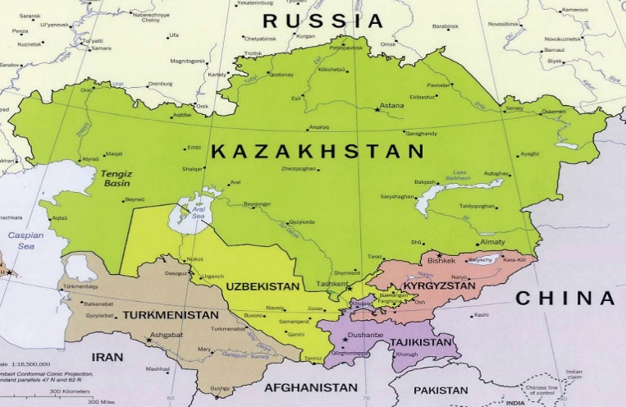
Map 1.1 (University of Texas Libraries 2002)

Currently, the area known as Central Asia is typically considered to encompass the five former Soviet Republics of Kazakhstan, Uzbekistan, Turkmenistan, Kyrgyzstan, and Tajikistan (Map 1.1). All these states, apart from the Persian Tajiks, are peopled by groups whose ancestral origin lies on a spectrum between Turkic and Mongol. This mix of cultures is a result of the well-known expansion of the Mongol Empire under Chinggis Khan into the Turkic populated Central Asia in the early 13th century. The differences between the peoples of Central Asian principally rests with shifting cultural and political practices through their history. Take the transition to independence for instance, Turkmenistan and Uzbekistan became very repressive authoritarian states; Kazakhstan and Kyrgyzstan did much more to liberalize; and Tajikistan has been in chaos attempting to recover from their civil war.
One of the most powerful factors in the region’s story has been the area’s physical geography. The landscape that is most synonymous with Central Asia is the steppe. It is this natural feature that has been one of the most profound influences on the molding of the Kazakhs. The territory of contemporary Kazakhstan is nearly wholly composed of this ocean of grasslands, save for a small portion of the country’s Southeast that lies within the Tian Shan mountain range (Map 1.2). The mountains continue South encompassing the entirety of both Kyrgyzstan and Tajikistan. Juxtaposed against the rolling steppe to the North and the towering mountains to the East, the Southwest portion of Central Asia is mostly inhospitable desert. This is the domain of the politically isolated Turkmenistan and Uzbekistan, Kazakhstan’s main rival for Central Asian hegemony.
Topographic Map of Kazakhstan:
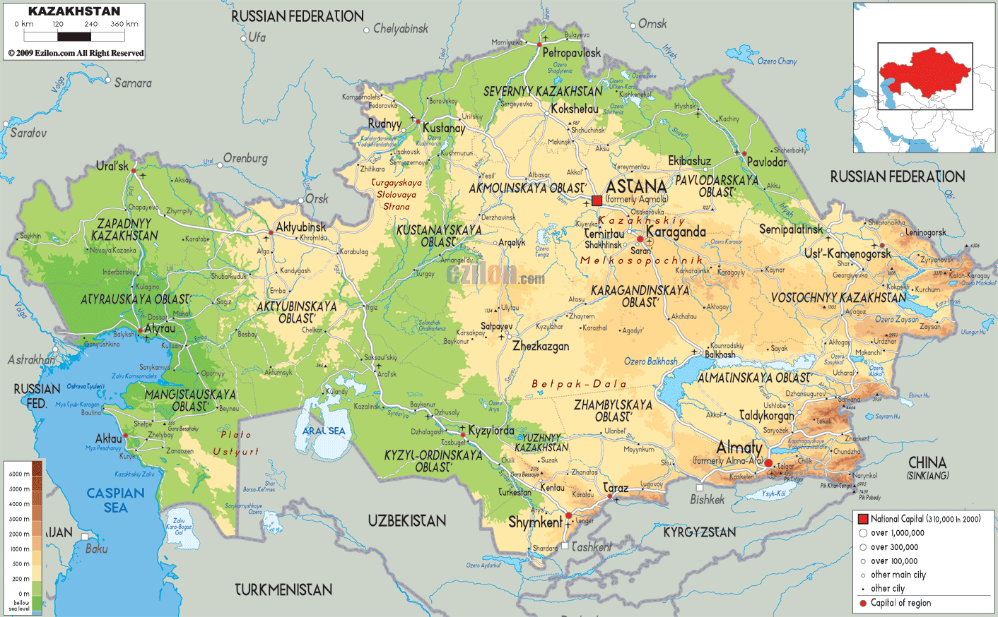
Map 1.2 Ezilon Maps, 2009)
Today Kazakhstan is the ninth largest state in the world with just over a million square miles of territory. The size of the country is often obscured to most that view it on the world map, as the Central Asian republic is dwarfed by its neighbors Russia and China. Despite the size of the country, it is relatively sparsely populated with only eighteen million citizens as of 2020 (Worldometer, 2020). This has resulted in a stark urban-rural divide where the majority of the population resides in a handful of a few large cities. The divide extends into the social sphere as well, urban Kazakhs are markedly more Russified and cosmopolitan while rural folk tend to be more traditional. The two largest cities, Almaty and Nur-Sultan (formerly Astana) are the principal stages on which political and social events revolve.

Emergence of the Kazakhs
The origin of the Kazakh people has been difficult to identify for scholars, as not much was recorded about the steppe or its nomads until the Russians entered the scene a few centuries ago. According to Olcott (1995), the dearth in scholarly literature covering the origin of the Kazakhs is filled in by a multitude of fantastic folk tales that use myth to explain their emergence. The narrative that is closest to the truth is that the Kazakhs began as a cohort of clans that split from the powerful Uzbek khanate in the late fifteenth or early sixteenth century (Olcott 1995). This newly formed Kazakh khanate was not seen as a unified ethnic group, but rather simply a collection of clans that banded together out of convenience, “…the Kazakhs were primarily a political union. The Kazakh khanate and the Kazakh people were synonymous, a people formed by the union of previously disparate clans and tribes of Turkish descent” (Olcott 1995 10). The patchwork nature of the Kazakh khanate becomes clearer when considering that the entity had dissolved into three distinct hordes (zhuz) sometime in the sixteenth century (Olcott 1995). The Great, Middle, and Small hordes all acted as separate khanates, each controlling a piece of the steppe that roughly lines up with the contemporary borders of Kazakhstan.
The division of the Kazakhs into these three groups would have a rippling impact through the eras to come. For one, it would increase the nomads’ susceptibility to the outside influence of encroaching Tsarist Russia. Beyond this, it is thought that these sub-ethnic identities were strengthened by Soviet intervention in the steppe as “…initial Soviet governance did not fundamentally disrupt identity, relations; rather, it ensnared them in a series of political contests” (Schatz 2004 37). Under the Soviet system clan identity became a way of Kazakhs to organize to compete with one another in the broader Soviet political structure. According to Schatz (2004), now they jockeyed for influence and power within the party apparatus.

The Khanate System
Since about the middle of the nineteenth century, the Central Asian experience has been one of political dynamism and fluidity. In this time ordinary Kazakhs lived under three very distinct forms of government (Khanate, Imperial Russian, and Soviet). This period of intense transition is in stark contrast to the long period that Central Asians lived under a more traditional form of political system, the khanate. Until the establishment of complete Russian dominion over Central Asia in the late nineteenth century, states within the region were primarily structured as khanates. Olcott (1995) identifies two elements of pre-Russian steppe society that is of relevance to my account: (1) the decentralized structure of the khanate government form and (2) the nomadic economy under which the Kazakhs lived. These two intimately bound elements of early Kazakh society have had implications that have endured through time to impact modern Kazakh society and the processes happening within it.
Olcott (1995) considers the Khanates to have been the predominant element of Central Asian politics since even before the short-lived Mongol empire that swept through Eurasia in the thirteenth century. The author points to Chinggis Khan’s infamous 13th century conquest as having brought profound change to the political structure of the many Central Asian states that would emerge thereafter. From that point on, society was then organized into two broad classes. The white bone were an aristocracy in which members could establish a hereditary link to Chinggis Khan and were qualified to be chosen as Khan; while the black bone was constituted by the masses of nomadic families who were limited in their social mobility (Olcott 1995). A select few individuals were privileged enough to belong to a family that could claim heredity toward the great Mongol conqueror, Chinggis Khan, and by extension claim legitimacy as a khan.
A khan would rule over a khanate which was organized by a rudimentary sociopolitical structure. According to Olcott (1995), the basic social unit in the khanate system was the aul, a collection of a few households and their livestock traveling together in their endless journey between summer and winter grazing lands. The author goes on to describe clans as a collection of auls with khanates being a confederation of a number of these clans. Of principal interest to my study is the role of the khan in this system.
While the days of khans and nomads seems distant it is important to understand the mechanics of a system that Kazaks lived under up until only a century ago. Olcott (1995) says that Khans were typically impotent political figures that had very little direct power despite their position at the head of the state; This was due to decentralized nature of the khanate. According to Olcott, the true power was held by clan leaders because they had direct access to the resources and manpower of the auls. A greater proximity to the supplies necessary for maintaining power gave clan leaders political leverage despite their lower official rank.
In fact, lower order Kazakh positions derived additional influence over the khan through the selection process. Olcott (1995) describes the process as a decision made by a council of clan leaders and sultans, a position between clan leader and khan that ruled over regions within the khanate. After an election the khan often ruled for life, whether death came from old age or a rival. However, Olcott also makes the distinction that a khan’s lifestyle was not very different from their black bone subjects, as they lived in auls that followed the same nomadic lifestyle.
This inherent weakness in the position of the khan resulted in a pronounced significance in the agency of individual khans, “The power of the khan was vested in the person, not the office, so the power a particular Kazakh khan enjoyed was a reflection of his perceived particular fitness to rule” (Olcott 1995 13). The direct result was that if a khan was perceived as weak, the entirety of a khanate would become marred by strife and discord among clans; Often leaving the khanate vulnerable to outside influence. Conversely, when a competent khan was in control, unity and stability were high which made expansion possible. This is a theme that is repeated consistently through the history of Kazakh society. This idea is very important in developing ideas on protests dynamics in contemporary Kazakhstan.
The khanate system seems remote in time in contrast to the modern geopolitical world order of the nation-state democracy, but in Kazakhstan the transition from this archaic system was relatively recent. It was the extension of the Soviet system into the region in 1930 that ultimately marked the end of the nomadic khanate in Kazakhstan (Kindler 2018). With such a recent past, the influence of the khanate system on contemporary Kazakh society cannot be discounted. In fact, the Kazakh khanate could be interpreted as an early iteration of what is called “patronal politics”. Taking the form of a vertical hierarchy, “Politics in patronalistic societies therefore revolves chiefly around personalized relationships joining extended networks of patrons and clients…” (Hale 2014 21). Just as with the khans of old, Hale describes how a single patron sits atop of the political hierarchy of the state and it is their particular agency that decides the degree of cohesiveness and functionality within the system.

The Nomadic Economy
For time immemorial, the peoples populating the Eurasian steppe have lived as pastoral nomads. This lifestyle came with a very distinct economy, the form of which was quite distinct from commerce-based economies of sedentary civilizations. The most basic and significant piece of the Kazakh economy was livestock (primarily sheep, goats, & horses) and maintaining a healthy herd was everything to a Kazakh, the herd meant life or death for them and their families (Olcott 1995). So, it is by extension that land for grazing was the principal object of desire for khans when they would expand their holdings. Olcott points to acquiring adequate pasture lands for auls as the requisite for a khan to maintain stability and without it a khanate would quickly become rife with instability and discord among clans. The author also implicates this same requisite in the nearly constant resistance of Kazakh nomads to Imperial Russian administration of the steppe, administrating land for migration and grazing was a constant issue for the colonial governors.
It was this distinct nomadic lifestyle and its associated economy that profoundly shaped Kazakh culture. A notable effect that nomadism had on Kazakh culture was that it infused the society with a degree of cultural aloofness towards the actions and events that corresponded to surrounding settled peoples. Stuck between encroaching foreign powers and competing Central Asian khanates “The persistent changing economic and social environment meant that Kazak religion, education, art, literature, music, and trade and industry corresponded closely to the nomadic way of life” (Sabol 2003 22). This was reinforced by the few interactions between the nomads on the steppe and the settled peoples in the Silk Road cities to the South, establishing a social distance between themselves and other Central Asians (Olcott 1995). This distance was reinforced by the rift in economic incentives between the livestock-based nomadic economy and the commerce-based trade economies of settled agricultural civilizations.
This remoteness is best illustrated by the relationship between Kazakhs and Islam. For the sedentary Uzbeks, Islam held a pronounced position in organizing society that is similar to Arab society, but “By contrast, the proto-Kazakhs, who were always on the move, initially had a very superficial exposure to Islam and persisted with their traditional beliefs and invocations which combined elements of tengrism, shamanism, Zoroastranism and Buddhism” (Yemelianova 2014 287). Compared to stricter followers of Islamic scripture, the Kazakhs have been Muslim in name mostly.

Legacy of the Nomadic Khanates
Contemporary Kazakhstan with its modern economy and vast oil wealth seems distant from its time of nomads and khans. However, this period established deeply embedded cultural and political mechanisms that still hold significant sway over modern Kazakh society. The three factors of significance identified in the preceding sections were the formation of the zhuz subethnic identity, the structure of the khanate state, and the cultural impacts of the nomadic economy. The most significant of the three is the implications of the khanate political structure on modern Kazakh politics. The connection is not lost on scholars, Alexander George points out that “…Nazarbayev’s preference for appointing relatives or loyal people to posts conforms to the point of view of the traditional Kazakh consciousness” (George 2001 30). This analysis is a direct comparison of the Kazakh state under Nursultan Nazarbayev to that of a khanate of the nomadic past. It also lends validity to the theories of both Henry Hale’s (2014) patronal politics and Edward Schatz’s (2004) modern clan politics.
Patronal politics is a more traditional political configuration of a state and in Hale’s (2014) theorization is pervasive across authoritarian states in the Eurasian region, roughly encompassing the former Soviet Union. The author describes these states’ structures as organized into vertical power networks that run off personal ties and relationships between clients and patrons. Furthermore, in this theorization, the head patron at the top of the pyramid must deploy a high degree of agency in the form of punishment and reward to shape expectations of network members and thus keep sub patrons and their associated clients in line. Hale says that when a head patron loses the ability to shape the expectations of network members, that instability and discord among members begins to emerge, which allows for the possibility of the head patrons’ usurpation.
Patronal politics sounds remarkedly similar to the structure and functionality of the nomadic steppe khanates as described by Olcott (1995). This is not lost on Hale (2014) who considers Pre-Soviet, traditional Eurasian political structures to be an early form of patronalistic societies. Through this lens the authoritarian state under Nazarbayev could be considered essentially to be very similar in functionality to the Kazakh khanates of the second millennium. Under both these systems a competent leader’s agency is needed in order to establish unity and stability within the state.
This idea of the Kazakh authoritarian state as a kind of a modern khanate is further reinforced by the examination of the role that sub-ethnic clan identity’s play in politics. If patronal politics are based off personal relationships, then in the Kazakh context the pre-existing kinship ties of clans and the broader zhuz would be the default avenue for organization. Karin and Chebotarov explicitly link the two concepts in the context of modern Kazakhstan in that “The republic’s political system is defined by paternal-clientistic relationships and the division of Kazakhs into three tribal groups [i.e. zhuz]” (Karin & Chebotarov 2002 12).This is supported by Sally Cummings (2005) who finds that there was a clear over representation of the senior zhuz among the top elites occupying high level positions within the state in the first decade of independence. This dominance by the senior zhuz makes sense as it is the zhuz of origin of Nursultan Nazarbayev, as well as the zhuz that holds sway over the former capital Almaty. In fact, Koch (2013) has speculated that curbing the influence of the senior zhuz could have been a significant factor in the president’s decision to move the capital in 1997.
If early independence era Kazakhstan has visible signs of the influence of clans and zhuz, then it follows that these connections must have existed through the Soviet period. This is discussed by Edward Schatz (2004) who has been the pioneer of the conceptualization in which clan identity influences political organization in Kazakhstan. He places clientism as the central mechanism of relevance in elevating the status of these traditional clan identities. Marlene Laruelle (2012) grounds this concept in the realities of contemporary patronal politics by asserting that these traditional loyalties “…must be understood mostly as one governing tool among others, and as a politics of symbolic participation, more than as a primordialist factor that pushes people to privilege their own kinship” (Laruelle 2012 319). Nazarbayev is above all a pragmatist, an attribute required to maintain stability in a patronalistic political system. Clan identity is simply a pre-established means of organizing, rather than the deciding factor in who is allowed into the political network.
Another reinforcing element in Kazakhstan’s patronalistic society is a culture that is derivative of nomadic customs. This comes from the deeply embedded position of the clan within cultures that have origins in nomadic economies, but also the social distance towards outside forces this culture engenders in its populace. From its very genesis the “Kazakh national identity, both prerevolutionary and Soviet, was configured by the intelligentsia around the cultural symbols (real and imagined) of the nomadic past” (Sabol 2003 9). The not so distant nomadic roots of the Kazakhs have been an easy foundation from which the elite have begun their construction of a national identity. This even remained the case to a lesser extent through the Soviet era and despite efforts from Moscow, “Among the critical ironies of Soviet rule was that a modernization project designed in part to eradicate clan divisions helped contribute to their ongoing importance” (Schatz 2004 46).
This remains the case today as Nazarbayev has consistently pushed this narrative of the Kazakh’s nomadic roots in his discourse on identity. The most obvious illustration of this being the “Spirit of Tengri” event, a festival organized by the Kazakh state to celebrate the cultural conventions of pastoral nomadism and the pre-Islamic Tengri religion (Rancier 2016). The emphasis on nomadic cultural roots serves to reinforce the clan-based patronalistic political structure. This remains the case on smaller scales in which traditional cultural activities serve a very utilitarian purpose for members of society. The cultural mechanisms of “…feasting and gift exchange are best understood by looking at the broader political and economic context. As before, those who appear to be the most magnanimous also seem to be the ones who benefit the most politically and materially from feasting activities (Svanberg 1999 49). In engaging in these nomadically sourced cultural activities, the participants benefit politically and economically. This process is coherent when embedded within the broader concepts of clan politics and patronal politics.
A crucial element of the nomadic culture constructed by the elite is the seeming aloofness it engenders within society. The promotion of a cultural narrative has been effectively used by the Nazarbayev regime to inoculate Kazakh society against undesirable social forces that may threaten the stability of the regime or the state (Koch 2018). The intelligentsia is essentially able to use these nomadic roots to articulate the idea that Kazakhs are distinct from other groups and thus immune to any social issues that plague those groups. The two most striking illustrations of this cultural vaccination is the absence of both radical Islam and any sort of colored revolution from Kazakhstan.
Even though both Tajikistan and Uzbekistan have had significant problems dealing with a radicalizing element forming within their Muslim community (Cornell 2005), Kazakhs have remained separate from any form of radicalization (Omelicheva 2011). This separation stems from the reality that “The ‘Muslimness’ of Kazakhs is commonly defined through their participation in an array of life-cycle rituals, adherence to values and social mores of the Kazakh communities, and celebration of communal traditions” (Omelicheva 2011 243). Islam in Kazakhstan is structured from the traditions and conventions of nomadic culture, rather than practices of canonical Islam. This stems from the fact that “Their society was self-contained, without regard to cities, and they sought to link customary practices to conditions of day-to-day life” (Olcott 1995 18). The result was a distinct version of Islam that is seemingly divorced of any radical sentiments that afflict stricter interpretations of the religion.
A similar process has taken place in preventing the instability and unrest associated with the colored revolutions from forming in Kazakhstan. This string of prodemocracy uprisings was famous for toppling authoritarian states in a few of the Former Soviet Republics (Ukraine, Georgia, Kyrgyzstan). These events were an intense upwelling of a genuine public desire for more genuine democratic practices in the respective states. Though, no uprising of the sort happened in Kazakhstan. A significant contributor to this was Nazarbayev’s utilization of this classic narrative of a distinct Kazakh culture. After the resultant chaos of the 2005 Kyrgyz Tulip Revolution, Nazarbayev was able to use the ‘specter of instability’ to spin the narrative that Western democracy and its destabilizing effects were not Kazakh (Koch 2018). The Kazakh culture and its nomadic roots have been artfully used by the elite to both reinforce the patronalistic political structure as well as tap into a degree of aloofness or apathy that exists in the Kazakh identity.

Tsarist Russia in Kazakhstan
The Russian empire’s entrance into the Central Asian political scene wasn’t until the late sixteenth century. Using a combination of conquest and diplomacy successive Tsars were able to wrest control over the holdings of three Kazakh zhuz during the latter half of the second millennium. Olcott (1995) describes the principal instrument of Russian expansion as being the construction of fortified lines, strings of fortified settlements that extending through the steppe. The author does acknowledge that Central Asia received very little attention in the wider context of Tsars’ expansion projects, it was really only the Great Game in the mid-19th century with the fear of British Imperial designs on the region that Imperial Russia gained the motivation to fully incorporate Central Asia.
The sheer size of the empire often shifted attention away from Central Asia to more active fronts that demanded the state’s attention. Olcott (1995) names trade as Russia’s sole interest in the region from the onset of the empire’s activity there; through Central Asia’s central geographic position Russian goods could access the Silk Road trade routes leading South to Persia and East to China. It was maintaining caravan routes across the steppe to connect to these markets that acted as the only real motive for Russians to enter the Kazakh steppe.
The encroachment of imperial Russia would begin to initiate the end of the khanate system among Kazakhs, but this would be a protracted process. According to Olcott (1995), initially while under Russian administration, the zhuz were still run under the khanate system with the alteration that khans were now appointed by the Tsar. While the political structure of khanates did not change in this early stage, there was a very dramatic shift in the khans’ ability to manage their holdings. This was primarily caused by the restrictions they now had on pastureland and their inability to take it from Russian settlers without accruing the wrath of Imperial Russia. As pastoral nomads the Kazakhs had a constant need for ever more pastureland to graze their livestock, a necessity that could not be fulfilled under the Russian empire’s system of administering land.
Through a progression of policy, the Russian colonial apparatus would quarter up and take Kazakh land. The Steppe Statute of 1891 determined that “Each Kazakh household was entitled to fifteen desiatians (about 40 acres) of land for their personal use or for use in common with other members of their aul” (Olcott 1995 87). The Statute also stipulates that all of the land in excess of this amount, which was needed by the nomadic Kazakhs for grazing, was to be appropriated by the Russian state.
By the 1990s, Russians now held the keys to administrating Kazakh society. Grazing land was valued above all else and through the use of the Steppe Statute and legislation like it the Russian colonial authorities now had direct control over its distributing. As a result, in the nineteenth century “The power of the clan leaders declined during colonial rule, largely because they could not perform their primary duty—the allocation of pastureland” (Olcott 1995 104). It is through this process that the Russian colonial administration effectively dismantled the traditional khanate aristocracy over the course of the nineteenth century.
This left a vacuum in the elite leadership of Kazakh society that needed to be filled. Olcott (1995) describes the Russians’ method of filling this void as education and integration. This method involved educating young Kazakhs in Russian universities and subsequently incorporating them into the colonial administration in Central Asia. According to Olcott, by the time of the 1917 Bolshevik revolution the elite structure of Kazakh society had been altered profoundly. Where khans and sultans once held sway was then a new young intellectual elite. However, the Kazakh masses were still living as pastoral nomads which put them in a direct course for conflict with Soviet ideals that were soon to come.

Political Change in Soviet Kazakhstan
On entering the Soviet’s sphere of influence massive social and political change would exact a horrible toll on the Kazakh people. Vladimir Lenin’s death in 1924 would result in control of the Soviet Union being wrested by Joseph Stalin after a power struggle with a few of the other Soviet elites. Hale (2014) maintains that Stalin’s ascendency to the helm of the USSR is what returned the Soviet political structure to a patronalistic system, after a brief period of genuine idealism under Lenin. The first order of business in Soviet Kazakhstan was to dispense with the region’s past and usher in the Soviet system.
The challenges in doing so were manifold considering the region’s history in relation to Russia. The principal of these issues was that “During the 1920s and 1930s the Soviet leadership was confronted with the problem of transforming Kazakhstan, as well as the other national regions of the East, from a colonial possession into a member of a multinational state” (Olcott 1995 199). According to Olcott, the Soviet leadership’s approach to this end was to develop the Soviet party apparatus as the new structure of administration in the region. This approach was received relatively well by Kazakhstan’s young intellectual elite who had surfaced in the twilight years of Tsarist Russia. though, Olcott explains that the extension of the party system was resisted by the majority of Kazakhs who still lived traditional lifestyles.
It was the resistance that came from the Kazakh public that caused the Soviets to decide to forcibly sedentarize and collectivize the nomads. Following the goal of modernization, the Soviets forced settlement on the Kazakhs but “Sedentarization often camouflaged interests that had nothing to do with the conditions of nomadic life. The drive was used to excuse the failure to meet delivery quotas or to undermine them; opportunities for corruption and nepotism emerged wherever scarce building materials and funding could be garnered; and settlements turned out to be fighting grounds for competing groups” (Kindler 2018 119). According to Kindler, the sedentarization project was used by Soviets in Kazakhstan to veil inefficiencies and the advancement of corruption in the system.
The event did successfully establish the Soviet party system within Kazakhstan. However, it did little to disrupt the traditional patronal politics of Kazakh society as “The Bolshevik governmental forms of party and Soviet bureaucracy were simply superimposed upon the existing local social and political hierarchies; traditional authorities merely assumed the new titles, and the Kazakh intelligentsia was visibly represented in the territorial bureaucracy” (Olcott 1995 158). Important figures in Kazakh society took on local positions, while the Kazakh intelligentsia filled higher positions in the regional administration. Effectively preserving and reinforcing patronalistic relationships as well as traditional clan identity in Kazakhstan.
In summary, the transition from the Tsarist colonial administration to Soviet party administration may have shifted the form of Kazakhstan’s political structure but not its functionality. Both political systems operated according to patronal logics. Though, now in the broader Soviet multinational state the Kazakhs had greater access to the center of power in Moscow and greater ability in jockeying for rewards in the form of development projects. Overall, the transition to the Soviet system acted to intensify patronal politics in Kazakhstan as “Soviet Patronal networks, far more intensely than tsarist era ones, stretched broadly downward into society through the state, which after Stalin was pretty much everything” (Hale 2014 52). Considering this history of intensifying patronal politics, it is unsurprising that patronal politics would extend into state structure of independent Kazakhstan.

Migration and a Shifting Demographic
The transition into the Soviet system also brought profound social transformation, notably in the demographic makeup of Kazakhstan. This demographic shift had begun long before the Soviet revolution. As previously mentioned by Olcott (1995), the use of fortified lines had been used in Tsarist Russia to slowly colonize the region, resulting in a sizable population of ethnic Russians in Kazakhstan’s North. The proportion of Russians in Kazakh became more significant when the Kazakh nomads were forced to settle and begin lives of collectivized agriculture. The immediate consequences were costly, a famine spread across Central Asia and millions of Kazakhs died or were forced to flee to neighboring states (Kindler 2018, Olcott 1995). It was in this depopulated condition in which major demographic began to take place.
The onset of the second World War would signal great change for Kazakhstan’s demographic profile. Stalin used the steppe as a place to exile a number of groups he found threatening, minority groups began to pour into the Kazakh SSR. Polian (2003) describes in detail the forced relocation of groups like Poles, Germans, Chechens, prisoners of war, etc. to different regions of Kazakhstan. Many groups that Stalin suspected to be a threat to the security of the Soviet Union were sent to Kazakhstan during WWII and through his reign afterwards. This is the primary cause of Kazakhstan’s broad ethnic diversity today. However, the most significant shifts in the country’s ethnic distribution would begin under Stalin’s successor Nakita Khrushchev.
The Soviet premier’s “Virgin Lands” program was a grand design aimed at increasing the union’s overall agricultural production. Under its auspices Russians and Ukrainians were encouraged and supported by the Soviet government to move to the empty steppe of Northern Kazakhstan and begin farming. The movement was successful, and the number of Slavs in republic swelled until Kazakhs were a minority in their own titular state (Table 1.1). The demographic changes in Kazakhstan’s Pre-Soviet and Soviet periods would have a significant degree of influence on the state’s action when entering independence. Of greater significance is the effect this precarious ethnic balance would have on protests in independent Kazakhstan.

Ethnic Composition of Kazakhstan
Nationality | 1989 | 1999 | 2009
Kazakh | 39.7% | 53.4% | 63.1%
Russian | 37.4% | 29.9% | 23.7%
Assorted Other | 22.9% | 16.7% | 13.2%
Table 1.1 (Agency on Statistics of the Republic of Kazakhstan)
Kazakhstan in the Soviet Economy
The vast and seemingly empty steppe of Kazakhstan occupied a relatively unique position in the larger Soviet economy. Its trajectory was notably distinct from the rest of the Central Asian Republics (CARS). Both Pomfret (1995) and Olcott (2010) note the relative advantage Kazakhstan had over many other SSRs upon independence because of the degree to which its economy had been diversified. This diversification came in large part due to Nikita Khrushchev’s Virgin Lands in the 1950s, a program that sought to alleviate the USSR’s cereal crop needs by utilizing the arable, empty steppe of Northern Kazakhstan.
The 1950s and 1960s saw mass immigration of Slavs, mostly Russians, into this part of the country, granting a massive boost in agricultural production. According to Pomfret (1995), aside from the agricultural sector it was in this period in which the subsoil resources of the country began to become of interest. The author suggests this is when industry was expanded via massive sites aimed at extracting precious minerals such as coal. The Karaganda industrial complex in North-Central Kazakhstan began its development in this period, a site that would be a recurring site of protests by miners in independent Kazakhstan.
Outside of extraction activity, the growth of the industrial sector in Kazakhstan and Central Asia more broadly would be constrained through the Soviet period. With industry concentrated in other areas of the USSR, “The industrial development was more limited in Central Asia than elsewhere in the USSR and often only made sense in the wider context of the Soviet economy (if then), as enterprises produced for captive markets or participated in Sovietwide processing chains” (Pomfret 1995 32). This had the effect of creating a high degree of specificity throughout all sectors of the CAR’s economies.
Producing activities were subject to the logic of the centrally planned, command economy. This resulted in supply chains that stretched far across the USSR. A hypothetical example of this would be a cereal crop that was harvested in Northern Kazakhstan, sent for processing in another state of the USSR, before being shipped to a third location for consumption. This configuration left member-states with glaring holes in components of their economy and would come to have a profound effect when independence and economic sovereignty came in 1991.

Kazakhstan on the Eve of Independence
By the time the Soviet Union was dissolved, the Kazakhs were among the most Sovietized members of the USSR. This is evidenced by the fact that the Kazakh SSR was the last of the fifteen republics to declare independence. In a March 1991 referendum held in Kazakhstan, 94.1 percent of Kazakhstanis voted to indicate that they wanted the political structure of the USSR to remain as a socialist union (Hoyer et al. 1991 26). This reluctance for independence stems from several factors. For one, Kazakhstan’s economy was not prepared to function without the support of the centrally planned Soviet economy behind it. Kazakhs had also been thoroughly Russified by this point, Russian culture had permeated deeply into the Kazakh identity.
Sociologist Alima Bissenova (2005) uses the case of Kazakh students studying Islam in Cairo to examine this complicated relationship, “For Kazakhs in Kazakhstan, Kazakh identity is usually constructed vis-a`-vis Russian identity; for Kazakhs in Cairo it becomes clear to what extent Russianness has been internalized and has in fact become an integral part of post-Soviet Kazakh and post-Soviet Muslim identity” (Bissenova 2005 261). The impacts of the Soviet experience were more complete one might think and the integration of Soviet ideals such as cosmopolitanism and secularism into the mainstream Kazakh identity has helped in maintaining stability in the country’s independence period.
From the Soviet system the Kazakhs also reaped some of the benefits of the modernization project that the Soviets undertook in the republic. Literacy rose quickly to nearly one hundred percent, education was provided to the bulk of the population, and the intensive industrialization effort resulting in ample economic opportunity. Coming out of the Soviet era, Kazakhstan was equipped “With a relatively small, well-educated, and reasonably well-disciplined population, the quality of the state’s human development—a UNDP-devised measure based on a combination of life expectancy, basic living conditions, education level, and gross domestic product (GDP)—put Kazakhstan in a similar position to Mexico and Poland” (Olcott 2010 128). The Soviet period had endowed Kazakhstan with a significant degree of high-quality human capital.
It was also during this time in which the patronal political system was reiterated under the form of a modern state. Furthermore, Stalin’s reign as premier only served to further institutionalize patronal politics into the republics of the USSR (Hale 2014). The beginning of Soviet rule over the Kazakhs briefly stifled the significance of clan identity in the political system but the later Soviet period saw a resounding resurgence of this subethnic identity in organizing Kazakhstan’s political landscape (Schatz 2014). In fact, George (2001) asserts that transitioning to independence heightened the role of clan identity in the patronalistic state under Nursultan Nazarbayev.
The period under the Soviet system resulted in great changes for the Kazakh state and society. The experience had an ambiguous effect with both positive and negative processes at work simultaneously. But broadly speaking the period within the Soviet Union was positive for Kazakhstan as it did much to prepare the country for transition to a contemporary nation-state. The political structure went through a number of iterations in structure but only intensified in its function as a patronal network. The economy was completely transformed from that of pastoral nomadism to a modern industrial economy. Waves of migrating Russians and other minority groups thoroughly changed the face of what the average Kazakhstani was. This influx also helped to contribute to the shifting cultural identity of Kazakhs, who left the period notably Sovietized and Russified. However, elements of the pre-Soviet Kazakh society not only survived but became more pronounced in this period. Namely the extent of patronal politics, the role of clan identity in political organization, and the progression of Kazakh culture all would become significant elements that would decide the trajectory of protests in the independence period.

Chapter II: Overview of Cotemporary Kazakhstan

It was on December 16th, 1991 that the Kazakh state would assume its newest iteration of a contemporary nation-state democracy. After seven decades adapting to the bureaucracy heavy structure of Soviet politics, the state had to reorganize to assimilate to a different world order of capitalist democracies. Rather than taking a path of radical liberal reform, like Estonia, the Kazakh elite chose to use an authoritarian style of governing in which civil and political liberties are not protected for the population at large but are instead foregone to focus on economic growth.
This trend toward authoritarianism has been ubiquitous through nearly the whole of the Former Soviet Union. Hale (2014) thinks that this trajectory was likely when considering that long-established patronal political systems have operated in this region for time immemorial. This was simply a continuation of a pre-existing condition. Other commentators consider this authoritarian persistence as a ‘failure of leadership’ in Kazakhstan (Olcott 2010). Some scholars take the approach of rigid objectivity through which they attempt to divorce themselves from any moral judgments and treat the Kazakh state as a subject to be studied (Cummings 2005). Whichever way one chooses to view the state and its action, the trajectory is clear, a calculated centralization of power under the regime of president Nursultan Nazarbayev.

Nursultan Nazarbayev
Any analysis of the most recent form of the Kazakh state must first begin with an introduction to Nursultan Nazarbayev. An ethnic Kazakh, Nazarbayev was born July 6th, 1940 in a rural village in the south of the country. As a young adult he did well in taking advantage of the Soviet education system to earn a position as a metallurgist at the massive Karaganda steel mill. By 1962 he was a member of the local Komsomol, the communist youth organization that acted as a first step in a political career in the Communist party (Aitken 2009). From there the young Nazarbayev began his climb of the Communist party ladder by first holding a few positions within the massive steel mill, before assuming stations with a regional scope.
It was 1984 when Nazarbayev became the Prime Minister of the Soviet Socialist Republic of Kazakhstan, positioning him as the number two directly under First Secretary Dinmukhamed Kunayev. From this point, it only took a little artful political maneuvering to vacate the position of First Secretary in 1986 (Cummings 2004 & Olcott 2010). However, Nazarbayev was passed over for a Russian, Gennady Kolbin, who was more familiar to Politburo members in Moscow. This would evoke anger from the Kazakh public who, in the atmosphere of rising nationalism, resented the action. Olcott (2010) described that the result of this appointment was the infamous 1986 December riots, in which police and military clashed with protesting Kazakhs ending in deaths and casualties.
Afterwards, Kolbin was sent back to Russia and Nazarbayev become First Secretary in 1989. Being of like mind with Mikhail Gorbachev, Nazarbayev was supportive of the General Secretary’s perestroika and glasnost reforms as he wished to see the preservation of the USSR (Cumming 2004 & Olcott 2010). After the union failed to persist in 1991, he easily won Kazakhstan’s first presidential election, held that same year, with 98.8 percent of the vote (Nohlen et al. 2001). A key contributor to his success has been his popular support, “Nursultan Nazarbayev has always been by far Kazakhstan’s most popular politician” (Olcott 2010 26).
Nazarbayev added to this popular support with a combination of constitutional manipulation and parliamentary control, allowing him to remain in his post as president for the first 28 years of the country’s independence (Olcott 2010). It was only March of 2019 that the 78-year-old politician decided to take his leave and resign. Though, with long-time subordinate Kassym-Jomart Tokayev chosen as his successor, it seems likely that the elderly bureaucrat is still holding sway.
In fact, Nazarbayev has placed measures within the constitution long ago just for this occasion. In 2010 Kazakhstan’s parliament passed a law that named Nazarbayev ‘Leader of the Nation’, a special title that can only be given to Kazakhstan’s first president (i.e. Nazarbayev). The constitution was amended and “The law grants Nazarbayev the right to shape policy after retirement and immunity from prosecution” (Nurshayeva 2010). This provident change to the constitution has set Nazarbayev up to control Kazakhstan’s state even after his tenure as president, which is now. This combined with his considerable fortune and personal influence makes his continued governing after resignation highly likely.

The Kazakhstani State
The structure of the Kazakh state has been less built upon its institutions then it has been built in relation to elite networks. Cummings (2005) says that in the Kazakh state, power does not necessarily lie within an institution but rather it lies with high-ranking members of the elite who inhabit these institutions. The author continues, that if a powerful elite moves from one institution to another, which is very often the case, their influence, fortune, and capacity to get things done moves with them. In general, official positions mean very little; it is the individuals who hold them that carry the weight.
This structure aligns heavy with that of Hale’s (2014) patronal politics in which networks are vertical pyramids and individual elites act as nodes within said network. As for the composition of the new Kazakh elite, it was not very new at all. Cummings (2005) found that of 244 identified members of the elite (1995-1996), 168 or 68 percent were holdovers from the Communist party. Just as Nazarbayev had shifted from First Secretary to President, it seems the rest of the elite followed suite, transitioning to the new state structure that appeared into 1991. This is likely why Nazarbayev saw no serious opposition at the onset of independence, as the hierarchy he had built in the Soviet government stayed intact through the transition.
Another instructive tool in understanding the Kazakh elite is Cummings’s (2005) classification of occupational categories, of which there are five: official, economic, professional, business, and technocratic. This classification was determined using the origin of each individual elite; Officials are those aforementioned Soviet state holdovers; the professional elite came from law, theology, or medicine; economic and business elites are similar in that they were elevated by taking advantage of the economic opportunities in the 1990s but the distinction lies with their proximity to the state, where economic elites were often in positions such as factory managers, the business elite operated exclusively outside the state; technocratic elite are individuals with expertise who were brought into the state from education. Of these five types the business elite would come to cause the most trouble for the Nazarbayev regime regarding influence on protests. According to Cummings (2005), this is because they operate outside of opportunity structures controlled by the state.
Despite the lack of direct control over business elite, Nazarbayev has been remarkably successful in managing the elite hierarchies that constitute the state and has kept the ship from any serious mutiny. Peyrouse (2012) explains Nazarbayev’s success in this as a balancing act between different circles of the elite in which he uses power that was obtained from wealth accumulation during the 2000s to enforce his will. He rewarded cooperation while doling out severe punishment to elite dissenters. This is highly reminiscent of the functionality of patronal politics in which patronalistic networks are bound together by “(1) the patron’s continued access to valuable resources for rewarding loyal clients and (2) the patron’s power of enforcement, his ability to selectively deliver punishments to the disloyal” (Hale 2014 31). The dual technique of reward and punishment is one of the principal methods by which Nazarbayev has managed elite networks in order to avoid far more serious challenges to his role as president.

Kazakhstan’s Geopolitical Strategy
Kazakhstan’s geographical location has acted as both a hinderance and a benefit in navigating the complexities of geopolitics in the Post-Soviet period. Its landlocked position precludes the ability to easily distribute its natural resource wealth to any buyer it chooses. This has made it necessary for Kazakhstan to work closely with its great power neighbors if it wishes to maintain access to world markets. This has prompted Nazarbayev to utilize what he calls a ‘multi-vector foreign policy’, a geopolitical strategy that seeks to maintain good relations with all countries that are relevant to Kazakhstan’s success.
The Kazakh state has seen significant success in utilizing this strategy, sustaining friendly relationships with nearly all countries with which it has dealings. This strategy has very little to do with any idealist agendas, rather it is motivated by pragmatic self-interest. Concerning the three world powers operating in the region, “Multi-vectorism has provided the country with multiple options in dealing with both Moscow and Washington and will inevitably pay dividends in the increasingly complex relationship with China” (Hanks 2009 266). The strategy allows Kazakhstan greater flexibility in interacting with these competing geopolitical actors. However, in a 2020 poll questioning ordinary Kazakhs about great power geopolitical influence in Kazakhstan, O’Loughlin et al. (2020) found that they preferred Russia as the great power of geopolitical primacy with Kazakhstan. This is unsurprising considering the deep social, political, and economic roots that exist between the two states.
The competition between the three global powers in Central Asia was ignited by the dissolution of the USSR. Their interest in the Republic of Kazakhstan has been primarily its vast natural resource wealth, particularly its large reserves of oil. Though, each player has its distinct collection of objectives in the region, each valuing some goals higher than others. It is these objectives that shape the interactions between the respective states and Kazakhstan. A significant motive that is shared by all is the desire to not allow Central Asia to fall under the influence of the others.
Russia
The Russian state’s interest in Kazakhstan is many-fold and it has a privileged position in dealing with the Central Asian republic. This is primarily a result of the social, economic, and political proximity the two states shared while under political union. Russia is very interested in Kazakhstan’s oil sector. Yet, its interest is not that of a consumer like China or the US. Rather, it is interested in maintaining control over Kazakh distribution and refinement capabilities.
This motivation stems from the nature of Russia’s own economy. Like Kazakhstan, Russia’s economy is configured as a resource economy which has a significant reliance on oil rents for economic performance. Currently, there is only one oil pipeline in Kazakhstan that doesn’t run through Russian territory. The vast majority of Kazakhstan’s oil is transported to markets via pipelines running through Russian territory (Map 2.1 & 2.2). This essentially gives Russia direct control over Kazakhstan’s capability to sell its oil. Specifically, the price at which Kazakhstan can sell it. With reserves enough to become a potential competitor on the world market, Russia sees it as imperative that it keeps Kazakh oil flowing through its pipelines as a method of control.

Oil Pipelines in Kazakhstan:
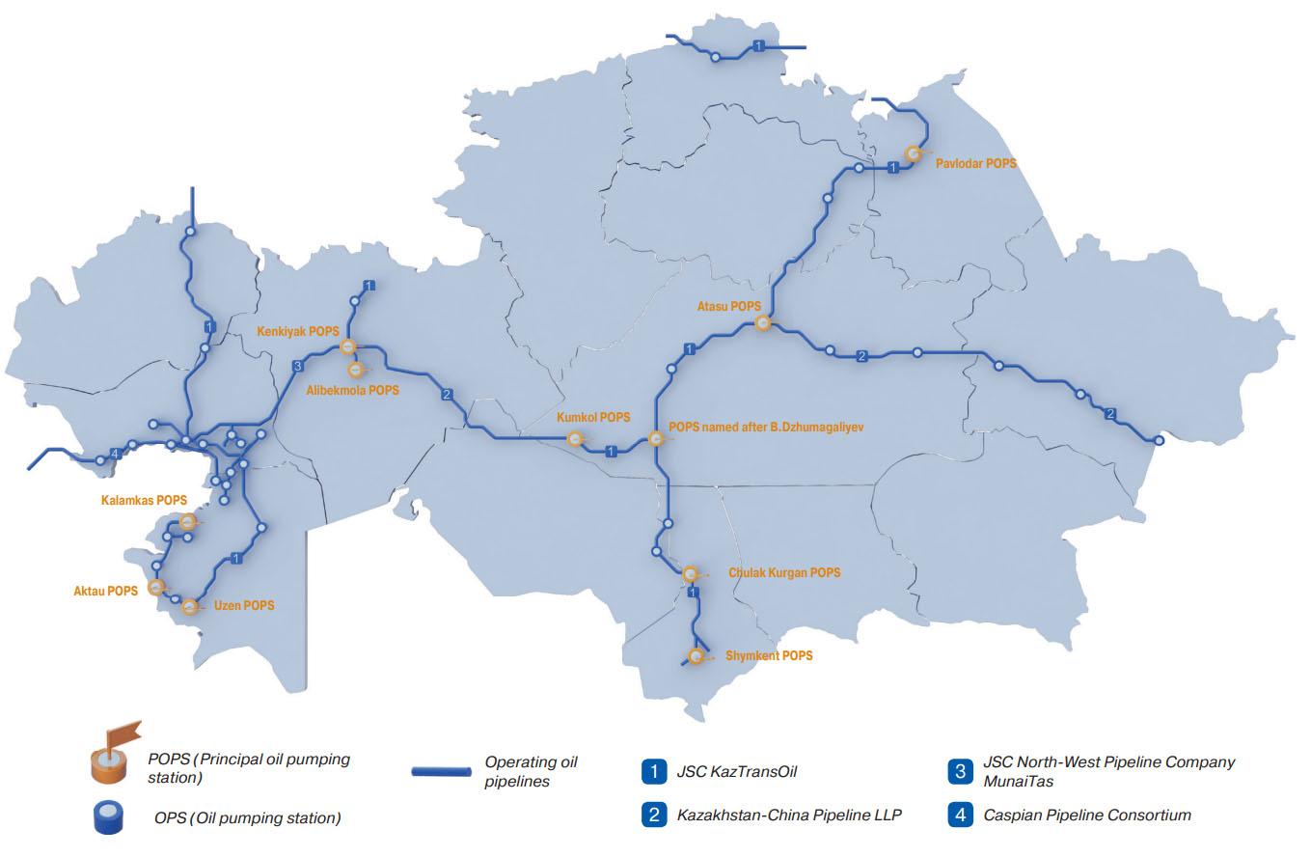
Map 2.1 (KazMunayGas 2017)

Oil Pipelines in Kazakhstan and Surrounding Countries:
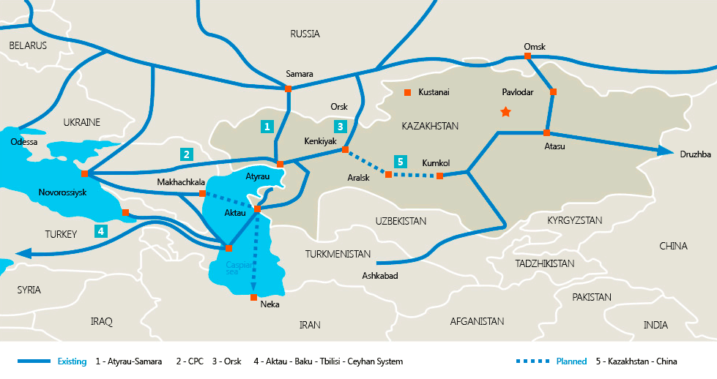
Map 2.2 (KazMunayGas 2017)
Laruelle and Peyrouse (2013) assert the preoccupation with Kazakhstan’s oil would begin to have diminished significance for the Russian Federation after the start of the US led “global war on terror” in 2001. The focus on hydrocarbons has been supplanted by a concentration on regional security. The rise of Islamic extremism in the region has pivoted Russia’s focus to ensuring the security of the area. In their publication describing the geopolitics of Central Asia, Laruelle and Peyrouse (2013) enumerate Russia’s concerns in Central Asia as the following:
Challenges are multiple, as any destabilization in the weakest (Kyrgyzstan, Tajikistan) or the most unpredictable (Uzbekistan) states could have immediate repercussions in Russia: Islamist infiltration in the Volga-Ural region and the North Caucasus; an increase in already considerable inflow of drugs reaching the Russian population; a loss of control over the export networks of hydrocarbons, uranium mines, strategic sites in the military industrial complex, and electrical power stations; a drop in trade exchanges; or an uncontrollable surge of migrants, in particular refugees (Laruelle & Peyrouse 2013 14).
The stakes for Russia are high in Central Asia, any dip from the status quo of stability could result in severely negative consequences for Kazakhstan’s Northern neighbor.
According to Laruelle and Peyrouse (2013), Russia’s main strategy in its pursuit of maintaining regional security has been close bilateral cooperation with the Central Asian Republics and the attempted creation of regional security infrastructure. In particular the authors point to Russia’s cooperative actions with the intelligence agencies and militaries of the Central Asian republics as the principal method of maintaining security. This cooperation is tightened through increased communication and collaborative exercise. The authors say that the principal approach in doing this is the creation of bilateral or multilateral organizations that institutionalize and streamline these processes.

Figure 2.1 (WorldBank)

Figure 2.2 (WorldBank)
To a lesser degree Russia attempts to maintain a close trade presence with Kazakhstan but this has mostly failed as cheaper Chinese goods have begun to capture Kazakhstan’s market. Despite this, Russia still holds a significant chunk of both Kazakh imports (Figure 2.1) and exports (Figure 2.2). This may be a deliberate strategy by the Kazakh state in following its multi-vector foreign policy. It may be consciously avoiding a trade dependence by attempting to balance trade between China or Russia. Plus, China has an incredible capacity for mass producing goods that cost very little relative to other producers. This makes it difficult for developing economies to avoid buying Chinese goods.

China
While Russia may have the most privileged position in interacting with the Central Asian Republics, China is by far the most active in the region. This is due to the East Asian giant’s rapid industrialization and consequent rapid economic growth. An ever-growing role in the world economy has given China ample resources to spread its influence through the world. According to Yu (2018), to date China’s has primarily stuck to a strategy that emphasizes economic development above all else, for both itself and the developing states it chooses to deal with. The Chinese state has a multitude of high-priority objective it seeks to achieve in Kazakhstan, all of these are to some degree attached to China’s ambitious One Belt One Road initiative (or Belt and Road Initiative).
China’s geopolitical strategy is to attempt to integrate all the economies of the old world into a single macro-economy. This is to be done by building shipping & transportation infrastructure in key countries that will ultimately result in two contiguous trading corridors across the old world (Map 2.3): A rail system spanning across inland Eurasia from China to Europe; also a constellation of ports along the South China Sea and Indian Ocean which would give China access to the Mediterranean via the Suez canal. The primary instrument in constructing these ambitious trade corridors is the development of transportation infrastructure that can facilitate trade under the control of China. More precisely, “Inter-connectivity infrastructure development forms a central part of China’s OBOR strategy” (Yu 2017 358). Central Asia’s role is invaluable in this grand scheme as “The Central Asian states provide new markets for Chinese products, markets that could open up to the whole of Russia, Iran, and Turkey” (Laruelle & Peyrouse 2013 35).

Belt & Road Initiative Map:
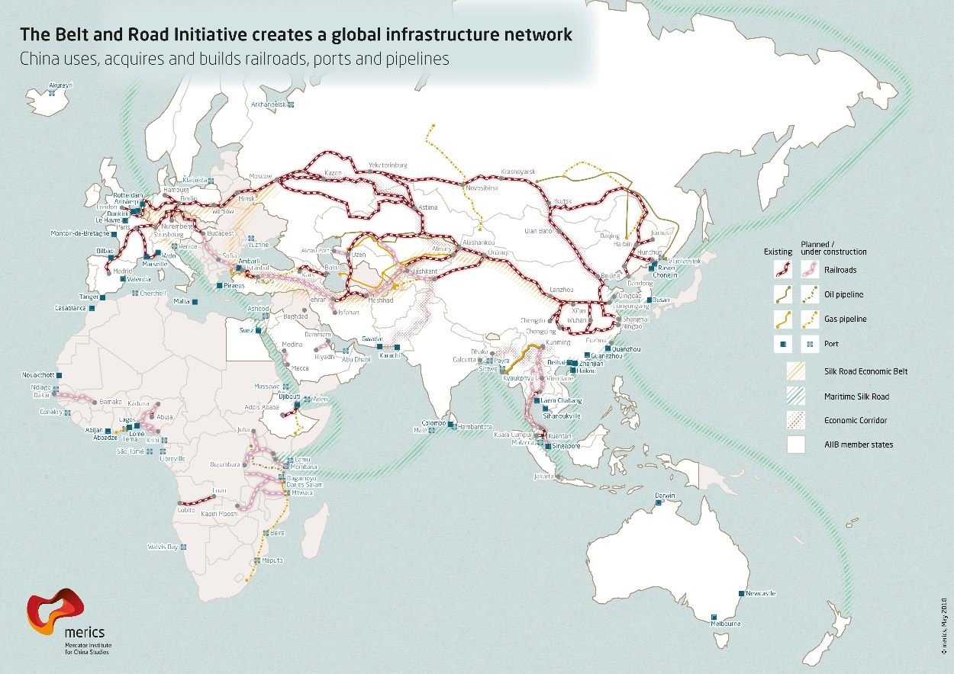
Map 2.3 (Mercator Institute of China Studies, 2018)
In understanding Kazakhstan’s role in this, we can begin with the massive Central Asian Republic’s geographical location. Bordering China’s West, it is the only real viable transportation corridor for China to access the rest of the wide world’s markets by land. The Himalayas to the South and the vast expanses of rivaling Russia’s Siberian taiga to the North both acts as formidable barriers in constructing rail systems for expedient shipping of Chinese goods to distant European and Middle Eastern markets. Therefore, China has not only invested significant sums into the oil sector but also into various types of infrastructure in Kazakhstan (Bitabarova 2018). Though, Kazakhstan’s vast oil wealth is another significant reason for Chinese involvement in its Central Asian neighbor. For China “The increasing dependence on foreign sources of oil is attributable to the sluggish growth of domestic production of oil and the rapidly rising consumption of the resource in the country” (Lee 2005).
The titanic rise of Chinese industry has had the effect of creating a huge demand for energy supplies to fuel mass production. China-adjacent Kazakhstan has a ready supply of energy products and is in need of transportation alternatives to its distribution networks that run solely through Russia. Already there has been one pipeline built to export Kazakhstan’s oil and gas products East into China’s Xinjiang region. This has been the first pipeline built in Kazakhstan that doesn’t run through Russia. The Chinese and Kazakhs are seeking to increase capacity of this pipeline to accommodate China’s ever-growing need for energy to run their massive economy (Kaiser & Pulsipher 2007).
Location of Xinjiang Region:
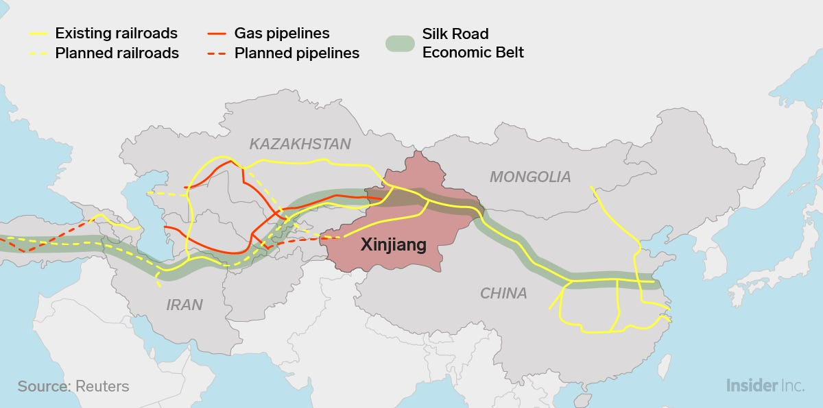
Map 2.4 (Reuters 2019)
Lastly, it is the recent events concerning the Uighur people in a Western province of China that contribute to China’s involvement in Kazakhstan. The Muslim Uighurs are natives of the Xinjiang region which lies adjacent to Kazakhstan on its East (Map 2.4). The Uighurs are of Turkic origin and thus are closely related to Kazakhs and other Central Asian groups. There is even a sizable Uighur population residing in Kazakhstan. Like the plight of the Tibetans, the Uighurs have little desire to remain a part of the majority ethnic Han Chinese state and desire sovereignty. This has reportedly resulted in wildly oppressive tactics being employed against the Uighurs (Davis 2008). In the eyes of the Chinese state, the pacification of the Uighurs has been heightened due to the Xinjiang region’s key geographic location concerning the construction of the BRI. This geographic significance is clearly illustrated in Map 2.4. In advancing friendly relations with the Kazakh state, China has intentions of placating an external force that could potentially lend legitimacy to the Uighur’s struggle.

United States
The reality of US involvement in Central Asia has been rather muted and underwhelming. Some Western analysts were initially excited by the geopolitical potential created by the region’s appearance onto the world stage (Starr 2007, Starr & Cornell 2018). After nearly two centuries firmly in the Russian sphere, it seemed Central Asia may now be free to be courted by the West. Nevertheless, not many connections have materialized between Kazakhstan and the US. Trade between the two countries has been virtually nonexistent and “… [US] objectives remain very general and only modestly shape everyday realities in Central Asia” (Laruelle & Peyrouse 2013 43). The US’s highest priority objective in the area is shared with Russia, that being the of security of the region. The Central Asian republics’ Muslim composition and adjacency to Afghanistan was concerning in the context of the US led “War on Terror”.
According to Laruelle and Peyrouse (2013), an American air base was opened in Kyrgyzstan from 2001 until it was vacated in 2014 and a group of American airmen operated out of an Uzbek airbase from 2001 until 2005. This dual Russian-American preoccupation with security in the region can be thought of as successful, with only Tajikistan seeing real instability through a civil war and uncontrollable extremist groups. As for oil, initially the US saw potential in Kazakhstan as a new source of hydrocarbons to fuel its developed economy. A stable oil source became increasingly important as events in the Middle East made oil purchase from that region more complicated.
According to Kaiser and Pulsipher (2007) this interest in Kazakh oil was the highest among American based International Oil Corporations (IOC), who have operated there since the late nineteen nineties. The authors also describe a waning of IOC enthusiasm in Kazakhstan’s oil market with the increase of authoritarian tendencies among the Kazakh state. This loss of enthusiasm has been compounded by the adoption of fracking in the US. The result has been a fading of US interest in Kazakhstan’s hydrocarbon supplies.
Predating China’s Belt and Road Initiative, early on a contingent of Western political analysts began pushing a remarkably similar Silk Road Narrative through which the US would facilitate the construction of transportation corridors through Central Asia and the Southern Caucasus states (Starr 2007, Starr & Cornell 2018). These ideas on American policy in the region did little to manifest any greater US action there.
There is also an ideological gulf that in some regard hinders cooperation between Kazakhstan and the US. An authoritarian atmosphere makes Western investors reluctant to do business in the country but “…the United States and other Western powers are reluctant to press too hard for political and economic reforms for fear that their access to the country’s valuable natural resources will be restricted” (Olcott 2010 2). The lukewarm engagement between the two countries is only worsened by the real gulf in geographic proximity. Kazakhstan and the United States are simply very remote from one another and this distance acts as a large barrier in their interactions.

Uzbekistan
Despite sharing close cultural, social, and economic connections the two Central Asian republics of Kazakhstan and Uzbekistan have not developed a close and cooperative bilateral relationship. In fact, intraregional cooperation between the five Central Asian Republics has been a failure with “All the attempts at regional economic alliances [having] stumbled on national sensitivities, on the personal competition between leaders, and on struggles for influence, in particular between Kazakhstan and Uzbekistan” (Laruelle & Peyrouse 2013 125). The two neighboring states have established a rivalry during the course of the independence era, both attempting to take the role of the regional power in Central Asia.
This rivalry isn’t necessarily unsurprising considering the two states are the most populous and have the largest economies of the five republics. It is also equally as unsurprising that a regional rivalry might result in Kazakhs occasionally protesting against the actions of the Uzbek state. This situation is further complicated by the close cross border economic ties that exist between the two countries “…in the border regions of southern Kazakhstan, where an increasing number of Uzbeks commute to work on the Kazakh side of the border during the day, and return home at evening” (Laruelle 2008 6). Add an Uzbek minority that lives permanently in those same southern regions and the appearance of protests against Uzbekistan begins to become easily understood.

Protests Data: Methods and Presentation
In collecting a dataset containing instances of protests through Kazakhstan’s independence period I hope not only to present a record of this phenomenon but also to interpret the multitude of forces that lie behind it. Both these goals will be used to make a tentative measure of how the Nazarbayev regime has done in engendering social stability in Independent Kazakhstan.
The methods used to collect data for this project are admittedly very rudimentary. Unfortunately, when conducting researching a place that is nearly on the opposite side of the globe, issues of access and proximity to relevant information are inevitable. This challenge was only worsened by the relatively small number of English-language sources. This challenge being particularly prevalent in the collection of primary data concerning protests in Kazakhstan. To bypass these issues, the Nexis Uni news database was used to acquire dates, locations, and short descriptions of individual instances of protests within Kazakhstan through the years January 1991 (year of independence) to December 2019. The key words ‘Kazakhstan protest’ were used in searching for the events.
No official definition for a protest was used in decided which events to collect, rather events were collected if they met these two criteria: a) took the form of an exhibition of discontent and b) took place in a public setting. Due the logistical constraints of time and scope, the only source that was used was ‘BBC Monitoring: International Reports’ as this significantly cut down the amount of reports and made data collection far more manageable. This also had the added effect of capturing instances of protests that were significant enough to percolate to an international reporting apparatus, removing a degree of uncertainty regarding the legitimacy of the reports. These data should be considered incomplete and incomprehensive, only showing a piece of the whole picture.
Initially data collection took place with no classification system but by the end of data collection for the 1990s some dominant, overarching themes had presented themselves. This then allowed for a simplistic classification system to be adopted to help organize the protests into larger groups with similar motivations.
The three groups of Economic, National Politics, and Geopolitics then became the categories to roughly identify the underlying motivation behind each of the individual protests. It is important to note the significant amount of variation that exists in each group. In each of these three classifications there are events and trends that work at various scales and lengths of time. The variations that lie behind the reasoning of different protests of the same classification will be the subject of Chapters 3-5. Below, the distribution of all 211 protests that took place between January 1991 and December 2019 is shown in Figure 2.3. The total number of each classification is shown in figure 2.4.

Figure 2.3 (BBC Monitoring: International Reports)

Figure 2.4. (BBC Monitoring: International Reports)
The Economic protests are those that arose from an issue that was economic in nature. More precisely, this classification represents those protests that were spawned by a perceived threat to a group’s ability to make ends meet; The consequence being a demonstration in the form of public protest by this group. Economic protests are the most numerous at 89 (figure 2.4), approximately 42 percent of the total. Though, this just barely beats out National Politics protests at 86 (figure 2.4), or roughly 41 percent of the total.
Protests under the National Politics label are those that are the result of the internal politics of Kazakhstan. All the protests in this classification are motivated by a dissatisfaction with the Kazakh state or its actions. Protesters participating in rallies of this nature perceive a threat to their rights rather than their economic livelihood.
Lastly, Geopolitical protests take place whenever any action taken by a foreign state is perceived to be an infringement upon Kazakhstan’s sovereignty. Geopolitical protests belong to the classification that shows up the least throughout the protest data (n=36; ≈17% of total), as seen in figure 2.4. There is only one other state actor that emerges in the geopolitical protests other than Russia, China, and the United States. Neighboring Uzbekistan has also provoked the ire of Kazakhs to the point of protest as well.
The subsequent three chapters will be broken into the three decades of Kazakhstan’s independence (1990s, 2000s, 2010s). Each chapter will attempt to explain the trends in protests in its assigned decade. This will be done by describing the distinct forces in each decade that underpin a group of protests in that period. Each of the sections within these chapters will examine a political, economic, or geopolitical element operating in the era that resulted in Kazakhstanis protesting. The sections will be sequenced in a way throughout the chapters that will attempt to preserve the chronological order of when protests happened through the three decades.
Protests that generally only appear near the beginning of a given decade will be placed in the beginning of a chapter. Trends that appear in the middle and latter portions of a decade will follow. The sections that come toward the end of a chapter will generally be examining trends that are pervasive through a decade and possibly beyond it. Nevertheless, it is impossible to keep a strict chronological order in examining these trends, so chronology is broken when necessary. Lastly, Chapter VI discusses macrotrends that are at work throughout the whole of Kazakhstan’s 29 years of independence.

Chapter III: Protests in the 1990s
The 1990s were Kazakhstan’s most active decade in protests and there is a clear proclivity toward those of the economic nature. The reasons for this proclivity should become clear through the course of this chapter. National Politics are restrained in comparison to the glut of economic protests. Consequently, there is not too many events or forces that fueled National Politics protests in the decade. Lastly, Geopolitical protests are rare and concentrated around mostly China.

Figure 3.1

Ethnic Tensions (National Politics)
The precarious ethnic balance of Kazakhstan was a major source of concern in the first decade of the country’s independence. It seemed as if the diverse collection of ethnic groups would act as a tinderbox that would set the republic aflame amongst the backdrop of such drastic changes to society. Despite this, this proved not to be the case with no conflict appearing along ethnic lines. This was primarily due to the artful promotion of the dual identities of Kazakh (ethnic) and Kazakhstani (civic) by the Kazakh State from the onset of independence (Diener 2016). However, there were a few instances of protests that did hint of some underlying ethnic tensions in the republic (Table 3.1).
Ethnic Protests
Date | Location | Description
9/16/1991 | Uralsk | Clashes prevented between Cossacks and Kazakhs in Uralsk
6/15/1992 | Temirtau | Protest against state language policy
10/18/1992 | Ust-Kamenogorsk | Tensions rise between Kazakhs and Chechens in eastern Kazakhstan
3/31/1997 | Almaty | Police injured in clashes with Kurdish demonstrators
2/18/1999 | Almaty | Kurdish demonstrators clash with police in Kazakhstan
Table 3.1
Two of the protests above were clashes between minority groups and ethnic Kazakhs in the early part of the decade. The two protests toward the end of the decade were Kurdish Kazakhstanis who were demonstrating in support of the struggle of their people back in Kurdistan. The remaining protest from this collection was a rally against the state language policy in the early part of the decade.
According to Fierman (1998), the issue of regulating official languages had been skirted by the state up to this point. This Temirtau protest may have been a demonstration of discontent with the state’s inaction on the issue. Soon after this protest, Kazakh was made the official state language and Russian was given the status of ‘language of cross-national communication’ (Fierman 1998). In practice this allowed the use of Russian in everyday life but established the requisite of knowing Kazakh to work in the state. This may have helped calm any significant dissent concerning the state’s language policy.
Chinese Nuclear Testing (Geopolitical)
The earliest geopolitical event that angered Kazakhs to the point of demonstrating was Chinese nuclear weapons testing in the Western Chinese province of Xinjiang, adjacent to Eastern Kazakhstan. Outside of this Chinese geopolitical influence has generally resulted in very few protests through most of the independence period. In fact, Kazakh protesters that cited grievances with the Chinese state will not be discussed again until Chapter 5. As for the 1990s, it was China’s use of sites in the Xinjiang region for testing nuclear weapons that would cause protests in Kazakhstan.
The Semipalatinsk Nuclear Testing Site
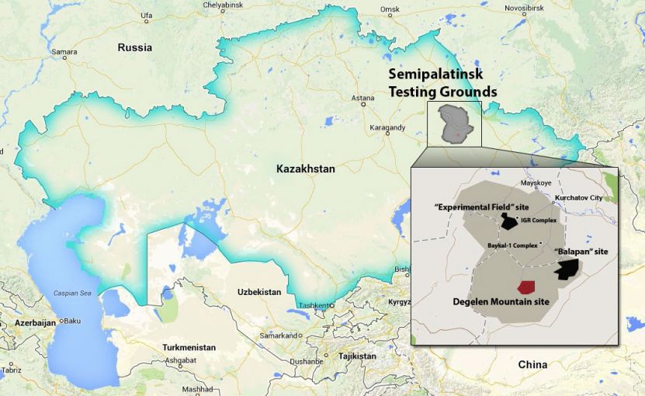
Map 3.1 (Autonavi / Basarsoft / Google via Belfer Center Plutonium Mountain report, 2013)

These protests are primarily a result of a significant aversion Kazakhs have to the testing of nuclear weapons. Throughout the Soviet period the red army used an area in the Semipalatinsk region to conduct 456 nuclear weapons tests (Map 3.1). These tests were unwanted by Kazakhstanis in all parts of society, even Communist party members in the state were staunchly against the activity. These tests have resulted in many adverse effects on the health of those Kazakhstanis living around the test site.
Anti-nuclear Protests Against China
Date | Location | Description
4/29/1994 | Almaty | Anti-nuclear protest during Li Peng’s visit
6/17/1994 | Almaty | Kazakhs demonstrate against Chinese nuclear tests
Table 3.2
This aversion to nuclear testing has been very prominent in the Kazakhstani national conscious throughout the independence period. The close proximity of Chinese testing to Kazakhstan did nothing to ease the tensions felt by Kazakhs on this issue. The two protests in Table 3.2 show the Kazakhstanis’ intense aversion as a reaction to Chinese nuclear weapons testing.

Economic Challenges of the 1990s
The decade of the 1990s presented wide-spread difficulties for all former Soviet republics. This held true for Kazakhstan despite its relative advantage over the other Central Asian Republics. It struggled despite its high-quality human capital and relatively diverse economy. The primary concern of this era was the successful transition to a free market-economy based on the global economy. While this objective was in essence simple, there was far more complexity in overcoming the obstacles needed to arrive at that destination.
In attempting to understand what these obstacles were, Olcott (2010) provides four clear hurdles the nascent Kazakh state faced in regard to economic development: 1) interdependence with Russia 2) the privatization of industry 3) Foreign Direct Investment (FDI) and 4) oil and gas development. While this is a simplification of what was really a complex of interconnected economic issues, it serves to inform the economic actions of the state under Nazarbayev through this decade.
What is crucial, is how the state’s successes and/or failures in these areas has served to directly or indirectly affect protests, or lack thereof. It does seem that there has been a notable connection between the condition of the economy and trends in protests in Kazakhstan. Times were hard for Kazakhstan’s economy in the 1990s and this can be felt by an increased amount of economic protests. In overcoming the obstacles that have been enumerated by Olcott (2010) above, the economy would face the necessity of going through some rough times through this decade.

Economic Proximity to Russia (Economic)
Despite its official independence, Kazakhstan remained firmly within the economic sphere of the Russian Federation through the early part of the 1990s. Olcott (2010) asserts that even with the lack of viable alternatives to this arrangement, it was not necessarily unwanted by Nazarbayev and the Kazakh elite. The desire to remain closely connected to Russia is easily understood. The Russian populated North of the country sparked serious concerns about separatist movements in the early years of independence. But there was never a sustained separatist movement.
Beyond this, the fragmentary nature of Kazakhstan’s economy caused serious disruptions upon independence. Few sectors of the economy had the capacity to stand on their own. Pomfret (1995) points to Kazakhstan’s insufficient capacity to process the wealth of raw resources it was producing (e.g. coal, oil, cereal crops, etc.) as a major weakness in the country’s immediate post-independence economy. This issue was not helped by the Soviet-specific infrastructure that was built with the explicit intent of integrating the peripheral economy of Central Asia with the core of Russian Europe. This infrastructure was constructed with the intent of denying access to other adjacent world/regional powers (i.e. China, Iran, British India).
However, despite a tacit acceptance of Russian influence in the Kazakhstan’s geo-economic orientation, it was exogenous forces that began moving Kazakhstan to become more economically independent. Olcott (2010) points to two incidents that acted as the impetus for this, the 1993 collapse of the ruble zone and the 1998 Russian financial crisis. The collapse of the ruble zone began with the circulation of a new ruble in the Russian Federation, marking the Soviet ruble unusable. According to Olcott, the Kazakh state tried in vain to secure a consistent supply of the new rubles so they could stay with the currency. Nevertheless, this attempt proved futile and the new tenge was made the official currency of Kazakhstan in November 1993.
Unfortunately, this introduction of the currency ended up coming a bit too late “…as the country was flooded with rubles from CIS states that were preparing to launch their national currencies, leading to an inflation rate of 2,500 percent in 1993” (Olcott 2010 133). Despite this big step taken to disentangle the two state’s economies, there remained a mutual dependence on one another in terms of trade. This dependence was heavily in the favor of Russia with a far larger and more advanced economy.
That is why the 1998 Russian financial crisis had a notable effect in Kazakhstan. Figure 3.2 provides the Russian proportion of Kazakhstan’s imports and exports. Considering these figures, it is easy to see how a Russian economic crisis could spell misfortune for Kazakhstan. With such a heavy

Figure 3.2 (WorldBank, 2018)
Concerning protests, Kazakhstan’s economic proximity to Russia and its subsequent move away from such a relationship is quite tangible. Of the two events mentioned above, the 1993 collapse of the ruble zone is far less detectable in instances of protests. There only seems to be two protests that explicitly cite discontent with macroeconomic stability in the years of 1993-1994 in Petropavlovsk (4/26/93) and Almaty (2/26/94). These two protests roughly correspond to the introduction of the tenge and the resultant inflammation.
The earlier half of the 1990s was rife with rapid policy implementation in reaction to frightening economic shocks. This makes it difficult to quantify the significance of a single change amongst a backdrop of so many. This may be why it is hard to detect the effect of the crash of the ruble zone on protests. Though, it is important to note the spike in economic protests in the two years that immediately follow the crash in 1993 (Figure 3.3). It is certainly plausible that the crash of the ruble zone directly contributed to these protests despite an explicit link to it. The crash and the resultant inflation would have left the economy severely depressed.

Figure 3.3

The effect of the 1998 Russian financial crisis on Kazakh protests is quite subtle in its own way. While economically motivated protests are ubiquitous throughout the decade, the only type of protest that took place in the year 1998 were economic (Figure 3.3). This separates this year from the ones flanking it. The two adjacent years (1997 and 1999) both have larger numbers of protests as well as a lower proportion of economically motivated protests (1997 ≈ 57%; 1999 ≈ 55%).
This leads to the speculation that the 1998 Russian financial crisis effected protests in a two-pronged fashion. First it had a constraining effect in which it acted to limit protests in this year. Second, it also focused the few protests that did take place to become exclusive to the economic motivation. In short people were less motivated to rally against anything that didn’t have to do with their personal outcomes of the economic crisis, they were also more generally less prone to protest.

Privatization and Associated Policy (Economic)
The second obstacle Olcott (2010) presents, privatization of industry, is likely the most significant series of economic and political events of the 1990s. Indeed, privatization is mentioned with some degree of depth in almost all economically and politically focused scholarly publications that deal with this period (Olcott 2010, Pomfret 1995, Cummings 2005). It best to understand privatization in Kazakhstan through the broader context of Kazakhstan’s economic policy in the 1990s. The crucial process of privatization took place in conjunction with a multitude of other policy aimed at reform. The first few years of the decade would see price reform, labor market reform, and financial sector reform implemented in conjunction with privatization (Pomfret 1995).
In fact, barring the latter stages of privatization, the Kazakh state is generally praised for its performance in using international standards to reform the economy through the course of the tumultuous 1990s (Olcott 2010 & Cummings 2004). Among the former Soviet Socialist Republics, it has been acknowledged to have liberalized at quite a rapid pace through the decade, especially in comparison to its neighbors Turkmenistan and Uzbekistan, but not as radically as Kyrgyzstan, and most closely resembling the Russian Federation in its progression.
The series of economic policy actions implemented with the objective of liberalizing reform was a major contributor to the economic chaos of the period. In particular, the termination of price regulation hit the ordinary Kazakhstani hard as “State subsidies on goods and services [had] been withdrawn without any equivalent rise in wages” (Odgaard & Simonsen 1999 32). Despite this development, price hikes had relatively little direct effect on protests action. Only two instances of protests concerned with the issue of rising prices would crop up int the decade. Both in 1994, one in Almaty (6/24/94) and the other in Ust-Kamenogorsk (10/25/94). Typically, these economic reforms would not have economic protests that would be explicitly linked to them. Rather, they would create the unstable economic conditions that would contribute to the pronounced number of economic protests that happened in the decade.
Returning to the privatization of industry, this process took the whole of the decade with its official launch in 1991 and the announcement of its completion in 2001. It unfolded in three distinct phases: “…small-scale privatization, including housing (1991-1992); mass privatization and, at the same time, privatization of agriculture (which involved the privatization of livestock and equipment but not land) (1993-1995); and case-by-case privatization which under the premiership of Kazhegeldin (1994-1997) also involved the attraction of foreign management contracts” (Cummings 2005 29). The first phase was completed quickly and successfully oversaw the transfer of a large proportion of small and mid-sized enterprises from state-ownership to private interests.
The second phase is when the process began to take a considerable turn toward corruption and cronyism. This phase is primarily associated with the production of a novel economic elite within the young republic (Cumming 2005 & Olcott 2010). This was like the process through which the infamous Russian oligarchs were formed. The creation of an oligarchic class was principally a result of the form in which the state chose for the second stage of privatization to take place. According to Cummings (2005), this period of privatization was modeled from a voucher system that had been used by the Czechs and later the Russians. The voucher system worked by distributing these vouchers to the Kazakh citizenry which could then use them to obtain shares of enterprises that were being made private. The vouchers were invested in an intermediary entity called an Investment Privatization Fund (IPF).
Under the voucher system, citizens would invest their vouchers into an IPF, which would then use the vouchers to acquire stocks in small and mid-sized enterprises being auctioned off by the state. Cummings (2005) says that this process became problematic when a large proportion of vouchers found their way into a small number of IPFs. It was the managers who ran these IPFs who were the actual beneficiaries of this program as “This second stage strengthened the personal fortunes of the leading fund managers, who went on to form Kazakhstan’s new economic elite” (Olcott 2010 138). It is this cohort of economic elite that now operates outside the opportunity structures of the state (Cummings 2005). Meaning that this group is able to pose genuine challenges to Kazakhstan’s president under the correct circumstances.
The third wave of privatization went in a decidedly new direction and would introduce a new type of actor into the economic landscape of Kazakhstan. It is in this phase in which Olcott (2010) identifies the arrival of foreign management companies to Kazakhstan, a crucial first step in making international investors comfortable investing in the country’s economy. Olcott states that a sufficient degree of privatization had been completed among the small and mid-sized enterprises at that point. Therefore, the focus of this final phase (1994-1997) was to auction off Kazakhstan’s large-scale enterprises. Olcott says this included companies in mineral extraction industry, utility groups, and other massive, revenue-earning corporations of the like. Considering the size and value of these enterprises, the state opted to take a case-by-case approach in which companies were evaluated on an individual basis and sales were negotiated behind closed doors.
These sales were done under the stewardship of then Prime Minister Akezhan Kazahegeldin, giving him ultimate power in the process. As this phase took place in the latter half of the 1990s, foreign corporations were now more willing to set up business in a country that had taken the steps to liberalize its economy (Olcott 2010). This first took the form of foreign management contracts in which ownership remained domestic, but the running of an enterprise was contracted out to a foreign company. However, some of the more dire times during the course of this phase saw some of these large enterprises sold entirely into foreign ownership.
The introduction of foreign based companies into the most valuable enterprises of the country was not received well by the public. While the process did not evoke any serious outbreak of protests, it did have a more constrained influence on the phenomenon. There was a single protest that took place against a Belgian utility group in Almaty (2/28/98). The period of 2005-2010 was more active with a protest against a Turkish contractor in Atyrau (1/18/07) and one held against an Italian contractor, also in Atyrau (12/20/08). These protests were typically workers who desire better wages or working conditions, overlapping with our next trend in economic protests.

Worker Desolation (Economic)
The introduction of foreign management contractors also acted to foreshadow an increased flow of FDI that would begin pouring into Kazakhstan around the turn of the 21st century. The bulk of this investment was devoted to the oil and gas sector. While this did provide the state with large revenues streams, it did little to help the struggling industrial and agricultural sectors.
It was the state’s neglect of Kazakhstan’s secondary sectors that may be the main contributor toward protests through the country’s twenty-nine years of independence. As has been noted previously, Kazakhstan had a relatively strong industrial and agricultural sector in the Soviet period. These sectors employed a lot of Kazakhstanis upon entering independence in 1991. Nevertheless, it was already clear by 1995 that the agricultural sector was facing a lot of difficulties in the form of price liberalization and the choice of the state to retain the land in privatization (Promfret 1995). As for industry, the excerpt below from a chapter on Industrial Dislocation, Worker Desolation perfectly captures a highly visible trend within the protests data:
From 1991 mass closures ensued. In the first half of 1996 alone a hundred enterprises in Karaganda closed down. The collapse of industries meant unemployment, miserly pensions and wages (which in real terms represented under 10 per cent of pre-perestroika salaries); corruption led to huge wage arrears and late pensions for months, even years, on end; lack of heating, water, and even electricity in homes, food shortages, etc., became commonplace. Kindergartens and schools, clubs and libraries, hospitals and polyclinics began to close. The authorities’ total indifference to the fate of people brought both Kazakhs and Russians alike to despair. (George 2001 113)
This passage perfectly captures the essence of a consistent force behind protests in Kazakhstan. As the emphasis of economic development shifted away from diversity to a sole focus on the hydrocarbon sector, millions were left working in sectors that could no longer afford to employ them. This inability to fairly compensate workers in industry and agriculture was exacerbated by the corruption introduced by privatization. This has led to a huge number of protests of workers in neglected industries striking because they were not paid enough, sometimes nothing at all. These protests are found in all periods of independence, though they are most common in the nineteen nineties.
Over the entire independence period, most protests have been caused by issues that arise from the mistreatment of workers. The most common complaints of Kazakhstani workers are arrears, insufficient wages, and poor working conditions. These problems were most acute during the nineteen nineties due to the multitude of economic disruptions that have been described above. In order to distinguish instances of protest that can be explicitly linked to worker desolation five keywords were used to identify these events: Worker, Arrear, Wage, Miner, and Pensioner. When these words showed up in the title of a news report, the protest in that report was always motivated by one of the three complaints listed above.
Although this phenomenon was most influential in the 1990s, it would also be a recurrent force behind protests in the subsequent two decades. Though, its appearance after 2000 would be significantly less frequent. Protests motivated be these complaints in those decades will be named in this section. Describing all of these protests in a single section was done in hopes of making their diminishing effect through time more apparent.
Prevalence of Five Keywords in Protest Data
 | Proportion of Economic Protests in Decade | Proportion of Total Protests in Decade
1990s | ≈ 61% (28/46) | ≈ 39% (28/71)
2000s | 50% (8/16) | ≈ 20% (8/41)
2010s | ≈ 41% (11/27) | ≈ 11% (11/99)
Total | ≈ 53% (47/89) | ≈ 22% (47/211)
Table 3.3
Worker desolation is clearly a very significant force in Kazakhstan’s independence protests with a little more than a fifth of all protests being linked to this phenomenon. It is certainly one of the largest contributors toward protests in the independence period. This could be expected considering the number of economic difficulties the country had in its first decade.

Chapter IV: Protests in the 2000s
Protests in the 2000s were much more restrained in number than the 1990s. Economic protests were far less. In their decline National Politics protests took a more pronounced significance toward the latter half of the decade. Geopolitical protests were no longer solely focused on China, rather they would shift their focus to new targets.

Figure 4.1

The Iraq War and US Engagement in Central Asia (Geopolitical)
The protests of Kazakhs’ against the US were the least energetic in comparison with those against Russia, China, and Uzbekistan. This is largely due to their remote geographic positions and the consequent lack of interaction between the two. Of the three geopolitical protests against the US by Kazakhs, two took place in the in the earlier years of the decade 2000 with the third happened just before the start of the decade. Only two events have sparked protests against the distant superpower: US involvement in Iraq and the movement of American troops into the region to fight the War on Terror in Afghanistan. Table 4.1 shows all anti-US protests in Kazakhstan.
Anti-US Protests
Date | Location | Description
9/12/1997 | Almaty | Demonstrators protest in Alma-Ata at US role in military exercises
2/2/2001 | Almaty | Antinuclear group pickets US embassy to protest Iraq bombing
3/3/2003 | Almaty | Anti-war protest held outside US embassy in Kazakhstan
Table 4.1
These three instances are the only three that appear within the protests data, reflecting the lack of engagement the US has had with Kazakhstan and the region at large. From the paucity of protests, US geopolitical actions clearly have had next to no effect on protests in independent Kazakhstan. This seems to be squarely the result of the nature of interactions between the two states. The two states are not deeply involved in one another’s affairs and this shows in the protest data.

Protests Against Uzbekistan (Geopolitical)
Protests against the Uzbek state have been few but are consistent in content. They primarily have to do with the Uzbek state’s action in the border area as this can often be disruptive of connections and processes in this area. This most likely has to do with Uzbek customs slowing border crossing in some fashion which could serious disrupt some of the economic ties in the region. Table 4.2 show protests against Uzbekistan that took place in Kazakhstan.

Anti-Uzbek Protests
Date | Location | Description
4/1/2000 | Lenin Zholy | Southern Kazakh district demo against opening of Uzbek border post
11/21/2003 | Almaty | Protest against Uzbek policy on Muslims held in southern Kazakh capital
6/6/2006 | Kuandyk | Kazakhs in south protest against border area handover to Uzbekistan
Table 4.2
The opening of an Uzbek border post may have inhibited the cross-border movement of goods and people, possibly spawning the protest in Lenin Zholy. The next protest was caused by Uzbekistan’s hard stance on Islamic radicalism, according to the data some Kazakhstanis thought Uzbek policy on the issue went too far. There public decrying of Uzbekistan’s treatment of Muslim is a bit surprising as Kazakhs practice a very secular form of Islam. A final issue of contention is the transfer of borderland territory from Kazakhstan to Uzbekistan. This resulted in a number of Kazakhs being officially transferred to living in Uzbekistan. The outrage here in this event is clear to understand.

Opposition in Independent Kazakhstan (National Politics)
In attempting to understand the nature of opposition in Nazarbayev era Kazakhstan it is important to return to patronal politics as a framework. Within Hale’s (2014) theorization, nonthreatening oppositional groups are allowed to exist because they lend legitimacy to the patronal president. Hale’s idea is that their presence in the political landscape acts as prove that a patronal president has been popularly and democratically elected despite this competition. In this framework, these groups activities are heavily monitored by the state and their members are subjected to repressive activities, such as arrest and censorship.
This conceptualization resonates heavily with the reality of how opposition groups operate in Kazakhstan during its independence period. This presents observers with much difficulty in attempting to understand how opposition groups have been involved in protests trends. It is easy enough to determine whether or not a group was involved in any given protest, as news reports are explicit in naming the groups when they are present at a protest. But information about these groups can be very hard to come by. This is especially true in the scholarly literature’s description of these groups. There are few articles in Western academia that identify, with any level of detail, the more obscure opposition groups operating in Kazakhstan’s protest scene. This is somewhat troubling as roughly 40 percent (w/ DCK) of all protests between 1991-2019 implicate these opposition groups as being involved. They are clearly a profound contributor to protests in independent Kazakhstan.
A few opposition groups stick out among protest entries as recurrent and prominent. Those are Ak-Zhol/Azat, Azamat, Alga, and the Democratic Choice of Kazakhstan (DCK). Fortunately, Bowyer (2008) provides a brief description for each of these groups. According to the author the story of the Ak-Zhol and Azat parties are intertwined, beginning as they started as a single entity. Of the two, Bowyer describes the Ak-Zhol party as having taken a more lenient stance toward Nazarbayev’s regime. By this, the author means that while Ak-Zhol advanced the promotion of democratic ideals, it did so in a fashion in which it remained friendly to presidentially controlled parties. Founded and led by Alikhan Baimenov, who could best be classified as a technocrat, the party began to lose what little potency it had towards the end of the decade 2000 with Baimenov accepted a position working for the state and by extension Nazarbayev (Bowyer 2008).
Bowyer (2008) describes Azat as the breakoff party that was run by a collection of business elite who thought Ak-Zhol’s position of cooperation was unacceptable. The author asserts that due to taking a far harder stance against Nazarbayev, Azat became rather harmless because of the difficulty it experienced in registering as an official party; It has been effectively precluded from having any real agency for change in Kazakhstan. Bowyer describes the Azamat movement as having had an even shorter lifespan than the two aforementioned parties. Started by a few estranged former prominent state officials, some of its members were reabsorbed into the state while the rest simply lacked the resources to achieve anything meaningful.
Bowyer (2008) says the Alga party was not plagued by logistical issues such as funding or organization but was hit the same barrier as all others, that being an inability to get properly registered. Lastly, the author describes the Democratic Choice of Kazakhstan as having produced the sincerest challenge to Nazarbayev’s position, in both its iterations. The first iteration of the party was dismantled before it could do any damage. The second form of the party has been able to cause quite a stir in independent Kazakhstan’s protests. This can be understood from the data presented below (Figure 4.4) and will also receive its own section in Chapter 6.
As can be understood from this brief history of a few of Kazakhstan’s opposition parties, they have had very little real agency in affecting the state. Nazarbayev has effectively used the dual technique of repression and cooption to incorporate and/or dismantle these threats (Cummings 2005). Every case above ends in either an oppositional elite receiving a position in the state or the party facing a blockage in securing official registration (Bowyer 2008).

Opposition Protests per Decade
 | Ratio | Percentage
1990s | 5/71 | ≈ 7%
2000s | 18/41 | ≈ 44%
2010s (w/o DCK) | 19/61 | ≈ 31%
2010s (w/ DCK) | 58/99 | ≈ 59%
Total (w/o DCK) | 42/173 | ≈ 24%
Total (w/ DCK) | 81/211 | ≈ 38%
Table 4.3
Accordingly, protests from these groups are typically very mild in their consequence. In examining the protest data, two distinct motives appear that lie behind protests organized by these groups. The first has taken the form of relatively generic demonstrations against the anti-democratic practices of the state. This may look like a call for Nazarbayev’s resignation or a rally against a piece of legislation. The second is far more specific in that it only happens surrounding the arrest of an opposition member. Detentions of prominent opposition members have typically sparked small demonstrations calling for the release of the detained. It seems the ultimate goal of these protests was to attempt to publicize the repressive activities of the state.
When considering the temporal element of these groups’ activities, they all become most active in the 2000-2015 period. Before this, they were only nominally active toward the end of the 1990s and not active at all toward the beginning of that decade. Excluded from this analysis is protests organized by Democratic Choice for Kazakhstan, appearing in 2018 and 2019. This was done because the DCK appears as a rather unprecedented oppositional entity, distinct from other opposition groups in its effect. Therefore, it will have its own section in the following chapter.
The surge of opposition protests in the period 2000-2015 makes sense when considering that this is the same period in which Nazarbayev began accumulating power after gaining an economic foothold after the turbulent 1990s. Olcott (2010) says that in the 2000s a stream of oil revenue began flowing into the pockets of Nazarbayev and his inner circle. With this fortune they had the capacity to centralize the state under themselves.

State Action as an Object of Protests (National Politics)
Probably the widest ranging and most difficult collection of protests to classify were those caused by actions of the state that seemingly spurred genuine public discontent. These protests are classified as National Politics protests but are distinct from others of the classification as they were seemingly absent of any entity (i.e. opposition groups or elite) as a catalyst. Rather, they seem to be moments of genuine public frustration with the state’s actions. Like how some opposition organized protests, these public rallies are strictly centered around an object of state action. Below, Table 4.4 lists the four instances of these types of protests that show up in the data.
State Action as an Object of Protests
Date | Location | Description
12/10/2006 | Nur-Sultan (then Astana) | Kazakh drivers protest against ban on right-hand drive cars
6/8/2008 | Almaty | Kazakh hunger strikers try to negotiate with authorities over houses demolition
10/11/2008 | Almaty | Kazakhs protest over housing problems in biggest city
4/5/2011 | Nur-Sultan (then Astana) | Kazakh Muslims on hunger strike over hejab – Iranian radio
Table 4.4
These three cases provide an insightful window into why and when genuine public unrest gets to a point of protest in Kazakhstan. Despite their differences they are all clearly connected by a similar theme, the state acting in a way that is depriving a group of a very personal right or privilege.
What is also instructive is how rare these types of protests are in the data; these four instances alone make up the most visible of these types of demonstrations. A final variable to consider is where these four protests lie in the overall distribution of total protests. They all took place in the latter half of the 2000s, it is hard to detect a reasoning for this. It could be speculated that they are result of Nazarbayev’s tampering with legislation at the height of his consolidation of power. If not, it could simply be coincidence. In any case, this type of protest is quite rare.

Chapter V: Protests in the 2010s
Excluding 2019, protests would be next to nonexistent in the 2010s. The inverse of the 1990s, Economic protests may be the least significant in this decade. They were typically protests caused by complaints against wage and working conditions, much like those protests that shook the 1990s. National Politics would be only nominally more significant in this period, clearly these types of protests would come to hold importance in 2019. The Geopolitical category remains relatively insignificant as with the following two decades. Though, in this decade the focus shifted to Russia. What is important in the 2010s is to understand what happened in the years 2011 and 2019 to cause the spikes protests.

Figure 5.1
The Zhanaozen Massacre
The reason for the significant spike in the year 2011 is due to a protracted bout of protests that sprung up in the city of Zhanaozen in Kazakhstan’s oil-rich west. According to Stapayev and Umbetaliyeva (2015) these protests started as peaceful demonstrations in which oil workers occupied the town square demanding better working conditions. As discussed in the section on industrial desolation, a protest such as this has been one of the most common in the protest data. However, the authors then describe the situation as escalating when local authorities got involved. They had deemed the protest as illegal, with the result being the firing of nearly 2,000 oil workers.
Stapayev and Umbetaliyeva (2015) explain the workers’ reaction to termination as an intensification of their protests attempt. They pitched tents in the central square of Zhanaozen in summer of 2014. According to the authors, it was a few months of workers occupying the square that eventually led to a violent clash between the entrenched protesters and police who had attempted to break the protest up. In the ensuing conflict “…at least 16 people were killed and more than 100 injured” (Stasyev & Umbetaliyeva 2015 126). This effectively put an end to the protest.
This single protest is the reason that there was a relative spike in economic and national politics protests in this year. This is seemingly the first instance of viral protests spreading throughout Kazakhstan. Protests in other parts of Kazakhstan were held in solidarity with the oil workers. This could be the reason why the Kazakh state reacted as harshly as it did in December of 2011. The popular and viral element to this protest may have spooked the state.
In considering the long-term effects of this event, it is very plausible that this violent response sent an effective message to would-be protestors. The next seven years would see a lull in protests that is only eclipsed by near complete absence of protests in the period 2000-2005. Although the Zhanaozen Massacre is not the sole reason for this, it certainly had some degree of contribution to the calm of that period.

Anti-Russian Protests (Geopolitical)
Russia has had a very special relationship with Kazakhstan, with such significant cultural and economic ties. Nazarbayev has been very careful in maintaining a friendly relationship with the Russian administrations. Ethnic Russians still make up a large proportion of Kazakhstan’s population and after seventy years in the Soviet Union, Russian culture is an inseparable piece of Kazakh identity (Bissenova 2005). Nevertheless, this close relationship has not precluded some instances of protests by Kazakhstanis aimed at Russian geopolitical influence (Table 5.1).
Anti-Russian Protests
Date | Location | Description
2/24/1992 | Leninsk | Baikonur protesters’ demands met investigations under way
7/1/2011 | Almaty | Kazakh youth activists protest against Customs Union
7/12/2011 | Almaty | Young Kazakh activists hold another protest against Customs Union
3/3/2014 | Almaty | Kazakh man gets seven days in jail for protesting Russia's moves in Crimea
4/28/2014 | Nur-Sultan (Then Astana) | Anti-heptyl Kazakhs protest Russian booster rocket launches
7/2/2014 | Nur-Sultan (Then Astana) | Kazakh activists protest near Russian embassy over Proton rocket launches
Table 5.1
The legacy of the Soviet military complex’s activity in Kazakhstan has been a point of contention for the Kazakhstani public. Above all else the famous Kazakhstanis resent the continued Russian use of the Baikonur Cosmodrome located in a Southern region of the country. For the Kazakhstanis, the use of the launching complex by the Russian state is seen as a visible reminder of the not so distant time spent under the Russian hegemony. Protests against perceived Russian encroachment have also come with two other events.
The first was the decision by the Kazakh state to enter a customs union with Russian in 2011. The second and last event concerning Russian geopolitical action was the annexation of Crimea in 2014. This was a concerning event for Kazakhstan due to the region densely populated with ethnic Russians along the Northern border with Russia. Scholars who have speculated on the possibility of an annexation of Northern Kazakhstan by Russia think it is unlikely considering the friendly ties between the two states. (Laruelle 2018, Diener 2015).
All but one of the protests against Russia have taken place in the 2010s, hence their place in this chapter. The lack of protests through the first two decades of independence is likely due largely to the close political, economic, and cultural connections that exist between the two states and their populaces. The protests taking place against Russia within this most recent decade are likely due to a combination of the increased geopolitical activity of Russia in this period as well as the greater visibility provided by the internet. Despite these protests, the recent research of O’Loughlin et al. (2020) has found that a Russian geopolitical presence is welcome by most ordinary Kazakhs.

Democratic Choice of Kazakhstan: Challenge to the Khan (National Politics)
Lastly, the spike in protests in 2018 and 2019 may be the most significant in Kazakhstan’s independence history. Explaining this spike will draw on a few elements that have discussed throughout the text. Of relevance are the production of an economic elite during privatization, the history of the Democratic Choice for Kazakhstan, and the ancient narrative of a challenger throwing the realm into chaos as he challenges the khan for supremacy. The process of the economic elite, independent of state opportunity structures, being created during privatization has already been covered in depth.
It is instead best to begin in 2001 with the formation of the original Democratic Choice of Kazakhstan, an opposition party that pushed Nazarbayev for economic reform. According to Bowyer (2008), the state’s response to the formation of this party was quick and absolute, using its usual tactics of cooption and repression. The movement was effectively pacified by autumn of the same year. The reason for such an immediate response was that the membership of this party was quite threatening, “What set the DCK apart from prior attempts at organized political opposition in Kazakhstan was the members’ experience in the political system, the civil service, and key business sectors” (Junisbai & Junisbai 2005). So effective was the state’s dismantling of this group that it was not implicated in being involved in any protests in the period of its existence at all. This would not remain the case for the group’s reincarnation.
The DCk would again resurface in 2017 as a party established by Glaymzhan Zhakiyanov and Mukhtar Ablyazov, prominent members of the business elite who have held several minor positions in the state. It seems the DCK’s intent to stir the Kazakh public didn’t begin until May and June of 2018. While there were only two days of protests reported to have been organized by the group in this year, one took place across five cities and another in three. This use of the internet and social media to organize viral protests in multiple locations would serve to be an incredibly effective tool wielded by the DCK going forward.
The situation would not begin to evolve until March of 2019 with the news of Nursultan Nazarbayev’s resignation as president of Kazakhstan. At the age of 78-years-old the elderly president’s resignation should appear as unsurprising. But for those who have only known a Kazakhstan under Nazarbayev the inevitability of his departure never seemed quite so certain. Regardless, he was replaced by Chairman of the Senate Kassym-Jomart Tokayev, a long-time close associate of Nazarbayev originating from the technocratic elite.
Tokayev served as interregnum president until snap elections were called in June of 2019 in which he won with a sizable majority, perhaps because of a lack of prepared and registered opponents. He is now officially the second president of Kazakhstan with Nazarbayev now apparently acting in a consultative capacity, although it very likely he has considerable agency in the decision-making process.
The DCK’s has responded to this transition in a fashion that harkens back to days of prominent members of the Kazakh white bone throwing the whole of the society into chaos in a bid to take power. Using the weapon of viral protests that were organized by social media, the DCK has sewn independent Kazakhstan’s greatest period of unrest. It began in May of 2019 with protests organized on the first of the month in both Nur-Sultan and Almaty. The protests have continued to gain strength through the summer. Through the autumn protests were in full swing and still going strong at the time that data collection ceased in December of 2019.
Of the fifty protests that have taken place in 2018 and 2019, thirty-eight (57 percent) have been organized by DCK across twelve cities in the country. These take the form of all three types of protest (Economic, National Politics, Geopolitical), a clever tactic most likely aimed at drawing attention to issues originating from different areas of the state. For instance, the DCK has organized multiple massive anti-Chinese protests to emphasize Nazarbayev’s and Tokayev’s cooperation with their East Asian neighbors. With this novel event still ongoing, it is difficult to divine how it will end and what will be the ramifications for protest trends going forward. Suffice to say there hasn’t quite been anything like it yet in the independence period.
That is why the narrative of those khans’ long past have been chosen for comparison. The event is strikingly familiar to the accounts provided by Olcott (1995) in her volume on the history of the Kazakhs. Nazarbayev was clearly a well-liked by the public and was perceived as a strong leader, which may have contributed to the relative lack of protests that appeared over his twenty-eight years as president. However, as soon as a new leader took his place, opponents sensed weakness in this time of transition and moved to incite rebellion among the country’s population. Not knowing the conclusion to this tale, the comparison ends there. Currently, Glaymzhan Zhakiyanov and Mukhtar Ablyazov are in political asylum in France and communicate with supporters via the internet.

Chapter VI: Overarching Trends in Protests
Using the methods detailed above, a total of 211 individual instances of protests were recording as taking place in the period January 1991 to December 2019. Over the twenty-eight-year period this roughly comes to an average of 7.5 protests per year. Using these simplistic metrics, Kazakhstan has seen a remarkable amount of stability in its independence period. This scarcity of protest events is even more extraordinary when considering the social, political, and economic shocks that accompanied independence. These shocks were far more influential in the relatively active protest period that constituted the 1990s.

Figure 6.1

Figure 6.2
The distribution of the total number of protests per year can be seen in Figure 6.1 and the volume by category is shown in Figure 6.2. Many of the trends that comprise this distribution have been discussed in detail throughout the previous chapters. Protests against events such as price hikes, the detention of an opposition member, and all other previously discussed forces and events can be found within this distribution. Still, the most significant trends and forces that have yet to be analyzed will find a place for their examination in this chapter.
Of these, two macro-scale trends will be discussed, one economic and one political. After, there will be an examination of the proportion of protests that can be attributed to each significant force discussed through the thesis.

Kazakhstan’s Insecure Resource Economy (Economic)
As mentioned in the third Chapter, economic protests had the greatest influence in the 1990s due to the many challenges that came with transitioning to a market economy. This is supported by the distribution of economic protests (Figure 6.3), nearly 52 percent of all economic protests happened in this decade. Spikes in protests can be detected after the ruble zone collapse in 1993 and the Russian Financial Crisis in 1998. However, the 1990s were just generally a mess of interconnected economic shocks that resulted in the sustained high amount of economic protests seen in figure 6.2.

Figure 6.3
What is just as striking is the complete absence of economic protests in the period just after (2001-2004). This absence correlates to the year of a growth in both Real GDP (Figure 6.4) and Oil Rents as percent of GDP (Figure 6.5). What this means is a period of economic growth that was initiated by the development of the Kazakh oil sector was likely a significant contributor in keeping Kazakhs from protesting about economic conditions within the country.

Figure 6.4 (WorldBank 2018)

Figure 6.5 (Macrotrends 2019)
In comparison to the chaos of the 1990s, the distribution of protests that appear in the period 2005 through 2018 are far clearer as they revolve around identifiable events. For instance, the spike in 2007-2008 was a result of protest arising from price hikes of basic food stuffs. This is unsurprising because there was a world food price crisis that happened these same two years. This resulted in a particularly bad year in 2008 as this is the same year that the 2008 Global Financial Crisis hit, evidenced by the dip in real GDP growth in that same year (Figure 6.4).
The bump in protests in 2014 was a result of the 2010s global oil glut. Going into the decade, global oil production exceeded demand which resulted in a surplus beginning created. Figure 6.5 shows that this surplus would drive the price for crude oil way down and this is reflected by a dramatic decrease in real GDP. The final spike of economic protests in 2019 were a result of the campaign against the state by the DCK.
In interpreting the distribution of economic protests, it becomes clear that these types of protests events are subject to the health of the national oil sector and the broader condition of the global oil economy. When business is booming, living standards are raised and Kazakhs are less prone to protests as evidenced by absence in economic protests during a growth in real GDP during the period 2001-2004. The spikes of economic protests in the new century also make certain that protests of this nature are significantly influenced by shocks from the global economy. In this period nearly all the rashes of economic protests were caused by global economic disruptions.
Interestingly, a final trend that appears here is the notably dampened volume of economic protests after the turn of the century. There was no lack of economic difficulties in this period but there were far less protests than the 1990s. For example, the 2010s oil glut hit Kazakhstan’s GDP hard but there were only three economic protests in that year and no more than one per year for the next four years. This apparent stability in the face of economic crises is due the provident creation of the massive Samruk-Kazyna National Welfare Fund during the 2008 crisis (Olcott 2010). This massive fund, filled with billions of dollars’ worth of capital from oil rents, became a very effective tool for the state to keep the economy afloat in crisis. Its effect is clear within the distribution.

The Tightening Grip of Authoritarianism (National Politics)
An oft referenced force throughout the chapters of this thesis have been the pivot toward authoritarianism by the Nazarbayev regime as time progressed and the economic situation was enhanced. This force has not yet received the proper attention to define how it interacts with protests within the country. The type of protests that needs to be inspected are those of the National Politics designation. Figure 6.6 shows the distribution of National Politics protests from 1991 to 2019. There are only two phases in which the move towards an authoritarian government would spark protests. The first phase took place in the early and mid-1990s. The second was a blip caused by events in 2006 and 2007.

Figure 6.6
The trend of advancing authoritarianism is a difficult trend to detect in the distribution (Figure 6.6). This is because protests against this force are centered around the individual events and actions that aimed to centralize power under Nazarbayev. Figure 6.7 shows a timeline of these events, a quick glance is all it takes to understand the rarity behind these events. This force is further veiled by a lack of volume in protests surrounding these key events, no single event has more than two demonstrations against it. It can also be speculated that strengthening authoritarianism acts as a self-reinforcing phenomenon. It is logical to assume that as a state centralizes power and resources, its capacity for preventing or repressing protests events would increase. Table 6.1 lists protests that resulted from these authoritarian actions.

Figure 6.7
Protests Caused by Authoritarian Action
Date | Location | Description
7/27/1995 | Almaty | Kazakh protest rally over new draft constitution
8/21/1995 | Almaty | Opposition stage hunger strike over constitution referendum
1/30/1996 | Almaty | Pickets protest as new Kazakh parliament opens
11/30/1997 | Almaty | Opposition movement stages rally outside parliament
10/30/1999 | Almaty | Kazakh opposition holds rally, demands fresh elections
7/5/2006 | Almaty | Kazakh journalists plant thistle in protest against media bill
5/24/2007 | Almaty | Kazakh journalist detained at rally against constitutional amendments
6/5/2007 | Almaty | Opposition activist stages protest against Kazakh constitution reform
Table 6.1

The story begins with Nazarbayev’s struggle against parliament in the realm of constitutional reform during the early 1990s. Olcott (2010) says that in 1993 the president was just barely able to get a parliament that was filled with dangerous oppositional figures to dissolve itself with fresh elections happening the next year. The 1994 parliamentary elections would be designed to elect a strong majority of Nazarbayev supporters into it. Despite this, a collection of opposition group members was able to win positions in the parliament and form a bloc (Olcott 2010). This caused serious trouble for Nazarbayev at a critical time in which he planned to implement a new constitution and needed to win elections in the coming year.
Again, Olcott (2010) says that parliament was dissolved, this time by a decision from the constitutional court. This resulted in Nazarbayev taking on expanded presidential powers for the interregnum until a new parliament could be elected, he used this time to push through his new constitution and to bypass elections in 1995. Yet again a new parliament would appear on the scene in 1996 but at this point the institution had been pacified by the 1995 constitution as “The new constitution expanded presidential power at the expense of the legislature, which became a largely consultative body, with legislation initiated by the president” (Olcott 2010 112). In 1999 Nazarbayev called snap elections a year early as to catch any potential rivals off guard. With some opponents not even able to get properly registered at that point, he won easily. This event resulted in a protest by the opposition.
Beyond the 1990s, a 2006 bill which banned editors from publications that had been closed by the state from working for any other publications was very unpopular with journalists. This would cause these journalists to protest in that year.
Lastly, the constitutional amendments of 2007 would result in protests in that year. The changes made by these amendments were quite significant, allocating much more power into the hands of the president. Some of the more blaring alterations include: The Prime Minister is now appointed by the President, the first President of Kazakhstan (Nursultan Nazarbayev) can now run indefinitely without the constraint of term limits, and the president can now select more senators. These changes mark a profound shift towards authoritarianism in which Nazarbayev has sweeping powers over the government and legislature with an indefinite time in office.
The authoritarian trajectory of the state under Nazarbayev has been a muted but important trend in Kazakhstan’s protests. It must not only be viewed concerning how it created protests but also how it has worked to preclude protests. In function it has had a similar effect to the development of the country’s oil economy, where the state’s means to control protests have increased with its centralization of power. However, this trend remains undetectable when viewing the distribution of National Politics protests.

What Constitutes Protests in Kazakhstan
Through this thesis a multitude of forces and elements have been discussed that contributed to the phenomenon of protests in independent Kazakhstan. It is difficult to keep track of the significance behind each of these disparate entities. Table 6.2 shows the percentage each significant force has had on protests.
Forces Behind Protests in Kazakhstan
Force | Proportion
Geopolitical Protests | 17 %
Democratic Choice of Kazakhstan (DCK) | 18%
Worker Desolation | 22%
Opposition Groups (w/o DCK) | 24%
Collection of Smaller Forces | 19%
Table 6.2
While there is some overlap between some of these elements, it is minimal. The only force in the table that has notable overlap with others is protests by opposition groups, but even then, this is still small. The purpose of this table is to give an idea of how significant each of the events and forces discussed throughout the thesis have been on protests in independent Kazakhstan. The final category ‘Collection of Smaller Forces’ is meant to represent those less significant elements (e.g. ethnic protests, state action as an object of protests, etc.).

The Head Patron’s Agency in Contributing to Protests
What seems to be a central element in dictating the occurrence of protests in Kazakhstan’s independence period has been the agency of the head patron (i.e. Nazarbayev). Indeed, Hale (2014) places this as one of the most crucial aspects in maintaining the stability of a patronal network. This is the reason why so much space was devoted to detailing the functionality of pre-Soviet Kazakh society in the beginning of this thesis. The stability of Kazakh society being dependent on the individual at the helm of the state seems to be a cultural artifact that has persisted since the beginnings of this Central Asian group.
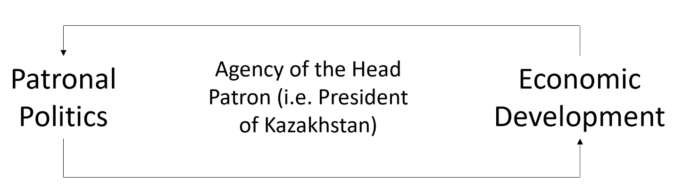
Figure 6.8
In contemporary Kazakhstan, the agency is most clearly seen in the close dialogue between patronal politics and economic development. These two are mutually reinforcing forces that have served to restrain the amount of protests through their development by Nazarbayev. Success in these intertwining endeavors has been completely dependent on Nazarbayev’s agency to fulfill the composite tasks (Figure 6.8), which he has done quite successfully. This is evidenced by the decrease in protests through the nearly three decades of his presidency.
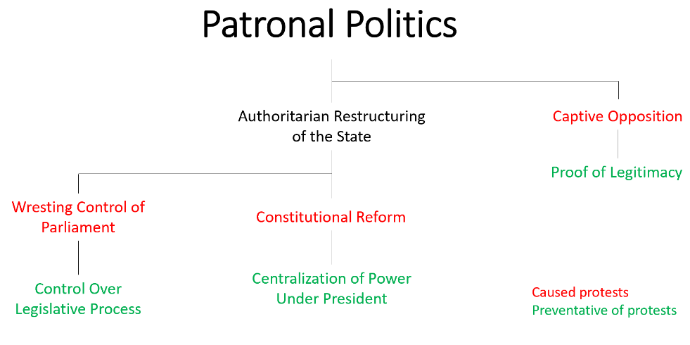
Figure 6.9
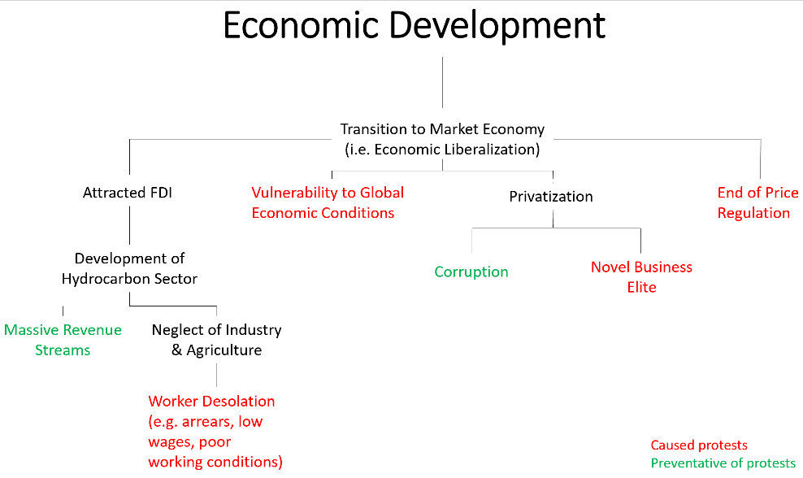
Figure 6.10
Above, Figure 6.9 illustrates how patronal politics and its resultant processes have worked to either cause or prevent protests. Of note is how patronal processes are linear in that they have at first caused protests before they then had a preventative effect on the phenomenon. In comparison, the processes associated with economic development had far less linear effects on protests (Figure 6.10). Instead they typically had bifurcated results that would either cause or prevent protests.
What is not highlighted by these two figures is the interplay the two have had with one another. For example, such a significant emphasis on economic development would not have been possible without the authoritarian restructuring of the state as prescribed by patronal politics. Moreover, the corruption generated by privatization during the early parts of economic development was critical in fortifying Nazarbayev’s patronal network.
The interplay between the two forces of economic development and patronal politics has figured prominently in the trajectory of protests in independent Kazakhstan. More specifically, it is the head patron’s agency in steering these forces that is deeply profound in creating or preventing protests. The small amount of protests that have occurred in Kazakhstan’s independence period has been a direct result of Nazarbayev’s successful attempts to guide these processes.

Chapter VII: Conclusion & Discussion
This approach to researching and the choice of three classifications schemes was chosen for an important reason. Each of the three classifications is meant to represent a broad type of challenge to Nazarbayev and the state from protests in Kazakhstan’s independence period. Each of these challenges were seemingly pacified by the Nazarbayev regime using distinct approaches that resulted in the lack of protests you see in the 2010s.
Developing the resource economy countered economic protests. A tightening authoritarian grip silenced national political protests and the multi-vector foreign policy left few geopolitical enemies for Kazakhstanis to protest against. But the most crucial piece of this story comes with Nazarbayev’s exit from the presidency. As soon as he had resigned, the highest number of protests in a single year took place. If 2019 is excluded from the data, the number drops by roughly nineteen percent of the total.
It seems that there might be specific triggers that may exist concerning the agency and ability of a leader in Kazakh society that lend to either the absence or pervasiveness of protests on the steppe. This was clearly the case for the khans of old and could be argued to be illustrated by what is currently happening in Kazakhstan today. This most recent relative increase in protests is unprecedented and comes from a direct challenge by an elite opponent. It happened as soon as Nazarbayev no longer officially led the state.
If this cultural connection does hold some merit, the implications could be profound. The 2019 protests could be the start of a protracted period of unrest for Kazakhstan. Nazarbayev exercised a powerful amount of agency in consolidating the state and society under his rule. If Kazakhstan’s stability is indeed contingent on the agency of its leader than this may now be the chaotic crash that was expected to happen upon entering the independence in the 1990s.
Nevertheless, this could simply be a cosmetic connection rather than mechanical. It is perhaps best to rely on structural frameworks such as Henry Hale’s (2014) patronal politics. It seems clear that Kazakh political structure has never existed as anything other than a patronalistic system. In that case, the protests surrounding the transition from Nazarbayev as president is a natural process. If Tokayev can fend off these rivals and bring the patronal network in line, this mess will end with him as continued president. If he is unable, a more capable member of the elite will rip power from his grasp, taking control of the Kazakh state and society.
In any case, it is foolhardy to draw any definite conclusions from a project that has such a small scope and limited capacity for firsthand interaction with the place in question. What is required is a far more comprehensive approach to this same topic. Casting a wider net on news publications, interviewing key individuals, and surveying key groups. Only then can a far more refined vision of what forces may be affecting protests in Kazakhstan could be attained.

References
Aitken, J. (2009). Nazarbayev and the making of Kazakhstan: From communism to capitalism. London, England: Continuum.
Agency on Statistics of the Republic of Kazakhstan. (2011). Results of the 2009 National Population Census of the Republic of Kazakhstan. [Dataset]. The Agency on Statistics of the Republic of Kazakhstan. stat.gov.kz/census/national/2009.
Agency on Statistics of the Republic of Kazakhstan. (1999). Краткие итоги переписи населения 1999 года. [Dataset]. The Agency on Statistics of the Republic of Kazakhstan. stat.gov.kz/census/national/1999
Autonavi / Basarsoft / Google via Belfer Center Plutonium Mountain report. (2013). Map of Soviet test site at Semipalatinsk within Kazakhstan. Retrieved from https://pulitzercenter.org/reporting/race-secure-kazakhstans-plutonium-mountain
Bitabarova, A. G. (2018). Unpacking Sino-Central Asian engagement along the New Silk Road: a case study of Kazakhstan. Journal of Contemporary East Asia Studies, 7(2), 149-173.
Bissenova, A. (2005). Central Asian encounters in the Middle East: nationalism, Islam and postcoloniality in al-Azhar. Religion, State and Society, 33(3), 253-263.
Bowyer, A. C. (2008). Parliament and political parties in Kazakhstan. Washington, DC: Central Asia-Caucasus Institute & Silk Road Studies Program.
Cornell, S. E. (2005). Narcotics, radicalism, and armed conflict in Central Asia: the Islamic movement of Uzbekistan. Terrorism and Political Violence, 17(4), 619-639.
Cummings, S. N. (2004). Kazakhstan: an uneasy relationship–power and authority in the Nazarbaev regime. In Sally N. Cummings (Ed.). Power and change in Central Asia (pp. 69-83). London, England: Routledge.
Cummings, S. N. (2004). Independent Kazakhstan: managing heterogeneity. In Sally N. Cummings (Ed.). Oil, Transition and Security in Central Asia (pp. 39-49). London, England: Routledge.
Cummings, S. N. (2005). Kazakhstan: Power and the elite. London, England: Tauris.
Davis, E. V. W. (2008). Uyghur muslim ethnic separatism in Xinjiang, China. Asian Affairs: An American Review, 35(1), 15-30.
Diener, A. C. (2015). Assessing potential Russian irredentism and separatism in Kazakhstan’s northern oblasts. Eurasian Geography and Economics, 56(5), 469-492.
Diener, A. C. (2016). Imagining Kazakhstani-stan. In Marlene Laruelle (Ed.). Kazakhstan in the Making: Legitimacy, Symbols, and Social Changes (pp. 131-154). Lanham, MA: Lexington Books.
Ezilon.com. (2009). The Physical Map of Kazakhstan showing major geographical features like elevations, mountain ranges, deserts, seas, lakes, plateaus, peninsulas, rivers, plains, landforms and other topographic features. Retrieved from https://www.ezilon.com/maps/asia/kazakhstan-physical-maps.html.
Fierman, W. (1998). Language and identity in Kazakhstan: Formulations in policy documents 1987–1997. Communist and Post-Communist Studies, 31(2), 171-186.
George, A. (2001). Journey into Kazakhstan: The true face of the Nazarbayev regime. Lanham, MA: University Press of America.
Hale, H. E. (2014). Patronal politics: Eurasian regime dynamics in comparative perspective. New York, NY: Cambridge University Press.
Hanks, R. R. (2009). ‘Multi-vector politics’ and Kazakhstan's emerging role as a geo-strategic player in Central Asia. Journal of Balkan and Near Eastern Studies, 11(3), 257-267.
Hoyer, S. H. et al. (1991). Referendum in the Soviet Union. A Compendium of Reports on the March 17, 1991 Referendum on the Future of the U.S.S.R. 1-45.
Junisbai, B., & Junisbai, A. (2005). The Democratic Choice of Kazakhstan: a case study in economic liberalization, intraelite cleavage, and political opposition. Demokratizatsiya, 13(3), 373-392.
Kaiser, M. J., & Pulsipher, A. G. (2007). A review of the oil and gas sector in Kazakhstan. Energy Policy, 35(2), 1300-1314.
Karin, E., & Chebotarev, A. (2002). The policy of Kazakhization in state and government institutions in Kazakhstan. The Nationalities Question in Post-Soviet Kazakhstan (pp. 69-108). Wakaba, Japan: Institute of Developing Economies, Jetro.
KazMunayGas. (2017). OIL TRANSPORTATION SYSTEM. Retrieved from http://kmg.kz/self/annual_report_2017/en/015.html
KazMunayGas. (2017). Transportation and Sales. Retrieved from http://kmgep.kz/eng/the_company/our_business/transportation_and_sales/
Kindler, R. (2018). Stalin's nomads: power and famine in Kazakhstan. Pittsburgh, PA: University of Pittsburgh Press.
Koch, N. (2013). The ‘heart’of Eurasia? Kazakhstan's centrally located capital city. Central Asian Survey, 32(2), 134-147.
Koch, N. (2018). Disorder over the border: spinning the spectre of instability through time and space in Central Asia. Central Asian Survey, 37(1), 13-30.
Laruelle, M. (2008). Kazakhstan, the new country of immigration for Central Asian workers. Central Asia-Caucasus Analyst, 10(9), 6-8.
Laruelle, M. (2012). Discussing neopatrimonialism and patronal presidentialism in the Central Asian context. Demokratizatsiya, 20(4), 301.
Laruelle, M., & Peyrouse, S. (2013). Globalizing Central Asia: Geopolitics and the challenges of economic development. New York, NY: ME Sharpe.
Laruelle, M. (2018). Why No Kazakh Novorossiya? Kazakhstan’s Russian Minority in a Post-Crimea World. Problems of Post-Communism, 65(1), 65-78.
Lee, P. K. (2005). China's quest for oil security: oil (wars) in the pipeline?. The Pacific Review, 18(2), 265-301.
Macrotrends.net. (2019). “Crude Oil Prices – 70 Year Historical Chart.” Global Metrics. Macrotrends LLC, 2020, www.macrotrends.net/1369/crude-oil-price-history-chart. Accessed 2 Dec. 2019.
Mercator Institute of China Studies. (2018). The Belt and Road Initiative creates a global infrastructure network. Retrieved from https://www.merics.org/en/bri-tracker/mapping-the-belt-and-road-initiative
Niyazbekov, N. (2018). Is Kazakhstan immune to color revolutions? the social movements perspective. Demokratizatsiya: The Journal of Post-Soviet Democratization, 26(3), 401-425.
Nohlen, D., Grotz, F., & Hartmann, C. (Eds.). (2001). Elections in Asia and the Pacific: A Data Handbook: Volume II: South East Asia, East Asia, and the South Pacific (Vol. 2). Oxford, England: Oxford University Press on Demand.
Nurshayeva, R. (2010, June 15). Kazakh president declared Leader of the Nation. Rueters. Retrieved from https://www.reuters.com/article/us-kazakhstan-president/kazakh-president-declared-leader-of-the-nation-idUSTRE65E0WP20100615
Odgaard, K., & Simonsen, J. (1999). The New Kazak Elite. In Ingvar Svanberg (Ed.). Contemporary Kazakhs: Cultural and Social Perspectives, (pp. 17-46). New York, NY: Saint Martin’s press.
Olcott, M. B. (1995). The Kazakhs (Vol. 427). Washington, DC: Hoover Press.
Olcott, M. B. (2010). Central Asia's Second Chance. Washington, DC: Brookings Institution Press.
Olcott, M. B. (2010). Kazakhstan: Unfulfilled Promise? Washington, DC: Carnegie Endowment.
O’Loughlin, J. et al. (2020). Degree of desired presence of Russia, the US, China, EU, and Muslim countries. Unpublished Raw Data.
Omelicheva, M. Y. (2011). Islam in Kazakhstan: a survey of contemporary trends and sources of securitization. Central Asian Survey, 30(2), 243-256.
Peyrouse, S. (2012). The Kazakh neopatrimonial regime: balancing uncertainties among the" family," oligarchs and technocrats. Demokratizatsiya, 20(4), 345.
Polian, P. (2003). Against Their Will: The History and Geography of Forced Migrations in the USSR. Budapest, Hungary: Central European University Press.
Pomfret, R. (2014). The Economies of Central Asia. Princeton, NJ: Princeton University Press.
Radnitz, S. (2012). Weapons of the Wealthy: Predatory Regimes and Elite-led Protests in Central Asia. Ithaca, NY: Cornell University Press.
Rancier, M. (2016). “The Spirit of Tengri”: Contemporary Ethnic Music Festivals and Cultural Politics in Kazakhstan. In Marlene Laruelle (Ed.). Kazakhstan in the Making: Legitimacy, Symbols, and Social Changes, (pp. 229-246). Lanham, MA: Lexington Books.
Rueters. (2019). A map showing some Belt and Road Initiative land routes that run through China's Xinjiang. Retrieved from https://www.businessinsider.com/map-explains-china-crackdown-on-uighur-muslims-in-xinjiang-2019-2
Sabol, S. (2003). Russian colonization and the genesis of Kazak national consciousness. Basingstoke, England: Palgrave Macmillan.
Schatz, E. (2004). Modern clan politics: the power of" blood" in Kazakhstan and beyond. Seattle, WA: University of Washington Press.
Satpayev, D., & Umbetaliyeva, Т. (2015). The protests in Zhanaozen and the Kazakh oil sector: Conflicting interests in a rentier state. Journal of Eurasian Studies, 6(2), 122-129.
Starr, S. F. (2007). New silk roads: transit and trade in greater central Asia. Central Asia-Caucasus Institute and Silk Road Studies Program at SAIS, Johns Hopkins University, Washington DC.
Starr, S. F., & Cornell, S. E. (2018). The Long Game on the Silk Road: US and EU Strategy for Central Asia and the Caucasus. Rowman & Littlefield.
Svanbeg, I. (1999). Contemporary Kazakhs: Cultural and Social Perspectives. New York, NY: Saint Martin’s press.
University of Texas Libraries. (2002). Central Asia, Formerly Part of the Soviet Union. Retrieved from https://saylordotorg.github.io/text_world-regional-geography-people-places-and-globalization/s11-07-central-asia-and-afghanistan.html
World Bank. “Oil rents (% of GDP) – Kazakhstan.” World Development Indicators. The World Bank Group, 2017, data.worldbank.org/indicator/NY.GDP.PETR.RT.ZS?locations=KZ. Accessed 16 Oct. 2019.
World Bank. “GDP (current US$) – Kazakhstan.” World Development Indicators. The World Bank Group, 2018, data.worldbank.org/indicator/NY.GDP.MKTP.CD?locations=KZ. Accessed 14 Oct. 2019.
World Bank. “Inflation, GDP deflator (annual %) – Kazakhstan.” World Development Indicators. The World Bank Group, 2018, data.worldbank.org/indicator/NY.GDP.DEFL.KD.ZG?locations=KZ. Accessed 14 Oct. 2019.
World Bank. “Imports of goods, services and primary income (BoP, current US$) – Kazakhstan.” World Development Indicators. The World Bank Group, 2018, data.worldbank.org/indicator/BM.GSR.TOTL.CD?locations=KZ&view=chart. Accessed 26 Sept. 2019.
World Bank. “Exports of goods, services and primary income (BoP, current US$) – Kazakhstan.” World Development Indicators. The World Bank Group, 2018, data.worldbank.org/indicator/BX.GSR.TOTL.CD?locations=KZ. Accessed 26 Sept. 2019.
Worldometer.info. (2020). Kazakhstan Population. Retrieved from https://www.worldometers.info/world-population/kazakhstan-population/
Yemelianova, G. M. (2014). Islam, national identity and politics in contemporary Kazakhstan. Asian Ethnicity, 15(3), 286-301.
Yu, H. (2017). Motivation behind China’s ‘One Belt, One Road’initiatives and establishment of the Asian infrastructure investment bank. Journal of Contemporary China, 26(105), 353-368.

