**Senior Honors Project**

Public Protest Art in the Internet Age:

The Civil Rights Movement and the Black Lives Matter Movement

A Senior Honors Project Proposal

Presented to the Faculty of the Department of Media Studies

College of Media, Communication and Information

Genevieve Duffy

March 2022

Committee:

Professors Polly E. Bugros McLean, Media Studies; Patrick Ferrucci, Journalism;

Steven Frost, Media Studies, Associate Chair for Undergraduate Studies

**Abstract**

This thesis explores how public protest art and the elements that shape it, such as ‘publics’ and ‘community,’ are changing as social media forces the medium to adapt to a more digital sphere. Both protesting and social media allows for greater connectivity and underrepresented voices to be heard on a public platform. The literature review details a history of public protest art in North America, a history of visual art and representation for African Americans, important symbols that stemmed from the Black Arts movement, a history of the Black Lives Matter movement, and an overview of social media practices used by political activists and artists. I will be analyzing multiple images of public protest art, specifically murals, that stem from the Black Lives Matter movement. A Systematic Visuo-Textual method is used to analyze these images based on their visual and textual elements, illuminating the emerging patterns, such as use of symbols or common phrases, from this public protest art. The thesis concludes with a greater examination of these patterns and how they speak to the contemporary Black rights movement as it shifts to an online sphere.

**Contents**

Introduction……………………………………………………………………….…....… 3

Research Overview………………………………………………………………..……… 4

History of Public Protest Art………………………………………...…....……….…....... 4

Visual Art: the Civil Rights Movement and the Black Lives Matter Movement………… 9

Aesthetics of the Black Arts Movement..……………………………………….......…… 11

Black Lives Matter Movement: Historical Development………………………...……… 18

Social Media, Protest, and Art…………..…...……………………..…………………..… 19

Methods……..……………………………………………………………………….…… 23

Results……………………………..………………………….……….………………….. 26

George Floyd Art……………………………………….…………….………...………… 26

Informational/Instructional Art……………………………….……………………...…… 30

Hope/Unity Art……..……………………….…………………………………………….. 34

Analysis of Online Galleries Patterns………………………………………………………37

Discussion……..……………………….………………………………………………….. 40

George Floyd Art Analysis……..……………………….………………………………… 40

Informational/Instructional Art Analysis………………………………………………….. 45

Hope/Unity Art Analysis………………………………………………………………..… 48

Online Gallery Pattern Analysis…………………………………………………………… 52

Limitations…………………………………………………………………………………. 56

Conclusion…………………………………………………………………………………. 57

Bibliography……………………………………………………………………………….. 60

**Introduction**

The rise of social media in the 2010s has caused public protest art to adapt to a digitized space, altering how the medium interacts with communities, public spheres, and its audiences.

Public protest art largely derives its meaning from the space it occupies and the community it is made for. When art is placed in a public space, there is a meaningful interaction between the art, the environment, and the people occupying that environment; the placement of public protest art in a communal sphere not only beautifies the space, but also generates a discourse for a wide audience and forms a collective by speaking to that community and their values.

This medium has a rich history in the United States, largely influenced by the work of artists in the Black Arts Movement, a movement that emerged in 1965 in the wake of the Civil Rights Movement and at the start of the Black Power movement; the art style and symbolism curated within the Black arts movement is often repurposed or evolved to fit the narrative of the Black Lives Matter movement (BLMM), harkening back to that history. As a result, public protest art maintains its strong ties in the continuing fight for civil rights in the United States, even as it evolves to fit an increasingly digitized society. Similarly, protesting is becoming more of an online practice, with the largest uptick in May 2020 Black Lives Matter (BLM) protests following the death of George Floyd, a Black man from Minnesota who was murdered by a police officer after being suspected of using a counterfeit twenty-dollar bill. Protesting, like public protest art, takes on a new, wider audience and community when placed in an online sphere that goes beyond geographic boundaries. This transformation of traditionally public, collective practices of protest to a digitized sphere is altering how people within the United States share their protest art and organize in a political movement.

I will examine how public protest art has adapted to an online digital space, while examining what traditions of Civil Rights Era activist art remain. As these political movements, such as the BLMM, become more globalized with the help of social media, it is important to understand how this protest art is evolving and functioning online. Understanding how to utilize the Internet in political movements is becoming increasingly dire as more collectives form in online spaces and protesting evolves as an online activity. Knowing how this digitized art form and the spaces it influences operate can help make a political movement more effective. My analysis will consist of an examination of online mural galleries with strong ties to the Black Lives Matter movement, looking specifically at artistic depictions of George Floyd, presentation of Information/Instructional messages in public protest art, and how Hope/Unity is presented and built upon in public protest art. I will also examine how these online galleries allow for public protest art to reach a wider audience and what that means for the Black Lives Matter movement as a whole. My guiding research questions will aim to find:

**1) How has public protest art remained the same or adapted in the Internet Age?**

**2) In what ways has the internet changed the definition of ‘public’ and ‘community’ within a contemporary political movement?**

**Research Overview**

**History of Public Protest Art**

Politics and community have always played a large role in the public art movement in North America. The public protest art I am examining stems from the traditions of the Mexican Muralism movement, which produced radical murals that represented the working-class and marginalized groups (Huebner, 2019, p. 5). The Mexican Muralism movement emerged in the decades following the Mexican Revolution, injecting the medium with class politics; for the muralists, murals were ways to use visuals to communicate with the illiterate populace and strengthen national pride (Art Story Foundation, 2022). This basis of communication with an underrepresented population is an important aspect in the modern iteration of the medium. The post-revolution muralists also emphasized the idea “that art belongs to the public, and should not be made elitist through privatization” (Art Story Foundation, 2022), reinforcing who the target audience was for this art and the political nature. The Mexican Muralist Movement was important in reconstructing the art form to take on a political edge. As a result, influence of the movement spread to the United States during the Great Depression, inciting American artists to take on these foundational values of accessible, political art (Art Story Foundation, 2022).

Public art takes on unique values that emphasize function and go beyond beautification. The medium evolved to serve those living in the environment the art piece is placed in, ultimately becoming an art form that educates a community, recognizes a shared local history and identity, and demonstrates the local values (Hasna, Tahir, & Baharuddin, 2012). This makes public art unique, as it is inherently for the environment it occupies and presents a political message related to that environment. Another unique trait about public art is that it is ephemeral by nature, allowing these communal messages to be modified or adapted to fit a new generation (Huebner, 2019). The impermanence of the medium allows for different representations of changing ideologies and discourses of a community through public art, so that political messages can adapt to fit more current, pressing issues of a movement. Another unique trait of public art is that it takes on “utilitarian purposes” (Hasna, Tahir, & Baharuddin, 2012, p. 4), making it so that the audience is all-encompassing, and its function is practical for the space it is placed in. This allows public art to be for all and speak to a larger public than is typical for other art mediums. As a result, public art becomes a medium that is for the people, interactive, relevant to its environment, and constantly evolving to fit new political narratives.

In the wake of the Mexican Mural Movement, public art was first commissioned in the United States by government programs in the 1930s, but most of the murals at the time were placed indoors with limited access, convoluting the nature of what makes that art ‘public’ (Huebner, 2019). With the constraints of government-funded work, there were limitations as to where this work could be placed, what its message was, and who it was speaking to. Despite the issues of accessibility, artists were largely using a Social Realism and Regionalism art style to speak to a large audience on the political struggles of the Great Depression (the Art Foundation, 2022), giving murals a revolutionary and nationalist tint tied to the U.S. politics of the day. Funding dwindled for the United States Muralist movement in the 1940s due to the nation’s entry into World War II, but Black artists were keeping the practice of murals alive, sticking to these more naturalist, realist art forms and working on commission (Huebner, 2019). Black artists were still excluded from the larger art establishment, meaning that they were likely only funded by the government or universities and working in communities that were not their own (Huebner, 2019).

This changed in the mid-1960s, as artists were inspired by the activism of the Civil Rights Movement, in particular Malcolm X and Martin Luther King Jr., which resulted in a shift to more communal based, “socially relevant art by, for, and with their people” (Huebner, 2019, p. 14). This allowed the public protest art to be more personal and tied to an open-air environment, so that political messages took on a wider scope and became more accessible. The practice also became more collaborative, as artists were becoming increasingly interested in their local politics and the voices of their community following the Civil Rights Movement and moving into the Black Power Movement. This grassroots approach to public art allowed these murals to be more collaborative in their construction and connected to a community, further deepening the approach to the art form.

William Walker, a Chicago muralist in the Black Arts Movement who radically transformed the nature of public art, made the greatest examples of this new art form. His murals were intended to create “artist-to-people communication” (Huebner, 2019, p. 6), uplift Black consciousness with murals that displayed pride and joy within Black communities and create a discourse that is sparked by discussions with locals and other artists. His most famous mural, the *Wall of Respect*, depicted various figures in Black history, such as Nina Simone, Marcus Garvey, Miles Davis, and Gwendolyn Brooks as a way to publicly recognize their accomplishments. Ultimately, the *Wall of Respect* inspired “a movement of political and community-engaged public or ‘street’ murals” (Huebner, 2019, p. 56) that swept across the United States in the late 60s and throughout the 70s. From then on, murals and public protest art as a whole became intrinsic with the ever-evolving Black rights movement in the United States. The BLMM has only strengthened this art tradition in a more contemporary era, with the artists taking new approaches to the medium by using unlikely placement, such as roadways, to display a message (Sell, 2020). However, this community-based movement of public protest art has weakened with the loss of Black public spaces and the negative connotations placed on murals in the United States, making it an art medium that is often misunderstood.

Over time, negative connotations have been placed on public protest art. Murals were not taken seriously due to their association with Black, Brown, and low-income communities (Huebner, 2019, p. 14), leading to the greater stigmatization of this medium. As a result, street art became associated with vandalism and urban decay, clouding the rich history of public art in the United States with false ideas of deviance (Buckley, 2021, p. 18). It is important to note that street art can be seen as a way for underrepresented groups, such as Black and Latino communities, to resist against an oppressive system through the First Amendment (Art Story Foundation, 2022); this can be seen as platform for urban communities to use when they are not being represented in mainstream media. Similarly, street art can also be reflective of the urban conditions these communities exist in, allowing the medium to translate local issues into public art pieces for a wide audience (Art Story Foundation, 2022). Street art as a subculture is misunderstood, as it is created by communities who are concerned with the local politics of their city and have a desire for change. This negative labeling of public protest art has unfairly narrowed the cultural appeal of the medium in the United States without consideration of its political and communal function.

Over time, Black communal spaces also began to be carved away, stripping the population of a safe space to collaborate in the United States. White capitalist politics fuel this loss of public space, forcing Black communities to be displaced “economically, socially, politically, and racially” (Prier, 2021, p. 148); this displacement leads to a greater loss of community and repression in an urban society, making it difficult to form a collective for this art practice. Gentrification as a practice only worsens the displacement of African Americans in urban settings. Consequently, the act of reclaiming space and creating counter publics for Black communities becomes a form of resistance against white supremacy, as it allows Black people to define themselves in their own contexts, outside of the mainstream, and confront systemic hardships such as poverty, tragedy, and oppression (Prier, 2021, p. 160). This creation of counter publics is necessary in organizing a political and artistic movement in the United States, whether that space is online or offline.

**Visual Art: The Civil Rights Movement and the Black Lives Matter Movement**

Historically, the visual depictions of Black Americans have played an important role in changing how they are seen within society at large and fueling different iterations of the Black rights movement in the United States. The act of subverting the Black American consciousness began in the early 1900s with W. E. B. Du Bois’s efforts to create positive Black media, such as political and fashion magazines (Berger, 2010), to counteract the harmful notions of Black Americans. Early on, there was an understanding that positive, sympathetic visuals of Black Americans were necessary for altering the minds of both Black and White Americans to gain greater freedoms (Sanger, 1991). It was not until the 1940s, post-World War II, that many Black Americans began to collectivize and act against the contradictions of a segregated nation after successfully fighting for freedom in foreign lands (Berger, 2010). This subversion of the Black image in America was enacted through various visual art forms, with photography arguably being the most impactful of the Civil Rights Movement.

According to Berger, photography as a medium is “inherently persuasive” (2010, p. 107) in its depiction of the realities of oppression. Photography involves the capturing of a moment in time, making it difficult to deny the horrible realities of being Black in America, while also shaping public opinion by “providing stark visual confirmation of injustice free of the limitations of language or geography” (Berger, 2010, p. 107). The political nature of photography during this era is significant, as it demonstrates the importance of visuals to the Civil Rights Movement and the effectiveness of political art to a movement. Grassroots Civil Rights photography worked in tandem with the circulation of picture magazines in the 1950s, allowing people to see positive images of Black Americans in magazines such as *Ebony*, and also giving Americans across the nation the opportunity to see up-close depictions of the dangers of a segregated nation through more political magazines, such as *Time* (Berger, 2010, p. 58). The impact of photography cannot be overstated, as the medium both subverted the harmful images of African Americans and acted as unequivocal proof for the nature of racism in the United States.

The aim of photographers during the Civil Rights era was to depict the ongoing movement around the United States and display the protesters within a positive light to gain greater support. Many photographers, such as Ernest Withers, were involved in the movement and used their art to push the agenda forward. Ernest Withers began doing commercial work in Memphis after World War II, depicting the African American lifestyle in a light that was rarely documented through photography at the time (Auchmutey, 2001); his images emphasized Black culture in the South, as it captured social life, street style, artists, and athletes from Memphis. By the 1950s, as the Civil Rights Movement heated up, he took on a grassroots approach to the medium by photographing pickets, sit-ins, and courtroom scenes related to the advancement of African Americans (Annas, 2018). His images captured the action and emotional tension underlying the movement, allowing him to become one of the most notable photographers of the era. His most famous photograph depicted sanitation workers picketing with “I Am a Man” signs displayed on their bodies; this image is now iconic in the Civil Rights Movement and a prime example of how dignity was visually established for African Americans through photography at the time (Blank, 2018).

The most impactful image of the Civil Rights Movement came in 1955; Emmett Till, a fourteen-year-old boy who was lynched after allegedly whistling at a white woman, was photographed in an open casket, and the image of his mutilated body circulated the nation. The photograph was irrefutable in its presentation of the immorality of white supremacy and activated the emotions of many Americans as a result. The image, due to its violent nature, was predominantly circulated by African American publications (Berger, 2010, p. 104), but its effect was undeniably persuasive on the Civil Rights Movement. After the summer of 1955, movements for school desegregation and bus boycotts throughout the South triggered important steps towards greater civil rights and gained national coverage. In its wake, a stronger collective grew within the Civil Rights Movement.

**Aesthetics of the Black Arts Movement**

A stronger collective allowed for a more unified Black Arts movement in the United States, where symbolism and repetition became a useful way to translate the ideologies and aims of the ongoing civil rights movement. A “Black aesthetic,” a term coined by T.V. Reed (2019, p. 51), was created as a result of the Civil Rights Movement; this aesthetic is one that takes pride in Black history and culture, synthesizing and codifying “all those creative and artistic expressions peculiar to Afro-­Americans” (Reed, 2019, p. 51). Various symbols formed from the Black aesthetic movement to celebrate visual or cultural elements of African American history that had been traditionally shunned. This encompasses gospel music, jazz, dance, Black slang, Black kinesics, and more. The use of repeated symbols tied to Black history and culture in America was elemental in creating stronger political protest art, as these symbols helped get a message across while also forming a collective consciousness through art.

Within the Black Arts Movement, colors were utilized as symbols to root the art in a unified history. The most important to note are the “black-nationalist colors (red, black, and green) that first became a sign of black nation building during Marcus Garvey’s 1920s United Negro Improvement Association movement” (Crawford, 2017, p. 69). These colors were representative of a Pan-African and Black nationalist movement that originally began in the early 1900s century and was revived with the Black Power Movement in the 60s and 70s. Most notably so, these colors are used within the Pan-African flag. This vibrant use of color is derived from African textile work and is a rejection of European influence on Black art and style (Pinder, 2016); the use of color is political and rooted in tradition, with the purpose of forming a unified Black art style in its application. The colors, as stated by Marcus Garvey, represent different things, with red as symbolic for the “color of blood which men must shed for their redemption and liberty,” black as denotative of skin color, and green representative of Africa’s natural beauty (Crawford, 2017, p. 69). The usage of these colors can vary, in particular the use of red, as the symbol of red as blood can show both brotherhood and suffering within black art depending on what message is being conveyed (Crawford, 2017). While interpretation can vary, the most important aspect of color usage within African American art is its identification with a unified Black nationalist movement rooted in historical movements; when employing these colors in art, a direct link is made between the creation of that art and an ever-evolving Black arts movement that is both national and global.

The use of religious symbols within Black art is tied to a complex tradition, as it represents Black religious history and functions as a symbol to memorialize the dead. From a theological perspective, the Civil Rights Movement, the Black Arts Movement, and the Black Power Movement were tied to Muslim and Christian traditions, the most notable religious leaders being Malcolm X and Martin Luther King Jr. (Powell, 2018). Religion has largely influenced multiple styles of Black art; despite this, the Black Arts movement did not prioritize religious-based artwork due to the oppressive history of White Christianity in the United States against Black communities, most notably the practices of the Ku Klux Klan (Pinder, 2016). However, in the wake of the Black Power movement, a new perspective was developed by James Cone that identified the Black race with Jesus Christ; there was also an emphasis on the word of the gospel to help its followers “exercise power and self-determination” in a spiritual way (Powell, 2018, p. 206). According to Pinder, this movement was followed by the production of “devout graffiti” (2016, p. 133) in 1980s Chicago, as well as the installation of historically significant church murals that tied ideas of Black pride into religious scenes (2018, p. 71). In the contemporary BLMM, religious symbols and makeshift memorials are used to honor the deceased as well as address political issues within the Black community (Vance & Potash, 2021). Religion as a metaphor for Black art functions in various ways, as it is a way to both commemorate those who lost while reflecting back on a religious history that is heavily present in Black art. These religious symbols are significant to understanding a shared history, but many symbols were created during the Black Arts Movement as a way to signal a new era.

Emory Douglas was arguably the most influential artist in creating well-known symbols within the Black Power movement. Douglas earned the title of “Ministry of Culture” within the Chicago chapter of the Black Panther Party; his artwork was circulated within the Party’s newspaper, which was “one of the most popular black newspapers of its day” (Mckinley & Russonello, 2016), and also through more transferable pieces of art, such as posters, pamphlets, buttons, and stickers. Through Douglas’s work, the tradition of media circulation and visuals was solidified within the Black rights movement of the United States. Many of the symbols utilized within his art, such as that of ‘pigs,’ children, the power fist, sunshine, and text remain significant to the art emerging from the BLMM.

The symbols Douglas used were essential to different messages within the Black Power movement, many of which remain. In particular, Douglas utilized the image of children often, using them as symbols for a future of Black people within America. Within the artwork, children represented the future that the Black Panther Party was working towards, showing that their work was to help future generations and create a lasting impact on Black livelihood in the United States as a whole (Duncan, 2012). The image of children is common within political protest art today, as it represents a desire for a better future and represents innocence and humanity in the face of racism.

Similarly, Douglas depicted men and women uniquely within his art to represent a more empowered understanding of the respective genders. Women were portrayed as “a reflection of the party,” with portrayals of them in powerful poses and leadership roles (Mckinley & Russonello, 2016); this was intended to show that women have a place within the movement. Black women in protest art from the BLMM are depicted comparatively, with emphasis on their strength and resilience, while also recognizing the intersectionality of being Black and woman. A similar technique was used by Douglas in his depiction of Black men as emotional, challenging these harmful ideas of Black men as hardened and invulnerable (Mckinley & Russonello, 2016). These symbols of Black male vulnerability are also common today, particularly within memorial pieces to those killed by racial violence, such as George Floyd and Elijah McClain. This symbolism is utilized to inject humanity within an image, creating a stronger emotional response for its audience. The use of various age groups and genders within Douglas’s work helped establish a Black aesthetic surrounding the depiction of humans and their humanity, a practice still used today in the art of the BLMM to stir emotion and deepen identification with the ideology.

Although Douglas did not engineer the ‘power fist’ himself, it certainly was an important symbol within the Black Arts Movement. The power fist became solidified as a symbol at the 1968 Mexico City Olympics, where Tommie Smith and John Carlos raised a fist as the United States national anthem played; this led prominent Black artists, such as Elizabeth Catlett and Betty Saar, to adopt the image and place it within their art (Hart, 2021). The usage of the power fist can vary depending on the art piece. In particular, Catlett’s use of the power fist symbolizes “defiance and aggression for those unsympathetic to the cause of Black Civil Rights;” Saar utilizes the first in a similar way through her art, as it is a symbol for defiance and “a new space for liberation” as a result of that defiance (Crawford, 2017). Strength is a defining characteristic of the symbol, but it also has been utilized to signal unity within the Black Rights movement. In particular, Amiri Baraka, a prominent 20th century writer, noted that he would graffiti the power fist in urban areas, placing the symbol on abandoned buildings or sidewalks, as a way to reclaim space and demonstrate unity among African Americans. The print of the power fist is now an iconic symbol that is apparent not only in the BLMM but other political movements as well, signifying a collective and resistance all at once.

Douglas took unique approaches to symbolism that turned common images into something representative of a larger issue or movement. Arguably, his most famous symbol is that of the ‘pig,’ which “became an international icon that everybody identified with as a symbol of oppression by government and the police” (Mckinley & Russonello, 2016). The pig was utilized by the Black Panther Party to fight back against the police, placing the negative connotation on the system as a whole. The slang and symbolism of ‘pig’ is relevant today, particularly in protest art that is attacking the culture of police brutality within the United States. Another common symbol that Douglas took was that of ‘sunshine,’ often tying into themes of hope and the beginning of a new era for Black people within the United States (Mckinley & Russonello, 2016). This tying of the Black aesthetic to the natural world and to a symbol of hope is often depicted within community-based, unifying artworks of the BLMM, articulating this ongoing desire for change in the United States. The transformation of these symbols allowed Douglas to create his own language through his art, while also utilizing text to back his political messages.

The language in Douglas’s art laid a foundation for how text would be used in art for future generations of political artists. The organization Afri-COBRA, a Chicago-based art collective founded in 1968, emphasized this practice of inputting phrases into art to create “an alternative understanding of text” and deliver clear messages to their audience (Crawford, 2017, p. 86); there was a fair amount of mutual influence between Black artists at the time, especially those working within Chicago-based organizations as Douglas did, but Douglas’s use of text is the most iconic in its political function. The language within his art was “was informative and spelled out very clearly what the Black Panther Party represented” (Mckinley & Russonello, 2016), making it so that these messages were not misinterpreted; the clarity of the text within Douglas’s art is both a response to the negative outside perceptions of the Black Panther Party and a way to spread a political message succinctly. Douglas’s use of text also emphasized the urgency of change within the United States, using phrases such as “‘revolution in our lifetime’” and “‘seize the time’” (Mckinley & Russonello, 2016). The text within his artwork was meant to stir emotions and mobilize its audience, a practice that is heavily apparent in contemporary political protest art. These concise political messages worked in tandem with the visual aspects of the art, such as these well-known symbols, creating an emotional, minimalist depiction of the Party’s ideology and goals. The impact of Douglas’s work on contemporary art cannot go unnoticed. Not only did his art influence how symbols are utilized within the art of the BLMM, but also how emotions can be used to persuade an audience through political art.

Emotions play a powerful role in making political art persuasive and relatable to the audience it is speaking to. Various emotions, such as anger, grief, or hope, can capture the state of a political movement and the shifting ideologies of its members in response to major events. Emotions can also act as “important sources of motivation, persuasion, strategy, participation, commitment, and collective identity” (Vance & Potash, 2021, p. 3), turning the processing of a movement into action and change. Anger is one of the most common emotions depicted within political activist art, as it shows the desire for change within society and a hurt derived from the state of politics at the time. Messages of anger within art are also tied in with depictions of “social justice messages and pride” (Vance & Potash, 2021, p. 6), showing that these emotions are aiming for something more than just an understanding of feelings, but a change in society and politics. Anger should be taken seriously as an emotion within art, as the underlying message of anger most likely stems from “fear for one’s self, relations, and others” (Vance & Potash, 2021, p. 6). The use of anger within BLM activist art is to both incite change and process the harsh realities of being Black within the United States through art, making an art piece inherently persuasive and political through a raw depiction of the self.

Vance & Potash also discuss how grief as an emotion is commonly used within political art, as it translates the pity and sadness of political events, such as racially motivated deaths, while also uniting those within a movement (2021, p. 4). Grief can be shown within art through the curation of memorials or portraits of those they are mourning, as a way to honor the loss and find closure through art. Grief-based art pieces are often tied to a religious tradition, such as crosses with names or memorial wreaths (Vance & Potash, 2021, p. 6), as a way to honor them and suggest peace is found in the afterlife. Artistic depictions of grief are layered, allowing its artists to “assert identity by marking survival and resilience as well as instilling racial pride rooted in resistance” (Vance & Potash, 2021, p. 2). This expression of grief allows for gratefulness, with an understanding that racially motivated crimes against Black people are common within the United States and often undiscerning in who they are affecting. Depictions of grief are common within the BLMM due to the nature of the organization and the subjects it focuses on. Art within the BLMM is not the only way to get a political message across, but also how members of the movement process emotionally charged events in a healthy way that also persuades the audience through that art.

**Black Lives Matter Movement: Historical Development**

The Black Lives Matter movement (BLMM) was originally ignited by the death of Trayvon Martin, a seventeen-year-old who was murdered while walking home from a convenience store. Following the acquittal of his murderer in 2013, three African American women, Alicia Garza, Patrisse Cullors, and Opal Tometi (who later founded the BLMM), began to post on various social media platforms, declaring that “#BlackLivesMatter.” The hashtag circulated extensively online, ultimately garnering 30 million shares from July 2013 to May 2018 (Auxier 2020) and became a nationwide movement against racism; the BLM organization was founded that same summer as a result. The BLMM can be seen as a continuation of the Civil Rights Movement due to the “recurrent injustices and intergenerational stress” that are emphasized in the current movement's ideology; prevailing issues, such as “disparities in Black health, economic opportunities, incarceration, and police brutality” remain relevant to the struggle for Black rights in the United States, as they were sixty years ago (Vance & Potash, 2021, p. 1). Consequently, the BLMM has been likened to the Civil Rights Movement in its ideology and structure.

The BLMM has been criticized for a “lack of organization, clear leadership and/or specific goals” (Edrington & Gallagher, 2019, p. 195); still, the movement is relevant in the United States for altering both the Black and White consciousness against racist institutions and pushing for greater action. The movement is decentralized and typically operates at a local or state-level, its structure reminiscent of the Civil Rights Movement. Similar to the Hasna, Tahir, & Baharuddin (2012) reading, I will be defining the Black Lives Matter Movement somewhat loosely within this paper, in the sense that its members are those who advocate for Black people and want to dismantle white supremacy within the United States, rather than a strict group with a specific platform that its members adhere to. This allows a more encompassing approach to the organization and turning points tied to the movement.

Certain political events in the 2010s, such as the protests in Ferguson, Missouri following the death of Michael Brown, have been associated with the BLM organization as successive iterations of the movement. The awareness of Floyd’s death led to the greater awareness of other racially charged killings, such as that of Breonna Taylor and Ahmaud Arbery (Hasna, Tahir, & Baharuddin, 2012, p. 2). As a movement, awareness of these racial injustices is core to mobilizing change and forming a collective spirit to understand that these issues are a national issue, rather than just local or unparalleled events. In response to these racially motivated murders, protests sprang up around the country in May 2020, igniting the biggest surge of support for the BLMM and placing it on a global scale due to the BLM organization’s dedication to awareness through social media.

**Social Media, Protest, and Art**

Since the beginning of the hashtag “#BlackLivesMatter” in 2013, activists have further adapted social media so that it is an online communal space to disseminate information related to the movement, create greater awareness around racial violence, and form a community with like-minded, politically active users (Edrington & Lee, 2018). Black social media users acknowledge that social media are necessary for giving a voice to underrepresented groups (Auxier, 2020), citing it as one of the affordances of websites such as Twitter or Instagram. This is necessary in understanding how the BLMM operates online, as it is about forming a collective and garnering awareness for systemic racism in the United States.

Black social media users acknowledge that social media are necessary for giving platforms to underrepresented groups (Auxier, 2020). Here, the formation of public spaces within a political community shifts from the streets to an online platform, allowing Black Americans to create a counter public. This reclamation of space in an online sphere has allowed Black social media users to redefine themselves and resist harmful mainstream narratives; access and representation on larger platforms fuels the awareness around each pivotal moment within the BLMM while also generating community, discourse, and memorials in Black online spaces with each new event. Social media allows for greater connectivity and growth within the BLMM, as well as bringing unavoidable presence to online spheres, such as Instagram and Twitter, to bring visibility to those outside the BLMM or a user’s community.

A research study by Edrington & Lee found that social media are commonly used for “or information dissemination rather than functions that are arguably more social like the Community or Action functions” (2018, p. 12). On social media, the importance of awareness is stressed; this allows locally based information related to BLM to become acknowledged on a nationwide scale. Similarly, studies conducted by Pew Research have shown that Black social media users, often coined “Black Twitter,” are more likely to spread political messages and encourage others to do the same (Auxier, 2020). By nature, Black users are inherently more political online, as they understand the importance of garnering a voice on public platforms. This advocacy does not only exist online, as studies also show that “online and offline activism are often integrated and are positively correlated” (Auxier, 2020). This research counteracts this fear of “slacktivism,” or the idea that social media does not create successful, active political movements. This correlation between online and offline activism is necessary in understanding how the BLMM operates successfully in two different spheres. However, one can argue that the BLMM is more effective in its approach to social media.

The circulation of the BLMM is apparent online, as the hashtag “BlackLivesMatter” circulated an aforementioned “nearly 30 million times” between 2013-2018; in 2020, the same hashtag was used 8.8 million times in the summer of 2020, with “above 2 million uses per day through June 7” after its initial circulation peak (Auxier, 2020). Edrington and Gallagher (2019) draw parallels between the contemporary BLMM and the Civil Rights Movement, discussing that “both efforts have relied upon and been influenced by the circulation and reception of images” (p. 195), with mention of similar depictions of systemic racism in the United States, such as police brutality images, as well as the reliance on these images to change the political narrative. In many ways, the BLMM likely wouldn’t be what it is today without the affordances of social media as a visual platform to spread their message. The scope of social media allows for a great acknowledgment of the movement that cannot be ignored, forcing social media users to confront the realities of racism in the United States, while also maintaining that essential visual element that was also important in the Civil Rights Movement.

Public protest artists have also slowly converted their public art to an online platform, altering who the audience of their public art is and how a community is formed around public art in an online space. The dissertation “The Place of Art Activism in the Digital Age: Perspectives from Black Lives Matter Street Artists,” written by Hannah Buckley, details interviews with BLM-supporting political mural artists who detail inherited traits of their art from past movements and how they are evolving with public art in the Digital Age. Buckley interviewed several artists after the May 2020 BLM protests, following an important moment that placed the BLMM on a global stage that it had never achieved before. In these interviews, there was an emphasis on communication between the political artists, their audience, and the environment their art is placed within, a practice established within the Black Arts Movement. When asked who their audience was, it was clear that “all artists cited their desired viewers to be all-encompassing” (Buckley, 2021, p. 36), wanting their political message to impact as many people as possible. This is reflective of how members of the BLMM use social media to garner awareness from those outside the movement, as the influence of these visuals and messages are crucial in gaining support.

Within the Buckley interviews, there was an emphasis on the importance of “connection to the movement, connection to other artists, connection to the local community,” (Buckley, 2021, p. 49-50). showing that the political ideologies and the art space that they are working in is still essential in the creative process of public murals. This tradition is one that remains from the early murals in the Black Arts Movement, where a collaborative spirit was necessary in creating meaningful, successful public art. Even as public protest art is being adapted to an online sphere, these core elements of community, collaboration, and proper political message remain integral to the medium.

Buckley’s interviews spurred discussion on how the pandemic colliding with the waves of protests in May 2020 made social media essential to garnering an audience for their political message; each artist was looking for community engagement for their public art, only to find that social media “became a prominent form of community in itself” (Buckley, 2021, p. 55). As a result, there is this hybrid art form of both public protest art and that placement of public art in a digitized form, which alters a mural’s status of impermanence and the community it is engaging with. This comes in various forms, such as posts and accounts for public protest art on Instagram, online galleries for murals, and the circulation and discourse surrounding public protest art on Twitter. Here, the beginning of what ‘community’ and ‘public’ art begins to break down, as social media are allowing these artists to “transcend geography in connection and collaboration” (Buckley, 2021, p. 55). This shift to a digitized public sphere is a natural development as the world becomes more globalized and social media becomes more ubiquitous within society, especially after the Covid-19 pandemic began in March 2020, forcing people to find communal spaces online during lockdown. Consequently, the idea that public protest art is only ‘public’ in a physical environment becomes convoluted when considering the digital sphere it is transitioning into.

**Methods**

To reiterate, the questions I plan on addressing are:

1) How has public protest art remained the same or adapted in the Internet Age?

2) In what ways has the Internet changed the definition of ‘public’ and ‘community’ within a contemporary political movement?

To answer these research questions, I will be using Systematic Visuo-Textual Analysis to study the commonalities between public protest art emerging from the BLMM and how that art is reflective of past traditions tied to the Civil Rights Movement and the Black Arts Movement. Systematic Visuo-Textual Analysis is a process in which “the researchers comb through images until patterns become evident” (Stanczak, 2011, p. 9). This requires that I collect an assortment of public protest art images and find commonalities between the visual and textual style of each image. Patterns can emerge from different elements of each image, such as context, art style, use of phrase, underlying political messaging, and authorship. The organization and analysis of these visual and textual patterns will ultimately speak to the political, communal nature of public protest art in the BLMM and answer questions on its evolution within a contemporary digital movement.

The function of this method is to “systematically connect visual and textual information and interpretation, whereby none of the modes of communications are seen as superior to the other” (Brown & Collins, 2021, p. 1280-1). Within this interpretation, the text within an image is just as important as the attributes that make up the image itself. This method requires that the researcher is open to various interpretations and gives both data sets, the visual analysis and textual analysis, equal weight within the analysis. Brown & Collins insist upon “treating the two modes combined as one rather than as two individual modes” (2021, p. 1287) as a way to avoid discrepancies or contradictions in the results.

It is important to note that “the Systematic Visuo-Textual Analysis method does not prescribe a particular interpretative lens but offers a guide for how to ensure that visual and textual data are accounted for within a project” (Brown & Collins, 2021, p. 1286). This method allows me to analyze public protest art within the context of the BLMM in the United States. In doing so, I can find commonalities between the BLMM that are tied to past Black rights and Black Arts movements. To narrow my scope even further, I will specifically be looking through three lenses in examining the overall messages of BLM public protest art pieces: 1) public protest art created in response to George Floyd’s death, which I will call “George Floyd Art'' within my research 2) “Informational/Instructional Art,” which is public protest art spreading a message of awareness for its community 3) “Hope/Unity art,” which is public protest art that is spreading a message of resolve, hope, or a collective spirit within its environment.

These three areas of examination will allow me to pull patterns tied to its political messaging within the context of a contemporary BLMM. Within each area of examination, I will study three images, all randomly chosen by CU Boulder students to avoid bias in my analysis. The method is flexible due to its lack of interpretive lens, as it allows the researcher to examine the visuals and text as they see fit; this still creates limitations, as implicit bias may play a role in how I interpret these patterns, due to the fact that I will not be interviewing constituents or utilizing other researchers to help analyze these images.

To conclude this step of the research process, I will conceptualize the found patterns and examine how they tie into a larger tradition of public protest art and how that is evolving to the contemporary BLMM. This will reveal consistencies in how past movements in the United States have informed the contemporary movement in its style, as well as explain the ways that the BLMM is forging its own path in its communication of art and politics in language and visuals to a public audience.

My research methodology is inspired by Stanczak’s analysis of street art within New Orleans. Similar to the images I will examine, their analysis looked at a combination of community murals and graffiti; these two forms of public protest art vary in their perception and legality in the United States, with community murals being deemed a more legitimate art practice (Stanczak, 2011). My research, stemming from Stanczak’s work, will bring forth further investigation in how resistance manifests itself in public art. For great context, their analysis tied in the political situation of the environment each art piece is placed within, whether that was local, national, or global (Stanczak, 2011). They go on to narrow down their places of examination, with emphasis on how that art is being communicated (“painting, written and sprayed graffiti, and mass-produced posters” (Stanczak, 2011, p. 8), the political messaging of each art piece, and the use of symbolism in conjunction with a piece’s political messaging; ultimately, this leads the analysis to examine both the material and symbolic factors of the street art in conjunction, so that the communication of a political message stems from the entirety of a visual and its context.

Stanczak also sections off the themes underlying their research, which is a practice I will be using when narrowing the lens of my analysis to “George Floyd Art,” “Informational/Instructional,” and “Hope/Unity.” This narrowing allows deeper analysis into various political concerns presented in street art, sectioning them by genre rather than trying to garner a unified image for street art subsections. The results of Stanczak’s research analyze how visual resistance manifests within street art, spatial politics of street art, and the complex use of symbols supplementing those politics; my conclusion will reflect similar findings, but within the context of the BLMM in the United States.

I will also be examining the effects that these online galleries have on public protest art, as the incorporation of this public art into a digitized space alters the nature of the medium and the audience the art is speaking to. Similar to that of the Systematic Visuo-Textual Analysis, I will look for emerging patterns within both the visuals and text of these online galleries. This examination will consider the affordances of an online platform for public protest art, as well as how these websites present and circulate art. This analysis will ultimately examine how the definitions of ‘public’ and ‘community’ are changing rapidly with the advancement of social media and digital technologies to share this art.

**Results**

**George Floyd Art**

Table 1 shows a qualitative analysis of the common patterns found within street art that falls under the category titled “George Floyd Art.” The data is divided into three categories: visual elements, textual elements, and a combination of both visual and textual elements. My analysis focused on three images associated with George Floyd and the circumstances surrounding his death. These images are listed at the bottom of this section, titled Image 1, 2, and 3.

| Element 1: Visual | Element 2: Textual | Element 3: Visuo-Textual |
| --- | --- | --- |
| * Emphasis on eyes * Muted color and use of B+W * Art style and symbols rooted in history of African American art * Floyd centered in each mural * Use of George Floyd’s face as a way to memorialize him | * Text is subtle in its reference to George Floyd * Common phrases within the BLMM * Linkage in text between these ideas of ‘justice’ and ‘change’ * Indication of peace through processing tragedy and change | * Clear, succinct use of font and phrase to get message across * George Floyd centered within the message and the image * Memorial to GF presented through both the text and visuals * Use of known symbols and phrases to connect to a larger movement * Underlying sadness in both text + images |

*Table 1: Visual and Textual Patterns found within George Floyd Street Art.*

The visual patterns found in the analysis of these images placed an emphasis on the eyes of George Floyd, using eyes symbolically in different connotations. The use of color in the presentation of George Floyd was relatively muted, using subdued variations of blues, purples, greens, and oranges; similarly, one mural uses only black and white within its depiction of Floyd, leaving it entirely void of coloring. The art style and symbols within the murals are common, with the use of symbols such as power fists, portraits of the memorial fixture, and backgrounds inspired by African textiles. Most importantly, within each mural, George Floyd is centered as the subject, making him the focus of the mural and its function politically. This placement of George Floyd at the center of each image is done through painted depictions of his face.

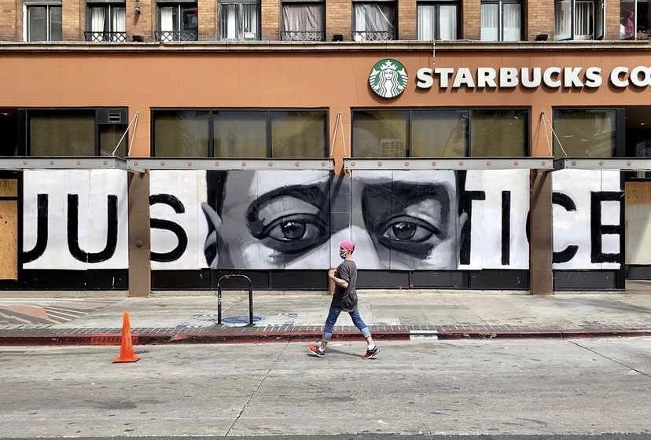

“George Floyd Art” Image 1: Vargas, R. (Instagram: @therobertvargas). (June 2020). “Justice // George Floyd.” Urban Art Mapping Research Project.<https://georgefloydstreetart.omeka.net/items/show/2910>

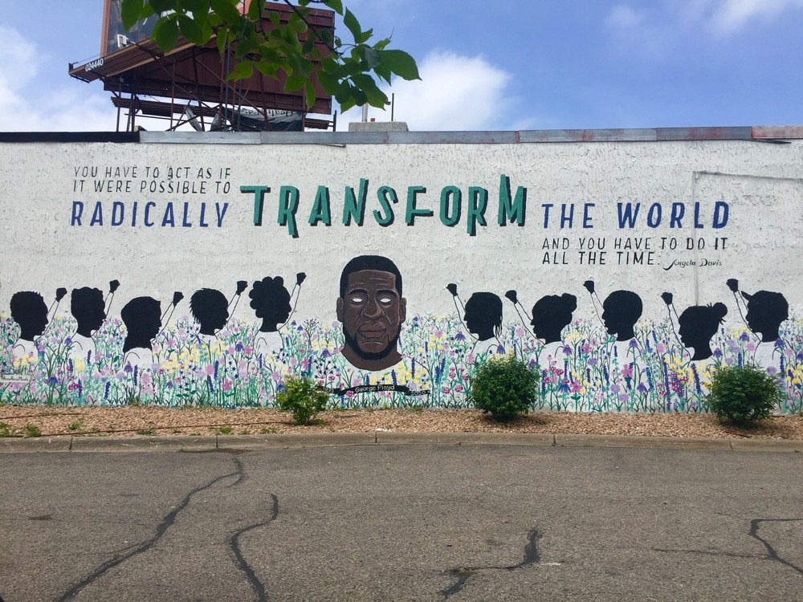

“George Floyd Art” Image 2: Know Peace Murals Collective (Instagram: @knowpeacemurals). (June 2020). “Radically Transform the World.” Urban Art Mapping Research Project.<https://georgefloydstreetart.omeka.net/items/show/1236>

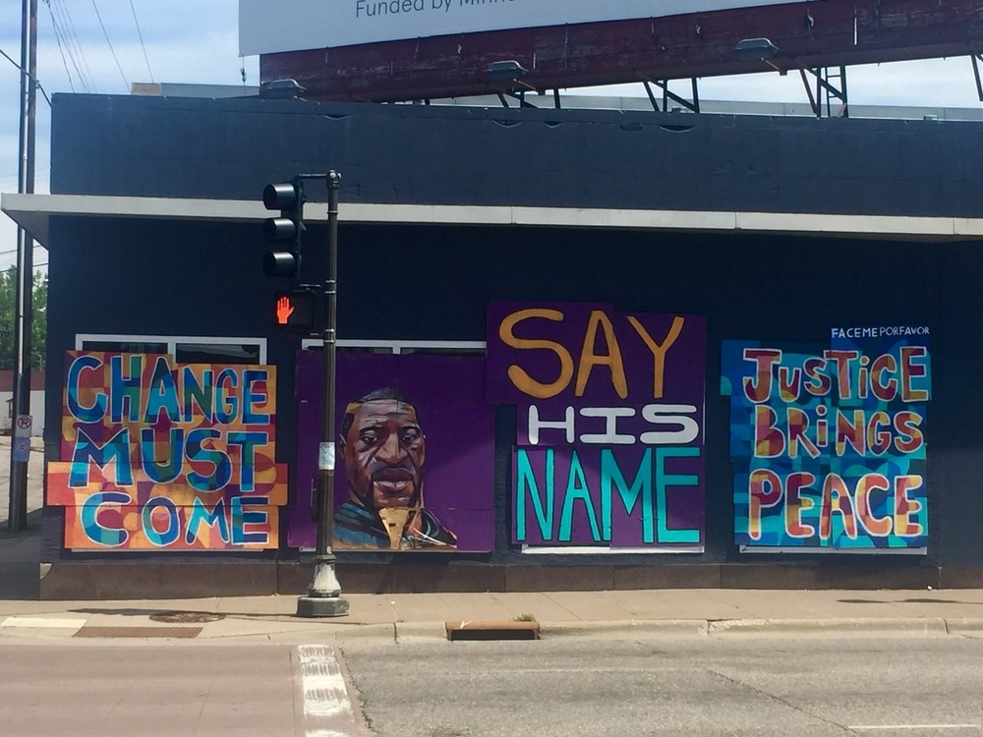

“George Floyd Art” Image 3: Face Me Por Favor (Instagram: @facemeporfavor). (July 2020). “Change Must Come - George Floyd Portrait - Say His Name - Justice Brings Peace.” Urban Art Mapping Research Project.<https://georgefloydstreetart.omeka.net/items/show/1218>

An analysis of the Textual-based elements in these three photos showed the inherent subtlety and simplicity of these political messages that allows them to be widely consumable. The text within each image is restrained, as it references the circumstances around George Floyd’s using indirect phrases tied to notions of ‘justice’ and ‘change.’ The subtlety of the text is speaking to a wide audience while also assuming an understanding of George Floyd’s death and the injustice underlying these messages. Much of the text is composed of phrases that are common within the BLMM, such as: “Say His Name”; “Justice”; “Change Must Come”; and a famous quote spoken by political activist Angela Davis. This use of common phrases allows the text, as well as the tragedy of George Floyd’s death, to be tied to a greater, historical movement for civil rights in the United States. The combination of the two also solidifies the art’s presentation of Floyd in a memorial-style, both honoring and mourning his death with a combination of phrasing and portraits. Likewise, the text links together these ideas of ‘change’ and ‘justice,’ suggesting that they have a symbiotic relationship that strives for a dismantling of oppressive systems in the United States and a desire for peace as a result. The notion of peace is also essential, as it is understood that this peace can only be achieved through processing the tragedy of Floyd’s death, done so here through public art memorials, and through changing these systems.

Analysis of the holistic Visuo-Textual aspects of each image emphasizes how the messages and the art depictions of George Floyd work together. The combination of clear visual font style and succinct messaging allows each message to be consumed easily by a wide audience; similarly, this allows the messages to be concise, so that they are not misinterpreted, making it clear that ‘justice’ and ‘change’ are necessary in understanding how the nation can heal from George Floyd’s death. The tone of each piece takes on a grieving connotation, bolstering this idea of injustice through its use of phrases and visuals. Within each image and message, George Floyd is centered, whether that is apparent within the art’s presentation, such as a depiction of his face, or understood within the message and its connection to the visuals; this makes it clear to the viewer what political stance the art is taking on and provides a historical basis for this messaging. Similarly, the use of symbolism and phrasing ties his death to a greater movement fighting racial violence within the United States.

**Informational/Instructional Art**

Table 2 shows a qualitative analysis of street art that is presenting Informational/Instructional messages tied to the BLMM. The analysis here looks at Image 4, 5, and 6 in the Informational/Instructional art section.

| Element 1: Visual | Element 2: Textual | Element 3: Visuo-Textual |
| --- | --- | --- |
| * Use of common, raw materials (plywood, paper, spray paint) * Messages easily movable/ removable * Clear visual presentation of the message * Presented in public spaces (buildings, telephone poles) | * Straightforward, succinct political messaging * Text is easily adaptable to current stage of the movement * Race relations at play within the text * Messages for community at a distinct time during local BLM events | * Impermanent sense to each public piece * Use of raw/common materials to convey message (plywood, paper, spray paint) * Use of clear presentation methods and succinct text to get message across * Messages are all towards a wide audience + for their community |

*Table 2: Visual and Textual Patterns found within Informational/Instructional BLM street art.*

Visual aspects of these Informational/Instructional street art pieces are made up of common, raw materials such as plywood, paper, and spray paint. This shows that the creation of these messages is typically fast and made up of household goods, making it so that anyone within the community can create these messages. Because of this, the messages are inherently movable and removable, making it easy to adapt them to the changing messages of the BLMM or the local events surrounding the movement in their own communities. Each message has a clear, straightforward visual presentation, making it so that they can be understood by a wide audience. The images I analyzed presented its art pieces on the sides of buildings or on telephone poles, solidifying these messages within public spaces so that they are community-based.

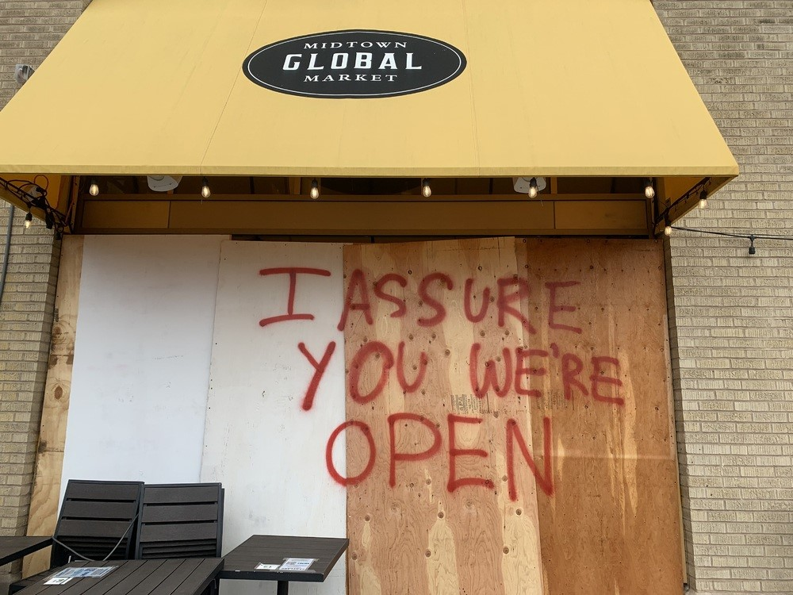

Informational/Instructional Image 4: (April 2021). “I Assure You We’re Open.” Urban Art Mapping Research Project.<https://georgefloydstreetart.omeka.net/items/show/2443>

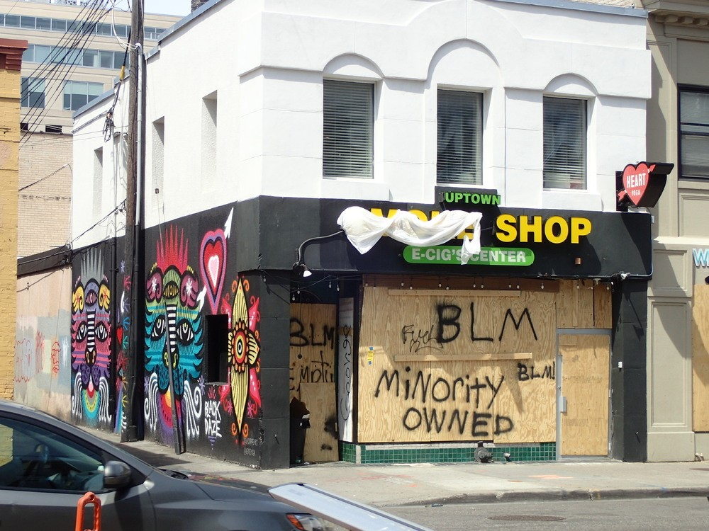

Informational/Instructional Image 5: (June 2020). “Minority Owned and BLM.” Urban Art Mapping Research Project.<https://georgefloydstreetart.omeka.net/items/show/900>

The text within each image is succinct and straightforward, directly tying its messaging to the political events occurring within the local BLMM. The text is easily adaptable to the changing tides of the movement, as they contain simple phrases that apply to the movement as a whole rather than specific occurrences. However, despite this encompassing approach to text, the messages are, by nature, tied to local iterations of the BLMM. Within the text, it is interesting to note that race relations are at play within the message, with the use of phrases such as “Minority Owned” or the details of “How to be a White or Non-Black Ally at a Rally.” Despite this, the audience for this text is still on a large-scale, as it is speaking to the community.

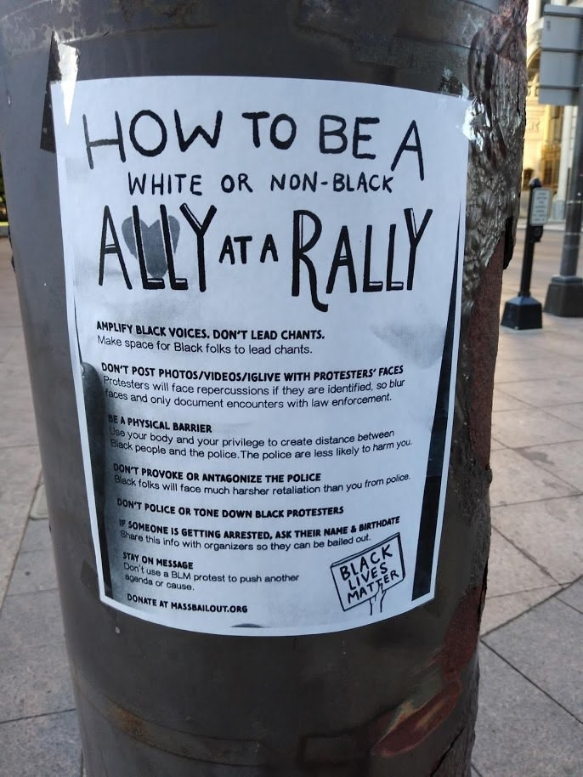

Informational/Instructional Image 6: (August 2020). “How to be a White or Non-Black Ally at a Rally.” Urban Art Mapping Research Project.<https://georgefloydstreetart.omeka.net/items/show/1443>

The Visuo-Textual elements underlying the Informational/Instructional images emphasize the impermanent nature of each piece of street art. The materials that are utilized to convey this message - plywood, paper, and spray paint - are cheap and easily accessible. Using common materials adds a communal nature to this messaging and adds greater weight to each message, as they are more urgent and personal. Similarly, this use of common materials and succinct phrasing allows the political message underlying each piece to be easily changed or placed within a different context of the movement. The nature of these materials also reinforces the impermanent nature of each piece, as materials such as plywood or paper can be taken down easily. This impermanent nature is an interesting aspect to the Informational/Instructional nature of these messages, as these messages have a shorter lifespan due to the materials used in comparison to paint-based murals.

**Hope/Unity Art**

The next iteration of results comes from the images chosen for Hope/Unity street art pieces tied to the BLMM.

| Element 1: Visual | Element 2: Textual | Element 3: Visuo-Textual |
| --- | --- | --- |
| * Use of bright colors (red, blue, pink, yellow) * Natural / Earth-based art (flowers as a symbol of growth/survival, Earth as a symbol of community) * Youth emphasis in all visuals * Images/symbols of community | * Memorial aspect to the text (other people’s names, phrases of survival + grief) * Turning the lens on audience; creation of discourse to see how they’re processing and helping the movement * Public text as a way to take up space + share a voice | * Clear, succinct use of font and text to get a message across * Memorial aspect in both text and image, using symbols (religious, natural) to do so * Messages overtly political, offset by use of color and imagery to convey hope * Images + text both promoting community * Youth emphasis in both language and visuals |

*Table 3: Visual and Textual Patterns found within Hope/Unity BLM street art.*

These results are the final patterns analyzed for the Visual, Textual, and Visuo-Textual analysis. The analysis here looks at Image 7, 8, and 9 in the Hope/Unity section. Visually, each image analyzed was adorned with bold, bright colors, particularly red, blue, pink, and yellow. This use of color is directly tied to the messages of Hope/Unity underlying each piece. The use of natural imagery, such as depictions of flowers or the Earth, help root each message in African American art history, with the continuing use of nature tied to the Pan-African movement. Each Hope/Unity art piece uses people to portray certain themes. Images of community or known symbols tied to community, such as a power fist to signal solidarity, are depicted within each art piece. Similarly, depictions of youth are present visually, creating a link between a notion of Hope/Unity within a community space and ideas of a new generation. All these visual elements are accompanied by text that deepen these ideas.

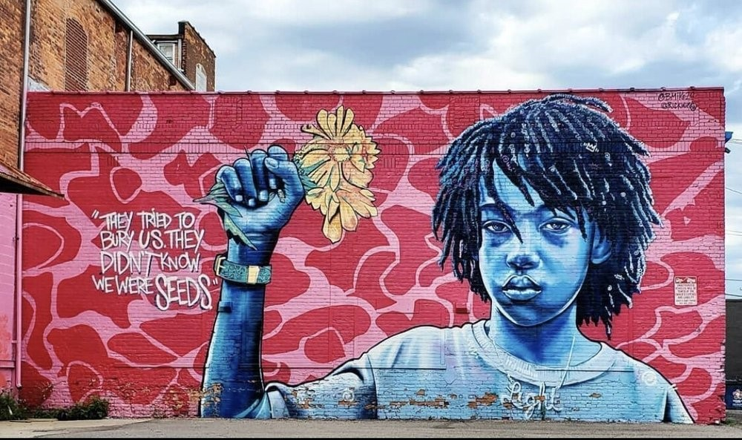

Hope/Unity Image 7: Odums, B. B. (Instagram: bmike2c). (June 2020). “We Were Seeds.” Urban Art Mapping Research Project.<https://georgefloydstreetart.omeka.net/items/show/2452>

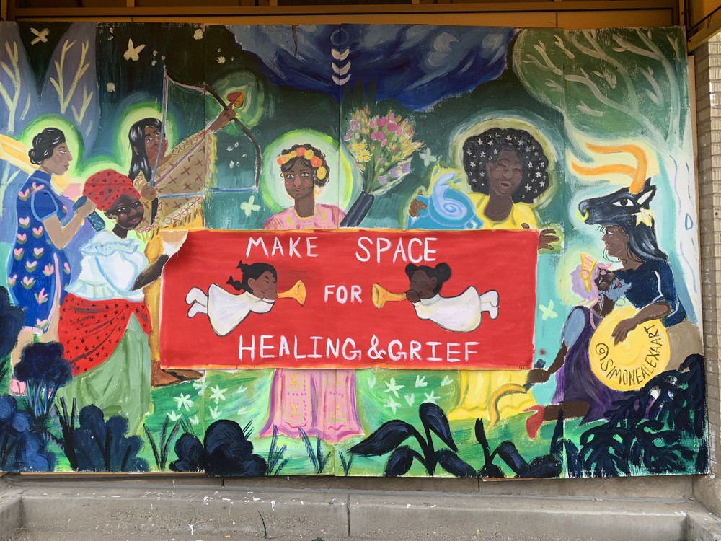

Hope/Unity Image 8: Alexa, S. (Instagram: simonealexaart). (April 2021). “Make Space for Healing & Grief.” Urban Art Mapping Research Project.<https://georgefloydstreetart.omeka.net/items/show/2445>

The textual basis of these three images presents public art as elemental in processing grief and carving out space for Black voices in a time of political strife. Two of these images only have one phrase to analyze, while one of them is a wall of multiple phrases that adhere to various realms of the BLMM. The messaging present within each image indicates a desire for change (“We Need Justice”; “Be the Change”), an understanding that survival is necessary for Black communities (“They Tried to Bury Us. They Didn’t Know We Were the Seeds''). Similarly, each art piece memorializes past tragedies within the ongoing Civil Rights Movement of the United States, with mentions of George Floyd and use of religious symbolism to underlie these messages.

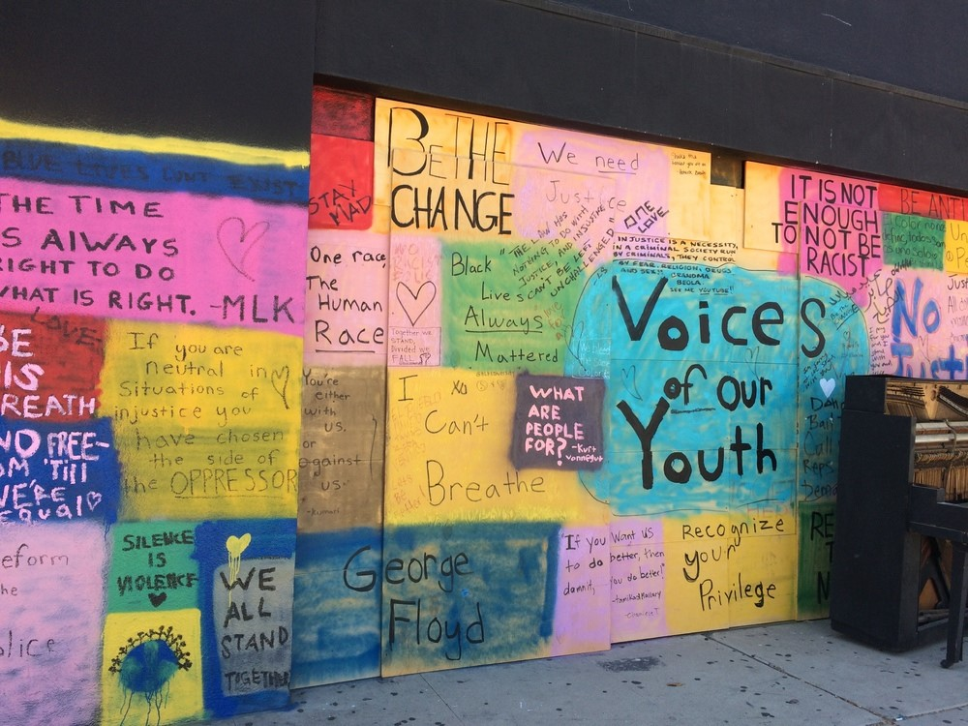

Hope/Unity Image 9: (July 2020). “Voices of Our Youth.” Urban Art Mapping Research Project.<https://georgefloydstreetart.omeka.net/items/show/1543>

The combination of visuals and text provide succinct, clear political messaging common within street art, using appropriate font and visual elements, such as bright colors, to present these ideas. The messages are overtly political and tied to the BLMM, often taking on a darker connotation within each message despite the use of bright colors and symbols of growth. Images and text also clearly promote the idea of community through both its visuals and text, with an understanding that community is needed to provide hope for the future. Similarly, the presentation of youth and youth voices in the text is prevalent in these messages of Hope/Unity. Common metaphors of healing are tied to images of nature and religion, calling back to a history of the Black Arts Movement and ideas surrounding Pan-African unity.

**Analysis of Online Gallery Patterns**

Similar to examining the Visuo-Textual elements of various street art pieces, I also analyzed the web interface of the online galleries that collect and organize these pieces. The websites are<https://georgefloydstreetart.omeka.net/> and<https://www.wallsofjustice.com/> respectively. The results are formed out of the same methodology of examination that was used on the street art; I examined both the visual and textual elements of these websites and these results reveal the patterns shared between the two galleries.

| Element 1: Visual | Element 2: Textual | Element 3: Visuo-Textual |
| --- | --- | --- |
| * Use of dark backgrounds * Use of graffiti/street style font * Similar images promoted within their galleries: similar themes, art styles, symbols, and figures displayed | * Upfront description of website purpose * Promotion of artists by giving them due credit; linking their social media, interviews * Presentation of resources tied to the BLM | * Categorized visually + textually by similar themes * Similar website layout to reinforce the online gallery feel * Emphasis on crowdsourcing / community engagement with the website’s function |

*Table 4: Visuo-Textual Analysis of Online BLM-based Mural Galleries*

The visual galleries have a similar layout. When opened to the home page of each website, similar visuals are presented on various fronts. Both websites have a dark background theme underlying each page. The heading of each website uses a font that is inspired by graffiti or street art, tying the galleries to the traditions of street art. Similarly, both websites present images that convey common themes, art styles, symbols, and use of figures. At times, the presentation changes due to the website’s affordances that allow a rotation of images to be shown. Still, since both websites are for the art of the BLMM, the visuals are intrinsically tied to each other, as they are going for similar political messaging and presentation.

Despite these galleries emphasizing visual elements, the use of text is necessary to understand how the website wishes to function. Both websites have an upfront description of their intentions for creating these galleries. Through description, these galleries emphasize the desire to have a positive impact on the movement; the Urban Anti-Racist Street Art Mapping Gallery cites “research and education” as the main function for collecting these images, while Walls of Justice gallery states that their gallery aims to “spread a message of positive change” and act as tribute to victims of racial violence. Underlying each of these mission statements is a desire for greater justice and understanding. Additional text on the website reinforces these ideas. Both websites hope to garner greater action by providing resources or statistics about issues within the BLMM. Similarly, the galleries aim to support the artists behind the street art. The Urban Anti-Racist Street Art Mapping gallery does so through inclusion of an artist’s social media, organizing the art through tags, as well as descriptions of the art. The Walls of Justice gallery does so through interviews of the artists as well as an inclusion of their social media.

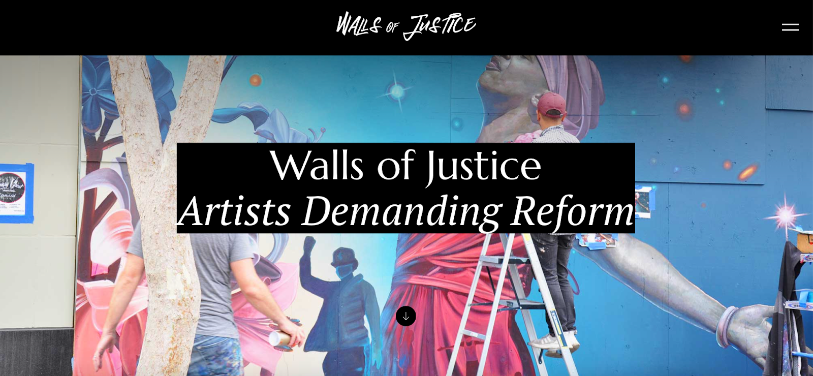

Walls of Justice Home Page. (March 2022). Walls of Justice LLC.<https://www.wallsofjustice.com/gallery>

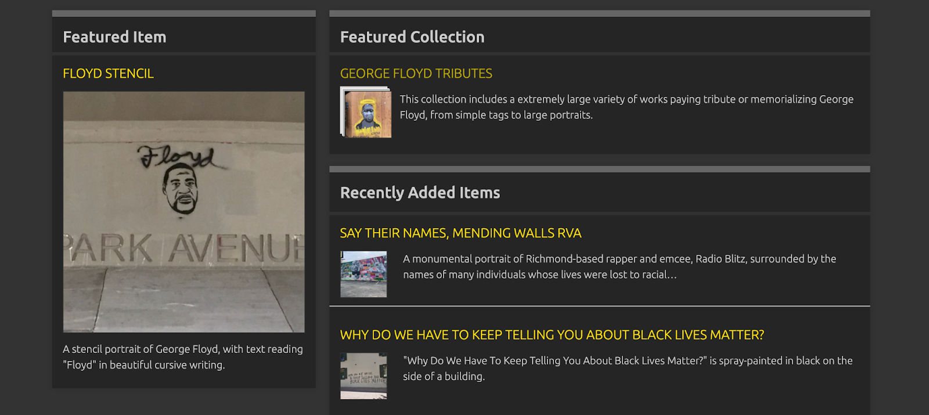

George Floyd and Anti-Racist Street Art Archive Home Page. (March 2022). Anti-Racist Street Art Mapping.<https://georgefloydstreetart.omeka.net/>

The affordances of these websites allow for an interesting use of Visuo-Textual elements. The layout of an online gallery is similar between the two websites. Both sites categorize their images through both visuals and text, organizing them by similar themes tied to the BLMM. To note, the Walls of Justice website has themes based on figures of the Civil Rights Movement, memorials to figures of the movement, and the geographic placement of the murals; the Urban Anti-Racist Street Art Mapping gallery has similar themes formed around figures and phrases, such as a “Say Their Names” collection that pays tribute to victims of racial violence, as well as broader themes of tied to “Anti-Racism & Social Justice,” “Black Lives Matter Murals,” or “Policing.” These galleries are presented in list forms and allow the viewers to choose what they want to examine easily. Both websites also emphasize the importance of crowdsourcing in both text and visuals. Symbols, such as an upload “cloud” symbol, and text emphasize why contributions are necessary in maintaining the galleries. A combined use of text and visuals emphasizes these messages on the page.

**Discussion**

Each chosen image and theme provided insight into how public protest art reflects history while also adhering to the Internet age. The patterns that emerged from these findings will be examined as they were presented, by theme, and contribute to the understanding of how political art is operating in the tradition of the Black Arts Movement and evolving with the BLMM.

**George Floyd Art Analysis**

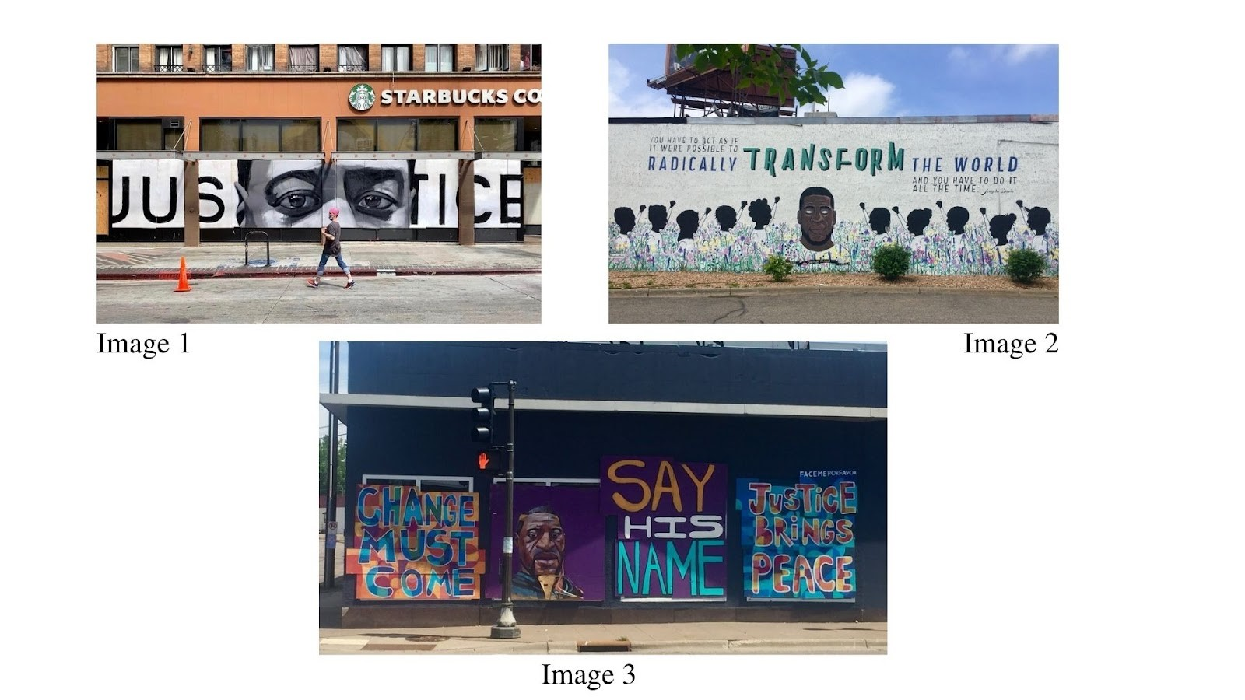

*Image 1, 2, and 3 of the George Floyd Art section.*

When George Floyd is depicted within public art, the function of that art is to both memorialize him as well as present a case for political resistance. The combination of both is necessary, as his death is considered an incendiary political event in the BLMM. As a result, patterns arise that speak to the tradition of memorializing death and resisting oppression through public art.

Floyd is centered within both the visuals and text of each chosen art piece (titled George Floyd Art Image 1, 2, and 3), reinforcing his place as the subject of the art despite its context within a larger movement. Each art piece positions him at the core of the image, which forces the viewer to recognize his face to understand the greater narrative underlying the art. With Floyd’s story at the heart of each image, there is an assumption that the audience knows about the event; the text is subtle and does not aid the visuals in understanding his story, but in understanding the implications of Floyd’s death in society. This aspect is important, as it shows the significance of George Floyd’s story within the BLMM, as his image speaks to a larger problem of police brutality and the treatment of Black male bodies in the United States that the movement is undertaking. This reinforces Floyd’s place as a figure within the contemporary civil rights movement, while also linking his death to a history of violence in the United States.

The phrases used in the chosen art pieces are operating in conjunction with Floyd’s image to present a political message that extends beyond his death. The texts present in the art are common in the BLMM, such as the phrases used in George Floyd Art Image 3: “Say His Name” and “Justice Brings Peace” (an offshoot of another popular protest chant: “No Justice No Peace”). Each phrase is succinct in its wording and artistic presentation so that the political message is unclouded when read by a wide audience; this is important, as these murals aim to be understood and persuasive in both text and visuals to best get the political message across to a varied audience. These phrases have repeated use during other incendiary BLMM events, so the use of wording ties Floyd’s death to a history of violence against Black men in the United States, while also allowing his portrait and story to be examined in an isolated, contemporary context using only his likeness. This is a necessary tactic for the BLMM, which uses connections between historical and contemporary events to educate a post-racial society on how racial violence is still prevalent today. In addition, the use of the Angela Davis quote in George Floyd Art Image 2 calls for its audience to “radically transform the world,” a quote that is both a call-to-action and a reflection on the ongoing fight for civil rights in the United States. Angela Davis is most known for her work within the 1970s Black Power Movement, making the connection that the struggle for equality in the United States is a movement rooted in recent history through the quote. Both the text and visuals operate to reflect and look forward, tying together the historical and current movement through subtle techniques. The use of popular phrases in murals allows a wide audience to understand the political aim of the art by connecting it to a greater historical movement that recognizes these deaths as an ongoing issue within the lives of African Americans.

While the art is overtly political, there is a mournful tone underlying each piece that is aided by its color use and symbols in both visuals and text. George Floyd Art Image 2 successfully employs muted colors to memorialize the image of Floyd. The muted colors adorn the flowers and the figures in the image. The use of subdued colors and flowers suggests that this art is a memorial for Floyd and a way to process his death in a public space, as the use of coloring and floral presentation is symbolically tied to the idea of a funeral and heaven; while the tone is somber, the use of flowers and color suggests that there is peace in the afterlife. This mural is processing Floyd’s death by giving him a peaceful burial through art despite the violent circumstances.

As noted in Vance & Potash (2021), the notion of grief in Black protest art is layered, often including symbols of survival amongst memorials to represent unity and resilience despite tragedy within the community. This unification is evident in the figures with raised fists surrounding Floyd, as the power fist operates as a double symbol for resistance and the liberation of African Americans (Crawford, 2017). The black and white color scheme shields the faces of the figures, contrasting with the detailed face of Floyd and allowing the audience to place themselves in the image. This is a persuasive function of the coloring in Image 2, as it creates a space for the audience to identify with George Floyd and the movement. The combination of visual techniques and text create a political memorial for Floyd through the medium of street art, creating an accessible, public way to honor him and elevate the political consciousness of those within the community.

Image 1 utilizes similar tactics in color, symbolism, and phrasing to convey a mournful depiction of Floyd. As noted, Floyd is placed within the center of the image, making his story the subject of the mural. Instead of a complete portrait of Floyd, it only depicts the upper half of his face by framing the mural around his eyes. Eyes are symbolically known as the “window to the soul” or a way to see a person’s true feelings. Floyd’s eyes display sorrow and look directly at the mural’s audience, asking for sympathy through a direct stare. The teary eyes combined with the use of black and white coloring adds a bleakness to the image; the lack of color offers little hope for justice, despite the mural’s desire. The word “JUSTICE” is secondary within the image, with partial obstruction by the portrait, suggesting that justice was not a consideration in the event of Floyd’s death. Simultaneously, the text and the portrait work together to call for justice. The pairing of the phrase with the close view of Floyd’s eyes forces the audience to make an association between the two, with the clear black lettering boldly speaking to the sympathetic depiction of Floyd. The text and visuals work together to create a persuasive political message that is demanding justice while also reflecting on the injustice of Floyd’s death. Similar to Image 2, the public nature of this mural and its Visuo-Textual tactics generate sympathy from a wide audience, as it reinforces the memorial aspect of Floyd’s portrait with text of resistance that aims to incite political action and stir emotions.

Image 3 of the George Floyd Art section is rooted in a similar tradition of memorializing victims of racial violence and a history of Black art. This public art piece utilizes common techniques that are present in the other photos examined: muted colors, the centering of Floyd in the image, and the use of common phrasing. Purple floods the background of Floyd’s portrait, with purple, blue, and orange making up the adjoining art pieces. The use of purple dampens the tone, despite its vividness, due to the context the color is used in. The blue and orange are deployed to recall the tradition of African textiles in the Black Arts Movement within this piece (Pinder, 2016); this use of an African art style is the artist’s way of tying the recent BLMM with a greater history of both art and struggle. Floyd’s portrait is unadorned with color, his face the main fixture so the message is not distracted by vivid coloring and an African art style.

The use of phrasing in Image 3 is reflective of the core ideas of the Civil Rights Movement and the early BLMM, where there is an understanding that achieving peace involves a formal struggle. “Change” and “justice” are the foundational elements to this notion. This art piece suggests that these two ideas are intrinsically linked. To achieve justice, change must occur; to achieve change, people and institutions must be brought to justice. This combination of “change” and “justice'' in the text is vague, but with the context of the portrait, the phrasing speaks to police reform in the United States due to the centering of Floyd in the image. Additionally, the phrase “Say His Name” uses the tactic of awareness that stems from the Civil Rights Movement and is commonly practiced in the BLMM; this phrase takes on different iterations such as “Say Her Name” and “Say Their Name,” all intended to keep the name of racial violence victims alive in the nation’s consciousness. The use of the three phrases creates a politically charged street art piece rooted in historical tactics while also adapting it to the contemporary movement. This is done through the presentation of phrasing around Floyd’s portrait. Image 3 maintains the memorial features exhibited in the other images, such as common phrasing, dark colors and tone, and the centering of Floyd as the mural’s main subject, yet it has the most active political messaging underlying the narrative as it is explicit in its call for greater action within its community.

**Informational/Instructional Art Analysis**

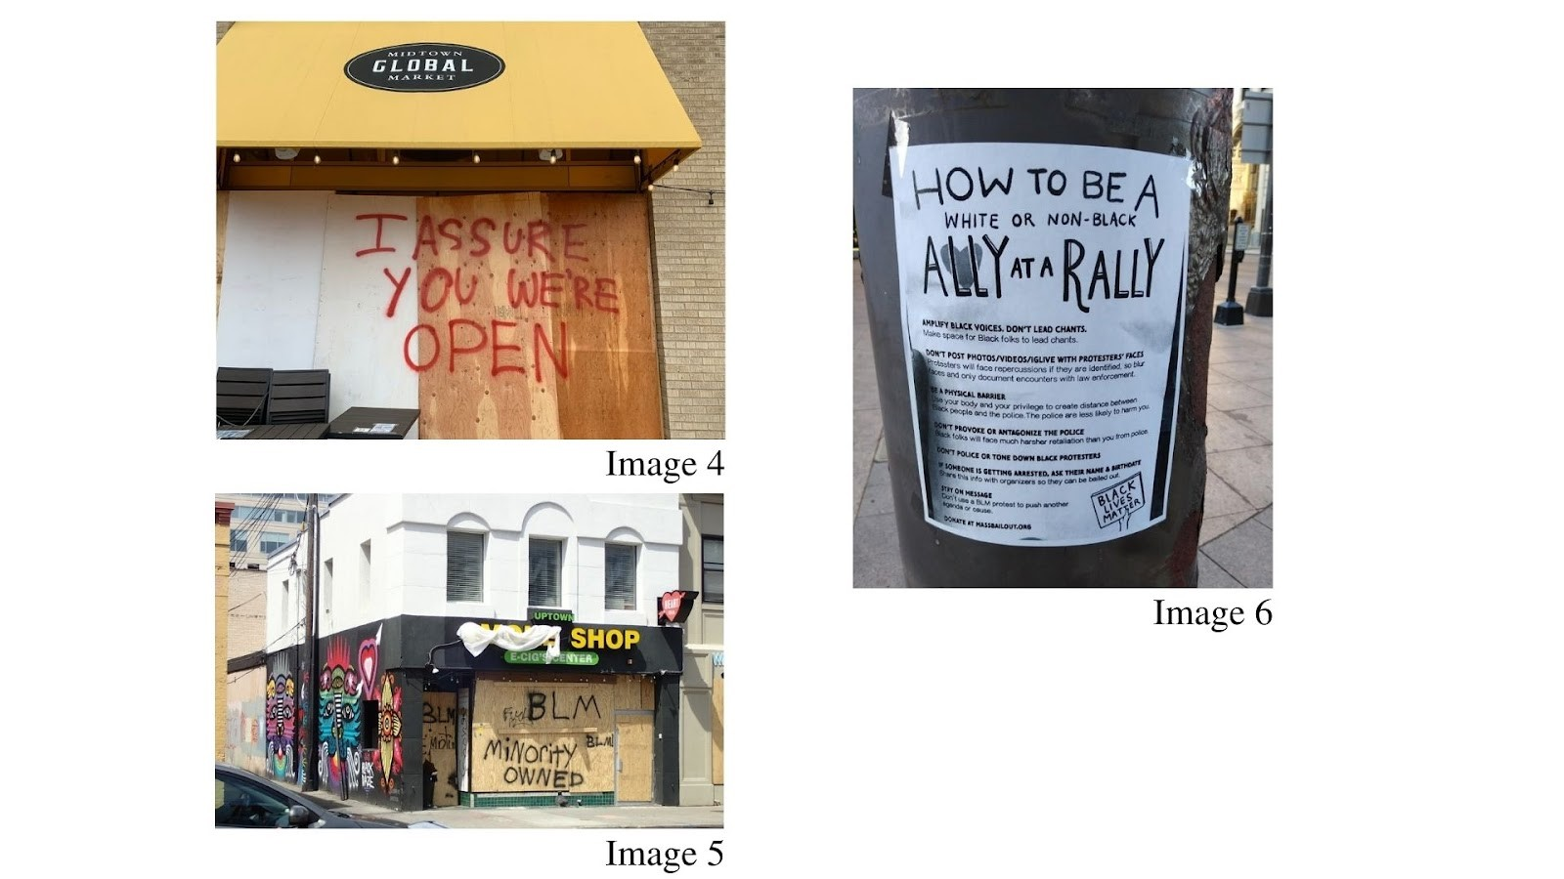

*Image 4, 5, and 6 of the Informational/Instructional section.*

Public protest art takes on unique functions that adapt to the needs of the movement. Public art that is informational and instructional, is one way that people can speak to their community and address current, localized political issues. When street art functions to spread information, the medium adapts to best suit its informational purpose. This section will be discussing how visuals and text function within Images 4, 5, and 6 of the Informational/Instructional art section.

Image 4 is the barest example in this analysis concerning the dissemination of information through BLMM art. The street art is succinct in its wording, like the art examined in the George Floyd Art section, however, this wording is lacking any subtlety. The message is straightforward, fulfilling its purpose of presenting direct information to the community. The wording manages to take on a voice of its own despite its succinctness: “I assure you we’re open” is written in red spray paint on plywood. “I assure you we’re open” is interesting as a phrase, as the “I assure you” evokes a blunt and almost weary tone from its author; had the message been stated as “we’re open,” its connotation would have appeared more indifferent. This voice is revealing, as it reflects the tenseness of the local political situation while also conveying the necessary information. The use of common materials to reinforce the message plays into the voice, as it reflects the creator’s tense undertones and quick methods of communication. The unadorned presentation of the message reflects this, as there is no visual fluff beyond the red coloring of the text. Even public messages with bare visuals and text can speak volumes to the localized political situation.

Image 5 within the Informational/Instructional section does not have as strong of a voice but uses similar tactics to get its message across. The use of plywood and spray paint is something to note, as it demonstrates a pattern of rapid methods to get a point across locally. The art itself is unadorned so that the audience is not distracted from its message. The street art on Image 5 is sprayed with repeated phrases of “BLM” in black paint, “Fuck 12,” and “Minority Owned.” Although the voice is not distinct, as these are common phrases used within the BLMM, they each take on a strong political stance. Similar to Image 4, the wording is straightforward, and the text can adapt to the evolving messages of the movement. Additionally, the art text is commenting on the racial politics of the community it exists within. The use of the phrase “Minority Owned” allows the author to identify with the racial politics of its community, indicating that their building is in support of the BLMM and affected by white supremacist systems; this phrase is important in protecting the building as well as maintaining its role in the community. While the author’s voice is not as strong due to the reuse of known BLMM phrases, the plain text functions so the audience can identify with the information it is sharing with its community and adhere to a progressive, unified political perspective.

The most unique of the chosen image set is Image 6, which features a poster placed on a metal pole in Columbus, Ohio. The contents of the poster indicate that it is speaking to a varied audience that is not comprised of one single community due to its identification of various racial groups in its text; like Images 4 and 5, the poster takes on a voice of its own in doing so. The message is directly addressing “White or Non-Black” allies, speaking in a straightforward tone that is serious and succinct in the information it is sharing. The poster is largely unadorned, with a clear black and white color scheme, clean font, and only two additional images of a heart and a hand holding a BLM sign. The lack of visuals is common within these public Informational/Instructional pieces, as they often reveal quick assembly and straightforward intentions of the author; however, the lack of visuals can also speak to the impermanent nature of the public art piece. Out of the chosen Informational/Instructional images, Image 6 has the most adaptable and impermanent medium. A nature of impermanence is essential to all mural art (Huebner, 2019); however, it is heightened by the medium’s moveability and the text’s adherence to a certain context within the movement, an organized protest. The combination of its fragile medium, the plain visuals, and straightforward messaging makes Image 6 the most informational and temporary public art piece presented in this section.

Through my analysis of the public Informational/Instructional art pieces, it is evident that each public protest piece takes on a function unique to its goal and molds the art to better adhere to that function. This section contrasts with the presentation of political messaging and visuals in both the George Floyd Art and Hope/Unity sections as the plain presentation and common medium allows for succinct, straightforward political messaging to be communicated to their community without the aid of visuals or historical symbolism..

**Hope/Unity Art Analysis**

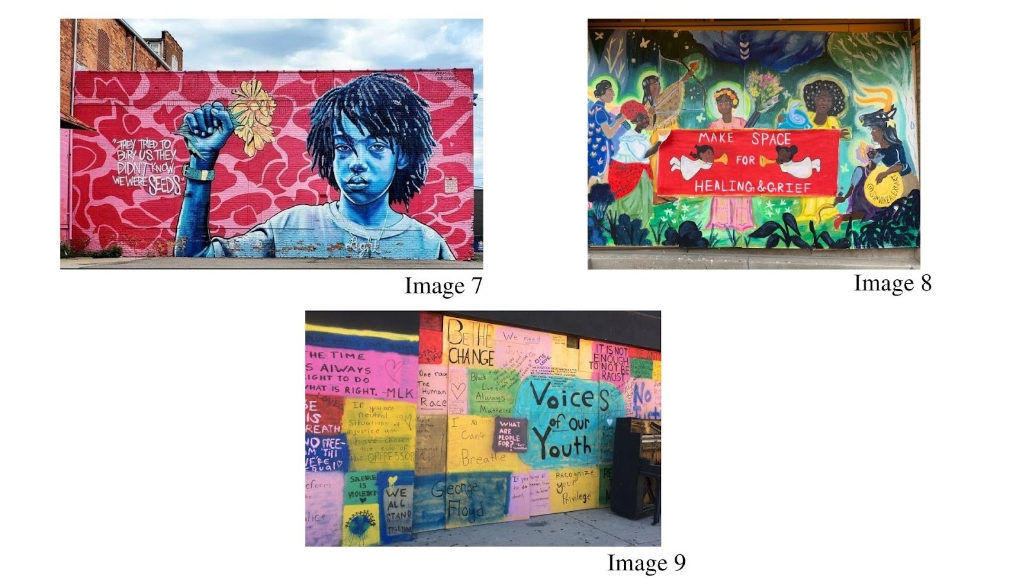

*Image 7, 8, and 9 of the Hope/Unity section.*

Murals are unique as an art form because the function of an art piece can shift to meet the needs of the local community. The Hope/Unity murals examined here are responses to localized events, as artists saw a need to reclaim space for processing trauma and provide a sense of hope. Through hope, resistance can be formed to bring greater equal rights for African Americans. This section will examine Images 7, 8, and 9 within the Hope/Unity subsection to see how hope and community are conveyed through public political protest art in the contemporary BLMM.

Bright coloring is necessary for the projection of hope within a community. This use of red, pink, blue, and yellow coloring is common within the three analyzed murals. This use of vivid colors within art pieces invokes traditions of African Art and textile work, where bright colors were utilized as a rejection of European art traditions (Pinder, 2016). The historical basis of color usage in Black art works well for the murals’ political messaging, as the vivid colors bring levity to the somber messages that underlie the work. Each mural examined reflects on tragedy within the BLMM, but the use of bright coloring indicates a notion of survival. To convey this tragedy, the murals use both text and visuals to reflect memorial traditions common in the BLMM. The repetition of names, such as the “George Floyd” text in Image 9, or the use of cherubs in Image 8 touches on these traditions but does not overload the murals with memorial imagery so that a notion of hope is maintained. While this art is important for processing grief, it also understands that a community must move beyond that grief to survive and progress in the process. The visuals offset these tragic political issues by making them more approachable to a wide audience and allotting community space to do so. Addressing issues publicly and offering a positive outlook to them is necessary in promoting hope for a community. The deployment of color tactics within art is necessary to promote hope and unity, as the use of color can present a brighter future in the face of tragedy.

Nature and the Earth as symbols are also common within an art piece’s presentation of hope and unity. Nature plays an important role in Black art history, as the use of the color green is rooted in the tradition of Pan-Africanism, where green is representative of Africa’s natural beauty (Crawford, 2017). The use of nature has been adapted to fit the needs of BLM protest art, but it takes on new metaphors in the process. Within the chosen Hope/Unity images, nature is a signifier for community and survival. Images 8 and 9 depict scenes of people coming together in natural scenes. Image 8 shows people against a whimsical scene that is teeming with natural imagery at its borders. This image is suggesting that immersion into a community and nature is elemental in processing tragic events; underlying the natural imagery is a need to survive and thrive despite societal oppression. Image 9 operates equivalently, using a depiction of Earth and figures holding hands to do so. The use of Earth within this art piece unites us as a human race, as the figures are faceless and linked together across the globe. This use of nature is rooted in a desire to unify on a global scale rather than a local scale.

Additionally, Image 7 uses nature to reinforce both survival and unification within a community. Flowers are gripped in the raised fist of the figure in the mural, combining those two symbols to suggest that unification and survival go hand-in-hand. These visuals are paired with a succinct presentation of text: “They tried to bury us. They didn’t know we were the seeds.” The use of this text is subtle and can apply to different events within the ongoing BLMM, making this message of hope and community a continued desire within that public space. The text and visuals both function to offset the tragedy underlying the image by utilizing common symbols of survival and unification. This symbolism creates a unique message as a result, as the Hope/Unity murals recognize the tragedies within the BLMM but choose to look beyond them for greater progress within the movement.

The symbolism of youth within Hope/Unity murals offers the chance for a brighter future, while also necessitating one in the process. Images 7, 8, and 9 all utilize the youth in separate ways. Images 7 and 8 are straightforward in their depictions of the youth and their symbolism within a political movement. Image 7 combines the image of the youth with a notion of survival, suggesting that the political work done in the BLMM is done for future generations. This alludes to a Black Arts Movement tradition popularized by Emory Douglas where children are symbols meant to stir political desire in its audience. The use of youth with the power fist, the natural imagery, and the text is offering hope to its community while suggesting that political unification is necessary to achieve this.

Image 8 depicts children as cherubs, depicting them amongst a red background and succinct text that states: “Make Space for Healing & Grief.” The placement of cherubs against the red background is reflective of the Pan-African symbolism of red, which traditionally represents bloodshed in Black communities. The mural has memorial aspects to it through the religious connotations and text, but the children depicted in the mural lighten the somber text and use of color. The specific imagery of cherubs plays with ideas of innocence in a racist society, as this piece is speaking to victims of senseless racial violence. The children also represent survival and growth for future generations; children can be seen as the aim of progress, as the political goals have the next generation in mind, as well as representative of a new era of growth. The mural asks its audience to process their grief, signaling that this is necessary to move forward within the BLMM.

While Image 9 has no depictions of youth, it shows the importance of youth within the BLMM by creating a space for children within a community to collaborate and speak their minds. The mural is a wall of curated messages written by youth within the community. Within African American political movements, the reclamation of space is a necessary form of resistance, as it creates a more unified coalition and a platform outside of mainstream media for youth voices to be heard (Prier, 2021). This tradition of space reclamation dates to the early Civil Rights Movement and is important for attaining a greater foundation within a movement, whether that is on a national or local scale. This mural is utilizing tactics of the Black Arts Movement and the Civil Rights Movement, which encouraged community collaboration and reclamation of space to gain a greater understanding of the local political aspirations.

The mural in Image 9 is highly political and takes on various tones due to the number of contributors to the piece. The text within the image memorializes certain figures or moments in the movement, such as “I Can’t Breathe” and “George Floyd,” while also generating discourse to spur community action. Phrases such as “It’s not enough to not be racist,” “Silence is Violence,” and “You’re either with us or against us” are straightforward and succinct in their visual and textual depictions. The use of these phrases turns the lens on the audience, asking them how they can make a difference within the movement. While youth is symbolized within the movement as a motivator for political progress, here they function as revolutionaries, asking older generations in their community if what they are doing is enough.

The art examined within the Hope/Unity section, similar to the work in the George Floyd Art section, is rooted in symbolism that is both memorial and forward-thinking in regards to the underlying politics. The insertion of youth is essential to the message of each piece, as it grounds these ideas in the notion that change is not immediate, but something for future generations.

**Online Gallery Pattern Analysis**

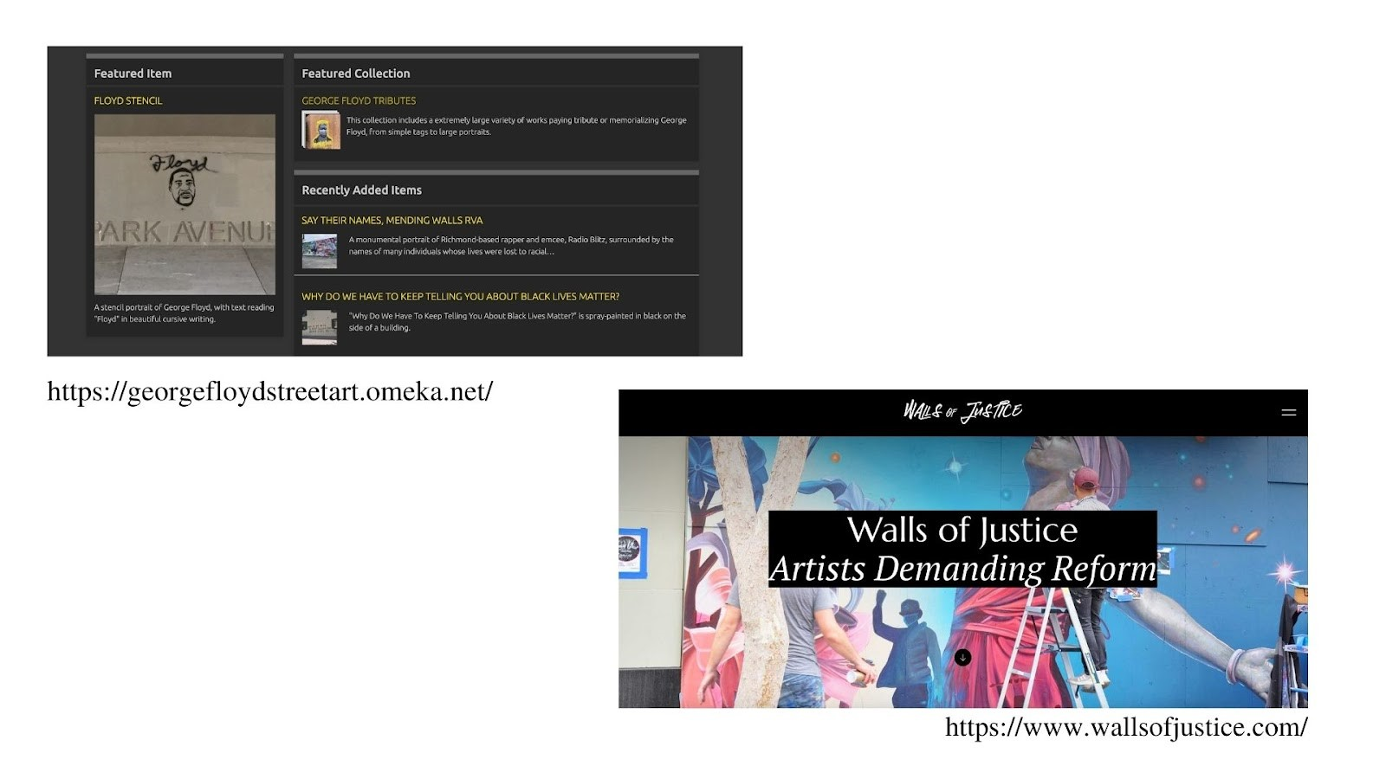

*Home pages to* [*https://georgefloydstreetart.omeka.net/*](https://georgefloydstreetart.omeka.net/) *and* [*https://www.wallsofjustice.com/*](https://www.wallsofjustice.com/)*.*

Since the practice of public protest murals is still alive within the BLMM, there have been online platforms created to place an art form traditionally bound to its community and environment in a digitized sphere. While it reinvents the experience of public protest art by altering its materiality and audience, the importance of community and political messaging remains the same.

The gallery websites utilize a similar aesthetic and layout tied to the style and needs of the BLMM. Dark backgrounds underlie both galleries, tying it to the BLMM and the traditional use of black in the Pan-African movement. The black background is unobtrusive in its presentation, allowing the art within each gallery collection to shine. This use of color is both political and practical in its approach to curating art in an online sphere. Similarly, the website logo text uses a graffiti-style font to present an understanding and acceptance of street art; this reclamation of font is reflective of the nature of both websites, as these galleries want to present public art in a positive, accessible light to its audience rather than depicting it as a deviant practice. This mindset on street art manifests a welcoming online space that accepts all types of art forms and political messaging on its platform, making it so that the transition from a public environment to a digitized community is effortless. This use of aesthetics tied to the BLMM fosters a positive, unobtrusive way to view public art in an online gallery.

The intentions of each gallery are made clear on their front page. Both galleries provide text on why they chose to curate public art in an online sphere; the goal for each website is to influence people through their art curation, whether that is to educate or create positive steps towards racial justice. This goal is reinforced by the presentation of resources pertaining to the BLMM. The Walls of Justice gallery tackles the issue of overinflated police budgets in cities, a political issue that is garnering more local focus after the May 2020 BLM protests. Likewise, the George Floyd and Anti-Racist Street Art archive presents a list of resources tied to public art, space reclamation, and social justice. This use of textual resources in conjunction with a visual archive aims at educating the public in a more conscious political mindset and spurring action within one’s community. These galleries encourage this political development since their galleries are maintained through crowdsourcing.

Street art manages to maintain its collective spirit even in an online space. These galleries require that people upload images of public protest art, so that they can be organized into a collection and shared with an online community. Both websites use text and visuals to encourage this; Walls of Justice places a space to upload art adorned with little “upload” symbols on the bottom of its homepage; the placement of this upload function is under hyperlinks to the gallery’s social media, stressing the importance of a digital community through both social media and their need for crowdsourcing. The George Floyd and Anti-Racist Street Art archive has a section on its navigation bar solely for gallery contributions. The placement of the “Contribute an Item” tab in the navigation bar reflects the website’s need for additional images, as that tab is at the same level of importance as the “Browse Collections” and “Resources” tab. The gallery website layouts promote crowdsourcing, as it is the basis of their galleries and allows them to garner information from various local chapters of the BLMM.

While the galleries promote crowdsourcing as their main way of accessing art, the street artists are also elevated through these websites. Both websites utilize features that give credit to the artist and make it so that their art is categorized properly. The galleries have similar collection themes tied to the BLMM, such as a “George Floyd” gallery or a “Black Lives Matter Memorial Fence” gallery, which allow the street artist’s work to be categorized. This categorization, which occurs through the curation of art collections, the use of tags, and the art’s location, allows the art to be found easily and according to a user’s needs. Once a user clicks on a gallery collection, a digital space opens up that uses strong visuals paired with smaller informational text as a digital plaque for each piece. This layout makes it easy for art to be scoured due to the long scroll function of each website and the visual-forward approach accompanied by text, as if a user were walking through a physical gallery. Both websites combine the aesthetics of the BLMM and the essence of a gallery to create an ideal sharing platform for a medium often overlooked by mainstream, in-person art museums.

Additionally, these galleries incorporate the name of the artists and links to their social media if available. This allows for the recognition of the artist and greater dissemination of their street art; as a result, the audience for each public art piece becomes more expansive in a digital sphere. The Walls of Justice website has conducted interviews with street artists so that their perspectives on their art can be understood and used to educate the masses on this misunderstood art practice. The affordances of these galleries encourage work promotion and recognition, demonstrating that they are oriented towards the art and the artists within the movement.

This shift of public art to a digital sphere is indicative of a greater movement occurring. The definition of ‘community’ and ‘public’ are becoming hybrids in a digital sphere, allowing communal spaces to be accessed in physical and virtual spaces. This is reflected in the contemporary mural movement as well as the BLMM, which uses social media to form connections and bring greater awareness to certain causes. These online connections transcend geography, making it so that community extends beyond your locale and cultural identity (Buckley, 2021). While this raises concerns about the loss of physical public spaces, social media allows for the endless creation of spaces; this is significant, as Black communal spaces have been diminished by white supremacist tactics, such as gentrification (Prier, 2021). The affordances of social media allows for a hybrid collaboration between people involved in political movements, regardless of geography, evolving the definition of a public or ‘community’ space to fit a virtual sphere.

When political movements shift primarily to social media, there are always concerns about whether the momentum will be maintained within the movement. The BLMM is the most popular online political movement to examine, as its members have been active on social media since the death of Trayvon Martin in 2013. This issue as to whether or not people will still be politically active as protesting shifts to an online sphere is becoming less contentious as more people utilize platforms to spread awareness, collaborative, and organize protests. This is depicted within my analysis through the publics’ response to crowdsourcing. The chosen galleries both ask for submissions of street art and each website has multiple collections for the different categories of BLM-based public art. The first step involves the creation of political street art, a physical form of protest. The submissions are sent in by people on the street viewing the art and then promoted through the online gallery. This is a crowdsourcing process that begins in the streets and aids in building an online sphere, creating a hybrid process similar to the occupation of a physical and virtual public. The digital sphere is aiding political resistance and forming a community in the process, as it promotes an artist’s work while sharing a message in support of the BLMM. This integration of protest onto social media is altering how community and collaboration formulate in a political movement, but rather than diminishing the work done for the movement, it is aiding it and allowing for greater connectivity between BLMM members.

**Limitations**

The results reported in this study should be considered with some limitations. The study’s scope was limited in varied ways. My research analyzed two gallery websites, resulting in a narrow pool of how this art form is being adapted to an online platform. This is due to the limited pool of online street art galleries to choose from, as they are a recent phenomenon, and my focus on how street art is utilizing historical tactics of the medium. Similarly, the selected street art hails only from the United States. The selection of only U.S. street art ignores the international techniques of street art and how other movements are adapting their political art to online spheres. Additionally, I was unable to interview street artists, as much of the art was from different major cities in the United States; due to the ebb and flow of Covid-19, traveling was not a possibility. Because of this, the identities and intentions of each artist are unknown, making my interpretation entirely my own of each piece. Although public protest art is ephemeral, it is not the only political and ephemeral art piece, and it is not the first political art practice to be adapted to an online sphere.

**Conclusion**

The aim of this thesis was to analyze how public protest art is adapting to a digital sphere while maintaining the traditional aspects of the art form. Using a pattern-based analysis called Systematic Visuo-Textual Analysis, I set out to answer questions regarding how the rise of the Internet has affected public protest art in the Black Lives Matter Movement, what elements from historical Black power movements remain in the art process, and how this introduction of a digitized sphere alters the definitions of ‘community’ and ‘public.’ Through these questions, I aimed to provide insight on how protest art is evolving to fit the contemporary movement, how a digital sphere impacts that, and what makes it effective in its approach.

Public protest art, whether that is in the form of graffiti or murals, has a rich background rooted in community collaboration and a winding political history. As social media becomes more foundational within our growing global society, forms that were rooted in their physical environment adapt to a digitized sphere. Public protest art has done this through the curation of online galleries, which allow artists and appreciators of public art pieces to submit works to be collected and exhibited for a digitized audience. The placement of public art in a digitized sphere drastically alters the audience and the context of the piece; as a result, the creation and understanding of these art pieces are communicated through well-known symbols from early to ground their meaning. This also forces these online galleries to form around the needs of public protest art. This is done through the organization of the websites, utilizing different techniques such as encouraging user engagement, art design, promotion, and research resources to support the political cause and the art. This development of online galleries molding to best fit public protest art is significant, as this shows a prominent future in how the medium adapts to a digital space despite the emphasis on a piece’s physical environment; as a result, public protest art can garner a globalized audience, which allows the art and its messages to influence more people and further a cause political cause. This is necessary as society becomes more enmeshed in online political activism, which alters how we collaborate with others in a political movement and how messages are communicated, making it important to understand what techniques are effective.

With this creation of a digital space for a collaborative, localized art medium, the definition of ‘community’ and ‘public’ are altering to fit a digital sphere. This has been an ongoing process since the creation of social media in the 90s, but only has it shifted to fit the needs of a political movement in the 2010s. Now, ‘community’ and ‘public’ spaces have been adapted to the Internet, evolving these concepts so that they can fit a non-physical, online sphere. However, traditional methods of political collaboration remain. The usage of techniques and symbols dating back to the Black Arts Movement are present in each examined piece, anchoring the audience’s understanding of Black history and the contemporary BLMM. Through the gallery websites, crowdsourcing and engagement is encouraged to garner a political community in an online space using the affordances of the site. Resources are also presented to encourage local action and education to further a political cause. While the adaptation of political activism to an online sphere seems daunting due to its lack of physicality, the 2010s have shown that it can successfully be done so that it is effective in creating community and inciting action without in-person interaction. Therefore, the shifting of activism to an online sphere should be understood as the inciting reason for the shift in the practices of street art and protesting. I speculate that as a result, the definitions of public and community are evolving into hybridized concepts where members of these political communities use tactics from historical movements to ground their collaboration and resistance, allowing both public art and protest to be converted into something that is formulated beyond geographical boundaries.

Bibliography

Annas, T. (2018). *Memphis Brooks Museum of Fine Art focuses on the photography of Ernest C. Withers and the Civil Rights Movement*. Athena Information Solutions. Accessed through:  [https://link.gale.com/apps/doc/A525022899/STND?u=colo boulder sid=summon&xid=74c21350](https://link.gale.com/apps/doc/A525022899/STND?u=coloboulder&sid=summon&xid=74c21350)

Auchmutey, J. (2001). *Withers' lens chronicled era in black, white*: *[Home Edition]*.The Atlanta Constitution. Accessed through:<https://colorado.idm.oclc.org/login?url=https://www-proquest-com.colorado.idm.oclc.org/newspapers/withers-lens-chronicled-era-black-white/docview/414078849/se-2?accountid=14503>

Auxier, B. (2020). *Social media continue to be important outlets for Black Americans*. Pew Research Center. Accessed through:<https://www.pewresearch.org/fact-tank/2020/12/11/social-media-continue-to-be-important-political-outlets-for-black-americans/>

Berger, M. (2010). *For all the world to see: visual culture and the struggle for civil rights*. Yale University Press.

Blank, C. (2018). *The complex story of Civil Rights photographer Ernest Withers*. NPR: Morning Edition. Accessed through:<https://www.npr.org/2018/03/28/597541648/the-complex-story-of-civil-rights-photographer-ernest-withers>

Brown, N. & Collins, J. (2021). *Systematic Visuo-Textual Analysis: a framework for analyzing visual and textual*. The Qualitative Report. Accessed through:<https://nsuworks.nova.edu/tqr/vol26/iss4/14/>

Buckley, H. (2021). *The place of art activism in the digital age: perspectives from Black Lives Matter street artists*. Fordham University. Accessed through:<https://research.library.fordham.edu/dissertations/AAI28547561/>

Crawford, M. N. (2017). *Black post-blackness: the Black Arts Movement and twenty-first century aesthetics*. University of Illinois Press. Accessed through:<https://ebookcentral.proquest.com/lib/ucb/reader.action?docID=4866472#>

Duncan, M. (2012). *Emory Douglas and the art of the Black Panther Party*. Spectrum: A Journal on Black Men. Accessed through:<https://muse-jhu-edu.colorado.idm.oclc.org/article/634851>

Edrington, C. L. & Gallagher, V. J. (2019). *Race and visibility: how and why visual images of Black Lives Matter*. Visual Communication Quarterly. Accessed through:<https://www.tandfonline.com/doi/abs/10.1080/15551393.2019.1679635?journalCode=hvcq20>

Edrington, C. L. & Lee, N. (2018). *Tweeting a social movement: Black Lives Matter and its use of Twitter to share information, build community, and promote action*. The Journal of Public Interest Communications. Accessed through:<https://www.researchgate.net/publication/328207614_Tweeting_a_Social_Movement_Black_Lives_Matter_and_its_use_of_Twitter_to_Share_Information_Build_Community_and_Promote_Action>

Hart, R. (2021). *The Black Arts Movement & Senga Nengudi*. Denver Art Museum. Accessed through:<https://www.denverartmuseum.org/en/blog/black-arts-movement-senga-nengudi>

Hasna, M., Tahir, O., & Baharuddin, N. (2012). *Art in the public spaces towards a liveable and quality outdoor environment*. STEDex. Accessed through<http://psasir.upm.edu.my/id/eprint/20167/1/Chapter%201.pdf>

Huebner, J. (2019). *Walls of prophecy and protest: William Walker and the roots of a revolutionary public art movement*. Northwestern University Press.

Mckinley, A. & Russonello, G. (2016). *Fifty years later, Black Panther’s art still resonates*. The New York Times: Art and Design. Accessed through:<https://www.nytimes.com/2016/10/16/arts/fifty-years-later-black-panthers-art-still-resonates.html>

Pinder, K. N. (2016). *Painting the gospel: Black public art and religion in Chicago*. University of Illinois Press. Accessed through:<https://ebookcentral.proquest.com/lib/ucb/detail.action?docID=4443560>

Powell, D. (2018). *The aesthetics of Blackness: theology, aesthetics, & Blackness in the Black Arts Movement Western aesthetics and Blackness*. The Journal of Pan-African Studies (Online). Accessed through:<https://www.proquest.com/docview/2064933903/2F6797BEDD0347E2PQ/2>

Prier, D. D. (2012). *Chapter 6: counter public spaces of resistance*. Counterpoints, 143–185. Accessed through:<http://www.jstor.org/stable/42981568>

Reed, T. V. (2019). *The art of protest: culture and activism from the Civil Rights Movement to the present*. University of Mississippi Press. Accessed through:<https://ebookcentral.proquest.com/lib/ucb/reader.action?docID=5630912>

Sanger, K. L. (1991). *The rhetoric of the freedom songs in the American civil rights movement*. ProQuest Dissertations Publishing. Accessed through:<https://colorado.idm.oclc.org/login?url=https://www.proquest.com/dissertations-theses/rhetoric-freedom-songs-american-civil-rights/docview/303949864/se-2?accountid=14503>

Sell, M. (2020). *Meet Adri Norris, one of the artists behind Denver’s Black Lives Matter street mural*. 5280. Accessed through:<https://www.5280.com/2020/06/meet-adri-norris-one-of-the-artists-behind-denvers-black-lives-matter-street-mural/>

Stanczak, G. C. (2011). *Visual research methods: signs of resistance: marking public space through a renewed cultural activism*. Sage Publications Inc. Accessed through:<https://methods-sagepub-com.colorado.idm.oclc.org/Book/visual-research-methods/n9.xml>

The Art Story Foundation. (2022). *Public art: history & concepts.* Accessed through:<https://www.theartstory.org/movement/public-art/history-and-concepts/>

Vance, L. D., & Potash, J. S. (2021). *Black Lives Matter protest art: uncovering explicit and implicit emotions through thematic analysis*. Peace and Conflict: Journal of Peace Psychology. Accessed through:<http://dx.doi.org/10.1037/pac0000584>