The Relationship Between Task Performance in Diadochokinetic Rate and Speech Naturalness in Cerebellar Ataxia
Kaily Georgen-Schwartz
Department of Speech, Language, and Hearing Sciences
University of Colorado Boulder
Boulder, Colorado 80309

Defense Date: Monday, February 21st, 2022
Honors Thesis Advisor: Allison Hilger

Defense Committee:
Dr. Allison Hilger, Department of Speech, Language, and Hearing Sciences, Thesis Advisor
Dr. Kathryn Arehart, Department of Speech, Language, and Hearing Sciences, Honors Council Representative
Dr. Patricia Limerick, Department of History, Outside Member

Abstract
The purpose of this study was to determine the relationship between the perceptual measure of speech naturalness and the objective measure of diadochokinetic rates (DDK) in individuals with ataxic dysarthria. Cerebellar ataxia results from disruption in cerebellar motor control and coordination. We hypothesized that the articulatory coordination task, DDK, would be strongly related to the perception of speech naturalness because of the coordinator deficits that contribute to both. Twenty-seven individuals with ataxia and 28 sex- and age-matched controls produced the DDK task. Syllable duration and rate of syllable production was assessed and compared with perceptual measures of speech naturalness. We found that syllable duration was significantly longer and syllable rate was consistently slower in the ataxia group. Furthermore, speech naturalness was highly correlated with both syllable duration and syllable rate. This study confirms that articulatory coordination in the DDK task is highly reflective of perceived speech naturalness in ataxic dysarthria and can be used clinically to support perceptual observations.

Introduction
Assessment of ataxic dysarthria presents challenges to speech-language pathologists (SLPs) because intelligibility is often minimally impacted regardless of severity (e.g., Brendel et al., 2013). Rather, the speech impairments in ataxia typically manifest as reduced speech naturalness and prosodic abnormality (Kent et al., 2000), both of which do not have objective measures for assessment and are assessed more using perceptually. For instance, one SLP may conclude that someone’s ataxic dysarthria is severe, but another SLP examining the same patient may decide that it’s moderately severe. Since prosody and speech naturalness are subjective measures, the goal of this study is to determine the relationship of these measures to an objective measure of articulatory coordination as a possible tool for assessment of ataxic dysarthria. Diadochokinetic rate (DDK) is a measure of articulatory coordination and sequencing that is sensitive to the coordinative impairment from cerebellar damage in ataxia (Duffy, 2013; Kent et al., 1997). To see if using DDK rate would be an appropriate objective method, we are going to determine the relationship between DDK rate performance and speech naturalness in ataxia and see if it could provide implications for assessment of severity of the disorder.
Cerebellar ataxia is a neurological condition resulting from cerebellar damage (Manto & Marmolino, 2009). The cerebellum is a structure of the brain that is vital for timing, coordination, and scaling of movement, therefore affecting articulatory coordination, rate of speech, and prosodic control (Ackermann et al., 2007). The prosodic impairments in ataxia often have significant effects on the perception of speech naturalness. Typical prosody is characterized by consistent pitch, intensity, and duration of speech (Selkirk, 1995), which is disrupted in cerebellar ataxia because of the incoordination among respiration, phonation, and articulation, resulting in variable pitch, loudness, vocal quality, and rhythm. Because speech in ataxia is characterized by these prosodic abnormalities, it impairs the perception of speech naturalness. Speech naturalness is defined as the degree to which speech is perceived as following normal standards of rate, rhythm, and prosody (Yorkston et al., 1996). Even though speech naturalness is affected in ataxia, intelligibility is often intact or less impacted, even for listeners unfamiliar with the speaker. Speech intelligibility is defined as the percentage of words that are correctly transcribed by a listener (Kent et al., 1989). The goal of this study is to measure the relationship among perceived measures of speech naturalness and prosody and objective measures of DDK rate. DDK rate is a speech task that assesses articulatory coordination by asking the patient to repeat simple consonant-vowel clusters or sequences (e.g., /papapapapa/ or /patakapatakapataka/) (Kent et al., 1987). DDK rate is measured as how consistent the rate and syllable duration are in these consonant-vowel clusters or sequences. In this study, we will objectively measure the DDK rate in patients with and without ataxic dysarthria and compare these measures with perceptual measures of speech naturalness.
We predict that DDK will be related to speech naturalness because speech coordination is impacted in ataxia and DDK is a measure of articulatory coordination. It is possible that a measure of articulatory coordination may be strongly related to the coordination of other speech subsystems (i.e., respiration and phonation) for natural-sound production of prosody. DDK has been assessed in ataxic dysarthria in prior studies but has yet to be modeled in relation to perceptual measures of speech naturalness and prosody. In prior studies of ataxia, DDK was observed to be sensitive to patterns of instability related to prosodic variability and poor pitch and loudness control (Spencer & Dawson, 2019). We hypothesize that speech coordination impairments in cerebellar ataxia, which impact prosody and speech naturalness, are reflected in simple articulatory tasks, such as DDK rate. We predict that measures of rate and syllable duration variability in DDK tasks will predict measures of speech naturalness in ataxic dysarthria.

Methods
Experimental Rating Procedure
Raters
Nine speech-language pathology graduate students at the University of Colorado Boulder provided ratings of speech naturalness. All raters were fluent in American English. Self-report revealed all had normal hearing abilities.
Speakers
Twenty-seven participants with ataxia (9 males, 18 females) were recruited for this study. Ages ranged from 24-79 years (M = 54.3, SD = 15.1). Education ranged from 12-22 years (M = 15.3; SD = 2.5). All participants were native speakers of American English. Participants had normal, or corrected to normal, visual acuity. Two participants did not pass the pure-tone audiometric thresholds of 40 dB HL or better in both ears at 500, 1000, 2000, and 4000 Hz, but did pass with thresholds at 50 dB HL. Ataxia diagnosis was confirmed through participant self-reports of neurologic and/or genetic testing. Participants were recruited through local support groups, outpatient clinics of local medical/rehabilitation facilities, flyers in the monthly National Ataxia Foundation newsletter (NAF, 2016), social media, word of mouth, the Communication Research Registry at Northwestern University, and the CoRDS registry (Trudeau, 2013; Coordination of Rare Diseases at Sanford). Summary characteristics of speakers with ataxia are provided in Table 1.
Table 1: Participant Characteristics. Participants are listed by group (AT = ataxia, CO = control), participant number, sex (M = male, F = female), education, ataxia diagnosis (SCA = spinocerebellar ataxia, AOA = ataxia with oculomotor apraxia, SCAR = spinocerebellar ataxia recessive autosomal, FA = Friedreich’s Ataxia), disease duration, and dysarthria severity.
Participant Group | Participant Number | Sex | Age | Education (years) | Ataxia Diagnosis | Disease Duration | Dysarthria Severity
AT | 1 | M | 67 | 14 | SCA-Unknown | 2.5 | Mild
AT | 2 | M | 47 | 14 | SCA-Unknown | 23 | Mild-Moderate
AT | 3 | M | 72 | 22 | SCA6 | 3 | Severe
AT | 4 | F | 62 | 14 | SCA6 | 1 | Mild-Moderate
AT | 5 | F | 42 | 16 | SCA2 | 0.5 | Mild-Moderate
AT | 6 | M | 36 | 12 | SCA7 | 0.5 | Mild
AT | 7 | M | 55 | 14 | SCA1 | 22 | Severe
AT | 8 | M | 24 | 14 | SCA2 | 3 | Mild
AT | 9 | F | 67 | 16 | SCA6 | 20 | Mild-Moderate
AT | 10 | F | 41 | 18 | SCA3 | 10 | Mild-Moderate
AT | 11 | F | 55 | 14 | SCA3 | 0.5 | Mild
AT | 12 | F | 63 | 14 | SCA6 | 3 | Mild
AT | 13 | F | 69 | 15 | SCA-Unknown | 10 | Moderate
AT | 14 | F | 70 | 16 | SCA3 | 5 | Mild
AT | 15 | M | 64 | 12 | SCA15 | 24 | Mild
AT | 16 | F | 65 | 14 | SCA-Unknown | 7 | Mild-Moderate
AT | 17 | F | 62 | 18 | Gluten Ataxia | 14 | Mild
AT | 18 | F | 36 | 18 | SCA5 | 13 | Mild
AT | 19 | F | 42 | 18 | AOA2 | 23 | Mild-Moderate
AT | 20 | F | 60 | 18 | SCAR8 | 21 | Mild-Moderate
AT | 21 | M | 55 | 16 | FA | 14 | Mild-Moderate
AT | 22 | F | 76 | 14 | SCA6 | 9 | Mild-Moderate
AT | 23 | F | 55 | 18 | SCA-Unknown | 2 | Moderate
AT | 24 | F | 79 | 12 | SCA-Unknown | 3 | Mild
AT | 25 | M | 31 | 12 | FA | 0.5 | Mild-Moderate
AT | 26 | F | 47 | 18 | SCA-Unknown | 25 | Mild-Moderate
AT | 27 | F | 28 | 12 | FA | 12 | Mild-Moderate
AT = Ataxia, CO = Control, SCA = Spinocerebellar Ataxia, FA = Friedreich’s Ataxia, M = Male, F = Female
CO | 1 | M | 68 | 18
CO | 2 | M | 45 | 16
CO | 3 | M | 71 | 18
CO | 4 | F | 61 | 12
CO | 5 | F | 38 | 18
CO | 6 | M | 38 | 18
CO | 7 | M | 55 | 18
CO | 8 | M | 24 | 16
CO | 9 | F | 65 | 16
CO | 10 | F | 40 | 16
CO | 11 | F | 51 | 12
CO | 12 | F | 66 | 18
CO | 13 | F | 70 | 22
CO | 14 | F | 70 | 18
CO | 15 | M | 63 | 18
CO | 16 | F | 63 | 18
CO | 17 | F | 60 | 18
CO | 18 | F | 36 | 22
CO | 19 | F | 41 | 18
CO | 20 | F | 58 | 18
CO | 21 | M | 50 | 18
CO | 22 | F | 71 | 16
CO | 23 | F | 79 | 16
CO | 24 | F | 54 | 18
CO | 25 | M | 36 | 18
CO | 26 | F | 42 | 18
CO | 27 | F | 23 | 20
CO | 28 | F | 62 | 18
CO | 29 | M | 70 | 18

Dysarthria type and severity were assessed using the Frenchay Dysarthria Assessment (FDA-2; Enderby & Palmer, 2008), a standardized assessment sensitive to various severities and subtypes of dysarthria. The FDA-2 assesses level of function for speech subsystems, including respiration, articulation, phonation, resonance, and intelligibility. Dysarthria severity was assessed by comparing the level of function across the speech subsystems. All participants were screened for dementia using the Montreal Cognitive Assessment (MoCA; Nasreddine et al., 2005). Only one participant received a score of mild cognitive impairment; all other participants scored within the normal range. Participants also completed the Dysarthria Impact Profile (DIP), which is a patient-completed survey on the impact of dysarthria on quality of life (Walshe et al., 2009). This study was approved by the Northwestern University and University of Colorado Boulder Institutional Review Boards.
Twenty-eight adults, with no reported history of speech, language, or neurological impairment, were recruited for this study as age- and sex-matched control participants (10 males, 19 females). All participants were native speakers of American English. Ages ranged from 24-79 years (M = 54.1, SD = 15.0). Years of education ranged from 12-22 years (M = 17.3; SD = 2.1). Participants had normal, or corrected to normal, visual acuity. Participants passed hearing and cognitive screenings.
Speech Samples
Transportation was limited for many of the study participants with ataxia, so participants were provided with four options for testing sites: (1) the Speech Physiology Lab at Northwestern University, (2) the Neurology Clinic at the Northwestern Memorial Hospital, (3) a rented office space in Downtown Chicago, or (4) a quiet room in their home. The experimental tasks consisted of three parts. First, participants were assessed using the FDA-2. Then, speech samples were collected which included a variety of speaking tasks such as passage reading, conversation, picture description, maximum phonation time, and DDK rates. Last, participants completed two auditory feedback perturbation paradigm tasks. For this study, only the speech samples from the DDK task were used. In the DDK task, participants were asked to produce syllable sequences as fast and steadily as possible. The syllable sequences were comprised of three sets of alternating motion rates (“puh-puh-puh,” “tuh-tuh-tuh,” and “kuh-kuh-kuh”) and one sequential motion rate task (“puh-tuh-kuh”). For some participants, two trials were required to complete the task. All data were analyzed in this study.
Participants vocalized into an over-ear microphone (AKG, model C420) positioned approximately one inch from the corner of the mouth. Recordings of the microphone signal were obtained using a multi-channel recording system (AD Instruments, model ML785, PowerLab A/D converter) and LabChart software (AD Instruments, v.7.0) with a sampling rate of 20 kHz.
Rating Task
For the perceptual ratings of speech naturalness, two phrases were randomly selected from the conversation task and two phrases were selected from the picture description task for each participant, resulting in a total of 220 trials. For measures of reliability, 15% of the trials were duplicated. The trials were intensity normalized at 70 dB. The ratings were performed using Pavlovia from an experiment developed in PsychoPy (Version 2020.1.2) (Peirce, 2020). The raters were provided with instructions for the ratings. For speech naturalness, they were instructed to rate each sample on an equal-appearing interval scale of 1-7, one being highly unnatural, seven being highly natural. Speech naturalness was described as how well the sample adhered to the rater’s standard of rate, rhythm, intonation, and stress patterning. For speech intelligibility, they were instructed to transcribe the sample to the best of their ability according to the procedures outlined in the FDA-2.
First, ten practice trials were presented for task familiarity. These trials were not repeated throughout the rest of the experiment. For each trial, the rater first rated the sample on the scale of naturalness and then provided an orthographic transcription. Therefore, each speech sample was heard twice by the rater as they first rated naturalness and then transcribed it orthographically. Raters were not able to play the sample more than twice. After the practice trials, the raters were presented with the full set of trials with procedures identical to the practice trials. The trials were pre-randomized so that no two samples from a single participant followed consecutively. The total duration of the rating session was approximately 60 minutes.
Naturalness ratings and orthographic transcriptions were compiled for the ten raters. Naturalness ratings consisted of the selected rating from 1-7 for each trial.
DDK Analysis
For the DDK analysis, we segmented and transcribed the phonemes in the DDK tasks using Praat software (Boersma & Weenink, 2019). The four DDK tasks we analyzed were /papapa/, /tatata/, /kakaka/, and /patakapatakapataka/. After the transcription and segmentation processes, custom Praat scripts were used to extract measures of syllable duration, and production rate for each participant in each trial. For syllable duration, only the duration of the vowel was analyzed.
Statistical Analysis
Statistical analyses were conducted with R version 4.0.5 (R Core Team, 2021) using RStudio version 1.4.1103 (RStudio Team, 2021). For statistical measures of reliability, the “irr” function from the R package “psych” was used to calculated Intraclass Correlation Coefficients (ICC) (Revelle, 2017). A two-way ICC analysis of consistency among raters using an ‘average unit’ was implemented according to guidelines by Koo and Li (2016). Four linear mixed effects regression models were built using the lme4 package (Bates et al., 2014). The first two models measured the effect of participant group (ataxia vs. control) and DDK task on syllable duration and rate with random intercepts included by participant. The second two models assessed the effect of speech naturalness rating and DDK task on syllable duration and rate only for the ataxia participants with random intercepts included by participants. Statistical significance was assessed as an alpha of less than 0.05.

Results
  - Reliability Analysis
High reliability was measured for inter-rater measure for naturalness. For reliability measurements, 15% of the trials were randomly repeated throughout the perceptual rating experiment and compared for agreement within raters. The ICC score for inter-rater reliability of naturalness was 0.93 (CI: 0.89 – 0.95; p < .0001).
  - DDK Task Performance by Group and DDK Task

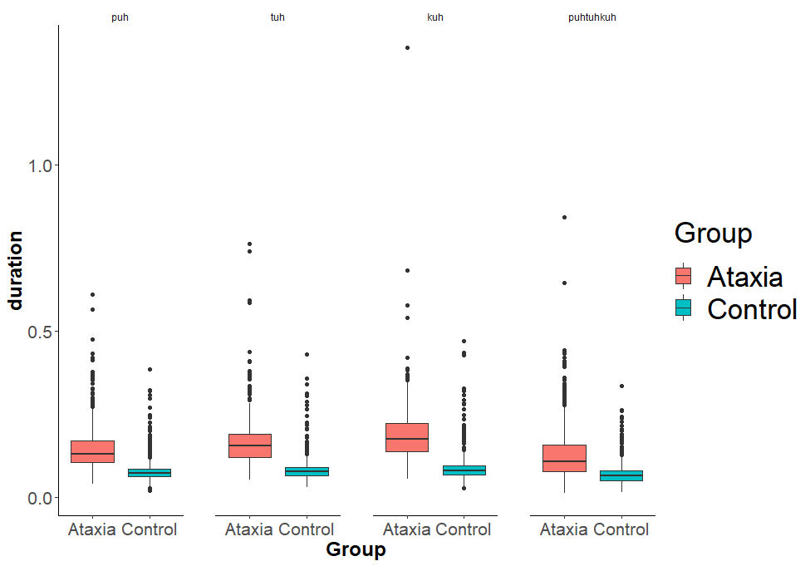
Figure 1: The effect of group (ataxia = orange, control = blue) and DDK task (puh, tuh, kuh, and puhtuhkuh) on syllable duration (seconds) in the DDK task.
Figure 1 displays the effects of participant group and DDK task on syllable duration. Ataxia participants produced significantly longer syllable duration overall than control participants (F_{1,49.8} = 63.02, p < .0001). On average, syllable duration was 166 ms (SE = 80) for ataxia participants and 80 ms (SD = 40) for the control participants. There was also an overall significant effect of DDK task on syllable duration (F_{3,5985.2} = 182.960, p < .0001). The “kuh” task had the longest syllable duration of 142 ms (SE = 6), followed by “tuh” at 130 ms (SE = 6), “puh” at 117 ms (SE = 6), and puhtuhkuh at 103 ms (SE = 6). All pairwise contrasts were statistically significant (p < .0001).
There was a significant interaction between participant group and DDK task (F_{3,5985.2} = 48.81, p < .0001). Essentially, ataxia participants had longer syllable duration across the four DDK tasks compared to control participants (p < .0001). Within the ataxia group, both “kuh” was produced with longest duration (mean = 197 ms, SE = 8), followed by “tuh” (mean = 175 ms, SE = 8), then “puh” (mean = 157 ms, SE = 8), and “puhtuhkuh” (mean = 137 ms, SE = 8). All interactions between task within the ataxia group were significant (p < .0001). Within the control group, all interactions were significant except for the difference between “tuh” (mean = 84 ms, SE = 8) and “kuh” (mean = 88 ms, SE = 8). Overall, ataxia participants had longer syllable duration across DDK tasks than control participants. Within the ataxia group, “kuh” was produced with the longest duration, followed by “tuh,” then “puh,” and finally “puhtuhkuh.” Within the control group, there were less significant effects by task.
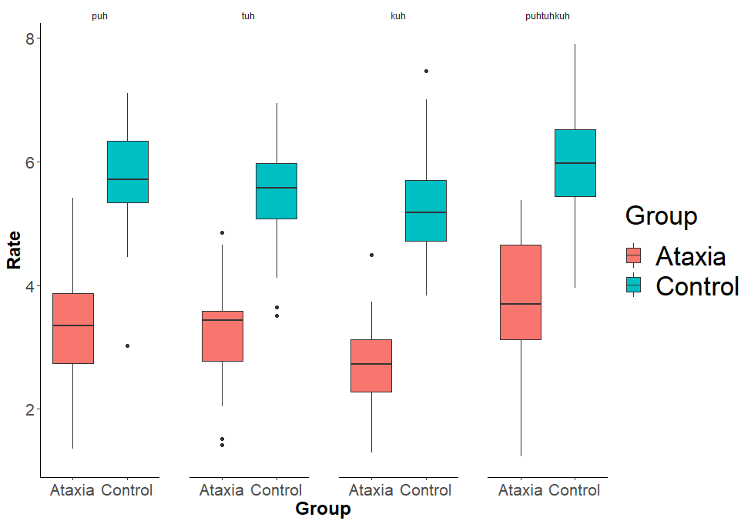
Figure 2: The effect of group (ataxia = orange, control = blue) and DDK task (puh, tuh, kuh, and puhtuhkuh) on syllable rate (syllables/second) in the DDK task.
Figure 2 displays the effects of participant group and DDK task on syllable rate. Ataxia participants produced slower syllable rate overall than control participants (F_{1,50.9} = 164.63, p < .0001). On average, syllable duration was 3.20 syllables/second (SE = 0.15) for ataxia participants and 5.61 syllables/second (SE = 0.13) for the control participants. There was also an overall significant effect of DDK task on syllable rate (F_{3,5984.7} = 889.48, p < .0001). The “kuh” task had the slowest rate at 3.91 syllables/second (SE = 0.09), followed by “tuh” at 4.34 syllables/second (SE = 0.09), “puh” at 4.54 syllables/second (SE = 0.09), and puhtuhkuh at 4.83 syllables/second (SE = 0.09). All pairwise contrasts were statistically significant (p < .0001).
There was a significant interaction between participant group and DDK task (F_{3,5984.7} = 15.94, p < .0001). Essentially, ataxia participants had slower rate across the four DDK tasks compared to control participants (p < .0001). Within both groups, “kuh” had the slowest rate, followed by “tuh,” “puh,” and then “puhtuhkuh.” Overall, ataxia participants had slower syllable rates across DDK tasks than control participants. Within both groups, “kuh” was produced with the slowest rate, followed by “tuh,” then “puh,” and finally “puhtuhkuh.”
  - DDK Task Performance and Speech Naturalness in Ataxia

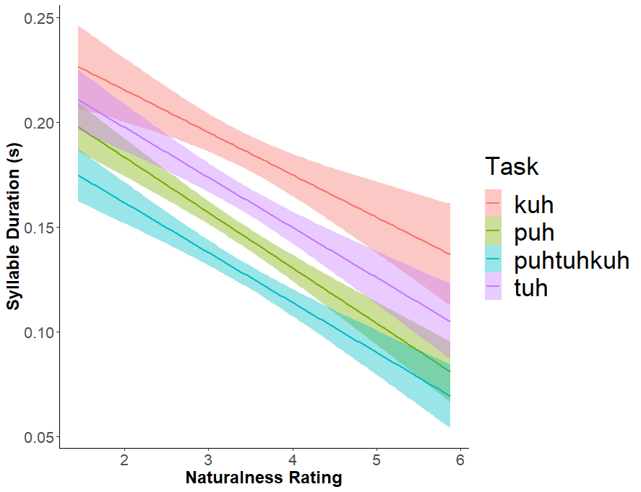
Figure 3: The relationship between speaker naturalness rating and syllable duration in the DDK task (puh = green, tuh = purple, kuh = red, and puhtuhkuh = blue) for the ataxia participants.
Figure 3 displays the relationship between speaker naturalness rating for the ataxia participants and syllable duration in the DDK task. Overall, there was a significant relationship between syllable duration and speech naturalness (F_{1,22.87} = 10.21, p = .004). Participants who produced longer syllables in the DDK task were perceived as less natural during conversational and passage reading tasks. There was no significant interaction between naturalness rating and DDK task, indicating that syllable duration across tasks was significantly related to speech naturalness.

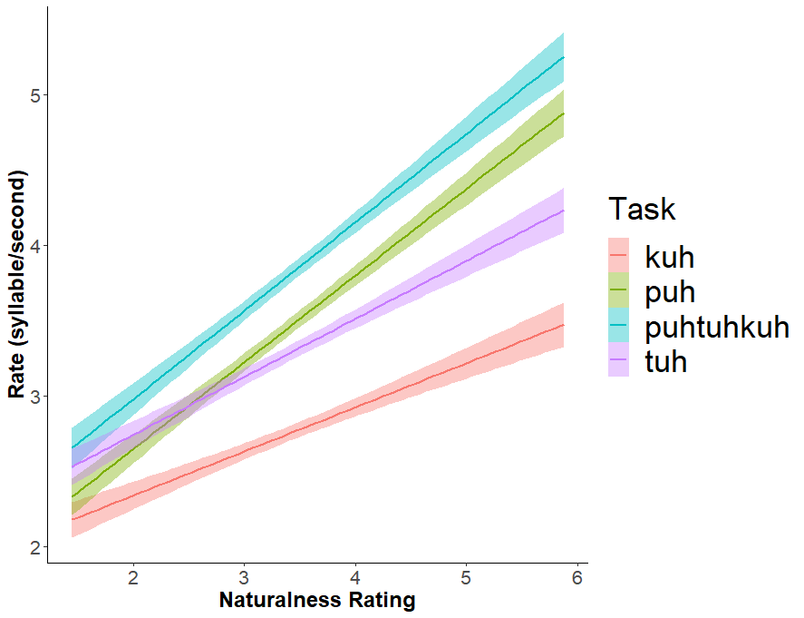
Figure 4: The relationship between speaker naturalness rating and syllable rate in the DDK task (puh = green, tuh = purple, kuh = red, and puhtuhkuh = blue) for the ataxia participants.
Figure 4 displays the relationship between speaker naturalness rating for the ataxia participants and syllable rate in the DDK task. Overall, there was a significant relationship between syllable rate and speech naturalness (F_{1,23.01} = 14.67, p < .0001). Participants who produced slower syllable rates in the DDK task were perceived as less natural during conversational and passage reading tasks. There was also a significant interaction between naturalness ratings and DDK task (F_{1,2188.17} = 58.00, p < .0001). Syllable rate for “puhtuhkuh” had the strongest relationship with speech naturalness ratings, followed by “puh,” “tuh,” and “kuh.”

Discussion
The goal of this study was to determine the relationship between the perceptual measure of speech naturalness and objective measures of articulatory coordination in the DDK task as a potential tool for assessment of ataxic dysarthria. We hypothesized that speech coordination impairments in cerebellar ataxia, which impact prosody and speech naturalness, are reflected in simple articulatory tasks, such as DDK rate. The findings of this study supported our hypothesis because both vowel segment duration and rate of production in the DDK task were significantly correlated with speech naturalness ratings. Speakers with lower naturalness ratings had longer vowel segment durations and a slower rate of production across DDK tasks in comparison with speakers with higher naturalness ratings. These results show that objective measures of segment duration and rate of production in the articulatory coordination task called DDK are reflective of perceptual measures of speech naturalness.
Between-group comparisons replicated previous research, finding that participants with ataxia performed more poorly on the DDK tasks than the control participants. Specifically, participants with ataxia had longer syllable duration and slower syllable rate across the DDK tasks compared with control participants. This finding is unsurprising given the significant role of the cerebellum in movement coordination and provides continual support for the application of the DDK task in assessment of dysarthria in ataxia.
Another expected finding from this study was that participants in both groups performed worse for some DDK tasks than others. Specifically, participants were slower with longer syllable durations for the “kuh” and “tuh” tasks than the “puh” and “puhtuhkuh” tasks. This task effect is due to articulatory coordination and control differences for the lips, tongue tip, and tongue dorsum. Speakers have greater control and coordination over lip movements than tongue movements, making it easier to repeat the “puh” syllable rapidly with short duration. The tongue tip is also better coordinated than the tongue dorsum, making it easier to repeat “tuh” compared with “kuh.” Lastly, the “puhtuhkuh” sequence may have been faster than “tuh” and “kuh” because it is easier for speakers to coordinate sequential movements rather than repeated movements. These task differences were noted for both groups of speakers in this study with one exception: control participants did not have a significant difference in syllable duration between “tuh” and “kuh.” A potential explanation is that control participants have better tongue control and coordination and performance differences between these two tasks are minimal.
The interesting and important finding from this study is that, for speakers with ataxia, performance on the DDK task is highly correlated with perceptual speech naturalness ratings. This is important because speech naturalness is a perceptual measure that is subjective and highly variable from clinician to clinician. This study shows that objective measures, such as segment duration in DDK are highly correlated with perceptual measures of speech naturalness. Clinically, speech-language pathologists can combine perceptual measures of speech naturalness and objective measures of DDK to obtain a comprehensive measure of speech ability when assessing patients with ataxic dysarthria.

Conclusion
The goal of this study was to determine whether objective measures from the DDK task are related to perceptual measures of speech naturalness in cerebellar ataxia. We found a strong relationship between syllable duration and syllable rate from the DDK task to speech naturalness ratings, supporting our hypothesis. Additionally, ataxia participants were slower with longer syllable durations during the DDK task than control participants, and all participants demonstrated better motor control over lip-movement tasks (e.g., “puh”) and sequential repetition tasks (e.g., “puhtuhkuh”) than repeated togue movement tasks (e.g., “tuh” and “kuh”). Overall, speech-language pathologists can incorporate both perceptual measures of speech naturalness and acoustic measures of DDK performance for a comprehensive evaluation of ataxic dysarthria.

References

Ackermann, H., Mathiak, K., & Riecker, A. (2007). The contribution of the cerebellum to speech production and speech perception: clinical and functional imaging data. Cerebellum (London, England), 6(3), 202–213. https://doi.org/10.1080/14734220701266742
Bates, D., Maechler, M., Bolker, B., & Walker, S. (2014). lme4: Linear mixed-effects models using Eigen and S4. R Package Version, 1(7), 1–23.
Boersma, P., & Weenink, D. (2019). Praat: doing phonetics by computer [Computer program], Version 6.0.46. Retrievable Online at Http://Www. Praat. Org.
Brendel, B., Ackermann, H., Berg, D., Lindig, T., Schölderle, T., Schöls, L., Synofzik, M., & Ziegler, W. (2013). Friedreich ataxia: Dysarthria profile and clinical data. Cerebellum, 12(4), 475–484. https://doi.org/10.1007/s12311-012-0440-0
Duffy, J. R. (2013). Motor Speech Disorders-E-Book: Substrates, Differential Diagnosis, and Management. Elsevier Health Sciences.
Enderby, P. M., & Palmer, R. (2008). FDA-2: Frenchay Dysarthria Assessment: Examiner’s Manual. Pro-ed.
Kent, R. D., Kent, J. F., & Rosenbek, J. C. (1987). Maximum performance tests of speech production. The Journal of Speech and Hearing Disorders, 52(4), 367–387. https://doi.org/10.1044/jshd.5204.367
Kent, R. D., Weismer, G., Kent, J. F., & Rosenbek, J. C. (1989). Toward phonetic intelligibility testing in dysarthria. Journal of Speech and Hearing Disorders, 54(4), 482–499. https://doi.org/10.1044/jshd.5404.482
Kent, R.D., Kent, J. F., Rosenbek, J. C., Vorperian, H. K., & Weismer, G. (1997). A Speaking Task Analysis of the Dysarthria in Cerebellar Disease. Folia Phoniatrica et Logopaedica, 49(2), 63–82. https://doi.org/10.1159/000266440
Kent, Ray D., Kent, J. F., Duffy, J. R., Thomas, J. E., Weismer, G., & Stuntebeck, S. (2000). Ataxic Dysarthria. Journal of Speech, Language, and Hearing Research, 43(1–5), 1275–1289. https://doi.org/10.1044/jslhr.4305.1275
Koo, T. K., & Li, M. Y. (2016). A Guideline of Selecting and Reporting Intraclass Correlation Coefficients for Reliability Research. Journal of Chiropractic Medicine, 15(2), 155–163. https://doi.org/10.1016/j.jcm.2016.02.012
Manto, M., & Marmolino, D. (2009). Cerebellar ataxias. Current Opinion in Neurology, 22(4), 419–429. https://doi.org/10.1097/WCO.0b013e32832b9897
NAF, N. A. F. (2016). National Ataxia Foundation.
Nasreddine, Z. S., Phillips, N. A., Bédirian, V., Charbonneau, S., Whitehead, V., Collin, I., Cummings, J. L., & Chertkow, H. (2005). The Montreal Cognitive Assessment, MoCA: a brief screening tool for mild cognitive impairment. Journal of the American Geriatrics Society, 53(4), 695–699.
Peirce, J. (2020). PsychoPy-Psychology software for Python Release 2020.1.2.
Revelle, W. R. (2017). psych: Procedures for Personality and Psychological Research.
Selkirk, E. (1995). Sentence prosody: Intonation, stress, and phrasing. The Handbook of Phonological Theory, 1, 550–569.
Spencer, K. A., & Dawson, M. (2019). Dysarthria profiles in adults with hereditary ataxia. American Journal of Speech-Language Pathology, 28(2 Special Issue), 915–924. https://doi.org/10.1044/2018_AJSLP-MSC18-18-0114
Trudeau, S. (2013). CoRDS Registry.
Walshe, M., Peach, R. K., & Miller, N. (2009). Dysarthria Impact Profile: development of a scale to measure psychosocial effects. International Journal of Language & Communication Disorders, 44(5), 693–715. https://doi.org/10.1080/13682820802317536
Yorkston, K. M., Strand, E. A., & Kennedy, M. R. T. (1996). Comprehensibility of Dysarthric Speech: Implications for Assessment and Treatment Planning. American Journal of Speech-Language Pathology, 5(1), 55–65. https://doi.org/10.1044/1058-0360.0501.55

