Tracking in Public Education
  - Does tracking in high school affect comfort levels in college courses?

By:
Emma Toussenel
Sociology
University of Colorado Boulder

Undergrad Honors Thesis
Defended: Thursday, March 17th, 2022

Thesis Advisor:
Jason Boardman, Department of Sociology

Honors Coordinator:
Amanda Stewart, Department of Sociology

Outside Reader:
Sara Staley, School of Education

Abstract
Background. Students entering college are often evaluated on a standardized platform which can negate their diverse high school experiences and thus affect their understanding of college courses and processes. This creates an invisible gap between students from high tracks, such as Honors and Advanced Placement (AP) courses, and students from common core programs or schools where advanced curriculums are not available. Without acknowledgement of this diversity in high school experiences, it can be easy to see certain students as seem quiet, disengaged, or careless towards their education, more specifically college courses. However, these students have not been exposed to the same types of interactions with professors and peers as those in focused and advanced groups or courses.
Aim. Explore the impacts of academic grouping in high school on students’ comfort levels in their college courses.
Sample. The analyzed sample is comprised of 30 subjects from CU Boulder and are from a variety of backgrounds. All students surveyed for this sample were anonymous.
Method. Subjects were provided with a 10-minute survey including questions about their demographics, their high school courses, and their experiences with their college courses.
Results and conclusions. Students who did not take AP or Honors courses showed greater discomfort in their college courses. They scored lower in most sections of academic and student identity and expressed more negative sentiments than students who had been in higher tracks in high school. While the differences in discomfort may seem smaller between Honors and non-Honors students, the difference is significant for one’s college experience.

Acknowledgements
Writing a thesis during undergraduate studies is no small feat and while I am always looking for a new challenge, I would not have been able to successfully carry out this research and write this thesis without the supporting of the following amazing people.
To my committee, Jason Boardman, Amanda Stewart, and Sara Staley, thank you for providing me with the structure and guidance required to design and complete this research. Going from ideas to tangible steps is often a rollercoaster of trial and error and you have all played a crucial role in my ability to push through the obstacles. Jason, thank you for taking a leap of faith on a student you did not know prior to this and for checking in on me every week to ensure I was on track. Amanda, thank you for meeting with me multiple times before my defense to calm my queries and provide tips to get me over the hurdles. Sara, I appreciate your patience and support as an Outside Reader so late in the process.
To the professors that inspired me to start research, thank you for sparking a new passion in me that continues to grow as I discover new systems and policies that require reforms. Without your dedication to your work and connecting with your students, I would not have pursued an Honors Thesis, let alone design my own study and collect my own data.
To my family and partner, thank you for cheering me on every step of the way even from miles away. Thank you for reminding me why I started and celebrating every small accomplishment along the way. Your endless support and love are so powerful especially on the tough days. Micah, thank you for being by my side every step. Your little nudges helped keep me on track and your patience with my late nights is a huge part of why I was able to finish today.
To RHA and my Stearns family, thank you for checking up on me and giving me the space to work and succeed. Every time you popped into the office to ask if I needed anything or to share some affirmation or motivation, you kept me going. I am so blessed to be surrounded with such supportive people even through all your personal challenges and classes. It is awesome to celebrate the end of a year-long project with you.
This process has been nothing short of an adventure and if it wasn’t for every single person who checked in, sent motivation and affirmation, and provided me with a space to try, fail, and grow, we would not be defending this thesis. Thank you for believing in me and being awesome humans all around!

Table of Contents
Abstract 2
Acknowledgements 3
Introduction and Purpose Statement 6
Literature Review 8
Current study 9
Defining Comfort 10
Research Methods 11
Data Collection 12
Survey Sections Explained 13
Data Sorting 14
Results 15
AP and Honors- is there a difference? 16
Analysis 21
Discussion 24
Importance 24
Limitations 24
Future studies 25
Conclusion 26
Bibliography 27
Appendix 28
Coding Lines 29

Introduction and Purpose Statement
According to the National Association of Secondary School Principals, tracking is an academic method where students are grouped based on perceived ability, IQ, and academic level (NASSP, 2006). Students are grouped in hopes of providing them with the curriculum, support, and resources they need to succeed academically. From a professor's point of view, tracking allows them to focus their instruction on one specific level. From a student’s point of view, however, being placed in lower track courses can seem stigmatizing and isolating. An example of this is reading groups; at some point in our education, we all experienced (or knew someone who experienced) being placed in different reading groups. Another example would be Advanced Placement and Honors courses; classes catered to higher achieving students which introduce them to college-style instruction and curricula in high school.
The purpose of this study is to identify how tracking in public education affects students’ identities with an emphasis on comfort levels in college courses. It covers the following questions:
- Are students aware of their tracking history through high school?
- Is their tracking identity important in their college student identity?
- Does high school tracking affect the comfort level of college students in their courses?
- Does high school tracking affect college student’s academic success?
This research is inspired by my belief that my opportunity should not be someone else’s obstacle. As a student who had the privilege of attending AP and Honors courses, I saw firsthand the benefits of being in higher level classes in high school. The instruction mode, teachers, and course content in higher track courses were created to challenge students and prepare them for college. While these classes were extremely beneficial to my academic success in high school and college, they had some detrimental effects on my personal life, including my social circle, and the larger campus community. Through my research, I hoped to identify some components of tracking that affect students’ identities, comfort in classrooms, and the connection to the level of courses they took. I believe it is important to acknowledge both the benefits and shortcomings of tracking and in doing so, provide potential solutions to biases in admission departments and professionals in colleges, professors, and teaching/learning assistants. In identifying the gap between students who were tracked into AP and Honors courses (high-track courses) and students who were not, we can modify curriculums and support students in a proactive way to reduce dropout and failure rates. Additionally, we can address the idea that stratified learning is beneficial to those being pushed and challenged, without neglecting all other students and creating a negative and unmotivating learning environment.

Literature Review
Tracking, whether it be higher tracks (AP and Honors) or standard tracks, plays a crucial role in student identity, academic identity, and sense of school belonging (Legette 2018; Legette and Kurtz-Costes 2021; Mazenod et al. 2019; Steenbergen-Hu, Makel, and Olszewski-Kubilius 2016). It compromises the connection between one’s personal identity and one’s role as a student (Legette, 2018, Crocker & Major, 1989; Osborne, 1997). As young as sixth-grade, and sometimes even before, students are discovering their own identities, and figuring out how those identities play into their overall education, and where they are situated in relation to others (Legette and Kurtz-Costes 2021). These factors are an example of social identity theory which explains how people define themselves and others based on their social group membership. If, from the moment students are stepping into classrooms, they are aware of the differences between themselves and their peers, it is no surprise that being in standard track courses negatively impacts students’ identities. Students unanimously state their heightened view of peers in higher tracks (Legette and Kurtz-Costes 2021; Tyson 2011). This leads to a generalized understanding that students in higher tracks are placed on a pedestal and view themselves as better or higher achieving than their peers. Not only does this increase the self-perceptions of AP and Honors students, but it also reinforces the stigma that lower track students are less able and capable.
Additionally, high school tracks can shape students’ educational aspirations post high school as a result of obvious differences in curricula (Venezia and Kirst 2005). As stated by Legette and Kurtz-Costes, teachers have an impact on students too, as their “perceptions of students’ academic abilities…might shape the support they provide students” (963). With the combination of family and school environment, students can internalize the labels placed on their track level and the messages received by their families surrounding education to determine their ability to succeed. This is most seen in students from lower socioeconomic statuses but has impacted students across the board.
As noted in most research on tracking, it is impossible to discuss academic identity and experience without acknowledging the impacts of race. Many identities play into one’s academic experience, but race is a consistent factor in identifying disparities in student experience and attainment at all educational levels (Legette 2018; Tyson 2011). One aspect of the intersectionality between race and academic experience appears when observing student behaviors and attitudes regarding their courses. The distinction between white students and students of color stems from stereotype threat or the psychological threat that arises when one is engaging in a space or situation in which a negative stereotype about one’s group exists (Legette 2018). Especially with differing perceptions of students among higher and lower tracks, students of color can engage in the self-fulfilling prophecy of struggling academically. In acknowledging this, curriculums and teaching styles can be adapted to reduce or even remove the impact of these threats.

Current study
Throughout my exploration of previous research on academic tracking, I discovered a few gaps in the literature that led me to seek answers for the questions listed in the Introduction. While all prior research has contributed important statistics and analysis on the vast impacts of tracking, many of the studies were carried out in the United Kingdom or other European countries. Legette (2018) and Legette and Kurt-Costes (2021) are the only articles I found done in the United States. This does not mean there are no other studies performed in the U.S but it shocked me the quantity of research from abroad. While studies from Europe and the United Kingdom still shed light on the impacts of tracking, their results cannot necessarily be extended to the US due to cultural differences. The second gap I found was educational stage at which these studies were taking place. All the studies I found were conducted before or during high school, gathering real-time data or prospective information on tracking. Therefore, I elected to do the study on college students to extend the educational timeframe of the research and focus more on the lasting impacts of high school tracking. Lastly, most of the research focused heavily on racial identity and sense of belonging, which is a key aspect of academic experience and success, but I chose to step away from this and focus on the larger impacts between tracks. I was interested in comparing those who took honors courses versus those who took AP classes versus those who took standard classes. Additionally, I developed what academic and student identity looked like when it comes to comfort level in classes- in groups, in larger lecture settings, in attending office hours, etc. which is something I have not yet found in any study. Something that I have not found in any study yet.

Defining Comfort
Throughout this research, I define what comfort in the classroom looks like and how students’ comfort levels vary but how exactly am I defining comfort? The key words I employ include “belonging” and “understanding”. I believe confidence plays an important role in academic experience, but it focuses more on visible and physical actions or behaviours. In comparison to confidence, comfort is connected to an internal feeling. As defined in psychology, comfort refers to being at peace with yourself and the current situation. For this research, comfort is defined as the lack of stress and panic when carrying out certain classroom tasks and engaging in classroom-related spaces. It is the absence of feeling out of place and the firm belief and understanding that one can participate in class regardless of prior tracking experiences.

Research Methods
In research there are two main methods of data collection, quantitative and qualitative. Quantitative research methods focus on numbers, categories, graphs, and statistics- a common method is surveys. Qualitative research methods focus on words, for example, interviews. Qualitative data can be assigned numerical values for the purpose of ordering or categorizing. For my research, I used a quantitative research method to create a simple, streamlined source of data for my analysis. The survey was created and monitored through Qualtrics, a program provided by CU Boulder, and password protected. This system provided me with weekly progress reports and live status updates on individual responses. Additionally, Qualtrics provided me with through data information including a summary of the results, analysis, and final reports.
The survey consisted of three sections: Demographic, Tracking Identity, and College Experience. The Demographic section provides information on the subject’s identity and background. The Tracking Identity section evaluated the subject’s experience with tracking in high school, the variety of classes that were offered, and if the subject participated in any tracked course. Finally, the College Experience section connected a subject’s tracking experience in high school with their experience in college courses. It asked about office hours, their comfort levels in specific situations, and their self-perception regarding academics. The questions in my survey related to the following topics:
- Grade
- Gender
- Race/Ethnicity
- Census Tract
- Class diversity (options)
- Context on course offered in school
- Academic Identity (Strongly Disagree – Strongly Agree)
- Self-perception of smartness
- MacArthur ladder for placement in school/class
- Student Identity (Strongly Disagree – Strongly Agree)
I aimed to achieve randomization by sharing my survey with all Honors advisors and requested that professors spread the survey to their colleagues too. While I am aware this was very similar to snowball sampling, given the anonymous aspects of my research, I was unable to completely control how random my results were. Nevertheless, I was not targeting a specific group or area of study on campus. I anticipated receiving 100 responses to my survey to decrease bias/skews as much as possible. The goal with N = 100 was to gauge how data varies across socioeconomic status (SES), tracking placement, and confidence level in college. I followed a 3-month data collection period and 4-month writing period for a total of a 7-month study period.
I hypothesized that students who were in high tracks in high school experience greater levels of comfort in their college classes and are more likely to succeed academically. Students who experienced low-level tracking in high school are more likely to experience discomfort in their college courses and struggle academically.

Data Collection
Throughout the first week I sent out over 20 emails to professors, teaching assistants, and advisors seeking their support for my research by sharing my survey with fellow colleagues as well as students. Over the course of the first month, I sent out different notices regarding my research including social media posts to Instagram, LinkedIn, and Facebook, reminder emails to professors, and shared a link to my survey in multiple group chats pertaining to CU Boulder’s student body.

Survey Sections Explained
To provide some context behind the selection or omission of specific questions, I am providing the rationale for each section. For the “Demographic” section I chose to focus on grade (and age), gender, race/ethnicity, and socioeconomic status via family income. Grade allowed me to see how long ago the subject was in high school so I could account for changes throughout the years; gender and race/ethnicity allowed me to identify if there are gender or racial disparities in experiences with tracking; finally, “Census Tract” allowed me to identify how socioeconomic status (SES) impacts students' access to and experience with tracking.
Given the length of the “Tracking Identity” section, I will provide a section breakdown of the crucial pieces I was trying to measure with specific questions and overall. Questions surrounding “Course-level diversity” indicated the types of courses (used interchangeably with classes) offered at a subject’s school. The importance of this section was the context it provided for the experience the subject had with tracking based on the options available. This prevents the possibility of making false correlations regarding academic experience if the courses were absent in the students’ school systems. I cannot compare the experiences of students with all tracking courses available to the experiences of students with only regular courses offered; however, this would be something to explore in future research.
The “Contextual” part of “Tracking Identity” allowed me to gauge the relative number of courses in each tracking level that students believed they were offered. This emphasized whether accessibility to courses and the variety of courses impacted the experience students had with tracking. “Academic Identity” started to explore the relationship between participation in courses of different levels and the individual’s sense of self relative to their peers. Moreover, it explored whether different course levels are directly related to the quality of teacher-student relationships. I believe this is important as there is increasing data that demonstrates the additional roles teachers and professors play in students’ lives beyond delivering knowledge in the curriculum. The “Ranking” subsection provided additional information regarding the interpersonal impact of students’ experiences with tracking. Lastly, the “Self-Rank” ladder, inspired by Elizabeth Goodman’s MacArthur Scale, served as an additional emphasis regarding a student’s interpersonal understanding of their position in their school environment.
This last section, in my opinion, is the most important. While the two preceding sections of the survey focused on past experiences and contextual background, this section exposed the long-term impacts of tracking on college experience. As mentioned earlier, the purpose of this research was to identify the impacts tracking has on students’ comfort levels in college (courses). The “Student Identity” section explored the areas of college related to classes where students experience comfort (unlike confidence, comfort ties in the feeling of belonging and understanding) and areas where students feel discomfort or hinderance. The “Office Hours” question simply emphasized the connection between a sense of comfort in classroom settings and classroom-related spaces, and likelihood to utilize resources offered to them. Overall, knowing subjects’ comfort level in college courses will allow me to identify if academic tracking has an impact on comfort level in college courses. Subjects were asked to rate how often they attend office hours, whether they feel comfortable leading a group, raising their hand in class, etc. This will be a way to see if students feel comfortable in college settings and how this has been affected by academic tracking.

Data Sorting
While only a fraction of the collected responses was complete for analysis, some variables required simplification. The following modifications were made to the final data set.
Race/ethnicity was simplified to “non-white” (0) and “white” (1).
AP courses was simplified to “did not take AP” (0) and “took AP” (1).
Honors courses was simplified to “did not take Honors” (0) and “took Honors” (1).
Likert scale values were assigned 1-5, 1 = strongly disagree; 5 = strongly agree
Categorical values, for coding purposes, were assigned numerical values ranging from 1-5 depending on the variety of possible response.

Results
Although I anticipated 100 responses, and I received 112, I was only able to use 39 responses (also referred to as observations) given the quantity of missing values beyond the “Demographic” section. During the data sorting, I further narrowed the usable observations to 30 to omit all remaining missing values. The only exception was the income observations where the one missing value was given the value of the mean- $117, 966.10. Given the limited observations viable for data analysis, the diversity of the demographics was significantly reduced. Of the final 30 observations, 20 identified as females, 7 as males, and 2 as “Other”- specified to be trans and non-binary. The racial diversity of observations was 25 white and 5 non-white subjects. The age range did not shrink significantly with respondents being between 18 and 28 years old with a mean age of 20.26, rounded to 20 years old. In the analysis, age and grade were omitted as they did not impact results significantly or provide additional correlations. Despite the sample reductions, the range of incomes provided me with a clear foundation for the variety of SES backgrounds. The lowest reported income was $50,000/year and the highest reported income was $243,063/year with no repetitions in the numbers and a mean of $117, 966.10. This variety made it hard to group the data points, but I was still able to create correlation plots using income brackets and other variables.
When evaluating course-level diversity, I had to remove most of the observations from the “common core” or “guided learning” sections as those observations were incomplete. The final analysis was performed with Honors and AP subjects only. Of the 30 respondents, 25 took Honors and AP, 1 took Honors but no AP, 1 took AP but no Honors, and 3 took neither. I also chose to omit all observations for the “Contextual” section given that I could no longer compare experiences between schools that offered or did not offer AP and Honors. All remaining observations indicated their schools offered high track courses.

AP and Honors- is there a difference?
The following tables explore the difference in academic identity amongst Honors (Table 1.1) and AP students (Table 1.2), and the difference in student identity amongst Honors (Table 2.1) and AP students (Table 2.2). To find these values, I ran t-tests in RStudio with each variable (listed on the left-hand side of each table) and whether the student took Honors/AP courses. T-tests provide the difference in two means and give the p-value which demonstrates the significance of the difference, if there is one, between the two groups. The p-value column indicates the level of significance in these means. Anything less than or equal to (≤) 0.05 proves to be statistically significant as this indicates there is a ≤ 5% chance the null hypothesis is correct. In this research, the null hypothesis would be that there is no (statistical) relationship between two variables, for example, income and taking AP or Honors.
Each variable listed is connected to a question and the mean response for that question is listed either in the ”Yes” or “No” column. The “Yes” column represents students who indicated they took Honors/AP courses and the “No” column represents students who indicated they did not take Honors/AP courses. Students responded using a Likert scale- strongly disagree (1) and strongly agree (5). Originally, I omitted all “neutral” responses but when calculating average response, the “neutral” option proved valuable to conceptualize what all the means meant.
When conceptualizing the p-value column, the decimal listed is the probability that the relationship between the “Yes” and “No” students for that variable is non-existent. For example, in Table 1.2, the first variable states “My classes played a role in my status at school” and the p-value is 0.441. This means that if I said those who took AP classes had a different perception about classes playing a role in their status than students who did not take AP classes, I would be wrong 44.1% of the time.
Table 1.1 and 1.2; In this section there were 13 variables which related to academic identity and asked students (also referred to as subjects) to respond on a Likert scale- strongly disagree (1) and strongly agree (5). These tables should be read in the following way: When asked whether subjects felt classes impacted their status at school (first variable), students who took Honors classes (Yes) had an average response of “neutral” (3) to “agree” (4) giving a numerical mean of 3.81. For students who indicated they did not take Honors classes (No), their average response to the same question was “agree” (4). The “Total” rows at the bottom indicate the mean response to all questions from (1) students who took Honors or AP and (2) students who did not take Honors or AP. If subjects responded strongly agree (5) to all questions the total mean would be 65 so Table 1.1 indicates that the total mean was 46.69 out of 65 (avg. 3.5 on scale) for students who took Honors courses which means most of the responses were “neutral” (3).
Table 2.1 and 2.2; In this section there were 8 variables which related to student identity. These tables should be read in the following way: When asked whether subjects felt comfortable in a class setting (first variable), students who took Honors classes (Yes) had an average response of “agree” (4) to “strongly agree” (5) giving a numerical mean of 4.31. For students who indicated they did not take Honors classes (No), their average response to the same question was “neutral” (3) to “agree” (4). The “Total” rows at the bottom indicate the mean response to all questions from (1) students who took Honors or AP and (2) students who did not take Honors or AP. The maximum score- if every subject said, “strongly agree” (5) to all questions- for the total mean would be 40, so Table 2.1 indicates that the total mean for students who took Honors classes (31.88 out of 40, avg. 3.9 on scale) means most responses were “neutral” (3) to “agree” (4).
In addition to the t-tests for these variables, I explored the connections between income and race, courses, and self-rank. Although there was a small sample of non-white subjects, the t-test was able to demonstrate a clear difference in mean income between the race categories. The mean income for non-white subjects was $98,444.60 whereas the mean income for white subjects was $121,870.40. A similar difference can be seen when comparing the mean income of students who took AP courses versus those who did not with the mean income of AP students at $121,473.30 and the mean income for non-AP students being $95,169.50. While this difference is significant, the difference in mean income between students who took Honors and who did not, was less significant. The mean income for non-Honors students was $100,481.20 and for Honors students was $120,656.10. Interestingly, there was no correlation between self-rank and income.
Other results that are important to this research include students’ “Self-Rank” score on the ladder, ranking in relation to their peers, and attendance in Office Hours. There were two forms of ranking included in the survey. The first compared self-perception of smartness to perception of others’ smartness. Subjects responded to whether their classes increased (18), maintained (11), or decreased (2) how smart they perceived themselves. In terms of how smart they perceived others to be, subjects responded to whether their classes increased (13), maintained (15), or decreased (3) their perceptions. The ladder self-ranking, which was out of 100, provided a wide array of how students perceived themselves in relation to their class. The lowest score was 35 and the highest was 97, with a few repetitions at 80, 82, 85, 90, and 91, with the median being 82 and the mean being 79.71. On average students ranked themselves above average in their classes. Lastly, the section regarding Office Hours evaluated subjects on a scale of “never” (1) to “more than once a week” (4) how often students attend Office Hours. The results indicate that regardless of track, students never attend Office Hours “more than once a week” but most of them attend “sometimes” (18) defined as once a month. In the analysis and discussion sections, I will explain the significance of the values listed below and provide some further context and suggestions, for future research.

Table 1.1- Academic Identity for Honors classes in High School
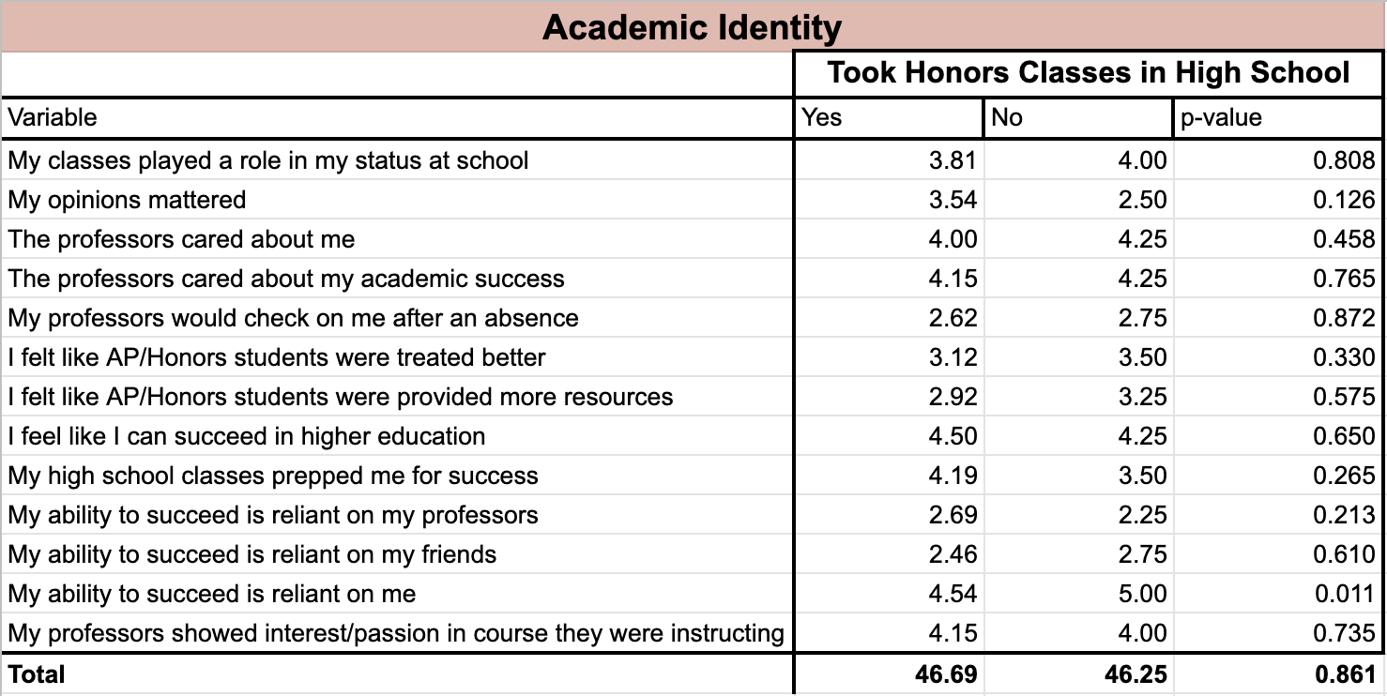

Table 1.2- Academic Identity for AP classes in High School
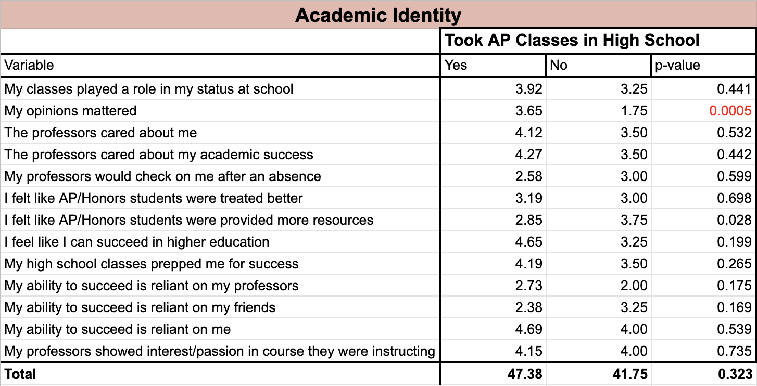

Table 2.1- Student Identity for Honors classes in High School
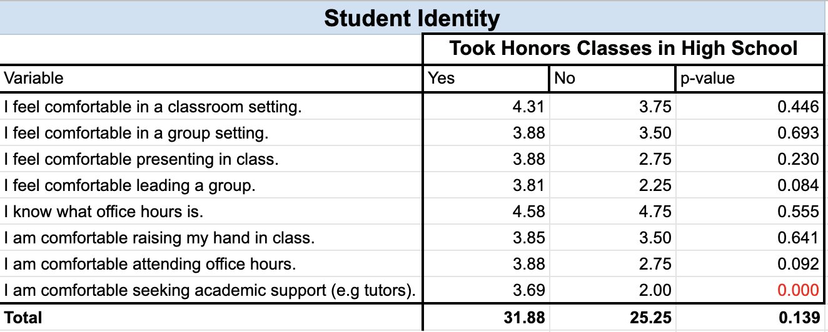

Table 2.2- Student Identity for AP classes in High School
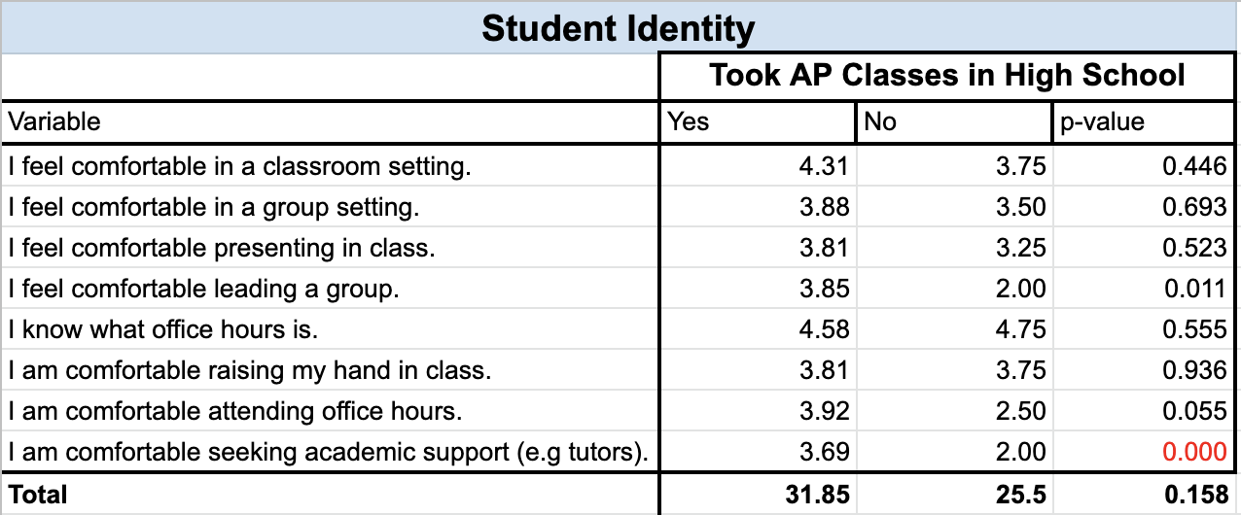

Analysis
Before diving into the analysis, I want to acknowledge that the results of my research were mostly what I had expected, but there were a few that shocked me. As a foundation for the analysis, I elected to focus on whether students had taken either AP or Honors courses (or both). Most of the analysis looked at differences in variables in relation to the subject’s participation in AP and/or Honors courses. To begin, I looked at the connections between demographics and course engagement. CU Boulder is a predominantly white institution (PWI) with 66.2% of the student body identifying as white and only 26.3% identifying as non-white, so the lack of racial diversity was expected but I was still able to find significant differences in income between the two categories (white and non-white). Moreover, the gap in mean income for students in AP courses and non-AP students reinforces the narrative that schools with higher income margins are more likely to offer AP courses and provide higher quality teaching. Beyond income, given the anonymous nature of this survey, it was hard to identify reasons for discrepancies in demographics. It is important to note gender and age were omitted from the data analysis as they did not provide additional relevant data points for this research.
Throughout the academic identity section (Table 1.1 and 1.2), there are differences between AP and Honors data sets but what fascinates me are the specific discrepancies between students who took Honors courses and students who did not. For example, there was an entire point difference between students in Honors versus non-Honors courses and feeling as though their opinions mattered. Non-Honors students indicated a majority response of “disagree” in comparison to Honors students who indicated a slight lean towards “agree”. This demonstrates the impact of the different approaches used by students and teachers when interacting in high versus standard track courses. While perceptions may be subjective, the differences in mean response indicate this experience is shared by at least half of the non-Honors respondents. It should be noted however, that the number of respondents for Honors (26) versus non-Honors (4) were vastly different. Nevertheless, this discrepancy can still support the theory that classroom environment, peer-to-peer interactions, and peer-instructor interactions are crucial to feeling valued in a course. Another example is the variance regarding higher tracks being provided with more resources, showing a stronger disagreement from the Honors students than the non-Honors students. While they both gave an average response of “neutral”, I believe this also indicates the disconnect between tracks regarding the quality and structure of their courses including resources provided. Furthermore, when looking at subjects’ opinions regarding the preparation for success in their classes, Honors students had a much higher rate of agreement than non-Honors students. Without negating the purpose of higher track courses, it is important to understand how fostering a curriculum to support those students plays a role in the experiences of out-group students (non-AP or Honors). There should not be this great of a difference in students feeling prepped for success. An interesting thing to note in this section is that non-Honors students unanimously agreed that their success is reliant on themselves, whereas Honors students had some disagreement. This stresses the variety in the socialization of higher track and standard track students regarding their responsibility for their education.
When analyzing the same variables but for AP courses, the same differences between tracks appear but there is one difference that I believe highlights the heightened value of AP courses, and thus students. Non-AP students share the negative experience of feeling like their opinions do not matter with their mean response being 2 points below AP students at a 1.75 (majority strongly disagree). Additionally, the overall academic identity score for non-AP students was 6 points lower than for AP students meaning non-AP students on average disagreed more with the statements.
For much of the student identity section (Table 2.1 and 2.2), there are minimal differences in experiences between AP and Honors students across all variables so I will refer to the two groups collectively as “higher track” observations, unless otherwise stated. Firstly, it is important to note the difference in total mean for students who took higher track courses versus those who did not. Given the maximum total mean score for this section was 40, a total mean of 25.5 for non-higher track students indicates, on average, that they skewed towards “disagree” for most statements. This is a demonstration of the detrimental impacts of focusing heavily on challenging students in higher tracks without providing equivalent resources and support to standard courses. Secondly, higher track students feel more comfortable in all college settings compared to non-high track students. While comfort levels are subjective and vary on a case-by-case basis, the positive feedback for the higher track students illustrates how differences in classroom environment and course structure have a lasting impact on student comfort.
Another demonstration of how the cycle carries through from secondary education into higher education is the lack of comfort non-higher track students feel raising their hands, attending office hours, or seeking academic support. I firmly believe that the interactions a student has with their teachers in high school sets the tone for the relationships and interactions they will have with their college professors. Furthermore, a student’s understanding of the classroom dynamic and the resources available to them also play a key role in their academic success beyond high school. This is to say, if a student has been socialized, in high school, to value seeking support, and has received positive feedback from asking questions in class, they are more likely to do so in college. With college being an intimidating transition from high school that requires greater independence, students are likely to fall back on what they learned and experienced in high school. This perpetuates the cycle of higher track students succeeding in higher education because of their high school experiences, and standard track students struggling to develop as individuals and succeed academically in higher education.

Discussion

Importance
Throughout this research, many of my personal views and experiences were portrayed and reinforced. One such view is the acknowledgement that we cannot talk about student identity, academic success, and academic identity without discussing personal identities such as race, gender, and class. While I chose to step away from demographic-heavy analysis for this study, I want to stress the impact they play in laying a foundation for one’s academic experience. Moreover, my data demonstrates the power of tracking systems in pushing those who need challenges but indirectly hurting those who are in common core classes. In alignment with this, it is important to understand that academic experience is not the sole responsibility of the individual student. A student is responsible for how they show up in spaces, and whether they do their assignments or engage in class, but there is a strong connection between the courses they are in and how they view and value their education.

Limitations
It goes without saying that all research has its limitations and without enumerating some of the more obvious logistical ones, I wanted to discuss some hurdles I overcame throughout this process. First, the geographic scale of this study is limited to CU Boulder’s campus which means data will be skewed towards white, affluent subjects. Second, after administering the survey I realized I did not include the option of “Latine/Hispanic” in the race/ethnicity question. Given Colorado’s and Boulder’s history as a hub for Spanish immigrants, it is possible they would comprise a larger portion of the non-white subjects. Third, although I frequently checked my survey and the responses, I have learned about the harsh nature of missing values- decreasing usable observations and increasing potential biases. Thus, my research is certainly not accurately representative of CU Boulder’s population or experiences with tracking instead it provides a first look at lasting impacts of tracking on 30 subjects. Finally, there was no control group which made comparing higher track experiences to standard tracks a complex task.

Future studies
This study has sparked a multitude of questions and future research that I want to continue with. A few aspects I want to explore (potentially for my Master’s) to expand on this study include larger geographic range, a more digestible survey, and questions about parental education. I believe a greater geographic range would provide a better understanding of tracking experiences and their role on college campuses and in students’ identities. A larger geographic range would look at campuses across Colorado and potentially other states. I would also aim to study a variety of student population sizes. Additionally, a more digestible survey would decrease missing values, a simple yet crucial part of research and removing biases. This could be remediated by having smaller sections, less sections, and a smaller diversity of possible answers. I would also remove “neutral” or “neither” options to encourage students to choose an opinion. Lastly, asking about parents’ education could provide more context on the subjects at-home experience and how this may also play a role in their academic experience and identities.
To explore other aspects of tracking, I believe building on prior research regarding high school and tracking experiences will provide new data given the drastic changes in curriculum and teaching approaches post-COVID. Taking a closer look at the impact of online learning and the quantity of students stepping away from education versus those accelerating their diploma. Pertaining to this research specifically, I would include a section about students having AP credits transferred to their college degree and how this has an impact on academic and student identity, more specifically regarding academic success.

Conclusion
Are students aware of their tracking history through high school? Yes, regardless of whether they are enrolled in higher tracks or standard courses, all the subjects indicated an awareness of tracking in their high school. Is their tracking identity important in their college student identity? Yes, students take the experiences they had in high school and use those to inform their approach to college courses and classroom settings. This is especially “visible” when it comes to office hours and seeking support from tutors or mentors. Students who took AP or Honors courses are more likely to seek out help support and build relationships with their professors. Does high school tracking affect the comfort level of college students in their courses? For the most part, yes. The gap between Honors and non-Honors students is less significant than that between AP and non-AP students but overall, students who took higher track courses scored higher in comfort levels in all categories. Given the strong relationship between sense of belonging and comfort, it can be inferred that with decreased sense of belonging comes decreased comfort levels. This would explain the connection between higher track courses and higher comfort levels because of individualized teaching and stronger connection to peers. Does high school tracking affect college student’s academic success? Given the impact being engaged, connected, and comfortable in college courses has on academic success, it can be inferred that tracking in high school does affect academic success in college.

Bibliography
Legette, Kamilah. 2018. “School Tracking and Youth Self-Perceptions: Implications for Academic and Racial Identity.” Child Development 89(4):1311–27. doi: 10.1111/cdev.12748.
Legette, Kamilah B., and Beth Kurtz-Costes. 2021. “Curricular Tracking, Students’ Academic Identity, and School Belonging.” The Journal of Early Adolescence 41(7):961–81. doi: 10.1177/0272431620977659.
Mazenod, Anna, Jeremy Hodgen, Becky Francis, Becky Taylor, and Antonina Tereshchenko. 2019. “Students’ University Aspirations and Attainment Grouping in Secondary Schools.” Higher Education 78(3):511–27. doi: 10.1007/s10734-018-0355-x.
Preckel, Franzis, Thomas Götz, and Anne Frenzel. 2010. “Ability Grouping of Gifted Students: Effects on Academic Self-Concept and Boredom.” British Journal of Educational Psychology 80(3):451–72. doi: 10.1348/000709909X480716.
Preckel, Franzis, Isabelle Schmidt, Eva Stumpf, Monika Motschenbacher, Katharina Vogl, Vsevolod Scherrer, and Wolfgang Schneider. 2019. “High‐Ability Grouping: Benefits for Gifted Students’ Achievement Development Without Costs in Academic Self‐Concept.” Child Development 90(4):1185–1201. doi: 10.1111/cdev.12996.
Steenbergen-Hu, Saiying, Matthew C. Makel, and Paula Olszewski-Kubilius. 2016. “What One Hundred Years of Research Says About the Effects of Ability Grouping and Acceleration on K-12 Students’ Academic Achievement: Findings of Two Second-Order Meta-Analyses.” Review of Educational Research 86(4):849–99. doi: 10.3102/0034654316675417.
Tyson, Karolyn. 2011. Integration Interrupted Tracking, Black Students, and Acting White after Brown. Oxford University Press.
Venezia, Andrea, and Michael W. Kirst. 2005. “Inequitable Opportunities: How Current Education Systems and Policies Undermine the Chances for Student Persistence and Success in College.” Educational Policy 19(2):283–307. doi: 10.1177/0895904804274054.

Appendix
Key for R.Studio coding
Code | Meaning | Notes
.r | The format of the file is accessible and compatible with “R Studio” | For this research the data is emma.RData
emma$ | Name of the data set | When I use this, I am telling the software to search my database for the variables
# | R Studio does not read # so I used it for note taking
[name]<-emma$x | Renaming variable ‘x’ | New name goes first, the backwards arrow indicates which variable is being renamed, followed by said variable  e.g emma$gender<-emma$Q2
str(x) | Shows me the structure of ‘x” | e.g str(emma) gives me all my variables and all the observations
na.rm=TRUE | Making all missing (NA) values TRUE
sapply(emma, function(x) sum(is.na(x))) | Providing me with a summary of all missing values and which questions they apply to
emma <- emma[is.na(x)=="FALSE",] | Any missing value in ‘x’ variable will be removed
emma <- subset(emma, select = -c(x)) | Removes the entire ‘x’ variable | e.g. removing variables and the observations attached that I felt were insignificant to the research
emma$x [emma$x=="response1"]<-"response2" | Creating a new category by combining response1 and response2 | e.g. this equation is saying any response coded as “6” shall now be grouped with the “3” to create an “other” in the gender category  emma$gender[emma$Q2=="6"]<-"3"
emma$x<-(emma$x==number)*1 | Creating a binary variable; 0 or 1 | e.g. the equation is telling R that any response that is not 1 (white) shall be coded as 0 (non-white)  emma$race<-(emma$Q3==5)*1
mean(x, na.rm=TRUE) | Any missing value in this variable will be assigned the value of the mean | e.g. income had 1 missing value so we made it equal the mean
table(x) | Creates a table with ‘x’ variable and frequency as the ‘y’
table(x,y) | Creates a table with ‘x’ and ‘y’ variables
mean(emma$x) | Gives the mean for this variable
t.test(x~y) | Providing the t.test data from ‘x’ and ‘y’ variables
hist(x) | Creates a histogram for ‘x’ variable with ‘y’ being frequency
cor(x,y) | Give the level of correlation between ‘x’ and ‘y’
ln(x) | Take the natural log of ‘x variable

Coding Lines
- load("/Users/em/Desktop/CU Boulder/3_Senior Year '21-'22/4_Spring '22/SOCY 4451/emma.RData")
- is(emma)
- sapply(emma, function(x) sum(is.na(x)))
- emma <- emma[is.na(emma$Q4)=="FALSE",]
- emma <- subset(emma, select = -c(Q6_3, Q6_4))
- emma <-- emma[is.na(emma$Q6_1)=="FALSE",]
- emma <-- emma[is.na(emma$Q6_2)=="FALSE",]
- mean(emma$Q4, na.rm=TRUE)
- sapply(emma, function(x) sum(is.na(x)))
- emma$gender<-emma$Q2
- emma$gender[emma$Q2=="6"]<-"3"
- table(emma$gender)
- emma$race<-(emma$Q3==5)*1 #emma$white<-(emma$Q3==5)*1
- emma$income<-emma$Q4
- table(emma$Q5_1)
- emma$took.hon<-(emma$Q5_2==1)*1
- table(emma$took.hon)
- emma$took.ap<-(emma$Q5_4==1)*1
- table(emma$took.ap)
- table(emma$took.hon, emma$took.ap)
- t.test(Q4~took.ap, data=emma)
- prop.test(table(emma$took.ap, emma$race))
- table(emma$took.ap, emma$race)
- install.packages("corrplot")
- library(corrplot)
- table(emma$Q6_1)
- table(emma$Q6_2)
- table(emma$Q6_1, emma$Q6_2)
- emma$classes.status<-emma$Q7_1
- table(emma$classes.status)
- emma$opinion<-emma$Q7_2
- table(emma$opinion)
- emma$prof.care<-emma$Q7_3
- table(emma$prof.care)
- emma$prof.acad.success<-emma$Q7_4
- table(emma$prof.acad.success)
- emma$absence<-emma$Q7_5
- table(emma$absence)
- emma$AP.Honors1<-emma$Q7_6
- table(emma$AP.Honors1)
- emma$AP.Honors2<-emma$Q7_7
- table(emma$AP.Honors2)
- emma$higher.ed<-emma$Q7_8
- table(emma$higher.ed)
- emma$prepped<-emma$Q7_9
- table(emma$prepped)
- emma$rely.prof<-emma$Q7_10
- table(emma$rely.prof)
- emma$rely.friends<-emma$Q7_11
- table(emma$rely.friends)
- emma$rely.me<-emma$Q7_12
- table(emma$rely.me)
- emma$prof.interest<-emma$Q7_13
- table(emma$prof.interest)
- emma$mysmarts<-emma$Q8_1
- table(emma$mysmarts)
- emma$othersmarts<-emma$Q8_2
- table(emma$othersmarts)
- emma$self.rank<-emma$Q9_1
- table(emma$self.rank)
- mean(emma$self.rank)
- median(emma$self.rank)
- emma$class.setting<-emma$Q10_1
- table(emma$class.setting)
- emma$group.setting<-emma$Q10_2
- table(emma$group.setting)
- emma$presenting<-emma$Q10_3
- table(emma$presenting)
- emma$lead.group<-emma$Q10_4
- table(emma$lead.group)
- emma$officehours<-emma$Q10_5
- table(emma$officehours)
- emma$hand.raise<-emma$Q10_6
- table(emma$hand.raise)
- emma$attend.OH<-emma$Q10_7
- table(emma$attend.OH)
- emma$tutors<-emma$Q10_8
- table(emma$tutors)
- emma$officehours2<-emma$Q11_1

- table(emma$officehours2)
- table(emma$took.ap/hon, emma$classes.status)
- table(emma$took.ap/hon, emma$opinion)
- table(emma$took.ap/hon, emma$prof.care)
- table(emma$took.ap/hon, emma$prof.acad.success)
- table(emma$took.ap/hon, emma$absence)
- table(emma$took.hon, emma$AP.Honors1)
- table(emma$took.ap, emma$AP.Honors1) --> unequal treatment
- table(emma$took.ap/hon, emma$AP.Honors2) --> resources
- table(emma$took.ap/hon, emma$higher.ed)
- table(emma$took.ap/hon, emma$prepped)
- table(emma$took.ap/hon, emma$rely.prof)
- table(emma$took.ap/hon, emma$rely.friends)
- table(emma$took.ap, emma$rely.me)
- table(emma$took.hon, emma$prof.interest)

- t.test(income~took.hon, data=emma)
- t.test(income~race, data=emma)
- t.test(self.rank~took.ap, data=emma)
- t.test(self.rank~took.hon, data=emma)
- t.test(income~took.hon, data=emma)
- t.test(income~took.ap, data=emma)
Notes- these are all the extra notes that accompany or explain the 100 lines of code above
# for Q6_1, 1 = more 2 = the same amount 3 = less
# the numbers equal the amount of people that voted for that value aka 12 people said their school offered more/less/same amount of X courses than other schools

# for missing values on Q4=income we are using the mean of all incomes for them
# for Q6 we are removing Q6_3 (6) and Q6_4 (15) given they have lots of missing values- common core and accommodations

# line 4: this means any missing value in Q4 will be removed
# line 5: removing those questions

# line 6-7: dropping missing values for Q6_1 and Q6_2 which is 2 and 3

# line 8: giving the 1 missing value for Q4 the mean of incomes

# line 9: re-running to ensure all missing values are gone now

# for gender we do, female, male and other and explain why
# for race we do white and non-white and explain why
# explore taking out the special accommodation courses
# there was so little variation between AP and Honors that these numbers did not bring much to the study
# use income to predict if AP and Honors existed
# predict academic identity through background
# academic experience as a dependent of demographics
# renaming [name]<-emma$Q#_#
# line 11: creating an "other" in the gender category with non-binary & trans

# line 13: white is 1 and 0 is non-white

# line 15: 1 is Yes for Honors; 3 is No for Honors

# line 16: this is people who said they TOOK/DID NOT TAKE an Honors course
# line 17: 0 is No; 1 is Yes

# line 18: this is people who said they TOOK/DID NOT TAKE an AP course
# line 16-18: take people who said 1 to Q5_2 and Q5_4 & make them a 1 and everyone else a 0.
# line 19: 0 is No; 1 is Yes
#line 20: 00 means took neither; 01 means took AP but not Honors; #10 means took Honors but not AP; 11 means took both

# line 21: compare the mean value of income of those who took AP and those who didn't
# mean income of those who DID NOT take AP = $95169.50
# mean income of those who DID take AP = $121473.30
# not statistically significant p<0.089

# line 22: comparing two binaries (race) and (took.ap)
# X-squared = 0.057692, df = 1, p-value = 0.8102
# line 23: #00 means neither; 01 means No AP & White; #10 means AP & not White; 11 means both, White & AP
# of all 25 white respondents, 21 took AP (84%)
# line 24-25: loading a new set of functions in the software to be able to run correlations and plots
# line 26-27: table of schools offering AP/Honors and how they compare to other schools around, 1 = offered more, 2 = offered the same, 3 = offered less
# line 26: offering AP; 1 (9); 2 (13); 3 (8)
# line 27: offering Honors; 1 (7); 2 (15); 3 (8)
# line 28: connecting schools that offered AP and Honors, and their comparison to other schools around
#11 means more AP AND Honors (7); 21 means same AP more Honors (2); 31 means less AP, more Honors (0)
#12 means more AP same Honors (0); 22 means same AP AND Honors (11); 32 means less AP, same Honors (2)
#13 means more AP less Honors (0); 23 means same AP less Honors (2); 33 means less AP AND Honors (6)

# Q7 --> 1- strongly disagree; 2- disagree; 3- neither; 4- agree; 5- strongly agree
# line 29-30: classes playing a role in students’ status
# classes played a role in my status: disagree(5), neither(6), agree(11), strongly agree(9)
# explore removing all the "neither" b/c they do not serve much purpose to this analysis

# line 31-32: my opinions matter: strongly disagree(2), disagree(7), agree(14), strongly agree(3)
# line 33-34: prof cared about me: strongly disagree(1), disagree(1), agree(14), strongly agree (10)
# line 35-36: prof cared about my acad. success: strongly disagree(1), disagree(1), agree(18), strongly agree (11)
# line 37-38: prof checked w/ me after absence: strongly disagree(3), disagree(15), agree(7), strongly agree (1)
# line 39-40: AP/Honors treated better: strongly disagree(1), disagree(9), agree(9), strongly agree (4)
# line 41-42: AP/Honors more resources: strongly disagree(3), disagree(11), agree(8), strongly agree (4)
# line 43-44: succeed in higher ed: strongly disagree(1), disagree(0), agree(11), strongly agree (18)
# line 45-46: my HS prepped me for success: strongly disagree(0), disagree(3), agree(15), strongly agree (11)
# line 47-48: my success is reliant on prof: strongly disagree(2), disagree(15), agree(4), strongly agree (2)
# line 49-50: my success is reliant on friends: strongly disagree(5), disagree(13), agree(5), strongly agree (1)
# line 51-52: my success is reliant on me: strongly disagree(1), disagree(0), agree(9), strongly agree (21)
# line 53-54: profs were interested in course: strongly disagree(0), disagree(0), agree(23), strongly agree (6)

#Q8 --> perception of my smarts and others smarts; 1- increased; 2- maintain; 3- decreased
# line 55-56: how smart i see myself: increased(18), maintained(11), decreased(2)
# line 57-58: how smart i see others: increased(13), maintained(15), decreased(3)

#Q9 --> ladder of self-rank
# line 59-60: where do students rank themselves on the MacArthur ladder, kin relation to their peers?
# line 61-62: mean and median of the rank students gave themselves

#Q10 --> student identity
# line 63-64: comfy in classroom: strongly disagree(0), disagree(3), agree(15), strongly agree (12)
# line 65-66: comfy in group: strongly disagree(1), disagree(5), agree(13), strongly agree (10)
# line 67-68: comfy presenting: strongly disagree(3), disagree(5), agree(14), strongly agree (9)
# line 69-70: comfy leading group: strongly disagree(2), disagree(6), agree(11), strongly agree (8)
# line 71-72: know office hours: strongly disagree(0), disagree(0), agree(13), strongly agree (18)
#simplifying to disagree (0) & agree (1) --> 8 disagree, 19 agree
# line 73-74: comfy w/ raise hand: strongly disagree(0), disagree(7), agree(11), strongly agree (10)
# line 75-76: comfy going to OH: strongly disagree(0), disagree(3), agree(15), strongly agree (12)
# line 77-78: comfy w/ tutors and mentors: strongly disagree(0), disagree(11), agree(10), strongly agree (8)

#Q11 Office Hours --> 1 never; 2 ~1/month; 3 ~1/week
# line 79-80: freq. in OH: never (6); sometimes (18); weekly (7)
cor(emma$income, emma$self.rank)
# 0.08269579 not highly correlated at all

emma$lninc<-ln(emma$income)
hist(emma$lninc)
cor(emma$self.rank, emma$lninc)
# cannot predict self-rank through income

# ran t.test(emma$variable~emma$took.ap/hon) for all academic identity
emma$academic.identity<-emma$classes.status+emma$opinion+emma$prof.care+emma$prof.acad.success+emma$absence+emma$AP.Honors1+emma$AP.Honors2+emma$higher.ed+emma$prepped+emma$rely.prof+emma$rely.friends+emma$rely.me+emma$prof.interest
# ran t.test(emma$variable~emma$took.ap/hon) for all student identity
emma$student.identity<-emma$class.setting+emma$group.setting+emma$presenting+emma$lead.group+emma$officehours+emma$hand.raise+emma$attend.OH+emma$tutors

