Can Differentiation of iPSC-Derived Cardiomyocytes be Improved by Culture on Rationally-Selected Extracellular Matrix Proteins

Ashlynn Marie Barnes
Molecular, Cellular, and Developmental Biology Departmental Honors Thesis

University of Colorado Boulder
Defense Date: March 31st, 2021

Thesis Advisor: Dr. Leslie Leinwand (MCDB & BioFrontiers Institute)
Honors Council Representative: Dr. Jennifer Martin (MCDB)
Outside Department Advisor: Member: Dr. Alison Vigers (Neuroscience)

Abstract
Current protocols used to differentiate human induced pluripotent stem cells (iPSCs) into cardiomyocytes (CMs) are lengthy and produce immature CMs. Additionally, current standard protocols use Matrigel, which is not a defined substrate. To investigate whether alternative substrates could increase efficiency of iPSC-CM differentiation protocols, iPSC-CMs were grown on seven rationally-selected extracellular matrix (ECM) proteins. Studies comparing iPSC-CM differentiation on multiple substrates compared to Matrigel have been limited. We hypothesized iPSC-CM differentiation speed and maturity could be improved by differentiation on rationally-selected ECM proteins. To test this hypothesis, the speed at which the iPSC-CMs differentiated as wells as maturity of the resultant iPSC-CM were tested. To analyze speed, confluency over time and days until contractility onset were quantified. To analyze maturity of the cells, expression of maturation marker MYL7 was monitored. The iPSC-CMs differentiated on Laminin-521, Laminin-221 + 521, and Laminin-332 showed increased confluency during differentiation compared to the Matrigel control. The date of contractions onset observed of the iPSC-CMs grown on ECM proteins Laminin-521, and Laminin-221 + 521 was earlier compared to Matrigel. Laminin-521, Laminin-221 + 521, mouse Laminin-111, and Laminin-332 ECM proteins had less variability in date of contraction onset compared to Matrigel. The iPSC-CMs cultured on Laminin-521 and Laminin-221 + 521 were observed to contract earlier, have less variability in day of differentiation contraction onset, and grow to a higher confluency quicker. Culturing iPSCs on select ECM proteins can result in quicker iPSC-CM differentiations.
Introduction
The heart, due to its internal location and essential function, is challenging to study. Creating accurate cellular models are necessary for investigating heart development and disease. Additionally, many people require a heart transplant, but donors are limited. A promising and unlimited source of cardiomyocytes (CMs) is from human induced pluripotent stem cells (iPSCs). CMs derived (or “differentiated”) from iPSCs can be used to create cellular models to investigate heart development and disease, and may be used for regenerative medicine/heart transplant efforts. However, existing protocols for differentiating CMs from iPSCs (iPSC-CM) are relatively inefficient, requiring months of continuous culture and producing CMs that are relatively immature and “contaminated” with other cell types.
This honors thesis project aimed to investigate how human iPSC-CM differentiation is impacted by the extracellular matrix (ECM), and specifically whether altering the substrate to be comprised of specific rationally-selected ECM proteins during iPSC-CM differentiation may improve the efficiency of the differentiation. Current protocols differentiate iPSC-CMs on Matrigel, a mouse tumor-derived substrate containing a mixture of ECM proteins. Matrigel is the default substrate for undifferentiated iPSC culture, and ECM optimization for iPSC-CM differentiation has been limited. While the ECM is known to affect iPSC differentiation in general, how the ECM affects iPSC-CM differentiation specifically and, importantly, maturation of the resultant iPSC-CMs, is unknown. We propose to test whether iPSC-CM differentiation speed and maturity is improved by differentiation on rationally-selected ECM proteins. In the future, purified ECM proteins may be used for cardiac tissue engineering efforts, creating xenogeneic (animal product)-free culture systems to avoid immune rejection.
Background
Extracellular Matrix Proteins
The extracellular matrix (ECM) is a network of extracellular macromolecules which interact with the cells via integrins, multifunctional transmembrane heterodimer receptors, each made up of a different individual α- and β- subunit. Integrins are involved in mediating key interactions between the cell and the ECM, including those involved in adhesion, proliferation, and a variety of signaling pathways including those that modulate differentiation and cell fate (Guilak et al., 2009). The ECM is made up of several protein and proteoglycan components. ECM proteins include collagens, laminins, fibronectin, vitronectin, and others. The ECM is known to affect iPSC differentiation in general, including differentiation to specific target cell types. The ECM serves the important purpose of mediating interactions between integrins and signaling molecules, which can ultimately have different effects on a cell. The composition of the ECM depends on developmental stages as well as the tissue type (Zhang et al. 2012). If select ECM proteins are able to impact CM maturity and identity, this may ultimately lead to developing CM differentiation protocols with improved efficiencies. A study aiming to use native cardiac ECM to improve CM differentiation identified a combination of 105 proteins that are unique to cardiac tissue, and 36 of these proteins were identified as constituents of the basement membrane of the ECM. The four main groups of identified ECM components were collagens (29.9%), laminins (7%), fibrillin (51.9%), and proteoglycans (8%) (Guyette et al., 2016). Exploration into the composition of cardiac ECM is essential in order to improve our available iPSC-CM differentiation protocols. Table 1 shows integrin subunits specific to human adult cardiac tissues with their respective ligands.
Table 1. Integrin expression in adult cardiac tissue
α-Integrin subunits expressed in cardiac tissue | β-Integrin subunit binding partners expressed in cardiac tissue | Primary ECM integrin ligands
α3 | β1 | Laminin-332, -511, and -521; collagen IV; fibronectin; thrombospondin-1
α5 | β1 | Fibronectin; fibrinogen; osteopontin
α6 | β1 | Laminin-111, -211, -221, -332, -511, and -521
α7 | β1 | Laminin-111, -211, and -221
α8 | β1 | Fibronectin; Vitronectin
αV | β1 | Vitronectin; fibronectin; fibrinogen; osteopontin
 | β5 | Vitronectin; osteopontin
Integrin ligands shown in bold are expressed in adult cardiac tissue (publicly available microarray data accessed through the Amazonia genome expression data website).

Laminins
Laminins are glycoproteins which are part of the basement membrane, as they are synthesized during embryogenesis. Laminins have many important functions, including cell adhesion, migration, angiogenesis, and differentiation (Timpl et al., 2000; Miner and Yurchenko, 2004; Suzuki et al., 2005). Laminins are heterotrimers each composed of three different subunits, an α, β, and γ chain that make up 15 isoforms (Bildyug, 2019), allowing them to bind varying integrins, as shown in Table 1 (the laminin numbers represent the subunits in order, e.g., laminin-521 is comprised of α5, β2, and γ1 chains).
Investigations comparing the effects of laminins to other ECM proteins in their ability to effect iPSC-CM have shown that laminins may be particularly promising for guiding this differentiation process. Laminin-521 and laminin-511 in particular have been shown capable of maintaining long-term adhesion, supporting efficient differentiation, and supporting increased growth rates compared to E-cadherin, vitronectin, and Matrigel (Burridge et al., 2014). A separate study showed that the primary laminin component of Matrigel, laminin-111, when tested alone yielded iPSC-CMs with lower maturation than those differentiated on Matrigel, making it of less interest for generating mature iPSC-CMs (Herron et al., 2016). Regarding the effects of different isoforms, a defined and xenogeneic (animal component)-free method for the differentiation of iPSC-CMs using laminin-521 and laminin-221 was recently published. This group had previously shown that laminin-521 is suitable for culturing and maintaining human embryonic stem cells (hESC) in a pluripotent (undifferentiated) state (Rodin et al., 2014). After determining that laminin-221 was the most common isoform expressed in the heart, cardiac differentiation efficiency of vitronectin, laminin-521 alone, laminin-521 mixed with laminin-221, and laminin-521 mixed with laminin-211 were compared. The combination of laminin-521 and laminin-221 yielded the best efficiency; the generated CMs were over 80% positive for expression of TNNT2, and displayed mature electrophysiological properties and appropriate drug responses (Yap et al., 2019). One recent protocol identified laminin-521 as one of the most suitable ECM proteins for iPSC-CM differentiation, as it, unlike laminin-511, had a beating similar to that of the adult heart (Sung et al., 2019). Based on these studies, Laminin-111, Laminin-221, Laminin-211, Laminin-521, and the combination of Laminin-221 + 521 would be best suitable for iPSC-CM differentiation.

Collagens
Collagens are the most abundant proteins of the myocardial ECM of adults (Bowers and Baudino, 2012), and different types of collagens have generally been shown to play different roles in development. Collagen IV and V are in the cardiac basement membrane while collagens I and III are the most highly expressed constituents of the cardiac ECM (Villareal and Dillmann, 1992; Nguyen-Truong and Wang, 2018). Collagen found in the human heart has been reported to be the only ligand for integrin heterodimers α1β1, α2β1, α10β1, and α11β1, which induce different types of intracellular changes (Gullberg et al., 1992; Heino, 2014). This also highlights the importance of the β1 integrin subunit, as all collagens are known to bind integrins with β1 subunits; it has been shown to be responsible for attaching to the network of collagen (Belkin et al., 1996). However, it has been shown that plating hESCs alone on collagen is not efficient, due to the failure of the cells to attach to the ECM (Sung et al., 2019). Based on these studies, it is thought that Collagen IV and V may be most likely to support efficient iPSC-CM differentiation.

iPSC-CM differentiation protocol
The most cited iPSC-CM differentiation protocol published by Lian et al., 2013, seeds undifferentiated iPSCs onto Matrigel and, by modulating Wnt/ β-catenin signaling, differentiation into cardiomyocytes is promoted. Matrigel is a substrate extracted from the Engelbreth-Holm-Swarm mouse tumor and contains a mixture of ECM proteins (Rowland et al., 2010). Culturing iPSCs on Matrigel can contaminate resultant cultures with mouse proteins, and because of this it is not a xenogeneic-free, or “xeno-free,” culture system. Xeno-free culture systems may be ideal for avoiding immune rejection during cardiac tissue transplants. Additionally, because Matrigel is derived from a mouse tumor containing a mixture of ECM proteins (and growth factors), it is impossible to determine which ECM proteins may be more important than others in supporting CM differentiation. Additionally, all components in Matrigel vary from lot to lot; therefore, it is not a “defined” substrate.
The Lian et al., 2013 paper was the first to show that suppression of the Wnt/ β-catenin pathway promotes iPSC-CM differentiation. The presence of Wnt stabilizes the presence of β-catenin in the cytoplasm by sequestering the Axin complex that normally degrades β-catenin. β-catenin is transported into the nucleus where it acts as a transcription factor where it increases the initiation of transcription. Wnt signaling must be inhibited in order for later differentiation stages to occur (Naito et al., 2006).
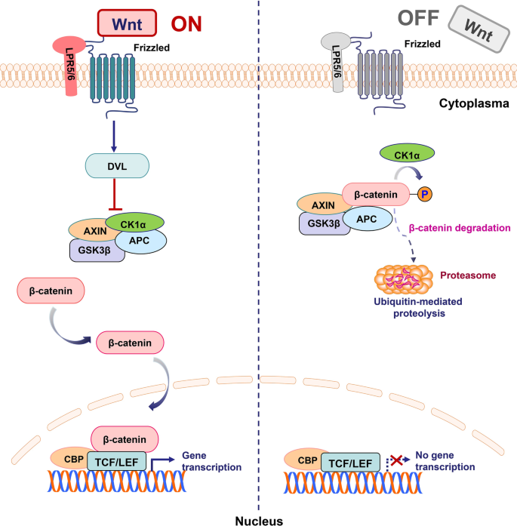
Figure 1: Wnt/ β-catenin signaling pathway (Y. Zhang & Wang, 20
When the ligand Wnt is present, β-catenin will not 20) be degraded by the AXIN complex. β-catenin when present can be relocated from the cytoplasm into the nucleus of the cell where acts as a transcription factor to turn on transcription.

Myosin Light Chain 7 Maturation Marker
Myosin Light Chain 7 (MYL7) is used as a maturation marker for iPSC-CMs because it is present in healthy human adult atrial cardiac cells. The cells used in this project were human iPSCs genetically modified to express MYL7 fluorescently labeled with mEGFP, as shown in Figure 2, which allows for live cell imaging of MYL7 protein expression.
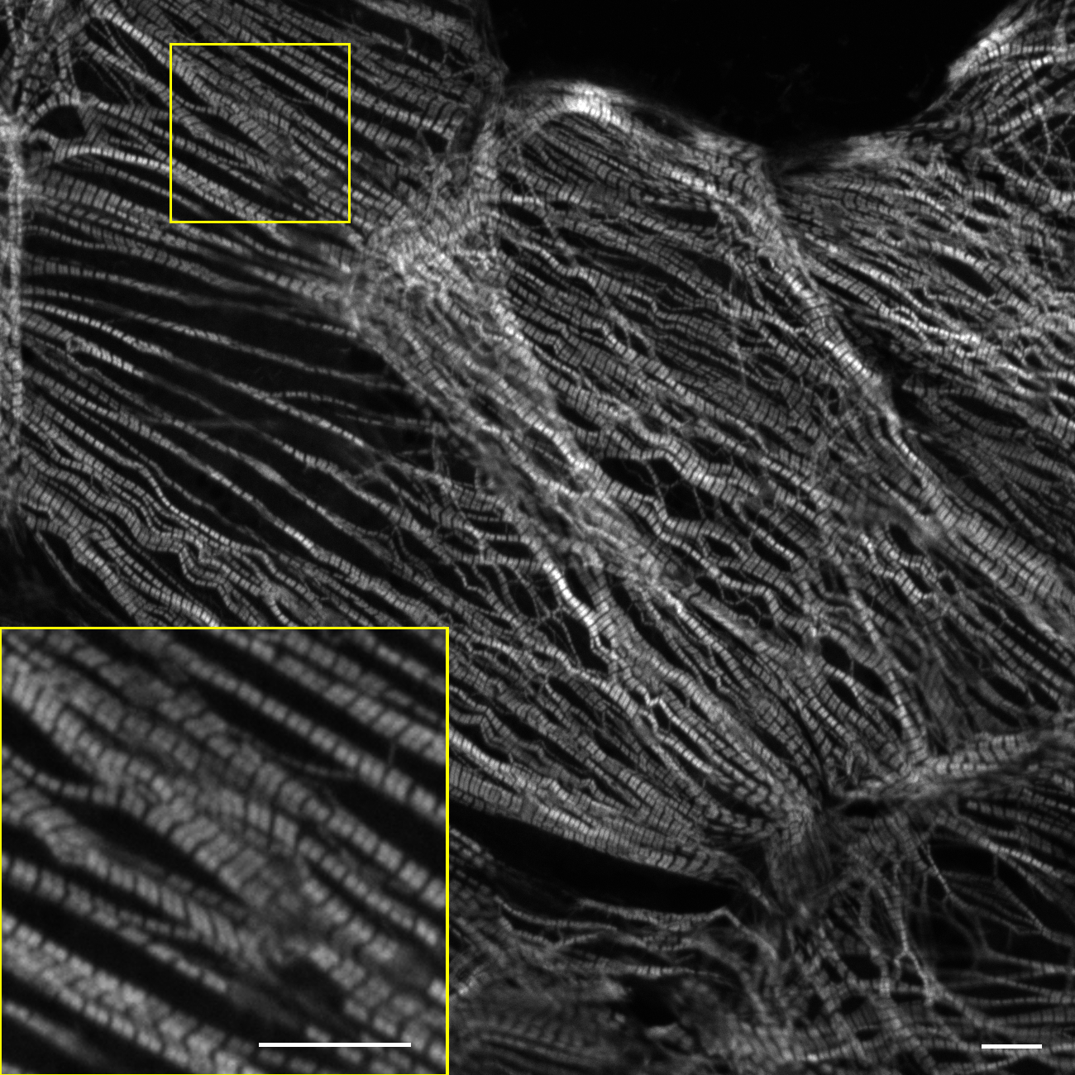
Figure 2: hiPSC-CM express mEGFP-tagged MYL7
Image is of human iPSC-CMs at day 32 of differentiation expressing MYL7 fluorescently labeled with mEGFP (image from the Allen Institute website). Cells were plated on glass coated with laminin and imaged using a confocal microscope 20 days after replating onto glass.
Specific Aims
The aim of this project is to investigate if the current iPSC-CM standard protocol can be improved upon using rationally-selected ECM proteins. The data collected will provide insight into determining whether ECM proteins can improve the speed of differentiation as well as the maturity of the iPSC-CM through the following two specific aims:
Aim 1: Can the speed of early iPSC-CM differentiation be improved when cultured on different ECM proteins?

Aim 2: Can maturity of early iPSC-CM be improved by culture on ECM proteins?
Materials and Methods
iPSC-CM Differentiation & Culture
WTC-11 iPSC cells genetically modified to express MYL7 (developed by the Allen Institute and distributed by the Stem Cell Research and Technology Resource Center, CU Boulder) were cultured using the widely cited Lian et al., 2013 protocol, with minor modifications. The Matrigel the cells were normally cultured on was substituted with multiple ECM proteins: Plates were coated with an ECM substrate at a concentration shown to be effective at supporting hiPSCs, overnight at 4°C: Collagen IV mouse (10 µg/ml;Corning), mouse Laminin-111 (50 µg/ml; Invitrogen), Laminin-221 (7 µg/ml; BioLamina), Laminin-332 (7 µg/ml; BioLamina), Laminin-521 (7 µg/ml; BioLamina), Laminin-221 + 521 (7 µg/ml; BioLamina), Laminin-211 (7 µg/ml; BioLamina), Matrigel (BD Biosciences). Once cells grew to confluency of at least 80%, 12 µM CHIR99021 RPMI/B27-insulin media replaced the maintenance media, mTeSR. CHIR99021 activates the Wnt pathway by inhibiting GSK3, a Wnt inhibitor. This is considered day 0 of iPSC-CM differentiation. Exactly 24 hours after the addition of CHIR99021 RPMI/B27-insulin media, the media was aspirated and RPMI/B27-insulin media was added to the wells. On day 3, combined media was made using half of the media in the wells added with new media and the reagent IWP2. IWP2 is a Wnt signaling pathway inhibitor and was used to promote cardiomyocyte differentiation. Starting on day 7 of differentiation, the media was switched to RPMI/B27 (+ insulin) and changed every three days until the end of culturing.

Provi Microscope
The plate of cells was monitored the first twelve days of differentiation using an in incubator Provi microscope (Stem Cell Research and Technology Resource Center, CU Boulder). The microscope was programmed to take bright field images at 4X and record the confluency of the wells every 3 hours, every day.

Fluorescent Imaging of Maturation Marker MYL7
WTC-11 iPSC cells genetically modified to fluorescently express the cardiac maturation marker MYL7 were differentiated into iPSC-CM and at day 31 were imaged using an Olympus IX83 microscope (Stem Cell Research and Technology Resource Center, CU Boulder). Live cells were imaged at 4X magnification.
Results
5.1 iPSC-CM can grow to confluency on different ECM proteins
The confluency of the wells was measured every three hours every day with a Provi microscope in the incubator seen in Figure 3. The iPSC-CMs were able to grow on the substrate. Seven ECM proteins were tested alongside a Matrigel control. Four of the ECM proteins grew to confluency as well as the Matrigel control. Laminin-332, Laminin-521, and Laminin-221 + 521 grew to 100% confluency within two days of differentiation. Matrigel grew to 80% confluency by day 6 of differentiation. Mouse Laminin-111 was able to expand but was not consistently above 80% confluency. Not shown in Figure 3 are Laminin-221 and Laminin-211 because the cells were unable to grow on the substrate and had a confluency of 0%.

Figure 3: iPSCs successfully expanded upon multiple extracellular matrix proteins during early cardiomyocyte differentiation. iPSC-CMs were differentiated on eight different substrates and the confluency was measured every three hours for twelve days using a Provi microscope in the incubator.

5.2: Over time iPSC-CMs expand on select ECM proteins
The wells were imaged after each media change using bright field microscopy at 4X magnification seen in Figure 4. Over time confluency and differentiation was observed. On mouse Laminin-111, and Matrigel, iPSCs became detached from Day 0 to Day 1 of differentiation. iPSCs on Laminin-332, Laminin-521, and Laminin-221 + 521 maintained a high confluency Day 0 to Day 1 of differentiation. By day 20 of differentiation, all the iPSCs on the different substrates had differentiated heterogenous multicellular structures. The areas where contractions were observed expanded from day 20 to day 32 of differentiation for Laminin-332, Laminin-521, Laminin-221 + 521, and Matrigel. Contractions of iPSC-CMs cultured on mouse Laminin-111 did not expand large regions of the well but rather remained as small isolated islands of contractions. The regions where contractions presented originally had lifted edges by day 32 of differentiation.
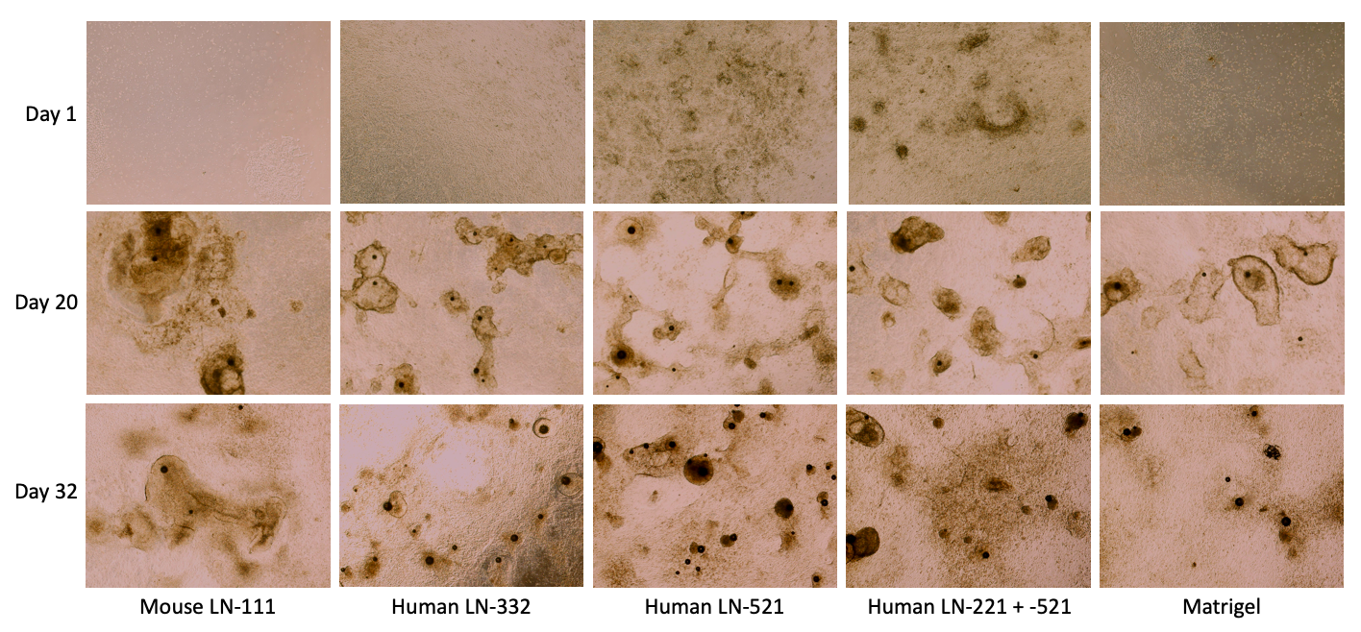
Figure 4: iPSCs expand upon select extracellular matrix proteins over the course of cardiomyocyte differentiation. iPSC-CMs cultured on different substrates, including different laminins (LN) or Matrigel (control), were imaged using bright field microscopy at 4X magnification after media changes.

5.3 The onset of contraction was recorded for each well
Using bright field microscopy at 4X, the cells were monitored for contraction before each media change, or typically every 3 days. Out of the seven ECMs tested, the cells differentiated on mouse LN-111, LN-332, LN-521, and LN-221 + 521 had contractions occur, seen in Table 2. Contractions were observed in the Matrigel control. Contractions were not present in the cells cultured on ECM proteins LN-221, LN-211. iPSC-CMs differentiated on LN-221+521 and LN-521 showed the earliest days until contraction onset (9.5 ± 0.5 and 11 ± 2 days, respectively), both showing contractions earlier than the Matrigel control (12.5 +- 3.5 days). The last ECM substrate to show contractions was LN-332 and mouse LN-111, which took longer than the Matrigel control (14.5 ± 1.5 and 16 ± 1, respectively).
Table 2: The date of iPSC-CM contraction onset differs on the multiple ECM substrates. Contraction onset of iPSC-CM was monitored using bright field microscopy before media changes. The date of contraction onset was recorded.
*On these substrates contractions were never observed during the course of the experiment, where iPSC-CM differentiation was carried out for 42 days total.
ECM Substrate | Average Days of Differentiation Until Contraction Onset
Mouse LN-111 | 16 ± 1
LN-332 | 14.5 ± 1.5
LN-521 | 11 ± 2
LN-221 + 521 | 9.5 ± 0.5
Matrigel | 12.5 ± 3.5
LN-221 | Never observed*
LN-211 | Never observed*
Collagen IV Mouse | Never observed*

5.4: Expression of iPSC-CM maturation marker MYL7
To assess the maturation of the iPSC-CM differentiated on different ECM substrates, live cell fluorescent imaging was performed to determine expression of maturation marker MYL7. Imaging was performed at 4X magnification on an iPSC line (WTC11) previously genetically modified to express MYL7 (obtained from the Allen Institute, and distributed by the Stem Cell Research and Technology Resource Center at CU Boulder) at day 31 of iPSC-CM differentiation (Figure 5). MYL7 expression was visualized in iPSC-CMs cultured on mouse Laminin-111, Laminin-332, Laminin-521, Laminin-221 + 521 as well as matrigel, via mEGFP fluorescence. Fluorescence was observed in wells where cells were able to grow to confluency above 80% and wells where contractions were observed.
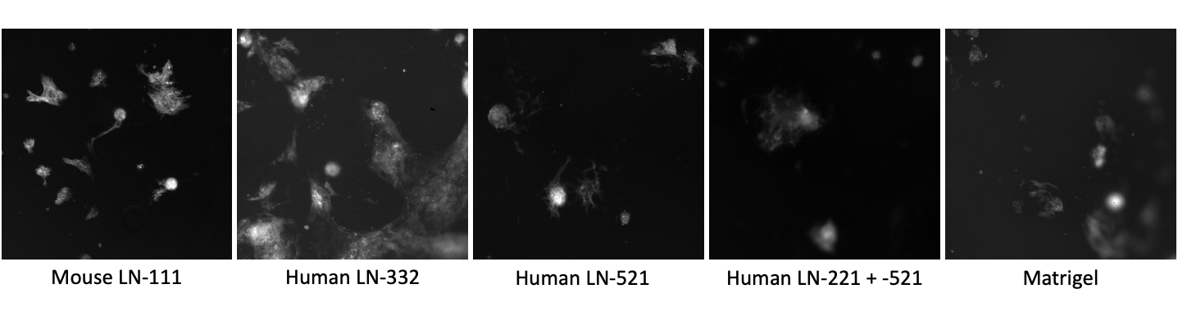
Figure 5: iPSCs express cardiomyocyte marker MYL7 via mEGFP during cardiomyocyte differentiation on select extracellular matrix proteins. MYL7 fluorescent marker expression was imaged on day 31 of differentiation using an Olympus IX83 microscope at 4X magnification.
Discussion and Future Directions
To create more consistent, robust differentiation protocols, which are essential for clinical translation, it may be best to avoid Matrigel because of its lot-to-lot variability and the presence of mouse proteins. The lot-to-lot variability likely impacts the reliability of iPSC-CM differentiation results. Of the seven ECM proteins tested, we found three could successfully support early iPSC-CM in terms of growing to confluency, demonstrating these substrates may be useful for early iPSC-CM differentiation. Laminin-332, Laminin-521, and the combination of Laminin-221+521 were able to grow to 100% confluency by day 2 of differentiation. The Matrigel control was also able to grow to confluency but at a longer time scale and had a maximum confluency of 94.37%. It took Matrigel until day 6 to be at a confluency above 80%. Multiple substrates performed better than Matrigel when comparing percent confluency. All three of the ECM proteins are human proteins which could provide an advantage over Matrigel.
Date of contraction onset was recorded, it was found both Laminin-521 (11 days) and Laminin-221 + 521 (9.5 days) had contraction date onsets earlier than Matrigel (12.5 days), seen in Table 2. These substrates out-performing Matrigel is notable since Matrigel is a combination of multiple ECM proteins and growth factors, whereas Laminin-221 + 521 and Laminin-521 are purified, individual ECM proteins. The other substrates mouse Laminin-111 and Laminin-332 had contraction dates later than Matrigel (16 days and 14.5 respectively). The variability in time for contraction onset is higher in Matrigel (± 3 days) possibly suggesting that a defined substrate leads to less variability in iPSC-CM differentiation. LN-221+521 had the lowest variability (± 0.5 days) as well as the soonest contractions observed (9.5 days). The other ECM proteins with contractions had less variability compared to Matrigel as well. Mouse Laminin-111 had a ±1 day variability, Laminin-332 had ±1.5 day variability, Laminin-521 had a ±2 day variability. It is promising Laminin-221+521 and Laminin-521 not only showed earlier dates of onset of contraction, but less variability as well, compared to Matrigel.
Expression of maturation marker MYL7 was seen in mouse Laminin-111, Laminin-332, Laminin-521, Laminin 221+521, as well as in the Matrigel control seen in figure 5. Each well all had similar expression of MYL7 at the timepoints when fluorescence microscopy was observed. A quantitative analysis was not performed. A future step would be a quantitative analysis (measuring areas of fluorescence over time), and measuring the date of first fluorescence for each condition, to see how it potentially matches the date of contraction onset. Quantitative analysis would show which condition has a higher expression level of the maturation marker, suggesting which is more supportive of mature iPSC-CMs. A mistake made is that a nuclear marker was not used, like Hoechst, which would have allowed us to quantify the percentage of cells that expressed MYL7. The only time point MYL7 was checked was late in differentiation at day 31. The iPSC-CMs grown on mouse Laminin-111, Laminin-332, Laminin-521, Laminin-221+521, and the Matrigel control all fluorescently expressed MYL7 at day 31 of differentiation. These ECM proteins were the best performers out of the tested substrates in terms of onset of contraction and had the highest confluency over time.
Out of the seven ECM substrates tested, four of them; Laminin-221+521, Laminin-521, Laminin-332, and mouse Laminin-111, were able to grow to a confluency, had contractions present, and expressed maturation marker MYL7. The mixture of Laminin 221+521 had contractions at the earliest date of differentiation and showed the least variability in time it took for contractions to begin (9.5 days ± 0.5). The iPSC-CMs grown on Laminin-221+521 had grown to a confluency of 100% by day 2 of differentiation. The ECM proteins with iPSC-CMs present all had similar levels of MYL7 expression. Retesting these four ECM proteins will be important in determining possible substrate candidates for improving iPSC-CM differentiation protocols.
Future directions for this project to better elucidate which substrate can be used for the highest yield in mature iPSC-CM include retesting ECM proteins where iPSCs were differentiated into CM. Early time points of MYL7 expression could be assessed to investigate which substrate leads to earlier maturation. Further experiments could include RT-qPCR at different time points of differentiation for maturation genes completed on iPSC-CM grown on select ECM proteins will give quantifiable data on the level the gene is being expressed and which substrate begins expressing genes earlier. Another test for maturation of iPSC-CM is a myosin separating gel. A myosin separating gel separates the different isoforms of myosin protein allowing you to quantify the percentage of each. Healthy human cardiac cells are approximately 90% β myosin and 10% α myosin (Deacon et al., 2012). Further analysis is necessary to determine if culture on ECM proteins improve iPSC-CM differentiation.
This honors thesis project aimed to investigate how human iPSC-CM differentiation is impacted by the ECM. Improvement of the differentiation protocol was measured by testing for speed of differentiation and maturation of iPSC-CMs. Speed was measured by analyzing speed at which a high percent confluency was achieved on each substrate and the date of contraction onset. Maturation was measured by MYL7 marker expression. Laminin-221+521 and Laminin-521 performed better to improve iPSC-CM differentiation compared to Matrigel. Both substrates had quicker onset of contraction when compared to Matrigel. Confluency of both Laminin-221+521 and Laminin-521 had a confluency of 100% by day two of differentiation while Matrigel did not reach a confluency of 80% until day 6 of differentiation. Laminin 221+521 had the quickest onset of contractions (day 9) and Laminin-521 had the second quickest (day 11). MYL7 expression was present in both iPSC-CM cultured on Laminin-221+521 and Laminin-521. ECM substrates can be used to improve iPSC-CM differentiation protocols by creating accurate cellular models and by making better heart tissues for regenerative medicine/heart transplant efforts. ECM proteins hold the advantage of being defined and being xeno-free over Matrigel. It is possible that by using an alternative substrate, such as other specific ECM protein(s), the maturity and efficiency of the differentiation process may be improved.
Acknowledgments
This project was funded by Undergraduate Research Opportunities Program (UROP).
Thank you to Dr. Teisha Rowland for being the most incredible mentor. Dr. Rowland began my research journey and has spent countless hours assisting me with writing UROP grants, planning projects, teaching me iPSC culture, analyzing data, and so much more. Without Dr. Rowland’s guidance and support I would not have had the undergraduate lab experience that I had. I am so grateful for Dr. Rowlands’s dedication to teaching me and best preparing me for research in the future.
Thank you to Dr. Leinwand for allowing me to join her lab in the Summer of 2021. Joining the lab gave me the opportunity to continue research and broadened my knowledge of experimental techniques learned in my MCDB courses. I feel incredibly privileged to be a member of the prestigious Leinwand lab and it has further prepared and excited me for graduate school.
Thank you to Xinyi Fu, my graduate mentor in the Leinwand lab, who spent many hours helping me with my project. She encouraged me and taught me an incredible amount about iPSC culture. Thank you to Dr. Kristen Bjorkman, who is currently teaching me RT-qPCR in the Leinwand lab. She has a talent for teaching and has been generous with her time.
Thank you to the rest of the Leinwand lab for being supportive and making my time spent in the lab so enjoyable. The wonderful community of the Leinwand lab solidified my decision to pursue graduate school.
Thank you to Dr. Martin for being an incredible MCDB professor and for your keeping me on track while writing my Honors Thesis.
Thank you to Dr. Vigers for being the amazing professor you are. Taking your courses have been the highlight of my undergraduate academic career. Your support during graduate school applications is so appreciated.

References
Belkin, A. M., Zhidkova, N. I., Balzac, F., Altruda, F., Tomatis, D., Maier, A., Tarone, G., Koteliansky, V. E., & Burridge, K. (1996). Beta 1D integrin displaces the beta 1A isoform in striated muscles: localization at junctional structures and signaling potential in nonmuscle cells. The Journal of cell biology, 132(1-2), 211–226. https://doi.org/10.1083/jcb.132.1.211

Bildyug N. (2019). Extracellular Matrix in Regulation of Contractile System in Cardiomyocytes. International journal of molecular sciences, 20(20), 5054. https://doi.org/10.3390/ijms20205054

Bowers, S. L., & Baudino, T. A. (2012). Cardiac myocyte-fibroblast interactions and the coronary vasculature. Journal of cardiovascular translational research, 5(6), 783–793. https://doi.org/10.1007/s12265-012-9407-2

Burridge, P. W., Matsa, E., Shukla, P., Lin, Z. C., Churko, J. M., Ebert, A. D., Lan, F., Diecke, S., Huber, B., Mordwinkin, N. M., Plews, J. R., Abilez, O. J., Cui, B., Gold, J. D., & Wu, J. C. (2014). Chemically defined generation of human cardiomyocytes. Nature methods, 11(8), 855–860. https://doi.org/10.1038/nmeth.2999

Deacon, J. C., Bloemink, M. J., Rezavandi, H., Geeves, M. A., & Leinwand, L. A. (2012). Identification of functional differences between recombinant human α and β cardiac myosin motors. Cellular and molecular life sciences : CMLS, 69(13), 2261–2277. https://doi.org/10.1007/s00018-012-0927-3

Guilak, F., Cohen, D. M., Estes, B. T., Gimble, J. M., Liedtke, W., & Chen, C. S. (2009). Control of stem cell fate by physical interactions with the extracellular matrix. Cell stem cell, 5(1), 17–26. https://doi.org/10.1016/j.stem.2009.06.016

Gullberg, D., Gehlsen, K. R., Turner, D. C., Ahlén, K., Zijenah, L. S., Barnes, M. J., & Rubin, K. (1992). Analysis of alpha 1 beta 1, alpha 2 beta 1 and alpha 3 beta 1 integrins in cell--collagen interactions: identification of conformation dependent alpha 1 beta 1 binding sites in collagen type I. The EMBO journal, 11(11), 3865–3873.

Guyette, J. P., Charest, J. M., Mills, R. W., Jank, B. J., Moser, P. T., Gilpin, S. E., Gershlak, J. R., Okamoto, T., Gonzalez, G., Milan, D. J., Gaudette, G. R., & Ott, H. C. (2016). Bioengineering Human Myocardium on Native Extracellular Matrix. Circulation research, 118(1), 56–72. https://doi.org/10.1161/CIRCRESAHA.115.306874

Heino J. (2014). Cellular signaling by collagen-binding integrins. Advances in experimental medicine and biology, 819, 143–155. https://doi.org/10.1007/978-94-017-9153-3_10

Herron, T. J., Rocha, A. M., Campbell, K. F., Ponce-Balbuena, D., Willis, B. C., Guerrero-Serna, G., Liu, Q., Klos, M., Musa, H., Zarzoso, M., Bizy, A., Furness, J., Anumonwo, J., Mironov, S., & Jalife, J. (2016). Extracellular Matrix-Mediated Maturation of Human Pluripotent Stem Cell-Derived Cardiac Monolayer Structure and Electrophysiological Function. Circulation. Arrhythmia and electrophysiology, 9(4), e003638. https://doi.org/10.1161/CIRCEP.113.003638

Lian, X., Zhang, J., Azarin, S. M., Zhu, K., Hazeltine, L. B., Bao, X., Hsiao, C., Kamp, T. J., & Palecek, S. P. (2013). Directed cardiomyocyte differentiation from human pluripotent stem cells by modulating Wnt/β-catenin signaling under fully defined conditions. Nature protocols, 8(1), 162–175. https://doi.org/10.1038/nprot.2012.150

Miner, J. H., & Yurchenco, P. D. (2004). Laminin functions in tissue morphogenesis. Annual review of cell and developmental biology, 20, 255–284. https://doi.org/10.1146/annurev.cellbio.20.010403.094555

Naito, A. T., Shiojima, I., Akazawa, H., Hidaka, K., Morisaki, T., Kikuchi, A., & Komuro, I. (2006). Developmental stage-specific biphasic roles of Wnt/beta-catenin signaling in cardiomyogenesis and hematopoiesis. Proceedings of the National Academy of Sciences of the United States of America, 103(52), 19812–19817. https://doi.org/10.1073/pnas.0605768103

Nguyen-Truong, M., & Wang, Z. (2018). Biomechanical Properties and Mechanobiology of Cardiac ECM. Advances in experimental medicine and biology, 1098, 1–19. https://doi.org/10.1007/978-3-319-97421-7_1

Rodin, S., Antonsson, L., Niaudet, C., Simonson, O. E., Salmela, E., Hansson, E. M., Domogatskaya, A., Xiao, Z., Damdimopoulou, P., Sheikhi, M., Inzunza, J., Nilsson, A. S., Baker, D., Kuiper, R., Sun, Y., Blennow, E., Nordenskjöld, M., Grinnemo, K. H., Kere, J., Betsholtz, C., … Tryggvason, K. (2014). Clonal culturing of human embryonic stem cells on laminin-521/E-cadherin matrix in defined and xeno-free environment. Nature communications, 5, 3195. https://doi.org/10.1038/ncomms4195

Rowland, T. J., Miller, L. M., Blaschke, A. J., Doss, E. L., Bonham, A. J., Hikita, S. T., Johnson, L. V., & Clegg, D. O. (2010). Roles of integrins in human induced pluripotent stem cell growth on Matrigel and vitronectin. Stem cells and development, 19(8), 1231–1240. https://doi.org/10.1089/scd.2009.0328

Sung, T. C., Li, H. F., Higuchi, A., Kumar, S. S., Ling, Q. D., Wu, Y. W., Burnouf, T., Nasu, M., Umezawa, A., Lee, K. F., Wang, H. C., Chang, Y., & Hsu, S. T. (2020). Effect of cell culture biomaterials for completely xeno-free generation of human induced pluripotent stem cells. Biomaterials, 230, 119638. https://doi.org/10.1016/j.biomaterials.2019.119638

Sung, T. C., , Liu, C. H., , Huang, W. L., , Lee, Y. C., , Kumar, S. S., , Chang, Y., , Ling, Q. D., , Hsu, S. T., , & Higuchi, A., (2019). Efficient differentiation of human ES and iPS cells into cardiomyocytes on biomaterials under xeno-free conditions. Biomaterials science, 7(12), 5467–5481. https://doi.org/10.1039/c9bm00817a

Suzuki, N., Yokoyama, F., & Nomizu, M. (2005). Functional sites in the laminin alpha chains. Connective tissue research, 46(3), 142–152. https://doi.org/10.1080/03008200591008527

Timpl, R., Tisi, D., Talts, J. F., Andac, Z., Sasaki, T., & Hohenester, E. (2000). Structure and function of laminin LG modules. Matrix biology : journal of the International Society for Matrix Biology, 19(4), 309–317. https://doi.org/10.1016/s0945-053x(00)00072-x

Villarreal, F. J., & Dillmann, W. H. (1992). Cardiac hypertrophy-induced changes in mRNA levels for TGF-beta 1, fibronectin, and collagen. The American journal of physiology, 262(6 Pt 2), H1861–H1866. https://doi.org/10.1152/ajpheart.1992.262.6.H1861

Yap, L., Tay, H. G., Nguyen, M., Tjin, M. S., & Tryggvason, K. (2019). Laminins in Cellular Differentiation. Trends in cell biology, 29(12), 987–1000. https://doi.org/10.1016/j.tcb.2019.10.001

Zhang, J., Klos, M., Wilson, G. F., Herman, A. M., Lian, X., Raval, K. K., Barron, M. R., Hou, L., Soerens, A. G., Yu, J., Palecek, S. P., Lyons, G. E., Thomson, J. A., Herron, T. J., Jalife, J., & Kamp, T. J. (2012). Extracellular matrix promotes highly efficient cardiac differentiation of human pluripotent stem cells: the matrix sandwich method. Circulation research, 111(9), 1125–1136. https://doi.org/10.1161/CIRCRESAHA.112.273144

Zhang, Y., & Wang, X. (2020). Targeting the Wnt/β-catenin signaling pathway in cancer. Journal of hematology & oncology, 13(1), 165. https://doi.org/10.1186/s13045-020-00990-3

