Regeneration of Ponderosa Pine Within the Southern Rocky Mountains

By Mykael Pineda
Geography, University of Colorado at Boulder

Defense Date (April 4th, 2022)

Thesis Advisor:
Holly Barnard, Geography

Defense Committee:
Dr. Holly Barnard (GEOG)
Dr. Carol Wessman (EBIO/ENVS)
Dr. William Travis (GEOG)
Dr. Teresa Chapman (NVM)

1.1 Introduction
Pre-colonial ponderosa pine (Pinus ponderosa) dominant coniferous forests in the southern Rocky Mountains of the United States (U.S.) are adapted to fire regimes characterized by low to mixed severity and high frequency wildfires with a mean fire interval of about 30 years (Bailey and Covington, 2002; Chapman, 2020; Malone, 2018; McKinney and Missoula, 2019.). These burns in the southern Rocky Mountains vary in size, intensity, duration, and seasonality to create macro- and micro- environmental heterogeneity (Bonnet et al. 2005; Prichard, 2021). The resulting compositional and structural diversity limit the extent of stand-replacing fire events (Coop, 2019; Malone, 2018; Prichard, 2021). However, U.S. land use and management in the 20th century has been marked by a disruption of the natural fire regimes due to logging, livestock grazing, and fire preventative actions. This has led to increased tree survival and an increase in stand density during the 20th century; in some places stand density has increased more than 300% (Bailey and Covington, 2002). As a result, ponderosa pine forests in the southern Rocky Mountains have experienced changes in their structure, composition, and processes, including increased fuel loading from the accumulation of surface and ladder fuels (Prichard, 2021; Stewart, 2021).
Mature ponderosa pine trees exhibit fire-adaptive traits that improve their resilience and recovery from fire such as: thick, insulating bark that flakes, deep roots, open crown structure, and the ability to self-prune (Coop, 2019; Fitzgerald, 2005). Their regeneration methods have also evolved around fire. Ponderosa pine trees that survive fire shape the spatial recovery by providing seeds for post-fire regeneration (Chapman, 2020; Stewart, 2021). As a seed-obligate conifer, ponderosa pine relies on seeding to repopulate; rates are regulated by the presence of sufficient seed producing adults (Bailey and Covington, 2002). Seedlings are most abundant less than 50 meters from a viable seed source, and widespread dispersal depends on wind or animal factors (Rother and Veblen 2016; Rodman, 2020). However, it has been concluded that greater seedling densities are found in the burned, compared to unburned, areas (Bonnet et al. 2005). The ability of a ponderosa pine seed to successfully germinate is based on multiple factors that fall under post-fire environmental conditions. Regular surface fires aid in preparing seedbeds for ponderosa pine by reducing grass competition and increasing soil nutrients (Bailey and Covington, 2002; Bonnet et al. 2005). Reduced vegetation competition allows the seedlings to become the primary successors of the area and establish themselves. The fire itself improves the seedbed receptivity, which can be defined by the established number of germinants (Grossnickle and Ivetić, 2017), by creating burned mineral soil within microclimates.

Ponderosa pine post-fire regeneration in large, high severity fire scars has become limited, suggesting that forest recovery may be delayed or not occurring at all, due in part to insubstantial post-fire surviving canopy (Malone, 2018; Rodman, 2020; Rother and Veblen, 2016). With changing climate patterns, there has been an increase in areas burned, accompanied by an increase in the proportion of crown fires; this creates sizable areas without a nearby seed source, making natural regeneration inadequate (North, 2019) and becoming a catalyst for vegetation change (Prichard, 2021). Changes in fire regimes can also leave the well-adapted ponderosa pine highly vulnerable because of the increased homogeneity across coniferous forests and reduction in post-fire surviving trees. (Chapman, 2020; Coop, 2019).

Along with a change in fire regime, ponderosa pine establishment, seedling growth and survivorship is sensitive to post-fire environmental conditions (Stewart, 2021). Climate warming is creating local post-fire environmental conditions outside of the regeneration niche of this dominant tree species (Coop, 2020). In the last few decades, there has been a decrease in summer precipitation and an increase in aridity driven by anthropogenic climate change within the western United States (Rodman et al. 2020). Ponderosa pine, within refugia, that become stressed from their surrounding environment, specifically with a drier climate, may mitigate the allocation of their carbon resources to further establish themselves in their environment (e.g., put carbon towards deeper root growth), rather than produce seeds through a stress-induced cone mast (Lauder et al. 2019). It has been found that inter-annual variation in seed production corresponds with climate factors including temperature and moisture, affecting critical phenological events during the reproductive cycle (Keyes and González, 2015). On average, mature ponderosa pine will produce sufficient seed for regeneration once or twice a decade (Bailey and Covington, 2002) if met with the right conditions, but the reproductive cone cycle itself is completed over a period exceeding two years (Keyes and González, 2015).

Being able to recruit enough ponderosa pine seedlings is a persistent challenge for managers seeking to naturally regenerate the species throughout the southern Rocky Mountains (Keyes and González, 2015). According to the National Forest Management Act, current US Forest Service nursery practices estimate that full site occupancy for ponderosa pine has a maximum of 35-55% on the Stand Density Index (SDI) to maintain healthy competition between trees (“FS.USDA”, 2022). To reach this maximum, onsite preparation, management of competing vegetation, and establishing regularly spaced trees is required for the first five years (North, 2019). However, many other planting programs put effort into planting ponderosa pine seedlings, but maintenance of the reforested site is uncommon past a few months (Castro, 2021). This can lead to large areas of coniferous forest that remain without a seed source for years if the seedlings fail to establish. Cohesive forest management amongst different organizations to propel ponderosa pine seedling establishment is especially critical in the 21st century as anthropogenic climate change and high severity, high frequency forest fires continue to ravage the western United States.

To advance the science of forest recovery following wildfires in ponderosa pine forests in this research project, I asked the two research questions: 1) Conducting a field experiment, what is the establishment rate of directly seeding of ponderosa pine seeds in a year-old fire and a two-decade old fire? and 2) Conducting a GIS analysis, where is traditional planting of seedlings and potential direct seeding most likely to occur in burned areas across the southern Rockies between 1984 and 2020? The combined results from this study have the potential to help forest managers address the different post-fire regeneration needs within fire scars and identify new methods to address gaps in management’s ability to reforest areas needing recovery assistance after wildfires. Identifying key spatial areas where traditional reforestation methods may be difficult can help forest managers identify what areas may not recover naturally or be planted by USFS crews and help managers calculate how much areas within wildfires may transition to non-forest..
2.0 Methods
2.1 Field Experiment
2.1.1 Study Sites
In collaboration with The Nature Conservancy, I experimentally tested the germination and establishment of ponderosa pine seeds in recent and two-decade-old scars from high severity fire using variations of seed stratifications, seed coatings, and planting seasons. My field experiment was conducted within two fires scars in Colorado’s Front Range in montane, ponderosa pine-dominated forest: 1) the Bobcat Gulch Fire (burned in 2000) and 2) the Calwood Fire (burned in 2020) (Figure 1). Both sites experienced moderate- to high-severities burns, were dominated by ponderosa pine prior to burning, and were accessible by nearby roads. The Bobcat Gulch fire was started by lightning in June of 2000, burned 9,700 ha (~24,000 acres), and resulted in large areas of forest mortality. The burn scar is located ~27.36 km west of the city of Fort Collins. In 2020, Calwood Education Center experienced an unknown ignition within their ponderosa pine forests. From October 17th to November 14th, strong winds aided in the fire burning 4,087 ha (~10,100 acres). On the property, 26 structures were lost to the fire. The burn scar is located ~16.1 km northwest of the city of Boulder.

2.1.2 Bobcat Gulch Field Design
Within the 2000 Bobcat Gulch fire scar, we selected ten sites based on four criteria, including: 1) 100% mortality of the surrounding forest (high-severity burn), 2) variation in slope aspects, 3) road accessibility (less than 400 m), and 4) avoidance of areas of previous research by the forest service. At each plot, there were six transects; two transects were set out and were randomly assigned to one of three seasons for seed dispersal: Fall 1, Fall 2, Spring 1, Spring 2, Summer 1, Summer 2. Each seasonal transect varied in length depending on which treatments were suitable for a specific season (Figure 2.). The Fall and Summer transects were 32m long because they had four different seed treatment groups; the Spring transects were 64 m long because they had eight different seed treatment groups. Along each transect, we established micro-transects every four meters. Two replicates of each treatment combination were randomly assigned to micro-transects. Each micro-transect consisted of four plastic rings, 10cm in diameter, separated one meter apart, arranged perpendicular to the transect. Within each ring, ten seeds of a specific treatment combination were placed and tagged.

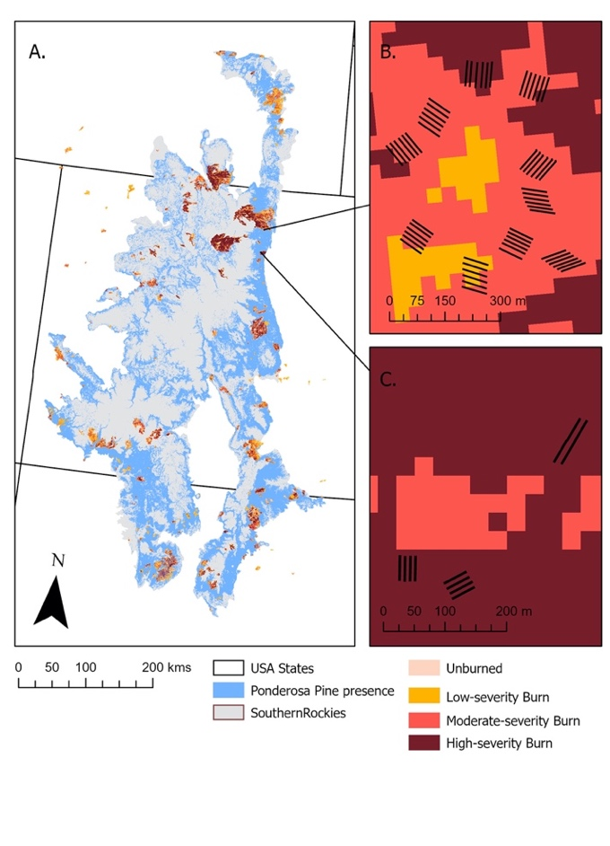 | Figure 1. This study map represents the overall study site of the southern Rocky Mountains (A) and its presence of ponderosa pine trees and burn scars from 1984-2020. The two burns in Colorado chosen for this research are also represented; (B) is Bobcat Gulch and (C) is Calwood Education Center. The location of each burn site is shown within the southern Rocky Mountains and where the plots were laid inside of the scar. Each burn scar is also colored to represent the severity of burn it received during its corresponding fire.  Study map of transects within the designated burn scars and their location in the southern Rocky Mountains.

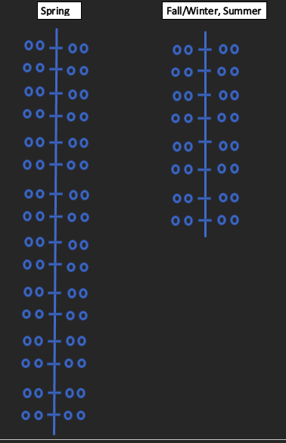
Figure 2. Schematic of transect study design at the Bobcat Gulch and Calwood field experiments. The Fall/Winter and Summer transects were 32 m in length and had 8 micro-transects. Spring transects were 64m in length and had 16 micro-transects.

2.1.3 Bobcat Gulch Seed Treatments
We used seeds collected in 2019 from Larimer County, the same county as the Bobcat Gulch fire. The seed lot had an 89% germination rate as measured by the Atlanta USDA seed lab in 2020. The three factors that made up the treatment combinations are: 1) whether seeds were partially stratified, 2) whether seeds were placed in a protected seedball case, and 3) if the seeds were coated to repel predators. The eight different combinations of stratification, seedball, and coating were randomly replicated twice within each transect (Table 1).

The stratification treatment of ponderosa pine seeds exposed them to a wet, cold environment to mimic the winter season for 28-45 days; this pretreatment breaks the seed from dormancy by mimicking the climate of winter and early Spring (Duryea et al. 1984). Partial stratification places seeds in a process where they are soaked in water for 16-24 hours, placed in a refrigerator for up to 28 days, and then dried. Seedballs, the second factor, are protective cases made from wet clay and steer manure and were intended to provide protection and nutrients to the seed. Seeds were individually rolled into a small ball of this mix, about one inch across, and air dried. The seeds not encased were labeled “naked.” The anti-predator coating came from a non-disclosed company and includes chili pepper extract that stimulates chemoreceptors nerve endings that indicate pain, a capsaicin extract water dispersible (i.e., chili pepper extract), and fungicide 42-s Thiram (a liquid fungicide suggested for the use on seeds).

Each season had a different number of treatments based on personnel capacity to implement the experiment and predicted outcome of the different treatments across the seasonal differences (Table 1). The Fall seed treatment variations at Bobcat Gulch included four treatment combinations. None of the seeds dispersed at this time would be partially stratified because the seed would naturally experience this process over the winter and spring. Naked-uncoated-unstratified is a ponderosa pine seed without any treatments done to it. Naked-coated-unstratified is a seed coated in a either chili powder or the anti-predator coating depending on the site. Seedball-uncoated-unstratified is s seed rolled into the clay/manure mix. Seedball, coated, unstratified is the seedball coated in the correct chili pepper for its location.

The Spring seeding treatments at Bobcat Gulch had more variations because of personnel capability to apply all the factors of the seeds and the positive predicted outcome of using all the treatments (Table 1). Eight different treatment combinations were created that allowed all factors to be combined without repeating. The four combinations from the Fall: naked-uncoated-unstratified, naked-coated-unstratified, seedball-uncoated-unstratified, and seedball-coated-unstratified were used again. Along with the former combinations, the factor partially stratified was added to the treatments, creating four new combinations: naked-uncoated-partially stratified, naked-coated-partially stratified, seedball-uncoated-partially stratified, and seedball-coated-partially stratified.

Summer of 2021 was the last season of seeding; Bobcat Gulch’s Summer transects had four treatment combinations because the seeds were processed with coating and partial stratification (Table 1). The seedball was not used in the Summer because there would not have been enough time or the right climatic conditions to break down the casing. The Summer used the treatments: naked-uncoated-unstratified, naked-coated-unstratified, naked-uncoated-partially stratified, and naked-coated-partially stratified.

Table 1. Bobcat Gulch 2000 fire and Calwood 2020 fire seeding treatment combinations across three seasons.
Treatment Groups |  |  | Bobcat Gulch 2000 Fire |  |  | Calwood 2020 Fire
 |  |  | Fall | Spring | Summer | Fall | Spring | Summer
Naked | Uncoated | Unstratified | x | x | x | x | x
naked | Coated | unstratified | x | x | x | x
seedball | Uncoated | unstratified | x | x |  | x | x
seedball | coated | unstratified | x | x |  | x
naked | uncoated | partially stratified |  | x | x
naked | coated | partially stratified |  | x | x |  | x
seedball | uncoated | partially stratified |  | x
seedball | coated | partially stratified |  | x |  |  | x

The reason we included partially stratified seeds in the Spring and Summer, and not the Fall, is because the Fall seeds would go through the full stratification process naturally. The Spring and Summer seeds would not be exposed to cold temperatures as long, resulting in a delayed start in growth when weather became favorable. Within each season, seeding days were selected by proximity to favorable weather conditions that would reduce the time-period of exposure to predation or increase the rate of germination. In the Fall, Bobcat Gulch was seeded on December 21st, 2020 because the team waited to seed until a snow event was approaching within a couple of days. Spring seeding began when the snow from the winter and early Spring was sufficiently melted so sites could be accessed. Seeds were distributed at Bobcat Gulch on April 7th, 2021. Due to June and July drought conditions, early August became the best month to seed. The team waited until a couple of days before the first monsoon/rainy day and seeded the Summer transects on August 5th, 2021.

2.1.4 Calwood Fire Field Design
The Calwood Fire field methods differed from the Bobcat Gulch Fire because our team had limited time to prepare the plots following the unanticipated 2020 fire, resulting in fewer transects and treatments. The Fall transects included four sets of factors; again, none of the seeds dispersed at this time were partially stratified because the seed would naturally experience this process over the winter and Spring. Naked-uncoated-unstratified, naked-coated-unstratified, seedball-uncoated-unstratified, and seedball-coated-unstratified were the treatment combinations used the Calwood Fire location. The Spring treatments at Calwood were only four treatment combinations used for each transect. Naked-uncoated-unstratified, seedball-uncoated-unstratified, naked-coated-partially stratified, and seedball-coated-partially stratified were determined most likely to germinate in Calwood Spring conditions. The dates that direct seeding occurred at Calwood were within a few days after direct seeding at Bobcat Gulch. In the Fall season, the team waited to seed till a snow event was approaching and accessed Calwood on February 2nd, 2021. Spring seeding began when the snow from the winter and early Spring was sufficiently melted so sites could be accessed; seeds were distributed at Calwood on April 13th, 2021. Summer 2021 was the last season of seeding for our overall research. Our team did not have access and the ability to seed Calwood during that Summer because the USFS and Calwood staff were mulching the forest and removing dead trees from the site. Another difference between the Bobcat Gulch and Calwood treatments was the process of coating ponderosa pine seeds with anti-predatory treatments. Because of this later addition of plots at Calwood, our team did not have enough time to send seeds to out to be coated by a private contractor; instead, we coated seeds and seed balls with a cornstarch and cayenne pepper mixture to mimic the coating of the Bobcat Gulch seeds.

2.1.5 Monitoring
One month after the Spring seeding in April, our team began monitoring the Fall and Spring transects at both Bobcat Gulch and Calwood. Sites were visited every third week of the month, from May through September. The location of each plot was tracked on an iPad provided by The Nature Conservancy by coordinate locations and recorded data. Beginning with Plot 1, one person would work through one seasonal transect at a time. Starting at the beginning of a transect, a team member walked to the first micro-transect and checked the rings moving left to right along the micro-transect for a total of four rings. Data were collected in the designated rows on the number of germinants and whether seeds were still present. This process continued until the whole transect was recorded. At Bobcat Gulch, the team collected seed presence and germination data on ten plots once a month. At Calwood, there were three plots; however, during the summer months of June, July, and August our team could not access Calwood. The summer months of May and September were recorded.

2.2 ANOVA and Tukey Test:
Data consisted of two independent variables: 1) the mean maximum number of germinants (“germinant maximum” - defined as the highest number of total germinants in a treatment group along one transect in a monitoring period) and 2) the mean number of established seedlings in a treatment group along one transect (“established seeds” - defined by the number of seedlings that survived to the end of September). To evaluate the statistical significance of treatment groups (seed coating, casing, season, and stratification) on the germinant maximum, I used a three-way analysis of variance test because the seeds had multiple treatment groups with two levels for all except season, which had three. An alpha of 0.05 was used to test for significance in the ANOVA. After, a Tukey Post Hoc test was conducted to analyze the mean of an individual treatment and its influence on the data while the other treatments are held at a constant.

2.3 Landscape GIS Analysis:
To determine areas within the southern Rocky Mountains that would be suitable for post-fire using traditional planting of nursery-grown seedlings, I conducted a GIS suitability analysis of ponderosa pine landscapes (Figure 1). The southern Rocky Mountains is a “high-elevation mountainous ecoregion” that extends 138,854 km² (Drummond 2012), and encompasses 73.5 % of Colorado, 18 % of New Mexico, and 8.5 % of Wyoming (“Southern Rocky Mountains Ecoregion // LandScope America” et al. 2022). Elevation along this region ranges from 2,286 to 4,267 m and the overall precipitation averages between 61 - 71 cm annually, mostly in the form of snowfall (“Chapter 43-Ecological Subregions of the United States”, 2022; “Stand Density Index (USFS)”, 2022). As a temperate, semi-arid climate, the southern Rocky Mountains have an annual average temperature that ranges from 1.7 to 7.2 degrees Celsius ( Drummond, 2012; “Southern Rocky Mountains Ecoregion // LandScope America”, 2022).

I categorized the ponderosa pine landscapes with three important criteria: 1) presence of high severity fire that may not recover naturally, 2) distance to roads for ease of planting crews, and 3) slope for safety. I then removed areas previously planted to determine future planting potential. Areas that were not within suitable areas for traditional planting were considered prime locations for potential direct seeding. All layers were clipped to the Southern Rocky Mountain Ecoregion at a 30 m resolution and spatial analyses were conducted in ESRI’s arcPro software with a NAD 1983 Albers projection. To create a spatial layer of ponderosa pine presence, I downloaded the vegetation Biophysical Settings layer from USGS Landfire. In ArcGIS Pro, I selected vegetation types with presence of “Ponderosa pine” or “Dry Mixed Conifer”: I created a binary layer by reclassifying the raster to the presence (1) or absence (NoData) of ponderosa pine. To remove small, pixelated patches, I expanded the presence pixels by 3 cells (90 m). The final suitability layer was constrained to this ponderosa pine mask since my experimental methods only tested seeding with ponderosa pine seeds.

To create layers of burn severity in recent fires that may require reforestation, I downloaded burn severity mosaics from Monitoring Trends in Burn Severity (MTBS) from 1984 to 2019 for US. MTBS burn severity raster classifies pixels from Landsat satellite images at a 30 m resolution into one of five classes: unburned, low-severity (10-40% canopy mortality), moderate-severity (40-70% tree canopy mortality), high-severity (greater than 70% canopy mortality), and new growth. Because MTBS layers have a lag of two years to update recent fires and there was no data on Calwood, I updated the burn severity time series with data from the USFS RAVG composite burn index data in 2020 and 2021. These data sources are generated in a similar manner, using a 30m Landsat satellite images before and after wildfire to assess the degree of tree canopy mortality and soil burn. They also both provide an estimate of areas where reforestation may be required, by filtering the data to areas of high canopy tree mortality. To create a distance to roads layer, I collected road polylines from the 2016 US Census Bureau Tiger/Line Shapefile for roads and merged it with roads from the USFS roads database within the Southern Rockies. I created a Euclidean distance raster to road polylines. For a slope layer, I downloaded a 30 m slope raster from the Landfire website. The slope was generated from a 30 m elevation model.

To characterize the landscape by previously reforested areas, I used The USDA Forest Service (USFS) Forest Activity Tracking System (FACTS) database reforestation polygons and downloaded the silviculture polygons. I selected layer by location in the Southern Rockies and then select by attribute “plant trees” (called traditional planting polygons). The traditional planting polygons were used to generate descriptive statistics on the three landscape variables to create a suitability layer. For burn severity layer, I used the arcPro tool “tabulate area” to calculate the area of the different burn severity classes in traditional planting polygons. Traditional planting occurred 5 % in unburned areas, 14.6 % in low-severity, 26.5 % in moderate-severity, and 52.8 % in high-severity. Because traditional planting in unburned and low-severity areas is most likely not a priority, I used moderate- and high-severity burned areas in the suitability ranking. All moderate- and high-severity areas were reclassified as 1 and unburned and low-severity were reclassified as 0. All areas outside burned areas were NoData. I used the arcPro tool “zonal statistics as a table” to calculate the mean and standard deviations of the traditional planting polygons, the slope, and distance to roads layers. I created thresholds from the mean plus 2 standard deviations to create binary layers for the slope and distance to roads layers. Areas within the mean +/- two standard deviations (SD) were considered potential areas for traditional planting. I used these threshold values to create binary layers for distance to roads and slope. The mean slope for traditional planting was 9.2 degrees +- 6.8 SD for a total threshold slope value of 22.7 degrees. For the suitability ranking, slope values < = 22.7 degrees were reclassified to 1 and greater values were reclassified to 0. For the distance to road layer, the mean distance for traditional planting polygons was of 286.1 m and the SD was 304.7. For the suitability ranking, distance to road values <= 895.5m were reclassified as 1 and greater values were reclassified to 0.

Areas included in the final suitability ranking for future traditional planting had to meet all the criteria, including: 1) within ponderosa pine forest type, 2) in moderate- or high-severity fire between 1984 and 2021, 3) on slopes less than or equal to 22.7 degrees, 4) within a distance of 895 m (.55 mi) to a road, and 5) not previously reforested by the USFS. To create the final suitability layer, I multiplied all layers together. Pixels with a value of 1 are suitable to future traditional planting. To calculate the area considered potentially more difficult and more expensive for traditionally planting methods, I reversed the traditional planting suitability map and reclassified all the zeros as 1 and vice versa. This layer was then multiplied by the moderate- and high-severity binary layer to determine areas most likely not recovering naturally and not suitable for traditional planting; this layer will be classified as suitable to directly seed.

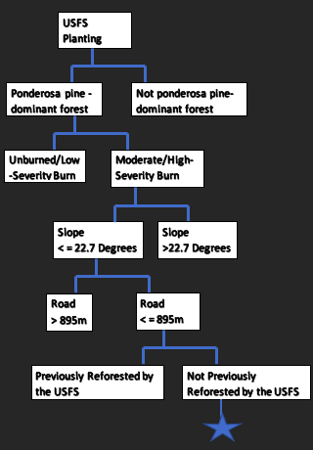 | Figure 3. A decision tree was used to determine suitability within the southern Rocky Mountains for potential sites that the USFS would traditionally plant. The five different factors in the decision tree are drawn from the means of the downloaded USFS silviculture polygons.

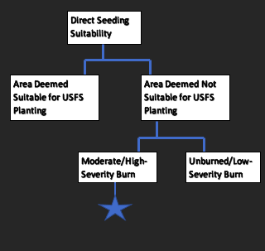 | Figure 4. This second decision tree shows the process of how I found sites to direct seed within the southern Rocky Mountains. Using the previous GIS suitability analysis for areas possible for traditional seeding, I reversed the binary layers and multiplied them by the moderate and high severity burn layer.

3.0 Results:
3.1 Bobcat Gulch
Bobcat Gulch was directly seeded with 25,600 ponderosa pine seeds between the Fall, Spring and Summer seasons. Out of the 25,600 seeds, 213 germinated within the research period from May to September of 2021. With Bobcat Gulch’s 0.83 % germination rate, a maximum number of 19 germinates were recorded within one micro-transect that had the treatment: no seedball-no coating-partial stratification -Spring season. I then used an ANOVA and Tukey post-hoc tests to look for significance amongst the data. The ANOVA test for maximum number of germinates found that season as an individual factor had the greatest significance (p<0.01), followed by coating (p<0.05) and then casing by season interaction (p<0.05). In the post-hoc test for maximum number of germinants, Spring season, was significantly higher than Fall and Summer. None of the other factors had significant differences among the treatments.

Using the Bobcat Gulch’s germinant data exclusively from the month of September, the establishment rate of the ponderosa pine seeds for a season was 25.8%; a total of 55 out of 213 germinates survived through September. The maximum number of established germinates in one micro-transect, with the treatment no seedball-no coating-no stratification-season: Spring, was 14. Using an ANOVA analysis for established germinates, two combinations of factors were significant: coating (p<0.05) and casing interacting with season (p<0.05). However, when a Tukey Post Hoc test was applied to the means of the treatment groups, there was no significance among any of the levels.

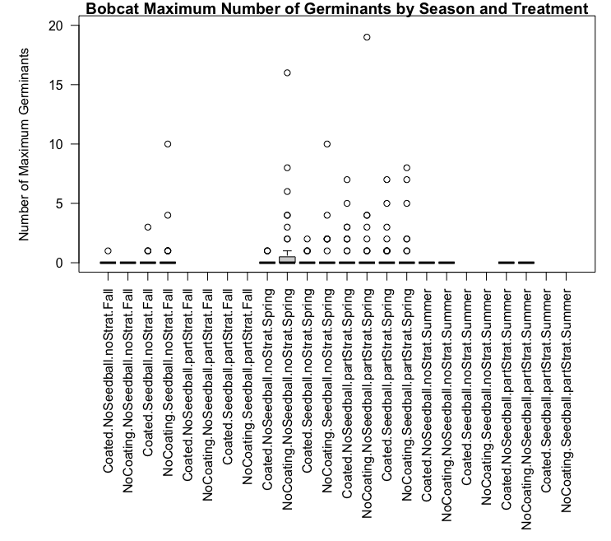
Figure 1 shows a box and whisker plot of the maximum number of ponderosa pine germinates throughout the research period in Bobcat Gulch by treatment type and what season the seeds were directly seeded. Every treatment and season shown in the plot has an outlier point that represents the successful micro-transects’ germinates from the ten plots. Because most of the data were 0’s, majority of the boxes show their lower quartile, upper quartile, and median value as 0. The areas with blanks above it (in the Fall and Summer) represent treatments within a season that did not occur at any of the ten plots.

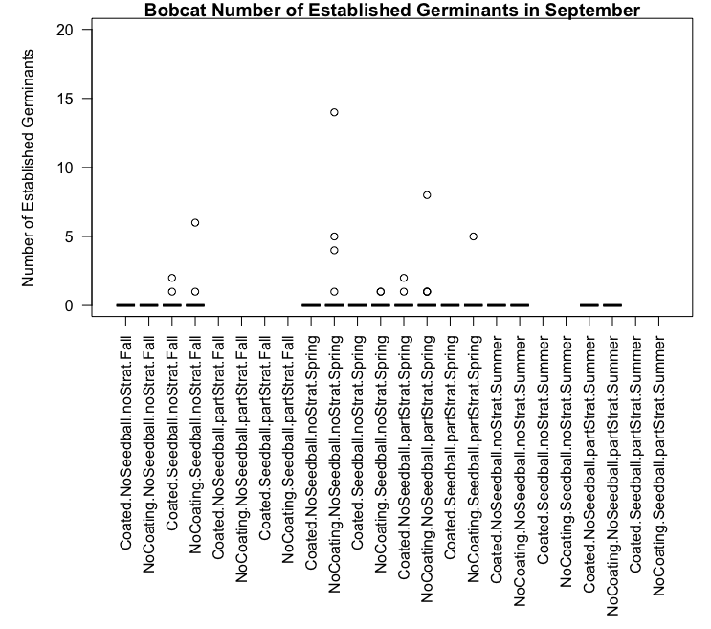
Figure 2 is a box and whisker plot that represents the number of established germinates in September in Bobcat Gulch. The data contained mostly 0’s for established germination in different treatment groups by season of direct seeding; this led to the lower quartile, median, and upper quartile equating to 0 with the outliers representing the established germinates in Bobcat Gulch. Each outlier point represents the number of established germinates within one micro-transect with a specific treatment group and season of direct seeding.

3.2 Calwood
At the Calwood Fire, 5760 ponderosa pine seeds were directly seeded amongst three plots. The ponderosa pine seeds had a 1.42% maximum germination rate with 82 of the 5760 seeds successfully germinated. One micro-transect with the treatment: no seedball-coated-no stratification- season: Fall was the most successful with 11 maximum germinates throughout the whole duration of research. When an ANOVA test was applied to treatment groups of Calwood’s maximum germination rate, casing: seedball - coating: no coating was significant (p<0.05). A Tukey Post Hoc test was then applied to all the means of the different treatment levels; there was no significance among the different treatment groups.
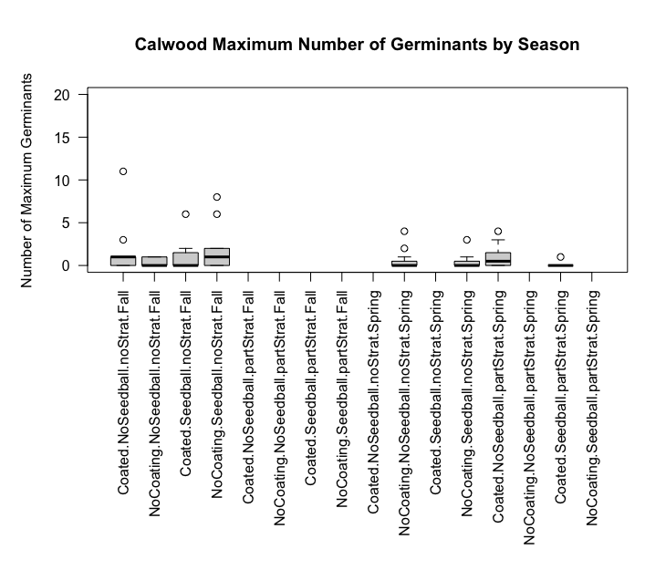
Figure 3 shows a box and whisker plot of the maximum number of ponderosa pine germinates throughout the research period in Calwood Education Center by treatment type and what season the seeds were directly seeded. Every treatment and season shown in the plot has an outlier point that represents the successful micro-transects’ germinates from the ten plots. Because there were less plots, there were less 0’s in the data, so majority of the boxes are able to show their lower quartile, upper quartile, and median value as a boxplot. The areas with blanks above it (in the Fall/Winter and Spring) represent treatments within a season that did not occur at any of the ten plots.

The rate of established germinates at Calwood was 37.8%, as 31 out of 82 germinates survived to the month of September. The maximum number of established germinates in one micro-transect was 3; however, three separate treatments resulted in having the highest number of established germinates: no seedball- coated- no stratification- season: Fall, seedball- coated- no stratification- season: Fall, and seedball- not coated- no stratification- season: Spring. With an ANOVA analysis, I found there was no significance amongst the different treatment groups. This was once again confirmed with a Tukey Post Hoc test, which found that none of the means were significant in the different treatment groups.
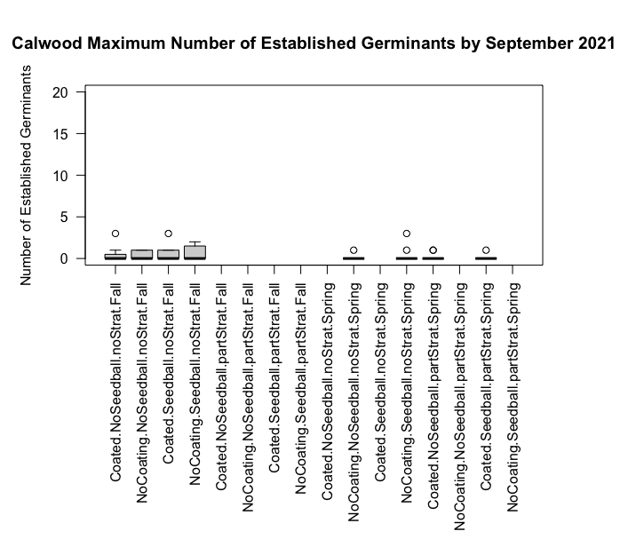
Figure 4 is a box and whisker plot that represents the number of established germinates in September in Calwood Education Center. The data contained mostly 0’s for established germination in different treatment groups by season of direct seeding; this led to the lower quartile, median, and upper quartile equating to 0 with the outliers representing the established germinates in Calwood Education Center. Each outlier point represents the number of established germinates within one micro-transect with a specific treatment group and season of direct seeding.

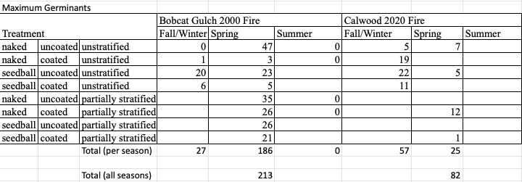
Table 1 encompasses the number of maximum germinants per treatment group type, season, and location during our 2021 research. The total number of maximum germinants for the seasons and location is summed at the bottom.

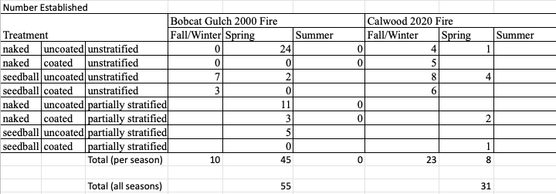
Table 2: Number of established ponderosa pine germinants by treatment type group, season, and site location for the month of September 2021. The total number of established germinants in September for season and location is summed at the bottom of the table.

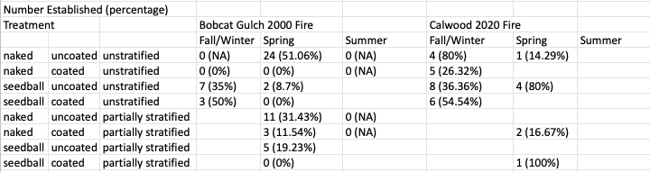
Table 3: The percentage of established germinants during the month of September 2021, by treatment type, season, and site location.

3.3 GIS Traditional Planting Suitability Analysis
Between 1984 and 2021, 668,525 ha of ponderosa pine forest types within the southern Rocky Mountains were burned into mosaics of severities. The unburned and low severity burnt areas consisted of 49.4 % of the total (17.7 % and 31.7 % respectively). Moderate- and high-severity areas consisted of 45.4 % of the total burned area (23.3 % and 22.1 % respectively), totaling 303,504 ha; the last 5% of area was determined to have new growth and did not need to be focused on. Of the 303,504 ha of moderate- and high-severity burned areas, 55.8 % (169,453 ha) was determined to be suitable for traditional planting based on our suitability ranking criteria. Within the remaining moderate- and high-severity areas, 41.3 % (125,243 ha) of the area is determined suitable for direct seeding because it is considered too difficult and expensive for traditional planting. The remaining 2.9% of moderate and high severity burnt area has already been planted by the USFS.
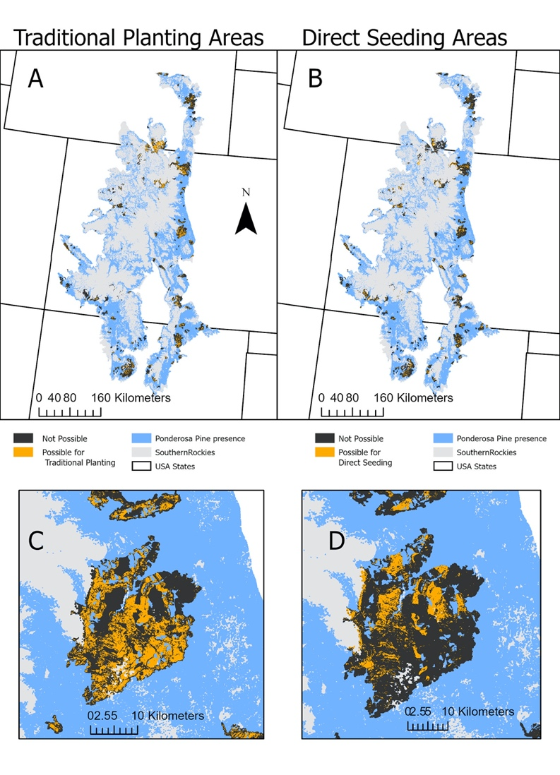 | Figure 5. The southern Rocky Mountains and where either traditional planting (A) or direct seeding (B) could occur within fire scars dating back to 1984. The Hayman Fire Scar from 2002 is included in this map to give an up-close look at a fire scar and how the traditional planting (C) and direct seeding (D) areas are affected by the factors used to decided where a specific type of restoration is needed.

4.0 Discussion
4.1 Germination and Establishment Rates
This field study was conducted to compare the establishment rates of directly seeding ponderosa pine (Pinus ponderosa) seeds in a one-year-old and a two-decade old fire scar. The number of seeds that germinated during the field season were recorded to find where mortality of ponderosa pine seedlings occurred within the establishment process. Field germination rates for both Bobcat Gulch (0.83%) and Calwood Education Center (1.42%) were extremely low, not surpassing 2%. Based on a review of 75 direct seeding trials, overall direct seeding germination rates range from 9 % to 92 % (Grossnickle and Ivetić, 2017). In the month of September, Bobcat Gulch and Calwood had establishment rates of 25.8 % and 37.8 % respectively, taken from the number of germinated seeds. I compared those establishment rates with the establishment rate formula (survival rate after one field season/ total number of seeds planted) from Grossnickle and Ivetić (2017). It was found that the established germinant rate at Bobcat Gulch was 0.21% while Calwood had a 0.54 % rate of establishment; well below the 16% average establishment rate for temperate conifers (Grossnickle and Ivetić, 2017). This data coincides with recent studies within the last twenty years that have recorded little or no tree regeneration within the Southern Rocky Mountains’ ponderosa pine forest, due partially to limited post-fire surviving canopy (Bonnet, 2005; Chambers, 2016; Chapman, 2020). The elements of low seed presence and predation were accounted for to offset their affect in the research, but lack of intermediate shade conditions and soil moisture are the variables that most often limit growth (Bonnet et al. 2005; Burns, 1990). NOAA’s data confirmed that 2021 was the fourth-warmest year on record and had three centimeters less precipitation than average, following 2020 as the second-driest year in Colorado’s modern history ( Otárola, 2022; “Tools & Interactives | NOAA Climate.Gov”, 2022). The recent severe wildfire regimes in ponderosa pine and arid summer seasons are not common for the species and can lead to complete failures of regeneration and loss of forest cover (Adams, 2013). As wildfires become larger and more severe with climate change, this trend seems sure to continue.

4.2 Microenvironments
Within the few micro-transects that successfully germinated and established ponderosa pine seedlings at Bobcat Gulch and Calwood, the majority had more than one seed out of forty germinate in the rings at the same time. The other micro-transects 4 m away on either side stayed completely bare throughout the research period in comparison. Bobcat Gulch had 14 established germinants in one micro-transect at the end of the field season with the treatment no seedball- no coating- no stratification- season: Spring. The physical characteristics of the area surrounding the successful micro-transect were not noted, but it can be inferred from qualitative field observations that tall grasses created some shade for the seedlings. Calwood also had large numbers of maximum germinates throughout the field season but had 3 established germinants in three different micro-transects by September; all three shared the treatment: no stratification despite whether they were planted in the Fall or Spring. Calwood’s landscape lacked grass from the recent fire but had a layer of mulch which could have helped moisture retention in the soil of the successful micro-transects. These observations indicate the possibility of micro-ground conditions that favor the presence of ponderosa pine seedlings and create the spatial pattern of microenvironments regardless of the treatment used (Bonnet, 2005). What this can mean for future direct seeding is that seed treatments are not as necessary as finding micro-environments for more success in established germinants. With the advancement of remote sensing, ecological niche modeling can help determine where direct seeding would be most successful on the landscape based on “satellite-derived high resolution ecosystem functioning variables” such as soil moisture and land surface temperatures (Castro, 2021).

4.3 Seasons
Ponderosa pine seeds that had the most success in germination and establishment during this study were the ones with the least number of treatments applied to them. Instead, season became the best predictor of germination and establishment for Bobcat Gulch. The Spring season was the most productive time to directly seed ponderosa pine after seed stratification because site conditions are the least stressful, meaning that the seeds had been stratified and ample soil moisture was available (Grossnickle and Ivetić, 2017). Germination success is dependent on time of emergence, and the seedlings that germinate early (in the Spring) and establish by July have a better chance of survival the following summer (Jinks, 2006; Rietveld and Heidmann, 1976). However, in this study, the Spring season being a significant variable for one location may be because Bobcat was directly seeded with four more treatment groups’ worth of seeds than Calwood (640 more seeds per plot), making the Spring transects 64 m in length, which is twice as long as the Calwood’s Spring transects. This means that Bobcat’s Spring transects had double the amount of micro-transects and covered more area that could have had microenvironments.

4.4 Qualitative Field Observations
Bobcat Gulch was directly seeded with 19,840 more seeds than Calwood yet had the lower rate of maximum and established germinants. Field observations during the Summer suggest that establishment of grasslands and lack of nearby trees could have played a role in Bobcat Gulch’s lower response to direct seeding. First, Bobcat Gulch’s transects were placed in more open areas because it has a larger fire scar than Calwood. In ponderosa pine forests, favorable conditions for seedlings come from nearby trees and include intermediate shade conditions and modified microsite conditions (Bonnet, 2005; Chapman, 2020). Calwood had these conditions near its plots, which allowed less harsh Summer temperatures for germinating seedlings. Bobcat’s burn scar was also the only one to convert into grassland over the Summer months of field observation because of its age. Calwood’s scar was too new for grass establishment and stayed relatively bare throughout the whole field season. Rodman, (2001) identified that site types, like those inside high severity burns or are characterized by their dry conditions, are more vulnerable to vegetation type conversions. Bobcat Gulch’s fire was high severity so many of the trees died. Grass becomes an effective competitor for ponderosa pine seedlings if there is no seed source to help replenish ponderosa pine (Savage and Mast, 2005). Also, rodents have their highest populations in old cutover or burnt areas (Schubert, 1970). High rodent populations become a large obstacle for ponderosa pine establishment because they prey on the seeds (Schubert, 1974). Bobcat Gulch is two decades old and has a better chance of hosting rodents than Calwood, which can also explain its smaller rate of maximum and established germinates. These observations are important to keep in mind when continuing the use of direct seeding in older fire scars.

4.5 Traditional Planting Spatial Characteristics
Using GIS to help identify within the southern Rocky Mountains spatial characteristics of areas traditionally planted with seedlings was an important task within my research. The goal of direct seeding is being able to regenerate areas that are considered not feasible for US Forest Service (USFS) traditional planting. The factors: burn severity, distance to road, and slope were used to generate descriptive statistics on the three landscape variables from the USFS planting polygons to create a suitability layer.

4.6 Burn Severity
Burn severity is one of the most important variables in this GIS suitability analysis. Areas that could not have fire severity determined are excluded from traditional planting and direct seeding, despite having other redeemable qualities for ponderosa pine to survive in. The silviculture planting polygons from the USFS have traditional planting occurring in 5% in unburned areas, 14.6 % in low-severity, 26.5 % in moderate-severity, and 52.8 % in high-severity areas. From these percentages, it can be inferred that the main concern of the USFS is to plant in areas that have moderate or high severity burns. Interior areas of severely burned sites may result in site conversions from coniferous dominated forests to non-forested areas (Roccaforte, 2014). Traditional planting is meant to reverse the effect of dominate vegetation change from lack of ponderosa pine regeneration. The 49.4 % (330,251 ha) of ponderosa pine within the southern Rocky Mountains that did not burn or had a low severity burn will be left alone to regenerate naturally. Evidence from fire scars, tree ages, and tree growth patterns show that historically, ponderosa pine forests experienced frequent, low intensity fires (Fitzgerald, 2005; Shatford et al. 2007). Reintroducing ponderosa pine forests to this interval of fire severity can help reintroduce heterogeneous forest conditions from pre-colonial times. The decision to have direct seeding occur only in the appropriate moderate and severe burn conditions, based on the suitability analysis, continues to encourage forest heterogeneity and creates a suitability map that is not the complete opposite of the USFS areas of potential traditional planting map (Fig. 5).

4.7 Distance to Road
Distance to road was created as a suitability variable for traditional planting because accessibility to designated areas while carrying the seedlings and equipment is critical. Site conditions and availability of equipment vary; therefore, augers are the preferred tool for hand planting in less than ideal areas of the forest; they speed up the planting process, reduce labor and improve seedling survival ( Schubert, 1970; Schubert, 1974). The USFS (2022) instructs that a hole should be dug that is slightly deeper than the length of the ponderosa pine roots whenever possible. Zonal statistics of distance to road from a USFS silviculture polygon had a mean of 286.1 m and had a standard deviation of 304.7 m. Adding two standard deviations to encompass the 95% of road distances near USFS planting polygons created a value of 895.5 m (0.55mi). Anything beyond this distance was considered suitable for direct seeding because the seeds are lighter to carry and there isn’t a need for equipment since there is no digging involved, only scattering the seeds.

4.8 Slope
Slope’s inclusion as a variable for determining where traditional planting and direct seeding occurs is necessary for adequate regeneration practices. The increase of slope has a direct relationship to the size of a wildfire and its rate of spreading, especially if wind becomes present during the fire (Butler, 2007). However, the US Department of Agriculture (USDA) has voiced a preference for “level or gentle slopes” because it has a positive impact on ponderosa pine with less shallow and dry soil and allows for optimal use of machine planting (Schubert, 1970; Schubert, 1974). In the case of using traditional planting or direct seeding to control erosion in forests, slopes of 45 degrees or less serve as “good seeding surfaces” and can be walked up by managers (“Seeding to Control Erosion Along Forest Roads”, 1978). The mean slope for traditional planting was 9.2 degrees, but I added two standard deviations of 6.8 to create a maximum slope of 22.7 degrees; this represents 95% of the slopes that have already been traditionally planted on. Direct seeding on slopes above the 22.7 degrees can be beneficial for the regeneration of the southern Rocky Mountains since high severity burns are also present on steep slopes that need seed sources. The seeds would have a better chance of establishing because they would be germinating in areas with less water availability. Traditional planting has seedlings that were germinated under optimal conditions and transferred into harsh environments. They would have better success on shallow slopes of <20 degrees because there are higher levels of moisture availability (Addington et al. 2018), which reduces the stress of seedlings during establishment.

5.0 Conclusion
As fire regimes in the southern Rocky Mountains continue to become more severe and periodic, the number of large fire scars will increase. Forest management will become more challenging as the rapid loss of ponderosa pine forest continues. Now, more than ever, understanding the establishment rate of ponderosa pine seeds can direct forest management with the proper actions needed to maintain the ponderosa pine forests of southern Rocky Mountains. Specifically, the ability to study direct seeding in two differently aged fire scars can provide useful insight towards regeneration efforts for forest managers. Because direct seeding had a very small success rate overall, it can be determined that conservation efforts of ponderosa pine forests will need to increase in order to yield improved results in the 21st century. More importantly, regeneration efforts need to begin directly after a wildfire to prevent the chance of primary vegetation change. Being able to target times of the year and micro-environments in the forest can give seeds and seedlings a better chance of establishment. Technology will also continue to become more advanced and will remain a great tool for further identifying the most suitable habitats for traditional planting and direct seeding. Using GIS to find suitable areas for traditional planting and direct seeding can be useful for the USFS and other organizations. Both methods are needed to repopulate forests and have their own benefits and setbacks on the variety of landscaped the southern Rocky Mountains boast. More research is needed to understand how to increase the number of established germinates as the climate and environment continues to rapidly change, but can be a call to action for forest managers and scientists alike.

Citations

Adams, M. A. (2013b). Mega-fires, tipping points and ecosystem services: Managing forests and woodlands in an uncertain future. Forest Ecology and Management, 294, 250–261. https://doi.org/10.1016/j.foreco.2012.11.039
Addington, R. N., Aplet, G. H., Battaglia, M. A., Briggs, J. S., Brown, P. M., Cheng, A. S., Dickinson, Y., Feinstein, J. A., Pelz, K. A., Regan, C. M., Thinnes, J., Truex, R., Fornwalt, P. J., Gannon, B., Julian, C. W., Underhill, J. L., & Wolk, B. (2018). Principles and practices for the restoration of ponderosa pine and dry mixed-conifer forests of the Colorado Front Range (RMRS-GTR-373; p. RMRS-GTR-373). U.S. Department of Agriculture, Forest Service, Rocky Mountain Research Station. https://doi.org/10.2737/RMRS-GTR-373
Arapaho & Roosevelt National Forests Pawnee National Grassland—Learning Center. (n.d.). Retrieved February 2, 2022, from https://www.fs.usda.gov/detail/arp/learning/?cid=fsm91_058299
Bailey, J. D., & Covington, W. W. (2002a). Evaluating ponderosa pine regeneration rates following ecological restoration treatments in northern Arizona, USA. Forest Ecology and Management, 155(1–3), 271–278. https://doi.org/10.1016/S0378-1127(01)00564-3
Becerra, P. I., Aqueveque, N., & Velasco, N. (2022a). Burying, not broadcasting seeds improves the seedling establishment of most woody species under different ecological conditions in a semiarid ecosystem of central Chile. Restoration Ecology, 30(2), e13551. https://doi.org/10.1111/rec.13551
Bonnet, V. H., Schoettle, A. W., & Shepperd, W. D. (2005a). Postfire environmental conditions influence the spatial pattern of regeneration for Pinus ponderosa. Canadian Journal of Forest Research, 35(1), 37–47.
Burns, R. M. (1990). Silvics of North America. U.S. Department of Agriculture, Forest Service.
Castro, J., Morales-Rueda, F., Navarro, F. B., Löf, M., Vacchiano, G., & Alcaraz-Segura, D. (2021). Precision restoration: A necessary approach to foster forest recovery in the 21st century. Restoration Ecology, 29(7), e13421. https://doi.org/10.1111/rec.13421
Chambers, M. E., Fornwalt, P. J., Malone, S. L., & Battaglia, M. A. (2016). Patterns of conifer regeneration following high severity wildfire in ponderosa pine – dominated forests of the Colorado Front Range. Forest Ecology and Management, 378, 57–67. https://doi.org/10.1016/j.foreco.2016.07.001
Chapman, T. B. (n.d.). Still standing: Recent patterns of post-fire conifer refugia in ponderosa pine-dominated forests of the Colorado Front Range. PLoS ONE, 15(1). http://resolver.scholarsportal.info/resolve/19326203/v15i0001/nfp_ssrpopfotcfr.xml
Chapman, T. B., Schoennagel, T., Veblen, T. T., & Rodman, K. C. (2020). Still standing: Recent patterns of post-fire conifer refugia in ponderosa pine-dominated forests of the Colorado Front Range. PLOS ONE, 15(1), e0226926. https://doi.org/10.1371/journal.pone.0226926
Chapter 43-Ecological Subregions of the United States. (n.d.). Retrieved March 6, 2022, from https://www.fs.fed.us/land/pubs/ecoregions/ch43.html
Coop, J. D., DeLory, T. J., Downing, W. M., Haire, S. L., Krawchuk, M. A., Miller, C., Parisien, M.-A., & Walker, R. B. (2019). Contributions of fire refugia to resilient ponderosa pine and dry mixed-conifer forest landscapes. Ecosphere, 10(7), e02809. https://doi.org/10.1002/ecs2.2809
Coop, J. D., Parks, S. A., Stevens-Rumann, C. S., Crausbay, S. D., Higuera, P. E., Hurteau, M. D., Tepley, A., Whitman, E., Assal, T., Collins, B. M., Davis, K. T., Dobrowski, S., Falk, D. A., Fornwalt, P. J., Fulé, P. Z., Harvey, B. J., Kane, V. R., Littlefield, C. E., Margolis, E. Q., … Rodman, K. C. (2020). Wildfire-Driven Forest Conversion in Western North American Landscapes. BioScience, 70(8), 659–673. https://doi.org/10.1093/biosci/biaa061
Davis, K. T., Dobrowski, S. Z., Higuera, P. E., Holden, Z. A., Veblen, T. T., Rother, M. T., Parks, S. A., Sala, A., & Maneta, M. P. (2019). Wildfires and climate change push low-elevation forests across a critical climate threshold for tree regeneration. Proceedings of the National Academy of Sciences of the United States of America, 116(13), 6193–6198. https://doi.org/10.1073/pnas.1815107116
Drummond, M. A. (2012). Southern Rockies Ecoregion: Chapter 8 in Status and trends of land change in the Western United States--1973 to 2000. In Southern Rockies Ecoregion: Chapter 8 in Status and trends of land change in the Western United States—1973 to 2000 (USGS Numbered Series No. 1794-A-8; Professional Paper, Vols. 1794-A-8, p. 95103). U.S. Geological Survey. https://doi.org/10.3133/pp1794A8
Duryea, M. L., Landis, T. D., & Perry, C. R. (Eds.). (1984). Forestry Nursery Manual: Production of Bareroot Seedlings (Vol. 11). Springer Netherlands. https://doi.org/10.1007/978-94-009-6110-4
Seeding to Control Erosion Along Forest Roads. (2022.).
Fitzgerald, S. A. (2022). Fire Ecology of Ponderosa Pine and the Rebuilding of Fire-Resilient Ponderosa Pine Ecosystems. 29.
Grossnickle, S. C., & Ivetić, V. (2017). Direct Seeding in Reforestation – A Field Performance Review. REFORESTA, 4, 94–142. https://doi.org/10.21750/REFOR.4.07.46
Home | MTBS. (n.d.). Retrieved February 19, 2022, from https://www.mtbs.gov/
Jinks, R. L., Willoughby, I., & Baker, C. (2006). Direct seeding of ash (Fraxinus excelsior L.) and sycamore (Acer pseudoplatanus L.): The effects of sowing date, pre-emergent herbicides, cultivation, and protection on seedling emergence and survival. Forest Ecology and Management, 237(1–3), 373–386. https://doi.org/10.1016/j.foreco.2006.09.060
Kaufmann, M. R. (2003). Using tree recruitment patterns and fire history to guide restoration of an unlogged ponderosa pine/Douglas-fir landscape in the southern Rocky Mountains after a century of fire suppression. Forestry, 76(2), 231–241. https://doi.org/10.1093/forestry/76.2.231
Keyes, C. R., & González, R. M. (2015). Climate-influenced ponderosa pine (Pinus ponderosa) seed masting trends in western Montana, USA. Forest Systems, 24(1), e021–e021. https://doi.org/10.5424/fs/2015241-05606
Lauder, J. D., Moran, E. V., & Hart, S. C. (2019). Fight or flight? Potential tradeoffs between drought defense and reproduction in conifers. Tree Physiology, 39(7), 1071–1085. https://doi.org/10.1093/treephys/tpz031
Leverkus, A. B., Lázaro González, A., Andivia, E., Castro, J., Jiménez, M. N., & Navarro, F. B. (2021a). Seeding or planting to revegetate the world’s degraded land: Systematic review and experimentation to address methodological issues. Restoration Ecology, 29(4), e13372. https://doi.org/10.1111/rec.13372
Malone, S. L., Fornwalt, P. J., Battaglia, M. A., Chambers, M. E., Iniguez, J. M., & Sieg, C. H. (2018). Mixed-Severity Fire Fosters Heterogeneous Spatial Patterns of Conifer Regeneration in a Dry Conifer Forest. Forests, 9(1), 45. http://dx.doi.org/10.3390/f9010045
McKinney, S.-F., & Missoula, M. (n.d.). Fire regimes of ponderosa pine (Pinus ponderosa) ecosystems in Colorado: A systematic review and meta-analysis. 44.
Meyer, M. D., Long, J. W., & Safford, H. D. (n.d.). Postfire Restoration Framework for National Forests in California. 220.
Mohan, M., Richardson, G., Gopan, G., Aghai, M. M., Bajaj, S., Galgamuwa, G. A. P., Vastaranta, M., Arachchige, P. S. P., Amorós, L., Corte, A. P. D., de-Miguel, S., Leite, R. V., Kganyago, M., Broadbent, E. N., Doaemo, W., Shorab, M. A. B., & Cardil, A. (2021). UAV-Supported Forest Regeneration: Current Trends, Challenges and Implications. Remote Sensing, 13(13), 2596. https://doi.org/10.3390/rs13132596
Multi-scale controls of historical forest-fire regimes: New insights from fire-scar networks on JSTOR. (n.d.). Retrieved March 16, 2022, from https://www-jstor-org.colorado.idm.oclc.org/stable/23034492?pq-origsite=summon&seq=2#metadata_info_tab_contents
North, M. P., Stevens, J. T., Greene, D. F., Coppoletta, M., Knapp, E. E., Latimer, A. M., Restaino, C. M., Tompkins, R. E., Welch, K. R., York, R. A., Young, D. J. N., Axelson, J. N., Buckley, T. N., Estes, B. L., Hager, R. N., Long, J. W., Meyer, M. D., Ostoja, S. M., Safford, H. D., … Wyrsch, P. (2019). Tamm Review: Reforestation for resilience in dry western U.S. forests. Forest Ecology and Management, 432, 209–224. https://doi.org/10.1016/j.foreco.2018.09.007
Otárola, M. (n.d.). The second half of 2021 was the warmest in Colorado history, national data shows. Colorado Public Radio. Retrieved March 25, 2022, from https://www.cpr.org/2022/01/11/colorado-climate-change-warmer-temperatures/
Precision restoration: A necessary approach to foster forest recovery in the 21st century—Castro—2021—Restoration Ecology—Wiley Online Library. (n.d.). Retrieved October 4, 2021, from https://onlinelibrary-wiley-com.colorado.idm.oclc.org/doi/full/10.1111/rec.13421
Prichard, S. J., Hessburg, P. F., Hagmann, R. K., Povak, N. A., Dobrowski, S. Z., Hurteau, M. D., Kane, V. R., Keane, R. E., Kobziar, L. N., Kolden, C. A., North, M., Parks, S. A., Safford, H. D., Stevens, J. T., Yocom, L. L., Churchill, D. J., Gray, R. W., Huffman, D. W., Lake, F. K., & Khatri-Chhetri, P. (2021). Adapting western North American forests to climate change and wildfires: 10 common questions. Ecological Applications, 31(8), e02433. https://doi.org/10.1002/eap.2433
Rietveld, W. J., & Heidmann, L. J. (1976). Direct seeding ponderosa pine on recent burns in Arizona. U.S. Department of Agriculture, Forest Service, Rocky Mountain Forest and Range Experiment Station.
Roccaforte, J. P. (n.d.). Planting to Restore Ponderosa Pine Sites Burned by High-Severity Fire. 4.
Rodman, K. C., Veblen, T. T., Battaglia, M. A., Chambers, M. E., Fornwalt, P. J., Holden, Z. A., Kolb, T. E., Ouzts, J. R., & Rother, M. T. (2020). A changing climate is snuffing out post-fire recovery in montane forests. Global Ecology and Biogeography, 29(11), 2039–2051. https://doi.org/10.1111/geb.13174
Rodman, K. C., Veblen, T. T., Chapman, T. B., Rother, M. T., Wion, A. P., & Redmond, M. D. (2020). Limitations to recovery following wildfire in dry forests of southern Colorado and northern New Mexico, USA. Ecological Applications, 30(1), e02001. https://doi.org/10.1002/eap.2001
Savage, M., & Mast, J. N. (2005). How resilient are southwestern ponderosa pine forests after crown fires? Canadian Journal of Forest Research, 35(4), 967–977.
Schubert, G. H. (n.d.). ARTIFICIAL REFORESTATION PRACTICES FOR THE SOUTHWEST. 29.
Schubert, G. H. (1974). Silviculture of southwestern ponderosa pine: The status of our knowledge /. Rocky Mountain Forest and Range Experiment Station, Forest Service, U.S. Dept. of Agriculture,. https://doi.org/10.5962/bhl.title.98816
Shatford, J. P. A., Hibbs, D. E., & Puettmann, K. J. (2007). Conifer Regeneration after Forest Fire in the Klamath-Siskiyous: How Much, How Soon? Journal of Forestry, 105(3), 139–146.
Shinneman, D. J., Means, R. E., Potter, K. M., & Hipkins, V. D. (2016a). Exploring Climate Niches of Ponderosa Pine (Pinus ponderosa Douglas ex Lawson) Haplotypes in the Western United States: Implications for Evolutionary History and Conservation. PLoS ONE, 11(3), e0151811. https://doi.org/10.1371/journal.pone.0151811
Shinneman, D. J., Means, R. E., Potter, K. M., & Hipkins, V. D. (2016b). Exploring Climate Niches of Ponderosa Pine (Pinus ponderosa Douglas ex Lawson) Haplotypes in the Western United States: Implications for Evolutionary History and Conservation. PLoS ONE, 11(3), e0151811. https://doi.org/10.1371/journal.pone.0151811
Southern Rocky Mountains Ecoregion // LandScope America. (n.d.). Retrieved March 6, 2022, from http://www.landscope.org/explore/natural_geographies/ecoregions/Southern%20Rocky%20Mountains/
Stand Density Index (USFS). (n.d.). Retrieved February 28, 2022, from https://www.fs.usda.gov/Internet/FSE_DOCUMENTS/stelprdb5270993.pdf
Stewart, J. A. E., van Mantgem, P. J., Young, D. J. N., Shive, K. L., Preisler, H. K., Das, A. J., Stephenson, N. L., Keeley, J. E., Safford, H. D., Wright, M. C., Welch, K. R., & Thorne, J. H. (2021). Effects of postfire climate and seed availability on postfire conifer regeneration. Ecological Applications, 31(3), e02280. https://doi.org/10.1002/eap.2280
The fire environment—Innovations, management, and policy. (n.d.). 8.
Tools & Interactives | NOAA Climate.gov. (n.d.). Retrieved March 25, 2022, from https://www.climate.gov/maps-data/tools-interactives
USDA Forest Service FSGeodata Clearinghouse—Post-fire Vegetation Condition. (n.d.). Retrieved February 19, 2022, from https://data.fs.usda.gov/geodata/rastergateway/ravg/index.php

