They Rage: A Documentation of Release and Resisstance

Summer S Taylor
University of Colorado College of Media, Communication and Information | Department of Journalism

Thesis Advisor: Ross Taylor | Department of Journalism

Committee Members:
Melinda Barlow | Department of Film
Christine Larson | Department of Journalism

Defense Date: April 7, 2020

April 9, 2020

Table of Contents:

ABSTRACT ---------------------------------------- 4

INTRODUCTION ----------------------------------- 5-8

METHODS -------------------------------------------- 9-12

INTERVIEWS ------------------------------------- 12-44
Marissa Wajda ----------- 13-25
Karia White --------------- 16-19
Amanda Edwards --------- 20-22
Sharry McAllister --------- 23-25
Bernardita Yunis ---------- 26-28
Gretchen Williams -------- 28-30
Wysteria Bristol ----------- 30-33
Cedar Rose MacInnis ----- 33-36
Jordan Hartnett ------------ 27-39
Angela Karami ------------ 39-41
Bex Schmetzel -------------42-49

DISCUSSION ------------------------------------ 44-46

SOURCES --------------------------------------- 46-47

ABSTRACT

They Rage: A Documentation of Release and Resistance is a photo and interview series that documents women(+)’s process of relating to anger in a controlled environment. This piece aims to challenge the societal notion that women(+)’s anger should not be seen in the public sphere. Viewers are forced to acknowledge the nuanced and complicated relationship that women(+) have with anger and it’s connection to a fight for broader social equity. This process utilizes the concept of combining controlled portraiture with documentary photography. The work stands as a combination of uncontrolled moments within a controlled environment in order to form a universal idea of what anger is. This piece challenges the notion of objectivity in any photography process, as my presence and observations are inserted into the work, highlighting my own positionalities. This piece aims to contribute to ongoing conversation among journalists and academics on the power of women(+)’s anger, and the place it historically and currently takes in United Politics.

INTRODUCTION:

Women’s Fury Matters
They Rage: A Documentation of Release and Resistance, is a photo and Interview series that documents women(+)’s process of relating to anger using a controlled environment in order to capture an uncontrolled experience. This documentation style is a conversation between control and release and emphasizes the importance of a secure process in order to capture unexpected emotions. The work challenges the notion of objective photojournalism and places myself as the photographer in an active role throughout the experience. The challenged notion of objectivity and the clear presence I have in relating to this work is influenced by Touch Me Not’s Romanian director Adina Pintilie. In conversation with Audre Lorde, Deborah Cohan, Patricia Hill Collins, Angela Davis, Jane Marcus, Susan Sontag, Siri Hustvedt, Barabara Ransby, Patrisse Khans-Cullors and journalists Rebecca Traister and Soryaya Chemaly, I aim to include this work in a long lineage of activists fighting for the presence and validity of women(+)’s anger. They Rage includes individuals who identify with the pronouns she/her/hers and they/them/theirs which includes women, gender-queer folks, gender-non-binary folks and trans women. For the purposes of this thesis I am using women(+) to signify this array of identities.
As an undergraduate pursuing a degree in both journalism and ethnic studies They Rage: A Documentation of Release and Resistance, is an interdisciplinary investigation into the use of critical theory to influence the process of photojournalism. This project has been, from the beginning, a personal research of anger and intimacy. The project serves as a reflection of this subjective journey, driven by my curiosity to discover how other people experience this challenging aspect of their life. The core of this research is to deconstruct specific narratives that I have learned surrounding anger, especially as it relates to women(+). By sharing these experiences with a wider audience I am challenging the viewer to acknowledge the nuanced relationship these participants have to the subject of anger. I hope this series serves as a mirror for reflecting on ones own relationship to anger and how one responds to another’s anger. I encourage viewers to note how ones own identity and others’ effects this experience.
Through this work, I am proposing a dialogue between different experiences of anger and how identity impacts these experiences within our society. Throughout this semester I continued to develop the best process by which to include as many different voices as possible into this project. I hope this work challenges viewers to accept reality and acknowledge that we all will have reactions to things that we may not like about ourselves. It is important that though this self-reflection may not be comfortable, it continues to challenge the viewer to expand their notion of anger as it relates to the personal and political. As I continue to expand this project, I hope to include more specific groups of voices that have been silenced across the world. I intend to continue conducting work through theory of allyship that Deborah Kohan outlines: “There are many things that people involved in activism may want and need from allies. These include: respect; (com)passion; the desire to find out about what moves the group without attempting to dominate it; material resources; taking risks even when it means making mistakes; not taking it personally, especially if the individual doing the allying represents the group that has historically oppressed the other group; the willingness to teach one’s children the consequences of oppression; understanding that, at times, the group may want time and space alone.”
The inspiration for this thesis was based off a small photo-series I conducted last year. At the time, I had been dealing with my own anger associated with politics and personal matters. I recognized there was no space for this anger to be expressed in its full form and wondered what it would look like to create this space for other women(+). It took me months to find a space, which ended up being a workshop for a construction company on the outskirts of Denver. I invited some friends, collected plates, glass and wood from the Goodwill and proceeded to photograph this experiment. At the time my method was undefined and I had no idea what to expect. The impact of this work was much deeper and more intimate than I could have imagined and so I decided to continue exploring this idea. The photographs from this session are illustrated below:
- 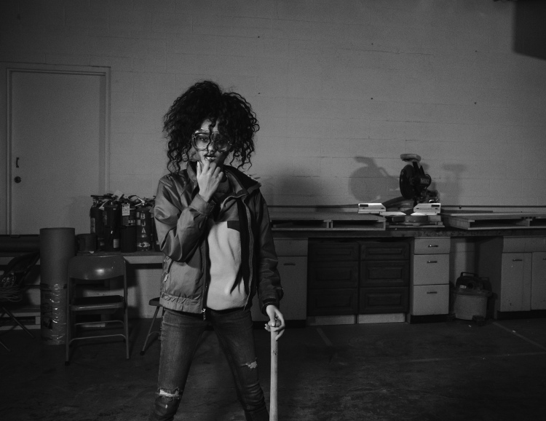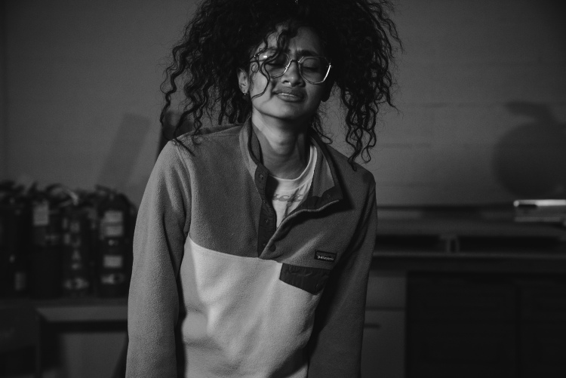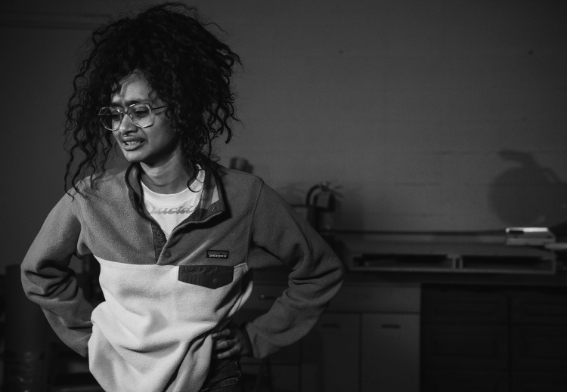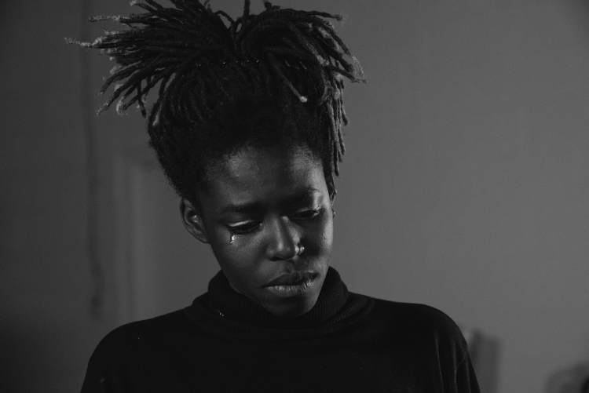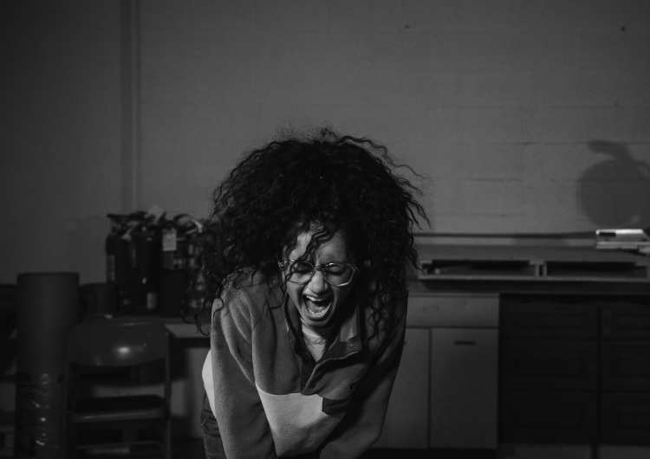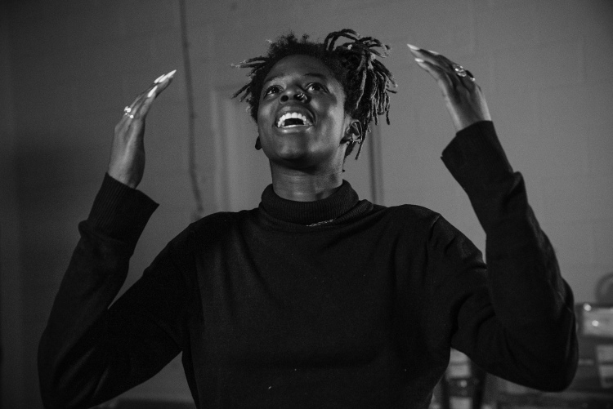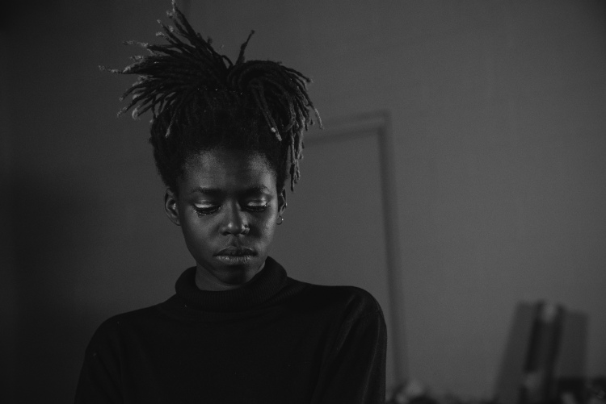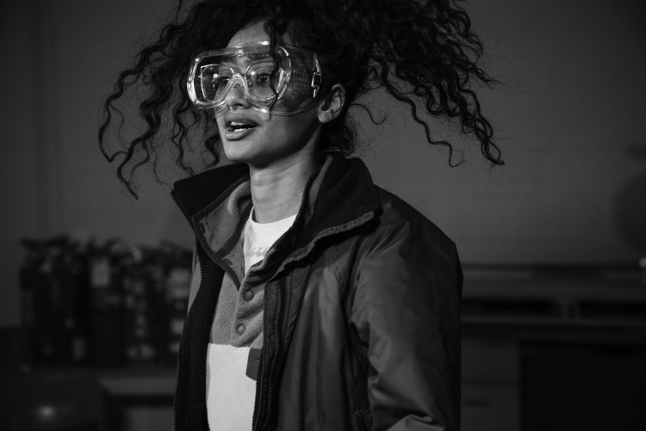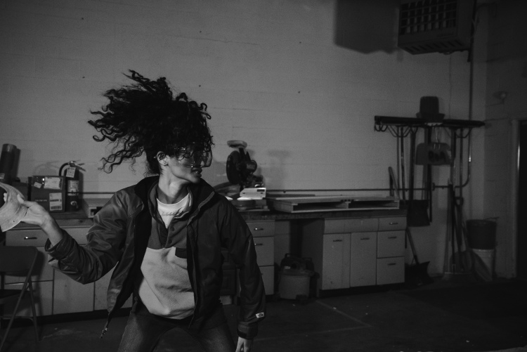
- 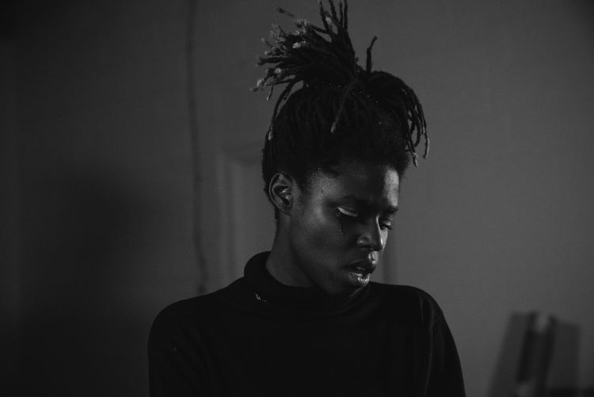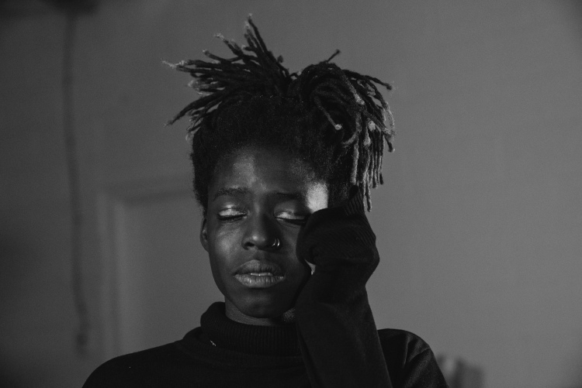
There have been a number of books recently published on the topic of women and anger. Some of these include Burn it Down by Soraya Chemaly, Good and Mad by Rebecca Traister and Eloquent Rage by Brittney Cooper. Anger is not a new topic within the conversation of feminist thought. Throughout the different waves of feminism, including Black Feminism, Queer of Color Critique and Black Feminist Thought, there has been continued dialogue and academia about the use of anger, and the appropriateness or inappropriateness of the expression of that anger given the constraints of identity. This topic is in dialogue with being seen or made invisible by the social categories that define our hegemonic society. One thing is for sure; as with anything else that relates to the social world, anger and the ability to display anger is gendered.
I aim to add to this conversation of anger as it relates to women through this collaborative photography series. It is important to analyze and critique cultural norms that confine and subjugate populations. However, at a certain point theory should combine with praxis and I am interested in exploring the topic of anger through the expression and documentation of it in order to further social and political activism. By photographing anger in women, or the resulting and underlying emotions associated with that anger, I am asking the viewer of these photographs to face a truth that many women keep hidden.
METHODS:

For this thesis, I conducted three full-day photography sessions. Two more sessions have been planned for the purpose of publication (the dates have been postponed due to Covid-19). Each session was shot at Medium 1 Studios, in Boulder Co. Prior to each session I set up the studio, roughly 4-7 hours-worth of work, which included: positioning lights, building walls, painting, and placement of props. After each session, I analyzed successes and failures in terms of the space and layout, shifting when necessary for the following shoot. Objects destroyed during each shoot were donated from CU’s ceramics department as well as Goodwill.
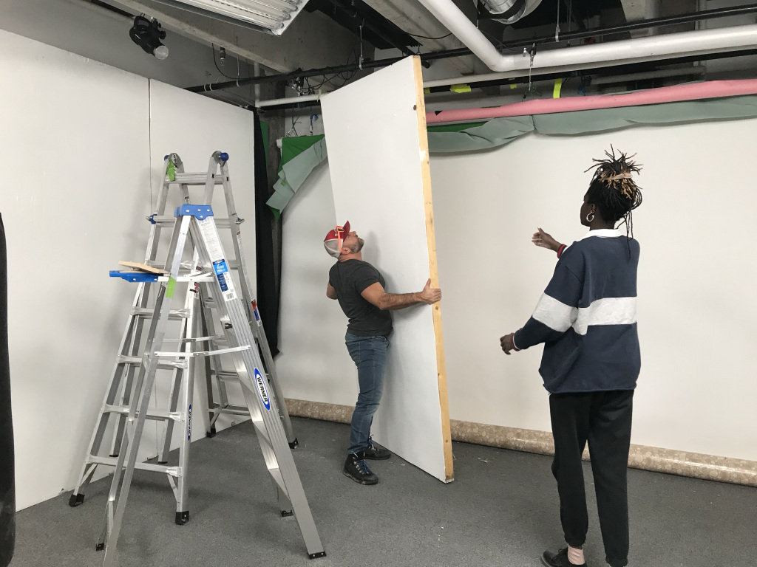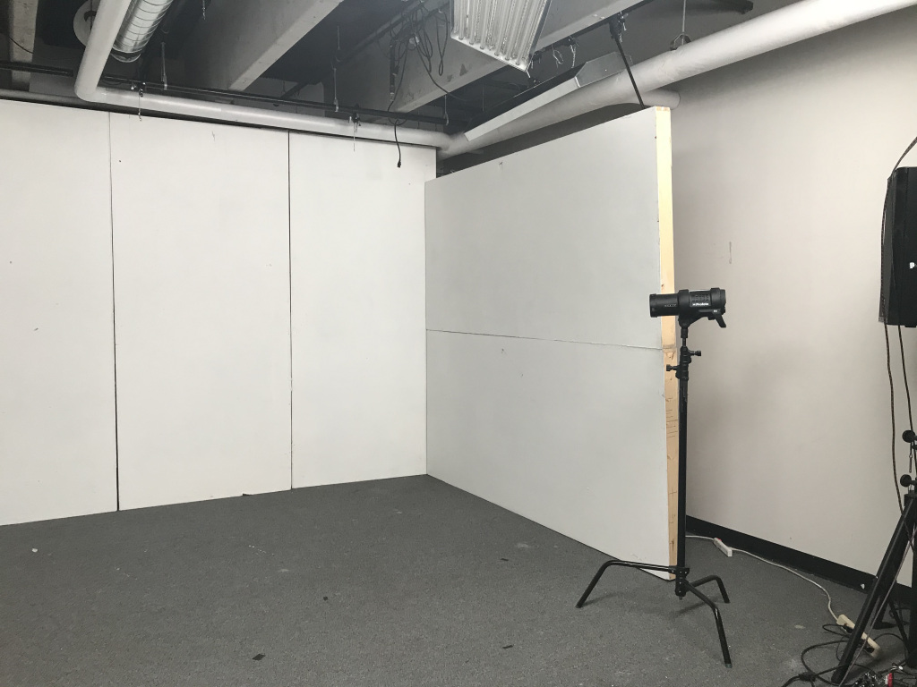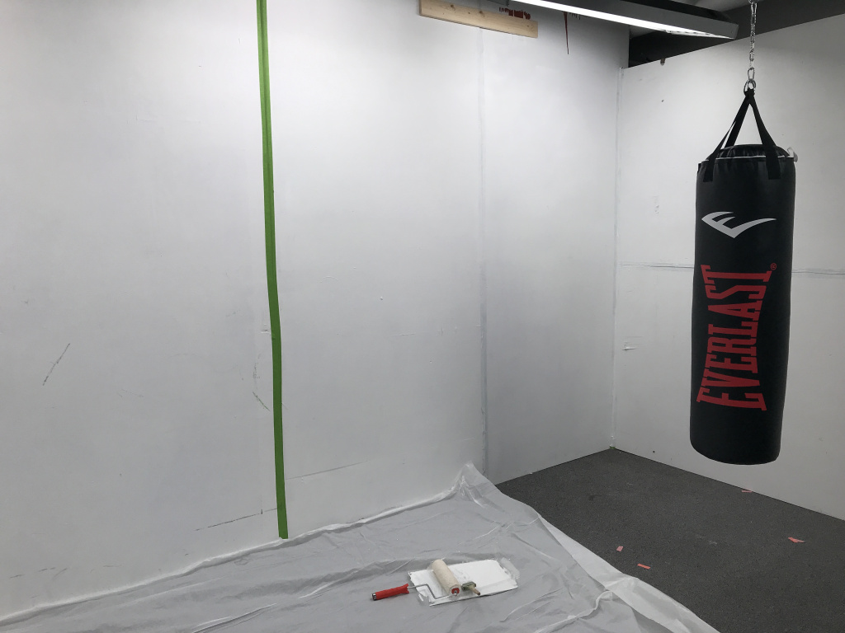
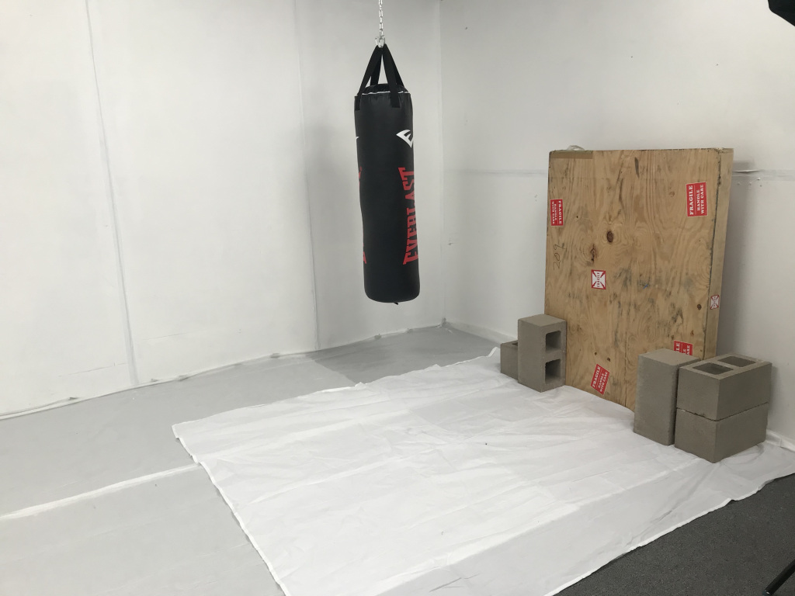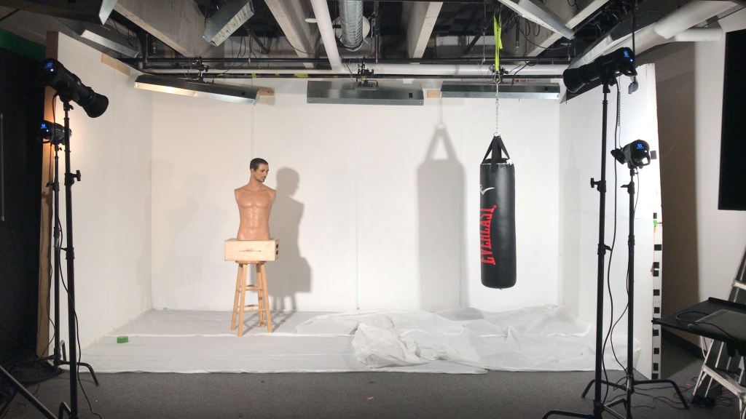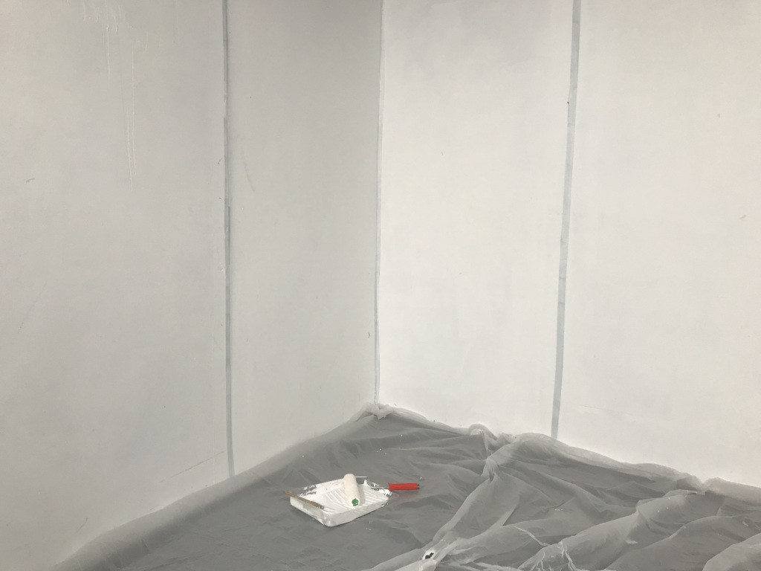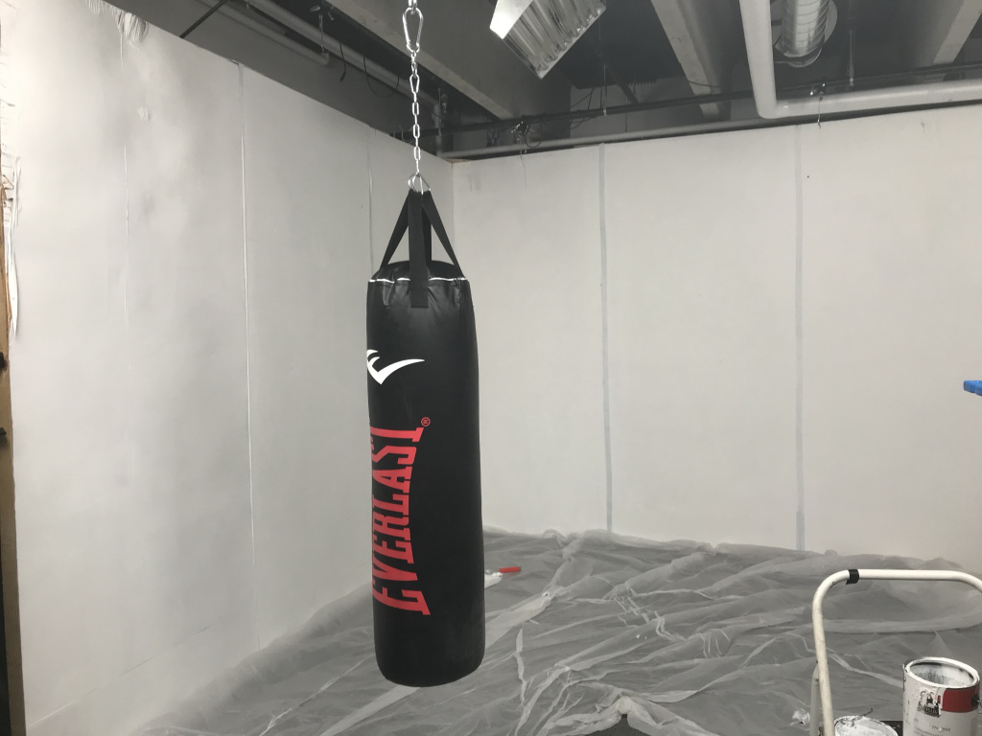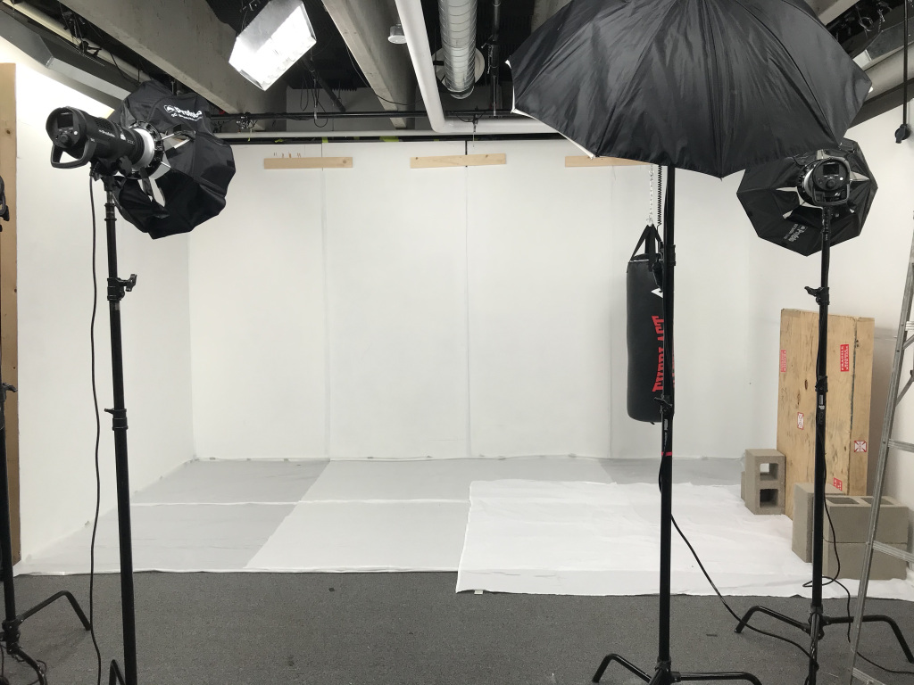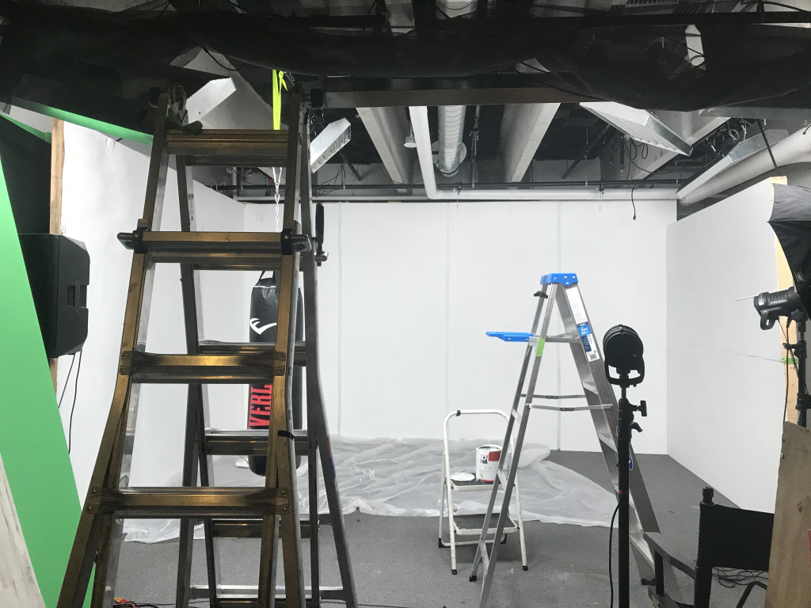
For each shoot, I photographed between four to seven women/gender-queer individuals (women+). These individuals ranged in age, ethnicity, gender identity and socio-economic class. The first two shoots I conducted alone and was assisted on the last shoot by Shammai Madding. Each individual session lasted roughly 1.5 hrs. At the beginning of each session I sat down with the participant and interviewed them about their thoughts on the topic of anger, and how they have related to anger in the past. The five questions that led these discussions are as follows:
- What brought you here today?
- How would you describe your relationship with anger?
- How do you define anger?
- How do you feel about how society responds to your anger?
- How does this make you feel?
The Process for each session is as follows:
Each interviews audio is recorded. The participants are then introduced to the studio, run through safety measures and shown what is available for them to use during the photoshoot in order to process their anger. At their disposal, there is: a punching bag, a baseball bat, a wooden board, ceramics and plates to be thrown, paper and a pen, gloves, protective eyewear, and two large speakers to play any music that they request. Throughout the process the importance of movement is emphasized. At the beginning of each session the participant is reminded that the studio is a space where “anything goes”, I am only present to reign them in or to shift the props to ensure their safety. The goal is to reassure the participant that it is safe to let go; that they don’t have to control themselves within this particular environment. This process is informed by the works of Rebecca Traister and Soraya Chemaly’s who emphasize the harming effects that surround the constant control women have over anger. This control is helpful for women in many cases, including gaining respect from society. However, women have developed this sense of control and silence in order to take care of the people around them; often at their own emotional cost.
A key element that is stressed throughout the process is the importance of choice. Within each session the participant gets to choose how they want to express their anger and how far they want to take the process. This focus on women/gender-queer individual’s choice influenced how I wrote my model- release form. In it I state that the participants have two full business days in order to revoke my right to use the images. Currently, nobody has told me not to use their images. A copy of this contract is able to be downloaded here:
When the participant is done processing their anger the “cool-down” interview begins. In this interview, the participant is asked how the process felt and which moments stood for to them. The questions focus on moments that I felt them shift their attitude during the process. I ask them how these moments felt in their body. This question is posed in order to steer the conversation away from narratives or stories about their anger that they have previously scripted. I am curious about how this script shifts during the process. The participants are then guided in a simple breathing exercise to help them slow their heart-rate and feel more grounded. It is important that each participant does not feel exposed and raw when they leave. This experience can take quite a toll on the women(+) and so it is important to leave ample time for them to feel ready to leave the studio and step back into the world. This “cool down” period usually takes about 20 minutes.
It is important that the focus of this piece rests on collaboration. It is paramount that participants do not feel that this process is taking advantage of their vulnerability. Giving participants a choice of when and how this experience goes is crucial to building trust. If a participant had reached out saying that they didn’t want their photos to be shared, I would have offered to send them all of the RAW images and delete them on my end. Their experience is not for me to own without their complete consent.
After each session, I transcribed the audio recordings. These interviews are interwoven into my reflections and observations on the experience. I am aware of the power-dynamic that is involved when I am photographing women of color and the history of this practice as a white woman. In my research and presentation of this piece privileged identities and the racial history of women’s feminism is highlighted. Much of my theory is centered on Black Feminist and Queer of Color critique and epistemology.
INTERVIEWS:

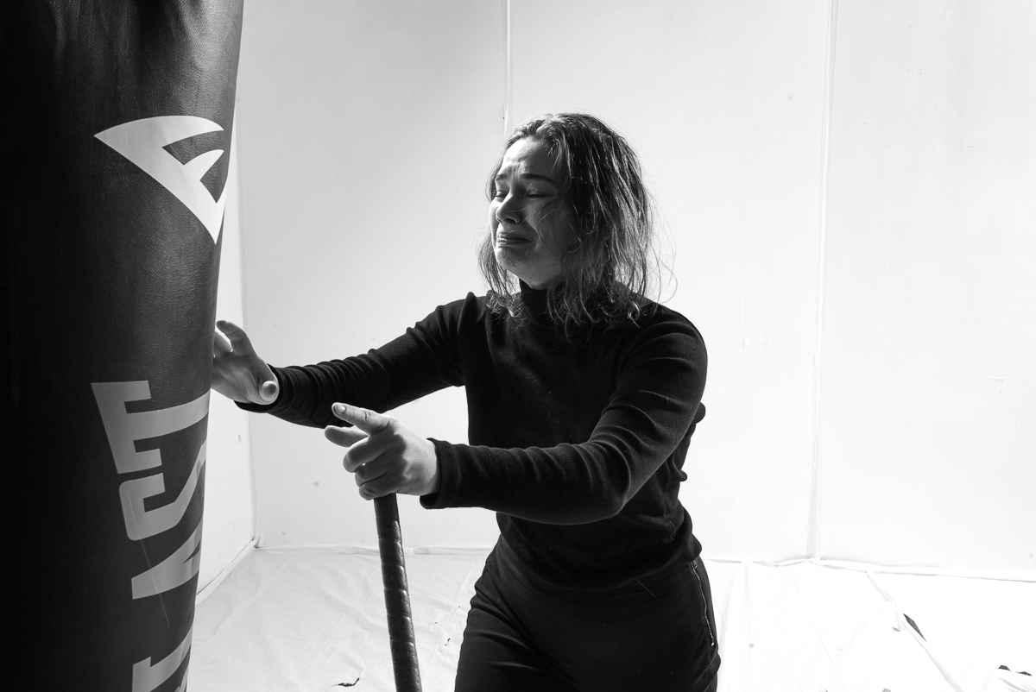
Marissa Wajda (She/Her/Hers) | Age: 26 | FIGHTING A MEMORY
Marissa walks into the room. I can sense her hesitancy. She shares with me that she has never been photographed professionally and has really bad social anxiety. She says she gets stressed when people look at her.
Marissa takes time to form long and articulate responses to my questions. She is thoughtful about everything, looking for the best way to present her opinions. I ask her to define anger. She responds, “It seems to be the point where I am beyond frustrated, where I become so frustrated that I don’t know what to do with my body; pushing the threshold of emotions that feel safe to me.”
Marissa describes her relationship to anger as being hidden, though she is confrontational if she feels she is being disrespected. I ask her what she will think about during the process and she highlights her frustration with the current political climate. Marissa mentions that she has been assaulted more than once. The most physical of these assaults occurred only three years ago. This is all she tells me. “I’m super nervous,” she says.
We begin the process. I consciously give her distance my when I pick up my camera. I want to give her space. I want to respect her anxiety about being looked at. Her anger spikes and retreats consistently for about 15 minutes. I can tell she is stuck in her thoughts. I suggest that she jump around in order to get out of her head and into her body. I am asking her to let go of the control that so many women(+) are forced to maintain in order to not upset the people around them.
Deborah Cohan explores anger as it is associated to social structure and activism. She describes anger as a “transformative resource” that individuals can draw upon while fighting against discrimination or disempowerment. Cohan writes, “If rage has no capacity for producing change, then it would not be regarded as being as threatening as it is.”
I encourage Marissa to yell and count down from three. Together we scream. I transition from observer to facilitator and back again. The space between us becomes more familiar. Marissa lets go of the bat and re-approaches the punching bag.
She holds the bag close for a moment. The motion is intimate and seems to be driven by a familiar memory. She throws her weight against it forcefully. She repeatedly throws herself at the punching bag; one, two, three, four, five times. She screams. A shift happens. The bag has transformed from object to memory. She is reliving a moment. It is the first time since photographing women in this space that I question whether or not I should put down my camera. I continue shooting. I stand behind this personified memory and capture the moment. Tears well-up in her eyes. She is fighting back.
Marissas’ process follows a pattern that many other women(+) exhibit. She says, “I feel like this process is representative of my experience with anger on a daily basis. I will let out the first initial anger, and then I think I’m done even though I don’t let out the stuff that’s really there. It’s the tip of the iceberg, that performative relationship to anger.”
The moments I aim to capture rests at this point; the decision we make whether or not to keep performing or face the reality of what it is we are feeling. Marissa mentions that is afraid that the photos might not “turn out right”. I assure her that they are exactly what they need to be.

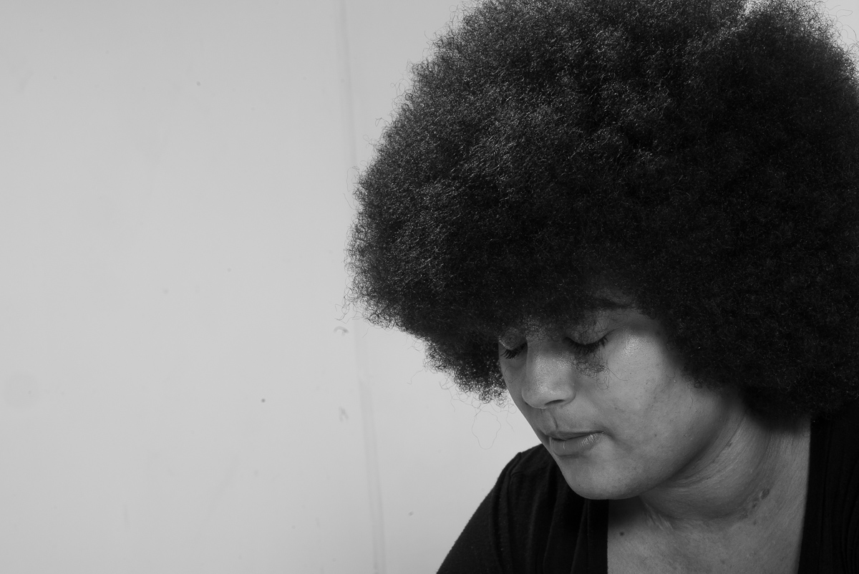
Karia White (She/Her/Hers | Age: 21 | I SEE YOU
“[Anger] is a topic I don’t talk about, especially as a black woman. We are made to navigate the world with policing everywhere.” Karia says that she feels an inherent need to internalize her anger; to police herself because of how policed her body feels in our society. She states, “I definitely show-up in places differently and suppress a lot of emotions so that I don’t come off as the ‘angry black woman’”.
“My relationship to anger has been suppression. I am a very sensitive person so I see a lot of my world through teary eyes. I think my anger comes up in crying or in isolation. But I am also of the belief that anger is not an emotion rooted in itself, it is made up of a lot of other components.” Karia expresses her anger as it relates to living in a society that, “does not view [my] anger as valid”.
Together, we talk about the impact of race as it relates to the expression of anger. This process cannot begin without the acknowledgement of what our different positionalities mean in our society. Karia emphasizes the need to “unlearn” the notion that her anger is not considered valid within our systems. “I have every right to be angry and my anger is painted with a very broad brush” she says, “We [as black women] are never allowed to be nuanced.”
In Audre Lorde’s famous 1981 keynote speech, “The Uses of Anger” she states, “Any discussion among women about racism must include the recognition and use of anger. This discussion must be direct and creative because it is crucial. Women of Color in American have grown up within a symphony of anger, at being silenced, at being unchosen, at knowing that when we survive, it is in spite of a world that takes for granted our lack of humanness, and which hates our very existence outside of its service.” Anger is tightly interwoven within resistance movements. Lorde’s work has helped to imbed this concept into Black Feminist theories and the praxis prominent activist movements such as Black Lives Matter. There is a fundamental understanding within these movements that until we are all free, none of us are free. I believe this understanding can also be applied to our understanding of anger.
Karia’s expression of anger is unreserved and powerful. With a background in martial arts she expresses her anger forcefully and just as quickly pulls it back. This push and pull is present throughout her experience; her expressions continues to be measured. She maintains a calm control in conversation with her anger.
The process begins to wind down, she sits on the floor and looks at the board she has destroyed. “It felt good to let some of that anger out, but I’m also sad” she says, “even though I know I am entitled to it, but it’s still destruction That’s not whole anymore” she says looking at the splinters that are left.
Karia relates this experience back to her own family, especially the women. She questions how much anger generations have carried with them. “I guess part of seeing everyone in their full humanity is allowing people to actually share their story” she states. Anger is undeniable as it weaves into the racial fabric of America’s story. Karia describes an anger that is intrinsically associated with fatigue. She has experienced this fatigue more specifically in the black communities she has lived and worked in. “We have to fight so hard for people to see us in our full humanity and as a black woman I am fighting on multiple levels” she says.
In her article, Rage and Activism: The Promise of Black Lives Matter Deborah Cohan writes, “When rage serves positive functions for activism, it is because rage helps people to access and build on the truth and authenticity of their lives.” Authenticity and personal narrative are foundational to Black Feminist Thought and other feminist theories. There is a lot of courage in consciously relating to our anger and being honest with that relationship. It is with this same courage that generations of black women have continued to fight ongoing intersectional, oppressive and violent systems in our country.
Cohan writes, “Rage, human agency, voice, black women’s activism, and the larger social structure are understood together using the sociological imagination.” Social imagination is a concept developed by C Wright Mills. The theory highlights that private troubles of ones personal milieu are connected to public issues of social structure. Just as rage can migrate along the spectrum of personal milieu to issues of social structure, so can the feeling of exhaustion.
“If you are living in the same America I am living in you can’t sit still” Karias says, “How do you not wake up angry, being black in America.” Everything’s not good, all the kids are not alright. If we are not willing to name it as anger, we can’t do anything. I don’t want my future children or grandchildren to continually have to carve-out space for themselves.” As I listen to this, I think about the other women who have gone through the process. They have all spoken about needing to create space. Karia however, draws our attention to the gendered and radicalized nature of this space.
“The best phrase we have in any language is, ‘I see you’ she says. “If you’re not able to see someone you can’t move forward in conducting a productive and fruitful conversation with them”. If we assume our anger is individual, isolated and only understood by ourselves, we are missing an opportunity to acknowledge each other’s full humanity.
“Healing is not always beautiful.” She says, “Breaking shit and allowing yourself to just feel is not pretty.” But it is necessary. Karia sits across from me and I see her nuanced understanding of the world. “I want women(+) to have the space to be seen. I want them seen through highlighting the pieces of them that are often regarded as invalid,” I say. We both smile and sit in silence.

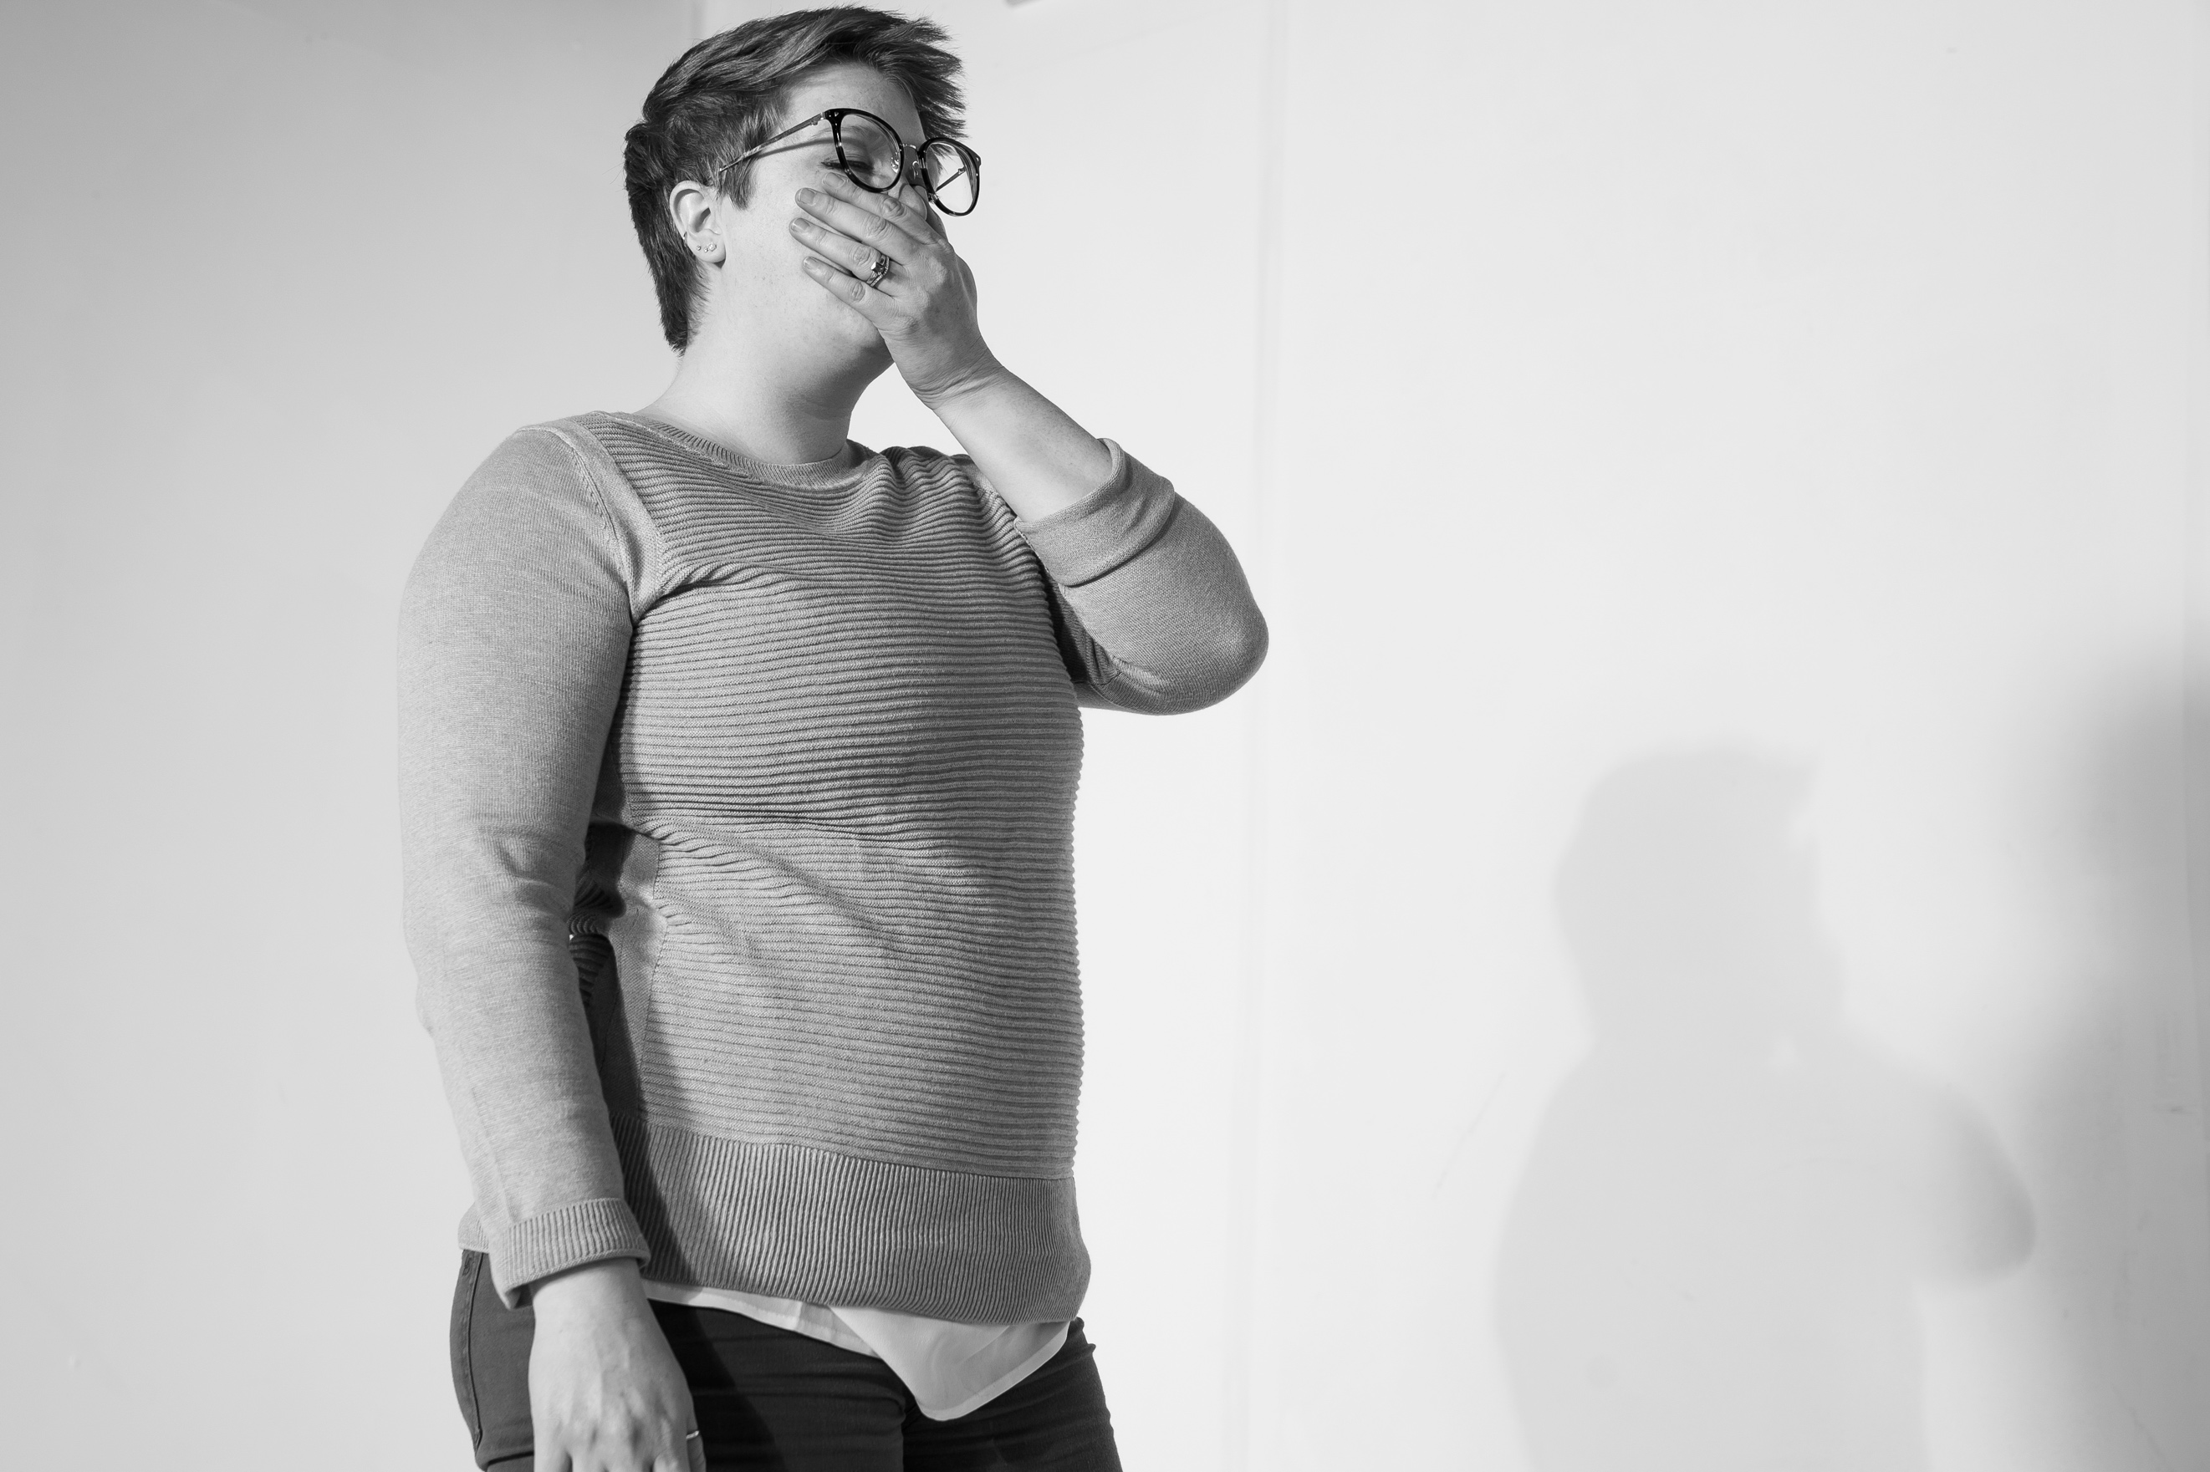
Amanda Edwards (She/Her/Hers) | Age: 29 | EXPECTATIONS
Amanda begins the interview by telling me that she is nervous about the process. “At 29 I don’t feel like I know myself very well and there is a big part of me that I’m really wanting to discover.” Amanda describes the weight of the expectations that were placed on her at a young age and how this has impacted the choices she has made in her life. These expectations were only heightened, after her father took his life three years ago; ten days before her wedding. A tear slides its way down her cheek. The room becomes heavy. There is nothing to say. We remain silent.
As a wife, expectations have continued to mount. “I’m just tired of being the wife that I’m expected to be, or the daughter-in-law that I’m expected to be and I just think of all of those times that I wanted to throw something or put a hole in the wall. Or just be angry and I think [that] because of those expectations I told myself that I wasn’t allowed to.”
Amanda describes her anger is “wrapped-up” in everything; at the center lays the rage felt for her father. She is angry at him for putting her through so much pain, “and not being here to be accountable for the hurt that he’s caused.” Tears run down Amanda’s face. She stops and wipes them away. We wait. Eventually Amanda stands and approaches the studio.
In her book, The Power of Women’ Anger, Soraya Chemaly writes, “Like most people, I had learned to think of empathy and compassion as divorced from anger, but empathy and compassion were fundamental to my anger. I have since learned that my rage is a critical part of my life, and it is a part of myself that I have grown to respect and love instead of suppress.” Like many of us, Amanda restricts herself from feeling rage at something that she has every right to be angry about because of a prescribed narrative; that anger means we do not also hold compassion for the one’s we are angry with.
Psychotherapist Brad Branton says that, “The stress that kills or cripples most of the population comes from being too hard on themselves when they don’t live up to their own imaginings about how other people think they should behave. We don’t know who we are and we try to guess what we ‘ought’ to be in order to do the “right thing” and be happy.” Anger is an emotion that many of us feel like we ‘ought’ not to express. A part of acknowledging our anger, is being more honest with ourselves about the true nature of what we’re feeling.
As hard as it is to admit, we get angry at people for dying. According to Branton, “One of the things that makes getting over the loss of a loved one take a long time is the refusal to admit that they are furious at the dead person for dying. Every one of us hates people we love who die on us.” It makes perfect sense that we are afraid to truly express our anger. But what happens when we begin to be more honest with ourselves about who we really are?
Amanda’s emotional interview carries her into the physical embodiment of anger quickly. With bat-in hand she begins throwing her weight against the punching bag. Throughout the whole process the tears never end; anger and softness intertwine into her expression. The combination of forceful anger and gentle tears cause the air in the room to grip the tension of this dichotomy. As her movements slow, Amanda leans her weight against the punching bag softly.
Eventually, Amanda drops to the ground and lays down among the broken ceramics and wood. Her exhaustion is palpable, her stomach rises and falls with deepening breaths. Slowly Amanda pulls herself to a seated position and gently rocks back and forth. Her eyes remain shut. She stands up. She opens her eyes and she walks back to the couch. “I feel like it is few and far-between that other people hold space for women. I feel like that’s what this process has been; holding space for all of us. It’s refreshing,” she says.

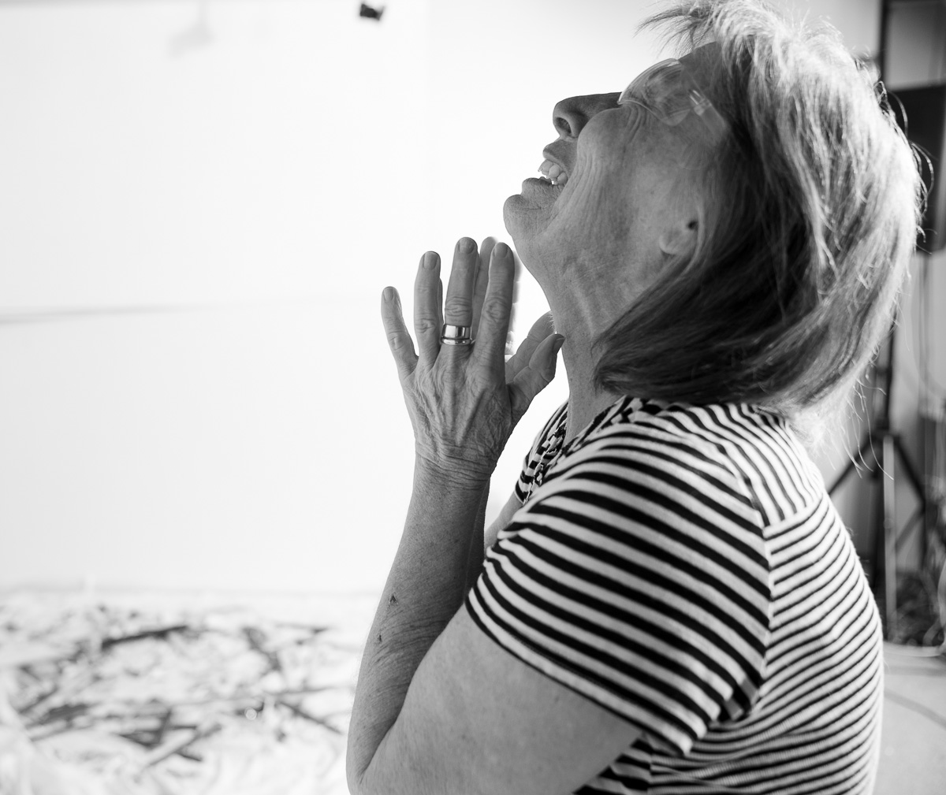
Sharry McAllister (She, Her, Hers) | Age: 65 | GENERATIONAL ANGER
Sharry is one of a group of five who have decided to go through this process together. One of these women is her daughter, Rachael. I pose the question; “What has been your relationship to anger?” Sharry grounds the conversation within the context of her own generation. “We never expressed anger outwardly. And if you did, then you know, you were throwing a ‘temper-tantrum’ or you couldn’t control your emotions. There was something wrong with that. And so, while I’ve never forcibly broken any dishes, the idea of that is pretty damn fun.” Our laughter lightens the room. However, this generational divide hangs in the air.
In Susan Faludi’s work, Blacklash, she tracks the varied and suffocating ways in which womens anger was silenced throughout the Reagan years. The era was marked by a stark contrast between the Housewife, the Career Woman and the Welfare Queen. Women were often overtly sexualized, especially in popular culture. Having followed the 60’s and 70’s feminist movement the term feminism, the idea of public and politicized challenge to male patriarchy, has been successfully coded by media outlets as unattractive, old, crazy, ugly etc. There were of course specific issues regarding the lack of economic and racial diversity that was a foundation of earlier feminist movements. However, the ways in which popular culture attacked this movement was to dichotomize the female feminist into categories that often focused on the physical characteristics of feminists rather than their intellectual labor.
Deborah Cohan has argued that rage has lost its respectability since the 1960s. She states, “The thing that you had in the civil rights revolution was an absolute upfront embrace of rage and a working with that. And, when you don’t rage against the evils and the enemies against you, what you do is you turn in against yourself and you begin to despair and give up.”
As Rebecca Traister points out in her book, Good and Mad, “Anyone who wants power within a white male power structure has been asked to quell anything that sounds like wrath, to reassure that they come in cooperative peace against those who have oppressed or subjugated them.” Women who signal fury and who use their anger to defend their visibility have historically been marked as unstable forces.
Rachael is slumped on the ground and breathing hard. She has just finished the process. Sharry walks up to her and puts her hand on her daughter’s shoulder. Rachael stands up and giver her mother a hug. They trade places and the process begins again.
Earlier Sharry had equated anger with embarrassment and failure, emotions she associates with her recent divorce. Without restraint, she picks up the bat and starts hitting the punching bag. She then demolishes the ceramics with impressive force and simultaneously confronts her emotions of betrayal by yelling at a figure we cannot see. We watch in silence.
After about twenty minutes Sharry slows and sits on the floor. She takes off her glasses and cries softly. The women behind me are silent. I look at this woman and experience a wave of respect for the boundaries she has just worked her way through. Her daughter walks up to her, gives her a hug and guides her back to the couch.
“You get into a different space after a few minutes out there” Sharry says, “I can’t explain it, but all of a sudden you just don’t care.” She goes on to say, “it is hard to explain, but I didn’t feel like me. I didn’t feel like I had to protect myself or have my little walls up; or be any certain way. The whole experience was very freeing”. The hairs on my arms rise as she states “I don’t think I have ever felt that I could let go like that, ever.”

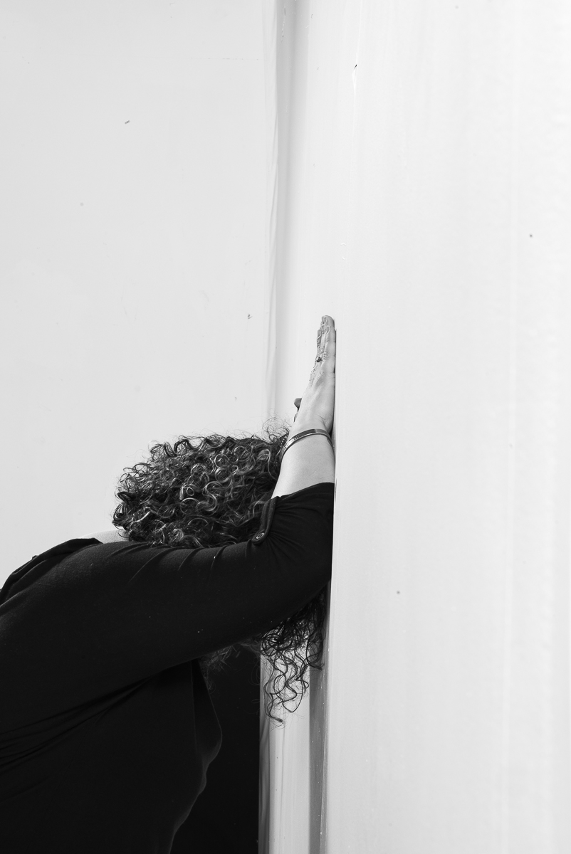
Bernardita Yunis (She/Her/Hers) | Age: 34 | I’M NOT ALLOWED TO BE ANGRY
“Bernardita, how do you define anger?”
“Two words come to mind: rage and release.”
She tells me she is nervous being angry in front of me. Bernardita says that she tries to never express anger outside of her family. She doesn’t want to fit the mold of being that, “loud angry Latina”. For her it is a safety measure; the restraint. I ask her how her relationship to anger looks. She replays that it’s complicated. “I’m angry all the time; it’s constant. Every news article I read of someone dying in ICE custody and every shooting that happens at the hands of police builds this anger. Last week two women were beat up in the street for speaking Spanish. When I am driving in my car I want to be able to blast my Spanish music without feeling afraid. That makes me angry. I feel like I have to explain myself to white people all of the time. It is exhausting. And then there’s the more personal anger that I think we all have with our own family.”
I ask her how society responds to her anger. She responds, “I’m not allowed to have it. I am a female woman and an immigrant in the United States.” She explains that reserving this emotion is a survival technique that her family has taught her. It is dangerous for immigrant communities to display anger. Bernadita examines this as a tactic of control.
In Rage Becomes Her, Soraya writes, “Anger is an assertion of rights and worth. It is communication, equality, and knowledge. It is intimacy, acceptance, fearlessness, embodiment, revolt, and reconciliation. Anger is memory and rage. It is rational thought and irrational pain. Anger is freedom, independence, expansiveness and entitlement. It is justice, passion, clarity, and motivation. In anger, whether you like it or not, there is truth.” Bernadita’s relationship to anger is influenced and constructed by her status as a Latina Immigrant in the United States. The danger of women(+)’s anger is that it illustrates how seriously we take ourselves and the values we stand for.
Bernardita works through the process in waves. Her experience mixes the physical exertion of rage with breaks in which she collects herself. We sit back on the couch. “I feel a lot in my body” she says. She explains that she didn’t feel how intense this wave of emotion was until she was sitting down. “I keep reflecting on why I was screaming. Thanks for creating space. A space where I can be angry.” She brings her face to her hands and cries softly.

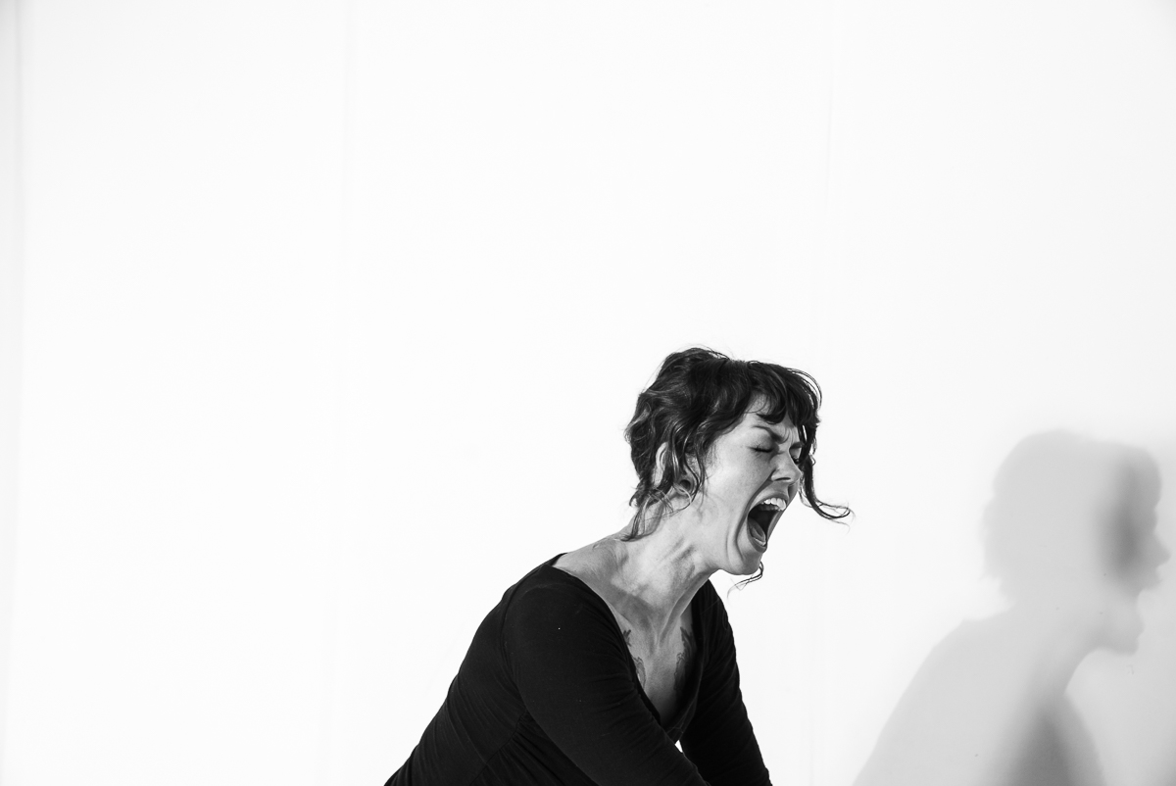
Gretchen Williams (She/Her/Hers) | THE STORIES WE TELL
Gretchen walks into the studio. Her hair is pulled back, her black wedges sneak-out from the bottom of her jeans. We sit down. I ask her what interested her in this project. She tells me that she has very recently been through a divorce and the anger she has felt throughout the process has been like a weight that won’t go away. Her ex-husband is a lawyer and within the judicial proceedings Gretchen describes feeling powerless. “I can’t really fight back in the way I would like to. I think a part of the helplessness is what is making me so angry and then there’s so many aspects mixed into it; feeling betrayed but mostly, I’m just pissed off.” Gretchen describes her experience as one that has made her feel crazy at times, hurt and confused. “I’m struggling,” she says.
As we end the initial interview I show her the space and then turn up the music. Gretchen is quick to pick up the bat and swiftly let her rage take over her body. Her movement is strong and she lends her whole body to the process. I begin to see an internal dialogue taking place between herself and these destructive actions.
In her Ted Talk title The Power of Women’s Anger, Soraya Chemaly argues that, “We learn to bite our tongues and swallow our pride. For women indignity becomes imminent in our notions of femininity. There’s a long personal and political tale to that bifurcation. This puts us at an enormous disadvantage, particularly when we have to defend ourselves and our own interests.” To be able to express anger, is to be able to stand up for ourselves and what we need.
Twenty minutes into the process, Gretchen begins to slow down. One of her hands is bleeding. She begins talking to me about betrayal. Instead of talking about her husband, she speaks about the betrayal she has felt from her family. They have sided with him on the divorce and she is living with them. She is being continually criticized for her anger towards a man they have sided with. Once this is recognized, Gretchen again picks up the bat picks-up her anger.
Finally, Gretchen rests. She paces around the space for a couple of minutes. She tells me she is done. I guide her back to the couch and we about her experience. “Before, I didn’t even know what I was saying” she says, “I feel like I came in here with a story and went with that. But what has actually been making my angry wasn’t that story I was telling myself, it was my family.” Gretchen continues, “Maybe whatever is seemingly at the surface isn’t really what anger is about. But you don’t know that until you hit something.” She laughs and her shoulders relax. I wait for her to get up and together we walk out of the studio. I guide her to the elevator and await the next participant.

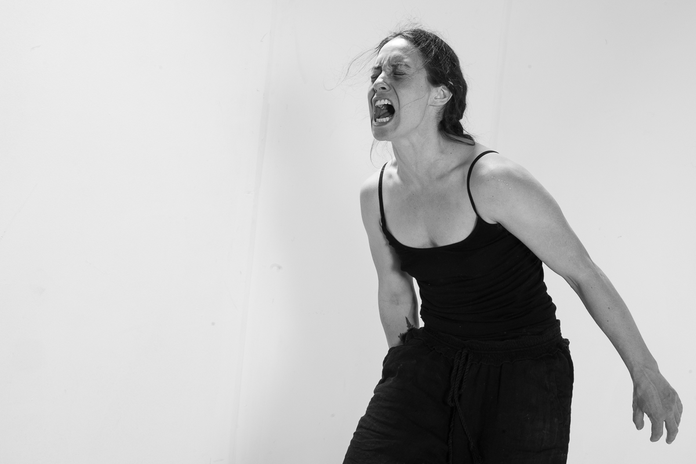
Wysteria Bristol (She/Her/Hers) | WE MANAGE ANGER ALL THE TIME WITHOUT REALIZING IT
Wysteria walks into the room. She rests against the white sofa; her posture is relaxed – her stare is intense. She tells me, “Anger is something I have been trying to have a better relationship with in my life.” She separates her anger into two dichotomies: simmering and held-back, hot and furious. It is an anger that is disruptive. “It is hard for me to come to terms with losing control like that.” She grasps her hands together. Her voice is strained, she is holding back tears. “Fear brings up a lot for me. I have had partners be frightened by my anger, which is really hard for me to feel like there is this thing inside of me that could accidentally hurt someone.” Wysteria looks away for a couple of moments. I tell her that she can’t hurt anything in this space. She stands up and walks toward the studio.
In The Uses of Anger, Audre Lorde states, “It is not the anger of other women that will destroy us but our refusals to stand still, to listen to its rhythms, to learn within it, to move beyond the manner of presentation to the substance, to tap that anger as an important source of empowerment.” I think about this when I listen to Wysteria. How can she listen to her angers’ rhythm if those around her feel scared of her expression of it? Is their reaction her responsibility? It makes me think of the fear I have felt in the face of more masculine, aggressive anger. There is a difference between that anger and the anger I have seen expressed in this space. But like any other emotion, anger is not completely clear. It is associated with so many other parts of ourselves. In the space I have created for this project, she will not be hurting anyone she loves. This raises larger questions about how space and safety are connected. How does space and safety change the way we express anger?
Dr. Brad Blanton will argue that self-opposition with regard to expressing anger is what continues to perpetuate the emotion. He calls for a full expression of anger, giving up as much constraints to it as possible. Wysteria’s hesitation to express her ager, rooted in her previous relationships, complicates this narrative.
It takes a couple of minutes for Wyteria to find her rhythm in the new space. After pacing around for a while, she gets comfortable with the options at her disposal and begins to move quickly among the different props. Her body is strong, each forceful hit reverberating in the air. I call to her to stop an action or adjust, in order to make sure she stays safe. The outside enforcement of control allows her own mechanisms of control to take a break for a bit. I watch as she becomes submerged in the experience of her anger. After a while she slows, tears fall down her reddened face. Wysteria sits against the opposite wall of the studio and places her head in her hands. Slowly, she lays down on the ground. Her face is soft, peaceful.
Wysteria sits back up and raises her hand to her heart. She takes a couple of deep breaths. Her actions are self-soothing and it amazes me how quickly she has transitioned from expressing rage to holding such a peaceful demeanor. “The part of me that doesn’t want to feel angry seems to be the part of me that wants to take care of other people. I know what it is like to have someone weigh their emotions onto you when you’re not able to deal with them. I have never wanted to do that to anyone.” She is not alone feeling this way. In her book Rage Becomes Her, Soraya Chemaly writes, “For women, healthy anger management doesn’t require us to exert more control but, rather, less. We are managing anger all the time without even realizing it.”
The expectation that women(+) need to maintain a space that makes everyone else feel comfortable is impractical in a world in which we also validate the anger that women(+) hold. Wysteria’s challenge of balancing her own mental health in a controlled way is built from a legacy of women before her. In fact, Wysteria seemed most relaxed and embodied only after the release of this anger.

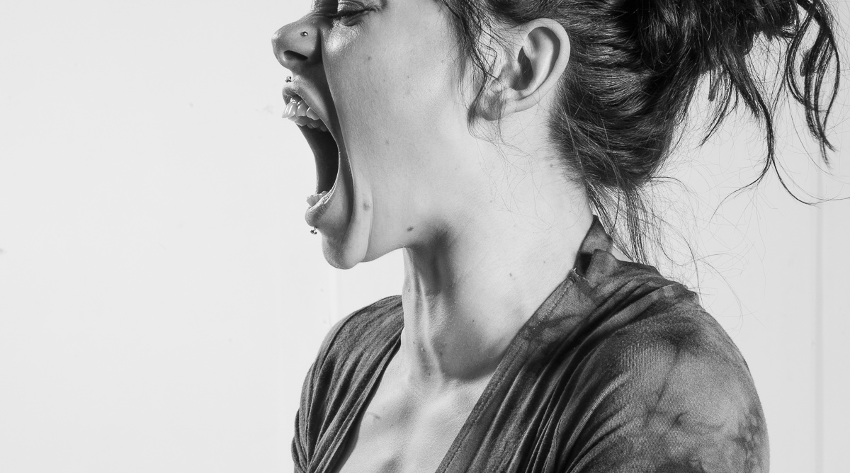
Cedar Rose (She/Her/Hers) | Age: 21 | LET HER RAGE
Cedar is my sister’s sister. Her and I didn’t grow up together but we are family.
“So, why did you decide to come and do this project?’ I ask.
“I have a habit of pretending things are okay while continually supporting other people’s emotions. This year has been difficult for me and I need to start being honest with myself and everyone around me and deal with this shit. That’s the only way you can really help people; is to share your own hurt so they don’t feel alone and learn from your experiences. Everyone is fucking struggling and no one wants to talk about it.”
Cedar continues, “I think anger is a really interesting emotion because it is connected to so many other emotions. Like for me it is mostly connected to sadness.” She states, “it feels more acceptable to lash out rather than breakdown, but the need to express it in some way is always present. I’ll go numb before I’ll do anything, because I have so much in me that I haven’t released. I’ve been angry for my entire life. When you’re little you can’t do anything about it, no one listens and then it just builds and blows up in my face. I got adopted by my grandmother for an incident where I just couldn’t handle my anger anymore.”
Though we grew up in different households, Cedar’s story and my own are very similar. The structure of family looks different than most and there has been responsibility to take care of others in ways that most children shouldn’t have to. This complicates anger. It feels good to be needed and to be able to help a person who you love that is suffering. But it doesn’t allow for the normal expression of anger that most kids they have a right to.
Rebecca Traister writes, “The issue is that societies that don’t respect women’s anger, don’t respect women. The danger of our anger is that it exactly shows how seriously we take ourselves, and we expect other people to take us seriously as well.” It is hard to ask for this as a women(+) in our society. It is even harder to ask for this if you have felt like you have needed to take care of your family and your environment for your entire childhood.
“I’m determined to feel the hurt from all of it, no matter how painful it is.” She tells me, “How can you live in the world we live in and not feel the collective hurt? It’s fucking painful, how can you not be angry about it?” It is important to be honest and upfront about the fact that we all get hurt. “You can be seen and not actually be seen.”
The Women’s March on January 21, 2017 was the biggest one-day political protest in this country’s history. This protest was women standing up and demanding to be seen. It was a march that utilized anger as a tool for being seen. Much like the #MeToo trend that was inspired by Tarana Burke’s 2007 MeToo Movement, the most recent political movements that have focused on women are utilizing anger as a tool for visibility; a visibility that is required in order for our rights to be centered in the conversation. In Good and Mad, Rebecca Traister writes, “We must train ourselves to even be able to see and hear anger from women and understand it not only as rational, but as politically weighty. “
Cedar begins the process with confidence. She is no stranger to confronting uncomfortable emotions and this becomes apparent quickly. She dives straight into the experience, calming herself down in intervals. I stand back and let her go. There is no need for me to do anything but bear witness to her experience. She moves about the space freely. Her expression of rage is raw. Tears fall down her face. She does not wipe them away. It is emotional for me to watch. My heart aches.
She slows her pace. We both take a seat. “You know” she says, “you can be seen and not actually be seen. It’s good to let it out, and to know that you are actually being seen”. I smile. She says that four years ago she would never have been able to do something like this. “To cry in front of someone? Hell no.” The shift she says, comes from an understanding that in order for her to work through her pain, she has had to learn to be okay with expressing both sadness and rage in public. “It’s fucking awkward and uncomfortable. But it’s real.”
In Good and Mad, Rebecca Traister states, “In our society tears are understood as vulnerability and weakness, when in fact they are the most-ready expression of our blind rage and our inability to find an outlet where it is not going to redound negatively to us.” Watching women(+) cry in this process has always been a sign of strength for me. It means they are reaching a place that is real. It doesn’t have to show itself in tears, but the wights of this expression is strong.
Cedar and I take the time to talk for an hour after I put down my camera. Cedar says that she is doing this in order to help herself help others. Her focus on the experience of others causes me to reflect on this project as a whole. I am here to witness and offer a platform for women(+) to express an emotion that has been historically demonized.

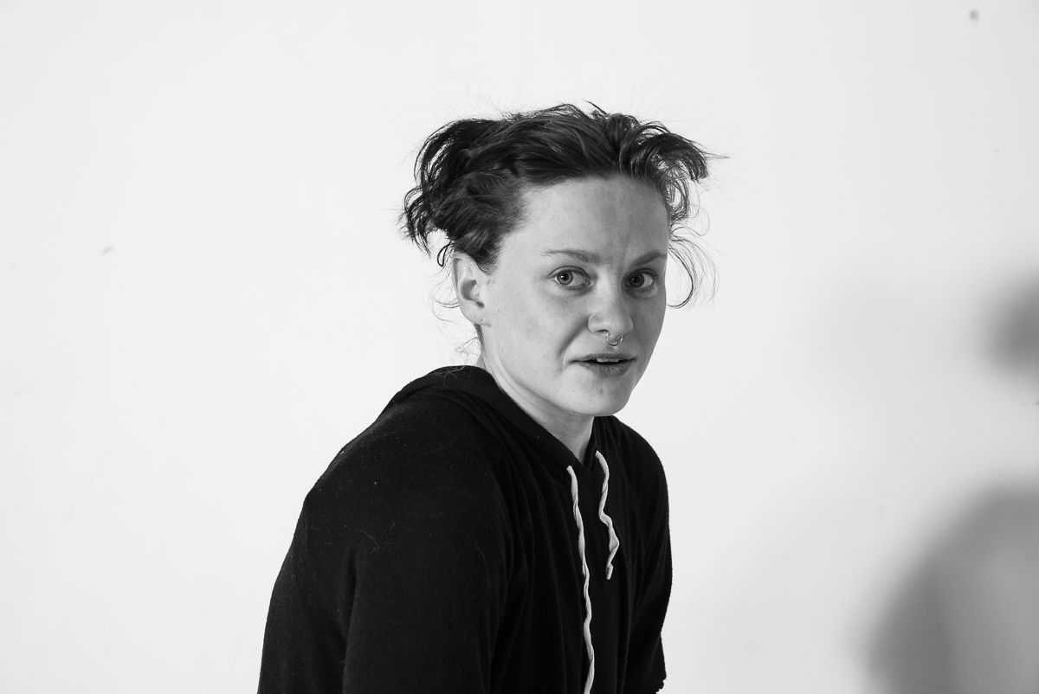
Jordan Hartnett (She/Her/Hers) | Age: 23 | DON’T ASK TOO MUCH
Jordan has been physically restricted for the last couple of months due to a leg injury. The stagnation that has accompanied this injury has forced Jordan to slow down and face emotions she describes are uncomfortable for her. “Almost everyone in society is shunned when it comes to anger; as if we are supposed to keep everything bottled-up” Jordan says. Jordan grew up surrounded by a lot of anger, but never was allowed to react. “I was supposed to take everything in, but not throw anything out” she says.
Just as we are afraid to honestly express many of our thoughts and emotions, it makes sense that we are afraid to truly express anger. Telling the truth means you have to put yourself “out there,” to make yourself vulnerable. This action opens yourself to possible harm. An honest relationship to anger can be painful, just as it can be destructive. But as we learn time and time again, the truth is always cathartic. In his book Radical Honesty, Brad Blanton PhD writes, “Paying attention to the experience of feeling in the body while angry is the key to learning how to use anger rather than have anger use you. That awareness of feeling in the body is what causes anger to change from a destructive force to a usable power.”
Due to her injury I had Jordan sits on a stool. This position restricts her movement with the props that are offered. She was a part of the five-woman group who had been watching her. I ask the group to leave. Jordan’s stiffness softens, but I can tell she is continuing to hold back. After some time her yelling feels more embodied, and there are moments that I see her come up against an emotion and turn away. photograph the fear. This tight-lipped expression speaks louder than many other’s screams. Jordan is facing something so internal and so terrifying that she forces herself to look away. I ask her about this experience. She acknowledges the hesitation.
In her Ted Talk The Power of Women, Soraya Chemaly poses the question: “What if we didn’t sever anger from femininity? Because severing anger from femininity means we sever girls and women from the emotion that best protects us from injustice.” She explains that by severing this connection, women learn to become deferential. Anger is incompatible with deference. I see this battle rage on Jordan’s face. I see her trying to use deference in place of anger as a way to protect herself. It is a tactic I know well and it breaks my heart.
There is a point in which we can either choose to fall into an unknown relationship with our anger, or pull back. Jordan plays on the edge of this decision. Her reaction to this process is fear. What she is confronting is real and the process of confronting it has real implications. She chooses not to fall into this anger. She is taking care of herself. I photograph her hesitancy. “It’s hard for me to let other people hold space for me. It doesn’t feel safe”. This honesty is striking, and my chest grows heavy. Her statement is heartbreaking and is one that resonates profoundly in my own experience of anger and its’ expression. We have pushed as far as she is willing to go. I invite the other women back into the space.

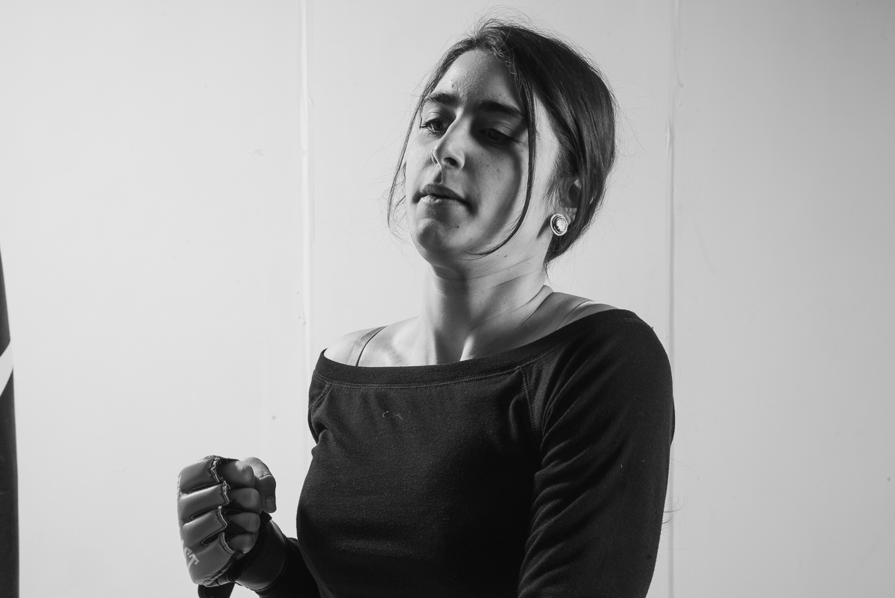
Angela Karami (She/Her/Hers) | Age: 26 | EFFEMINATE ANGER
Angela is soft-spoken and gentle. She tells me she’s here because she wants to be challenged with something she is not normally comfortable with. I ask her to define anger. She responds, “An intense release of something that you feel resistance with; either within yourself or within some context of space between yourself and something or someone.”
“What has been your relationship with anger in the past?” I ask her.
“I feel like as a woman, I have learned to internalize my anger. I surprise myself when I release my anger. But I feel like society doesn’t really take anger seriously.”
Angela chooses to focus her attention on hitting the punching bag consistently for long periods of time. Her rhythm is measured, and she holds a controlled stance. She is playing with an effeminate anger and the control speak to a different kind of beautify. It is an expression that resistant to the process that I have created, since the process I have created is focused on destruction. She is choosing not to destroy, but rather to use the repetitive action of attacking the punching bag in order to work through her relationship with anger.
The whole process is measured. Her energy is consistent from start to finish. As we talk with one another afterwards she tells me that she lives with type 1 diabetes. Because of this, everything in her life has to be planned in order to ensure that she is taking care of herself. It seems that her experience with anger may be influenced by this.
Angela expresses her frustration when people question where she is from. “Knowing that my father is an Iranian immigrant isn’t your treat for the day.” She says, “I shouldn’t have to explain my heritage to someone because they can’t quite figure me out.” She mentions the miss-conceived notions of the Middle East that she equates to the media’s addiction to telling fear-based stories. Our conversation on the topic of anger has evolved into a conversation surrounding global fear.
In her essay Art and Anger Jane Marcus writes, “Most women writers have learned to disguise their anger. But their protest never died.” Though for some women(+) the release of control was helpful in processing their anger, there was a beauty in Angela’s quieter approach. Her protest was present, but she did not have to scream in order for it to be heard.


Bex Schmetzel (They/Them/Theirs) | Age: 24 | ENGENDERED ANGER
Bex strolls into the room with a striking outfit that consists of a leather jacket, black shorts and black boots. This is the third day and Shammai Madding is helping co-facilitate. I ask Bex about what interested them in the project. They tell me that anger is an emotion they have trouble accessing, “I wanted to see if this process could give me permission to access my anger, because I often feel like I can’t have that”. I ask them to describe what anger is. Bex responds, “The first words that come to my mind are ‘unapologetically lashing out’. I feel like anger comes from fear to exist authentically as myself in the world that we live in… I’d like to be better friends with my anger, but I’m scared.”
Bex is frustrated by continually being miss-gendered and having to hold-back that anger in the presence of the person who misgenders them, even when they apologize. This apology, they say, takes over the conversation. It no longer is about their identity, but rather their experience of Bex’s identity. “I would love to get to a place where I say, ‘thank you, do better’ but I’ve never been able to say that” Bex states.
When I ask how they feel society responds to their anger Bex responds, “Society doesn’t accept it, it is condescending to it and invalidates it constantly. It feels like my anger is a joke. As soon as I muster-up the courage to let my anger out, it’s immediately invalidated. I’m left saying ‘Maybe I was wrong, maybe I shouldn’t be mad about this’.”
In a talk on her book Good and Mad, Rebecca Traister argue that societal restraints works so well in keeping women(+)’s anger hidden that, “nobody asks me why [we’re] angry.” Anger is a taboo emotion. Thus, the actual cause of this emotion is almost often disregarded. This experience mirrors Bex’s experience of being misgendered.
There is a specific direction that power travels. Actions that move against this direction stand-out. A “scene” is created surrounding this tension. This disruption can sometimes mask the very reason for the original resistance. Because of this, Traister highlights the importance of maintaining a curiosity and interest in why women(+) are angry.
The process begins again. Bex requests a stack of papers. Others had previously used paper to write on, but Bex grabs it and begins tearing it apart. They put the pieces in their mouth and spit it back out. When they were younger Bex would pull-out their hair when they got stressed. Bex uses paper to substitute this habit. Ripping paper is a safer way for Bex to exert this need. Between throwing ceramics and punching the bag, Bex returns to the paper.
Bex’s expression is performative and intense. Their background is in performative arts and there is no shyness when it comes to me and my camera. The energy is electrifying, but it makes it hard to discern when they are expressing anger rather than conversing with it. At one point, Bex sits close to the wooden board and begins talking about their family. At this point I expect to she a shift from their performance of anger to the embodiment of anger. I watch and wait.
Dr. Brad Blanton writes, “One has to look and listen carefully to distinguish between a phony expression of anger and an authentic one. A noisy expression of anger is not always the truth. The over-expression of anger can also be a form of lying, or a way of covering other feelings, like grief.” Bex’s performative nature made it hard for me to understand when and how to respond. Most participants followed a similar emotional arc throughout the process. They often began with a performative expression of anger and say they were done (at which point I lower the music and get them to start talking. Then a shift would occur. This moment is what interests me most. At this point, participants will either go in one of two directions: a more authentic and deeper anger will appear, or a softer and more vulnerable emotion like grief or sadness emerges. I don’t see this process in Bex’s experience and I wonder if it is their experience or my interpretation of their experience.
In our interview following their process Bex expresses that they had more authentic with their anger than ever before. Bex explains that for a moment, they had completely let their body take over. Bex says they felt most intentional during the time that they were talking about their relationship to their family.
In previous experiences I had observed a play with the concept masculine and feminine part os anger. When I ask about this dichotomy Bex responds, “That’s interesting because I think inherently my gender identity is tied up in that. I don’t identify as either and so that dichotomy doesn’t really resonate with me. I can’t relate to it.” I reflect on this, and how gender-binaries has previously played a large role in my ability relate to and understand this work. Working with Bex challenges this notion and contributes an alternative option. Inherently anger itself is not gendered, but because we live in a gendered society it becomes gendered.
In the theory of Queer of Color Critique, theorist Roderick Furguon argues that to disidentify means to… “recycle and rethink encoded meaning and use the code of the majority as a raw material for representing a disempowered politics of positionality…” that has been subdued by dominant culture. Bex disidentifies with the binary of gender and by doing this has shifted the encoded language of gender in this experience.
DISCUSSION:

“If rage has no capacity for producing change, then it would not be regarded as being as threatening as it is.”

– Deborah Cohan.
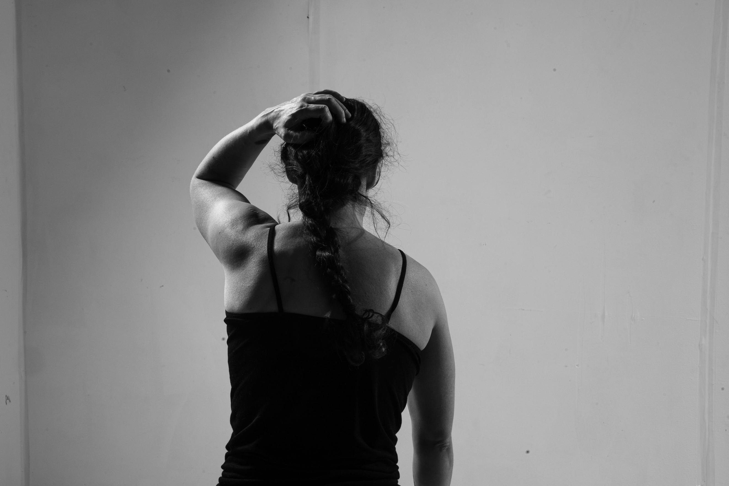

Publication
I have two more photography sessions scheduled this spring which may now need to be pushed back because of Covid-19. With each session, I have needed less and less props. I am interested in the idea of introducing mirrors as a prop. I will continue to use the same lighting design. After I have gone through the process two more times. I will select and edit images for publication purposes.
I am planning on showing this images in a gallery show. Pattern Gallery, in Denver, has agreed to exhibit my pieces in-between two of their shows this summer. My goal for showing this work in a gallery space is to invite the community and participants to witness the personal work that these women have created. I will be printing the best photo of each participant. They will all be invited, along with their community, to the opening. I think it is important for people to physically stand in front of a photograph of the nuanced expressions of women(+)’s anger.

Expanding This Project
In the future I would like to travel tp other countries to expand upon this series. I am curious how culture and space changes the way that women(+) express anger. I already have a list of women(+) in Germany and France who have said they want to be a part of this project. I would also like to focus on more specific populations such as women(+) who have experienced domestic abuse, adults who grew up in foster-care, homeless women(+), women(+) who have served in the military, war refugees, sex workers and others. Thus far, I have been photographing women(+) who have all been college educated. I am interested in focusing on women(+) who are newcomers to this conversation with/about anger; women(+) who might reject feminist theories.
I would like to extend this idea and focus on the impact of space as it relates to anger. So far I have created the space for women(+) to express their anger. I am interested in how space relates to the expression of anger. How is the expression of anger influenced by the white background I have chosen, and the specific props that are available? I want to explore the spaces in our own lives where we allow ourselves to be angry. I intend to do this by focusing on a smaller number of women(+) and discussing with them what these spaces look like. I would like to photograph the experience of anger in these spaces. How do these different environments change the expression of anger, and in what ways is this more freeing or more restrictive? It is certainly more subjective. Which aspects of these spaces allow for women(+) to express anger? What do these spaces look like? Are they private or public? Will the expression of anger be as authentic?

SOURCES:

ACADEMIC SOURCES:

- Hayyám, Omar. Rubáiyát Of Omar Khayyam. Translated by Edward Firzgerald.
- Rumi. The Essential Rumi. Translated by Coleman Barks. New York, NY: HarperCollins Publishers, 1995.
- Sontag, Susan. On Photography. New York: Picador, 1977.
- Sontag, Susan. Regarding the Pain of Others. New York: Picador, 2003.
- Hustvedt, Siri. A Woman Looking at Men Looking at Women: Essays on Art, Sex, and the Mind. London: Hodder & Stoughton Ltd, 2016.
- Foster, Nicole. Photography and The Gaze: The Ethics of Vision Inverted. Parallax, 14:2, 78-92, 2008.
- Marcus Jane. “Art and Anger.” Feminist Studies 4, no. 1 (1978): 69-98
- Sturken, Marita and Cartwright, Lisa. Practices of Looking: An Introduction to Visual Culture. New Yorrk Oxford University Press, 2018.
- Traister, Rebecca. Good and Mad: The Revolutionary Power of Women’s Anger. New York, NY: Simon and Schuster (2018).
- Lorde, Audre. “The Uses of Anger.” Women’s Studies Quarterly. Vol. 25, No.1/2 (1997). pp. 278-285.
- Chemaly, Soraya. Rage Becomes Her: The Power of Women’s Anger. New York, NY: Atria Publishing Group (2019)
- Reckitt, Helena, Lucinda Gosling, Hilary Robinsons, Amy Tobin, Maria Balshaw, and Xabier Arakistain. The Art of Feminism: Images that Shaped the Fight for Equality, 1857-2017. San Francisco: Chronicle Books, 2018.
- Mills, Charles W. 1997. The Racial Contract. Ithaca: Cornell University Press.

Articles, Discussions and Films:
- “The Power of Women’s Anger” TED Talk | TEDWomen, 2018. Soraya Chemaly. https://www.ted.com/talks/soraya_chemaly_the_power_of_women_s_anger/up-next?language=en
- Chemaly, Soraya. “Soraya Chemaly on the Gendering of Anger and Sadness”. Insititue for Gender and Economy, 2019. Accessed March 5, 2020. https://www.youtube.com/watch?v=fuHSA262JUE
- Traister, Rebecca. “Good and Mad”. Politics and Prose, 2018. Accessed March 1, 2020. https://www.youtube.com/watch?v=QERlQDjFjnU
- Pintilie, Adina. Touch Me Not. 2018; Berlin: Manekino Film, Rohfilm, Pink Production, Film.
- Urieta, Leticia. “Giving Women Permission to Own Their Anger.” Electric Lit: Reading into Everything (2019). Accessed December 8, 2019. https://electricliterature.com/giving-women-permission-to-own-their-anger/
- Levantovskaya, Maggie. “Anger Persists: On Rebecca Traister’s, “Good and Mad: The Revolutionary Power of Women’s Anger.” LARB (2018). Accessed December 8, 2019. https://lareviewofbooks.org/article/anger-persists-on-rebecca-traisters-good-and-mad-the-revolutionary-power-of-womens-anger/
- Golhill, Olivia. “2018 is the year Women tried to reclaim anger but failed.” Quartz (2018). Accessed December 8, 2019. https://qz.com/1496726/2018-is-the-year-women-tried-to-reclaim-anger-but-failed/

