Potential of Combining Emerging Therapies for Post-Traumatic Stress Disorder

Richard Park
Department of Ecology and Evolutionary Biology, The University of Colorado at Boulder

Thesis Defense Date:
March 31, 2021

Thesis Advisor and Department: Barbara Demmig-Adams, Ecology and Evolutionary Biology

Defense Committee Members and Departments:
Dr. Barbara Demmig-Adams, Ecology and Evolutionary Biology
Dr. Pieter Johnson, Ecology and Evolutionary Biology
Dr. Christopher Lowry, Integrative Physiology

Table of Contents
Abstract ……………………………………………………………………….…2
Introduction……………………………………………………………………...3
Background………………………………………………………………………5
Current Pharmacological Approaches to PTSD Treatment………………….8
Emerging Pharmacology for PTSD………………………………………….…10
Lifestyle Factors………………………………………………………………….11
Literature Synthesis……………………………………………………………..14
Stress Hormones & Chronic Inflammation………...……………..…………...14
Gut Microbiome & Endocannabinoids………………………………………...18
Cannabinoids…………………………………………………………………….20
Physical Activity…………………………………………………………………22
Electrotherapies………………………………………………………………….23
Other Emerging Therapies……………………………………………………...24
Conclusion & Proposed Treatment Regime……………………………………26
Acknowledgments……………………………………………………………….30
Bibliography……………………………………………………………………..31

Abstract

Post-traumatic stress disorder (PTSD) is a complex, multi-faceted psychological disorder involving dysregulation of systems that govern stress and immune response, and affecting civilians and military personnel alike. An increased prevalence of PTSD and an incomplete understanding of its underlying mechanisms makes treating, and even diagnosing PTSD challenging. Diagnostic criteria for PTSD are in flux due to the ambiguity surrounding this disorder. This literature synthesis presents a comprehensive overview of the current treatment options for PTSD to identify common targets and synergies (potent multiplicative benefits rather than merely additive effects). This insight is then used to suggest combinations of synergistically acting components for use in novel integrative therapies. Chronic inflammation, resulting from dysfunction of the immune system, is identified as a defining characteristic in PTSD patients and a target of multiple external modulators. These modulators of the immune response include dietary factors as well as many other aspects of lifestyle. For example, omega-3 fatty acids and antioxidants such as Vitamin E can mitigate chronic inflammation and the associated dysregulation of the hypothalamic pituitary adrenal axis. Other novel therapies like trauma sensitive yoga, cannabinoids, therapy dogs, virtual reality exposure, electroacupuncture, probiotics to promote a healthy gut microbiota, exercise, and pharmacology can also be linked to immune-modulatory effects and may thus contribute further to synergistic benefits when used in conjunction with other immune-modulatory therapies. This literature synthesis suggests that a combination of multiple therapies, medications, and lifestyle management has the potential to exert multiplicative benefits in restoring balanced immune and stress responses and thereby treat PTSD. Furthermore, suggestions are formulated for further research and development which is necessary to fully realize the untapped potential clinicians and medical professionals can use to better diagnose and treat PTSD.

- Introduction

Post-traumatic stress disorder (PTSD) is a crippling, and often chronic, psychiatric disorder triggered by a severe traumatic event (Ozer et al. 2003). PTSD can occur concomitantly (has comorbidity) with other disorders, including eating disorders, suicidal ideation, bipolar mania, major depressive disorder, sleep disorders as well as an increased risk for poor-lifestyle choices (Mills et al. 2006). Onset of PTSD requires a traumatic stressor as the precipitating event, which interacts with multiple biological and psychosocial risk factors that affect symptom onset, severity and duration (Abdallah et al. 2019). PTSD disrupts brain circuitry, neurochemistry, and cellular, immune, endocrine and metabolic functions (Leclercq et al. 2016). Furthermore, what is perceived as a traumatic event varies considerably among individuals (Ozer et al. 2003). PTSD is commonly associated with intrusive memories, distressing dreams, dissociative reactions, avoidance of trauma-related stimuli, negative cognition and mood, increased arousal and irritability, and clinically significant distress and impairment in functioning (Lapierre et al. 2007; Abdallah et al. 2019; Fitzpatrick et al. 2020). An estimated 70% of the world population has been exposed to trauma, and approximately 6% of trauma-exposed individuals develop PTSD (Koenen et al. 2017; Abdallah et al. 2019). Populations with a higher-than-average prevalence of PTSD include combat-exposed veterans who exhibit rates close to 25%, or 1 in every 4, of combat veterans (Richardson et al. 2010; Gates et al. 2012; Fulton et al. 2015). There has been stigma surrounding PTSD, i.e., the disorder is often associated with negative connotations like unpredictable behavior or violent tendencies (Lapierre et al. 2007). Unfortunately, treatment options are currently limited to only two medications approved by the Food and Drug Administration (FDA) that both are classified as slow-acting antidepressants with narrow efficacy (Abdallah et al. 2019; Ong 2020).

The purpose of this thesis is to provide a summary of newly discovered methods for diagnosis, prevention, and treatment of PTSD, including trauma sensitive yoga, ketamine, cannabinoids, other electrotherapies, transcranial magnetic stimulation, probiotic diet, exercise, virtual reality exposure therapy, omega-3 supplements, vitamin E supplements, and therapy animals. This summary is then used to identify possible synergy among individual treatments by searching for common mechanistic targets of multiple treatment options (as the basis for multiplicative rather than merely additive benefits). The alarmingly high prevalence of PTSD within the veteran population and the severe, manifold effects of the condition creates a need for the scientific and medical community to develop a comprehensive, empirically tested intervention to treat PTSD. Since existing literature reviews typically focus narrowly on pharmacological methods, this thesis comprehensively reviews multiple promising treatment options for PTSD beyond what is currently FDA approved. The background section summarizes standard pharmacological antidepressants used to treat PTSD, such as paroxetine.

The literature synthesis addresses the following research questions:
- Are there existing common mechanistic denominators that can be identified for some or all emerging therapies for PTSD?
- May chronic inflammation be such a common denominator and be a point of emphasis for various PTSD therapies?
- Does available evidence support formulating a novel combination therapy to treat PTSD using components that act in synergy and may thus potentiate benefits?
- Refer to Fig. 7 below for a visual representation of this hypothesis.

- Background

Exposure to traumatic events, including violence, has presumably always been a part of the human condition. In the U.S. alone, there are 21 million military veterans living amongst the civilian population (Veteran Affairs, 2015a) with 413,000 veterans in Colorado alone (Veteran Affairs, 2015b). Unfortunately, the battle is not over for many of these veterans because a staggering number of them are combating PTSD. The American Psychiatric Association (APA) states that PTSD is one of the most common trauma-induced mental illnesses, affecting 20% of military veterans in the U.S. (Krause-Parello et al. 2020). Neurobiological effects of PTSD include dysregulation of the hypothalamic pituitary adrenal axis (HPA; Fig. 1), as was also shown for survivors of the meltdown of the Chernobyl nuclear power plant who exhibited abnormalities in hormone concentrations (Tseylikman et al. 2017). One hormone that has received particular attention in PTSD research is corticotrophin-releasing hormone (CRH; Herman et al. 2016; Dunlop and Wong 2019; Fig. 1). Stress is commonly defined as any perceived challenge to homeostasis and physiological responses to such stressors involve the endocrine, nervous, and immune systems, collectively labelled as the stress response (Henry 1991). Activation of the stress response initiates a number of behavioral and physiological changes, which presumably increases an individual’s chance of survival when faced with homeostatic challenges and the HPA axis is a pivotal component of the body’s stress response (Smith and Vale 2006). CRH is one of the primary peptide hormones utilized in the HPA axis and increases the concentration of circulating cortisol, the key glucocorticoid (a type of steroid stress hormone) during a stressful event, effectively increasing levels of glucose and fats for energy use to presumably increase chances of survival (Aguilera 1998). PTSD patients have a dysfunctional HPA-axis that continuously releases CRH, which makes the body’s physiological response to one stressful event very prolonged. This prolonged response is related to the key role of CRH in the chronic inflammation associated with PTSD symptomology (Herman et al. 2016; for more detail see below).

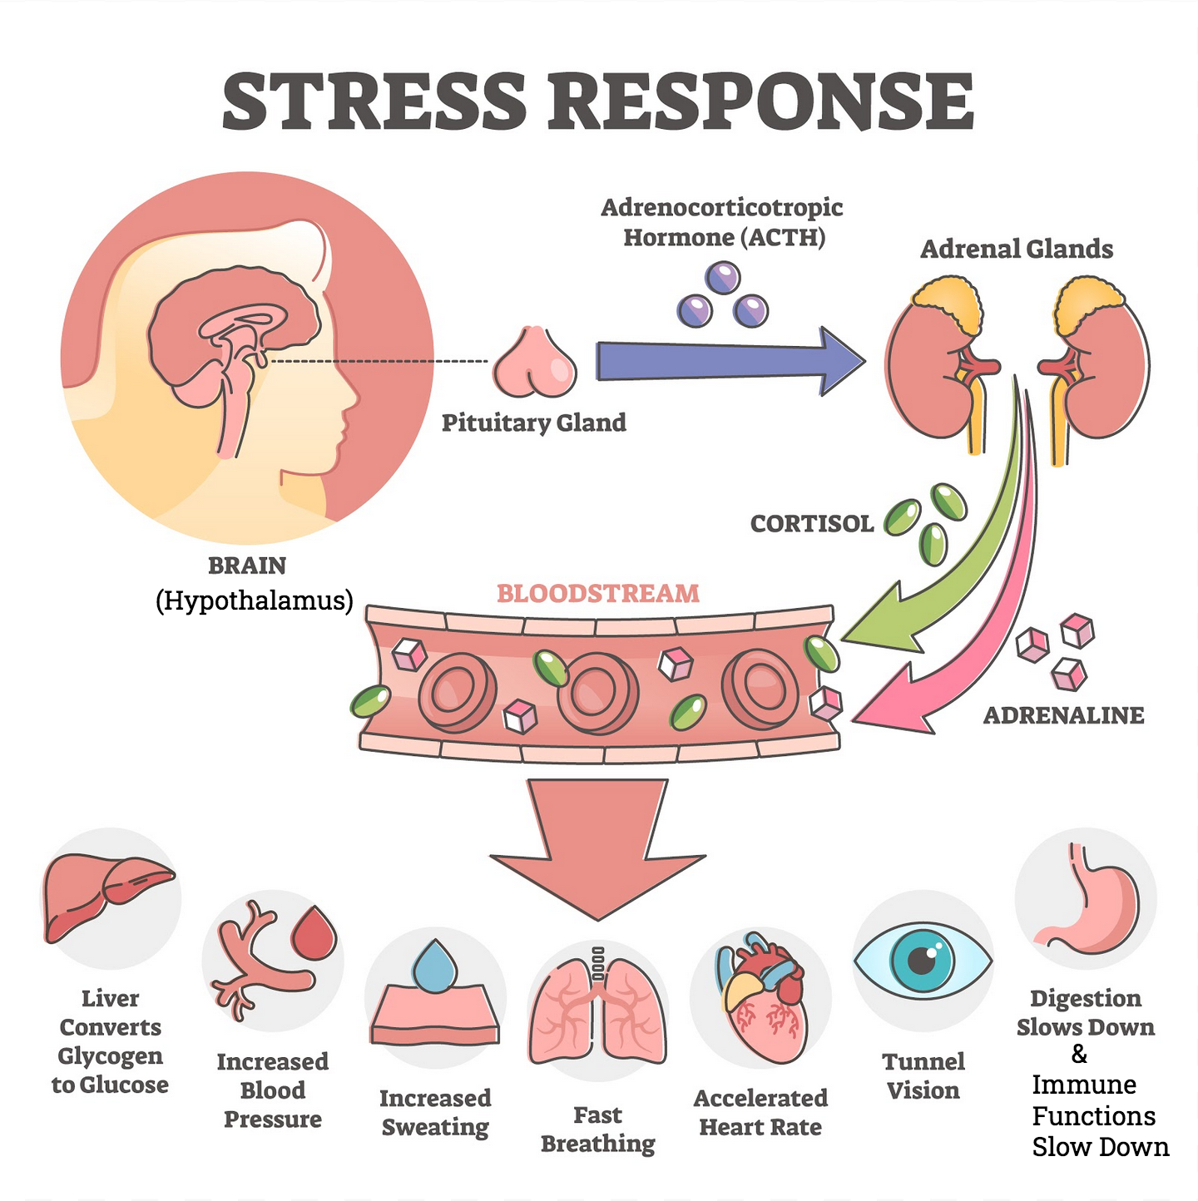
Figure 1: Components of the hypothalamus-pituitary-adrenal axis (HPA axis) and key hormones that are produced by and/or link these components. CRH = corticotrophin-releasing hormone. ACTH = adrenocorticotrophic hormone. Figure made by author using BioRender

New discoveries in recent years are suggesting additional options for PTSD treatment and/or prevention that could improve the lives of patients suffering from PTSD. For example, the propensity to exhibit prolonged stress responses from PTSD is now recognized to be a complex pathophysiological processes reflecting genetics, history of environmental exposures, stage of life, and the social context of traumatic stress itself and the post-traumatic period (Ozer et al. 2003; Aguilera et al. 2009; Auxéméry 2012; Brock et al. 2019). During the stressful event, the body’s response is mediated by the sympathetic nervous system (Brock et al. 2019) and this response occurs almost immediately. The HPA axis normally serves as a beneficial cascade that presumably helped humans survive throughout evolutionary history (Ozer et al. 2003) with the final hormone released being cortisol. While proper functioning of the HPA axis is essential for dealing with stress, a dysfunctional HPA axis can lead to dysfunction of the immune system and cause chronic low-grade inflammation, as will be detailed below.

Current Pharmacological Approaches to PTSD Treatment

Antidepressant selective serotonin reuptake inhibitors (SSRIs) such as paroxetine and sertraline, are the only drugs approved by the Food and Drug Administration (FDA) to treat PTSD. Randomized controlled trials (RCTs) have demonstrated that paroxetine and sertraline improved PTSD symptomatology versus a placebo, and produce remission in about 30% of study participants (Lee et al. 2016; Miller 2020). SSRIs were designed to selectively block post-synaptic reuptake transporters for serotonin, thereby increasing synaptic concentrations of serotonin and its continued reversible binding to receptors to elicit responses (Preskorn et al. 2004). Serotonin is a neurotransmitter implicated in appetite, emotion control, motor reflexes, and autonomic functions. SSRIs inhibit the brain's noradrenergic pathways and can reset an arousal state. The noradrenergic pathway and the HPA axis are linked through the release of CRH in response to stressors (Young et al. 2005). This pathway is thought to play a key role in anxiety and fear-based pathophysiology behind PTSD (Davidson et al. 2006; Puetz et al. 2015; MacNamara et al. 2016; Lake et al. 2019). Continuous reuptake of serotonin in the noradrenergic pathway during PTSD causes symptoms such as hypervigilance and hyperarousal because the brain is deceived to respond to “non-existent” pain-stimuli. SSRIs have shown efficacy in this context because they increase synaptic serotonin concentrations, which function as the reset button to the noradrenergic pathway and puts the brain in a less-vigilant state.

PTSD also involves imbalances in brain electrochemistry associated with the ATP-driven Na⁺/K⁺ pump (MacNamara et al. 2016). The Na⁺/K⁺ pump creates the electrochemical gradient needed to produce electrical impulses in response to the stressful stimuli. This pump also provides a connection to the diet; sufficient quantities of dietary polyunsaturated omega-3 fatty acids like docosahexaenoic acid (DHA) are needed to support the Na⁺/K⁺ pump and thus neuronal function (Adams et al. 2016; see also Fig. 2 below in the section on diet). Electrical imbalances are thought to cause many of the symptoms related to PTSD (Butt et al. 2019) but the targets of SSRIs target are not fully understood and individual patients respond differently to therapeutic treatments (Kalinić et al. 2016; MacNamara et al. 2016). Other classes of medications, such as antipsychotics, are also under consideration but have produced mixed results (Adetunji et al. 2005).

The stress responsivity of PTSD also involves other compounds linked to the systems discussed above, such as gamma-aminobutyric acid (GABA), corticotropin-releasing factor (CRF), and noradrenaline systems (Steckler and Risbrough 2012). Double blind trials demonstrated considerable efficacy of paroxetine and sertraline compared to control (baseline Clinician-Administered PTSD, CAPS-2 scale; Attari et al. 2014; Kelmendi et al. 2016). In veterans seeking treatment through the Department of Veterans Affairs (VA) hospital, sertraline showed mixed results depending on dosage (Ursano et al. 2004; Friedman et al. 2007; Kelmendi et al. 2016).

Emerging Pharmacological Approaches for future PTSD treatment

Ketamine

New forms of medication are being tested at the forefront of medical innovation and move past the narrow fear-based perspective of treating PTSD patients, which has had limited success. New medications focus on stressed-induced neuronal dysfunction associated with anxiety-inducing symptoms and depressive episodes of PTSD (Park and Poo 2013). One notable example is ketamine that is used to increase the levels of brain-derived neurotrophic factor (BDNF), a growth factor that reinforces survival of existing neurons and proliferates synaptogenesis and neuronal differentiation in the brain (Park and Poo 2013). BDNF factor is also a pivotal part of the stress response by functioning as a signaling component and regulatory factor in the HPA axis (Kunugi et al. 2010). Ketamine thus promotes proliferation and survival of pre-existing neurons, and counteracts neuronal dysfunction and its related symptoms (Andero and Ressler 2012; Zhang et al. 2016; Hou et al. 2018). Specifically, ketamine administered intravenously at a dose of 15 mg/kg was found to up-regulated the BDNF protein levels by inhibiting the expression of hyperpolarization activated cyclic nucleotide gated potassium channel 1 (HCN1) protein that adversely affects neuron survivability (Hou et al. 2018). Ketamine is an antagonist of the N-methyl-d-aspartate (NMDA) receptor, and also has anxiolytic- and antidepressant-like effects in rodents (Kos et al. 2006; Ardalan et al. 2017). NMDA receptor is found in the central nervous system (CNS), and is linked to the HPA axis where it binds the neurotransmitter glutamate and has a modulatory effect on CRH release (Ravindran and Stein 2009). Following a traumatic event, increased glutamate concentrations cause continuous activation of NMDA receptors, which leads to formation of fear-based memories (Krystal et al. 1994) and can eventually have neurotoxic effects that involve neuronal cell death. Ketamine decreases this neurotoxic effect of elevated glutamate concentrations by inhibiting NMDA receptors. Ketamine improved overall neurological health in several rodent models (Kos et al. 2006; Ardalan et al. 2017). Before Ketamine can be used to treat humans with PTSD, the effect of dose and delivery method on BDNF protein levels must be determined for humans (Feder et al. 2014), and possible side-effects addressed.

Lifestyle Factors and PTSD

A sedentary lifestyle (especially in combination with an overly energy-dense diet) may contribute to both PTSD and its comorbidities, such as, obesity, elevated levels of LDL cholesterol from insufficient exercise, and less efficient elimination of reactive oxygen species (ROS, including free radicals), which exacerbates anxiety and depressive disorders associated with PTSD (Wilkins et al. 2020). A controlled, randomized pilot study conducted through the Warrior Wellness program in the VA hospital measured the physical outcomes (strength, mobility, balance), cardiovascular health, and health-related lifestyle factors (waist circumference, sense of belonging) of 54 veterans suffering from PTSD and found that aerobic endurance exercise intervention significantly improved all criteria for a majority of the patients (Hall et al. 2020). This pilot study demonstrated the efficacy of exercise intervention to prevent PTSD comorbidities like obesity and cardiovascular disease. Furthermore, many PTSD patients described in the pilot study benefited from the social aspect of working out with other patients towards a common goal, giving them a sense of belonging.

As stated above, diet is also relevant for PTSD. Antioxidant deficiency is linked to increased concentrations of ROS that stimulate the immune system and can, when unchecked, trigger chronic inflammation (Fubini and Hubbard 2003) and promote neurodegenerative disease in PTSD patients (Miller et al. 2017 Oct; de Souza et al. 2019). In higher concentrations, ROS damage cell structures (Pham-Huy et al. 2008) and promote neurodegenerative disease linked to PTSD (Miller et al. 2017 Oct; de Souza et al. 2019). Antioxidant vitamins include Vitamin E. Many patients with PTSD have a constant hyper-aroused mental state associated with elevated ROS levels, which are presumably exacerbated by dietary deficiencies of antioxidants, such as vitamin E, and trigger neurological disease development (de Souza et al. 2019). Vitamin E and omega-3 supplementation has shown efficacy in reducing chronic inflammation and ameliorating neurodegenerative diseases associated with PTSD (Alquraan et al. 2019). A pilot study conducted with 26 Croatian homeland war veterans showed that after 12 weeks of omega-3 supplementation with 600 mg tablets containing both EPA and DHA, severity of PTSD symptoms significantly decreased by an average of 8 to 13% (Kalinić et al. 2016). Since this small study was not done with a double-blind design, future research must be conducted to further demonstrate efficacy. Future studies should also use combinations of omega-3 fatty acids and vitamin E. Omega-3 fatty acids, which are particularly prone to oxidation, presumably benefit particularly from protection by membrane-soluble antioxidants like vitamin E. In addition, high caloric intake, which is also prevalent in PTSD patients (Pietrzak et al. 2011), further exacerbates chronic inflammation (Fubini and Hubbard 2003). Furthermore, the gut microbiome provide support for a functional immune system and requires a diet (prebiotic diet) that supplies the types of carbohydrates that are not digested by humans but are starting materials for the formation of gene regulators like butyrate by colonic bacteria (Brenner et al. 2017).

As stated above, cell membranes in the brain need to be of the right fluidity to support the sodium-potassium pumps in generating the electrochemical gradients required for normal neuronal activity (Adams et al. 2016). Omega-3 fatty acids have been suggested to ameliorate the neuronal dysfunction as well as inflammation seen in PTSD and similar impairments (Hasadsri et al. 2013). Sufficient dietary intake of omega-3 fatty acids (docosahexaenoic acid, DHA and eicosapentaenoic acid, EPA) may thus support the Na⁺/K⁺ pumps and counteract PTSD-related Na⁺/K⁺ pump impairment (Alquraan et al. 2019). Supplementing PTSD patients with omega-3 polyunsaturated fatty acids may provides the membranes of neurons with the components required to alleviate anxiety and electrochemical imbalances in the brain (Alquraan et al. 2019). The beneficial effect of consuming omega-3 oils, antioxidants, and multiple other plant compounds can be seen in a Mediterranean diet which has shown to ameliorate depressive symptoms (Sánchez-Villegas et al. 2019).
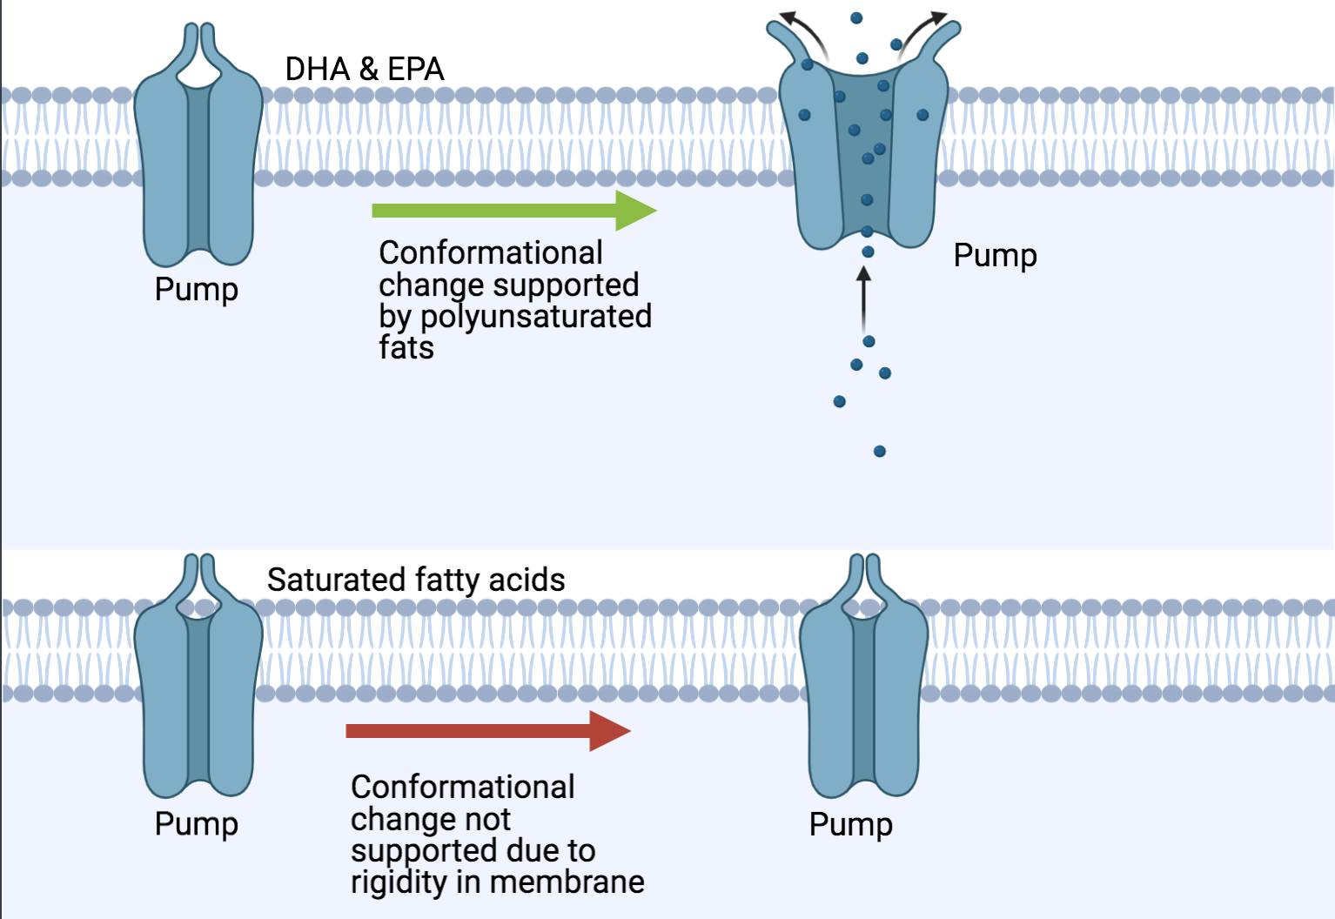
Figure 2: Schematic depiction of the Na⁺/K⁺ pump that creates the electrochemical gradient needed to produce electrical impulses and the role of dietary fatty acids and membrane fluidity. Membrane fluidity requires sufficient amounts of polyunsaturated omega-3 fatty acids as part of membrane phospholipids. The multiple kinks and bent shape of the fatty acid tails in DHA (docosahexaenoic acid) and EPA (eicosapentaenoic acid) prevent the phospholipid bilayer from becoming too tightly packed and rigid. This resulting fluidity allows the sodium-potassium pumps to undergo the necessary conformational changes to generate an electrical gradient across the membrane.

- Literature synthesis linking multiple factors that affect PTSD to chronic inflammation

The link between stress hormones and chronic inflammation

PTSD alters the HPA stress axis by inducing overproduction of multiple nuerotransmitters and hormones involved in the stress response (Stoppelbein et al. 2012; Fig. 3). For example, prolonged release of stress messengers like adrenaline and cortisol and causes a snowball-like effect and leads to chronic inflammation (Fig. 3). Cortisol, the primary stress hormone, increases glucose availability and glucose uptake by the brain when the HPA axis detects a fight-or-flight situation (Dedovic et al. 2009). Adrenaline increases heart rate and causes vasoconstriction (raising blood pressure) to shunt blood to the more important organs when the HPA axis responds to a stressful event (Henry et al. 1994; Fig. 1). In short-term acute scenarios, cortisol signals the immune system to stand down (refer to Fig. 1), presumably to allocate all available resources to thinking and running rather than to the immune function. However, in PTSD patients, the stress response is continuously producing cortisol, which desensitizes the immune system to cortisol due to constant exposure (Dedovic et al. 2009). As a result, continuous activation of the sympathetic nervous system and decreased activity of the parasympathetic nervous system due to fear-and anxiety-based disorders increases the release of pro-inflammatory cytokines (protein hormones) within the bloodstream through a feedforward loop (Stoppelbein et al. 2012). Eventually, PTSD and the associated chronic stress leads to a fatigued HPA axis (Fig. 3, 4) and basal cortisol concentrations in the blood that are actually significantly lower in individuals with PTSD (Atsak et al. 2012). This phenomenon also impairs the ability of glucocorticoid stress hormones to suppress the immune response, which contributes to a continuous pro-inflammatory state (chronic low-grade inflammation) that, in turn, disrupts neurocircuitry, and behavior (Fig. 3).
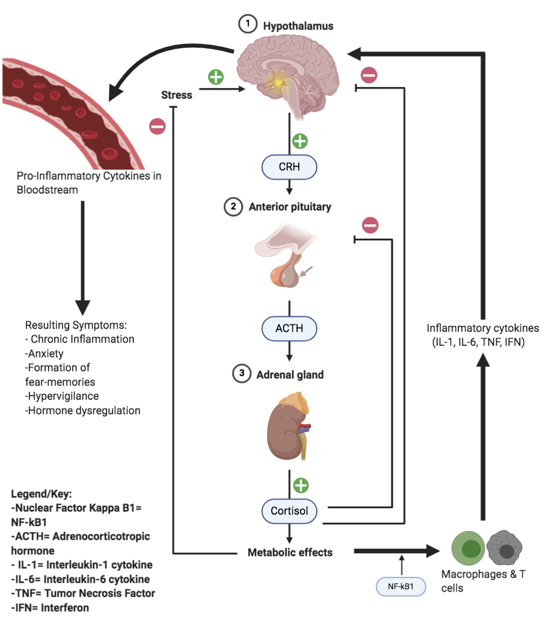
Figure 3: Schematic depiction of the feedforward loop leading to chronic inflammation and other symptoms associated with PTSD. CRH = Cortisol Releasing Hormone. ACTH = Adrenocorticotrophic hormone. Figure made by author using BioRender software.

Cortisol is a pivotal hormone to monitor in PTSD patients because it can have a wide array of pathophysiological effects on the human body; cortisol induces the body to support environmental stress responses (Stoppelbein et al. 2012), by inhibiting insulin production and enhancing glucose availability, regulating immune system functions (suppression during acute exposures), and increasing electrolyte balance (Klengel et al. 2013; Myers et al. 2014; Binder et al. 2008; Fig. 1). As stated above, steroid-stress-hormone production, like the production of cortisol, suppresses the immune system to allocate all energy/resources to the essential organs activated during a fight-or-flight response. Cortisol also acts as the reset button for the HPA axis but due to the significantly lowered levels of cortisol in PTSD patients, the associated feedback loops are disabled, which results in immune system dysfunction (a continuous low-grade inflammation) and HPA axis dysfunction (Myers et al. 2014) as seen in PTSD patients (Atsak et al. 2012; Fig. 4). Over prolonged stress exposure, the adrenergic system becomes insensitive to cortisol (Gaffey et al. 2018).
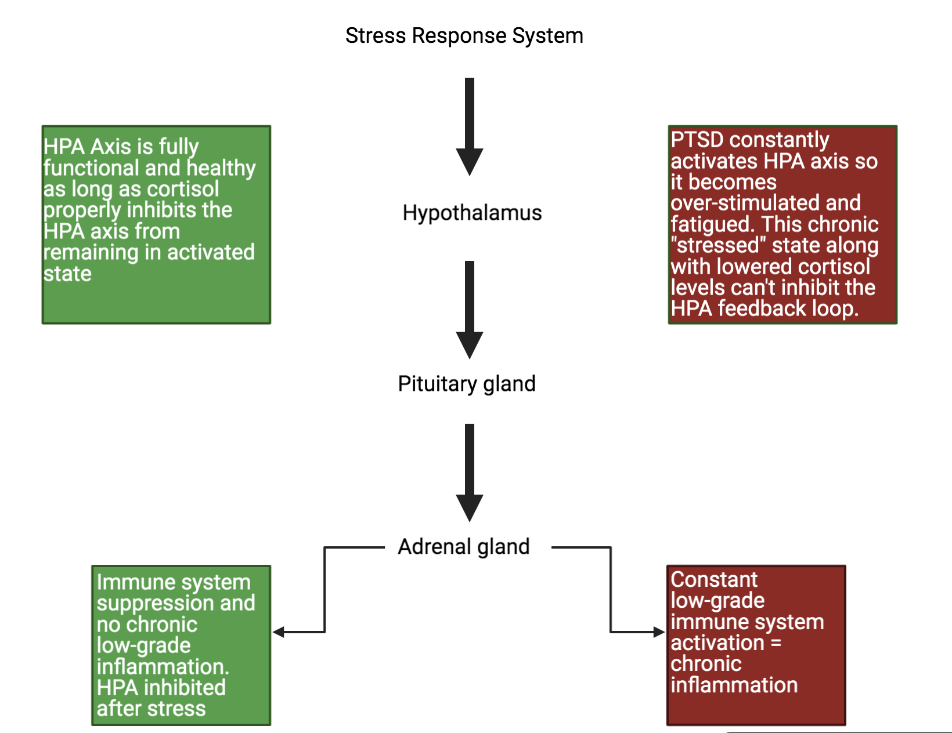
Traumatic/chronic stress response
Acute intermittent stress response
Figure 4: Functional state of the HPA axis associated with immunosuppression and the dysfunction/fatigued HPA axis state in PTSD assocaited with chronic low-grade immuno-activation (chronic inflammation).

Gut microbiome, endocannabinoids, and chronic inflammation

Functional development of the mammalian brain requires a healthy gut microbiome in conjunction with a nutritious diet. This gut-microbiota-brain axis profoundly influences neuron health and neurotransmitter production as well as mood and behavior (Hemmings et al. 2017). The snowballing effect of chronic inflammation in the body can create gut dysbiosis (an altered gut microbial community), which results in a failure to produce gut-bacteria-derived gene regulators, such as short-chain fatty acids like butyrate (Halverson and Alagiakrishnan 2020) needed not only to regulate brain function but also for the production of proteins that support gut barrier integrity. Failure to produce these gut-bacteria-derived gene regulators, and resulting gut-barrier impairment, allow transmission of bacteria coated with lipopolysaccharide (LPS) from the gut to the bloodstream, where they trigger an immune response and thus enhance the chronic neuro-inflammatory state exhibited by PTSD patients (Stilling et al. 2014; Halverson and Alagiakrishnan 2020). This neuro-inflammation further contributes to dysregulation of the HPA-axis (Figs. 3,4). Gut microbiome health and gut barrier integrity are thus are likely critical to avoiding the chronic system-wide inflammation in PTSD patients.

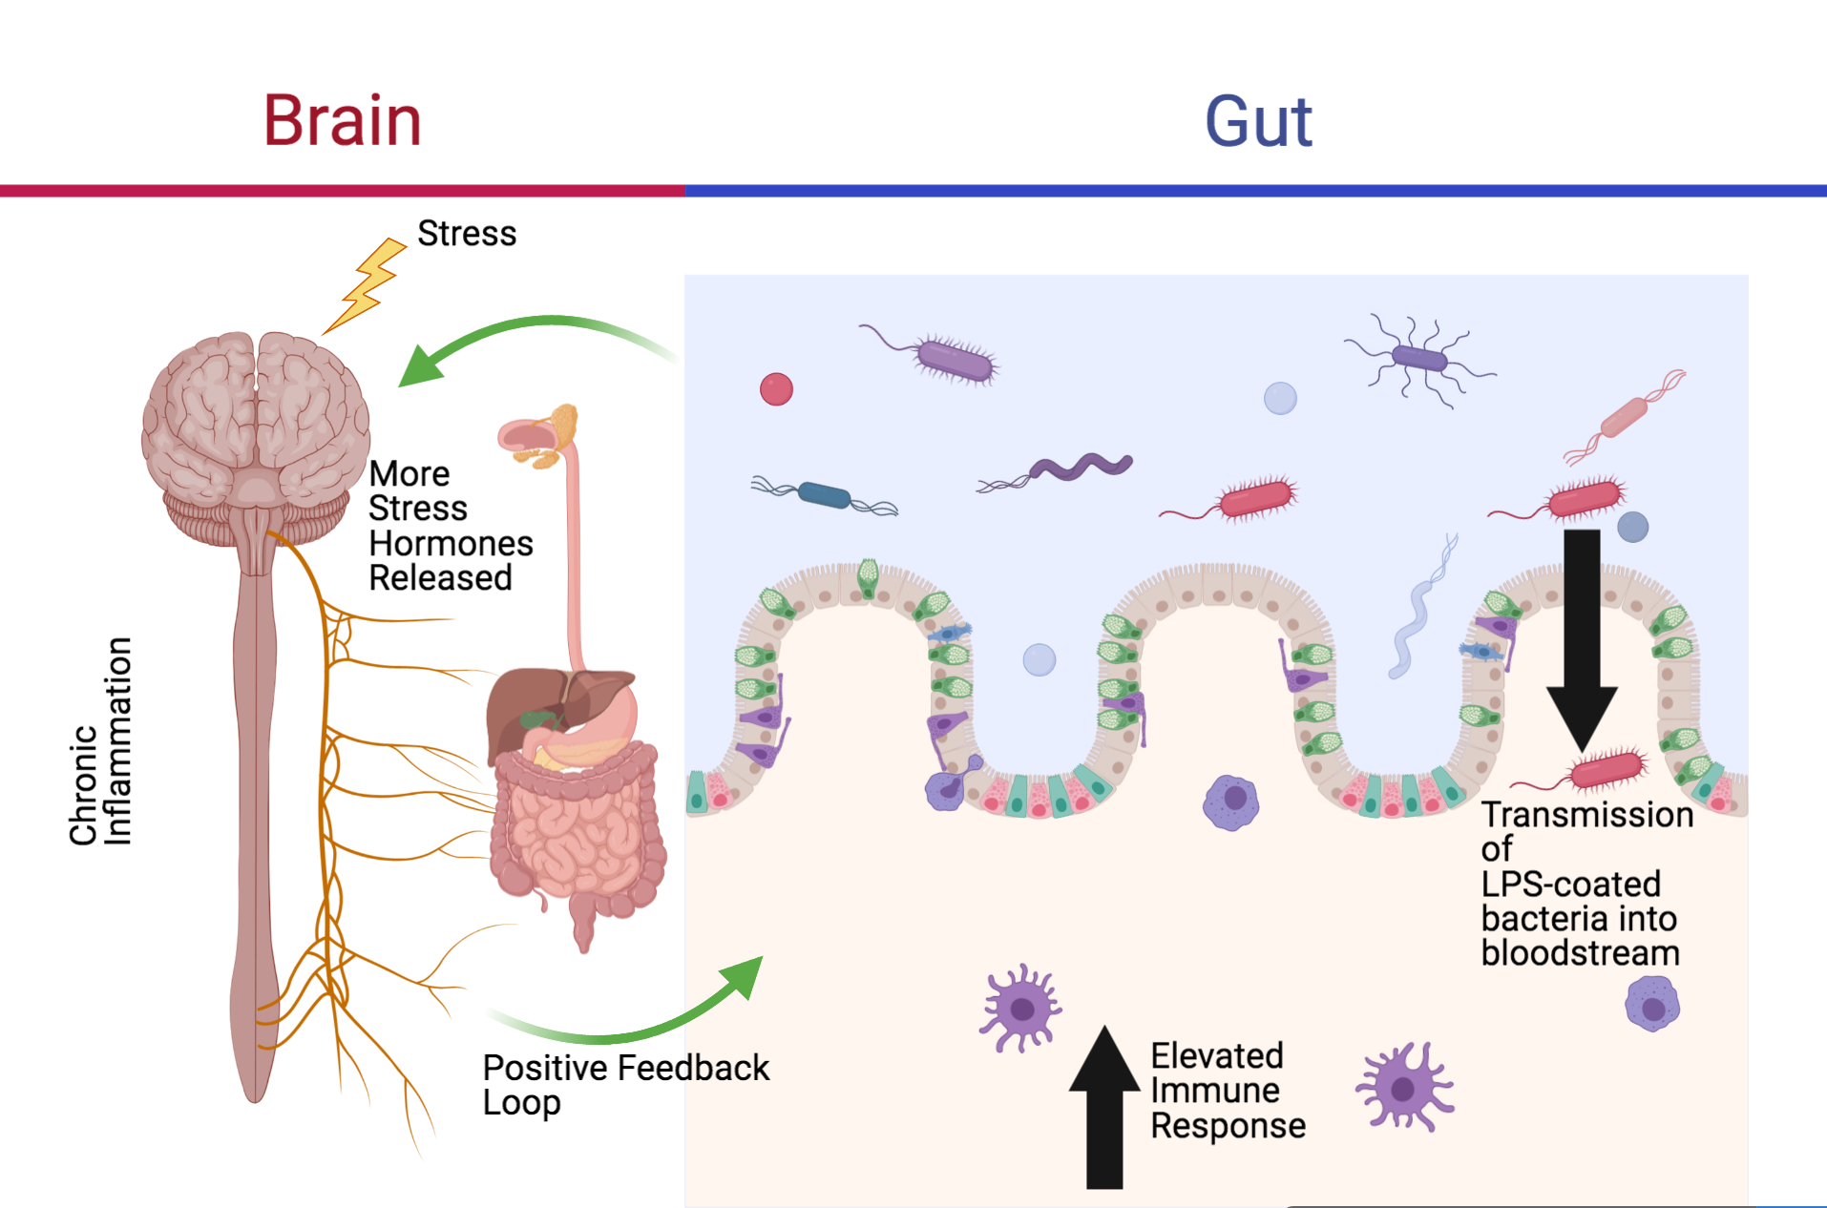
Figure 5: Schematic depiction of the link among HPA axis dysfunction, the gut microbiome, gut barrier integrity, and immune system dysfunction. Figure made by author using BioRender software.

A healthy gut microbiome features a diversity of bacteria that can ferment carbohydrates to produce short chain fatty acids such as acetate, propionate, and butyrate that act as regulators of the immune system, the HPA axis, and neurotransmitters (Leclercq et al. 2016). All of these modulatory effects ameliorate the symptoms of PTSD, such as the chronic inflammation commonly associated with PTSD.

Probiotics can be delivered as a stool transplant which has been shown to effectively restore a healthy gut microbiome and requires maintenance via a prebiotic diet thereafter (Schmidt et al. 2020). There are mixed results with oral consumption of a prebiotic diet with some studies showing that long-term oral prebiotic supplements actually prevented restoration of a healthy gut microbiome (Lawrence and Hyde 2017; Schmidt et al. 2020). To remedy chronic low-grade inflammation, a prebiotic diet along with a probiotic fecal transplant can be a feasible treatment option if duration and bacterial gut cultures are monitored closely (Leclercq et al. 2016; Lawrence and Hyde 2017; Schmidt et al. 2020). In addition to this lifestyle intervention, exercise and stress reduction management are presumably needed to maintain a gut microbiome that can support the immune and stress systems (Fubini and Hubbard 2003).

Cannabinoids

It is widely documented that PTSD, as a multifactorial condition with HPA axis dysregulation and autonomic nervous system dysfunction as well as chronic inflammation, also increased the likelihood for substance abuse and drug dependence (Whooley 2008; Cohen et al. 2009; Pietrzak et al. 2011). However, there is also a prospect of using modulators such as cannabis in PTSD treatment

The cannabinoid receptor 1 (CB1) is the most abundant receptor within the central nervous system (Glass et al. 1997; LeDoux 2000; Atsak et al. 2012); the highest concentrations of CB1 receptors are located in a part of the brain that is fundamental to coordination of fear-related behaviors and the processing of fear-related memories (Neumeister et al. 2015). This neurological circuit (amygdala-hippocampal-corticostriatal, AHC circuit) and CB1 are implicated in the consolidation and extinction of aversive memories (such as frightening flashbacks) or conditioned fear response that many PTSD patients display (Bonn-Miller et al. 2011; Neumeister et al. 2015). A conditioned fear is a negative response to a neural stimulus. For example, a person who suffered from a traumatic car accident might express a negative response or aversive behavior when walking past a car in a parking lot, even though cars did not create a sense of fear in the person prior to the accident.

PTSD patients are increasingly using cannabis that interacts with the endocannabinoid CB1 receptors throughout the body, and act as CB1 receptor agonists. Endocannabinoids interact with synapses within the CNS, play a role in transmission of nerve impulses across synapses by inhibiting neurotransmitter release (Kano et al. 2009; Cachope 2012; Castillo et al. 2012) and can help modulate inflammation (Bonn-Miller et al. 2020). However, the role of endocannabinoids is complex with both anti-inflammatory and pro-inflammatory effects (Schönke et al. 2020). Cannabinoids have the potential to ameliorate the aberrant behaviors associated with PTSD (Neumeister et al. 2015), reminiscent of the effects of exercise in stimulating endocannabinoid receptors. Due to the complex effect of cannabinoids, dose and duration of cannabinoid administration need further attention.

By acting as CB1 agonists, cannabis may be able to reduce depressive and anxiety disorders commonly associated with PTSD. Preclinical trials conducted on animal models suggest that the CB1 receptor agonists at low doses of the cannabinoid delta-9-tetrahydrocannabinol (Δ⁹-THC), the main cannabis ingredient with psychoactive properties, may reduce anxiety-like behavior by activating the CB1 receptors (Moreira and Wotjak 2010; Buckner et al. 2013) and down-regulating pro-inflammatory such as cytokine levels (H.P. Miller et al. 2020). Cannabidiol (CBD) is the other major constituent and nonintoxicating ingredient in cannabis and has the potential to act synergistically with Δ⁹-THC in eliminating fear-based memories; a double-blind trial performed on 48 volunteers indicated that CBD can enhance extinction of fear-based memories in humans (Das et al. 2013). However, long-term use of cannabis containing Δ⁹-THC and CBD can have detrimental outcomes and increase the risk of mental illnesses, including addiction and psychosis as well as impairing executive functions (Pagano et al. 2020). Future research is needed to determine dose and duration of a treatment for PTSD with Δ⁹-THC and CBD.

Physical Activity, Inflammation, and PTSD Treatment

As stated above, lifestyle interventions beyond diet, such as physical activity, can ameliorate both the symptoms of PTSD and its comorbidities (Caddick and Smith 2018). However, a sedentary lifestyle is also common in PTSD patients (Pietrzak et al. 2011). Such physical inactivity fails to produce endogenous antioxidant enzymes triggered by exercise (Adams et al. 2014), which links physical inactivity to chronic inflammation. A novel therapy based on the growing literature on exercise intervention for PTSD, trauma-sensitive yoga (TSY), is designed for complex trauma survivors (West et al. 2017). As TSY continues to grow in popularity and integrates itself into various mental health treatment facilities, the timely response to address the prospect of pairing TSY with conventional psychotherapeutic interventions is critical (Ong 2020). Participants in a 12-week intervention regime based on TSY reported a lessening of emotional suppression (restricted expression of emotions; Dick et al. 2014; Ong 2020). TSY therapy has potential due to its low cost and benefits (in the form of relaxing sensations) for PTSD patients. Yoga serves as a viable intervention to reduce inflammation due to its beneficial effects on inflammatory cytokines (Djalilova et al. 2019). Many studies on TSY have shown significant improvements in inflammatory biomarker, thereby reducing the concentrations of certain cytokines known to cause inflammation (IL-6, CRP, and TNF-α) (Mourya et al. 2009; Lakkireddy et al. 2013; Djalilova et al. 2019). Yoga can be seen as a combination of physical activity with stress reduction.

Stress, Inflammation, and PTSD Treatment
To mitigate these negative consequences of chronic stress, many clinicians have turned to stress managing techniques such as open-monitoring mediations (often synonymous with transcendental meditation) which involves paying attention to a persons’ thoughts, feelings, and their bodily sensations as they arise, without any form of judgment (Barnes et al. 2016; Hilton et al. 2017). This introduces a sense of self-awareness to PTSD patients and in some cases lowered their dependence on prescription medications. Some evidence is also available that mindfulness therapy ameliorates chronic inflammation in PTSD patients (Gallegos et al. 2015), and it would be worthwhile to conduct more research on this topic in the future.

Electrotherapies, Inflammation, and PTSD Treatment

Transcranial Magnetic Stimulation

Transcranial magnetic stimulation affects the neuron activity (Isserles et al. 2013) and may have benefits in people suffering from depressive disorders as a result of PTSD. Transcranial magnetic stimulation is a noninvasive neuromodulatory technique that uses electromagnetic fields to alter the local electrical activity and replace neuronal firing patterns, and produce, widespread connectivity modifications (Gouveia et al. 2020). Although this method is relatively new and understudied, it is thought that the high frequency magnetic vibrations may restore neuronal function in areas of the brain affected by HPA-axis dysregulation (Isserles et al. 2013).

Electroacupuncture

Novel interventions like electroacupuncture have shown efficacy when used in conjunction with anti-inflammatory methods of treating PTSD. Electroacupuncture is a clinical therapy that increases BDNF levels, supports neurogenesis, reduces anxiety-related disorders associated with PTSD, and decreases systemic inflammation (Li et al. 2019; Zhou et al. 2019). This intervention is invasive and was used in conjunction with a minimum of 14-day post-treatment supplementation with anti-inflammatory supplements such as omega-3 fatty acids and antioxidants (Alquraan et al. 2019; Zhou et al. 2019). This intervention is very similar to the ketamine intervention in that both increase BDNF growth factors (Park and Poo 2013; Zhou et al. 2019). Further research attention is needed on this topic.

Other Emerging Therapies

Virtual Reality Exposure

Virtual Reality (VR) technology integrates real-time computer graphics, visual displays, body tracking devices, and other sensory inputs to immerse the user into a computer-generated environment (Rothbaum et al. 1999). This provides PTSD patients with the opportunity to immerse themselves in a virtual, low-threat environment to decondition themselves to their trauma through habituation (Rizzo et al. 2009). VR exposure therapy has shown efficacy in increasing stress resilience (Rizzo et al. 2013) and lessening inflammation following a stressful event (Reger et al. 2011). This technology is brand-new and still needs to be refined by more research.

Therapy Animals

Therapy dogs have been used as a non-invasive intervention in hospitals like the VA referring to canine therapy as animal-assisted therapy (AAT). These animals can create a positive environment which enables the patient to forge a working-relationship with the animal to restore trust into their relationships (Furst 2016). This has great potential in changing the psychology of many patients because their trauma might have reduced their sense of self-esteem and depending on the nature of the incident which caused the trauma, human-to-human interactions might have caused them to lose all trust in relationships; therefore, integrating canines into the equation might be a great alternative to restore this trust (Lass-Hennemann et al. 2018). Companionship with animals have shown to have similar effects as other psychological stress management practices like exercising or dieting (Lass-Hennemann et al. 2018; Wilkins et al. 2020). Therapy dog ownership can be viewed as multi-faceted approach which combines stress reduction, physical activity, and exposure to natural biomes outdoors. One study has already proven the anti-inflammatory effect of having a dog early in life and the beneficial effect pet ownership has on the microbiome (Hoisington et al. 2018).

- Conclusion and Proposed Treatment Regime

Thus far only very limited research has been conducted on a synergistic approach to PTSD, but the evidence summarized above suggest that a combination of multiple facets of treatments that all have the same targets may have a multiplicative benefit. Combination of several or all of the above-mentioned therapies that have a common anti-inflammatory effect may act in synergy to potentiate reduction of chronic inflammation and ameliorate the symptoms of PTSD. The evidence summarized in this thesis thus warrants future research into the benefits of such a synergistic relationship among multiple novel therapies for treating PTSD. I propose a treatment regime that combines some or all of the following interventions – pharmacology (i.e. ketamine and cannabinoids), exercise, stress reduction, probiotic supplementation and a prebiotic diet, omega-3 fatty acid rich diets, virtual reality exposure, therapy animals, transcranial magnetic stimulation, electroacupuncture, and trauma-sensitive yoga (Figs. 6,7).
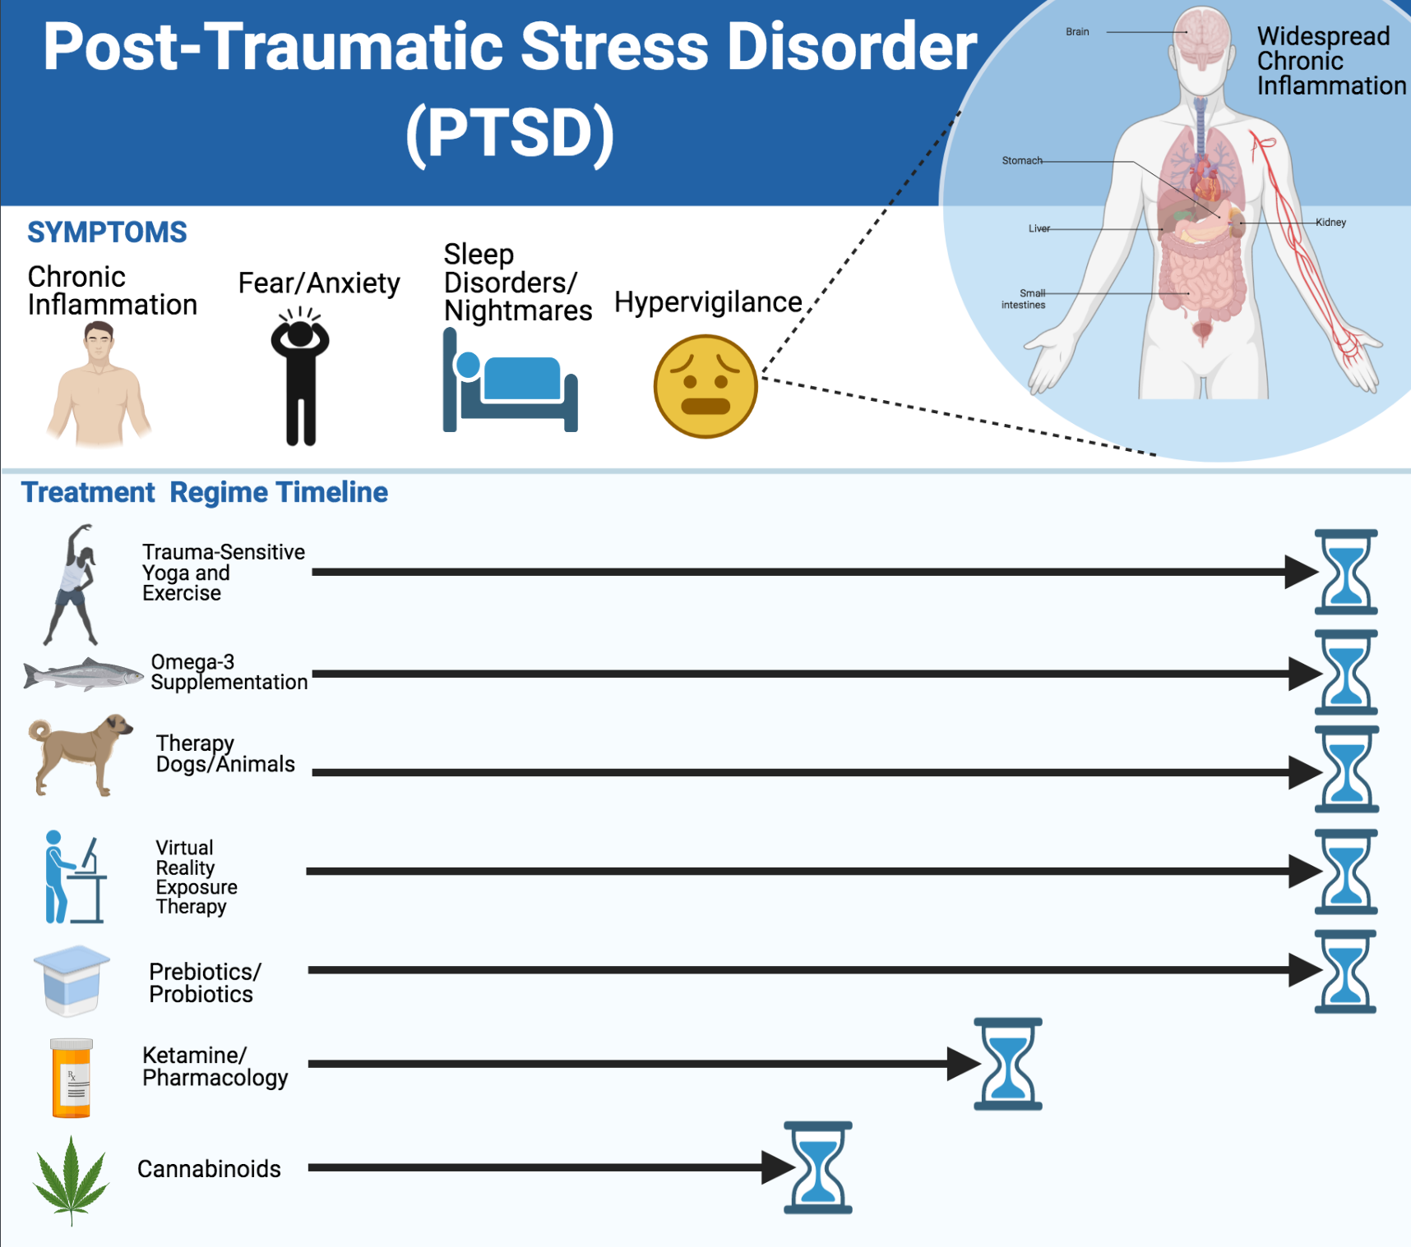
Figure 6: Proposed treatment regime combing multiple treatment interventions. Figure generated by author using BioRender software.

Trauma-sensitive yoga and exercise along with omega-3 supplementation, therapy animals, VR exposure therapy, and probiotics are proposed to last for the entire duration of patient recovery. This is due to the evidence-based efficacy explained above or low risk of developing side effects. Ketamine and other pharmacological interventions like cannabinoids are indicated to finish much sooner before full recovery is achieved because of addiction, side-effects, or adverse changes to patient health due to prolonged drug usage. Cannabinoids, in particular, have not been proven to be effective over prolonged periods of time and the dosage amount still needs further research.

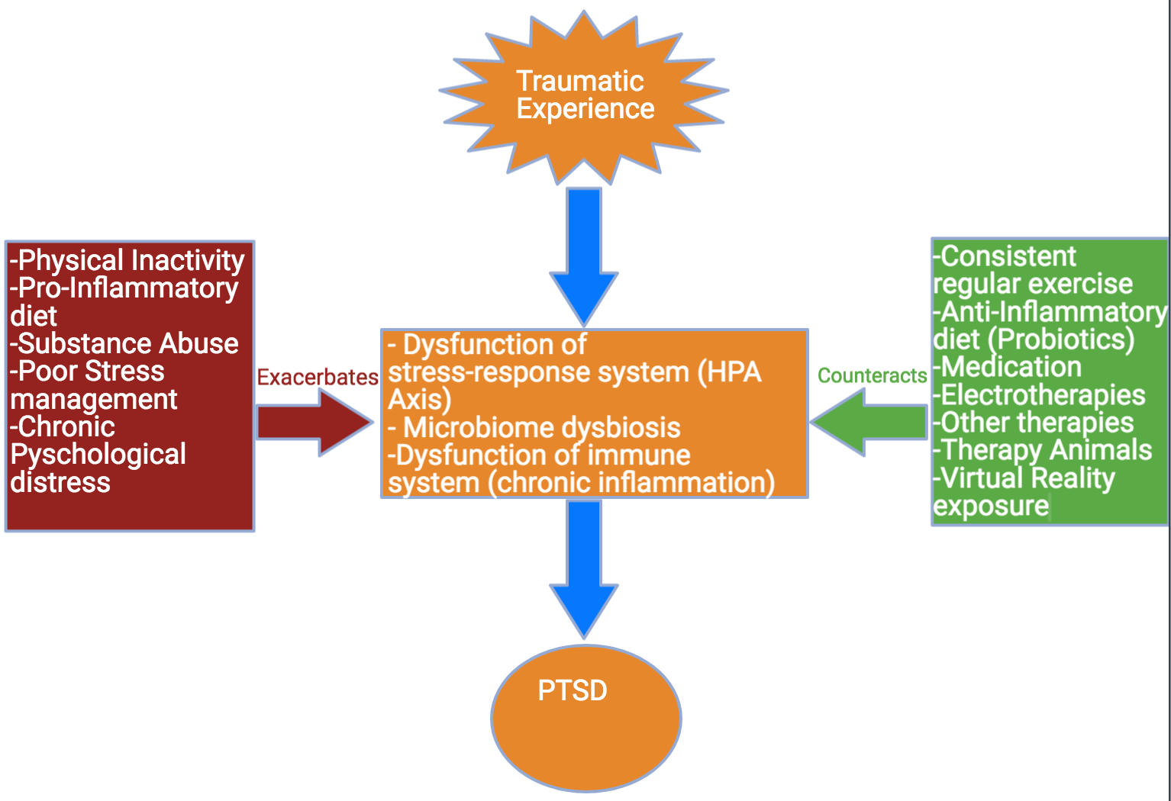
Figure 7: Summary of conditions or interventions that either exacerbate or counteract the development of PTSD. Made by author using BioRender.

Figure 7 serves as a visual summary of the major connections discussed in this Honors thesis. It highlights multiple conditions or lifestyle habits (i.e., physical inactivity, substance abuse, poor stress management, etc.) that exacerbates PTSD symptomology. The right side shows all interventions highlighted in the Honors thesis that have the potential to counteract the conditions that exacerbate PTSD.

In conclusion, this Honors thesis demonstrates the existence the existence of common mechanistic denominators for some or all emerging therapies in PTSD. Every intervention depicted in my treatment regime (see Figs. 6,7) has the potential to ameliorate chronic inflammation and the resulting neurological damage. This Honors thesis also illustrates that chronic inflammation plays a key role in PTSD symptomology. Although PTSD is understudied, the research reviewed here indicates the potential for a combination of treatment interventions to have multiplicative benefits. Future research is needed to test the promise of such a system in the hope to devise novel treatments with the potential to restore the livelihoods of millions of people across the globe and deepen our understanding.

- Acknowledgements

I would like to extend my deepest sense of appreciation towards Barbara Demmig-Adams for encouraging me to pursue an honors thesis in a topic I am passionate about. Without her compassionate attitude and her bountiful knowledge, my honors thesis would not have been possible. I am especially thankful for the countless hours you spent editing my rough drafts, investing immense amounts of energy into furthering my academic career, and always managing to remain faithful throughout the whole process. Your persistent guidance will have an everlasting impact on me as I continue my academic journey. I am forever grateful.

I’d also like to thank my committee members: Christopher Lowry, Pieter Johnson, and Barbara Demmig-Adams, for also providing the support I needed during this process. Every committee member individually influenced my course of study here at the University of Colorado at Boulder. There was so much advice given to me along the way and I learned so much thanks to my wonderful committee. Your contributions have resonated in the most brilliant ways; for that, I am forever grateful.

Lastly, I’d like to thank my loving mother for supporting me throughout my undergraduate journey here at CU. Without her love and support I would not have the opportunities that I have today. You always managed to keep my heart filled with joy and my tummy even more full! Thanks for being so awesome Mom, I love you!

- Bibliography

Abdallah G, Averill A, Akiki J, Raza M, Averill L, Gomaa H, Adikey A, Krystal H. 2019. The Neurobiology and Pharmacotherapy of Posttraumatic Stress Disorder (PTSD). Annual Review Pharmacology Toxicology. 59:171–189.
Adams S, Adams B, Wessman A, Demmig-Adams B. 2016. Nutritional Cues Tie Living Organisms to Their Environment and Its Sustainability. Front Nutr. 3:28.
Adetunji B, Mathews M, Williams A, Budur K, Mathews M, Mahmud J, Osinowo T. 2005. Use of Antipsychotics in the Treatment of Post-Traumatic Stress Disorder. Psychiatry Edgmont. 2(4):43–47.
Aguilera G. 1998. Corticotropin Releasing Hormone, Receptor Regulation and the Stress Response. Trends Endocrinol Metab. 9(8):329–336.
Aguilera M, Arias B, Wichers M, Barrantes-Vidal N, Moya J, Villa H, Van Os J, Ibáñez I, Ruipérez A, Ortet G, et al. 2009. Early Adversity and 5-HTT/BDNF Genes: New Evidence of Gene-Environment Interactions on Depressive Symptoms in a General Population. Psychol Med. 39(9):1425–1432.
Alquraan L, Alzoubi H, Hammad H, Rababa’h Y, Mayyas F. 2019. Omega-3 Fatty Acids Prevent Post-Traumatic Stress Disorder-Induced Memory Impairment. Biomolecules. 9(3):100.
Andero R, Ressler J. 2012. Fear Extinction and BDNF: Translating Animal Models of PTSD to the Clinic. Genes Brain Behav. 11(5):503–512.
Ardalan M, Rafati H, Nyengaard R, Wegener G. 2017. Rapid Antidepressant Effect of Ketamine Correlates with Astroglia Plasticity in the hippocampus. Br J Pharmacol. 174(6):483–492.
Atsak P, Roozendaal B, Campolongo P. 2012. Role of the Endocannabinoid System in Regulating Glucocorticoid Effects on Memory for Emotional Experiences. Neuroscience. 204:104–116.
Attari A, Rajabi F, Maracy R. 2014. D-cycloserine for Treatment of Numbing and Avoidance in Chronic Post-Traumatic Stress Disorder: A Randomized, Double Blind, Clinical Trial. J Res Med Sci Off J Isfahan Univ Med Sci. 19(7):592–598.
Auxéméry Y. 2012. [Post-traumatic Stress Disorder (PTSD) as a Consequence of the Interaction Between an Individual Genetic Susceptibility, a Traumatogenic Event and a Social Context]. L’Encephale. 38(5):373–380.
Barnes A, Monto A, Williams J, Rigg L. 2016. Impact of Transcendental Meditation on Psychotropic Medication Use Among Active Duty Military Service Members With Anxiety and PTSD. Mil Med. 181(1):56–63.
Benjamin Adams R, Nkechiyere Egbo K, Demmig-Adams B. 2014. High-Dose Vitamin C Supplements Diminish the Benefits of Exercise in Athletic Training and Disease Prevention. Nutr Food Sci. 44(2):95–101.
Binder B, Bradley G, Liu W, Epstein P, Deveau C, Mercer B, Tang Y, Gillespie F, Heim M, Nemeroff B, et al. 2008. Association of FKBP5 Polymorphisms and Childhood Abuse with Risk of Post-Traumatic Stress Disorder Symptoms in Adults. Volume :15.
Bonn-Miller O, Brunstetter M, Simonian A, Loflin J, Vandrey R, Babson A, Wortzel H. 2020 Dec 9. The Long-Term, Prospective, Therapeutic Impact of Cannabis on Post-Traumatic Stress Disorder. Cannabis Cannabinoid Res. 25(3): 485-491.
Bonn-Miller O, Vujanovic A, Drescher D. 2011. Cannabis Use Among Military Veterans After Residential Treatment for Post-Traumatic Stress Disorder. Psychol Addict Behav. 25(3):485–491.
Brock S, Powell A, Creamer L, Moore A, Mysliwiec V. 2019. Trauma Associated Sleep Disorder: Clinical Developments 5 Years After Discovery. Curr Psychiatry Rep. 21(9):80.
Buckner D, Ecker H, Welch D. 2013. Psychometric Properties of a Valuations Scale for the Marijuana Effect Expectancies Questionnaire. Addict Behav. 38(3):1629–1634.
Butt M, Espinal E, Aupperle L, Nikulina V, Stewart L. 2019. The Electrical Aftermath: Brain Signals of Posttraumatic Stress Disorder Filtered Through a Clinical Lens. Front Psychiatry. 10. 368-370.
Cachope R. 2012. Functional Diversity on Synaptic Plasticity Mediated by Endocannabinoids. Philos Trans R Soc B Biol Sci. 367(1607):3242–3253.
Caddick N, Smith B. 2018. Exercise is Medicine for Mental Health in Military Veterans: a Qualitative Commentary. Qual Res Sport Exerc Health. 10(4):429–440.
Castillo E, Younts J, Chávez E, Hashimotodani Y. 2012. Endocannabinoid Signaling and Synaptic Function. Neuron. 76(1):70–81.
Cohen E, Marmar C, Ren L, Bertenthal D, Seal H. 2009. Association of Cardiovascular Risk Factors with Mental Health Diagnoses in Iraq and Afghanistan War Veterans Using VA Health Care. JAMA J Am Med Assoc. 302(5):489–492.
Das K, Kamboj K, Ramadas M, Yogan K, Gupta V, Redman E, Curran V, Morgan A. 2013. Cannabidiol Enhances Consolidation of Explicit Fear Extinction in Humans. Psychopharmacology (Berl). 226(4):781–792.
Davidson J, Baldwin D, Stein DJ, Kuper E, Benattia I, Ahmed S, Pedersen R, Musgnung J. 2006. Treatment of Post-Traumatic Stress Disorder With Venlafaxine Extended Release: A 6-Month Randomized Controlled Trial. Arch Gen Psychiatry. 63(10):1158–1165.
Dedovic K, Duchesne A, Andrews J, Engert V, Pruessner JC. 2009. The Brain and the Stress Axis: The Neural Correlates of Cortisol Regulation in Response to Stress. NeuroImage. 47(3):864–871.
Dick M, Niles L, Street E, DiMartino M, Mitchell S. 2014. Examining Mechanisms of Change in a Yoga Intervention for Women: The Influence of Mindfulness, Psychological Flexibility, and Emotion Regulation on PTSD Symptoms. J Clin Psychol. 70(12):1170–1182.
Dunlop W, Wong A. 2019. The Hypothalamic-Pituitary-Adrenal Axis in PTSD: Pathophysiology and Treatment Interventions. Prog Neuropsychopharmacol Biol Psychiatry. 89:361–379.
Feder A, Parides K, Murrough W, Perez M, Morgan E, Saxena S, Kirkwood K, Rot M aan het, Lapidus B, Wan B, et al. 2014. Efficacy of Intravenous Ketamine for Treatment of Chronic Post-Traumatic Stress Disorder: A Randomized Clinical Trial. JAMA Psychiatry. 71(6):681–688.
Fitzpatrick S, Saraiya T, Lopez-Castro T, Ruglass LM, Hien D. 2020. The Impact of Trauma Characteristics on Post-Traumatic Stress Disorder and Substance Use Disorder Outcomes Across Integrated and Substance Use Treatments. J Subst Abuse Treat. 113:107976.
Friedman J, Marmar R, Baker G, Sikes R, Farfel M. 2007. Randomized, Double-Blind Comparison of Sertraline and Placebo for Post-Traumatic Stress Disorder in a Department of Veterans Affairs Setting. J Clin Psychiatry. 68(5):711–720.
Fubini B, Hubbard A. 2003. Reactive Oxygen Species (ROS) and Reactive Nitrogen Species (RNS) Generation by Silica in Inflammation and Fibrosis. Free Radic Biol Med. 34(12):1507–1516.
Fulton JJ, Calhoun S, Wagner R, Schry R, Hair P, Feeling N, Elbogen E, Beckham JC. 2015. The Prevalence of Post-Traumatic Stress Disorder in Operation Enduring Freedom/Operation Iraqi Freedom (OEF/OIF) Veterans: A Meta-Analysis. J Anxiety Disord. 31:98–107.
Furst G. 2016. Helping War Veterans with Post-Traumatic Stress Disorder: Incarcerated Individuals’ Role in Therapeutic Animal Programs. J Psychosoc Nurs Ment Health Serv Thorofare. 54(5):49–57.
Gaffey E, Walsh C, Ladd O, Hoks M, Abercrombie C. 2019. Alterations in Systemic and Cognitive Glucocorticoid Sensitivity in Depression. Biol Psychiatry Cogn Neurosci Neuroimaging. 4(3):310–320.

Gates A, Holowka W, Vasterling J, Keane M, Marx P, Rosen C. 2012. Post-Traumatic Stress Disorder in Veterans and Military Personnel: Epidemiology, Screening, and Case Recognition. Psychol Serv. 9(4):361–382.
Glass M, Dragunow M, Faull RL. 1997. Cannabinoid Receptors in the Human Brain: a Detailed Anatomical and Quantitative Autoradiographic Study in the Fetal, Neonatal and Adult Human Brain. Neuroscience. 77(2):299–318.
Gouveia V, Davidson B, Meng Y, Gidyk C, Rabin S, Ng E, Abrahao A, Lipsman N, Giacobbe P, Hamani C. 2020 May 28. Treating Post-Traumatic Stress Disorder with Neuromodulation Therapies: Transcranial Magnetic Stimulation, Transcranial Direct Current Stimulation, and Deep Brain Stimulation. Neurotherapeutics.
Hall S, Morey C, Beckham C, Bosworth B, Sloane R, Pieper F, Pebole M. 2020. Warrior Wellness: A Randomized Controlled Pilot Trial of the Effects of Exercise on Physical Function and Clinical Health Risk Factors in Older Military Veterans with PTSD. Newman A, editor. J Gerontol Ser A. 75(11):2130–2138.
Halverson T, Alagiakrishnan K. 2020. Gut Microbes in Neurocognitive and Mental Health Disorders. Ann Med. 52(8):423–443.
Hasadsri L, Wang H, Lee V, Erdman W, Llano A, Barbey K, Wszalek T, Sharrock F, Wang H. 2013. Omega-3 Fatty Acids as a Putative Treatment for Traumatic Brain Injury. Journal of Neurotrauma. 30(11):897–906.

Hemmings J, Malan-Muller S, Van-den Heuvel LL, Demmitt A, Stanislawski A, Smith G, Bohr D, Stamper E, Hyde R, Morton T, et al. 2017. The Microbiome in Post-Traumatic Stress Disorder and Trauma-Exposed Controls: An Exploratory Study. Psychosom Med. 79(8):936–946.
Henry P. Biological Basis of the Stress Response. STRESS RESPONSE.:18.
Herman P, McKlveen M, Ghosal S, Kopp B, Wulsin A, Makinson R, Scheimann J, Myers B. 2016. Regulation of the Hypothalamic-Pituitary-Adrenocortical Stress Response. In: Comprehensive Physiology. American Cancer Society. p. 603–621.
Hoisington J, Billera M, Bates L et al. Exploring Service Dogs for Rehabilitation of Veterans with PTSD: A Microbiome Perspective. Rehabilitation Psychology 2018;63:575-587.

Hilton L, Maher AR, Colaiaco B, Apaydin E, Sorbero E, Booth M, Shanman M, Hempel S. 2017. Meditation for Post-Traumatic Stress: Systematic Review and Meta-Analysis. Psychol Trauma Theory Res Pract Policy. 9(4):453–460.
Hou L, Qi Y, Sun H, Wang G, Li Q, Wang Y, Zhang Z, Du Z, Sun L. 2018. Applying Ketamine to Alleviate the PTSD-like Effects by Regulating the HCN1-related BDNF. Prog Neuropsychopharmacol Biol Psychiatry. 86:313–321.
Isserles M, Shalev Y, Roth Y, Peri T, Kutz I, Zlotnick E, Zangen A. 2013. Effectiveness of Deep Transcranial Magnetic Stimulation Combined with a Brief Exposure Procedure in Post-Traumatic Stress Disorder – A Pilot Study. Brain Stimulat. 6(3):377–383.
Kalinić D, Mimica N, Jeroncic A, Lalovac M, Delaš I. 2016. Association of Pro-Inflammatory Cytokines with PTSD Severity in Patients Treated with Omega-3 Supplementation – a Pilot Study. Eur Psychiatry. 33(S1):S214–S214.
Kano M, Ohno-Shosaku T, Hashimotodani Y, Uchigashima M, Watanabe M. 2009. Endocannabinoid-Mediated Control of Synaptic Transmission. Physiol Rev. 89(1):309–380.
Kelmendi B, Adams G, Yarnell S, Southwick S, Abdallah G, Krystal H. 2016. PTSD: From Neurobiology to Pharmacological Treatments. Eur J Psychotraumatology. 7.
Klengel T, Mehta D, Anacker C, Rex-Haffner M, Pruessner JC, Pariante M, Pace W, Mercer B, Mayberg S, Bradley B, et al. 2013. Allele-Specific FKBP5 DNA Demethylation Mediates Gene–Childhood Trauma Interactions. Nat Neurosci. 16(1):33–41.
Koenen C, Ratanatharathorn A, Ng L, McLaughlin A, Bromet J, Stein J, Karam G, Meron Ruscio A, Benjet C, Scott K, et al. 2017. Post-Traumatic Stress Disorder in the World Mental Health Surveys. Psychol Med. 47(13):2260–2274.
Kos T, Popik P, Pietraszek M, Schäfer D, Danysz W, Dravolina O, Blokhina E, Galankin T, Bespalov Y. 2006. Effect of 5-HT3 Receptor Antagonist MDL 72222 on Behaviors Induced by Ketamine in Rats and Mice. Eur Neuropsychopharmacol. 16(4):297–310.
Krause-Parello A, Friedmann E, Blanchard K, Payton M, Gee NR. 2020. Veterans and Shelter Dogs: Examining the Impact of a Dog-Walking Intervention on Physiological and Post-Traumatic Stress Symptoms. Anthrozoös. 33(2):225–241.
Krystal H, Karper P, Seibyl P, Freeman K, Delaney R, Bremner D, Heninger R, Bowers B Jr, Charney S. 1994. Subanesthetic Effects of the Noncompetitive NMDA Antagonist, Ketamine, in Humans: Psychotomimetic, Perceptual, Cognitive, and Neuroendocrine Responses. Arch Gen Psychiatry. 51(3):199–214.
Lake P, Mitchell G, Shorter I, Kosten T, Domingo B, Walder M. 2019. Buprenorphine for the Treatment of Post-Traumatic Stress Disorder. Am J Addict. 28(2):86–91.
Lakkireddy D, Atkins D, Pillarisetti J, Ryschon K, Bommana S, Drisko J, Vanga S, Dawn B. 2013. Effect of Yoga on Arrhythmia Burden, Anxiety, Depression, and Quality of Life in Paroxysmal Atrial Fibrillation: the YOGA My Heart Study. J Am Coll Cardiol. 61(11):1177–1182.

Lapierre B, Schwegler F, LaBauve J. 2007. Post-Traumatic Stress and Depression Symptoms in Soldiers Returning from Combat Operations in Iraq and Afghanistan. J Trauma Stress. 20(6):933–943.
Lass-Hennemann J, Schafer K, Ramer S, Holz E, Streb M, Michael T. 2018 Sep 4. Therapy Dogs as a Crisis Intervention After Traumatic Events? - An Experimental Study. Front Psychol.
Leclercq S, Forsythe P, Bienenstock J. 2016. Posttraumatic Stress Disorder: Does the Gut Microbiome Hold the Key? Can J Psychiatry. 61(4):204–213.

LeDoux E. 2000. Emotion Circuits in the Brain. Annu Rev Neurosci. 23:155–184.
Lee J, Schnitzlein W, Wolf P, Vythilingam M, Rasmusson M, Hoge W. 2016. Psychotherapy Versus Pharmacotherapy for Post-Traumatic Stress Disorder: Systemic Review and Meta-Analyses to Determine First-Line Treatments. Depress Anxiety. 33(9):792–806.
Li M, Li K, Zhang H, Jiang Y. Study on the Mechanism of TMRK Electroacupuncture in Repairing Synaptic Plasticity in Amygdala and Hippocampus to Relieve Fear Memory in PTSD Rats. Technol Health Care. 27(Suppl 1):425–443.
MacNamara A, Rabinak A, Kennedy E, Fitzgerald A, Liberzon I, Stein B, Phan L. 2016. Emotion Regulatory Brain Function and SSRI Treatment in PTSD: Neural Correlates and Predictors of Change. Neuropsychopharmacology. 41(2):611–618.
Miller P, Bonawitz C, Ostrovsky O. 2020. The Effects of Delta-9-Tetrahydrocannabinol (THC) on Inflammation: A review. Cell Immunol. 352:104111.
Miller W. 2020. Leveraging Genetics to Enhance the Efficacy of PTSD Pharmacotherapies. Neurosci Lett. 726:133562.
Miller W, Lin P, Wolf J, Miller R. 2017 Oct. Oxidative Stress, Inflammation, and Neuroprogression in Chronic PTSD: Harv Rev Psychiatry.:1. 57-69.
Mills L, Teesson M, Ross J, Peters L. 2006. Trauma, PTSD, and Substance Use Disorders: Findings from the Australian National Survey of Mental Health and Well-Being. Am J Psychiatry. 163(4):652–658.

Moreira A, Wotjak T. 2010. Cannabinoids and Anxiety. In: Stein B, Steckler T, editors. Behavioral Neurobiology of Anxiety and its Treatment. Berlin, Heidelberg: Springer. (Current Topics in Behavioral Neurosciences). 2(1) 429–450.
Mourya M, Mahajan S, Singh P, Jain K. 2009. Effect of Slow- and Fast-Breathing Exercises on Autonomic Functions in Patients with Essential Hypertension. J Altern Complement Med. 15(7):711–717.

Myers B, McKlveen M, Herman P. 2014. Glucocorticoid Actions on Synapses, Circuits, and Behavior: Implications for the Energetics of Stress. Front Neuroendocrinol. 35(2):180–196. d
Neumeister A, Seidel J, Ragen J, Pietrzak H. 2015. Translational Evidence for a Role of Endocannabinoids in the Etiology and Treatment of Post-Traumatic Stress Disorder. Psychoneuroendocrinology. 51:577–584.
Ong I. 2020. Treating Complex Trauma Survivors: A Trauma-Sensitive Yoga (TSY)-Informed Psychotherapeutic Approach. J Creat Ment Health. 10(1):1–14.
Ozer J, Best R, Lipsey L, Weiss S. 2003. Predictors of Post-Traumatic Stress Disorder and Symptoms in Adults: a Meta-Analysis. Psychol Bull. 129(1):52–73.
Pagano S, Coniglio M, Valenti C, Federici I, Lombardo G, Cianetti S, Marinucci L. 2020. Biological Effects of Cannabidiol on Normal Human Healthy Cell Populations: Systematic Review of the Literature. Biomedicine & Pharmacotherapy. 132:110728.

Park H, Poo M. 2013. Neurotrophin Regulation of Neural Circuit Development and Function. Nat Rev Neurosci. 14(1):7–23.
Pham-Huy A, He H, Pham-Huy C. 2008. Free Radicals, Antioxidants in Disease and Health. Int J Biomed Sci IJBS. 4(2):89–96.
Pietrzak H, Goldstein B, Southwick M, Grant F. 2011. Prevalence and Axis in Comorbidity of Full and Partial Post-Traumatic Stress Disorder in the United States: Results from Wave 2 of the National Epidemiologic Survey on Alcohol and Related Conditions. J Anxiety Disord. 25(3):456–465.
Preskorn H, Ross R, Stanga Y. 2004. Selective Serotonin Reuptake Inhibitors. In: Preskorn Sheldon H., Feighner JP, Stanga Christina Y., Ross Ruth, editors. Antidepressants: Past, Present and Future. Berlin, Heidelberg: Springer. (Handbook of Experimental Pharmacology). pp. 241–262.
Puetz W, Youngstedt D, Herring P. 2015. Effects of Pharmacotherapy on Combat-Related PTSD, Anxiety, and Depression: A Systematic Review and Meta-Regression Analysis. PLOS ONE. 10(5):e0126529.
Ravindran N, Stein B. 2009. Pharmacotherapy of PTSD: Premises, Principles, and Priorities. Brain Res. 1293:24–39.
Reger M, Holloway M, Candy C, Rothbaum O, Difede J, Rizzo A, Gahm A. 2011. Effectiveness of Virtual Reality Exposure Therapy for Active Duty Soldiers in a Military Mental Health Clinic. J Trauma Stress. 24(1):93–96.
Richardson K, Frueh C, Acierno R. 2010. Prevalence Estimates of Combat-Related Post-Traumatic Stress Disorder: Critical Review. Aust N Z J Psychiatry. 44(1):4–19.
Rizzo A, John B, Newman B, Williams J, Hartholt A, Lethin C, Buckwalter G. 2013. Virtual Reality as a Tool for Delivering PTSD Exposure Therapy and Stress Resilience Training. Mil Behav Health. 1(1):52–58.
Rizzo A, Reger G, Gahm G, Difede J, Rothbaum O. 2009. Virtual Reality Exposure Therapy for Combat-Related PTSD. In: LeDoux JE, Keane T, Shiromani P, editors. Post-Traumatic Stress Disorder: Basic Science and Clinical Practice. Totowa, NJ: Humana Press. p. 375–399.
Rothbaum O, Hodges L, Alarcon R, Ready D, Shahar F, Graap K, Pair J, Hebert P, Gotz D, Wills B, et al. 1999. Virtual Reality Exposure Therapy for PTSD Vietnam Veterans: A Case Study. J Trauma Stress. 12(2):263–271.
Sánchez-Villegas A, Cabrera-Suárez B, Molero P, González-Pinto A, Chiclana-Actis C, Cabrera C, Lahortiga-Ramos F, Florido-Rodríguez M, Vega-Pérez P, Vega-Pérez R, et al. 2019. Preventing the Recurrence of Depression with a Mediterranean Diet Supplemented with Extra-Virgin Olive Oil. The PREDI-DEP Trial: Study Protocol. BMC Psychiatry. 19(1):63.

Schönke M, Martinez-Tellez B, Rensen C. 2020. Role of the Endocannabinoid System in the Regulation of the Skeletal Muscle Response to Exercise. Curr Opin Pharmacol. 52:52–60.
Smith M, Vale W. 2006. The Role of the Hypothalamic-Pituitary-Adrenal Axis in Neuroendocrine Responses to Stress. Dialogues Clin Neurosci. 8(4):383.
Souza P, Gambeta E, Stern J, Zanoveli M. 2019. Post-Traumatic Stress Disorder-Type Behaviors in Streptozotocin-Induced Diabetic Rats can be Prevented by Prolonged Treatment with Vitamin E. Behav Brain Res. 359:749–754.
Steckler T, Risbrough V. 2012. Pharmacological Treatment of PTSD – Established and New Approaches. Neuropharmacology. 62(2):617–627.
Stilling M, Dinan G, Cryan F. 2014. Microbial Genes, Brain & Behaviour – Epigenetic Regulation of the Gut–Brain Axis. Genes Brain Behav. 13(1):69–86.
Stoppelbein L, Greening L, Fite P. 2012. The Role of Cortisol in PTSD Among Women Exposed to a Trauma-Related Stressor. J Anxiety Disord. 26(2):352–358.
Tseylikman E, Davydovich G, Tseilikman B, Feklicheva V, Shankova A, Boyarinova V. 2017. PTSD-Related Shifts in HPA axis, DHEA Levels in Chernobyl Nuclear Plant Clean-up Workers. Psychoneuroendocrinology. 83:39.
Ursano J, Bell C, Eth S, Friedman M, Norwood A, Pfefferbaum B, Pynoos S, Zatzick F, Benedek M, McIntyre S, et al. 2004. Practice Guideline for the Treatment of Patients with Acute Stress Disorder and Post-Traumatic Stress Disorder. Am J Psychiatry. 161(11 Suppl):3–31.
West J, Liang B, Spinazzola J. 2017. Trauma Sensitive Yoga as a Complementary Treatment for Post-Traumatic Stress Disorder: A Qualitative Descriptive Analysis. Int J Stress Manag. 24(2):173–195.
Whooley A. 2008. Depressive Symptoms, Health Behaviors, and Risk of Cardiovascular Events in Patients with Coronary Heart Disease. JAMA. 300(20):2379.
Wilkins S, Melrose J, Hall S, Blanchard E, Castle C, Kopp T, Katzel I, Holder A, Alexander N, McDonald S, et al. PTSD Improvement Associated with Social Connectedness in Gerofit Veterans Exercise Program. J Am Geriatr Soc.
Young A, Abelson L, Cameron G. 2005. Interaction of Brain Noradrenergic System and the Hypothalamic–Pituitary–Adrenal (HPA) Axis in Man. Psychoneuroendocrinology. 30(8):807–814.
Zhang K, Xu T, Yuan Z, Wei Z, Yamaki N, Huang M, Huganir L, Cai X. 2016. Essential Roles of AMPA Receptor GluA1 Phosphorylation and Presynaptic HCN Channels in Fast-Acting Antidepressant Responses of Ketamine. Sci Signal. 9(458):ra123–ra123.
Zhou C, Xue F, Xue S, Sang H, Liu L, Wang Y, Cai M, Zhang J, Tan Q, Wang H, et al. 2019. Electroacupuncture Pretreatment Ameliorates PTSD-Like Behaviors in Rats by Enhancing Hippocampal Neurogenesis via the Keap1/Nrf2 Antioxidant Signaling Pathway. Front Cell Neurosci. 13:275.

