**Financing Marine Conservation from Restructured Debt:**

*A Case Study of The Seychelles*

By

Mara Booth

University of Colorado Boulder

A thesis submitted to the

University of Colorado Boulder

In partial fulfillment

Of the requirements to receive

Honors designation in

Environmental Studies

Defense Date: 11.3.21

Thesis Advisors:

Cassandra Books, Environmental Studies, Primary Reader

Roger Pielke Jr., Environmental Studies, Honors Council Representative

Daniel Kaffine, Economics, Outside Reader

© 2021 by Mara Booth

All rights reserved

# **Abstract**

This thesis is an exploratory case study of a Seychelles debt conversion which examines the financial mechanism’s ability to fund impactful conservation projects, particularly in marine Economic Exclusion Zones (EEZ) of Small Island Development States (SIDS) . The focus on SIDS is vital because they are extraordinarily predisposed to climate change consequences and tend to have economies which lack resilience to extragoneous shocks. In 2016 the UNDP found that 15 out of 36 SIDS had public debt to GDP ratios above 60% and 4 carribean islands over 100%. This combination of climate vulnerability and high commercial debt can create a rapidly deteriorating cycle. The Seychelles finalized a conversion of their sovereign debt with Paris Club creditors and The Nature Conservancy as a broker in 2015. They have received notable recognition for multiple innovative aspects of this deal as well as the sheer scale of the marine space involved (400,000 sq. km), and thus serves as a robust case study to analyze the ways that debt restructuring has evolved since its theoretical conception in 1984. This research suggests that while the model has yet to be cemented, there is a definite evolution in debt restructuring practices which compounds in potential with the current global markets being ripe for impact investment growth and the COVID-19 debt crisis. By examining the critical governance factors that were employed in the Seychelles, this research reveals key takeaways for future implementation and establishing national candidacy. The findings highlight debt status relative to the economy, political willpower, funding streams utilized, and the use of coproduction practices.

**Table of Contents:**

## 

**Abstract**2

**Acronyms and Definitions**4

**Acknowledgements**5

**Introduction**6

The Seychelles Case Study Background 9

**Methods**16

**Results and Discussion**19

Part 1: Analysis of debt swaps from 1980s to present 19

Historical Deal Structures 20

Main Criticisms 22

Evidence of Evolution 23

Part 2: Identifying the commonly cited characteristics 28

Debt status relative to the economy 29

Political Willpower 32

Funding Streams 34

The Use of Co-production Practices 39

Limitations 42

**Conclusion**42

**References**46

## 

# **Acronyms and Definitions**

* **SDG**: Sustainable Development Goals
* **EEZ**: Exclusive Economic Zone
* **SIDS**: Small Island Development State
* **SeyCCAT**: Seychelles Conservation and Climate Adaptation Trust
* **MSP**: Marine Spatial Plan
* **MPA**: Marine Protected Areas
* **TNC**: The Nature Conservancy
* **HIPC**: Heavily Indebted Poor Countries
* **LDC**: Least Developed Countries
* **DFC**: Development Finance Corp
* **UNDP**: United Nations Development Program
* **UNFCCC**: United Nations Framework Convention on Climate Change
* **ESG**: Environmental Social and Governance
* **LEK**: Local Ecological Knowledge: “understood as a cumulative body of knowledge, practice, and belief, evolving by adaptive processes and handed down through generations by cultural trans- mission, about the relationship of living beings (including humans) with one another and with their environment” (Baker and Constant, 2020).
* **Coproduction**: Refers to a collaborative and dynamic knowledge-generation process that more fully grounds scientific understanding in a relevant social, cultural and political context. (Schuttenberg and Guth, 2015).
* **Political Will**: “an amalgam including managers with adequate financial, technical and administrative capacity over sufficient periods of time, a political agenda with space for environmental issues, leadership in government and the community, manageable levels of corruption, and an environmentally well-informed community giving strong support for management actions” (Sale, 2015).

# **Acknowledgements**

I would like to thank my primary advisor, Cassandra Brooks, for being a constant source of support, feedback and encouragement. Beyond her critical support of this paper, she has been an outstanding source of personal and academic inspiration during my time at CU. Furthermore, I thank Roger Pielke and Daniel Kaffine for taking the time to serve as additional readers and members of my committee. I would also like to thank the Undergraduate Research Opportunities Program for providing me with funding this Fall semester to support my time working on this project. I want to recognize the willingness and participation of my interviewees who proved critical to my research. Finally, I want to acknowledge the friends and family who listened, brainstormed and read through my work.

# **Introduction**

While conservation initiatives and programs are predominantly a practice in scientific analysis, planning, and implementation, all environmental programs require significant funding. Finances are a tenuous underlying component to both the actionable elements of conservation, as well as the theoretical opportunity cost to nations. This numbers game is complex and often has a lot of political and social implications. A 2017 study found that only ~0.002% of global GDP is invested in the conservation of biodiversity - they determine the level required to meet conservation needs is 4x this (Sumaila *et al*., 2017). Clearly, securing adequate funding for conservation projects is a difficult task, and it extends beyond the initial funding since incorporating a strategic evaluation of how the finances will continue is critical to any project. Furthermore, many conservation initiatives combat local economic norms as natural resources are sequestered which forces a “sharp tradeoff between conservation and economic development” from a stakeholder perspective. (Brooks *et al.,* pg. 2, 2013). Finally, a recent paper concluded that, specifically in marine spaces, “the best ocean policies and practices can be undone by inadequate finance and by economic externalities that undermine conservation and sustainable use” (Sumaila *et al.,* pg. 9, 2021). Given these difficulties, studying innovative and adaptive processes to “better mobilize a full suite of financial tools” to aid in conservation and sustainable development should be at the forefront of research - this is the most effective way to “turn challenges into opportunities” (Sumaila *et al.,* pg. 9, 2021).

This thesis evaluates the efficacy of debt restructuring as a financial tool to support marine conservation, with a particular focus on the application possibilities for Small Island Development States (SIDS). SIDS are defined as 38 UN Member and 20 Non-UN Member States, identified as island nations, which are located in the Caribbean, Atlantic, Pacific, Indian Ocean and South China Sea that face unique social, economic, and environmental vulnerabilities (UN, 2021). In particular, I use The Seychelles, an island nation in the Indian Ocean, as a descriptive and exploratory case study. While debt restructuring has been used as a conservation tool since the late 1980s, it was not until 2015 when the Seychelles finalized a new and innovative debt swap that this tool was employed in marine conservation (Silver and Campbell, 2018). This method of conservation financing historically only focused on land protection deals, particularly regarding deforestation. This case study presents an interesting opportunity to see how a longtime financial process can be newly adapted for marine spaces.

To trace the evolution of debt swaps, it is important to outline its history. The idea of debt swaps came about in 1982 after Mexico defaulted on debt payments and there was fear that other nations would follow suit (Macekura, 2016). This demonstrated the intensity of the financial burden amidst Least Developed Countries (LDC) and there was concern that LDCs would resort to environmentally destructive practices as a short-term revenue fix to long term development problems (Macekura, 2016). Two years later Thomas Lovejoy (then the vice-president of the World Wildlife Fund) wrote an op-ed in the New York Times which highlighted the interrelated problems of debt and LDCs “borrowing” from their natural resources to stand a chance of meeting the payments (Lovejoy, 1984). This article questioned if there was a way to use the debt crisis to additionally help an environmental one (Lovejoy, 1984). The thought-provoking op-ed introduced the foundational idea of what has come to be relatively common practice in the intersection of financial and conservation worlds: Debt for Nature Swaps. These transactions naturally vary in structure and cause, as each is negotiated uniquely by the debtor's specific debt/environmental dilemma. For example, in 1990 the Costa Rican government restructured 10.8 million in debt for domestic currency bonds issues to fund a variety of activities from planning, administration, infrastructure, training plans, environmental education and more (Deacon and Murphy, 1997). Later in 2002, Peru and multiple NGO brokers restructured 14.3 million dollars in debt for sustainable forestry initiatives. (Gokel and Gray, 2011). While each deal has fine-tuned agreements outlining the nuances, their overarching structure stems from the same framework. Debt restructuring always involves a nation which is defaulting on its foreign debt brokering a deal bilaterally with a creditor nation, or multilaterally with a third party (i.e., NGO) to “forgive” a portion of the debt so that it may be repaid on more favorable terms (e.g., in local currency, with slashed interest rates and longer timescales to repay) with the funds reallocated to national conservation projects (Steele and Patel, 2020). Figure 1 illustrates the general outlined structure upon which debt swaps are built, but the negotiations and specifics per each case differ. Further documentation and details of Seychelles debt swap is provided in the results/discussion section.

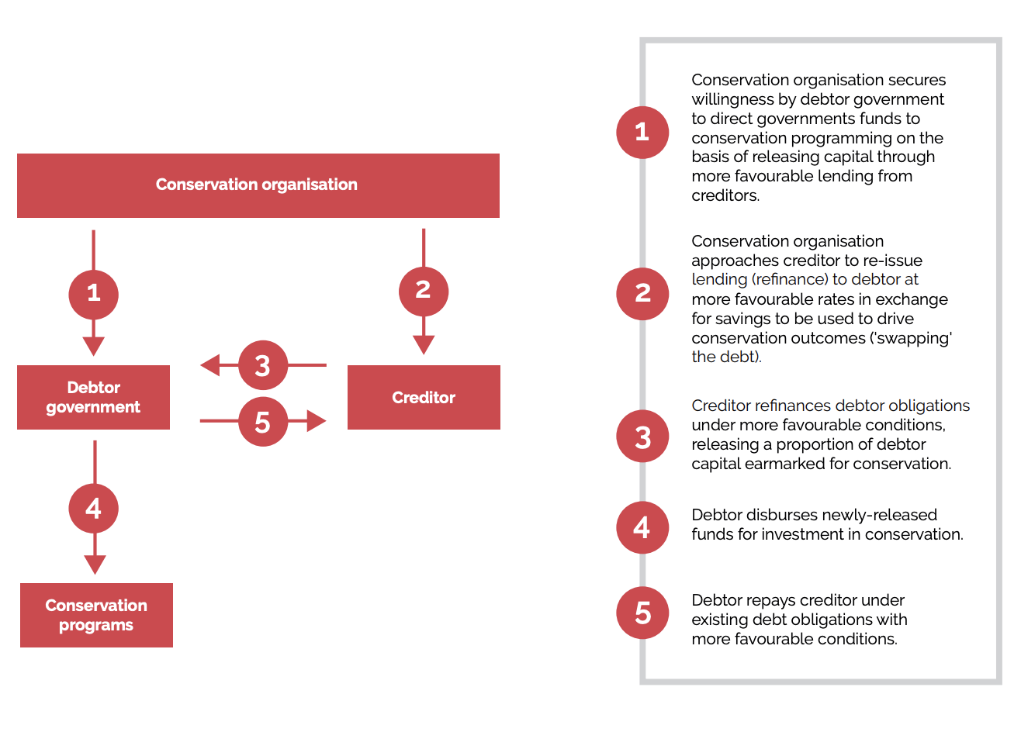

**Figure 1.** Adapted from the Ocean Finance Handbook (2021), this flowchart demonstrates an outline of the common structure debt-for-nature swaps are often founded upon. The key provides additional depth to explain what the use of each specific transaction is.

## 

## **The Seychelles Case Study Background**

The Seychelles is a prime candidate for case study analysis in regard to evolving debt swaps and their defining characteristics. The island is characterized by their “blue economy” which emphasizes a heavy reliance on fisheries and marine tourism to support local livelihoods (SMSP, 20201). The net national commercial activity which is dependent on the ocean (i.e., tourism or fisheries) generates over 90% of the Seychelles GDP (International Finance Corporation, 2017). This statistic alone - along with the numerous at-risk marine species in Seychelloise territorial waters - demonstrates how imperative action is on both environmental and financial levels. As overfishing and climate change threaten these critical resources (Christ *et al.,* 2020), the Seychelles was highly interested in novel ways to fund conservation efforts while simultaneously implementing sustainable economic practices and encouraging economic diversification (NatureVest, 2021). This blue economy was the founding pillar upon which the debt swap was created - all conservation policies, programmes funded, and initiatives invested in since have focused on driving these industries in a sustainable direction (Blue Economy Roadmap, 2016). The concept of the blue economy has been well established in scientific literature as a “strategy for safeguarding the world’s oceans and water resources” that must “emerge when economic activity is in balance with the long-term capacity of ocean ecosystems” (Lee *et al.,* 2020, pg. 1). The concept is foundational to the inherent relationship between growth, development and protection of ocean resources. Establishing the vitality of the blue economy in island nations can help elevate the candidacy of SIDS for debt swaps so they are considered equally, if not more intriguing, as land-based debt conversions.

The origins of the Seychelles deal started when the Seychelles government approached The Nature Conservancy in 2012 and started a negotiating process which wrapped in 2015, and a consequent conservation planning process which is still ongoing (SMSP, 2021). Seychelles’ economic structure (discussed in detail in the Results and Discussion) and their EEZ (which stands among the top 25 largest in the world and represents a biodiversity hotspot with two UNESCO World Heritage Sites) makes it a highly attractive candidate for progressive protection acts. The conservation initiative in mind is a Marine Spatial Plan (MSP) which “analyses and allocates spatial and temporal distribution of human activities in marine areas to achieve ecological, economic, and social objectives” (SMSP, 2021). Marine Spatial Planning is different from a Marine Protection Area (MPA) as it signifies the process which uses tools and frameworks to designate varying degrees of protection and use cases (Blue World Institute, 2017). Therefore a MSP may be used to designate MPAs within its waters as well as areas which are still available for higher rates of use because it is essentially the plan which guides implementation of the conservation act. This distinction is relevant to this paper as the Seychelles is still implementing zones of their marine conservation commitments and are therefore working within an MSP at the moment until an official MPA is finalized. The MSP has a rigid framework which includes a steering committee, core team, and technical working groups with prominent stakeholder representatives at the helm - their goal being to drive sectorial advice and feedback as the plan develops (SMSP, 2021). The use of this process is important as it demonstrates a commitment to coproduction with long timescale integrations and milestone frameworks.

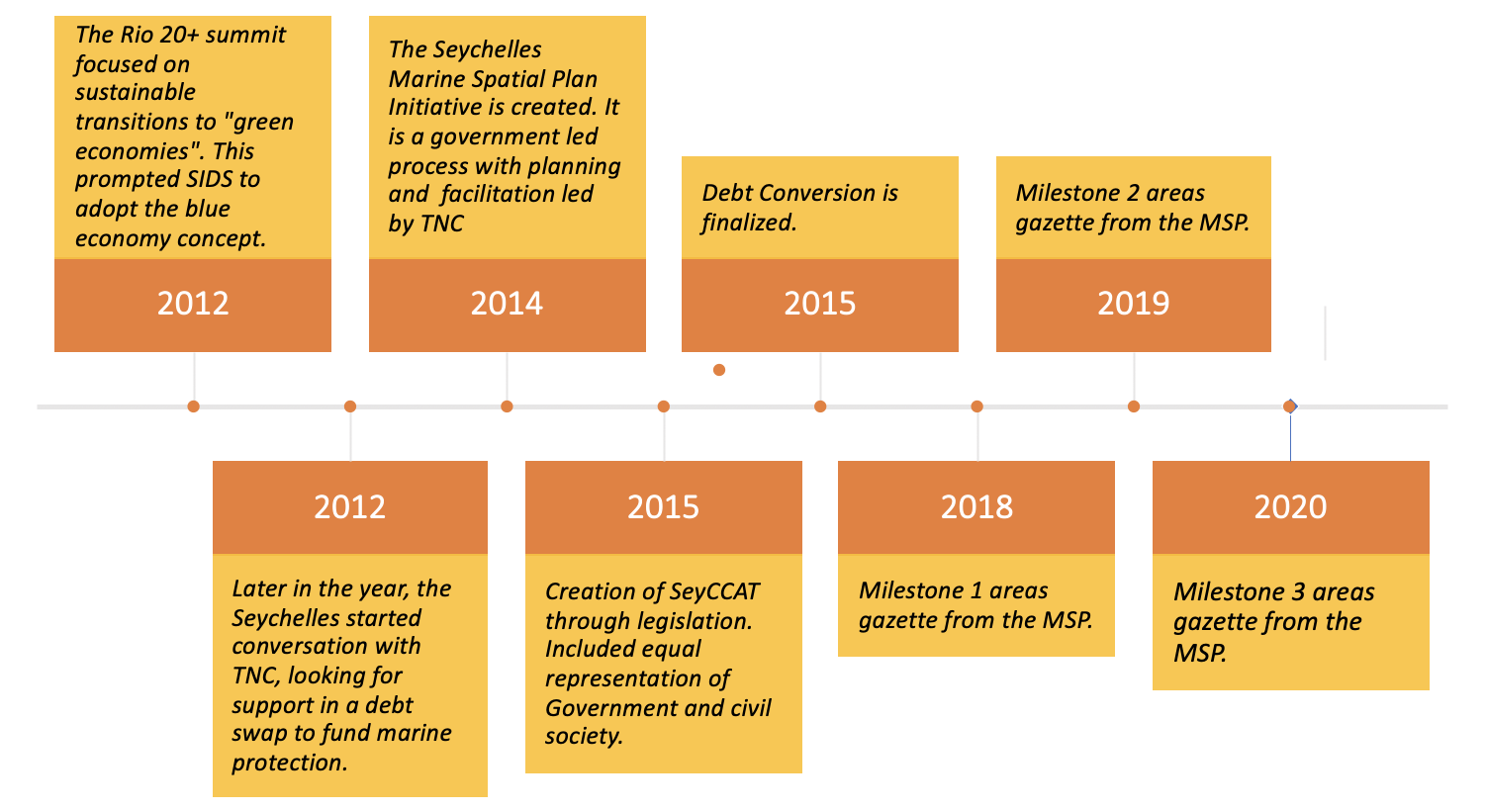

**Figure 2:** This is a timeline meant to lay out the major events of the debt swap and MSP thus far (2012-2021). There is a lack of more detailed information available to gain specific insights or more exact dates. Info for the timeline comes from SMSP, TNC, and SeyCCAT.

The debt swap stated that the Seychelles would allocate capital raised in the conversion to fiance their recently determined goals from 2012: protecting “50% of all terrestrial areas and 30% of the Exclusive Economic Zone (EEZ) including 15% in fully protected areas ... by employing an ecosystem-based approach to propose new MPAs in conjunction with improved management for uses and activities'' (SMSP, “The Initiative”, 2021). The Seychelles MSP initiative states that the Seychelles used “global best practices, scientific data, local expert knowledge, and stakeholder input to create maps showing how to best use the ocean and what [they] know about its ecology” (SMSP, 2021).

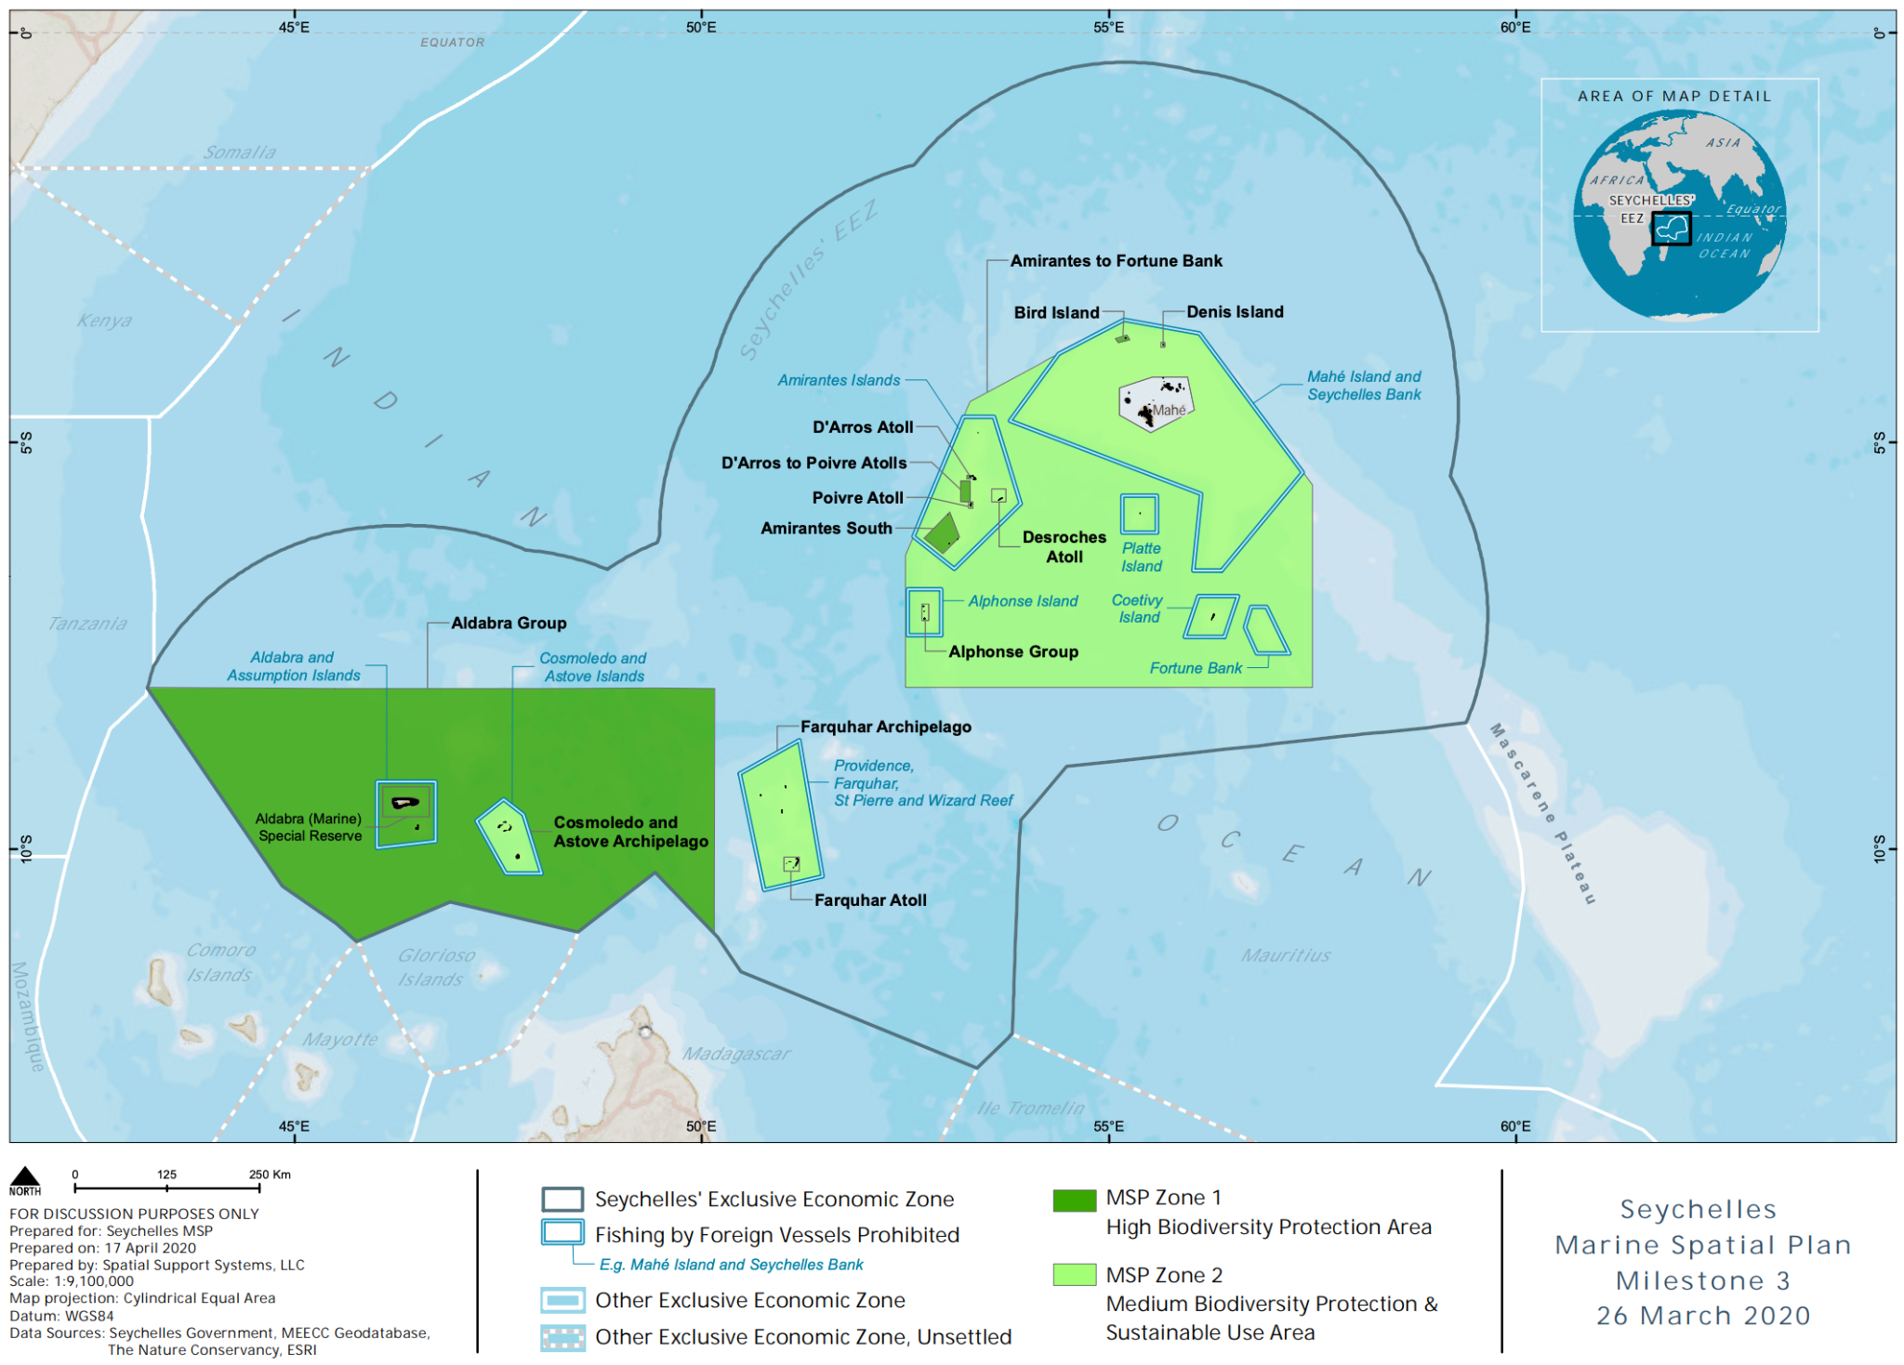

**Figure 3**: This map (SMSP, 2021) shows the extent of the Seychelles EEZ and the progress implemented thus far as of March 6, 2020. The small icon in the upper left corner identifies the global position of the Seychelles. The project, at full implementation, will cover a marine space the size of Germany.

This particular debt swap is novel for its focus on marine resources, but also for its use of impact investing, and adaptation practices. These deals are traditionally called “debt-for-nature” swaps, but the Seychelles has labeled theirs a “debt-for-adaptation” swap (TNC, 2016). While the difference is subtle, it emphasizes that this deal is the first of its kind constructed with specific climate adaptation practices in mind. This alludes to the complexity of the MSP which was founded with the debt funds. The plan is unique in its size, scope, and inclusion of local stakeholders. The Seychelles hopes to fund conservation activities which can grow and adapt to the changing climate - the focus on adaptation means specifically building resilience to reduce the vulnerability of a community against the impacts of the changing climate (Angelique Pouponneau, personal communication, 2020). This specific and differentiated label (compared to past “debt-for-nature” swaps) is also a nod to the timing of the deal as it was created and marketed after the Paris Agreement. This was cited as giving the deal some momentum and a huge point of discussion was this commitment to adaptation (Angelique Pouponneau, personal communication, 2021). The need for climate adaptation practices is rapidly growing in SIDS as they are highly exposed to tropical storms, rising sea levels, and bleaching or acidification events which could topple their economy (Rambarran, 2018). When this exposure is coupled with burdensome sovereign debt, the economic risks are huge- this is where the need for innovative financial mechanisms is highlighted.

This sort of deal allows the debtor nation not only financial allowances on their debt, but to invest in their own sustainable future which will certainly help grow the economy in the long term. This positive economic/conservation feedback loop may allow conservation financiers to multiply their impact in both economic and environmental need areas of developing nations. The benefits to the creditor are a politically and socially palatable way to write off a portion of debt which then limits the amount of loan loss reserves it must put aside - this then makes debt repayment more tenable by reducing the overall debt burden (Occhiolini, 1990) . Some countries are discussing an integration with the current EU Emissions Trading System (ETF) system in place where a creditor receives a tax break, or - in response to many of the ambitious climate goals created at international conventions - may apply the funds of a debt swap towards their nations work to meet certain environmental goals or statements (Steel and Patel, 2020). Finally, the creditor is essentially investing in the hope for more economic stability long term, of a country which will still owe them. No debt swap writes off entire debts, only portions, so the deal becomes financially beneficial to the creditor if the programs it implements strengthen the debtor nation's GDP (i.e., ability to meet future debt payments of the remaining sum) (Post, 1990).

The Seychelles deal proved intriguing enough to the financial world, that it attracted major attention from three major financial institutions. The World Bank, Prudential Financial, and Nuveen and Calvert Impact Capital each provided five million to fund the first sovereign blue bond issued to the Seychelles in 2018 (Commonwealth Secretariat Blue Charter, 2020). It seems that the infrastructure created by a successful debt swap has the potential to draw interest from future investors down the line. This may be because the terms of the swap implement programmes and controlling entities - such as The Seychelles Conservation and Climate Adaptation Trust (SeyCCAT) - which presents a more stable foundation which private investment funds are more willing to back due to decreased risk and higher impact potential. SeyCCAT is tasked with managing and allocating funding streams from both the debt swap, and the blue bond (SeyCCAT, 2021). Furthermore, this blue bond is another first pioneered by the Seychelles - this demonstrates that a nation whose government is willing to prioritize innovation and sustainability has a lot of space for opportunity.

The Seychelles debt conversion demonstrates a new use case for debt restructuring to focus on the marine conservation space. This case study provides an opportunity to investigate a possibly high impact model which could theoretically be adopted by numerous other SIDS who have similar debt and climatological issues. As the COVID-19 crisis has drastically exacerbated many islands’ debt struggles, a renewed focus on sustainable debt mechanisms is timely; a deeper understanding of the process can provide insights in moving forward. My research questions are: (1) Does this case study represent an evolution in debt restructuring practices and provide a new standard for conservation financing? If so, how and in what ways? (2) What are the critical governance characteristics that facilitated the creation of the Seychelles debt swap?

# **Methods**

A case study includes multiple sources of evidence to draw inferences about the situation and it favors qualitative analysis over statistical (Cox, 2015). Using a case study approach, my methods included a literature review, a content analysis of online resources, and a select number of semi-structured interviews with key informants. The triangulation of information provided by these different sources offers a varied and fair lens through which to analyze the case study. This method is cited as a “vehicle of cross validation” in qualitative studies (Jick, 1979).

My initial research began as a robust literature review which included numerous peer reviewed sources dating from the 1980s to present. Much of this literature focused on the social impacts of debt for nature swaps to determine the most outstanding issues with the mechanism. Other literature delved into the financial incentives at play in many debt conversions. I reviewed literature which featured analysis of roughly 10 other key case studies of past debt swaps to better acquaint myself with the past standards and examples. Finally, I found literature which investigated the common issues and highest needs of SIDS to see how/when debt restructuring an applicable solution is.

I analyzed both primary (interviews) and secondary (news articles, opinion pieces, government documents, official websites) data in my case study. I reviewed and synthesized the data and applied qualitative models that are best used to explore the structure of a system (Cox, 2015). These models include “box and arrow” diagrams to determine impact or linkage within the governing systems who worked on this deal, as well as the systems created as a result of the debt swap. This sort of relationship analysis is prevalent in environmental social science literature as “a way of developing an understanding of the system in question, particularly in case study analyses” (Cox, 2015, pg. 63; Neudoerffer *et al.*, 2005; Homer-Dixon, 2010; Alberti *et al*., 2011; Österblom and Sumaila, 2011; Fazey *et al*., 2011; Downing *et al.*, 2014). Furthermore, these models are often developed “collaboratively with local resource users and other participants to explore scenarios for future change in the target system” (Cox, 2015, pg 63; Marín *et al.*, 2008; Delgado *et al*., 2009; Guimarães *et al.*, 2013).

Finally, I also used methods of comparative analysis to hold this case study as a benchmark against analogous historical case studies. By reviewing a series of previous case studies of debt-for-nature swaps, I determined patterns and standards which I then use as a baseline against which to compare the highlighted case study: the Seychelles. This method has been established in social science literature and is often referred to as “pattern testing” or “congruence testing” (George and Bennet, 2005; Yin, 2014). The official method for congruence testing involves measuring the defining features of a case to determine the extent to which they are congruent to a hypothesis or a theory. For my paper, I use this method to determine if this case studies can be considered a deviation from a theoretical standard of historical debt swaps, as outlined by literature and case studies of older debt swaps. By either establishing or disestablishing congruence, I can make assumptions about the degree to which debt swaps have evolved from a social, environmental, and fiscal standpoint. I acknowledge that with this method, it often takes more than one case study against a theory to definitively determine a level of congruence, so my statements will be a suggestion at the possibility of evolution rather than proof of such.

To include primary data, I focused on sourcing a small number of interviews from key informants whose knowledge and input seemed deeply intimate with the specifics of the deal. I sought representation from the three main groups who negotiated the debt swap: the Paris Club (creditor), The Nature Conservancy (broker), and the Seychelles government (debtor). The Paris Club is the colloquial name for a group of officials from major creditor countries who came together to determine solutions to large-scale outstanding debt (Club de Paris, 2021). The nations specifically involved in this deal are: Belgium, Germany, France, Italy, Japan, Russia, Spain, UK, and South Africa (Club de Paris, 2015). The Nature Conservancy and Nature Vest (the impact investing arm of the NGO) worked as primary facilitators in the deal negotiations, structure, and now have representatives aiding in implementation. Finally, the Seychelles government in conjunction with TNC created a trust managed by a new group, SeyCCAT. My key informants were Rob Weary (primary architect of the debt-for-nature swap from TNC, now independently contracting debt swaps), Joanna Smith (Marine Spatial Planning core team and representative from TNC) and Angelique Pouponneau (CEO of Seychelles Conservation and Climate Adaptation Trust). This research received ethics approval from the University of Colorado at Boulder’s Institutional Review Board under Protocol 21-0162.

# **Results and Discussion**

## **Part 1: Analysis of debt swaps from 1980s to present**

To address my first research question, “Does this case study represent an evolution in conservation financing?" I reviewed roughly 10 of the major case studies and examples of debt swap cases primarily dated between 1987- to present (Macekura, 2016; Steel and Patel, 2020, Thapa, 1999, Hansen, 1989, Gockel and Gray, 2011, Hrynik, 1990, Bedarff *et al.*, 1989). The first twenty years represent the conception of debt for nature swaps and the subsequent inaugural deals, followed by the momentum of many subsequent swaps. This analysis notes a much higher volume of debt swaps in those earlier decades and a notable waning in the use of this mechanism in the 2000s. There is also a lower number of case studies published and reviews written as the interest and popularity in the mechanism seems to have decreased. Aside from noting this general downtick pattern based on the dates of case studies reviewed and online attention/discussion, multiple studies also noted that the instrument became rather dormant (Fenton *et al*., 2014; Mitchell, 2015). A reason for this lull may be the rise of debt prices in the secondary market and the enactment of other debt relief programs such as HIPC (Steel and Patel, 2020). This timeline of initial momentum, followed by a documented slowing, and current uptake in attention, intent, and progress align with the assumption that debt conversions have undergone an evolution to the point where they may perhaps deserve an official rebranding and departure for the historical implications of “debt-for-nature”. Below I elaborate on this theory by analyzing historical deal structures, main criticisms, and evidence of evolution to determine the degree of progression.

### **Historical Deal Structures**

Debt swaps have been utilized globally since 1987 to fund numerous conservation projects (Hrynik, 1990). The earliest of attempts at structuring these deals saw varying levels of conservation success, but were often faulted for not restructuring enough capital to have a substantive impact on the net debt burden of the countries in question (Macekura, 2016; Cassimon *et al.*, 2011). For a timescale reference, between 1988 and 1990 the US generated donations amounting to 10 million dollars to relieve 69 million dollars of debt, but this total sum accrued over 14 different small deals (Brijesh Thapa, 1999). This demonstrates that while there was early potential to accrue capital, its distribution ended up feeling sparse amongst many different nations. To contrast, the case study of the Seychelles totaled 21.6 million in a single deal which can be considered representative of current debt swap standards (SMSP, 2021).

The 21.6 million deal in the Seychelles redirects a portion of their current debt payments to fund nature-based solutions to climate change through the Seychelles Conservation and Climate Adaptation Trust (SeyCCAT), an independent, nationally based public-private trust fund. The stated streams for redirected debt payments will go to: (1) finance marine and coastal management to increase resilience to the impacts of climate change, (2) capitalize an endowment to finance work to support adaptation in the future, and (3) repay impact investors (Payet, 2021). The timescale of debt repayment was changed from 8-20 years and 70% of the debt will be payable in local currency rather than foreign currency which would have caused a crushing exchange rate (TNC, 2021). The capital allocation alone demonstrates that from its conception, debt swaps have grown significantly in magnitude and, consequently, potential conservation impact. The specifics of the Seychelles debt conversion, along with the subsequent blue bond issuance are laid out below.

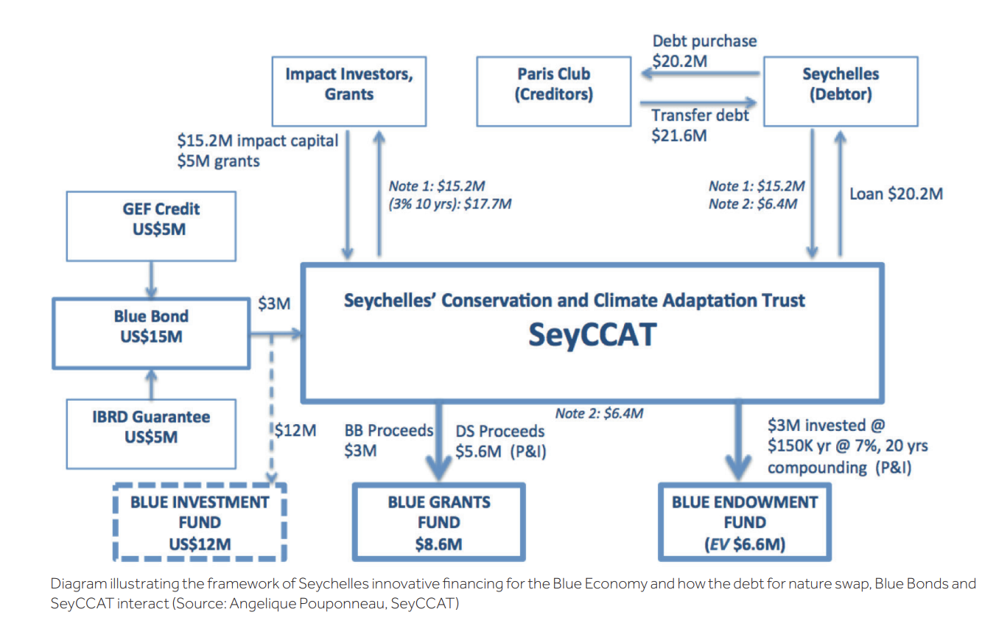

**Figure 4**: This diagram is useful to understand the specific transactions that took place throughout the debt swap, as well as to finance the blue bond. There are many complex relationships and financers and this boiled down structure gives an understanding to how complex these deals can be, considering this took years to negotiate (Commonwealth Blue Charter, 2020).

### **Main Criticisms**

Beyond the financial records that set a historical standard, extensive literature

has also determined a pattern of debt swaps being too small and riddled with high transaction costs compared to other financing instruments (Thapa, 1988; Moye, 2001; Silver and Campbell, 2018; Hansen, 1989; Reilly, 2006; UNDP, 2021). This key criticism leads to discussion about the net efficacy of debt swaps when only minor percentages of debt are reconstructed (Hansen, 1989). This issue has the potential to be exacerbated if debt swaps are not properly implemented and cause drastic limitations to local economies. This possibility comes with the assumption that the conservation agreements outlined in most swaps are at odds with the stakeholder usage of natural resources and commons (Bedarff *et al.*, 1989). Scientific literature strongly outlines the importance of co-production practices which include local stakeholders in the planning, design, and implementation in order to achieve the highest rates of adoption, incorporate local ecological knowledge (LEK), and prioritize the people who will be fiscally impacted in the near term (Sterling *et al.,* 2017, Kittinger *et al.*, 2014, Brooks *et al.*, 2013).

The second consistent criticism of debt swaps is the possible detrimental social and political implications. Case studies in Bolivia, Costa Rica, and Madagascar have highlighted examples of farmers being displaced from their land, circumstances that drive locals closer to poverty, and restrictions against traditional foraging practices (Hassoun, 2012). There was also a concern, particularly in those early decades of conversions, that debt swaps led to sovereignty issues (especially in the case studies on forestry projects) where the creditor essentially controlled land areas of the debtor country (Moye, 2001). This issue persists as one of the more difficult critiques to evolve from as many governments are still reluctant to link debt for nature swaps to policy change (Moye, 2001). A more recent publication argues that these reluctances are currently more based more in perception than current reality as this issue is now well included within negotiations (Warland and Michaelowa, 2015). However, these perceptions pose a barrier if governments do not feel direct ownership over the negotiation process. The debtor country playing a major role in allocating funds from the debt swap is important to avoid perceived state sovereignty issues and to properly align with national strategies and plans (Warland and Michaelowa, 2015). For this reason, nations with mitigation or adaptation practices or commitments already in place may be the most attractive candidates for future swaps (Fenton *et al.*, 2014).

Finally, debt conversions are a niche instrument but belong to a much larger category of conservation financing. There is a sentiment that conservation financing in general is “slow and clunky” with a tendency to be “performative” with “optimistic claims” which eventually bring in “low returns” (Dempsey and Suarez, 2016, p. 654). Dempsey and Suarez (2016) argue that this is why the “big big money” has yet to really appear on the conservation financing scheme. They further discuss the preexisting notions of for-profit-conservation, and it seems that even as mechanisms evolve, bias may be a factor in convincing the private sector or individuals to bite (Dempsey and Suarez, 2016).

### **Evidence of Evolution**

To compare the Seychelles case study against these outlined critiques, there is evidence to suggest progress. The Seychelles was a very sustainably oriented nation well prior to the debt conversion and already had ambitions to improve their resilience to climate change (SMSP, 2021). Their government initiated the deal and individuals interviewed stated that the government was deeply involved and took a lot of ownership over the process (Weary, personal communication, 2021; Pouponneau, personal communication 2021; Smith, personal communication, 2021). This ensures they don’t fall into issues of real or perceived sovereignty infringement. To address the possibility of displacement or poverty, the MSP has been extraordinarily detailed in its transparency and use of stakeholder inclusion. The Seychelles Marine Spatial Plan Initiative website (central page for the MSP) includes comprehensive frameworks, archived documents for every step of the process, past meeting details for stakeholder workshops, and the names of key local representatives (SMSP, 2021). They have segmented the MSP implementation into zones and have preset milestones which likely ensures that the process is not overly jarring to local stakeholders. This also allows for feedback and adaptation should the local economy suffer from a high degree of backlash and gives adequate time for stakeholder voices to have continued impact.

While this deal, in its overarching structure, suggests it will perform favorably against the historical standard of debt swaps; its small financial scale is the one limiting factor which remains to cement the model. This is perhaps the only element of this swap which doesn’t demonstrate a noticeable evolution from previous standards. 21.6 million isn’t a large amount of debt and doesn’t stand against that common criticism of the fiscal impact being too small. The 21.6M USD sum of the swap does not properly reflect the economic opportunity cost to the Seychelles in designating so much ocean as protected (Silver and Campbell, 2018). The Seychelles has very lucrative economic resources such as seafloor mineral/energy deposits - and this is the case in many other SIDS EEZs. With this factor in mind, it seems that the “durability of MSP zoning and LMPA will depend on the extent to which adequate attention has been given to economic activity in planning and implementation and whether local people are engaged as stakeholders” because it's critical that they “feel that they are the beneficiaries over time” (Silver and Campbell, pg. 12., 2018). A core member of the TNC marine spatial planning team, Joanna Smith, commented on this aspect of conservation planning. She noted that there are a lot of nuances often not considered by the general public when evaluating a plan as complex as this case studies. She explained that it's difficult to consider the built-in price of proper implementation and the externality costs of not using best practices. She stated that TNC, SeyCCAT, and the Seychelles Government have made transparency, inclusion, and best governance practices the ultimate focus of their work and that in order to achieve these goals, there are extra costs and longer timescales (Smith, personal communication, 2021). While the upfront efficacy and results may look below the bar to some perspectives, there is a strong scientific consensus in the literature that best practices for (in this specific case study) co-production are necessities when long-term social and ecological goals are in mind. Additionally, the small amount of debt converted, compared to the other details of the deal, may suggest that this swap instead prioritized large scale conservation initiatives, and co-production practices the highest. This prioritization has resulted, thus far, in a very successful endeavor which may now be considered a model that future deals can use in conjunction with more substantial capital agreements.

To further answer the main critique of low converted sums, Rob Weary (personal communication, 2021) explained that he, in partnership with Pew Charitable Trusts, has multiple new deals in the pipeline that prove that debt restructuring is only just starting its rise. These debt conversions are tentatively set to be announced at UNFCCC and another within 6 months after. One of these soon to be announced swaps will, possibly, more than double the no take area in the Galapagos marine reserve will come out of a 1.5-billion-dollar debt conversion that includes a 500 million dollar impact investment into the Galapagos. This will be the largest deal the US government (referring to political risk insurance) has ever supported on any project. Ecuador has 16 billion dollars in debt that trades at 61 cents on the dollar. The government will end up saving 250 million dollars just in debt interest alone. A second example of a soon to be announced swap (structured by Weary and executed by TNC) will buy out all of Belize’s commercial debt to the tune of 500 million (Weary, personal communication, 2021). These examples of near future debt swaps suggest an improvement that might remedy the biggest criticism of debt swaps overall, and certainly the largest issue in the Seychelles case study. These forthcoming deals are proof of scalability as a concept using methodology developed during the Seychelles deal. It contradicts primary criticisms that debt swaps can’t support large enough sums to realize true impact. Additionally, the issue of high transaction costs are ameliorated with this progress since those costs are essentially fixed, and as the scale of deals increases, the percentage of transactional costs becomes more and more negligible. In a new financing structure (which really began with the Seychelles deal) the transaction costs are also included in the debt conversion sums so it shouldn't require more money externally for the nation involved (Weary, personal communication, 2021).

To determine specific characteristics of this debt swap evolution, my primary analysis focused on the novelty of the Seychelles case study in the deal’s structure, implementation methods, and results. While the skeleton structure of the deal is based on a long history of debt restructuring frameworks, this case study has been lauded as particularly innovative. Designated as “pushing the boundaries of conservation financing” it won an award in 2017 from the Financial Times/International Finance Corporation for “Catalyzing Finance and Disruptive Technologies to Boost Sustainable Solutions” (IFC, 2017). This deal rose in global attention because of all the firsts it entailed. It was the first deal ever done in the marine space, the first time a developing country creditor has entered a debt deal with another country from the Global South, the first debt swap designed explicitly for climate adaptation and the first to include impact investing. Impact investing is particularly exciting when looking forward because this combination of private and public funds - each leveraging the other creates a new model for co-investment debt swaps in other areas of the world (Weary, personal communication, 2021). With this long list of novel aspects, the Seychelles deal may truly embody a new chapter, supported by an evolved framework and environment, for debt swaps globally and particularly for SIDS.

While discussing with Rob Weary the future deals (e.g., Galapagos, Belize), underscored against his past 20 years of experience structuring debt swaps, he ultimately agrees that the Seychelles deal was undoubtedly the turning point to usher in a new frontier of debt swaps. While it was novel in many ways, he considers the success of including impact capital to be a pioneering aspect of this evolution (Weary, personal communication, 2021). From a debtor nation perspective: the impact investing is promising because it focuses on the social/financial element of sustainable development, and it could potentially bring them into progressive market relationships for the future - beyond this deal. From the broker's perspective: raising grant money is often what took the vast majority of time and resulted in the multi-year timescales (Weary, personal communication, 2021). Furthermore, grant raising is resource intensive as it often takes many small grants from many different sources who all had to be individually pitched and negotiated with - a transition to loan capital is massively progressive (Weary, personal communication, 2021). Equally as pivotal, the innovative use of the US Development Finance Corporation (DFC) allows brokers to use their political risk insurance policy as a form of credit enhancement has been a game changer in debt swaps from this case study on to the present day. While many other development banks have this sort of policy, it was historically intended for contract insurance on brick-and-mortar projects, and only the US DFC is willing to use it non-traditionally to support new debt deals (Weary, personal communication, 2021). The mechanism has loan guarantee abilities reaching a billion dollars and without this specific insurance, this evolution would be obsolete.

The literature focused on past deal structures illuminates the new opportunity for debt conversion relative to past global financial standings. In the 1980s and 1990s when the concept originated, bilateral and multilateral debt dominated the external portfolios for national debt, particularly in Caribbean SIDS (Rambarran, 2018). However, in recent decades there has been a shift towards more expensive commercial borrowing and domestic debt (Rambarran, 2018). This shift is augmented by the international ratings agencies assigning new credit ratings to many SIDS resulting in these nations relying heavily on commercial bond issues as a primary finance source (CDB, 2013; Rambarran, 2018). This is relevant because the deals evaluated in this paper, such as the Seychelles conversion, can only be applied to commercial debt. Bilateral debt is concessionary and doesn’t offer the same discounting features that allow numbers to add up (Weary, personal communication, 2021). The high interest rate of commercial debt effectively makes it the best opportunity over bilateral swaps. This is important for evaluating candidacy and opportunity because the structure of a nation's debt is just as important as its sum for the purpose of conversion potential.

## **Part 2: Identifying the commonly cited characteristics**

To address my second research question, “What are the critical governance characteristics that facilitated the creation of the Seychelles debt swap?", I identified the most referenced characteristics from my primary interviews, and secondary research. In the evaluation of what national level criteria and governance characteristics facilitated the Seychelles case study, these key characteristics were: the debt status relative to the economy, the political willpower, the funding streams, and the use of coproduction practices. I elaborate on each of these characteristics below.

### **Debt status relative to the economy**

The Seychelles suffered a severe economic downturn following the global financial crisis in 2008. Their primary bank was Lehman Brothers who’s crash infamously precipitated the economic meltdown which struck nations and business worldwide (Weary, personal communication, 2021). The Seychelles economy was fragile previous to this collapse and moved into a state of bankruptcy after. Their debt as a percentage of GDP in 2008 was nearly 200% and stayed around 80% throughout the early 2010s (Country Economy, 2021) while this deal was in the negotiating stages. This high debt to GDP ratio is a detrimental aspect of the financial stability of any nation but becomes vastly more important when considering the vulnerability of SIDS. A systematic review of literature on the vulnerability and adaptability of SIDS relative to climate change found that these nations are the most susceptible populations to external shocks and climatic disasters (Robsinson, 2020). This research, which analyzed over 200 studies definitively determines SIDS to be on the “frontlines of climate change” which specifies that the most vulnerable sectors are tourism, fisheries, and water resources with a sensitivity to climate related events which can bring on economic losses as high as 40% each year (Robsinson, 2020). This sort of ecological, social, and economic vulnerability designates SIDS as an at-risk population well before factoring in the burden of high debt ratios - the combination of both is clearly detrimental. The financial strain of debt leaves the nation unable to invest in their own climate adaptation, economic resilience, and biological conservation practices; furthermore, it seems generating external funding or investment is a tall order in this scenario. This leaves SIDS in such a predicament with minimal viable recourse and debt swaps seem to offer one of the more palatable options - if designed and implemented properly.

For a debt swap of any magnitude to be fiscally or politically possible, a debt burden must be present, and it must be significant. While theoretically a nation with any level of debt could instigate a debt conversion, if they are looking for a third-party broker (such as TNC) to facilitate they should be in a dire situation relative to global scales of debt. This seems a critical characteristic because there is so much opportunity for nations in need of debt restructuring that for an NGO to be interested, the impact must be evaluated as of the highest potential. Additionally, the more severe the debt crisis, the lower the market value the debt trades at because creditors recognize that, in this circumstance, it’s unlikely for them to get their initial loan back (Steele and Patel, 2020). This becomes a keystone criteria of high impact debt swaps as NGOs naturally want to maximize their impact per dollar spent. If a nation is gravely defaulting on their debt, their creditors are likely looking for a socio-politically palatable way to write off the debt and will give a lower price in cents on the dollar which is a financial link in making the net transaction feasible. When you buy debt for (hypothetically) 80 cents on the dollar, you free up 20 cents with every dollar spent. This seems insignificant until you scale to 10 million and you are getting 2 million free, or 20 million freed up from a 100-million-dollar conversion (Weary, personal communication, 2021). Clearly, the compounding effect of discounted debt is essential to make this financial mechanism appealing over simple grant writing or loans. This discounted debt factor is so key that Robert Weary referred to it as “the secret sauce”. Weary did comment that an alternative structure to ameliorate the finances is working with the interest rate since many commercial debts have high rates of 7-9%. In this scenario it may be worthwhile to buy the debt, even at face value, because an NGO’s cost of capital is (hypothetically) 5%. So, this means they are paying the debt at 5% cap, and charging the debtor nation 7%. This transaction leaves a 2% differential on both sides of the transaction which results in a satisfactory deal all around if a high enough quantity of debt is purchased. While this sort of transaction wouldn’t free up the same capital flows as a big discount, it’s another tool to tackle these deals with if alternative procedures prove necessary. This interest rate buying method is one that Weary says brokers are just now starting to look at (Weary, personal communication, 2021). This demonstrates that those pioneering upcoming debt swaps are constantly refining the methods which support the concept of net evolution in this sector.

As discussed, the Seychelles has a prime example of a blue economy. The blue economy is not a concept designed by the Seychelles, but their adoption of the idea has risen as a massively defining characteristic for their national agenda and identity. This concept is a critical component of both selection criteria for any of the SIDS looking to swap debt for marine conservation, and as the guiding pillar of the deal’s framework. The blue economy concept is found, via a literature survey from 1998-2018, to be highly correlated with the United Nations Sustainable Development Goals (SDG) 14-17 with the stipulation that stakeholders prefer SDG 3 (Good Health and Wellbeing) and SDG 8 (Decent Work and Economic Growth) in the blue economy discourse (Lee et al., 2020). The Seychelles recognition of their blue economy is deeply ingrained in their national identity as determined by extensive analysis of government published frameworks, roadmaps, and public agendas (Blue Economy Roadmap, 2018; SMSP, 2021). Their Strategic Policy Framework and Roadmap was published following the close of the debt conversion as a means of outlining their plan to use new funding, new agreement, and ideals from 2018 until 2030 (Blue Economy Roadmap, 2018; SMSP, 2021). It mentions that the Seychelles government considers the blue economy brand to be a “unique comparative advantage based on sustainability credentials” (Blue Economy Roadmap, 2018). In 2016, as payments on the debt swap and the MSP process were underway, the Seychelles government underwent a public process to declare a framework for their blue economy to “implement the concept at the national level as a framework to foster an integrated approach for sustainable development programmes” (The Commonwealth Secretariat, 2019).

### **Political Willpower**

Across the board, the three interviews unanimously cited political will as one of, if not the biggest, factors in debt conversion success. Political will (while undefined by interviewees), in the context used, seems to align with the definition listed in the Acronyms and Definition section: “an amalgam including managers with adequate financial, technical and administrative capacity over sufficient periods of time, a political agenda with space for environmental issues, leadership in government and the community, manageable levels of corruption, and an environmentally well-informed community giving strong support for management actions” (Sale, 2015). The debtor nation's political will, in this scenario, would ideally be centered around conservation commitments to the degree that it stands as a priority against other significant political agendas such as economic sectors, or global relationships. The degree of political will directly dictate the time spent in negotiations - if a government is holistically ready to commit to the conservation agreements, the deal could now be closed in 5-6 months (opposed to multiyear timescales demonstrated in the past) (Weary, personal communication, 2021). The Seychelles was cited in interviews as an example of a nation who agreed up front. In contrast, the upcoming Ecuador deal has already faced heavy backlash from key fishing sectors which the government has taken deeply into account (Weary, personal communication, 2021). It seems that striking the balance in wanting to maximize conservation initiatives over minimal negotiation time must come with foundational detail that local interests are properly considered. Only the debtor government has the power to determine this balance and problems may arise to compromise efficient timing if they cannot strike that balance properly. To aid in this delicate nuance, science can offer tangible pathways. An example of this is the Ecuador deal which threatened (from stakeholder perspectives) to detract from their most profitable fishing industry: tuna. To support negotiations, the 3rd party brokers used collected data from geo-tagged fishery activities to design the no-take areas so that only ~5-8% of the ocean area relative to the sector should be impacted. Additionally, this impact should (from past survey predictions) be short term followed by catch and biomass growth surrounding the no take area. (Weary, personal communication, 2021).

Political will is a key enabling factor but may conversely be detrimental. There are multiple examples of deals that were attempted, and nearly fully structured in the past couple of years but failed to cross the finish line because of a lack of political will. These cases, which exist across multiple nations, had gone through negotiations, but ended up dissolving the deal when it came time to sign because the nations weren't willing to commit to the conservation agreements (Weary, personal communication, 2021). While there are many abstract reasons that a nation may be hesitant to commit to a debt conversion (see e.g., above discussion on the critiques on debt restructuring), at a micro level, the government doesn’t have to do anything other than review documents because the broker is responsible for many of the other responsibilities such as getting the lawyer, outlining terms, creating the trust funds, and conceptualizing the workshops. So, for an interested nation the actual time and effort required in the process is really quite minimal, and the fiscal obligation is simply the cost of hiring their own legal counsel to review the proposal (Weary, personal communication, 2021).

While political will has always been a relevant governance factor in debt swap cases, the Seychelles case study further demonstrates exactly how powerful it can be. The sheer size of the conservation commitments at 400,000 sq. km is massive (equivalent to the size of Germany) and will create the 2nd largest marine protected space in the Indian Ocean. So, while the financial amount of debt relief may not be groundbreaking, the conservation agreement certainly is, and that is the aspect of the deal that stems much more directly from the government. This consideration has ties to the concepts from Fenton *et al.* (2014) which states that a nation with preexisting adaptation or mitigation plans make the most attractive candidates for this sort of deal. This is likely because nations with such programs in place almost certainly have a progressive government supporting these structures.

### **Funding Streams**

As always with any large conservation initiative, securing the funding is among the trickiest parts to find momentum with. A recent study outlines that the major challenges in financing a sustainable ocean economy are “a weak enabling environment for attracting sustainable ocean finance, insufficient public and private investment in the ocean economy, and the relatively high-risk profile of ocean economic sectors (Sumaila *et al.,* pg. 9, 2021). The recommendations to overcome these barriers are the creation and mobilization of a “full suite of financial tools and approaches” which particularly include “women, youth, and marginalized communities” (Sumaila *et al.*, pg. 9, 2021). That same paper highlights the Seychelles case study as an example when discussing debt conversion potential and makes the ultimate recommendation that more similar debt swaps should be designed.

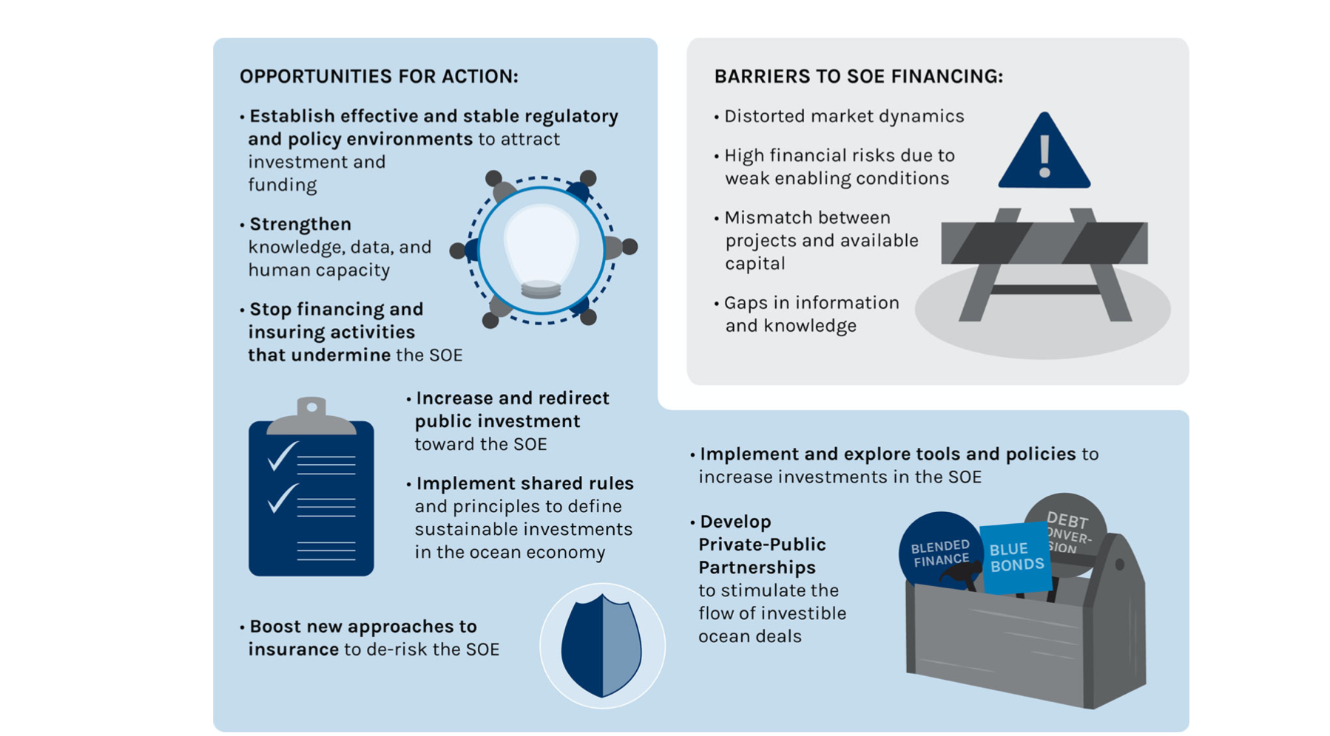

**Figure 4:** This graphic, from (Sumaila *et al*., 2021) highlights the tools recommended in their assessment of innovations which can best advance financing a sustainable ocean economy.

With the recommendation that debt swaps qualify as an innovative financing tool, comes the need for innovative funding streams to support the growing mechanism. Weary (personal communication, 2021) explained that only recently have leaders in this space “cracked the code” of how to generate the financial means to move large deals forward. The US has a Development Finance Corporation (DFC, formerly the Overseas Private Investment Corporation) which provides payment/loan guarantees and political risk insurance. Private insurers do exist, but their premiums could be two to three times higher than DFC, if they would even offer the insurance at all for some countries (Weary, email correspondence, 2021). Third party brokers are using this political risk guarantee to buy on the market with full faith backing from the US government. This means the notes they issue can be rated at AA- (a metric of determining their creditworthiness) which allows them to raise the capital very cheaply. Another recent breakthrough is the role investment banks are willing to play in the capital raising process. Funding historically relied entirely on grant money but has transitioned to using 100% loan capital funded by the capital markets. Credit Suisse, a major international investment bank, was the underwriter for the Seychelles’ Blue Bond capital raise and is providing even larger capital guarantees for the deal in Ecuador (Weary, email correspondence, 2021). When an investment bank agrees to “underwrite” a deal, they are providing assurances that the entire amount of capital will be raised. This avoids uncertainty in promising specific capital, which can be a major obstacle in the negotiation process with the sovereign country, as they naturally want to know precisely what they will be getting in proceeds for the terms negotiated. Failure to raise the prerequisite capital may be a clause that causes a deal to fall apart. In the past deals were negotiated on a “best effort” basis, meaning that there was no guarantee that the funds promised as part of a swap agreement would be available. This occurred in the Seychelles and it led to the deal being a much smaller sum than originally targeted. As Rob Weary explained, (email communication, 2021) Other major commercial banks would only offer “best efforts”, which means if they can only find buyers a lesser sum, the broker is put in a very difficult spot when they show up with less funds for the deal they promised. The funding stream coming from loan capital, underwrote by a major investment bank and backed by USDFC are the key financial aspects deals can aspire towards with this new model - especially given the goal of larger capital commitments.

Funding streams are considered a key governance criteria in both the creation of the debt swap, but also the continued allocation of funds post swap. Once the conversion of debt is set, there must be institutions in place to not only manage the funds from a governance perspective but guide the community in capitalizing upon implementation. The obvious management institution is a trust fund such as SeyCCAT, but their role goes beyond just ensuring payments and directing money towards conservation. They have taken on a role to ensure the community is able and aware of the potential of the grant money. SeyCCAT holds a lot of stakeholder consultations while designing their requests for grant proposals and prioritizes diversity in its beneficiaries (Pouponneau, personal communication, 2021). In total, with proceeds from the blue bonds and the debt swap SeyCCAT distributes $700,000 annually towards local driven conservation projects (Commonwealth Blue Charter, 2020). Considering this Seychelles case study, there has been some difficulties with accessibility and inclusivity for this funding stream. This comes from the fact that the Blue Grants Fund is supported by international donors and organizations who may not recognize the local challenges in applying for these grants. A cited example of this is that the application form was based on a standard EU format which was unfamiliar and intimidating for local Seychellois who would otherwise desire to apply for grants (Commonwealth Blue Charter, 2020). This is where SeyCCAT (or any other analogous trust fund) must assume an intermediary role. SeyCCAT has, for example, removed language barriers through translation programs, conducted public island meetings and one-on-one meetings with community members (fisheries, young female entrepreneurs, public sector representatives etc.), and dedicated resources to capacity building (Commonwealth Blue Charter, 2020, Pouponneau, personal communication, 2021). The capacity building element involves sessions during the first application stage to cover project and budget writing skills, project management, monitoring and evaluation, as well as dedicated mentors to facilitate the application process (Commonwealth Blue Charter, 2020).

SeyCCAT demonstrates that the role of the trust fund created out of the debt swap should go beyond simple money management in order to properly encourage community participation in the conservation funds available. However, this case study further demonstrates that this role is compex and must be adaptive to the unique problems faced by the community at large. A lack of original ideas in grant applications are noted as causing a pattern to emerge where one idea is copied with slight variations again and again. This may come from SeyCCAT’s request for grant proposals giving an example or theme that becomes overused (Pouponneau, personal communication, 2021). Additionally, the duration of grants is two years and behavioral change can take longer than that so it may be tricky to strike the balance of following the stipulations outlined in donor/debt agreements and ensuring that the desired impact is actually achieved (Pouponneau, personal communication 2021). A recent adjustment SeyCCAT has made is to hire monitoring and enforcement employees to follow the grant proposals more closely beyond just the application process, and initial satisfaction of the project - to evaluate the effectiveness of these initiatives and find measurables from a conservation, social, and economic perspective (Pouponneau, personal communication, 2021). This role is clearly nuanced as it must have a strong intuition of how the community is receiving these grant opportunities, they must drive achievement for sustainability solutions, but above all must remain financially stable to meet its fiscal mandates and continue providing funds in the long term (pouponneau, personal communication, 2021).

An important consideration for future nations looking to implement a successful debt swap/conservation program is clearly capacity building and strength of internal institutions. Any agreement is going to have specific disbursement periods and to best capitalize upon this, a nation could consider engaging in capacity building during negotiations so that once the deal is established, the local population is ready, educated, and capable of utilizing benefits. While trust funds have always been created as a standard outcome of debt swaps (OECD, 2007), the institution itself is not sufficient as it must be adaptive in its integration and implementation methods for capital disbursement. This role is highlighted as prominent in the segment of “funding streams” above, because an impediment to more free flow of capital supporting SDGS is the lack of measurement, reporting, and reliability provided by a fund. Trust that the governing institution is going to transact the money in a way which actionably generates positive social returns is a strong incentivizer for future investment. A standardization in this process of operating and evaluating will only augment the model for greater scalability.

### **The Use of Co-production Practices**

The final core governance factor which facilitated the Seychelles swap, and its success, is their use of strong coproduction practices and transparency. A comprehensive study investigating the integration of stakeholders and application of their LEK found the MSP that came out of this deal to be a strong case study (Baker and Constant, 2020). They found several studies from Seychelloise researchers which demonstrated how well understood sustainability in fishing practices is by the local artisanal fishers. Examples include fishers’ knowledge which led to informing key sites and vulnerable species in the Seychelles (Robinson and Payet, 2007) and key locality and temporal patterns of spawning aggregations (Robinson *et al.*, 2004). Another example of LEK is the fishers use of traditional bamboo traps called Kayse which differ in structure depending on the depth of placement. Three different depths have different weights, constructions, and timing methods, all to ensure that there is space for juveniles to escape and allows for prudent monitoring of by catch (Baker and Constant, 2020). Multiple fisheries also describe monsoon season (which affects their ability to reach many offshore areas) as a welcome respite for fish stocks and they even describe the phenomenon as “nature assisting [them]” to create a “biological rest” (Baker and Constant, 2020, Artisanal Fisher, C). This sustainably minded community had a lot to contribute, as well as enough skin in the game that their involvement in participatory planning was necessary.

Transparency, inclusivity and participation are listed as guiding principles for the MSP and are “cornerstones of engagement, consultation, and communication with stakeholders and civil society” (SMSP, 2021). They have deeply complex stakeholder frameworks, which are clearly published online, including individuals and groups from energy, finance, fisheries, marine ecology, maritime security, terrestrial ecology, and tourism sectors. Each of those groups have between 2-12 associates listed under them, with their professional information provided. To replicate this degree of transparency, the government needs to support a participatory process, the stakeholders need to be calling for it, and the facilitators (in this case TNC) need to determine best practices that encourage coproduction and transparency. (Smith, personal communication, 2021). Smith (personal communication, 2021) said that while TNC and the MSP steering committee were all excited about the use of best practices, they were unaware how far it would lead. Since 2014 they have held over 265 meetings, ranging from one-on-one consultations, large assemblies, committee meetings, and workshops. This is exemplary practice in regard to stakeholder engagement. Weary (personal communication, 2021) further agreed that the case in the Seychelles did a particularly good job of making sure that all the people who should be sitting around a table talking about these issues actually start having meetings. He indicated that he sees these deals as generating a very positive externality in the creation of trusts like SeyCCAT because these institutions with such direction and mandated missions didn't exist prior (Weary, personal communication, 2021). SeyCCAT has audits published yearly, a reservoir of published governing documents, archives, board meeting minutes, and updates, all available via their website (Weary, personal communication, 2021; Pouponneau, personal communication, 2021; SeyCCAT, 2021). This sort of authentic communication demonstrates not just transparency and stakeholder engagement but may draw interest from further investors and partners down the line who recognize the highly reliable level of management in place. Pouponneau (personal communication, 2021) mentioned that stakeholder engagement remains core to not only the design of a deal like this, but also the continued impact. She explained that SeyCCAT does a lot of stakeholder consultation in terms of designing their requests for proposals and aims for a lot of diversity in terms of grant beneficiaries (Pouponneau, personal communication, 2021). Furthermore, other stakeholders and technocrats can sit on the grants committee, and the conception of SeyCCAT was deliberate in giving out seats that exemplified the diverse economic and political structure of the nation (Pouponneau, personal communication, 2021). These seats on the grants committee mean that varied voices are all included in the decisions about where the money goes because while there are outlined stipulations, there is still variability for what the priorities year by year should be (Pouponneau, personal communication, 2021). This sort of ongoing coproduction is a significant lesson learned because even if coproduction is used in striking the deal, the standard must be maintained in perpetuity for continued buy-in and socio-economic success to match the conservation.

## **Limitations**

These three interviews all provided a detailed account of the debt swap process, current implementation, ongoing vision, and key takeaways. These individuals (Smith, Pouponneau, and Weary) represent the perspectives of both ecological planning, social/economic integration, and macro level funding respectively. While my intention was to procure more interviews, I found willingness to communicate over the limited allotted timespan to be a significant limiting factor. Of numerous email solicitations, only three panned out. This points to the high-profile nature of this case study as it is actively ongoing and delicate to comment on in respects to the process and its future. Furthermore, as this mechanism is only just starting to gain more momentum and global recognition, there are few authoritative sources to reach out to. The Seychelles case study was worked on, and continues to be implemented, by a small team which limits the number of potential interviewees as well.

# **Conclusion**

The details of the Seychelles debt swap are complex and adaptive in a way that debt restructuring has never seen before; the deal has thus been hailed as a promising new case which provides hope for other nations facing similar struggles. The evolved structure of debt swaps and lessons learned from successful case studies poise the mechanism to do well when paired with the current global social, economic and political environment. COVID-19 has drastically impacted many nations commercial debt and this crisis has risen to become a hot topic on many global forum agendas. As solutions are being discussed, the timing is very opportune for this reinvigorated mechanism to step up. However, with this timing comes the hope that deals don’t rush into implementation without gaining a holistic understanding of key lessons and takeaways from past examples. Debt swaps have a lot of potential, but without careful consideration and structures this potential could lead to adverse results (such as those outlined in the main critiques section of this paper).

With this global environment breathing new life in a well-established procedure, it is imperative to continue deeply analyzing the way this concept excels, falls short, and has opportunity to grow. This time represents a possible acceleration point in conservation financing as Environmental, Social, and Corporate Governance (ESG) market forces are on the rise and there is revitalized interest in methods. With this potentially progressive time, comes the crucial stipulation that methods for design and implementation are refined to create hard standards for best practice. Successful debt swaps now present a higher opportunity for impact than in the past because global markets are showing increased desire to diversify their impact investing portfolios. A nation with the conservation infrastructure created by a debt swap naturally attracts these investors.

The Seychelles issuing a Blue Bond - the first one in the world - is relevant despite being a separate entity from the actual debt conversion. The debt swap places the Seychelles on a better credit footing which allows them to issue the blue bond (Pouponneau, personal communication, 2021). The institutions, like SeyCCAT, created out of this deal have huge potential to take on a life of their own and that strength of infrastructure becomes magnets for additional funding (Weary, personal communication, 2021). Without the frameworks created by a debt conversion, the attention and security for investment seems like it would have been unlikely.

For this momentum on debt swaps to scale long term, other countries outside the US would need to have a change in their foreign banks policy. The use of political risk insurance cannot be overstated. Many of these foreign banks are simply risk averse, but others have concerns about use of proceeds and fine print of the policy itself (Weary, personal communication, 2021). Since this political risk insurance instrument wasn’t designed for debt conversion use, the development bank either needs to be flexibly progressive in their allowances or needs internal willpower to push amendments in a more favorable direction.

As evidenced in this case study, the Seychelles is in the spotlight. They have taken on the responsibility of being an early adopter to this newly evolved era of debt converting and with that comes a responsibility to perform exemplarily. They have essentially been elevated as the model of both hope and comparison for other SIDS and with that comes responsibility. If there are ambitions for convincing these other development finance institutions to amend their insurance policies, or for convincing potential nations that these debt swaps are in their best interests, the pioneer case studies must succeed. Positive examples have the power to win people over, but also the potential to tank the model. This is not a burden held only by the Seychelles; the next group of adopters using these more innovative and nuanced swap instruments will collectively create the standard. By this logic, candidacy and governance characteristics are essential. By virtue of having vulnerable ecological status and defaulting on high volumes of debt payments these case studies are inherently risky. While structures have been innovated to minimize this risk, there is a real possibility that a nation ill equipped to commit long-term to either the financial or conservation obligations should not be considered as the pioneering candidates.

This model is racing to scale because the subsidies it relies on comes with a cost. Reducing interest rates in purchase to 5% dictates the risk and the assumed cost will eventually be paid on either the front or back of the bell curve if this mechanism scales. This warning is to further emphasize the importance of diversification, selection criteria, use of best practices, and political will for execution - particularly in the next couple high impact/high capital deals. Once the model is proven and bolstered by case study evidence it becomes stronger on its own. In a future where this model is solidified there is less reliance on things like an exceptionally progressive government (a key factor cited in the Seychelles deal, but tricky to consistently find or replicate). This prediction aligns with the theory that there are leaders and followers in everything and adoption rates of any new idea, practice or framework almost always go up past the initial push to establish credibility.

The most important thing for any early adopting nation under this emerging model is that they meet their financial obligations since this is the element under the most fire and critique. They are proving the methodology and the framework - should they stumble and fall, it may set back the progression of fundraising and weaken the evidence needed to cement and promote these credit enhancement policies globally. In a circumvented way, it is even more important for such a nation to meet its fiscal obligations before reaching its conservation milestones - this will, from a longer timescale and larger scope, ensure net better global conservation from debt swaps. The consequence of missing a conservation milestone is a setback ecologically, but it wouldn’t compromise the framework as detrimentally as a missed payment. Currently the Seychelles is balancing both these obligations very well and have met all their responsibilities. This only confirms that they exemplify both the selection criteria and execution prowess necessary to be a leading nation in this sphere.

# 

# **References**

Ameli, N., Dessens, O., Winning, M., Cronin, J., Chenet, H., Drummond, P., Calzadilla, A., Anandarajah, G., & Grubb, M. (2021). Higher cost of finance exacerbates a climate investment trap in developing economies. *Nature Communications*, *12*(1), 4046.<https://doi.org/10.1038/s41467-021-24305-3>

Baker, S., & Constant, N. L. (2020, April 3). *Epistemic justice and the integration of local ecological knowledge for marine conservation: Lessons from the Seychelles.* *Marine Policy.* Retrieved October 26, 2021, from https://www.sciencedirect.com/science/article/pii/S0308597X19304920.

Bedarff, H., Holznagel, B., & Jakobeit, C. (1989). Debt-for-nature swaps: Environmental colonialism or a way out from the debt crisis that makes sense? *Verfassung in Recht Und Übersee*, *22*(4), 445–459. https://doi.org/10.5771/0506-7286-1989-4-445

Bennett, N., & Dearden, P. (2014). From measuring outcomes to providing inputs governance. *Marine Policy*. Retrieved October 26, 2021, from https://mrnathanjbennett.files.wordpress.com/2012/08/bennett-dearden-2014-governance-management-and-livelihoods-for-effective-mpas.pdf.

Brooks, J., Waylen, K. A., & Mulder, M. B. (2013). Assessing community-based conservation projects: A systematic review and multilevel analysis of attitudinal, behavioral, ecological, and economic outcomes. *Environmental Evidence*, *2*(1), 2.<https://doi.org/10.1186/2047-2382-2-2>

Caribbean Development Bank (CDB). 2013. “Public Sector Debt in the Caribbean: An Agenda for Reduction and Sustainability.” Barbados: CDB.

Cassimon, D., Prowse, M., & Essers, D. (2010, November 12). *The pitfalls and potential of debt-for-nature swaps: A US-Indonesian case study*. Global Environmental Change. Retrieved October 26, 2021, from https://www.sciencedirect.com/science/article/pii/S0959378010000981.

Christ, H. J., White, R., Hood, L., Vianna, G. M. S., & Zeller, D. (1AD, January 1). *A baseline for the Blue Economy: Catch and effort history in the Republic of Seychelles' domestic fisheries*. Frontiers. Retrieved October 26, 2021, from https://www.frontiersin.org/articles/10.3389/fmars.2020.00269/full.

Club de Paris. (2021). Retrieved October 14, 2021, from <https://clubdeparis.org/>.

*Commonwealth secretariat 12PP roadmap brochure.* SMSP. (2018). Retrieved October 26, 2021, from https://seymsp.com/wp-content/uploads/2018/05/CommonwealthSecretariat-12pp-RoadMap-Brochure.pdf.

Convergence*, Seychelles debt conversion for marine conservation and climate ... - iw:learn*. (2017). Retrieved October 14, 2021, from <https://www.iwlearn.net/resolveuid/2f9af46e-aefb-45b6-bc68-b1e141d609bd>.

Deacon, R. T., & Murphy, P. (1997). The Structure of an Environmental Transaction: The Debt-for-Nature Swap. *Land Economics*, *73*(1), 1–24.<https://doi.org/10.2307/3147074>

Dempsey, Jessica, and Daniel Chiu Suarez. “Arrested Development? The Promises and Paradoxes of ‘Selling Nature to Save It.’” *Annals of the American Association of Geographers* 106, no. 3 (May 3, 2016): 653–71.<https://doi.org/10.1080/24694452.2016.1140018>.

De Vos, K., & Hart, B. (2020). *The Ocean Finance Handbook - World Economic Forum*. Retrieved October 1, 2021, from <http://www3.weforum.org/docs/WEF_FOA_The_Ocean_Finance_Handbook_April_2020.pdf>.

*Debt swaps for climate change adaptation and mitigation- A Commonwealth proposal 2015.pdf*. (n.d.). Retrieved October 21, 2021, from<https://thecommonwealth.org/sites/default/files/inline/Debt%20swaps%20for%20climate%20change%20adaptation%20and%20mitigation-%20A%20Commonwealth%20proposal%202015.pdf>

*Debt for nature swaps*. SDG Finance & UNDP. (2021). Retrieved October 26, 2021, from https://sdgfinance.undp.org/sdg-tools/debt-nature-swaps.

Dempsey, J., & Suarez, D. C. (2016). Arrested Development? The Promises and Paradoxes of “Selling Nature to Save It.” *Annals of the American Association of Geographers*, *106*(3), 653–671.<https://doi.org/10.1080/24694452.2016.1140018>

Earth.Org - Past | Present | Future. “What Are Debt-For-Nature Swaps & How Can They Be Used to Address Countries’ Climate and Debt Crises?,” February 16, 2021.<https://earth.org/debt-for-nature-swaps/>.

*Environmental trust funds*. SDF Finance & UNDP. (2021). Retrieved September 1, 2021, from<https://www.sdfinance.undp.org/content/sdfinance/en/home/solutions/environmental-trust-funds.html>

Fenton, A., Wright, H., Afionis, S., Paavola, J., & Huq, S. (2014, July 30). *Debt relief and financing climate change action*. Nature News. Retrieved October 26, 2021, from https://www.nature.com/articles/nclimate2303.

“From Measuring Outcomes to Providing Inputs: Governance, Management, and Local Development for More Effective Marine Protected Areas.” *Marine Policy* 50 (December 1, 2014): 96–110.<https://doi.org/10.1016/j.marpol.2014.05.005>.

FT/IFC Transformational Business Awards. (2017). *Catalysing Finance and Disruptive Technologies to Boost Sustainable Solutions*. Retrieved October 20, 2021, from https://na.eventscloud.com/file_uploads/a218954b6a7384a46c957a07dd6c7596_NATUREVEST_WINNERS_PROFILE.pdf.

Gockel, C., & Gray, L. (2011). Debt-for-Nature Swaps in Action: Two Case Studies in Peru. *Ecology and Society*, *16*(3).<https://doi.org/10.5751/ES-04063-160313>

Hansen, S. (1989). Debt for nature swaps—Overview and discussion of key issues. *Ecological Economics*, *1*(1), 77–93.<https://doi.org/10.1016/0921-8009(89)90025-6>

Hassoun, N. (2012). The Problem of Debt-for-Nature Swaps from a Human Rights Perspective. *Journal of Applied Philosophy*, *29*(4), 359–377.

Hrynik, T. J. (n.d.). *Debt-for-Nature Swaps: Effective But Not Enforceable*. *22*, 25.

*Iflr-out-of-the-blue-discuss-seychelles-first-blue-bond.pdf*. (n.d.). Retrieved October 13, 2021, from<https://www.lw.com/thoughtLeadership/iflr-out-of-the-blue-discuss-seychelles-first-blue-bond>

*Innovative Debt Swap to Finance Climate Adaptation in Seychelles*. (n.d.). Retrieved October 23, 2021, from<https://www.glispa.org/glispa-bright-spots/191-innovative-debt-swap-to-finance-climate-adaptation-in-seychelles>

Jick, T. D. (1979). Mixing Qualitative and Quantitative Methods: Triangulation in Action. *Administrative Science Quarterly*, *24*(4), 602–611.<https://doi.org/10.2307/2392366>

Lee, K.-H., Noh, J., & Khim, J. S. (n.d.). *The Blue Economy and the United Nations’ sustainable development goals_ Challenges and opportunities |* Elsevier Enhanced Reader.<https://doi.org/10.1016/j.envint.2020.105528>

Lee, K.-H., Noh, J., Lee, J., & Khim, J. S. (2021). *Blue economy and the total environment: Mapping the interface.* Environment International, 157, 106796.<https://doi.org/10.1016/j.envint.2021.106796>

Lovejoy, T. E. *(1984, October 4). Aid debtor nations' ecology.* The New York Times. Retrieved October 21, 2021,fromhttps://www.nytimes.com/1984/10/04/opinion/aid-debtor-nations-ecology.html?searchResultPosition=1.

Macekura, S. (2016). Crisis and opportunity: Environmental NGOs, debt-for-nature swaps, and the rise of “people-centred” conservation. *Environment and History*, *22*(1), 49–74.<https://doi.org/10.3197/096734016X14497391602206>

Mitchell, T. (2015). *Debt swaps for climate change adaptation and mitigation*. Commonwealth Secretariat Discussion Paper. https://doi.org/10.14217/5js4t74262f7-en

Moye, M. (2001). *Overview of debt conversion - development finance.* Retrieved October 25, 2021, from <https://www.development-finance.org/en/component/docman/doc_download/73-publication-4-debt-conversion>.

*MPA and MSP*. Blue World Institute. (2017, August 7). Retrieved October 4, 2021, from <https://www.blue-world.org/conservation/mpa-and-msp/>.

*Naturevest Ocean Protection*. The Nature Conservancy. (n.d.). Retrieved October 20, 2021, from https://www.nature.org/en-us/about-us/who-we-are/how-we-work/finance-investing/naturevest/ocean-protection/.

*Naturevest winners Profile - na.eventscloud.com*. (2017). Retrieved October 14, 2021, from https://na.eventscloud.com/file_uploads/a218954b6a7384a46c957a07dd6c7596_NATUREVEST_WINNERS_PROFILE.pdf.

Occhiolini | , M. (1990). *Debt-for-nature swaps* . International Economics Department. Retrieved October 27, 2021, from https://catalogue.nla.gov.au/Record/1968177.

OECD. (2007). Lessons Learned from Experience with Debt-for-Environment Swaps in Economies in Transition. *OECD Papers*, *7*(5), 1–65.<https://doi.org/10.1787/oecd_papers-v7-art15-en>

*Our evolution*. SeyCCAT. (2021). Retrieved October 14, 2021, from <https://seyccat.org/our-evolution/>.

*Paris Club and Seychelles agree to a deal to support ocean conservation*. Club de Paris. (2015). Retrieved October 25, 2021, from https://clubdeparis.org/en/communications/article/paris-club-and-seychelles-agree-to-a-deal-to-support-ocean-conservation-25-02.

Payet, P. (2021). *Debt for nature swap and blue bond - thecommonwealth.org*. Retrieved October 26, 2021, from https://thecommonwealth.org/sites/default/files/inline/Patrick%20Payet_Seychelles-DfN%20Swap%20%26%20Blue%20Bonds.pdf.

Picolotti, R., Zaelke, D., Silverman-Roati, K., & Ferris, R. (2020). *Debt-for-climate swaps - IGSD*. Retrieved October 26, 2021, from <http://www.igsd.org/wp-content/uploads/2020/08/Background-Note-on-Debt-Swaps-11Aug20.pdf>.

Post, M. (1990). The Debt-for-Nature Swap: A Long-Term Investment for the Economic Stability of Less Developed Countries. *The International Lawyer*, *24*(4), 1071–1098.

Pouponneau, A. (2021, Oct. 11th). Personal Communication with Angelique Pouponneau, CEO of SeyCCAT.

Rambarran, J. (2018). Debt for Climate Swaps: Lessons for Caribbean SIDS from the Seychelles’ Experience. *Social and Economic Studies*, *67*(2/3), 261-291,319-320,324.

Reilly, W. (2006). *Using International Finance to Further Conservation: The First 15 Years of Debt-for-Nature Swaps* (pp. 197–214).<https://doi.org/10.1093/0195168003.003.0010>

Robert Weary*—Structuring a Debt Conversion.pptx*. (n.d.).

Robinson, J., M, M., Payet, R., & M, I. (2007). *Investigation of the importance of reef fish spawning aggregations for the sustainable management of artisanal fisheries resources in Seychelles*.

Robinson, S. (2020). Climate change adaptation in SIDS: A systematic review of the literature pre and post the IPCC Fifth Assessment Report. *WIREs Climate Change*, *11*(4), e653.<https://doi.org/10.1002/wcc.653>

Sale, P. (2015). Coral reef conservation and political will. *Environmental Conservation,* *42*(2), 97-101. doi:10.1017/S0376892914000344

Schafer, K. (n.d.). *Debt-for-Nature Swaps and Heavily Indebted Poor Country (HIPC) Debt Relief*. 19.

Sheikh, P. A. (2010). *Debt-for-nature initiatives and the tropical forest ...* Retrieved October 26, 2021, from https://www.cbd.int/financial/debtnature/g-inventory2010.pdf.

​​Schuttenberg, H. Z., & Guth, H. K. (2015). Seeking our shared wisdom: A framework for understanding knowledge coproduction and coproductive capacities. *Ecology and Society*, *20*(1). https://doi.org/10.5751/es-07038-200115

*Seychelles Blue Economy Strategic Roadmap and Implementation*. The Commonwealth. (2019, August 12). Retrieved October 5, 2021, from <https://thecommonwealth.org/project/seychelles-blue-economy-strategic-roadmap-and-implementation>.

*SeychellesDebtSwap.pdf*. (n.d.). Retrieved October 4, 2021, from<https://www.glispa.org/images/SeychellesDebtSwap.pdf>

*Seyccat Investment policy - seyccat - the Seychelles ...* (n.d.). Retrieved October 14, 2021, from https://seyccat.org/wp-content/uploads/2018/11/SeyCCAT-Investment-Policy_Sept-2018.pdf

*Seychelles: Introducing the world’s first sovereign blue ...* The World Bank. (2018). Retrieved October 26, 2021, from <http://pubdocs.worldbank.org/en/242151559930961454/Case-study-Blue-Bond-Seychelles-final-6-7-2019.pdf>.

*Seychelles Marine Spatial plan initiative*. Seychelles Marine Spatial Plan Initiative. (2021, May 13). Retrieved October 22, 2021, from https://seymsp.com/.

*Seychelles National Debt 2020*. countryeconomy.com. (2021, October 15). Retrieved October 26, 2021, from https://countryeconomy.com/national-debt/seychelles.

Silver, J., & Campbell, L. (2018). Conservation, development and the blue frontier: The Republic of Seychelles’ Debt Restructuring for Marine Conservation and Climate Adaptation Program. *International Social Science Journal*.<https://doi.org/10.1111/issj.12156>

Smith, J. (2021, Oct. 4th). Personal Communication with Joanna Smith, Marine Spatial Planning Science Manager at TNC.

Steele, P., & Patel, S. (n.d.). *Tackling the triple crisis*. 48.

Sterling, E. J., Betley, E., Sigouin, A., Gomez, A., Toomey, A., Cullman, G., Malone, C., Pekor, A., Arengo, F., Blair, M., Filardi, C., Landrigan, K., & Porzecanski, A. L. (2017). Assessing the evidence for stakeholder engagement in biodiversity conservation. *Biological Conservation*, *209*, 159–171.<https://doi.org/10.1016/j.biocon.2017.02.008>

Sumaila, U. R., Rodriguez, C. M., Schultz, M., Sharma, R., Tyrrell, T. D., Masundire, H., Damodaran, A., Bellot-Rojas, M., Rosales, R. M. P., Jung, T. Y., Hickey, V., Solhaug, T., Vause, J., Ervin, J., Smith, S., & Rayment, M. (2017). Investments to reverse biodiversity loss are economically beneficial. *Current Opinion in Environmental Sustainability*, *29*, 82–88.<https://doi.org/10.1016/j.cosust.2018.01.007>

Sumaila, U. R., Walsh, M., Hoareau, K., Cox, A., Teh, L., Abdallah, P., Akpalu, W., Anna, Z., Benzaken, D., Crona, B., Fitzgerald, T., Heaps, L., Issifu, I., Karousakis, K., Lange, G. M., Leland, A., Miller, D., Sack, K., Shahnaz, D., … Zhang, J. (2021). Financing a sustainable ocean economy. *Nature Communications*, *12*(1), 3259.<https://doi.org/10.1038/s41467-021-23168-y>

*Summary Report—Debt-for-climate swaps webinar.pdf*. (n.d.). Retrieved October 21, 2021, from<https://thecommonwealth.org/sites/default/files/inline/Summary%20Report%20-%20Debt-for-climate%20swaps%20webinar.pdf>

Thapa, B. (1999). *The relationship between debt-for-nature swaps and ...* Retrieved October 26, 2021, from <https://www.fs.fed.us/rm/pubs/rmrs_p015_2/rmrs_p015_2_268_272.pdf>.

The Commonwealth Blue Charter. (2020). *Sustainable Blue Economy.* Retrieved October 25, 2021, from https://bluecharter.thecommonwealth.org/wp-content/uploads/2020/10/D17094_V2_CBC-Case-Studies_14_BlueEcon_Seychelles.pdf.

The Nature Conservancy: A World Where People & Nature Thrive. (2021). *The nature conservancy in Seychelles*. Retrieved October 22, 2021, from https://www.nature.org/en-us/about-us/where-we-work/africa/seychelles/.

The Nature Conservancy*. (2016). Seychelles investing for resiliency.* Retrieved October 25, 2021, from https://www.cbd.int/doc/meetings/mar/soiom-2016-01/other/soiom-2016-01-seychelles-01-en.pdf.

The Commonwealth. (2020). *Sustainable Blue Economy - Commonwealth Blue Charter*. Retrieved October 26, 2021, from <https://bluecharter.thecommonwealth.org/wp-content/uploads/2020/10/D17094_V2_CBC-Case-Studies_14_BlueEcon_Seychelles.pdf>.

*The Ocean Finance Handbook*. (2021). Retrieved October 14, 2021, from <https://oceanium.world/wp-content/uploads/2021/05/ocean-finance-handbook.pdf>

United Nations. (2020). *About small island developing states | office of the high representative for the least developed countries, landlocked developing countries and Small Island Developing States*. United Nations. Retrieved October 21, 2021, from <https://www.un.org/ohrlls/content/about-small-island-developing-states>.

Waldron, A., Adams, V., Allan, J., Arnell, A., Asner, G., Atkinson, S., Baccini, A., Baillie, E., Balmford, A., Beau, J. A., Brander, L., Brondizio, E., Bruner, A., Burgess, N., Burkart, K., Butchart, S., Button, R., Carrasco, R., Cheung, W., … Zhang, Y. (n.d.). *Protecting 30% of the planet for nature: Costs, benefits and economic implications*. 58.

Weary, R. (2021, Sept. 24th). Personal Communication with Rob Weary, Previously employed at TNC, currently independent.

Weary, R. (2021, Oct. 21st). Email Communication with Rob Weary, Previously employed at TNC, currently independent.

*What Are Debt-For-Nature Swaps & How Can They Be Used to Address Countries’ Climate and Debt Crises?* (2021, February 16). Earth.Org - Past | Present | Future.<https://earth.org/debt-for-nature-swaps/>