# Strategic Public Relations Planning

# Strategic Public Relations Planning

### Burton St. John III



Strategic Public Relations Planning by Burton St. John III is licensed under a [Creative Commons Attribution-NonCommercial 4.0 International License](https://creativecommons.org/licenses/by-nc/4.0/), except where otherwise noted.

# Contents

* Acknowledgements
* Main Body
* Chapter 1 – What is Strategic Public Relations About?
* Chapter 2 -- Research
* Chapter 3 -- Action Planning
* Chapter 4 - Communication
* Chapter 5 - Evaluation

1

# Acknowledgements

Strategic Public Relations Planning is licensed under a [CC BY-NC](https://creativecommons.org/licenses/by-nc/4.0/), except where otherwise noted.

This text is provided to you as an Open Educational Resource (OER) which you access online. It is designed to give you a comprehensive introduction to public relations planning at no or very nominal cost. It contains both written and graphic text material, intra-text links to other internal material which may aid in understanding topics and concepts, intra-text links to the appendices and glossary for tables and definitions of words, and extra text links web material that clarifies and augments topics and concepts.

Chapters and sections were adapted from the following OER textbooks. Without these foundational texts, a lot more work would have been required to complete this project. Thank you to those authors who shared their work before us.

Information Strategies for Communicators by Kathleen A. Hansen and Nora Paul is licensed under a [Creative Commons Attribution 4.0 International License](https://creativecommons.org/licenses/by/4.0/), except where otherwise noted.

• Lesson 2. Information Strategy Process and the Needs of Communicators

• Lesson 3. Question Analysis: From Assignment to Message

• Lesson 4. Question Analysis: Who’s the Audience?

• Lesson 5. Question Analysis: What’s the Topic?

• Lesson 6. Question Analysis: Who Contributes Information?

[The Evolving World of Public Relations](https://pressbooks.nscc.ca/evolvingpr/) by NSCC and Rosemary Martinelli is licensed under a [Creative Commons Attribution 4.0 International License](https://creativecommons.org/licenses/by/4.0/), except where otherwise noted.

• Chapter 3. Public Relations Basics

• Chapter 2. Digital Culture and Social Media

• Chapter 10. Advertising, Public Relations and Propaganda

[Cover image](https://unsplash.com/photos/3fPXt37X6UQ) is by [Charles Forerunner](https://unsplash.com/@charles_forerunner?utm_source=unsplash&utm_medium=referral&utm_content=creditCopyText) is licensed under the [Unsplash License](https://unsplash.com/license).

The creation of this work “Strategic Public Relations Planning” was supported by Open CU Boulder 2021-2022, a grant funded by the Colorado Department of Higher Education with additional support from the CU Office of the President, CU Office of Academic Affairs, CU Boulder Office of the Provost, and CU Boulder University Libraries.

1

## Chapter 1 – What is Strategic Public Relations About?

Where you likely have heard some things about public relations

Public relations is a large industry. By late 2021, *Business Insider* reported that, in the U.S. alone, [more than 270,000](https://www.businessinsider.com/latest-news-on-public-relations-business-growth-hiring-compensation-2020-11) people worked in U.S. public relations.  Even though the COVID pandemic of the early 2020s led to some shrinking of the industry, the Bureau of Labor Statistics (BLS) predicts that [public relations specialist positions will increase by 11 percent by 2030](https://www.bls.gov/ooh/media-and-communication/public-relations-specialists.htm)—BLS indicates that is a “faster than average” growth.

Odds are, however, that unless you have a friend or family member working in public relations, or have interned in the field, you have not had direct exposure to public relations. You certainly have witnessed public relations products (see “Who uses public relations” below), but likely you have not seen how the field goes about creating the products in a systematic way.  Instead, you have likely seen public relations alluded to in news accounts, where journalists may fall into two extremes: either willingly quoting PR people in their news accounts, or at least sharing PR info sometimes word-for-word.  Secondly, you may have witnessed popular portrayals of public relations people in TV shows like “Scandal” or “Better Call Saul” or movies like “Our Brand is Crisis,” or “Thank You for Smoking.” Finally, you likely have seen public relations directly in action during crisis situations like product recalls, school shootings and recovery from natural disasters like hurricanes and floods.

It is common to learn much about our world through news and entertainment, and the examples listed above provide some approximations of how public relations works. The problem, however, with overreliance on these portrayals of public relations people is that they tend to distill these professionals into stereotypes: the unscrupulous publicity seeker, the spinner of bad information, and the glad-hander who simply can’t stop being a sycophant to the client/boss who cuts their check.

With this book, you have a more accurate portrayal of what public relations is about—strategic approaches to a client’s stakeholders that are designed to advance mutual goals.

## **What is public relations?**

The Public Relations Society of America (PRSA) defines public relations as “a strategic communication process that builds mutually beneficial relationships between organizations and their publics.” Simply put, public relations helps to influence an audience’s perceptions by building relationships and shaping public conversations about a client or company. These public conversations often take place through mass media and social media, which is why public relations professionals need to understand how to work with and write effective messages for the media.

## **Who uses public relations?**

When you’ve seen news stories (whether in print, online or in video form) that communicate that, for example, an airline is opening new routes at your local airport, or a military member has returned early for the holidays, or a blood drive has broken a record, or Tom Cruise is donating to a charity 10 percent of his earnings from his newly-released movie, you’ve seen evidence of the range of institutions and individuals who use public relations.  These are all forms of proactive public relations. You’ve also seen evidence of public relations when a company announces a recall, or an oil company communicates how it is dealing with a gas leak. These are evidence of reactive public relations. In fact, in the early 20th century, clients tended to not see the value of public relations, unless a crisis happened. Even now, some public relations professionals face challenges in convincing key executives of their value to the function of the company.

With the abundance of information readily available to audiences worldwide, clients are more vulnerable than ever to misinformation about their brand. An audience’s attitudes and beliefs about a company can greatly influence its success. Therefore, the public relations professional helps to monitor and influence conversations about a client and manage its reputation among its stakeholders. Viewing public relations as a key management function or an essential strategy to manage one’s reputation will help accomplish important goals such as establishing trust among key publics.

# **Differences between marketing, advertising, and public relations**

Many people confuse public relations with marketing and advertising. Although there are similarities, there also are key differences.

Probably the most important difference between marketing, public relations, and advertising is the primary focus. Public relations emphasizes cultivating relationships between an organization or individual and key publics for the purpose of managing the client’s image. Marketing emphasizes the promotion of products and services for revenue purposes. Advertising is a communication tool used by marketers in order to get customers to act. The image below outlines other differences.

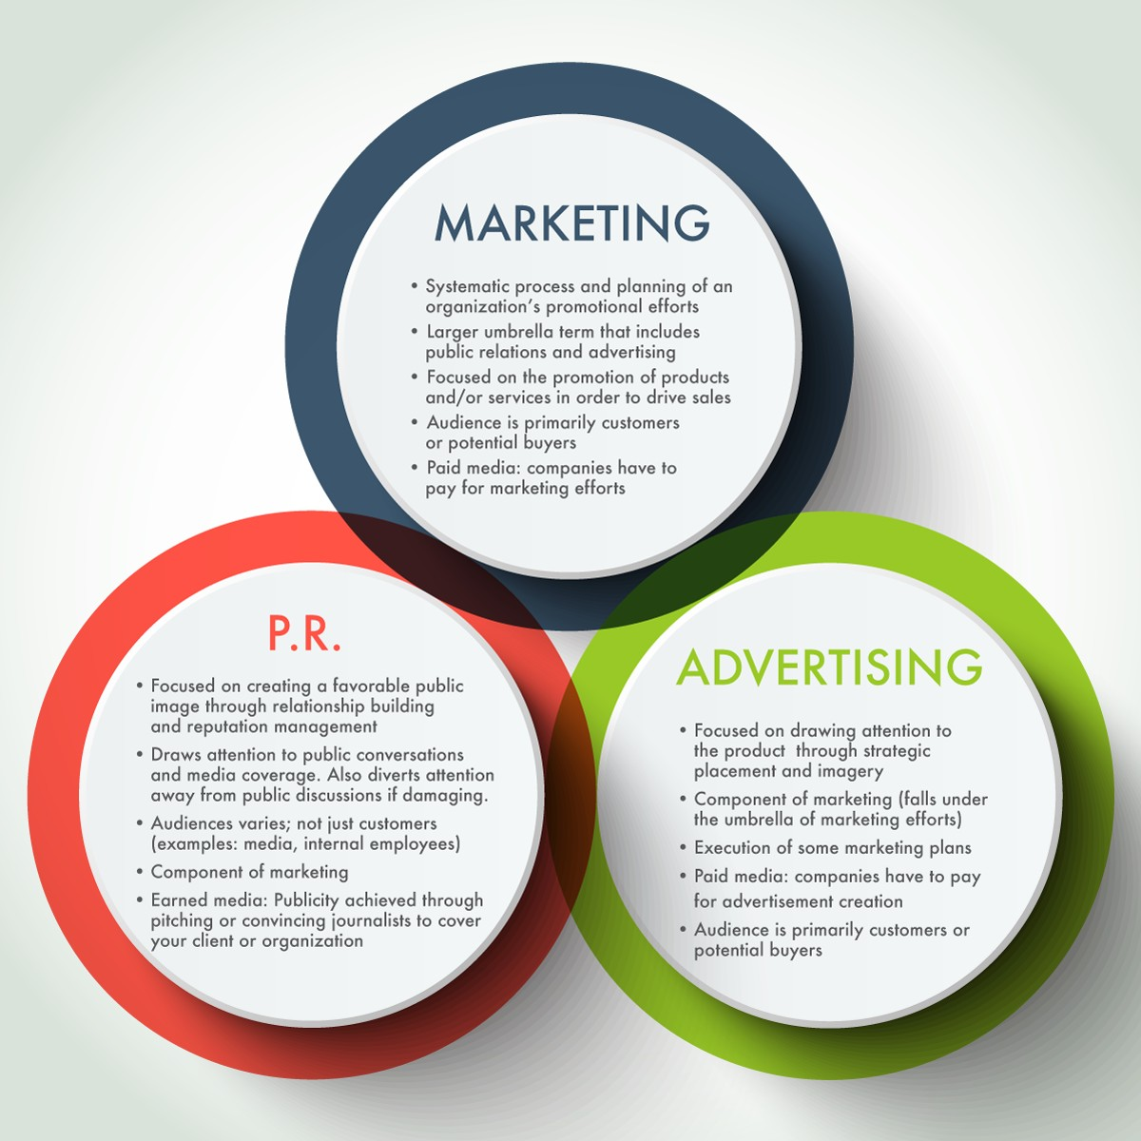[The differences and relationships among marketing, public relations, and advertising](https://ohiostate.pressbooks.pub/stratcommwriting/chapter/public-relations-vs-marketing-vs-advertising/), by Jasmine Roberts and Michael Shiflet is licensed under [CC BY 2.0](https://creativecommons.org/licenses/by/2.0/).

Clarifiers about the Venn Diagram:

### **Marketing**

* Systematic process and planning of an organization’s promotional efforts
* Focused on the promotion of products and/or services in order to drive sales
* Audience is primarily customers or potential buyers
* Paid media: companies have to pay for marketing efforts
* Often works in tandem with public relations and advertising

## Public Relations

* Focused on creating a favorable public image with stakeholders through relationship building and reputation management
* Audiences are not just customers, both other stakeholders like community members, investors, employees and public officials
* Not a component of marketing, but works with marketing
* Earned media: Publicity achieved through pitching or convincing journalists to cover your client or organization
* Assists with risk and crisis management planning and messaging

## Advertising

* Focused on drawing attention to the product through strategic placement and imagery
* Not a component of marketing, but works with marketing
* Paid media: companies have to pay for advertisement creation
* Audience is primarily customers or potential buyers

# The importance of stakeholders

Public relations is the practice of managing the flow of information between an individual or an organization and the public.  To be more accurate, most public relations doesn’t focus on reaching out to an amorphous “public” — instead it attempts to reach various groups who have specific connections to the public relations client. These various groups are known as “stakeholders.”  Public relations, then, works within an ecology (or an interconnected system) of stakeholders with the aim of persuading these differing audiences (e.g. investors, employees, shareholders) to maintain or adjust their beliefs, predispositions and/or actions in ways that can attain mutual benefits.

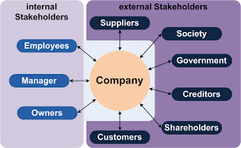

Public Relations operates within an ecology of stakeholders. “[Stakeholder](https://commons.wikimedia.org/wiki/File:Stakeholder_(en).png)” by Grochim is licensed under [CC BY-SA 3.0](https://creativecommons.org/licenses/by-sa/3.0/deed.en).

**Four models of public relations**

Grunig and Hunt (1984) developed four models of public relations that describe the field’s various management and organizational practices. These models are good reference points for public relations practitioners as they create programs, strategies, and tactics.  Public relations activities often flow back and forth among these four models.

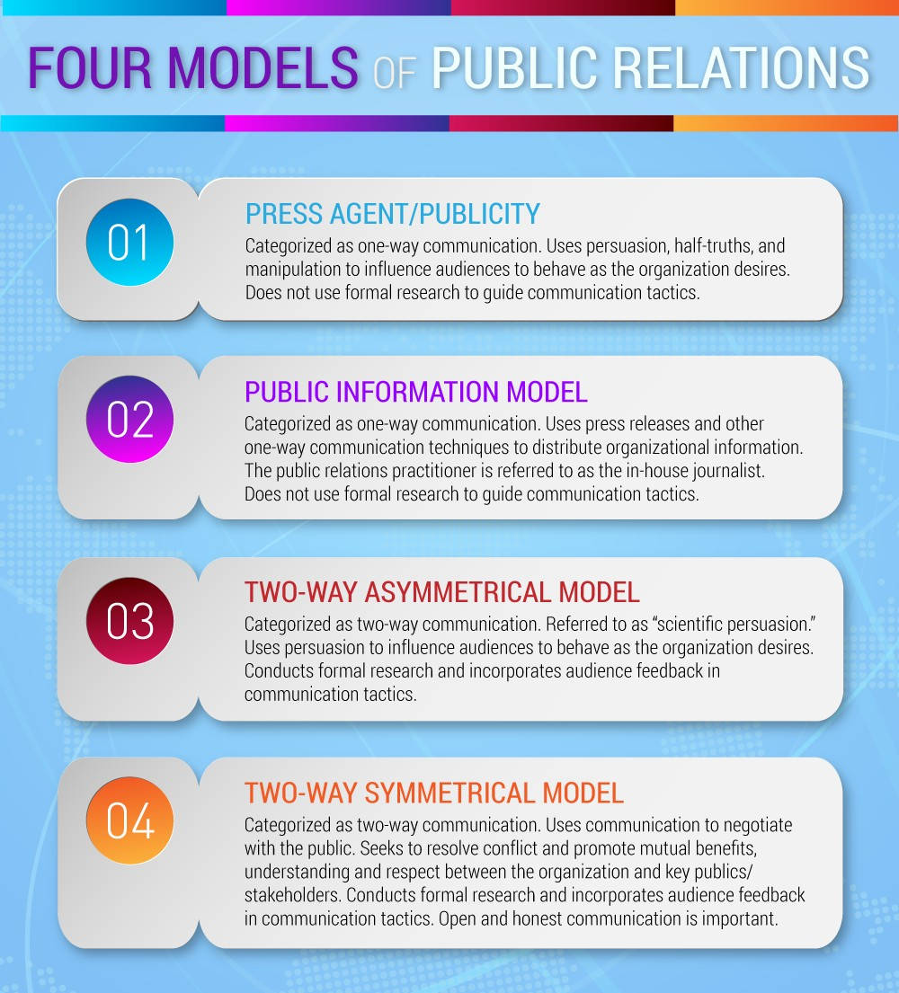

“[Four Models of PR](https://ohiostate.pressbooks.pub/stratcommwriting/chapter/public-relations-vs-marketing-vs-advertising/)” by Michael Shiflet and Jasmine Roberts is licensed under [CC BY 2.0](http://creativecommons.org/licenses/by/2.0/)

In the **press agent/publicity model**, communications professionals use persuasion to shape the thoughts and opinions of key audiences. In this model, achieving awareness is more important than complete accuracy, and organizations do not seek audience feedback or conduct audience analysis research. It is a one-way form of communication. One example would be a public relations campaign to help advance the sale of concert tickets for a celebrity musician’s comeback tour.

The **public information model** moves away from the hype tactics used in the press agent model and presents more accurate information. However, the communication pattern is still one-way. Practitioners do not conduct audience analysis research to guide their strategies and tactics. Some press releases and newsletters are created based on this model, when audiences are not necessarily targeted or researched beforehand. Another example of this model is the one-way communication that a government office uses, in the midst of a pandemic, to inform and instruct members of a community about how to lower their risks of contracting a deadly virus.

The **two-way asymmetrical model**  features public relations professionals conducting research to better understand the various audiences’ attitudes and behaviors which, in turn, informs the message strategy and creation. Still, persuasive communication is used in this model to benefit the organization more so than audiences; therefore, it is considered asymmetrical or unbalanced.  An example of this is a rideshare company researching how various demographics uses their service so that they can make adjustments and improvements and then sending out messages to those various demographics about these adjustments.

Finally, the **two-way symmetrical model** argues that the public relations practitioner should serve as a liaison between the organization and key publics, rather than serving solely as a persuader. Here, practitioners are negotiators/facilitators and use communication to ensure that all involved parties benefit, not just the organization that employs the public relations professional. The term “symmetrical” is used because the model attempts to create a mutually beneficial situation. The two-way symmetrical model is deemed the most ethical model, one that professionals should aspire to use in their everyday tactics and strategies (Simpson, 2014). An example of this would be a fast-fashion company that seeks out feedback from their audiences about what changes they need to make to be more environmentally friendly (e.g., enhancing the durability of their products, using less natural resources to create their products). The company’s adjustments would be communicated to the audiences with the intent of getting more feedback and making additional changes to their business model.

# **General roles in public relations**

According to Smith (2014), public relations practitioners can be placed in two groups based on responsibilities: communication managers and communication technicians. Communication managers assist in the strategic planning of an organization’s communication efforts. The broad term “communication manager” includes several similar public relations positions: expert prescriber, communication facilitator, and problem-solving facilitator (Broom & Sha, 2013).  Problem-solving facilitators provide crisis management to an organization during an obstacle. Liaisons speak on behalf of the brand and facilitate communication between the organization and its key publics.

Before entering a managerial role, most public relations practitioners begin their career as a **communication technician**. This can refer to a variety of entry-level positions, including public relations specialist, communication assistant, and junior account executive. Communication technicians write press releases, pitches, feature articles, and other communication materials and assist in event planning.

**Expert prescribers** do more with strategic planning than communication technicians. They are seen as an authority on public relations and develop specific communication plans and roll out tactics to help achieve organizational goals.  Because management perceives       this role as “owning” public relations, practitioners in this role need to be aware that a particular downside of this role is that other managers and workers in the organization may not see the roles they play in advancing good relations with stakeholders.  Instead, public   relations concerns and approaches can be simply routed to the expert prescriber, off-loading the wider public relations responsibilities to the expert prescriber.

**The communication facilitator** role focuses on serving as a broker between the PR client and its audiences. This role is more about the exchange of information between the organization and its audiences.  This role is not primarily focused on problem-solving but on facilitating the exchange of ideas and information.

**Problem-solving facilitators** are part of the “C” suite planning team.  They consult management on the nature of the problem and how to approach it in ways that help advance the organization’s goals while also addressing the attitudes and needs of the stakeholders. This role is often filled by senior public relations people.

Together, communication managers and technicians play a vital role in relationship building. They are all vitally  important and a public relations professional, over the course of their career, will likely advance from communication technician to problem-solving facilitator. However, even a senior public relations person will often fufill the other roles at various times. It’s not unusual to see a senior practitioner help in problem-solving planning, and then move into helping write a part of the annual report (communication technician) or lead a focus group (communication facilitator).

# **PR functions**

Either private PR companies or in-house communications staffers or PR firms carry out PR functions. A PR group generally handles all aspects of an organization’s or individual’s media presence, including company publications and press releases. Such a group can range from just one person to dozens of employees, depending on the size and scope of the organization. The chart below shows most of the key roles that PR people carry out (with the surprising omission of risk and crisis communication).

Public Relations’ Components and Roles

| Components of Public Relations | Explanations of Role |
| --- | --- |
| Counseling | Providing advice to management concerning policies, relationships, and communications |
| Research | Determining the attitudes and behaviors of groups to plan public relations strategies. Such research can be used to generate mutual understanding or influence and persuade publics. |
| Media Relations | Working with mass media (television, web sites, newspapers, magazines, and the like) by seeking publicity or responding to their interests in the organization. |
| Publicity | Disseminating planned messages through selected  media to further an organization’s interests. |
| Employee Member Relations | Responding to concerns, informing, and motivating and organization’s current employees or members. |
| Community Relations | Undertaking activities within a community to maintain an environment that benefits both an organization and the community . |
| Public Affairs | Developing effective involvement in public policy and helping an organization adapt to public expectations. The term “public affairs” is also used by government agencies to describe their public relations activities and by many corporations as an umbrella term to describe multiple public relation activities. |
| Government Affairs | Relating directly with legislatures and regulatory agencies on behalf of an organization. Lobbying can be part of a government affairs program. |
| Issue Management | Identifying and addressing issues of public concern that affect an organization. |
| Financial Relations | Creating and maintaining investor confidence and building good relationships with financial community. |
| Industry Relations | Relating with other firms in the industry of an organization and with trade associations. |
| Development/Fund-Raising | Demonstrating the need for and encouraging the public support charitable organization primarily through financial contributions. |
| Multicultural Relations/Workplace Diversity | Communicating with individuals and groups in various cultural groups. |
| Special Events | Stimulating an interest in a person, product, or organization by means of focused “happenings” as well as other activities designed to encourage interacting with publics and listening to them. |
| Marketing Communications | Employing a combination of activities, designed to sell a product, service, or idea, including advertising, collateral materials, publicity, promotions, direct mail, trade shows, and special events. |

# Anatomy of a public relations campaign

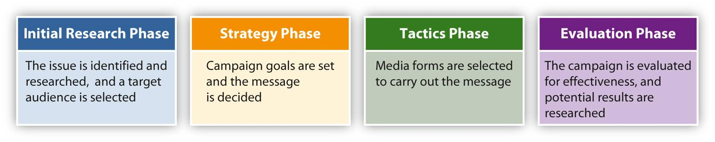

Not everything in public relations is about campaigns.  Sometimes public relations people put out important announcements about breaking news (e.g., the appointment of a new CEO) or help management find out what employees and stakeholders are thinking about through focus groups, interviews, and management by walking around (walking the workroom floor to see what is happening or visiting with news media contacts).

However, it is important to understand the dynamics of a public relations campaign because a) it will sharpen your thinking about how public relations makes a difference for clients and b) it will prepare you to take on the larger inter-connected components that more senior public relations people need to manage.

PR campaigns occur for any number of reasons. They can be a quick response to a crisis or emerging issue, or they can stem from a long-term strategy tied in with other marketing efforts. Regardless of its purpose, a typical campaign often involves four phases.

## **Research phase**

The first step of many PR campaigns is the initial research phase. First, practitioners identify and qualify the issue to be addressed. Then, they research the organization itself to clarify issues of public perception, positioning, and internal dynamics. Strategists can also research the potential audiences of the campaign. These audiences may include media outlets, constituents, consumers, and competitors. Finally, the context of the campaign is often researched, including the possible consequences of the campaign and the potential effects on the organization. After considering all of these factors, practitioners are better educated to select the best type of campaign.

## Action Planning (or “strategy”) phase

During the action planning phase, PR professionals usually determine objectives (both quantitative and qualitative) focused on the desired goals of the campaign and formulate strategies to meet those objectives. Broad strategies such as deciding on the overall message of a campaign and the best way to communicate the message can be finalized at this time. In essence, the action planning phase is about determining what themes need to be communicated to what audiences. This phase of the campaign may be the most challenging as it requires empathy regarding what audiences care about and then figuring out what kind of thematic messaging can connect/resonate with the different audiences.

## Communication (or “tactics”) phase

During the communications phase, the PR team decides on the tactics to implement the strategies they formulated during the action planning phase. This process can involve devising specific communication techniques and selecting the forms of media that suit the message best.

## Evaluation phase

This phase involves capturing the objectives (or outcome) data that were established in the action planning phase with an eye toward assessing how well the public relations campaign helped the client achieve their objectives.

# Public relations and risk and crisis management



“[Extra Strength Tylenol and Tylenol PM](https://commons.wikimedia.org/wiki/File:Extra_Strength_Tylenol_and_Tylenol_PM.jpg)” by [Ragesoss](https://commons.wikimedia.org/wiki/User:Ragesoss) is licensed under [CC BY-SA 4.0](https://creativecommons.org/licenses/by-sa/4.0/)..

As mentioned at the start of this chapter, the general public is often aware of public relations through its efforts to manage risk and crisis. Although it is beyond the scope of this book, it is important to understand a few important elements of this part of public relations.

In 1982, Johnson & Johnson’s Tylenol medication commanded 35% of the US over-the-counter analgesic [market](http://oer2go.org/mods/en-boundless/www.boundless.com/marketing/definition/market/index.html) and represented 15% of the company’s [profits](http://oer2go.org/mods/en-boundless/www.boundless.com/marketing/definition/profit/index.html). Unfortunately, one individual succeeded in lacing the drug with cyanide. Seven people died as a result, so a panic ensued about how widespread the contamination might be. By the end of the episode, everyone knew that Tylenol was associated with the scare. The company’s market [value](http://oer2go.org/mods/en-boundless/www.boundless.com/marketing/definition/value/index.html) fell by $1 billion as a result. When the same situation happened again in 1986, the company had learned its lesson. It quickly ordered that Tylenol be recalled from every [outlet](http://oer2go.org/mods/en-boundless/www.boundless.com/marketing/definition/outlet/index.html), not just those in the state where it had been tampered with. The company also decided that the [product](http://oer2go.org/mods/en-boundless/www.boundless.com/marketing/definition/product/index.html) would not be re-established on the shelves until something had been done to provide better product protection. As a result, Johnson & Johnson developed the tamperproof packaging that would make it much more difficult for a similar incident to occur in the future.

The best way to build good PR is to carefully maintain a good reputation over time and to avoid behaviors as an individual, company or corporation that might harm others. In other words, avoid actions that present undue risk to the organization and its stakeholders. At a basic level, prevention against bad PR calls on your organization to follow your industry’s ethical codes and you to follow the ethical codes of public relations (the Public Relations Society of America provide an excellent set of codes for the PR profession). Even if you and your organization do this, you might face a crisis. For example, a politician might decide to target your brand regardless of whether your business practices are ethical.

The first rule of crisis communications is to plan ahead by anticipating the kinds of problems your company might have. Chemical companies should prepare for chemical spills. Sports teams will probably not prepare for environmental disasters, but they may have to prepare for the social media scandals that players sometimes land themselves in. If there is a disaster, the advice is to [“be truthful and transparent,”](https://www.forbes.com/sites/theyec/2013/06/20/the-3-ts-of-a-great-pr-experience-truth-trust-and-transparency/#55043cd74c1d) to not say too much, and to correct any exaggerations that emerge in the news media and on social media, within reason. The major, overarching goals of PR efforts during a crisis is to fix the problem, do better, and, in the process, help people forget there ever was a crisis.

Journalists often have the opposite interest because reporting on conflict is interesting. Helping people to survive is one of the primary functions of journalism. This explains why negative news gets so much more attention than positive news. No one dies when people do their jobs salting the roads and drivers maneuver safely in snowstorms. When people crash, that, sadly, is news. Journalists know that people care about safety perhaps more than any other issue, so they focus on safety concerns during times of crisis. At these times, PR and journalism can be at odds, but truth and transparency are still advisable to the PR professional. You do not legally have to tell journalists everything that has happened (and, in fact, there may be legal reasons to not tell everything you know about the crisis) but if journalists discover a negative impact that you failed to disclose, they will wonder what else you are hiding, and they may give your critics and detractors extra consideration and attention.

In any emergency situation, it is imperative that a company put the public interest ahead of the organization’s interest. The company’s first responsibility is to the safety and well-being of the people involved. Once safety has been restored, the company needs to face the public and face the facts. The company should never try to minimize a serious problem or “smooth it over” in the hope that no one will notice. Conversely, don’t blow minor incidents out of proportion or allow others to do so. [Social media](http://oer2go.org/mods/en-boundless/www.boundless.com/marketing/definition/social-media/index.html) has accelerated the speed at which information about a crisis can spread; the viral affect of [social networks](http://oer2go.org/mods/en-boundless/www.boundless.com/marketing/definition/social-network/index.html) such as Twitter means that [stakeholders](http://oer2go.org/mods/en-boundless/www.boundless.com/marketing/definition/stakeholders/index.html) can break news faster than traditional media, which makes managing a crisis harder. However, a company should not speculate; if they don’t know the facts, they should say so and promise to get back to the media as soon as possible.

Finally, in PR there is the need to learn from mistakes and to analyze a company or corporation’s crisis responses. As difficult as it might be to go back and discuss where communication failed, it is essential. Reflection is a critical step in learning and corporations are like any other social institution. They need to learn to survive and to thrive.

Ultimately, one of the core lessons of risk and crisis management is this: you and your organization don’t determine if a risk has elevated into a crisis — your stakeholders do.

Public relations and branding



“[Public Relations NYPD Style](https://search.creativecommons.org/photos/b63583fe-6ae6-4786-919f-bddb4b564f30)” by [Dave Hamster](https://www.flickr.com/photos/14265068@N00) is licensed under [CC BY 2.0](https://creativecommons.org/licenses/by/2.0/).

Pioneered by such companies as Procter & Gamble during the 1930s, the older, advertising-centric model of branding focused on the product, using advertisements to associate a particular branded good with quality or some other positive cultural value. Yet, as consumers became exposed to ever-increasing numbers of advertisements, traditional advertising’s effectiveness dwindled. The ubiquity of modern advertising means the public is skeptical of—or even ignores—claims advertisers make about their products. This credibility gap can be overcome, however, when PR professionals using good promotional strategies step in.

The new PR-oriented model of branding focuses on the overall image of the company rather than on the specific merits of the product (see the NYPD’s outreach bus, at right). This branding model seeks to associate an organization or company with specific personal and cultural values that hold meaning for consumers. In the early 1990s, for example, car company Saturn marketed its automobiles not as a means of transportation but as a form of culture. PR campaigns promoted the image of the Saturn family, associating the company with powerful American values and giving Saturn owners a sense of community. Events such as the 1994 Saturn homecoming sought to encourage this sense of belonging. Some 45,000 people turned out for this event; families gave up their beach holidays simply to come to a Saturn manufacturing plant in Tennessee to socialize with other Saturn owners and tour the facility.

Toyota faced a crisis when it instituted a massive recall based on safety issues. To counter the bad press, the company launched a series of commercials featuring top Toyota executives, urging the public to keep their faith in the brand (Bernstein, 2010). Toyota used a style of self-awareness to market its automobiles. The positive PR campaign presented Toyotas as cars with a high standard of excellence, backed by a company striving to meet customers’ needs.

## Branding backlashes (or, be true to who you are)

An important part of maintaining a consistent brand is preserving the emotional attachment consumers have to that brand. Just as PR campaigns build brands, PR crises can damage them. For example, the massive Gulf of Mexico oil spill in 2010 became a PR nightmare for BP, an oil company that had been using PR to rebrand itself as an environmentally friendly energy company.

In 2000, BP began a campaign presenting itself as “Beyond Petroleum,” rather than British Petroleum, the company’s original name. By acquiring a major solar company, BP became the world leader in solar production and in 2005 announced it would invest $8 billion in alternative energy over the following 10 years. BP’s marketing firm developed a PR campaign that, at least on the surface, emulated the forward-looking, two-way symmetric PR model. The campaign conducted interviews with consumers, giving them an opportunity to air their grievances and publicize energy policy issues. BP’s website featured a carbon footprint calculator consumers could use to calculate the size of their environmental impact (Solman, 2008). The single explosion on BP’s deep-water oil rig in the Gulf of Mexico essentially nullified the PR work of the previous 10 years, immediately putting BP at the bottom of the list of environmentally concerned companies.

A company’s control over what its brand symbolizes can also lead to branding issues. The Body Shop, a cosmetics company that gained popularity during the 1980s and early 1990s, used PR to build its image as a company that created natural products and took a stand on issues of corporate ethics. The company teamed up with Greenpeace and other environmental groups to promote green issues and increase its natural image.

By the mid-1990s, however, revelations about the unethical treatment of franchise owners called this image into serious question. The Body Shop had spent a great deal of time and money creating its progressive, spontaneous image. Stories of travels to exotic locations to research and develop cosmetics were completely fabricated, as was the company’s reputation for charitable contributions. Even the origins of the company had been made up as a PR tool: The idea, name, and even product list had been ripped off from a small California chain called the Body Shop that was later given a settlement to keep quiet. The PR campaign of the Body Shop made it one of the great success stories of the early 1990s, but the unfounded nature of its PR claims undermined its image dramatically. Competitor L’Oréal eventually bought the Body Shop for a fraction of its previous value (Entine, 2007).

Branding as a part of public relations

That so many different groups have adopted branding as a means of communication is a testament to its ubiquity. Even anticommercial, antibrand groups such as Adbusters have created brands to send messages. Social media sites have also encouraged branding techniques by allowing users to create profiles of themselves that they use to communicate their core values. This personal application is perhaps the greatest evidence of the impact of PR on modern culture. Branding, once a technique used by companies to sell their products, has become an everyday means of communication.

Branding focuses on the lifestyles and values inherent in a brand’s image as opposed to the products that are manufactured. Ultimately, however, public relations is about more than branding. This is because branding is always associated with a performative element; it is concerned with how well a product or service connect with the values, attitudes, and lifestyles of key audience. Public relations certainly addresses these elements, but it encompasses more.  Public relations works to help clients adjust their policies, organizational culture and their mission/goals so that they come into some degree of alignment with the concerns and ambitions of key publics.

# References

Broom, G. & Sha, B-L. (2013) *Effective Public Relations* (11th edition). New York: Pearson.

Grunig, J. & Hunt, T. (1984). *Managing Public Relations*. New York: Holt, Rhinehart and Winston.

Smith, R. (2013). *Public Relations: The Basics*. New York: Routledge

# Image Attribution

[“The differences and relationships among marketing, public relations, and advertising”](https://ohiostate.pressbooks.pub/stratcommwriting/chapter/public-relations-vs-marketing-vs-advertising/), by Jasmine Roberts and Michael Shiflet is licensed under [CC BY 2.0](https://creativecommons.org/licenses/by/2.0/).

“[Stakeholder](https://commons.wikimedia.org/wiki/File:Stakeholder_(en).png)” by Grochim is licensed under [CC BY-SA 3.0](https://creativecommons.org/licenses/by-sa/3.0/deed.en).

“[Four Models of PR](https://ohiostate.pressbooks.pub/stratcommwriting/chapter/public-relations-vs-marketing-vs-advertising/)” by Michael Shiflet and Jasmine Roberts is licensed under [CC BY 2.0](http://creativecommons.org/licenses/by/2.0/).

“[Extra Strength Tylenol and Tylenol PM](https://commons.wikimedia.org/wiki/File:Extra_Strength_Tylenol_and_Tylenol_PM.jpg)” by [Ragesoss](https://commons.wikimedia.org/wiki/User:Ragesoss) is licensed under [CC BY-SA 4.0](https://creativecommons.org/licenses/by-sa/4.0/).

“[Public Relations NYPD Style](https://search.creativecommons.org/photos/b63583fe-6ae6-4786-919f-bddb4b564f30)” by [Dave Hamster](https://www.flickr.com/photos/14265068@N00) is licensed under [CC BY 2.0](https://creativecommons.org/licenses/by/2.0/).

2

## Chapter 2 -- Research

The first step of many PR campaigns is the initial research phase. First, practitioners identify and qualify the issue to be addressed. Then, they research the organization itself to clarify issues of public perception, positioning, and internal dynamics. This part is key to beginning any public relations campaign as it allows you to 1) determine what is the current state of the client and where it wants to be and 2) what are the needs and concerns of the client’s distinct stakeholder groups.  These groups (also known as “audiences”) may include media outlets, constituents, consumers, and competitors. Finally, the context of the campaign is often researched, including the possible consequences of the campaign and the potential effects on the organization and its audiences. After considering all of these factors, practitioners are better educated to select the best type of campaign (e.g., issues advocacy, brand positioning, risk and crisis management).

**Why do clients resist research?**

It’s important to realize that clients may exhibit a resistance to doing upfront research before starting a campaign. In many ways this is reflective of the culture of capitalism, especially in the US, which equates time with money and also is focused on an anticipated return of investment at the outset of discussions of strategic imperatives.  The author of this book (St. John) once visited a Fortune 500 company in St. Louis on an information interview. When he walked into the Marketing and Communication Director’s office, after a few moments of pleasant small talk, this director asked St. John, “So, how many projects do you work on in any average month?”

St. John paused, then said, “Well, outside of routine public relations smaller items–like sending out a news release or helping polish a speech, I have two major clients and I work on about 5-7 projects in total between them.”

The director leaned back in his seat and said, “About 5-7 projects, eh?” He paused and then pointed his thumb back to the cubicles behind him. “I’ve got people working on about 60 projects a month.”

From that example, it’s clear that corporate America has tended to prize activity over, for example, up front research. However, if you internalize that, before starting any public relations campaign one needs to do research, you will likely distinguish yourself from those subsumed in activity after activity.  Clients pay for results, not activities.

Some of the reasons that clients will not support research

* It’s not in the budget.
* We don’t have enough time for it.
* We’re not going to evaluate the campaign, so why bother doing upfront research either?
* We don’t pay you for research, we pay you to get things done.
* Let’s see how things go this time and, if everything works out OK, then we can do research next time.
* We don’t have the right people to do the research.
* We have the right people, but they are busy on other tasks and project.

### **Real State/Ideal State Analysis**

Let’s imagine that your boss sends the following text: “Our client (a major wealth advisor firm) is interested in exploring bitcoin and perhaps doing a special event about his company can move into this area. See what you can find out.” How do you even start?  Before you can begin to understand the specifics of the research task itself, you need further clarification about the client’s expectations.

A real state/ideal state analysis will better position both you and the client for deciding what kind of public relations campaign the client may benefit from. It features a *problem statement* (Broom & Sha, 2013) that addresses the following components:

* It is written in the present tense. It describes the current situation without going into any suggestions about what could or should be done.
* It points out what is the source of the concern.
* It points to where the problem is most visible.
* It indicates when the problem occurs.  
    
    
  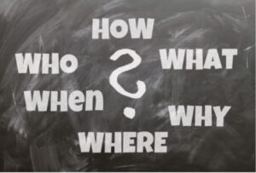[Untitled](https://pixabay.com/illustrations/board-ask-who-what-how-why-where-776688/) by Geralt is licensed under [CC0.](https://creativecommons.org/share-your-work/public-domain/cc0/)
* It describes who is involved or affected
* It clearly states why this is a concern, both for the client and its stakeholders.

The ideal state then logically comes out of the factors identified in the real state analysis. That is, it should be written as in depth as necessary to draw a picture of what, ideally, the client would like to happen after the public relations campaign has been completed.

Here is how the real state/ideal state could appear regarding the bitcoin example above.

*Town Square Wealth Advisors firm and the increasing interest in bitcoin*

Real state: The firm is facing increasing inquiries over the last three months from high net-worth individuals (i.e., $1 million and above) who, when U.S. market indicies go down, are indicating they may wish to transfers some their assests into bitcoin. However, many of these investors indicate that 1) the firm is not educating investors on the pro and cons of such an investment and 2) does not partner with financial firms who are reputable in bitcoin investments. Several of our clients have indicated that this is making them re-think keeping their holdings in Town Square as they are concerned that the firm is “behind the times” and missing out on new sources of potentially high returns.

Ideal state: The firm has kept its current client base and is well-positioned to grow it number of clients because 1) it is seen as a trusted educational source on the risks and benefits of bitcoin investments and 2) it has established well-functioning working relationships with reputable firms who have a wide range of bitcoin investments. Customers, with a better education base, are doing bitcoin transactions through our firm partnership and are satisified with our knowledge and responsiveness.

### **Research modes**

There are two main types of research modes: *quantitative (or formal) research* and *qualitative (or informal) research*.  Quantitative research focuses on gathering data in numerical formats so that progress can be clearly delineated over time.



“[Analyzing Financial Data](https://www.flickr.com/photos/davedugdale/5099605109)” by Dave Dugdale is licensed under [CC BY-SA 2.0.](https://creativecommons.org/licenses/by-sa/2.0/)

In that way, it tests propositions and provides valuable descriptive markers.  In contrast, qualitative research examines how people make sense of phenomena; it too is descriptive, but concentrates on providing narratives about perspectives, values, and beliefs.

There is also another aspect of research gathering: *primary* and *secondary*.  Primary data is information (whether quantitative or qualitative) that has been directly gathered through, for example, retail sales, surveys, focus groups and interviews. Secondary data may be similar types of information, but it has been gathered and presented by others (e.g., an opinion survey from Pew Research, news stories on how consumers rate your newest products).

Types of quantitative research

* **Social media metrics**: tracking and assigning numerical values to level of activities, followers and interactions.
* **Content analysis**:  tracking and assigning numerical values to text and associated imagery and where/how the content appears. This involves training coders using a coding book; usually agreement between the coders of about 80 percent is required for validity of the results. This process does NOT code for audience attention or retention of the content.
* **Surveys:** these are queries of audiences who are subsets of a wider population.  To be valid, samplings within this wider population must be randomized–that is, everyone within a subset population must have an equal probablity of being asked to participate in the doing the survey.  Surveys can beadministered through email, traditional mail or via the phone. Online surveys can be conducted in a way that is randomized, but careful thought must be taken to make sure they are truly randomized.
* **Databanks:** organizations and governments track large sets of data. For example, for-profit organizations may track retails sales, numbers of customer inquiries and customer traffic in a bricks and motor store. Governments tracks traffic patterns, demographics and labor output.

Types of qualitative research

* “[Food Innovation 1](https://live.staticflickr.com/4116/4950542571_2e0942998c.jpg)” by [Penn State](https://www.flickr.com/photos/pennstatelive) is licensed under [CC BY-NC 2.0](https://creativecommons.org/licenses/by-nc/2.0/).  
  **Personal observation**: this simply involves doing direct observations.  For example, you may want to visit with customers and/or employees in your workplace. This is often referred to as “Management by Walking Around.” This approach allows you to see directly what is happening and how people talk about it.  This also includes going to community meetings and trade association events, or even visiting with stakeholders where it is most convenient to them.
* **Focus groups**: this approach calls for bringing about 6-12 people together to get their impressions about a subject, issue, product, or service. Focus groups normally involve one facilitator who helps lead the discussion and another person who captures the threadlines of the participants’ observations.
* **Key informants and one-on-one interviews**: this approach is less formalized than the focus group; this often involves finding out the perspectives of opinion leaders like mentors, civic leaders, academics, social movement leaders and clergy. Such meetings can be one-on-one, or in small groups.  This approach, however, normally works best when the information gathering is done through one-on-one interviews
* **Community forums:** consider these to be like a focus group on steroids. Normally, the number of people can be much higher than the 12 maximum for a focus group. This is because the attendees at a forum, unlike those at a focus group, may already be well versed on the subject to be discussed and are motivated to approach the matter in a particular way.  Thiink of town hall meetings where a client may be seeking info on, for example, where to locate a new facility.
* **Advisory committees**: unlike a focus group, advisory committees consist of interested and motivated community members who see that they have direct stake in your organization. They operate as an advise and consult group; organizations may choose to use this forum to share ideas about new products and services or to ask committee members to provide ideas about solutions to problems both internal and external to the organization.
* **Call-in telephone lines:** these are normally toll-free and can be offered to customers in a more passive way (e.g., the number is offered as a customer service line, and is often printed on the packaging of the product) or can be offered in a more high-profile way (e.g., a server points out the number on your restaurant receipt, or you see a “How’s my driving?” sign on the back of a delivery vehicle, with the phone number clearly displayed.  
    
    
  One-on-one interviews are a valuable qualitative research approach. “[Job Interview](https://pixabay.com/photos/job-interview-colleagues-business-437026/)” is licensed under a [Pixabay license](https://pixabay.com/service/license/).
* **Thematic analysis:** as opposed to content analysis, this approach calls for tracking major thematic elements that appear in the information you have gathered. Rather than counting the appearances of certain items, this approach calls for segmenting information into various “buckets” (e.g., researching a company newsletter for over a four-year span has found that three major themes covered have been: 1) financial responsiblity, 2) employee commitment and 3) customer satisfaction).  The buckets of information are then analyzed for thematic insights.
* **Field reports:** this approach is similar to “Management by Walking Around,” but it calls for a more structured approach. For example, field managers can observe processes/procedures/norms in a workplace and then draft a formal report. This approach should be paired with one of the others above, particularly quantiative approaches like surveys or databanks, as field reports can tend to be written with overly positive or negative observations with an eye to getting the client to react a certain way.

### Positioning research for action planning

The research or “R” element of the RACE approach calls on careful real state/ideal state analysis at the front end. This is not a “nice to do” but a “must do.”  Using the real

state/ideal state approach will position you and your client to better understand context and content. As the information strategy model shows, you can then pursue finding research materials through *insitutional*, *scholarly*, *journalistic*, and *informal*

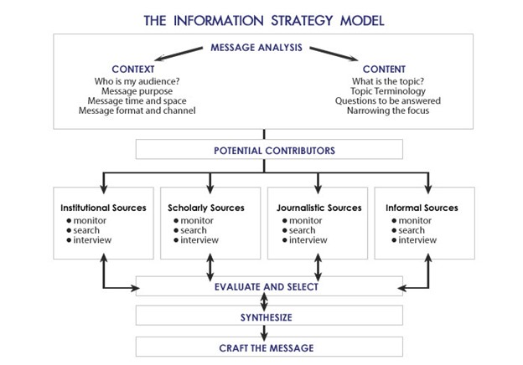

The Information Strategy Model provides clarity about how the Research element leads up to the Action Planning element. “[The Information Strategy Model](https://open.lib.umn.edu/app/uploads/sites/174/2015/08/Info-Model.png)” by [Hansen & Paul](https://open.lib.umn.edu/infostrategies/) is licensed under [CC BY 4.0.](https://creativecommons.org/licenses/by/4.0/)

sources. Depending on your client’s situation, you may pull from only one of these source areas, or a combination of these sources. It is then vitally important to carefully *evaluate* the information you receive from among these sources, then *select* the most important research material to help you *synthesize* for the client what is happening. Finally, you move into *crafting* *the* *message* and then working with your client to take that message and develop strategies.  This sequence of steps logically leads you to Action Planning, or the “A” element of RACE, which is the subject of Chapter 3.

# References

Broom, G. & Sha, B-L. (2013) *Effective Public Relations* (11th edition). New York: Pearson

### **Image Attribution**

[Untitled](https://pixabay.com/illustrations/board-ask-who-what-how-why-where-776688/) by Geralt is licensed under [CC0.](https://creativecommons.org/share-your-work/public-domain/cc0/)

“[Analyzing Financial Data](https://www.flickr.com/photos/davedugdale/5099605109)” by Dave Dugdale is licensed under [CC BY-SA 2.0.](https://creativecommons.org/licenses/by-sa/2.0/)

[“Food Innovation 1](https://live.staticflickr.com/4116/4950542571_2e0942998c.jpg)” by [Penn State](https://www.flickr.com/photos/pennstatelive) is licensed under [CC BY-NC 2.0](https://creativecommons.org/licenses/by-nc/2.0/).

“[Job Interview](https://pixabay.com/photos/job-interview-colleagues-business-437026/)” is licensed under a [Pixabay license](https://pixabay.com/service/license/).

[“The Information Strategy Model](https://open.lib.umn.edu/app/uploads/sites/174/2015/08/Info-Model.png)” by [Hansen & Paul](https://open.lib.umn.edu/infostrategies/) is licensed under [CC BY 4.0.](https://creativecommons.org/licenses/by/4.0/)

3

## Chapter 3 -- Action Planning

Action Planning sometimes proves to be one of the hardest elements of the RACE approach.  In fact, during the Enron crisis of the early 2000s, prominent public relations practitioner Frasier Seitel was once asked a public relations conference about the lack of good public relations consulting for senior management at Enron.  Without hesitation, Seitel responded that it was not exactly a surprise that Enron was is an ongoing crisis mode.  “Frankly,” he said, “Too many senior public relations people, like at Enron make it to the upper levels of their organizations by telling their CEOS and Chief Operating Officers what they want to hear.” Seitel’s point was that this ability to ingratiate oneself with upper management does not necessarily correlate with the ability to do strategic planning and advising for a client.

The action planning element, therefore, does not come naturally for many in public relations.  It is not, however, some magic formula that is difficult to understand and then put in place. To the contrary, it is a vital part of the RACE process because it is fundamental to making linkages between and organization and its stakeholders. It involves these essential elements:

* Clearly stating the organization’s goal(s).
* Developing quantifiable objective statements to help realize those goals.
* Identifying key stakeholder groups and clearly stating a message for each group.

### Goals

Goals are statements of intent; the real state/ideal state approach shown in Chapter 2 can help the client solidify where it wants to be. Here are some examples of goal statements:

“By the end of next year, we will be seen as the number one provider of smoking-cessation devices in the U.S.”

“Within two years, our non-profit will be seen as the preferred location for housing families who are escaping domestic violence.”

“Our intent is to have our slate of diverse, progressive entertainment offerings become a leading source of artistic discourse and creation.”

From these examples, it’s clear that goal statements point to where a client wants to be, normally within a specific period of time. Note that goal statements do NOT have specific measureables; such indicators appear within objective statements.

### Objective statements

These statements are informed by the overarching goals of the organization. However, they offer more specificity by pointing to specific deliverables, or outcomes, that the public relations plan attempts to reach.  Every objective statement should point to one clear deliverable and indicate what is the timeframe for reaching that outcome. Here’s an example of how objective statements can be developed from the goal statement:

Goal Statement: Chipotle’s wants to be a market leader in fast-casual Mexican food.

Objective Statement #1: By the third quarter of this year, Chipotle’s total revenue will be up by 10 percent.

Objective Statement #2: By the fourth quarter of this year, random surveys will reveal that at least 60 percent of respondents will list Chipotle’s as one of their three favorite Mexican restaurants.

Objective Statement #3: By the end of the next calendar year, Chipotle’s stock market valuation will have increased 15 percent.

Objective statements aren’t arbitrarily created; they come from the real state/ideal state analysis and the subsequent information gathering that is performed in the Research element. From this hypothetical example, it is apparent that the work done in the research element points to data in these areas that management wants to address: 1) a flattening of revenue, 2) customers failing to indicate in survey research that Chipotle’s is a Mexican food provider of choice, and 3) a stagnation in Chipotle’s stock market valuation. Additionally, many objectives are not necessarily better. This example demonstrates the power of the “rule of three” — that we normally do better with focusing on, and retaining, pattern recognitions that have no more than three items.

One note: Objective statements should always point to something that can be quantified, otherwise clients will not know what exactly public relations indicates it can deliver to meet their needs. However, in the evaluation (or “E” element) section, you will see more information on how qualitative research (e.g., interviews, focus groups, etc.) can provide additional richness to the qualitative information indicated in the objective statements.

### Audience messaging

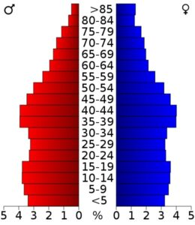

Demographics are key to thinking about specific stakeholder audiences. “[USA Missouri age pyramid](https://commons.wikimedia.org/wiki/File:USA_Missouri_age_pyramid.svg)” by [Artur Jan Fijałkowski](https://commons.wikimedia.org/wiki/User:Mulat) is licensed under [CC BY-SA 2.5.](https://creativecommons.org/licenses/by-sa/2.5/deed.en)

Your research work should have provided you and your client insights as to what audiences need to be addressed to reach your goals and objectives. A substantive and meaningful public relations plan should never address an audience as a “general public.” Also, while the client’s employees may certainly be an important stakeholder audience, *your client is never an audience* — they are the managers of the messaging.

Deciding upon audiences to communicate with, like the identification and creation of objectives, is not arbitrary. This, too, comes from the real state/ideal state analysis and the review of information in the Research component. Staying with the Chipotle case, we’ve found, in our Research element, that Chipotle’s has seen a significant downturn in their revenue, with customers indicating that they don’t find the food to be as fresh as in previous years. Here is an example of stakeholder messaging developed for particular audiences:

Audience #1 — Mothers, ages 24-34: Chipotle’s is a provider of choice when it comes to fresh ingredients for your food choices.  Bring the whole family to see how Chipotle’s has the biggest selection of fresh ingredients for your food.

Audience #2 — College students, ages 18-22: Chipotle’s gives you the freshest ingredients for your food, at a price you can afford.

Audience #3 — Financial journalists: Chiptole’s is updating its supply chain to make sure we bring in the freshest ingredients, efficiently and at low cost. We are positioned to grow our business by more than 5 percent over the previous year.

### Moving from storytelling planning to storytelling execution

Action Planning is primarily about getting the connections right with your identified audiences. The graphic at right presents three elements of the planning process (source, voice, intent) that then inform the format of your communications,

Source — these are the materials that you

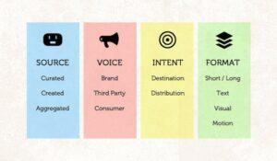

Storytelling is at the heart of public relations action planning. [Storytelling](https://www.flickr.com/photos/cambodia4kidsorg/6046110796/in/photolist-adgU6A-7yxpiu-72vGGP-7Pzkeh-srfSEK-mw3P4k-aW3w1g-by3UW2-nz42mA-omM2Ru-4ZfvrQ-cPTY4E-uaRFP-6peN67-5RFu6T-5RFtUB-66YHvc-z7hLF-fArLK9-fArJh1-8RqNBM-4RDEHU-dwzxMA-95GJuS-8gQJ3k-gfx1Cd-awCsAu-8HJT9d-ebvBCm-ebpZ7V-aJ7igp-hyq3Zy-ebpZ8Z-ebvBAU-ebpZ86-7nW36c-ebpZa4-ebvBCq-ebvBCd-ebpZ94-ebpZ8P-ebvBB3-ebpZ8n-nx1rgK-ku7sL6-rEBWF7-z1xef-7NWRVR-eSbLji-8BBABc) by [Beth Kanter](https://www.flickr.com/photos/cambodia4kidsorg/) is licensed under [CC BY 2.0](https://creativecommons.org/licenses/by/2.0/).

have gathered in the Research component that you have begun to put into thematic elements. This could be information that you simply pulled, or “curated,” from other sources. Or this is information that you have created by, for example, doing your own research. Or, with aggregation, you have a compilation of research that you had curated and aggregated.

Voice — What is the tone of the messages you plan to communicate?  Is the tone mostly informed by the voice of the brand, or is it also complemented by the voice of third-party endorsers, and the consumer?

Intent — This is greatly linked to the audience messaging section immediately above.  Who are the people (the destination) that you are planning to reach?  Also, although this is primarily a function of the Communication component, you should have some initial thoughts abut how you would want to distribute the message.

Format — this is mostly a function of the communication element that will be discussed in the next chapter.

With the completion of the Action Planning section, the public relations person then presents options for communicating these key messages within the Communication element of RACE; the “C” element is the next chapter of this book.

### Image Attribution

“[USA Missouri age pyramid](https://commons.wikimedia.org/wiki/File:USA_Missouri_age_pyramid.svg)” by [Artur Jan Fijałkowski](https://commons.wikimedia.org/wiki/User:Mulat) is licensed under [CC BY-SA 2.5.](https://creativecommons.org/licenses/by-sa/2.5/deed.en)

[Storytelling](https://www.flickr.com/photos/cambodia4kidsorg/6046110796/in/photolist-adgU6A-7yxpiu-72vGGP-7Pzkeh-srfSEK-mw3P4k-aW3w1g-by3UW2-nz42mA-omM2Ru-4ZfvrQ-cPTY4E-uaRFP-6peN67-5RFu6T-5RFtUB-66YHvc-z7hLF-fArLK9-fArJh1-8RqNBM-4RDEHU-dwzxMA-95GJuS-8gQJ3k-gfx1Cd-awCsAu-8HJT9d-ebvBCm-ebpZ7V-aJ7igp-hyq3Zy-ebpZ8Z-ebvBAU-ebpZ86-7nW36c-ebpZa4-ebvBCq-ebvBCd-ebpZ94-ebpZ8P-ebvBB3-ebpZ8n-nx1rgK-ku7sL6-rEBWF7-z1xef-7NWRVR-eSbLji-8BBABc) by [Beth Kanter](https://www.flickr.com/photos/cambodia4kidsorg/) is licensed under [CC BY 2.0](https://creativecommons.org/licenses/by/2.0/).

4

## Chapter 4 - Communication

The Communication element of strategic public relations focuses on how the PR effort will deliver its messages to the client’s key stakeholder groups. Once you have identified key messages for key audiences, then you begin to conceptualize how you will roll out those messages. In this chapter, we’ll hit broadly upon some of the aspects of Communication; this is because this element is normally the easiest for public relations practitioners to engage with.  That is, PR pros often have notions of the kind of communication roll outs they have at their ready. Often, this may happen because public relations people start out their careers as public relations technicians and, in that capacity, they focus on the tactical elements of public relations.  Therefore, in this chapter, you’ll see some important rollout planning elements to consider and what kinds of communication tactics public relations people can pull from.

### **Rollout (or tactical) planning**

One of the most important aspects to consider as you plan message rollout is *framing.*  This term signifies that you are: a) putting together succinctly the client’s message for distribution, and b) that you are also making sure the client’s message aligns with the needs and interests of each stakeholder group.  There are several considerations to use as you solidify the messaging (Sha & Broom, 2013, p. 292):

* Use media and other distribution formats that the audiences are most likely to use.
* Make sure that the vehicle for communication is seen as highly credible to the audience.
* Minimize differences between what your client wants to communicate and the views of the stakeholder audiences.
* As events develop, modify the message as needed.

As you keep these tactical aspects in mind, there are six further elements to consider (Broom & Sha, 2013, p. 293):

* Understand how the audience sees the *impact* of your client’s messages and actions
* Focus on the *proximity* of the content of the messaging; that is, how much does what you are conveying relate to audience’s day-to-day lives?
* Consider the *timeliness* of the messaging — is what your addressing relevant now, or has the time passed your client by?
* What is the *prominence* of the matter you are addressing? Is it well-known or obscure?
* Is there some *novelty* to what you are communicating? The offbeat and/or unusual more readily captures audiences’ attentions.
* Is there some kind of *conflict or drama* in the situation you are addressing?  Tension of this sort can make for ready-made attention among your stakeholders.

### **The importance of words**

Words mean things, therefore, how we use them can make all the difference in the success of a public relations campaign. Additionally, how we use labels make all the difference. For example, an NPR reporter said he was “terrified” to ask an interviewee about how she dealt with a struggle in her life.  More than likely, this reporter was not terrified about asking that question; that word means one is extremely afraid and filled with alarm. So, for example, a solider in warfare will likely be terrified, but not so much a reporter who has a difficult question for his interviewee.  It’s more likely that the reporter meant that he was “apprehensive” or “feeling nervous” about asking that question.  Additionally, many Americans use the words “I feel,” when they are really wanting to say “I think.”  For example, a woman considering buying a big screen TV would say, “I feel that price is too high.”  How does one have a “feeling” about a price and where it fits on the scale of affordability?  Obviously, this is not about a feeling but about a fact — she knows that the price is higher than what hse has seen among competing TVs.  The important thing to consider from these examples is this: be precise on your word choices and how you see them helping your client take steps toward acheiving their objectives and goals.

The meaning of the word “semantics” is not how it is understood in everyday language; for example, it’s not unusual to hear one person criticize another’s point of view by saying, “You’re simply playing word games and semantics.”  In that use, the accuser is saying the other person is using words to manipulate or obscure. However, semantics actually is about the study of what words mean.

There are two important ways of understanding what words mean: *denotative* and *connotative*.  The word “pig” denotes a four-legged animal that one may find on a farm or ranch.  However, it also connotes something unfavorable: “Tim is such a pig when it comes to taking care of his apartment.” Clearly, the denotative understanding of pig means a sloppy person. One must be very careful of how different stakeholder groups understand the denotation and the connotations of a word.  In one campaign course, a group of students proposed that a campaign for a fast-food restaurant should offer the message “Get your hustle on.”  They intended their slogan to use the denotative meaning of hustle — moving fast — which fits with the idea of prompt providing of food.  However, they didn’t realize that the word “hustle,” especially for older demographic groups, carries the connotative meaning of being a con artist!

Other important aspects of words involve *symbols* and *stereotypes*.  Symbols are often combinations of words and images that stand for something else.  For example, Smokey the Bear, who has been around for almost 80 years, is a readily identifiable image to most Americans. The image of the bear, with his ranger hat and his shovel in hand, immediate sends the message, “Only you can prevent forest fires.”  Little if any words are needed; the word “Smokey” on his hat may often suffice.  Stereotypes are another form of shorthand; in this case, however, they are words and images that offer generalities about groups of people. Although these stereotypes may come from some truths about some people, they are often inaccurate and harmful when they are attributed to a whole group of people.  This is true whether they are negative stereotypes or seemingly positive stereotypes.  A negative stereotype like “most Blacks are late for meetings,” is a destructive and harmful point of view. While it may be based on some truths — some Black people may, indeed, be repeatedly late,  — this certainly isn’t a generalizable truth; many people from various backgrounds are repeatedly late for meetings.  What about a positive-sounding stereotype? Is it really true that all Asians are good at math? No. While many may, indeed, be good at math, this statement is an overgeneralization that not only unfairly typecasts Asians into a certain trait, but also demeans the abilities of others from different cultures and experiences.

The bottom line here is: know your stakeholder groups and make sure to use appropriate messages that aren’t prejudicial to people and/or slant their viewpoints in unhelpful ways.

### **Understanding the five stages of adoption**

When your audience is exposed to a new idea, product, or service, realize that your stakeholder audiences will need to go through stages of adoption.  While you may have heard the phrase “early adopter” (i.e., individuals who are the first to take on a new idea, product, or service), even these individuals will follow the stages.  For example, let’s consider Pete, who wants to buy a new car. He’s not quite sure what he wants, but he’s heard that electric vehicles are the way to go. Here is one way that Pete can follow the five adoption stages:

* *Awareness:* Pete is aware that there are several types of electronic and hybrid cars available. As he reads some more about these cars, he’s come to the conclusion that he wants a fully-electric vehicle that can have a range of 250 miles on a fully-charged battery.
* *Interest:* He reads up on about eight vehicles that seem to fit his requirement. He continues to gather specs about these vehicles and what auto reviewers say about each of them.
* *Evaluation:* He compares all the information that he has found about these vehicles and narrows them down to three vehciles that appear to be a good fit for him.
* *Trial:* He test drives the three vehicles and notices more of what he likes and doesn’t like about each. He sees one vehicle as standing out above the others.
* *Adoption:* Pete purchases that vehicle.

### **The Seven Cs of public relations communication**

Prior to deciding what communication tactics to use for a public relations campaign, it is vital to consider factors that will likely influence the effectiveness of the campaign’s Communication element. Here are seven Cs (Broom & Sha, 2013, pp. 308-309) that a public relations professional can use to help decide on the tactics that will be optimal for the campaign:

* *Credibility:* How believable is the originator of the messages?  If the messages are coming directly from the organization, how credibile the organization regarding the subject matter? If the message is being primarily carried by a third-party (e.g., a celebrity, a high-profile person in the community, a subject matter expert), how believable is that third party on the subject matter?  If your stakeholder audiences don’t have confidence in the organization and/or third-party messengers, the public relations campaign is hampered from the outset.
* *Context:* Is the environment conducive for individuals receiving the messaging?  That is, how well do the messages of the campaign square with the lived experience of the various stakeholder groups?
* *Content:* How well are the messages relevant and useful to the stakeholder groups? Moreover, how compatible are these messages to the values of each stakeholder group?  Messages that are not meaningful and pertinent to these audiences will likely be ignored.
* *Clarity:* How clear is the messaging? Do the words have the same meaning for the sender as for the stakeholders (e.g., differences between connotations and denotations)? Can the messages be readily conveyed with brevity and, for example, be offered as themes or slogans?
* *Continuity (and consistency):* Can the messages be repetitively communicated and done so with one voice? If so, does the message have sufficient consistency?
* *Channels (or vehicles):* Can the messages be relayed through communication channels that stakeholders use and find credible? Different channels (e.g., social media, print, video) have different strengths and weaknesses regarding the encoding of the campaign’s messages and the various stakeholder groups’ decoding of the messages. Be wary about trying to convince a stakeholder group who normally uses print to find your messaging on social media. Understand what your target audiences find most valuable for a communication channel and structure your messages for that channel.
* *Capability* *(of the audience):* Can the messages be readily decoded by the audience, or are they filled with jargon or technical or abstract elements that stretches the capability of the stakeholders? If the messaging requires signficant discretionary effort on the part of the stakeholders, the campaign will likely struggle.

### **Common communication tactics**



Public speeches by high-profile individuals can be an important part of public relations communications. [“CEO Brian Taylor Delivers State of the Port Address”](https://www.flickr.com/photos/24847875@N05/12526770915) by [JAXPORT](https://www.flickr.com/photos/24847875@N05) is licensed under [CC](https://creativecommons.org/licenses/by-nc/2.0/?ref=ccsearch&atype=rich) BY-NC 2.0..

*Publications:*  These can be directed to internal (inside the organization) audiences or external audiences.  The external audiences may include customers, community members, political offices and the news media. For internal audiences, newsletters are a good way to keep employees up to date on organizational strategies and activities. External audiences may be of different types — for example, employees, volunteers, stockholders — and, depending on organizational priorities and resources, there may be a newsletter for each audience, or a combination of these audiences. Note: a particularly important publication for many organizations is the annual report; this format provides to stakeholders a yearly accounting of organizational activities and how those measures relate to the organization’s goals.

*Speeches:* Management may often find that they need to present the organization’s view of events through speeches at events. Public relations people are often a natural for providing this communication tactic as 1) they know the goals, visions and objectives of the organization, 2) they have developed an “ear” for how different managers speak, and can write the speech in a way that is true to the speaker and 3) they know how to structure a speech to both grab, and keep, an audience’s attention.  At times, public relations people may take the speech and use it to inform other materials like backgrounder sheets (background information on an organizational viewpoint, product, or service and position papers (documents which lay out an organizational stance, customarily regarding a matter under review by political officials).

*News media stories (also known as media relations):* Public relations professionals are well-positioned to provide information to traditional and emerging news outlets. Such information is often first sent out to the media through a format known as the news release. Effectiveness in this area calls upon public relations practitioners to understand what the news outlet covers, who their audience is, and how they like to receive news leads from PR people. In addition to a news release, doing media relations can require signficant flexibility across numerous formats, based on the media’s preferences. This can mean, for example, doing telephone and/or video conference calls with reporters who cover the client’s industry, or interacting with reporters at trade shows or special events.  Some reporters appreciate media kits, which provides an extensive array of news materials both in text and visual formats.  Successfully placing a story is known as “earned media”; in contrast, buying advertising space for the client is known as “paid media.”  Surveys have revealed that stakeholder groups find earned media more persuasive than paid media.

*Social media:* This tactical area calls upon public relations people to 1) know how different social media platforms work, 2) who the audiences are for various trend lines in social media, and 3) how to best use text and/or visuals to help amplify the



Media kits may often be key to a PR campaigns reaching out to reporters. “[Preparing the media kit](https://www.flickr.com/photos/stillmemory/578244065/)” by [Irina Souiki](https://www.flickr.com/photos/stillmemory/) is licensed under [CC BY-NC 2.0.](https://creativecommons.org/licenses/by-nc/2.0/)

client’s messages. It’s crucial for public relations people to avoid “sales” language in many of the social media platforms; users often find sales pitches distasteful on platforms that they expect to be focused on conversation and information sharing.  Paying an “influencer” to talk about your client on social media is not public relations — it’s marketing.  Asking an opinion leader to do a live-streamed interview about your client, and the opinion leader is not compensated, would be public relations.

*Special events:* Sometimes also called “media events,” these are used to 1) get in-person attention and involvement from key stakeholder groups and 2) garner news media and/or social media attention. Compelling visuals are essential for garnering the attention of groups that could not attend and view the special event through mediated communication.  So, if a special event is mostly about a speech being given by an organizations’ CEO, it will likely fail to garner traction through the media. However, if that speech is accompanied by a compelling backdrop for the speaker (e.g., bright colors and an audience listening from the behind the speaker), an interesting and perhaps offbeat venue (e.g., near a river that moves briskly, in front of a building that is almost completed) and any necessary props (e.g., a large simulation of a check, posters of children who rely on the organization’s services), the speaker may gain media attention.  Special events often require extensive pre-planning checklists that most public relations professionals use to prevent any unwanted surprises.  Note: such checklists tend to forget an important aspect of special events — make sure that the sound system used at the event is working an adequate to the venue.  Nothing is more frustrating to have an event that is visually compelling, but the attendees can’t hear.

Advertorials: These are paid media placed in outlets that stakeholders follow. These are a version of an opinion column; they offer detail on the thinking and viewpoints of the organization without being filtered through reporters or other intermediaries. As this format normally calls for some extensive presentation of supporting materials and/or extensive explanations of the clients’ positions, advertorials most often appear in text format, either in a printed newspaper, for example, or a website.



Media tours can be an effective way to bring reporters to the client’s operations. “[Media tour 130415-N-HU377-23](https://commons.wikimedia.org/wiki/File:Media_tour_130415-N-HU377-235.jpg)” by the United States Navy is licensed under [CC0 Public Domain](https://creativecommons.org/share-your-work/public-domain/cc0/).

Miscellaneous other supportive approaches include:

* Flyers and brochures.
* Inserts into newsletters, statements, or bills.
* Bulletin boards.
* Telephone hotlines.
* Email (note: this approach can be difficult as emails may be caught in recipients’ spam filters).
* Streaming video (either pre-recorded or live)

# References

Broom, G. & Sha, B-L. (2013) *Effective Public Relations* (11th edition). New York: Pearson

### **Image Attribution**

[“CEO Brian Taylor Delivers State of the Port Address”](https://www.flickr.com/photos/24847875@N05/12526770915) by [JAXPORT](https://www.flickr.com/photos/24847875@N05) is licensed under [CC](https://creativecommons.org/licenses/by-nc/2.0/?ref=ccsearch&atype=rich) BY-NC 2.0.

“[Preparing the media kit](https://www.flickr.com/photos/stillmemory/578244065/)” by [Irina Souiki](https://www.flickr.com/photos/stillmemory/) is licensed under [CC BY-NC 2.0.](https://creativecommons.org/licenses/by-nc/2.0/)

“[Media tour 130415-N-HU377-23](https://commons.wikimedia.org/wiki/File:Media_tour_130415-N-HU377-235.jpg)” by the United States Navy is licensed under [CC0 Public Domain](https://creativecommons.org/share-your-work/public-domain/cc0/).

5

## Chapter 5 - Evaluation

One of the challenges for public relations is that it has a reputation for being a field that operates on intuition and intangibles. That is, too often public relations practitioners leave the impression with clients and bosses that the knowledge and perceptions of stakeholder audiences cannot be sufficiently measured through either quantitative or qualitative measures. Sometimes, this is informed by more senior-level public relations managers who have several motivations for not pushing for the evaluation component in a public relations campaign. Those motivations could include:

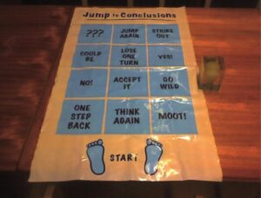

Sound evaluation of a PR campaign can help avoid the pitfalls of making decisions too quickly. “[It’s a Jump to Conclusions mat of course](https://www.flickr.com/photos/thejof/331634958)” by [The Jof](https://www.flickr.com/photos/thejof/) is licensed under [CC BY-NC-SA 2.0](https://creativecommons.org/licenses/by-nc-sa/2.0/).

* Not wanting the client/boss to know that they don’t have the skills to do evaluation.
* Avoiding asking the boss for more money in the budget to do evaluation.
* No knowing where to find existing mechanisms that can provide low-or-no cost evaluation.
* Playing to the client’s/boss’s inclination to focus on activities not measurements.
* Wanting to impress the client/boss that public relations is something mystical that really can’t be thoroughly measured and, therefore, the public relations manager can avoid a higher level of accountability.

### **Three broad areas of evaluation**

While we can certainly stipulate that self-preoccupied motivations can afflict public relations just as much as any field, that doesn’t mean these rationales should carry the day.  The truth is almost all aspects of a public relations campaign can be measured through a mix of quantitative and qualitative approaches (more on that later in this chapter). To that end, the Evaluation element of RACE focuses on providing assessments of the PR campaign.  There are essentially three areas of evaluation — preparation, implementation, and impact. Broadly, the evaluation element asks these kinds of questions (Broom & Sha, 2013, p. 319):

Preparation

* How well did we prepare this campaign?
* How appropriate was the messaging?
* How technically sound were the messaging and events?

Implementation (or outputs)

* How many messages were distributed?
* How many messages actually appeared?
* How many people were potentially exposed to the messages?
* How many people actually paid attention to the messages?

Impact

* How many people learned and/or retained the messages?
* How many people changed their opinion based on the messages?
* How many people changed their attitude or inclination based on the messages?
* How many people acted on the messages?
* How many people continued this behavior?
* What long-term societal/cultural changes may be apparent from the campaign?

Let’s stay with the Chiptole example first offered in chapter 3.  From its research and action planning, recall that, in this hypothetical scenario, Chiptole has three objectives:

Objective Statement #1: By the third quarter of this fiscal year, Chiptole’s total revenue will be up by 10 percent.

Objective Statement #2: By the fourth quarter of this fiscal year, random surveys will reveal that at least 60 percent of respondents will list Chiptole’s as one of their three favorite Mexican restaurants.

Objective Statement #3: By the end of the next calendar year, Chiptole’s stock market valuation will have increased 15 percent.

Next, looking at the three areas of evaluation, Chiptole may choose to establish these kinds of evaluations:

Preparation:

* How well did we identify the key data points that came from our research?  For example, we didn’t get sales data per square feet of each retail outlet; did we need that?
* Did the statistical data we focused on — sales trends — allow us to make the best decisions about our messaging?
* Did the slogan we develop for our campaign align well with our research findings and our goals?
* When we used a YouTube video to help launch our campaign, how well was it edited for optimal viewing?

Implementation (or output)

* What was the complete count of social messaging posts we put up on FB and Instragram?
* How well did those message get picked up by local and regional news outlets?
* What was the potential reach of the messages through news outlets that carried our message?
* Is our survey data about stakeholder awareness of our message comprehensive, or did we miss some key audiences?

Impact (featuring assessing audience awareness, inclination to act and/or audience behavior

* What do our stakeholder surveys tell us about how positively key audiences now see us?
* What do we know about what influences people’s viewpoints of us?
* What do we know about how inclined various stakeholder groups are to visit our restaurants?
* What are the sales trends since the end of the campaign?
* What are our competitors doing in reaction to our campaign?

These three aspects of evaluation likely *will not be equally important to the client.*  For example, the preparation stage is particularly pertinent for the public relations person, and perhaps not as important to the client, because it is assessing the “behind the scenes” aspect of campaign development. Therefore, the preparation area of evaluation would more likely be of value to the public relations team, and other associated teams in marketing and advertising, as they do an inventory of how well they put together data and message points, and conceptualized the campaign roll out, all in advance of implementation.

The client (and also the public relations person’s boss) will likely be more interested in implementation. In fact, it’s not unusual for the client/boss to want, at a minimum, weekly updates on the extent of outputs (e.g., number of news releases sent out, number of interviews done, number of social media posts).  Some bosses/clients put a high premium on outputs as the level of activity leads them to reassure themselves that the campaign is progressing well.  The numbers focus is reflective of an experience this book’s author had when he did an informational interview with a marketing and communications director at a Fortune 500 company in St. Louis. Recall that this was briefly mentioned in Chapter 2 (Research); here’s more detail about that discussion:

Director: Welcome, Burt.  So, you’d like to find out more about how public relations operates in our field?

St. John: Yes, I’d appreciate knowing more about the top PR priorites for your company.

Director: (moves to sit in a chair that has a large opaque window directly behind him; the office behind him revealed rows of cubicles). Glad to do that. But first tell me about what you do.

St. John: I provide public relations services for two major clients in the Midwest.

Director: Really? Well, tell me how many projects your work on in a given month.

St. John: Well, of course there are small day-to-day things I do for them like take media inquiries and speechwriting. But, when it comes to larger projects, I do, in an average month, about 5-6 projects across the two clients.

Director: (leans back in his seat and nods to the opaque window) About 5-6 projects, eh? (He pauses for dramatic effect). Well, I have people back there working on 60-70 projects each month!

Two things happened next: 1) St. John knew the information interview was essentially over and he played it out to its end, and 2) this discussion crystallized for him that those who oversee public relations campaigns, whether bosses or clients, often focus much more on activities performed than how activities may (or may not) have lead to the accomplishment of their goals.

### **The importance of pairing quantitative evaluation with qualitative findings**

A focus beyond outputs to examining what has truly happened — or impact — is something that many clients/bosses are interested in knowing. Therefore, public relations people should report back, at a minimum, on how well the campaign achieved its numerical objectives. Look again at the objectives laid out in the hypothetical Chipotle campaign. For the impact element, the public relations team should answer:



Evaluation can be qualitative, such as interviews done one-on-one, in small groups or in focus groups. [“Brazil Rio+20 – GEF Evaluation Office Book Launch”](https://www.flickr.com/photos/40412379@N02/7414197342) by [Global Environment Facility (GEF)](https://www.flickr.com/photos/40412379@N02) is licensed under [CC BY-](https://creativecommons.org/licenses/by-nc-nd/2.0/?ref=ccsearch&atype=rich)NC-ND 2.0.

Objective Statement #1: Did total revenue, by last year’s fiscal third quarter, go up at least 10 percent?

Objective Statement #2: Did random surveys reveal, by last year’s fiscal fourth quarter, that at least 60 percent of respondents listed Chiptole’s as one of their three favorite Mexican restaurants?

Objective Statement #3: Did Chiptole’s stock market valuation increase by at least 15 percent by the end of the last calendar year?

*It is also vital to include qualitative measurement to complement objective statements* (which are always focused on quantiative measurements).  So, for example, these objectives can be accompanied by focus groups, one-on-one interviews with key stakeholder members, and field observations of Chiptole restaurants. Why also include qualitative evaluations? The “by-the-book” answer is that qualitative measurements provide a depth and richness concerning how well the public relations campaign made a difference for the client. That is, simply tracking Chiptole’s revenue numbers may not reveal the fuller impact of the campaign; there could be other factors, like the competition going out of business, or new lines of products being introduced that have sold particularly well (and maybe even better than anticipated).  So, having qualitative data about how well the campaign reached and effected stakeholder audiences allows the public relations team to point to where its campaign made a difference no matter what other factors may have affected outcomes for Chipotle.  Therefore, this reason for using qualitative data in evaluations is about demonstrating the soundness of the campaign; it displays that the campaign made its own impacts. There is, however, another sound reason for using qualitative data: it demonstrates how public relations, in work environments where managers scramble for resources, deserves appropriate support from upper-management. Consider this hypothetical example of a discussion in the “C” suite at Chipotle:

CEO: Well, St. John, how well did the PR campaign support our “We’ve Got the Food You Crave” initiative?

St. John: It delivered very well on the objectives. For example, we exceeded our total revenue and stock market valuation goals and we got the 60 percent favorability response on the surveys!

Marketing Manager: (in a loud voice) Well, St. John, I don’t see that you can claim that your PR campaign lead to those results. We started up a new marketing campaign the pointed out the range of new products we have launched in this past year.  We put together some slick ads that showed young and hip people biting into our new line of exotic burritos, and we saw revenue spike about three weeks after we started these ads!

CEO: St. John, your thoughts?

St. John: We know that the PR campaign worked well in partnership with those ads?

Marketing Manager: How do you know that?

St. John: Because we did focus groups with several of the customers in key markets.  When we asked them how much they noticed the ads, they pointed out that they did, but they also said they were often drawn in by the special events we held and/or saw the news stories we placed in both traditional media and social media. We also walked up to customers who were waiting for their food in our restaurants and they said they also remembered both of these approaches.

Marketing Manager: (in a quieter voice) Oh…

There are some lessons to learn from this exchange:

* A PR campaign needs both qualitative and quantitative evaluation.
* The PR people running the campaign need to have both sets of data when talking with senior management.
* If the PR people don’t have qualitative measurements, others can claim they are responsible for the ostensible successes of the PR campaign.
* Other staff managers (e.g., those over marketing, human resources, and financing) may make such claims because they want more resources and/or prestige.
* It’s best to not do what the marketing manager did and avoid asking questions you don’t have an answer for.

### **A word about AVE**

Over the last 30 years, some public relations practitioners have

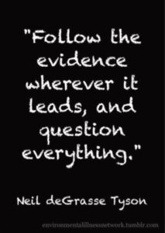

“[Neil deGrasse Tyson Question Everything](https://www.flickr.com/photos/environmental_illness_network/14149255055)” by the [Environmental Illness Network](https://www.flickr.com/photos/environmental_illness_network) is licensed under [CC BY-NC-ND 2.0](https://creativecommons.org/licenses/by-nc-nd/2.0/).

maintained that there is another quantitative approach to establishing the effectiveness of a PR campaign: Advertising Value Equivalency (AVE). The argument for using AVE is that it allows the PR team to offer a succinct accounting of how the campaign made a difference for the client. Simply put, it measures the amount of publicity attained in various news outlets and tells the client how much it would have cost for them to purchase a similar amount of space or time via advertising.  This kind of measurement is suspect as it doesn’t directly address what the campaign is trying to accomplish with the client’s stakeholders. However it is popular among some PR professionals because:

* It’s a readily accessible way of demonstrating a “big numbers” numerical effect of the campaign
* It speaks to client’s concerns about return on investment in the campaign
* It’s a clear way of demonstrating why public relations, and not advertising, should receive more resources
* It allows the practitioner to hold down evaluation costs for the campaign
* It’s a way for a PR person with little understanding of evaluation to still deliver some quantitative “results.”

Several public relations evaluation experts (Broom & Sha, 2013, p. 324), however, maintain that AVE is not an appropriate evaluation, because:

* Advertising is NOT public relations; therefore AVE is not measuring PR’s efforts.
* AVE measures cost, not the value that the campaign is delivering
* AVE doesn’t measure place or position of the messaging
* AVE dosen’t measure the prominence of the messaging (is it central to the news piece, or tangential?).
* AVE doesn’t measure if how much “share of voice” (depth of coverage) the client received.
* AVE doesn’t measure exactly what messages were conveyed.
* AVE doesn’t account for collaterals to the messaging, like photos, video,  and logos.

Rather than AVE, the public relations team needs to gather convincing qualitative and quantitative data that reveals how the campaign did at least one of these three things among the client’s stakeholders: 1) generate awareness about the client and its messages, 2) spark a predisposition that is favorable to the client’s messages and 3) generate action from the stakeholders that can lead to the client accomplishing their goals.

Ultimately, good evaluation of a PR campaign is like the successful ending of a movie’s storyline: if it finishes in a convincing way, the actors involved may be called upon to do a sequel.  And that’s where the public relations team goes back to the beginning by doing up-front research for the next story!

# References

Broom, G. & Sha, B-L. (2013) *Effective Public Relations* (11th edition). New York: Pearson

### **Image Attribution**

“[It’s a Jump to Conclusions mat of course](https://www.flickr.com/photos/thejof/331634958)” by [The Jof](https://www.flickr.com/photos/thejof/) is licensed under [CC BY-NC-SA 2.0](https://creativecommons.org/licenses/by-nc-sa/2.0/).

[“Brazil Rio+20 – GEF Evaluation Office Book Launch”](https://www.flickr.com/photos/40412379@N02/7414197342) by [Global Environment Facility (GEF)](https://www.flickr.com/photos/40412379@N02) is licensed under [CC BY-](https://creativecommons.org/licenses/by-nc-nd/2.0/?ref=ccsearch&atype=rich)NC-ND 2.0

“[Neil deGrasse Tyson Question Everything](https://www.flickr.com/photos/environmental_illness_network/14149255055)” by the [Environmental Illness Network](https://www.flickr.com/photos/environmental_illness_network) is licensed under [CC BY-NC-ND 2.0](https://creativecommons.org/licenses/by-nc-nd/2.0/).