**Emotion, Moral Judgement, and Psychic Numbing**

Katlyn Blacksten

Psychology Honors Thesis

Defense Date: 04/07/2023

Committee: Eric Pedersen (Psychology Honors Thesis Advisor), McKell Carston (Psychology Honors Council Representative), Jason Potter (Philosophy)

Abstract

Emotions’ influence is often neglected within normative decision-making models. While research has often supported decision models such as prospect theory and dual process theory, both of which do not include emotion within evaluative decisions. In contrast, current research on moral judgements has illustrated a strong relation to emotion. The broad scope of our research sought to demonstrate a connection between emotion, how we perceive moral judgements, and the so-called psychic numbing effect. In study one, we sought to examine emotion in relation to individual moral foundations, proposing that, similar to previous research, shame, guilt, anger, and disgust would have the strongest effects within the individual moral foundations. Our analysis partially supported our hypothesis as guilt, shame, and anger each had strong significant (p < .01) predictive relationships within one or more of the individual emotions, and disgust’s strongest influence was found in connection to overall moral vigilance. Following these results, in study two we aimed to examine the relationship between emotion and psychic numbing by priming participants to think emotionally about a moral decision in which lives were at stake, in hopes that emotionality would reduce psychic numbing. Our results failed to reject the null hypothesis, finding that there was no significant difference between conditions.

**Emotion, Moral Judgements and Psychic Numbing**

There has been extensive research examining how emotion influences moral judgments generally (So et al., 2015: Lerner et al., 2015: Damn, 2010). Here, I extend this work by examining the overall role of emotion’s influence on individual moral foundations (Haidt, 2007), and further test if specific emotions influence individual foundations more so than others. Because of the importance of emotion in moral judgments generally, and my hypotheses regarding its relation to the moral foundations, I also examine the role that emotions play in so-called psychic numbing—a type of scope insensitivity in which people are relatively insensitive to increases in mass casualties when making decisions to save lives. The aim of study 1 is to separate broad moral judgements into narrower subsets allowing the examination of emotionality in relation to individual moral foundational pillars. We predict that, similar to previous research, guilt, shame, anger, and disgust will have the strongest influence in relation to each moral pillar. Further, as we hope to demonstrate that emotion does influence moral decisions, we additionally hope to demonstrate that decisions that evoke the psychic numbing effect--affect rich at lower magnitudes, similar in nature to moral judgements--would similarly be influenced by emotion. Thus, if emotion is applied to a normative model of decision making in a manner mirroring that of moral judgements, we should be able to avoid the loss in affect at the higher magnitudes and therefore mitigate the level of psychic numbing participants experience. In study 2, we theorize that priming participants to consider evaluative questions in a similar manner to which they would moral judgements--affect rich--will reduce the influence of the psychic numbing effect, causing participants to demonstrate less support for a decision that would result in a loss of life as the number of deaths increases.

**Emotion and Moral Agency**

The role that researchers have previously believed emotion to play in moral judgments and decisions is contested due to what some researchers insist is the nature of emotion--temporary and unconscious (Ben-ze’ev, 1997). Old research focused on emotions’ nature, being unconscious and short lived--now understood as valance emotions--rather than their ability to motivate behavior. As such, non-deliberate emotional evaluations–-valance or incidental emotions (So et al., 2015 & Lerner et al., 2015) --seemingly contradict the concept of moral responsibility. Moral responsibility, or moral agency, is the assertion that the individual is responsible for their actions and judgements (Damn, 2010). Thus, since emotions can be unconsciously evoked and influence moral judgments and decisions, the concept of moral agency seems to be undermined.

**Affect and Decision-making Frameworks**

Affect and emotion have been shown to influence both how information from an environment is processed and what form that environment processed, for example if you love the color red and are happy you will be more likely to recognize and remember red items within your environment (Lerner et al., 2015: Slovic et al., 2013). Emotion acts as a lens that focuses an individual's attention (Bandyopadhyay et al., 2013: Ben-ze’ev, 1997), narrowing the individual's observational scope to ascertain details that are related to the object or event that initially caught the individual’s attention. Research examining how emotions influence decisions has demonstrated that emotions arise through the reaction to changes in an individual's environment which, through exposure, creates evaluative patterns (Ben-ze’ev, 1997), also known as learned releasors (Velasquez, 1998). Learned releasors allow for an immediate reaction when the environment supplies the appropriate priming measures and allows an individual to “react” without spending additional time deliberating (Velasquez, 1998). As affect influences the manner in which information is understood, researchers have found that if information lacks affect it will not be prioritized in an individual's judgements (Bandyopadhyay et al., 2013; Ben-ze’ev, 1997). Previous literature has proposed several theories concerning the manner in which individuals make judgments and decisions. The most commonly accepted theory regarding the use of emotion within decision making is referred to as the dual-process theory. This theory proposes that there are two separate systems of thought–system 1 being automatic and affect focused and system 2 being slow, methodical, and focused on logic (Osman, 2004: Slovic et al., 2010). The theory proposes that thought is separated between the two distinct systems and at times they come into direct opposition with one another. Researchers have found system 1 to be composed of affect, intuition, and automatic responses to stimuli, while system 2 is considered to be abstract, affect-free, and analytical resulting in a slower response when presented with a stimulus (Osman, 2004). Furthermore, a study undertaken by Hsee and Rottenstreich (2001) implemented an affective approach to risk assessments, reexamining the weighting function within Kahneman and Tversky’s prospect theory (Kahneman & Tversky, 1982). They proposed that current models of normative decision making did not accurately adjust for the influence affect has on decisions–specifically hope and fear in relation to affect rich and risky decisions (Hsee & Rottenstreich, 2001). The model they present is referred to as valuation by feeling (Hsee & Rottenstreich, 2004). This model corresponds with the decreased sensitivity that is found within the psychic numbing effect (Slovic et al., 2010), as both insist that emotion or affect is relatively insensitive to increased increments of a stimulus (magnitude) (Hsee & Rottenstreich, 2004). Within this and Osman’s theory, we would understand an initial reaction to the loss of life as an evocation of the automatic system 1 response causing it to be rich in affect until a certain magnitude of devastation is reached at which point system 2 takes over and affect ceases to be an included factor.

**Appraisal Networks**

Other researchers have argued that the dual process theory does not do an adequate job of explaining moral judgements. As research has demonstrated that decisions of this nature intwine emotion throughout the entire system process from the initial evocation to the outcome/behavior, further finding that emotions act as motivators. More recent research has since shifted to examine the motivational power that emotion is capable of demonstrating, including the appraisal theory (Lerner et al., 2015 & So et al., 2015 & Dalgleish et al., 2005). The appraisal theory speculates that emotions involve appraisal networks and as such are intertwined rather than seen as an additive or external factor within an individual's decisions, allowing for the capacity to directly motivate action. The appraisal theory examines emotions as complex networks of information-rich associations defined by their relation to the six appraisal dimensions, which are: pleasantness, certainty, perceived controllability, attentional activity, anticipated effort, and agency (So et al., 2015 & Lerner et al. 2015). Within this framework, it is proposed that “unique appraisals associated with each emotion activate a cognitive predisposition” (So et al., 2015), referred to as an appraisal tendency. Each decision or action is the result of an appraisal tendency that is consistent with its core emotional appraisals, as such subsequent behavior and judgements differ based upon the “constellation of underlying appraisals that comprise each emotion” (So et al., 2015).

**Moral Foundations Theory**

One of the most influential theories regarding morality was proposed by Graham and Haidt (2004) and is referred to as moral foundations theory, which consists of five “pillars” that define an individual's morality. The original five foundational pillars of morality are: authority, loyalty, purity, care, and fairness. Further research has resulted in a sixth pillar, liberty (Araque et al., 2021). Within this theory it is held that moral emotions operate similarly to normal emotions, in that they are automatic and naturally arise out of appraisal networks (Haidt, 2007) evoked through social interrelationships and intra-relationships. Research examining moral judgments has demonstrated that they are by nature affect rich as they deal with interpersonal issues, thus activating emotional appraisal pathways.

**Moral Emotions and valance**

Moral emotions are defined as “emotions that are linked to the interests or welfare either of society as a whole or at least of persons other than the judge or agent” (Graff et al., 2016). Predominantly before 1990 previous research examining moral judgements, similarly to research on decision making, undervalued the role emotions played. However, more recent research has begun to take an affective approach to moral decision making. Both guilt and shame are commonly classified as moral emotions. (Tangney et al., 2007). Further research has both expanded the range of emotions and broken this wider range of emotions into four main categories: other-condemning emotions, self-conscious emotions, other-suffering emotions, and other-praising emotions (Haidt, 2003, Graff et al., 2016). There is disagreement within the literature, as researchers disagree with which emotions constitute each category and further the use these categories generally, as some researchers have examined emotions through their valance: positive or negative (Shuman et al., 2013). Other research prefers to isolate individual emotions or small subsets, rather than examine emotions within categories, with the most commonly isolated emotions constituting those that have traditionally been connected with moral judgements, shame, and guilt, both of which are negatively valanced (Tangney et al., 2007). Valance is conceptually basic, simply referring to forces that either attract (positive) or deter (negative) individuals from pursuing certain behaviors (Shuman et al., 2013). As such, valance is not only connected to individual emotions but also appraisal networks, most notably in appraisal networks that focus on goal conductivity and pleasantness, which are often considered valance judgements (Shuman et al., 2013). This accounts for the multifaceted predictive nature of appraisal networks when examined in connection to either positive or negative valance. Negative valanced emotions include those that repel an individual from a certain behavior or judgment, such as anger, shame, guilt, disgust, or sadness (Shuman et al., 2013: Turner & Stets, 2006). Positively valanced emotions include elation/happiness or pride and encourage a behavior or judgment (Zarinpoush et al., 2000). Moral judgements such as those that invoke the foundational pillars normally involve negatively valanced emotions.

**Individual Emotions and Moral Vigilance**

One of the largest breadths of literature examining the manner in which emotion influences moral judgements concerns the evaluation of isolated emotions in relation to perceived morality and the self. Shame and guilt are often conflated by laypeople, however there is a significant: guilt is considered an other-oriented emotion--concern for others is central and stems from the individual’s violation of moral norms. In contrast, shame is self-oriented--concern for the whole self (identity) is central (Turner & Stets, 2006). This distinction influences the manner in which each emotion motivates moral judgements and behaviors. Guilt motivates moral judgements and behaviors through appealing to empathy and sadness that focuses on the fear for others, whereas shame motivates moral judgements and behaviors out of sadness and fear of consequences combined with anger at the self. Anger is another negatively valanced emotion that can be considered either self-conscious or, in the case of righteous anger, other condemning (Plaks et al., 2021). There is a difference between righteous anger and anger in relation to motivating moral judgements and behaviors: research has demonstrated that righteous anger specifically does not require personal experience of the perceived moral violation, similar to guilt (Plaks et al., 2021).

Though past researchers have traditionally determined shame and guilt to be morally significant emotions involved in moral judgements, more recent research has found disgust (negatively valanced) to be a stronger predictor of moral motivation (Landy et al., 2015). Disgust is similar to righteous anger and guilt in that it does not require the individual to personally experience the moral violation, although it is unique in that it is considered prenormative–activation does not require a violation (Landy et al., 2015). Research examining the manner in which disgust influences moral judgements has resulted in three theories. The first theory is the elicitation hypothesis, which proposes that once an individual judges an action to be a moral violation, then disgust is evoked (Landy et al., 2015). The second theory is the amplification hypothesis, which states that an individual's experience of disgust results in them judging the action to be a moral violation (Landy et al., 2015). The final theory is referred to as the moralization theory and it proposes that the experience of disgust alone is enough to transform an otherwise neutral action into a moral violation (Landy et al., 2015). The connection between each of these theories is that disgust has a substantial role in the motivation of avoidance in relation to the individual's moral judgment that an action constitutes a violation. Moreover, as previous research has demonstrated the extensive connection between disgust and moral judgements, it would follow that scenarios involving moral perceptions such as those that elicit the psychic numbing effect in response to high levels of casualties, would demonstrate a similar connection between disgust and the psychic numbing effect.

**Psychic Numbing Effect**

Limiting the effect of psychic numbing would allow individuals to evaluate the loss of life more accurately in dire situations. However, little research has been completed examining how to go about doing so. Most literature surrounding the limitation of this effect focus on the frame at which the scenario is presented rather than targeting the cause of the effect itself–the loss of affect. The term psychic numbing was originally used by psychiatrists in 1936 to describe the loss of affect in individuals as a defensive mechanism in response to trauma. Robert J. Lifton then began to use the term in his work interviewing victims who survived the holocaust, citing it as a way for people to process large numbers of death (Lifton, 1975). He explained that individuals will separate their emotions from their awareness of the danger in order to process the potential loss of their own lives and the lives of those around them (Lifton, 1982). Within the last two decades, Paul Slovic and others have expanded the research on psychic numbing and its influence. In 1997 Fetherstonhaugh et al. used the term to explain that people “exhibited diminished sensitivity in valuing life-saving interventions against a background of increasing numbers of lives at risk” (Fetherstonhaugh et al., 1997).

The studies run by Fetherstonhaugh et al. were three of the first undertaken that sought to examine how psychic numbing influenced various levels of decision making. The first study illustrated the hindrance psychic numbing is to a participant’s accurate understanding of the value of lives as the magnitude of a situation increases. They presented participants with several governmental programs; each was said to help the same number of people in addition to one of two Rwandan refugee programs. The first proposed that 4,500 people would be saved out of 11,000, with the second proposing the same number of lives saved but increased the size of the refugee camp significantly (250,000). The programs were paired and the participants were asked to express which program they preferred. The results confirmed the research hypothesis predicting that the participants would prefer the scenario in which the support was provided to the small camp saving 4500 out of 11000 rather than the larger camp which would have saved 4500 out of 250,000. Additionally a study has since replicated these results, similarly comparing the distortion in affect to other sensory systematic distortions, finding that if granted that deaths caused by war carried a magnitude of .32 (valuation of the deaths), when presented with two wars in which the second had 8 times as many deaths people would only consider it to be twice as devastating (2*.32 = .64 rather than 8*.32 = 2.56) (Slovic et al., 2007).

**Framing and Psychic Numbing**

Attempting to limit the effect found within the first study, the subsequent studies Fetherstonhaugh et al. (1997) ran focused on the frame in which each scenario was presented. The second study kept much of the same structure from the first but omitted the four governmental programs and included a new manipulation framing when the aid would be given to those in need as either early into the crisis or near the end. This study sought to determine if the frame in which the scenario was presented would significantly alter the level of psychic numbing that participants experienced. The study found that while participants again felt that the smaller camp would benefit more from the implementation of the water system, it also found that the participants considered both programs to be more beneficial if they were implemented near the end of a crisis–framing of the timeline (Kahneman & Tversky, 1982). Study three demonstrated that framing decisions in a positive manner did reduce the effect that psychic numbing had within the participants' responses.

The third study asked participants to estimate the number of lives saved by medical institutions through decisions regarding a fixed amount of money, again shifting the frame at which the participants examined the number of lives affected. The study design first asked participants to estimate how large the reduction in the number of deaths at each institution would need to be to justify the level of funding. Participants then ranked the three medical institutions in order of which they felt most deserved the funding provided the following: “Institution X would reduce deaths from Disease A from approximately 15,000 per year to about 5,000 per year, (b) Institution Y would reduce deaths from Disease B from approximately 160,000 per year to about 145,000 per year, and (c) Institution Z would reduce deaths from Disease C from approximately 290,000 per year to about 270,000 per year”. The results the first task demonstrated a similar pattern to the first two in that the psychic numbing effect impacted 65% of participants in the first task, indicating that as the number at risk increased, participants felt so should the number of lives necessary to justify the reception of funding (11 times greater for a disease killing 290,000 than one killing 15,000 annually) illustrating a decreased sensitivity to the number of lives lost--the central effect of psychic numbing.

The second task differed from the previous findings, as the researchers found that 60% of participants chose to rank highest the institution that saved the highest number of lives (290,000 down to 270,000) despite it presenting as the lowest percentage. The choice to rank the largest institution as the most deserving of the funding opposed the hypothesis and demonstrated that the majority of participants were not influenced by the psychic numbing effect when completing this task. Other research (Slovic, 2007: Slovic et al. 2013) found similar results, showing that participants' insensitivity to the magnitudes could be decreased through framing the questions alternatively as deaths per day (lower magnitude, higher in affect) rather than deaths per war (greater magnitude, lower in affect), again illustrating that while affect diminishes when working with larger numbers it can be limited through alternative framing.

Very little research has attempted to examine affect at higher levels of magnitude, rather many studies choose to narrow the perceived harm/death to focus on an individual or small group and in doing so this lowers the magnitude of the situation. This in turn allows individuals to again establish a stronger affective attachment and thus allows them to better evaluate the loss of life or perceived magnitude of harm (Slovic, 2007). However, in lowering the magnitude of the situation to increase affect levels the severity of the situation is not effectively communicated and could result in decisions not reflecting the actual response necessary to address the situation.

**The Current Research**

Normative decision-making models often deemphasize the influence emotion has on individuals’ decisions and behavior. However, models examining moral judgements and behaviors has continued to demonstrate the influential capacity of emotions. Our research seeks to demonstrate that a connection lies between the manner we perceive moral judgements and the psychic numbing effect as decisions that often evoke the psychic numbing effect involve aspects of moral judgements. We believe that the connection between moral judgements, emotion, and the psychic numbing effect centers on emotion’s ability to motivate/influence action and further decisions, regardless of the perceived increased in the severity of a scenario. The effect that is essential to decisions that evoke the psychic numbing effect.

In study 1 we sought to replicate previous research that indicated shame, guilt, anger, and disgust would have the strongest influence in relation to moral judgement and further to examine if specific emotions influenced individual moral foundations more so than others.

**Study 1**

**Methods**

**Participants**

The convenience sample of the initial study included 211 participants recruited from the University of Colorado Boulder general psychology subject pool to participate in an online survey. Participants ranged in age from 18 to 51 years old (*M* = 19.13, *SD* = 2.95).

**Procedure**

In this study, participants were first presented with a modified scenario pulled from a previous research study undertaken by Sagen and Valentino in 2017. Our modified version presented participants with a military proposal stating that the United States would send a retaliatory nuclear strike to end a ground war and prevent the loss of further American soldiers’ lives. The strike would kill 100,000 Iranian civilians and prevent the loss of 20,000 American soldiers (see appendix figure 16). This scenario was followed by questions asking their level of support for the retaliatory nuclear strike at three levels beginning with the initial 100,000 proposed casualties then either decreasing to 20,000 or increasing to 1 million deaths. All three levels were displayed to participants, however the level that followed 100k was randomized. Participants were then asked to evaluate the level at which their emotions influenced their decision to either support or oppose the strike using our first emotional influence measure— “Recall your response about how much you would oppose or support the strike when the Iranian civilian death toll was 100,000. To what extent did your emotional reaction influence your decision to support or oppose the proposed strategy?”. They were then shown the second emotional influence measure asking to what level each of the individual emotions influenced their previous decisions at each of the three levels from the first scenario. Finally, participants were shown our moral foundations measure in which they responded two three items for each of the six foundations. An example of one of the fairness vignettes being “A referee intentionally making bad calls that help his favored team win” and we asked participants to judge how wrong they perceived the action to be (1 being not wrong at all and 7 being extremely wrong).

**Measures**

**Endorsement measure**

Our study’s endorsement measure drew from a previous study designed by Sagen and Valentino in 2017. Our measure asked participants to evaluate their level of endorsement relation to a scenario calling for a retaliatory nuclear strike resulting in the death of 100,000 civilians initially. Which was then followed by the number of deaths decreasing to 20,000 before lastly increasing to 1 million. This measure implemented a likert scale with 1 representing a strong opposition to the strike and 7 demonstrating strong support for the strike. See appendix Figure 16.

**Emotion measures**

The study included two measures examining participants emotional influence in relation to the given scenario. The first measure utilized a 7-point likert scale with 1 = no influence and 7 = a strong influence in response to questions examining their perceived emotional influence on their endorsement scores at each of the three levels (100k, 20k, and 1 million civilian deaths).

The second measure also included three questions in relation to the three levels presented by the scenario of our first measure. It further included an emotion matrix the included 7 emotions: happiness, sadness, guilt, anger, guilt, shame, and fear, along a 7-point likert scale mirroring that of the previous measure with 1 = no influence and 7 = a strong influence. See appendix figure 17.

**Moral Foundation measure**

The last measure our study implemented was a modified version of Haidt’s 2007 Moral Foundations Questionnaire. This section asked participants to rate the moral wrongness of 3 vignettes for each foundation: fairness, authority, loyalty, purity, and care, utilizing a 7-point likert scale with 1 being not wrong at all and 7 being extremely wrong. Our adaption of the measure included 3 vignettes that examined the participants perception of liberty in addition to the original 15. See appendix figure 19 for an example of three moral judgement vignettes.

In order to examine each of the relationships, multiple multilinear regressions were performed. Further, the study used Qualtrics ([http://www.qualtrics.com](http://www.qualtrics.com/)) to create and administer the survey questions and a free version of RStudio Cloud (<https://rstudio.cloud/plans/free>) was used to analyze the data.

**Results**

First, we examined the relationship between emotions and an averaged moral vigilance score--participant’s average endorsement of the six moral foundations measures. Next, we examined each foundation separately in the same manner.

**Overall Emotionality and Morality**

In order to determine if participants' emotionality influenced their averaged moral vigilance, three multiple regression analyses was run to determine the prediction of averaged moral vigilance based upon happiness, sadness, anger, disgust, shame, guilt, and fear at each of the three casualty levels. Results of the multiple [linear regression](https://www.statisticssolutions.com/free-resources/directory-of-statistical-analyses/what-is-linear-regression/) examining the 100k casualty level indicated that there was a collective significant effect between happiness, sadness, disgust, anger, guilt, shame, fear, and a participants averaged level of moral vigilance (F(7, 202) = 5.607, p < .001, R2 = .1337). The individual predictors were examined further and indicated that disgust (t = 2.251, p < .05) was a significant predictor in the model. Results of the second regression examining the 20k casualty level found that there was a collective significant effect between happiness, sadness, disgust, anger, guilt, shame, fear, and a participants averaged level of moral vigilance (F(7, 202) = 4.893, p < .001, R2 = .1158). The individual predictors were examined further and indicated that disgust (t = 2.917, p < .01) was a significant predictor in the model. The third analysis examining the 1 million casualty level determined that there was a collective significant effect between happiness, sadness, disgust, anger, guilt, shame, fear, and a participant’s averaged level of moral vigilance (F(7, 202) = 3.235, p < .01, R2 = .0694). There were no significant individual predictors. See appendix figures 19 - 21.

**Figure 1**.

*Participants’ averaged emotionality score (happiness, sadness, anger, disgust, guilt, shame, and fear) vs their averaged moral vigilance score (fairness, liberty, loyalty, authority, purity, and care) including all three casualty levels.*

**Fairness**

At the 100k casualty level, there was not a collective significant effect of the emotions on participants’ fairness scores (F(7, 202) = 1.129, p > .05, R2 = .0043). However, the individual predictors were examined further and indicated that shame (t = 1.993, p < .05) was a significant predictor in the model. At the 20k casualty level, we found that there was a collective significant effect of the emotions (F(7, 202) = 2.694, p < .05, R2 = .0539). The individual predictors were examined further and indicated that sadness (t = 3.013, p < .01) was a significant predictor in the model. At the 1 million casualty level, there was a collective significant effect of emotions (F(7, 202) = 2.179, p < .05, R2 = .0378). The individual predictors were examined further and indicated that sadness (t = 2.21, p < .05) and guilt (t = 0.0346, p < .05) were significant predictors in the model. See appendix figures 22 - 24.

**Figure 2.**

*Participants’ averaged emotionality score (happiness, sadness, anger, disgust, guilt, shame, and fear) vs**their average fairness score including all three casualty levels.*

**Liberty**

At the 100k, there was a collective significant of the emotions on participants’ liberty scores (F(7, 202) = 2.647, p < .05, R2 = .0523). The individual predictors were examined further and indicated that happiness (t = -3.145, p < .01) was a significant predictor in the model. At the 20k casualty level, we found no collective significant effect of the emotions (F(7, 202) = 1.931, p > .05, R2 = .0304). However, the individual predictors were examined further and indicated that shame (t = 2.211, p < .05) was a significant predictor in the model. Similarly at the 1 million casualty level there was not a collective significant effect of the emotions (F(7, 202) = 1.585, p > .05, R2 = .0191). Despite this the individual predictors were examined further and indicated that happiness (t = -2.036, p < .05) was a significant predictor in the model. See appendix figures 25 - 27.

**Figure 3.**

*Participants’ averaged emotionality score (happiness, sadness, anger, disgust, guilt, shame, and fear) vs**their average liberty score including all three casualty levels.*

**Loyalty**

At the 100k casualty level, there was a collective significant effect of the emotions on participants’ loyalty scores (F(7, 202) = 2.057, p < .05, R2 = .0342). The individual predictors were examined further and indicated that guilt (t = 2.080, p < .05) was a significant predictor in the model. Analysis of the 20k casualty level found that there was not a collective significant effect of the emotions (F(7, 202) = 1.157, p > .05, R2 = .0053). There were no individual predictors. At the 1 million casualty level, there was a collective significant effect of the emotions (F(7, 202) = 2.764, p < .01, R2 = .0555). The individual predictors were examined further and indicated that guilt (t = 2.766, p < .01) was a significant predictor in the model. See appendix figures 28 - 30.

**Figure 4.**

*Participants’ averaged emotionality score (happiness, sadness, anger, disgust, guilt, shame, and fear) vs**their average loyalty score including all three casualty levels.*

**Authority**

At the 100k casualty level, there was not a collective significant effect of the emotions on participants’ authority scores (F(7, 202) = 2.034, p > .05, R2 = .0335). However, individual predictors were examined further and indicated that fear (t = 2.583, p < .05) was a significant predictor in the model. At the 20k casualty level found that there was a collective significant effect of the emotions (F(7, 202) = 2.11, p < .05, R2 = .036). The individual predictors were examined further and indicated that disgust (t = -2.185, p < .05) was a significant predictor in the model. At the1 million casualty level, there was a collective significant effect between of the emotions (F(7, 202) = 2.508, p < .05, R2 = .0479). As such the individual predictors were examined further and indicated that fear (t = 2.737, p < .01) was a significant predictor in the model. See appendix figures 31 - 33.

**Figure 5.**

*Participants’ averaged emotionality score (happiness, sadness, anger, disgust, guilt, shame, and fear) vs**their average authority score including all three casualty levels.*

**Purity**

At 100k casualty level, there was not a collective significant effect between of the emotions on participants’ purity scores (F(7, 202) = 1.515, p > .05, R2 = .017). However, individual predictors were examined further and indicated that guilt (t = 2.347, p < .05) was a significant predictor in the model. At the 20k casualty level, there was not a collective significant effect between of the emotions (F(7, 202) = 1.515, p > .05, R2 = .017). Although, individual predictors were examined further and indicated that guilt (t = 2.013, p < .05) and disgust (t = -2.313, p < .05) were significant predictors in the model. Analysis examining the 1 million casualty level determined that there was a collective significant effect of the emotions (F(7, 202) = 2.324, p < .05, R2 = .0423). As such the individual predictors were examined further and indicated that guilt (t = 2.963, p < .01) was a significant predictor in the model. See appendix figures 34 - 36.

**Figure 6.**

*Participants’ averaged emotionality score (happiness, sadness, anger, disgust, guilt, shame, and fear) vs**their average purity score including all three casualty levels.*

**Care**

At the 100k casualty level indicated that there was not a collective significant effect of the emotions on participants’ care scores (F(7, 202) = 5.196, p < .001, R2 = .1232). The individual predictors were examined further and indicated that anger (t = 2.888, p < .01) and happiness (t = -2.017, p < .05) were significant predictors in the model. Analysis at the 20k casualty level found that there was not a collective significant effect of the emotions (F(7, 202) = 3.404, p < .01, R2 = .0749). Individual predictors were examined further and indicated that anger (t = 2.847, p < .01) and disgust (t = -2.107, p < .05) were significant predictors in the model. At the 1 million casualty level, there was a collective significant effect of the emotions (F(7, 202) = 3.902, p < .001, R2 = .0882. The individual predictors were examined further and indicated that anger (t = 2.641, p < .01) and fear (t = 2.255, p < .05) were significant predictor in the model. See appendix figures 37 - 39.

**Figure 7.**

*Participants’ averaged emotionality score (happiness, sadness, anger, disgust, guilt, shame, and fear) vs**their average care score including all three casualty levels.*

**Emotion and Nuclear Endorsement**

**100k**

A multiple linear regression was used to test if happiness, sadness, disgust, anger, guilt, shame, and fear produced a significant effect in relation to participants level of endorsement at 100,000 casualties. There was a collective significant effect of the emotions on participants’ level of endorsement at 100k casualties (F(7, 202) = 5.607, p < .001, R2 = .1337). The individual predictors were examined further and indicated that happiness (t = 2.385, p < .05), disgust (t = 2.251, p < .05), and guilt (t = 2.537, p < .05), were significant predictors in the model. See appendix figure 40.

**Figure 8.**

*Participants’ averaged emotionality score (happiness, sadness, anger, disgust, guilt, shame, and fear) vs**their average endorsement at the 100k casualty level.*

**20k**

At the 20,000 casualty level, there was a collective significant effect of the emotions (F(7, 201) = 8.391, p < .001, R2 = .1992). The individual predictors were examined further and indicated that happiness (t = 2.149, p < .05) and disgust (t = -3.466, p < .001) were significant predictors in the model. See appendix figure 41.

**Figure 9.**

*Participants’ averaged emotionality score (happiness, sadness, anger, disgust, guilt, shame, and fear) vs**their average endorsement at the 20k casualty level.*

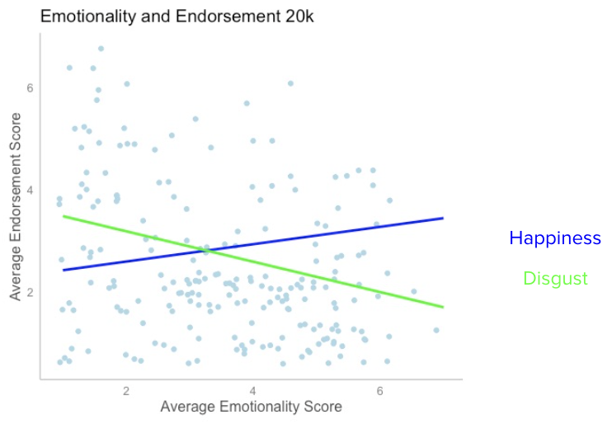

**1 Million**

At 1 million casualties, there was a collective significant effect of the emotions (F(7, 203) = 5.497, p < .001, R2 = .1304). The individual predictors were examined further and indicated that disgust (t = -3.491, p < .001) and guilt (t = 3.354, p < .001) were significant predictors in the model. See appendix figure 42.

**Figure 10.**

*Participants’ averaged emotionality score (happiness, sadness, anger, disgust, guilt, shame, and fear) vs**their average endorsement at the 1 million casualty level.*

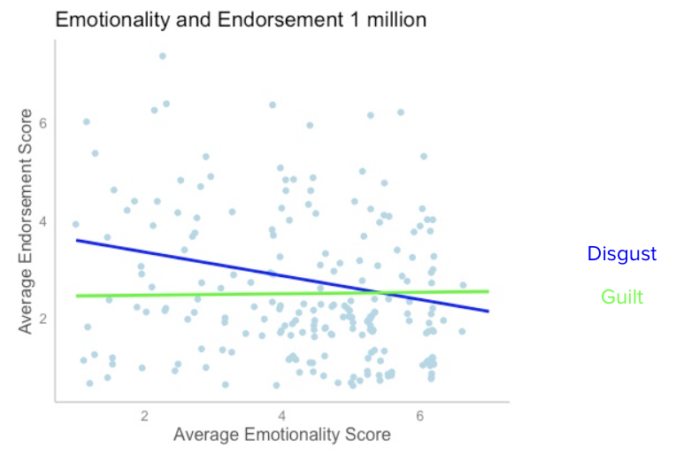

**Discussion**

**Emotion and Moral Vigilance**

The results examining emotionality’s predictive nature regarding perceived morality among participants mimic that of the previous studies mentioned, with general emotionality demonstrating a statistically significant influence in relation to moral judgements– (Turner & Stets, 2006: Tangney et al., 2007: Shuman et al., 2013). Although, while further analysis regarding general moral judgements consistently returned a strong effect between disgust and moral perception as previous research exhibited (Landy et al., 2015), our results did not support the previous results that demonstrated an effect between shame, guilt, and general moral judgements (Tangney et al., 2007). The failure to determine a significant relationship between shame, guilt and general moral judgements could be explained by the two emotions’ tendency to be conflated. As mentioned by Turner & Stets, shame and guilt are often misunderstood, which in theory could have influenced the participants perception of the two emotions leading to each being seen as less influential and thus negatively impacting their effect regarding general moral perception.

**Emotion and Individual Moral Foundations**

Further, while our initial results did not mirror previous studies in respect to guilt and shame, further analysis of the individual moral precepts found that disgust, guilt, happiness, anger, shame, and fear all held a significant effect with at least one or more foundational pillars. Moreover, as predicted guilt, anger, and shame held strong individual relationships within several levels of the examined moral foundations proposed by Haidt. Guilt’s strongest effect was in relation to loyalty as the only significant predictor of that foundation at all levels (p < .01). Guilt was further found to have the strongest influence on participants’ level of endorsement at each casualty level. Anger was found to have the strongest interaction when examining care at the 1 million level (p < .001). Lastly, as predicted, shame held its strongest effect in relation to liberty at the 20k level (p < .01). Disgust’s strongest effect was in relation to general moral judgment rather than any of the individual foundations. Now, previous research has demonstrated that negatively valanced emotions are typically more influential in regard to moral judgements with disgust, shame, guilt, and anger having the strongest effects (Turner & Stets, 2006: Plaks et al., 2021) which was consistent with our results. Anger (righteous anger) and guilt are considered other-centered emotions and as such it follows that their strongest relationships would be in relation to similarly other-focused moral foundations, care, and loyalty (Shuman et al., 2013). Consequently, shame and disgust, while both of which are considered self-centered emotions, only shame held its strongest significant effect in connection to a similarly self-centered moral foundation liberty, with disgust having the largest effect on moral judgments in general. Happiness and fear held smaller significant relationships, again illustrating the influence that valance holds over individual emotions in relation to moral foundations, with happiness relating to liberty and fear connecting significantly to authority (Zarinpoush et al., 2000 & Turner & Stets, 2006).

**Emotion and Nuclear Endorsement**

Lastly, our analysis examining participants level of affect in relation to their level of endorsement for the retaliatory strike did support our hypothesis as disgust demonstrated a strong effect at each casualty level (p < .001) and guilt was found to be predictive at the 1 million casualty level. Both of these results indicated that as a participant’s level of guilt and disgust increased, their endorsement for the retaliatory strike decreased. Additionally, while an effect between the level of endorsement, guilt and disgust appeared as we expected we did find two surprising effects. Further analysis found that happiness was strongly correlated within the 20,000 casualty level. It was found that as a participant’s level of happiness increased so did their level of endorsement for the retaliatory strike. Previous research has not demonstrated a relationship of this manner, although there is literature that could be attributed to why this relationship was found. Happiness is an emotion that has both other-suffering and self-conscious aspects (Haidt, 2003, Graff et al., 2016), and as such focus on both how others would be affected as well as how the participant is affected. If as a participant’s level of happiness increases their level of endorsement increases it could potentially be understood through the elation felt in ending the conflict (Zarinpoush et al., 2000, Turner & Stets, 2006).

**Study 2**

In study 2, we sought to directly manipulate emotionality in the decision-making process by priming participants to consider the role of emotions in their decision before responding.

**Methods**

**Participants**

140 participants were recruited from the University of Colorado Boulder general psychology subject pool to participate in our online survey. Participants ranged in age from 18 to 31 years old (*M* = 19.21, *SD* = 1.61).

**Procedure**

Our study included two conditions with one half of the participants being part of the control group which mirrored the flow presented within the first study. In this condition, participants were first presented with the same scenario from the first study followed by questions seeking their level of support for a retaliatory nuclear strike at three levels beginning at 100,000 casualties then either decreasing to 20,000 or increase to 1 million deaths. All three levels were displayed to participants, however the level that followed 100k was randomized. The students were then asked to evaluate–using a likert scale (1 being no influence, 7 a strong influence)–the level at which their emotions influenced their decision to either support or oppose the strike-- “Recall your response about how much you would oppose or support the strike when the Iranian civilian death toll was 100,000. To what extent did your emotional reaction influence your decision to support or oppose the proposed strategy?”. The last set of questions they were asked to answer was the emotion matrix pulled from study 1 that included 7 emotions–happiness, sadness, anger, disgust, shame, guilt, and fear–asking to what level each of the individual emotions influenced their previous decisions at each of the three levels from the first scenario.

Now, the manipulation condition altered this flow, presenting participants with the 3 questions examining to what extent they felt their emotion would influence their support for the strike at each casualty level (“To what extent would your emotional response influence your decision to support or oppose the proposed strategy if the Iranian civilian death toll was 100,000?”) using a likert-scale with 1 being no influence and 7 being a very strong influence, followed by the emotion matrix questions. After answering these two groups of questions they were then shown the initial set of questions regarding their support for the nuclear strike at 100k deaths and the two subsequent endorsement questions with the level of deaths decreasing to 20k, then increasing to 1 million or vice versa.

**Measures**

**Endorsement measure**

Our study’s endorsement measure drew from a previous study designed by Sagen and Valentino in 2017. Our measure asked participants to evaluate their level of endorsement relation to a scenario calling for a retaliatory nuclear strike resulting in the death of 100,000 civilian initially. Which was then followed by the number of deaths decreasing to 20,000 before lastly increasing to 1 million. This measure implemented a 7-point likert scale with 1 representing a strong opposition to the strike and 7 demonstrating strong support for the strike. See appendix Figure 16.

**Emotion measures**

The study included two measures examining participants emotional influence in relation to the given scenario. The first measure utilized a 7-point likert scale with 1 = no influence and 7 = a strong influence in response to questions examining their perceived emotional influence on their endorsement scores at each of the three levels (100k, 20k, and 1 million civilian deaths).

The second measure also included three questions in relation to the three levels presented by the scenario of our first measure. It further included an emotion matrix the included 7 emotions: happiness, sadness, guilt, anger, guilt, shame, and fear, along a 7-point likert scale mirroring that of the previous measure with 1 = no influence and 7 = a strong influence. See appendix figure 17.

In order to examine each of the relationships, multiple multilinear regressions were performed. Further, the study used Qualtrics ([http://www.qualtrics.com](http://www.qualtrics.com/)) to create and administer the survey questions and a free version of RStudio Cloud (<https://rstudio.cloud/plans/free>) was used to analyze the data.

**Results**

This study implemented several linear regressions to determine if priming participants to increase their affect towards the given scenario would limit the impact of the psychic numbing effect. Results of the first [linear regression](https://www.statisticssolutions.com/free-resources/directory-of-statistical-analyses/what-is-linear-regression/) demonstrated that there was not a significant effect between the condition (Manipulation vs Control) and participants' support for the retaliation strike at the initial 100k level (*R^2* = .01443, *F*(1, 138) = 2.02, p > .05). Further analysis also revealed that there was not a significant effect between the control and manipulation groups at the 20k nor the 1 million casualty levels, reporting (*R^2* = .0043, *F*(1, 138) = .5966, p > .05) and (*R^2* = .0049, *F*(1, 138) = .6852, p > .05) respectively. See appendix figures 46 – 48.

**Figure 12.**

*Participants’ average level of endorsement for the presented scenario calling for 20,000 deaths separated by experimental conditions (manipulation and control). The error bars represent the standard deviation for participants’ level of endorsement.*

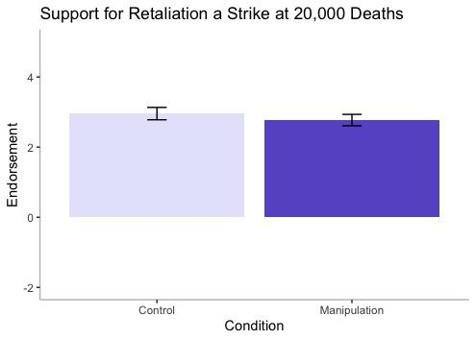

**Figure 13.**

*Participants’ average level of endorsement for the presented scenario calling for 100,000 deaths separated by experimental conditions (manipulation and control). The error bars represent the standard deviation for participants’ level of endorsement.*

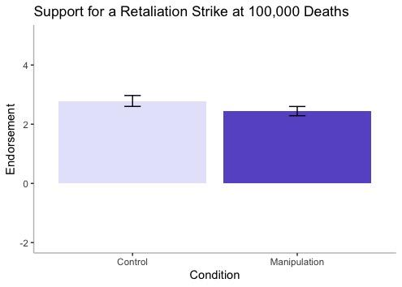

**Figure 14.**

*Participants’ average level of endorsement for the presented scenario calling for 1 million deaths separated by experimental conditions (manipulation and control). The error bars represent the standard deviation for participants’ level of endorsement.*

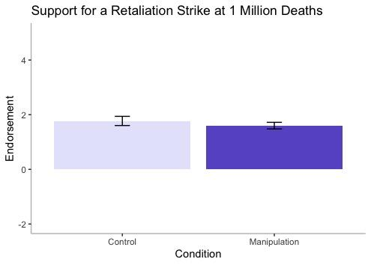

As there was no significant effect between the control and manipulation groups within any of the three levels of severity, further analysis was run to examine if there were any significant interactions between condition and the effect of emotion rating on nuclear retaliation endorsement. The first regression determined that there was a significant condition by emotion interaction effect for both happiness and disgust in relation to endorsement for the relation strike at the 100k levels (*R^2* = .19, *F*(15, 124) = 3.197, p < .001). The interaction was such that happiness had a stronger effect on strike endorsement in the control condition and disgust had a stronger effect in the manipulation condition. A result that was further found significant at the 1 million level. The second regression illustrated the same interaction effect for condition and the effect of happiness (p < .001) and disgust (p < .05) in relation to endorsement for the relation strike at the 1 million casualty level (*R^2* = .35, *F*(15, 124) = 6.091, p < .001). The results of the third linear regression analysis further demonstrated a significant interaction effect by condition for effect the of disgust and shame on endorsement for the relation strike at the 20k level (*R^2* = .27, *F*(15, 124) = 4.46, p < .001). The effect was such that the effect of disgust and shame on retaliation endorsement was lower in the control condition. However, only one interaction was found to be statistically significant once conditions were applied, with happiness at the 1 million level retaining its significant effect (p < .05). See appendix figures 43 - 45.

**Figure 15.**

*Participants’ averaged emotionality score (happiness, sadness, anger, disgust, guilt, shame, and fear) vs**their average level of endorsement at the 1 million deaths level controlled for by condition.*

**Discussion**

The study sought to determine if priming individuals to evoke higher levels of affect at greater magnitudes of severity would reduce the impact the psychic numbing effect has displayed in previous studies. The hypothesis proposed that participants within the manipulation group would report lower support for the scenario at all three magnitudes of severity, however the study failed to reject the null hypothesis as there was no statistically significant difference between the control and manipulation groups. Although the results failed to reject the null hypothesis, demonstrating no significant difference between the control and manipulation groups within any of the levels (20k, 100k, 1 million) our analysis did illustrate a pattern that could potentially lead to a significant effect within a larger sample.

Comparing the means between the manipulation and control groups found that participants who were primed to consider the scenario with a higher level of affect reported lower support for the retaliation strike at each level. The means being 2.96 (control) and 2.77 (manipulation), 2.79 (control) and 2.44 (manipulation), lastly 1.77 (control) and 1.6 (manipulation) at the 20k, 100k, and 1 million levels respectively illustrating a pattern of increased affect even at higher magnitudes of severity. This pattern appears to oppose previous literature on the psychic numbing effect as the average support for the strike decreases as the magnitude of the situation increases steadily (Slovic et al., 2007: Slovic et al., 2013: Fetherstonhaugh et al., 1997). However, unlike most research on the psychic numbing effect, we manipulated casualties within subjects rather than between subjects. Thus, participants may have anchored on the 100k casualty level and adjusted their estimates in relation to that due to having a clear comparison level.

When examining emotionality’s influence controlling for condition, it was found that there was a significant interaction between the conditions and happiness at the 1 million deaths level, with happiness displaying a steeper slope within the control group than within the manipulated group. As such the results demonstrated that as participants reported level of happiness increased so did their endorsement of the retaliation strike. Our findings were not consistent with previous research surrounding the dual process theory (Osman, 2004), as there were significant interactions between individual emotions and participants’ endorsement of the retaliation strike at each level demonstrating a larger effect of emotion influencing evaluative decision-making processes. Therefore, similar to our findings in study 1, our research is more consistent with the appraisal and somatic marker theories that propose an interaction between emotion networks and normative decision-making models. Although, as we did not see a large difference between the conditions as the magnitude increased our results were slightly consistent with Hsee and Rottenstreich’s findings illustrating a decreased level of sensitivity after the initial interaction.

**General Discussion**

As mentioned earlier, normative decision-making models often deemphasize the influence emotion has on intra/intersocial behaviors, decisions, and in the psychic numbing effect. The results of both studies illustrated a significant relationship between emotion and decision-making frameworks (moral judgements and endorsement strategies), consistent with both the appraisal and somatic markers theories (So et al., 2015: Lerner et al. 2015: Bandyopadhyay et al., 2013). Further, although we did not see a significant effect between the level of endorsement and the experimental conditions in study two, there is indication that within a larger sample there could be an effect of our manipulation. Several individual emotions were found to be marginally significant (happiness, disgust, guilt, and fear) and our initial analysis determined that there was a pattern of lower endorsement for participants within the manipulated condition.

However, our analysis from study 2 examining the participants level of support in relation to their level of affect mirrored that found in study one. Both results found that happiness and disgust were strongly correlated at several casualty levels (p < .001), illustrating that as a participant’s level of disgust increased their level of support for the strike dropped, replicating previous research (Turner & Stets, 2006: Landy et al., 2015). Additionally, we found participants’ level of support increasing as their level of happiness increased, a relationship that previous research had not found.

Further, there were two strong effects found through further analysis within study 2 that demonstrated a connection to the results found within study 1. Results from study 2 illustrated a strong effect between disgust and participants' endorsement of the strike. This result follows from early research and the findings of our own initial study, as the decision to endorse a retaliatory strike resulting in the deaths of 20,000 - 1 million people would intuitively evoke a moral violation (causing death). The results found that as a participant's level of disgust rose their support for the strike (all three levels of magnitude) decreased, although once controlling for condition the effect was found to have been marginal. An unexpected result arose when further analyzing the relationship between individual emotions and participants' endorsement in relation to the conditions, finding that happiness was often statistically significant. Happiness within the first study was found to have a limited effect within the moral foundation liberty (p < .05), while not exhibiting any other effects, making its strong effect on participants' endorsement (all three levels) within study 1 and 2 intriguing. Previous literature surrounding happiness's effect within normative decision-making models and moral judgements is limited, with most examining the relation between happiness as a mood rather than a valanced emotion (Zarinpoush et al., 2000).

There are several avenues in which future research can continue to examine the manner that emotion influences moral judgements and further the psychic numbing effect. The first being a repetition of study two with an increased sample size to better discern if there was a viable difference between the manipulation and control groups in priming the participants level of affect. Additionally, as there was a significant difference between the control and manipulation groups in respect to happiness and disgust, future research could narrow the scope of emotions included within the study to target this effect more directly. Drawing from research completed by Slovic as well as Hsee and Rottenstreich’s theory of valuation by feeling, further research could examine if framing the questions surrounding endorsement to include an increased focus on affect would better limit the psychic effect, similarly to the results found by Fetherstonhaugh. Another avenue in which future research could expand would be to cater the frame of moral judgements to directly evoke external vs internal appraisal networks and moreover positively vs negatively valanced emotions (Shuman et al., 2013).

Finally, there were several limitations that both studies suffered from stemming mainly from the small sample size. The sample size of subjects who engaged in each of the studies were relatively small, consequently constricting the power and generalizability of the study. Further, there was not a large amount of demographic variation within the two samples creating a homogenous group lacking diversity that could have influenced the results of both study 1 and 2. Another limitation was that the manner in which the questions inquiring about participants' moral judgements were not controlled for which valance they would evoke. This is partially due to moral judgements being determination of norm violations, however, future research could include moral judgements that were designed to evoke positively valenced emotions such as asking participants to rate how morally right or wrong would: “A man helping an older woman cross a busy street”. As our study focused on the measures previous established by Haidt we did not include any moral judgements simply controlling for valence and as such, negatively valanced emotions were unequally favored causing positively valanced emotions’ influence on moral judgements was not adequately considered.

**Conclusion**

In conclusion, our first study found that disgust held a significant effect in relation to both participants averaged moral vigilance and their level of endorsement for each casualty magnitude, supporting an aspect of our hypothesis and further supporting previous research. We further determined that while shame, anger and guilt did not hold a significant effect in connection to participants averaged moral vigilance, as previous research had demonstrated, they each held a significant relation to one or more of the individual moral foundations. Moreover, our first study indicated that happiness also significantly influenced participants level of endorsement (all three causality levels) which was mimicked by the findings of our second study. Our second study again mirrored the findings of our first study with disgust having a significant effect on participants level of endorsement within each casualty level. In study 2, when controlling for condition we did not find any significant differences between the control and manipulation groups when examining participants level of endorsement at each of the three levels. Although we did see that at each level the participants within the manipulation group reported lower support for retaliatory strike. Furthermore, there was one significant condition by emotion interaction effect. We found that happiness displayed a steeper slope within the control group than within the manipulated groups at the 1 million casualty level. We hope that future research includes a larger sample size, and further that it narrows the scope of emotions included within the study to target the effects this study found more directly. In doing so we hope that future research is better able to discern how emotion could influence moral judgements and further limit the effects of psychic numbing, thus allowing individuals to more accurately evaluate the loss of life at larger magnitudes.

References

Araque, O., Gatti, L., & Kalimeri, K. (2021). The language of liberty: A preliminary study. *Companion Proceedings of the Web Conference 2021*. https://doi.org/10.1145/3442442.3452351

Bandyopadhyay, D., Pammi, V. S. C., & Srinivasan, N. (2013). Role of affect in decision making. *Progress in Brain Research*, 37–53. https://doi.org/10.1016/b978-0-444-62604-2.00003-4

Ben-ze’ev, A. (1997). Emotions and morality. *The Journal of Value Inquiry*, *31*.

Dalgleish, T., Power, M., & Ekman, P. (2005). Basic Emotions. In *Handbook of Cognition and Emotion* (pp. 45–55). essay, Wiley Interscience.

Damm, L. (2010). Emotions and moral agency. *Philosophical Explorations*, *13*(3), 275–292. https://doi.org/10.1080/13869795.2010.501898

De Graaff, M. C., Schut, M., Verweij, D. E. M., Vermetten, E., & Giebels, E. (2014). Emotional reactions and moral judgment: The effects of morally challenging interactions in military operations. *Ethics & Behavior*, *26*(1), 14–31. https://doi.org/10.1080/10508422.2014.975815

Fetherstonhaugh, D., Slovic, P., Johnson, S. *et al.* Insensitivity to the Value of Human Life: A Study of Psychophysical Numbing. *Journal of Risk and Uncertainty* 14, 283–300 (1997). <https://doi.org/10.1023/A:1007744326393>

Haidt, J. (2003). The moral emotions. In R. J. Davidson, K. R. Scherer, & H. H. Goldsmith (Eds.), *Handbook of affective sciences* (pp. 852–870). Oxford University Press.

Haidt, J., & Bjorklund, F. (2007). Social intuitionists answer six questions about moral psychology. *Moral Psychology*. https://doi.org/10.7551/mitpress/7573.003.0006

Landy, J. F., & Goodwin, G. P. (2014). Does incidental disgust amplify moral judgment? A meta-analytic review of experimental evidence. *PsycEXTRA Dataset*, 10(4), 518–536. https://doi.org/10.1037/e573552014-059

Lerner, J. S., Li, Y., Valdesolo, P., & Kassam, K. S. (2015). Emotion and decision making. *Annual Review of Psychology*, *66*(1), 799–823. https://doi.org/10.1146/annurev-psych-010213-115043

Lifton, R. J. (1975). On death and the continuity of life: A psychohistorical perspective. *OMEGA - Journal of Death and Dying*, *6*(2), 143–159. https://doi.org/10.2190/1e3d-35h3-644d-3a6k

Lifton, R. J. (1982) . Beyond psychic numbing: A call to awareness. American Journal of Orthopsychiatry, 52, 619-629.

Osman, M. (2004). An evaluation of dual-process theories of reasoning. *Psychonomic Bulletin & Review*, *11*(6), 988–1010. https://doi.org/10.3758/bf03196730

Sagan, S. D., & Valentino, B. A. (2017). Revisiting Hiroshima in Iran: What Americans really think about using nuclear weapons and killing noncombatants. *International Security, 42(1), 41–79.* [*https://doi.org/10.1162/ISEC_a_00284*](https://doi.org/10.1162/ISEC_a_00284)

Shuman, V., Sander, D., & Scherer, K. R. (2013). Levels of valence. *Frontiers in Psychology*, *4*. https://doi.org/10.3389/fpsyg.2013.00261

Slovic, P. (2007). "If I look at the mass I will never act": Psychic numbing and genocide. *Judgment and Decision Making*, 2(2), 79-95. Retrieved from https://colorado.idm.oclc.org/login?url=https://www.proquest.com/scholarly-journals/if-i-look-at-mass-will-never-act-psychic-numbing/docview/621711026/se-2

Slovic, P., Zionts , D., Woods, A., Goodman, R., & Jinks, D. (2013). Chapter 7. psychic numbing and mass atrocity. *The Behavioral Foundations of Public Policy*, 126–142. https://doi.org/10.1515/9781400845347-011

So, J., Achar, C., Han, D. H., Agrawal, N., Duhachek, A., & Maheswaran, D. (2015). The psychology of appraisal: Specific emotions and decision‐making. *Journal of Consumer Psychology*, *25*(3), 359–371. https://doi.org/10.1016/j.jcps.2015.04.003

Tangney, J., Stuewig, J., & Mashek, D. (n.d.). Moral Emotions and Moral Behavior. *Annual Review of Psychology*, *58*(1), 345–372.

Tversky, A., & Kahneman, D. (1982). Judgment under uncertainty: Heuristics and Biases. *Judgment under Uncertainty*, 3–20. https://doi.org/10.1017/cbo9780511809477.002

Turner, J. H., & Stets, J. E. (2006). Moral Emotions. In *Handbook of the sociology of emotions* (pp. 544–566). essay, Springer.

Velásquez, J. D. (1998). Modeling Emotion-Based Decision-Making.

Zarinpoush, F., Cooper, M., & Moylan, S. (2000). The effects of happiness and sadness on moral reasoning. *Journal of Moral Education*, *29*(4), 397–412. https://doi.org/10.1080/713679391

**Appendix**

**Figure 16.**

*Image of the scenario that participants were initially shown within both study 1 and study 2 (both conditions).*

**

**Figure 17.**

E*xample of the emotion matrix participants saw at the 100,000 deaths level*.

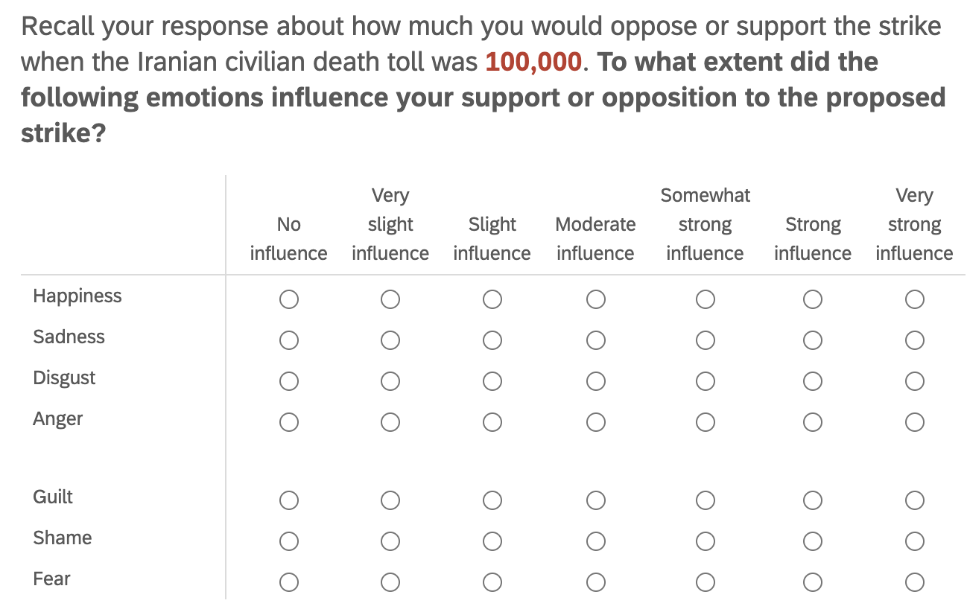

**Figure 18.**

*Example of three moral judgment evaluations drawn from Haidt’s Moral Foundation Questionnaire.*

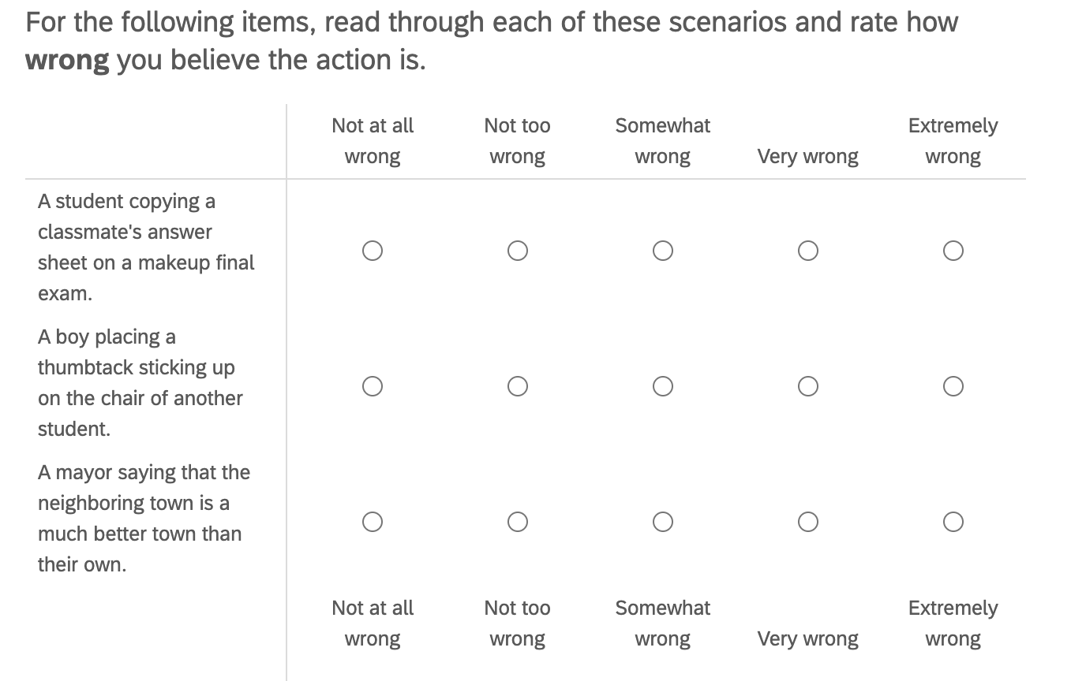

**Individual moral foundations and Emotion Analysis**

**Figure 19.**

*Analysis demonstrating the effect between emotions and overall moral vigilance at the 100k casualty level.*

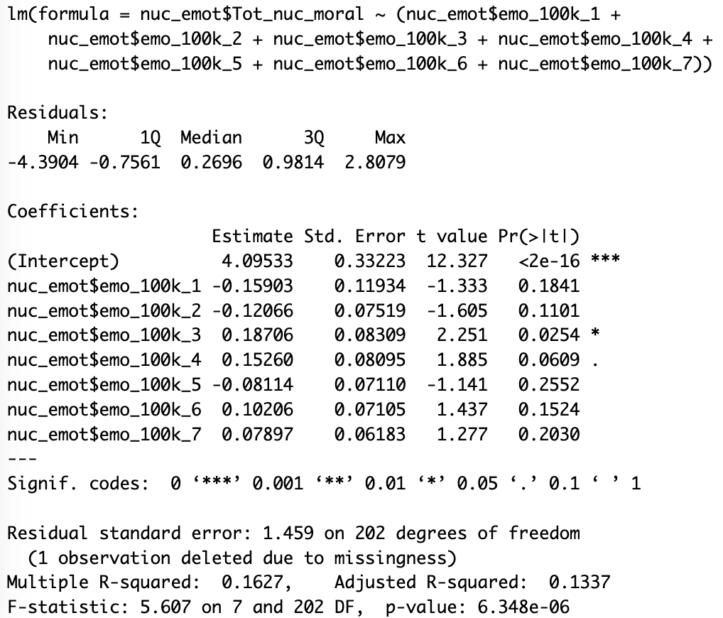

**Figure 20.**

*Analysis demonstrating the effect between emotions and overall moral vigilance at the 20k casualty level.*

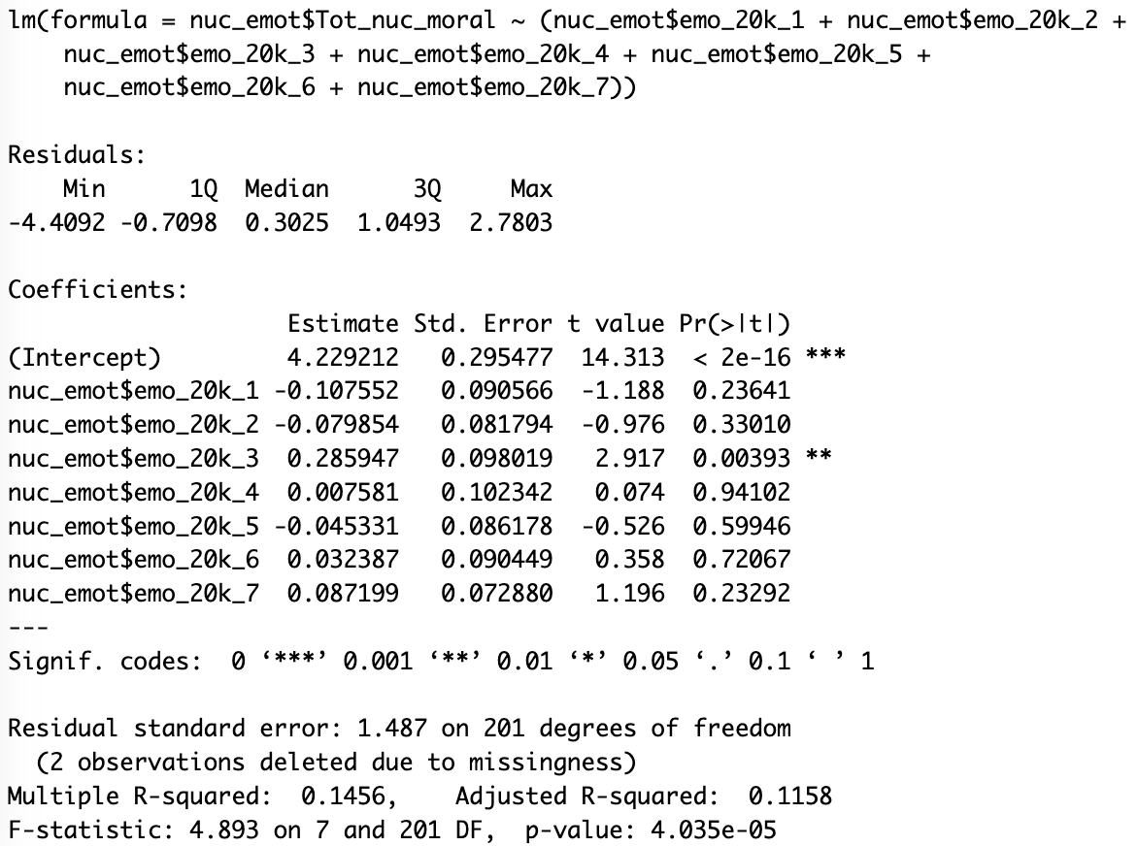

**Figure 21.**

*Analysis demonstrating the effect between emotions and overall moral vigilance at the 1 million casualty level.*

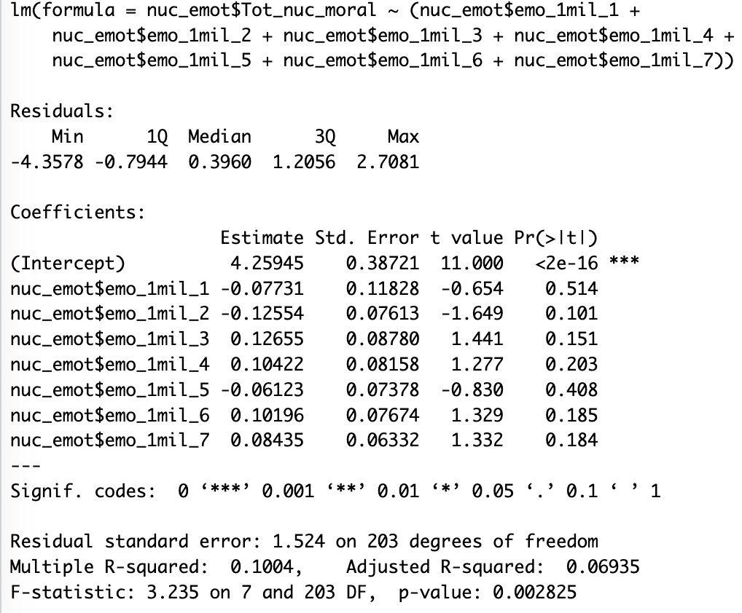

**Figure 22.**

*Analysis demonstrating the effect between emotions and Fairness at the 100k casualty level.*

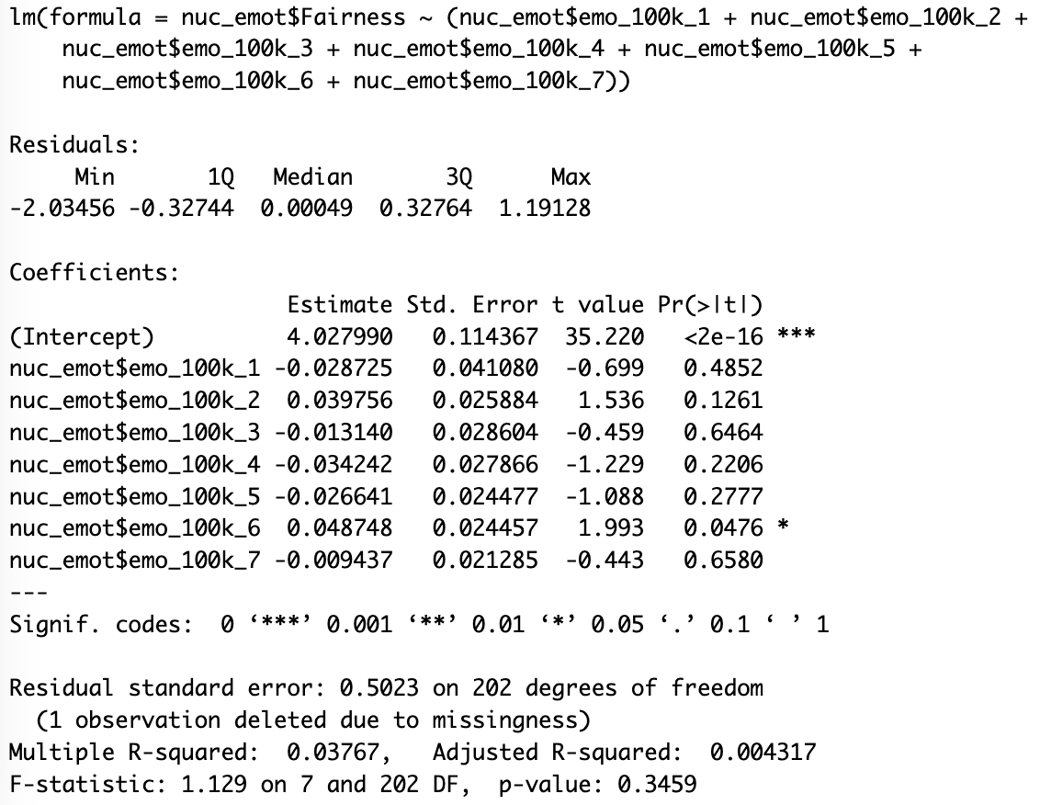

**Figure 23.**

*Analysis demonstrating the effect between emotions and Fairness at the 1million casualty level.*

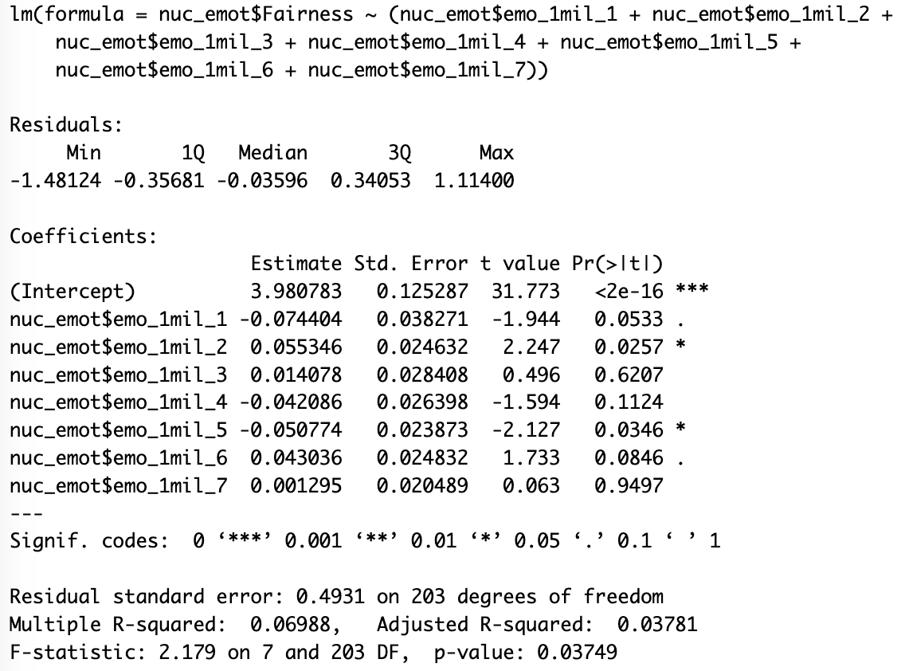

**Figure 24.**

*Analysis demonstrating the effect between emotions and Fairness at the 20k casualty level.*

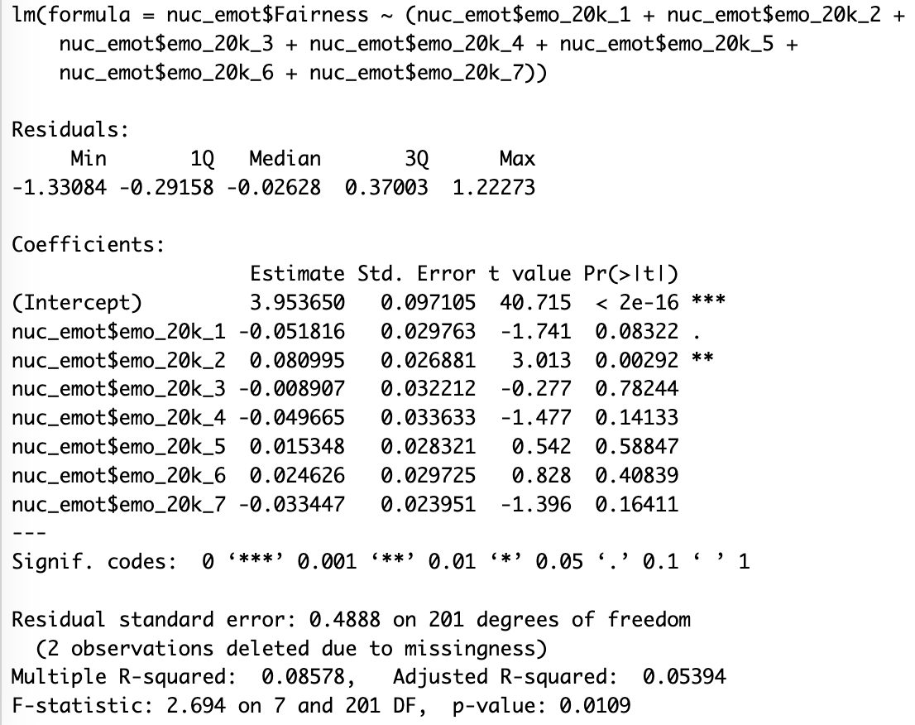

**Figure 25.**

*Analysis demonstrating the effect between emotions and Liberty at the 100k casualty level.*

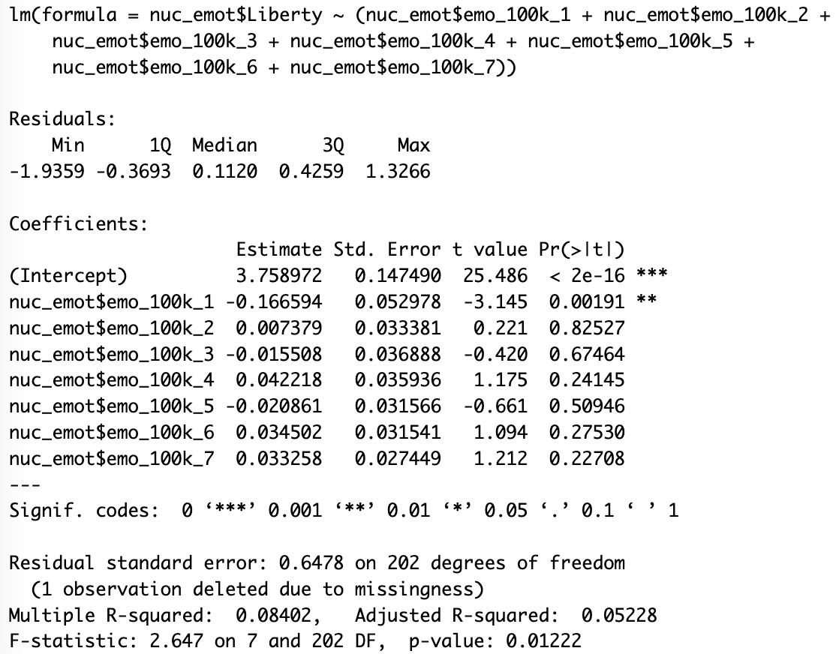

**Figure 26.**

*Analysis demonstrating the effect between emotions and Liberty at the 20k casualty level.*

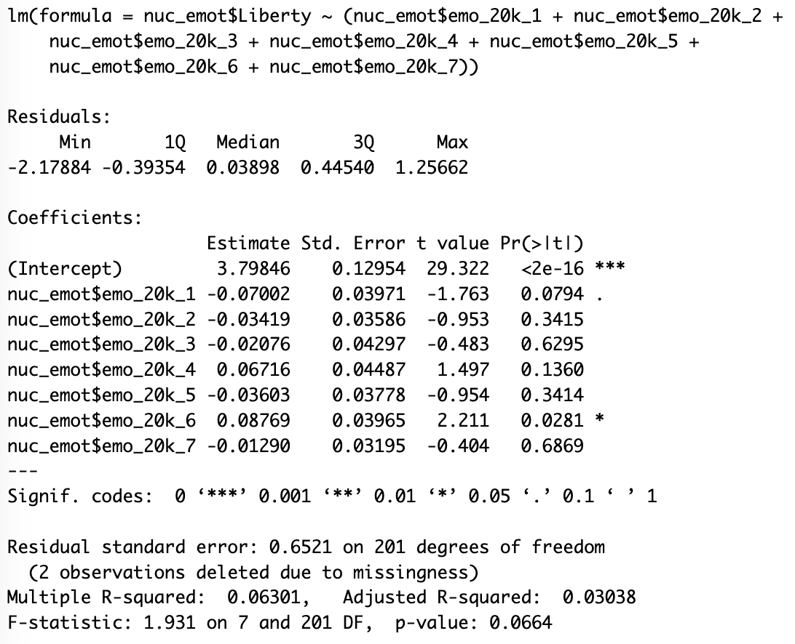

**Figure 27.**

*Analysis demonstrating the effect between emotions and Liberty at the 1 million casualty level.*

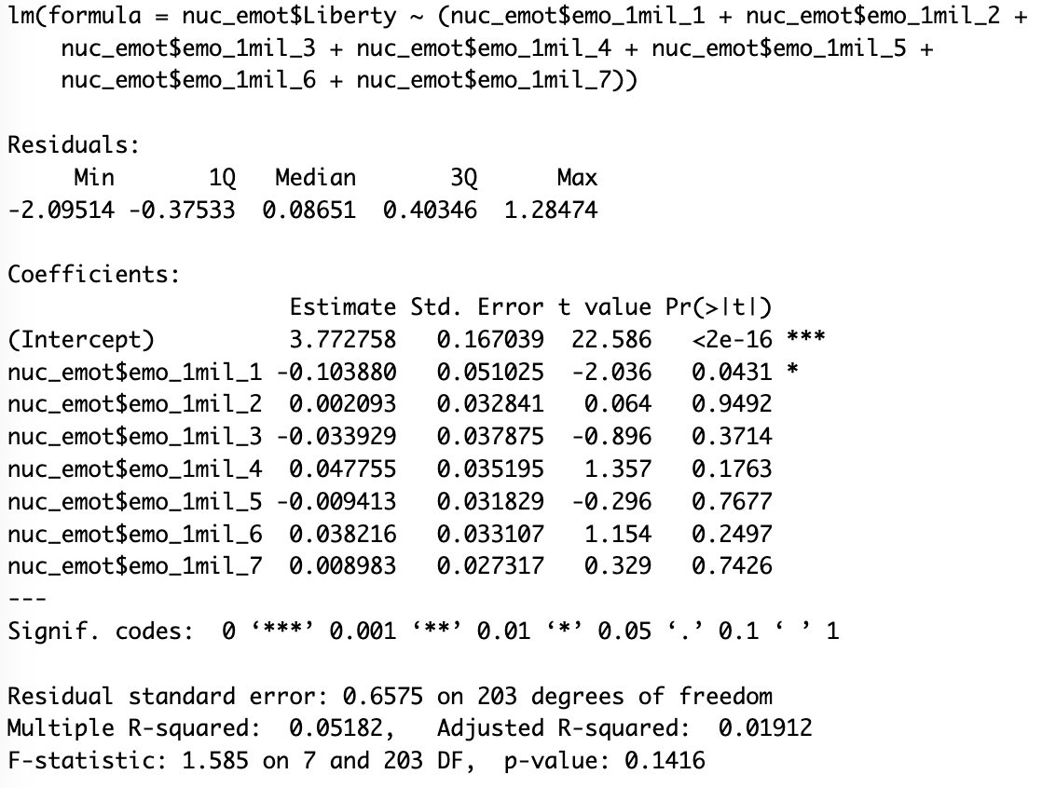

**Figure 28.**

*Analysis demonstrating the effect between emotions and Loyalty at the 100k casualty level.*

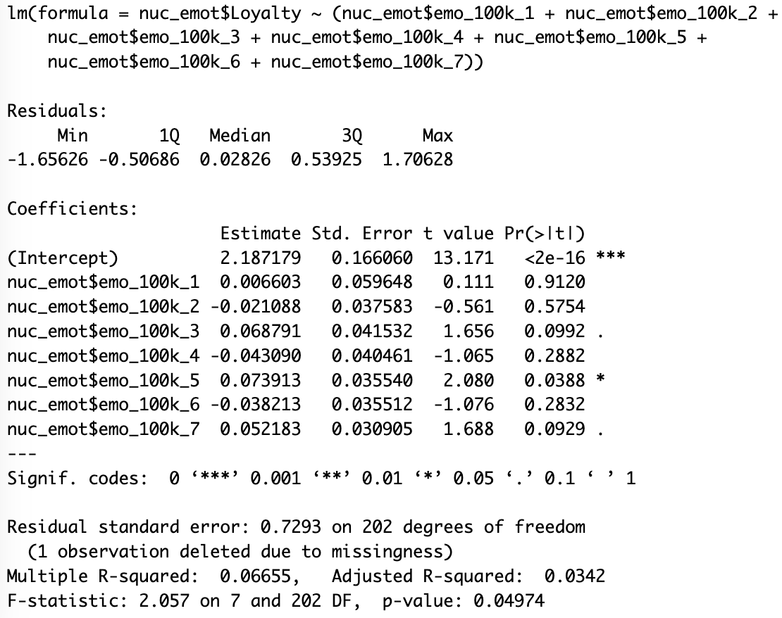

**Figure 29.**

*Analysis demonstrating the effect between emotions and Loyalty at the 20k casualty level.*

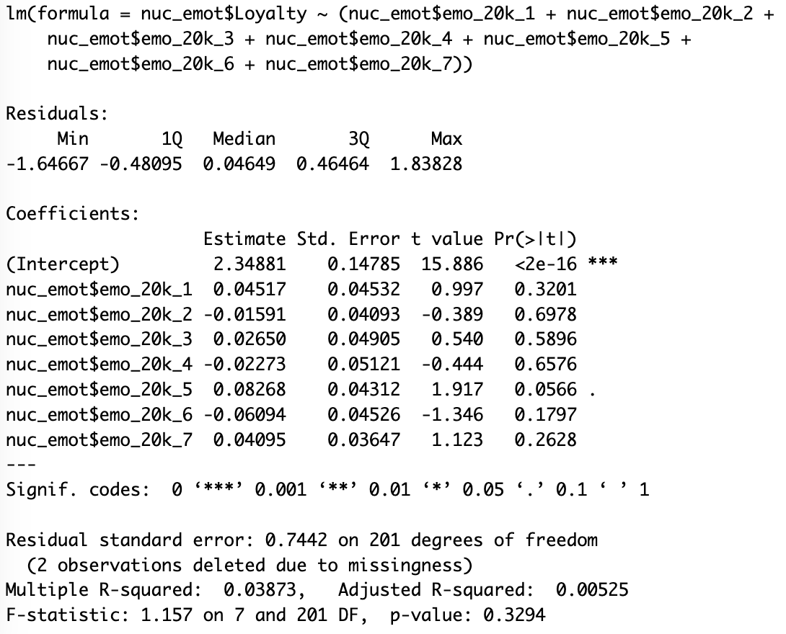

**Figure 30.**

*Analysis demonstrating the effect between emotions and Loyalty at the 1 million casualty level.*

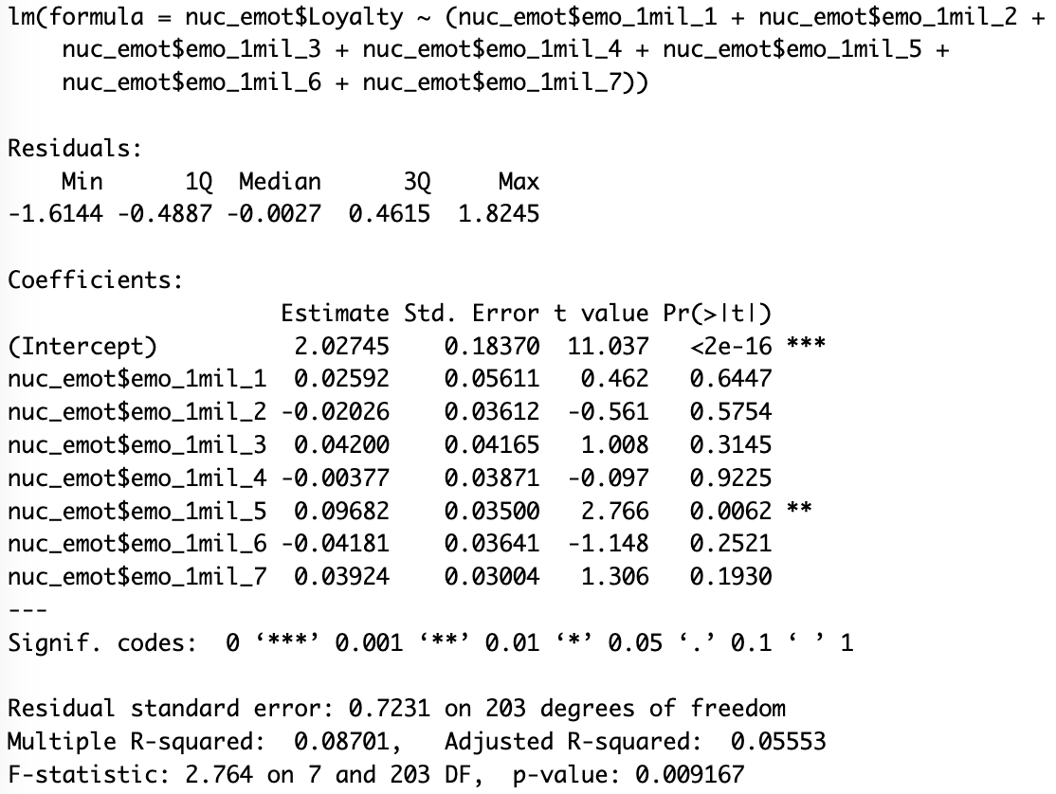

**Figure 31.**

*Analysis demonstrating the effect between emotions and Authority at the 100k casualty level.*

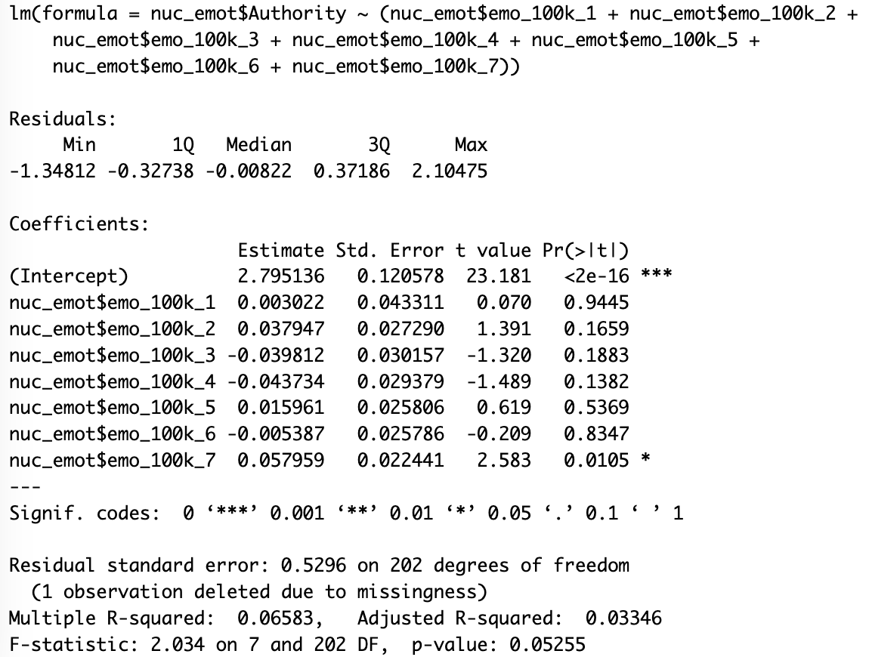

**Figure 32.**

*Analysis demonstrating the effect between emotions and Authority at the 20k casualty level.*

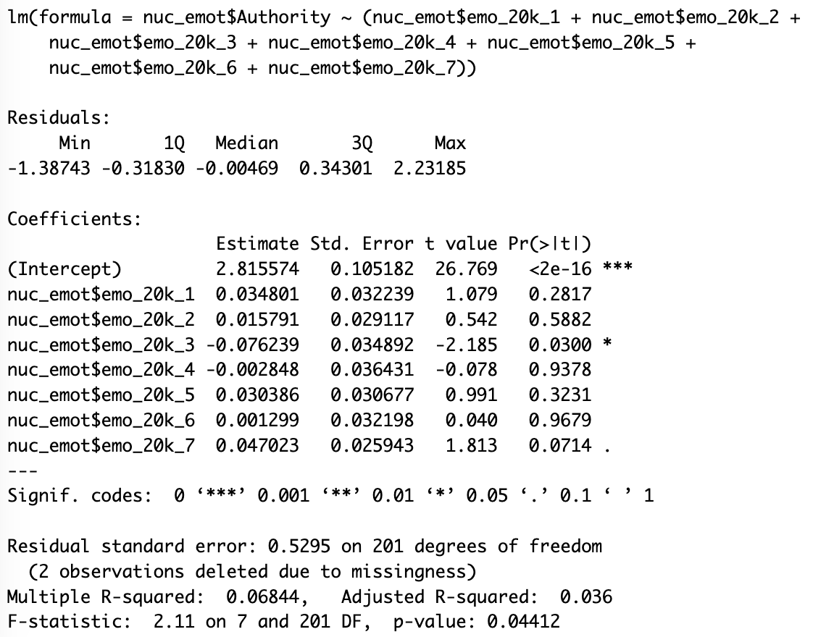

**Figure 33.**

*Analysis demonstrating the effect between emotions and Authority at the 1 million casualty level.*

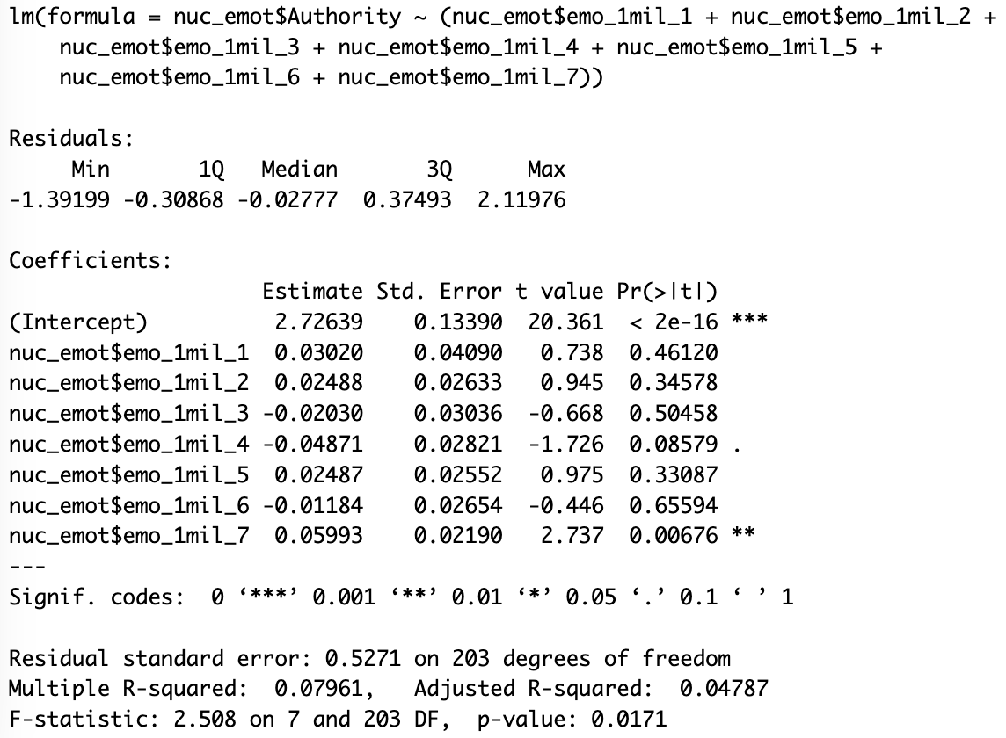

**Figure 34.**

*Analysis demonstrating the effect between emotions and Purity at the 100k casualty level.*

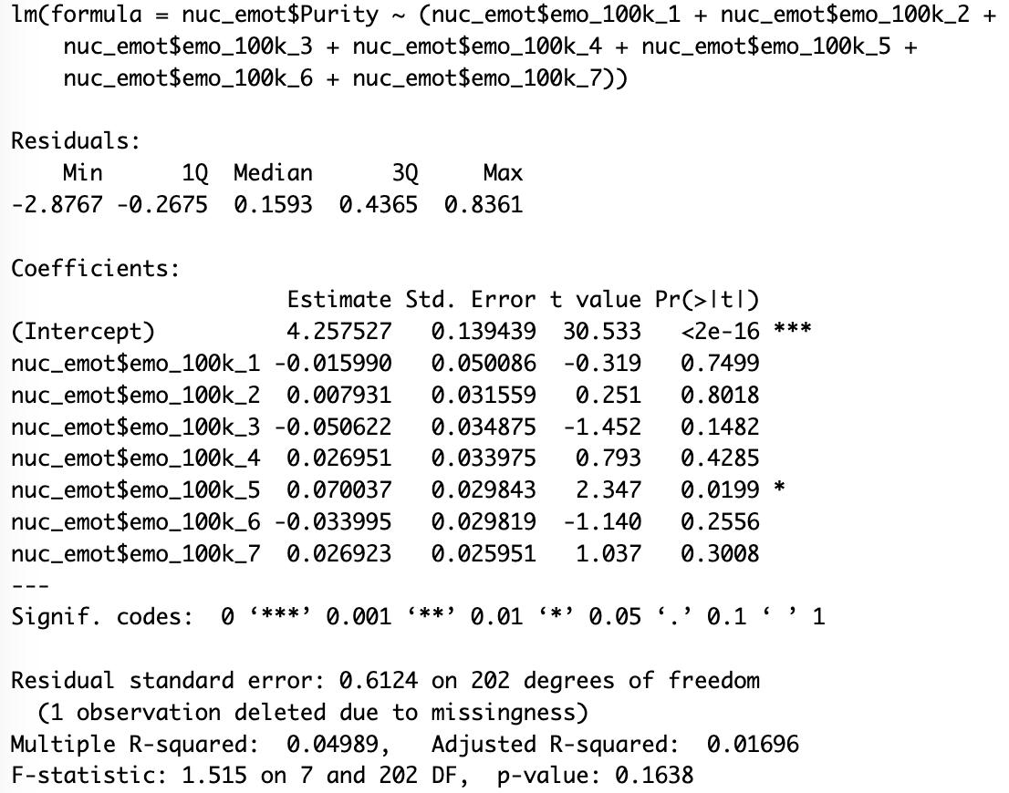

**Figure 35.**

*Analysis demonstrating the effect between emotions and Purity at the 20k casualty level.*

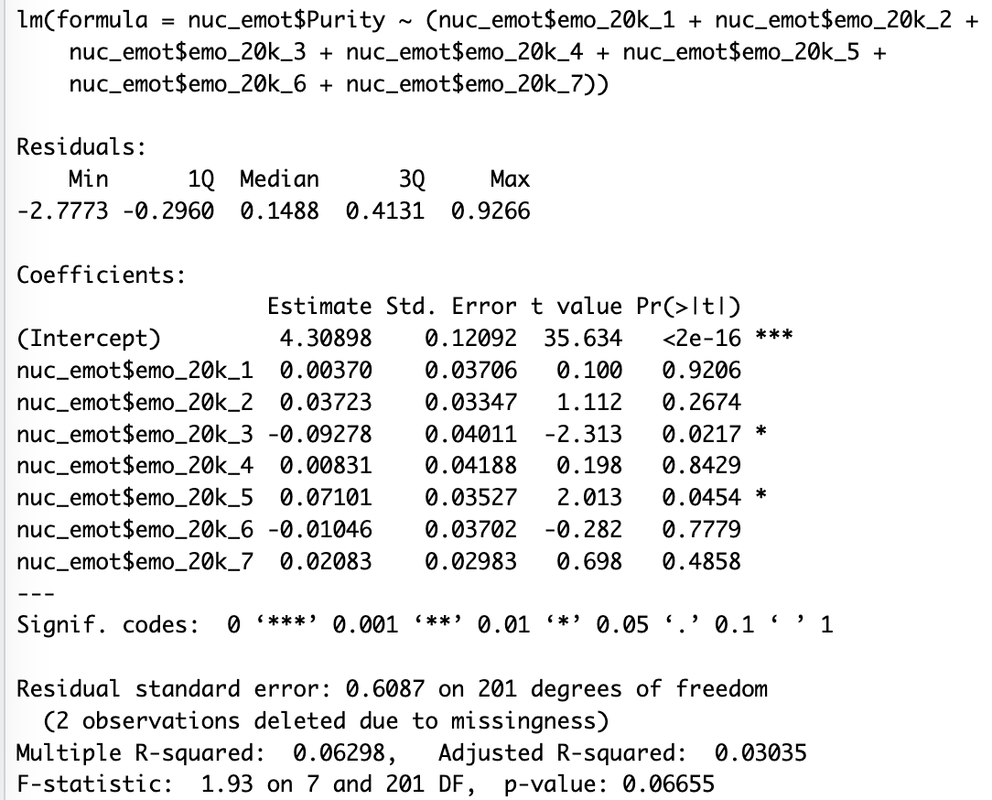

**Figure 36.**

*Analysis demonstrating the effect between emotions and Purity at the 1 million casualty level.*

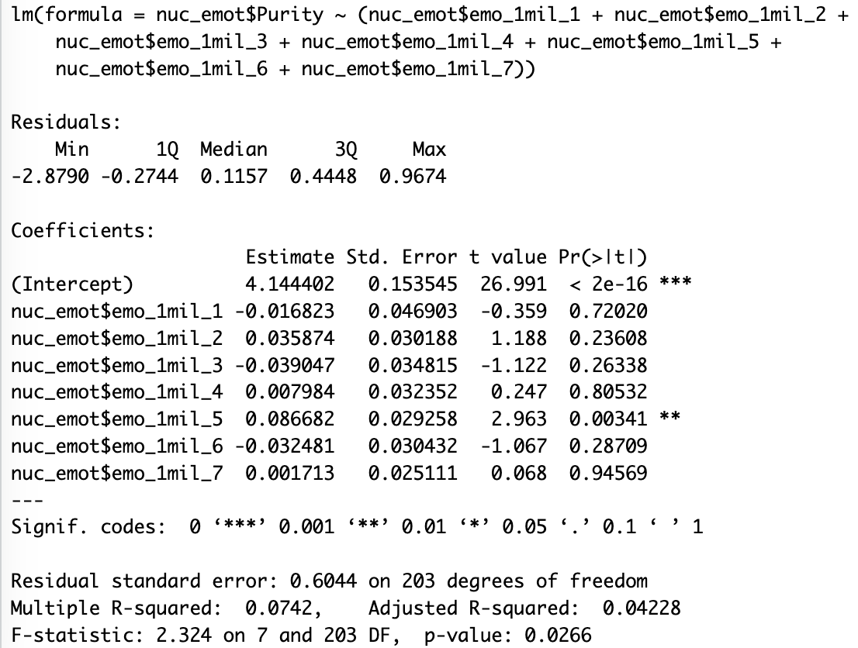

**Figure 37.**

*Analysis demonstrating the effect between emotions and Care at the 100k casualty level.*

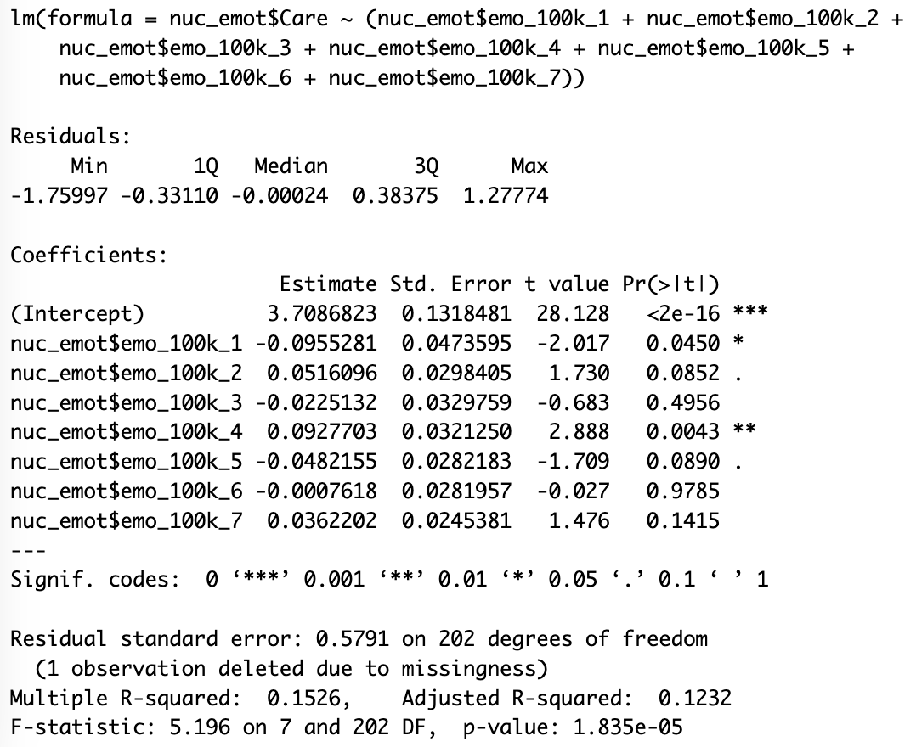

**Figure 38.**

*Analysis demonstrating the effect between emotions and Care at the 20k casualty level.*

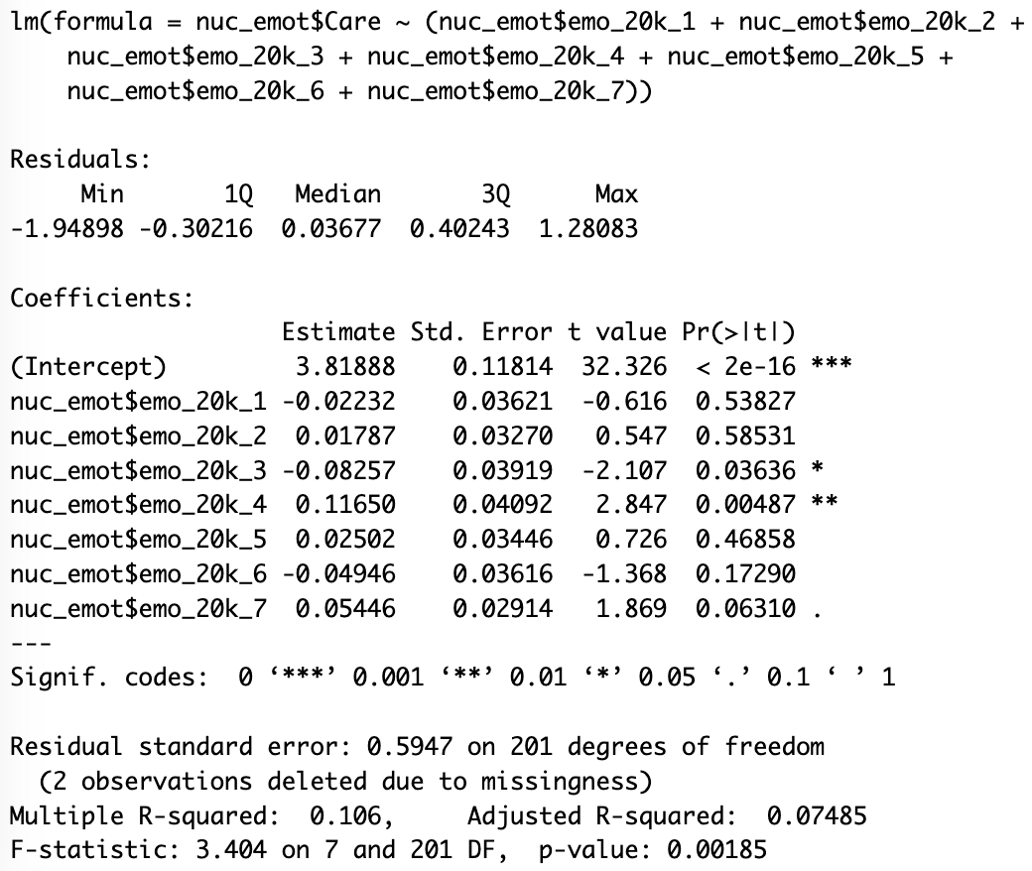

**Figure 39.**

*Analysis demonstrating the effect between emotions and Care at the 1 million casualty level.*

**Emotion and Endorsement Analysis - study 1**

**Figure 40.**

*Analysis demonstrating the effect between emotions and participants level of endorsement at the 100k casualty level.*

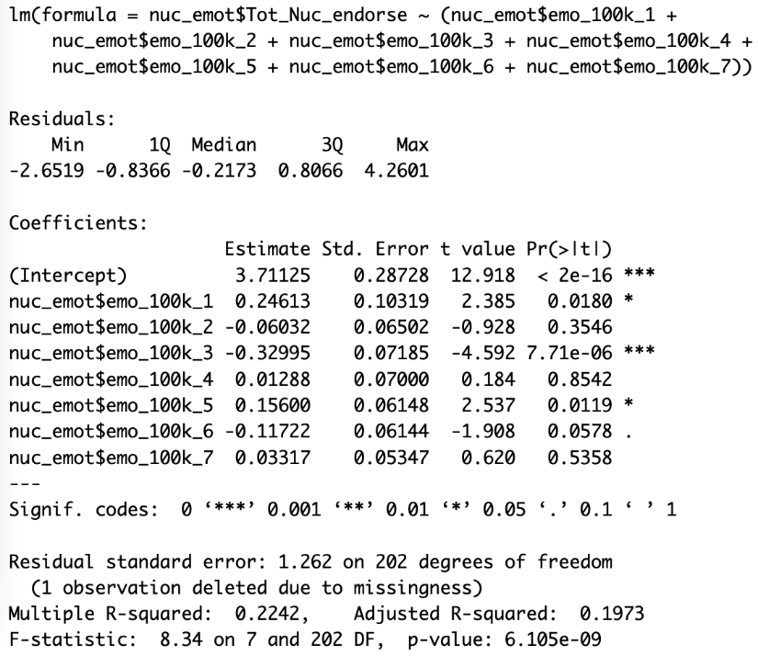

**Figure 41.**

*Analysis demonstrating the effect between emotions and participants level of endorsement at the 20k casualty level.*

**Figure 42.**

*Analysis demonstrating the effect between emotions and participants level of endorsement at the 1mil casualty level.*

**Emotion and Endorsement Analysis - Study 2 (controlled for by condition)**

**Figure 43.**

*Analysis demonstrating the effect between emotions and participants level of endorsement once controlled for by condition at the 100k casualty level.*

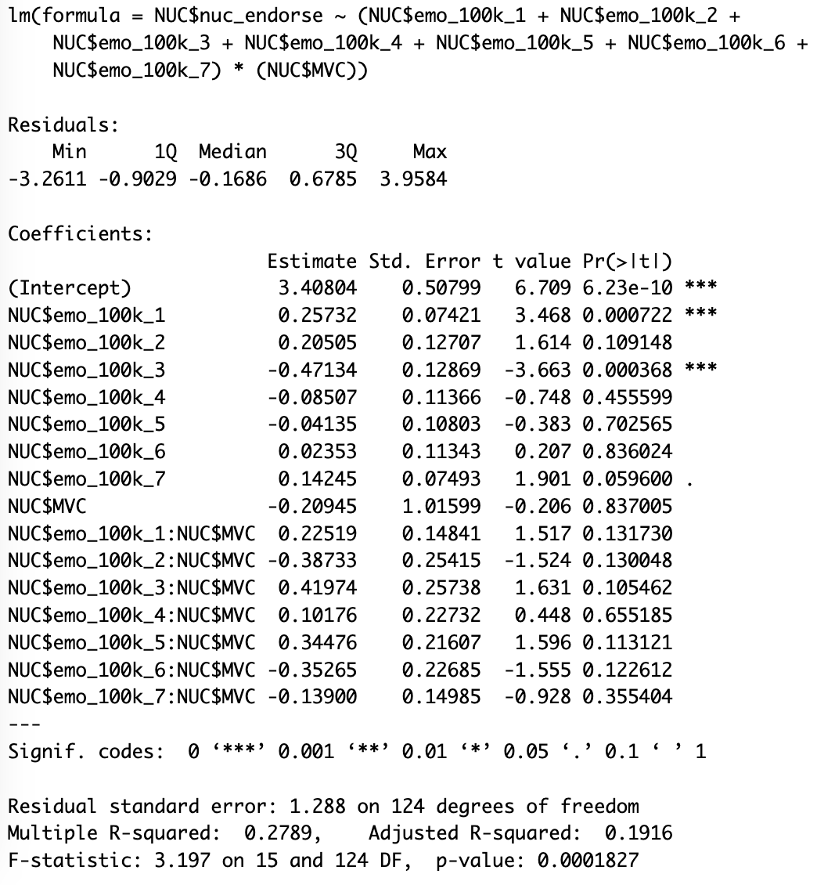

**Figure 44.**

*Analysis demonstrating the effect between emotions and participants level of endorsement once controlled for by condition at the 1 million casualty level.*

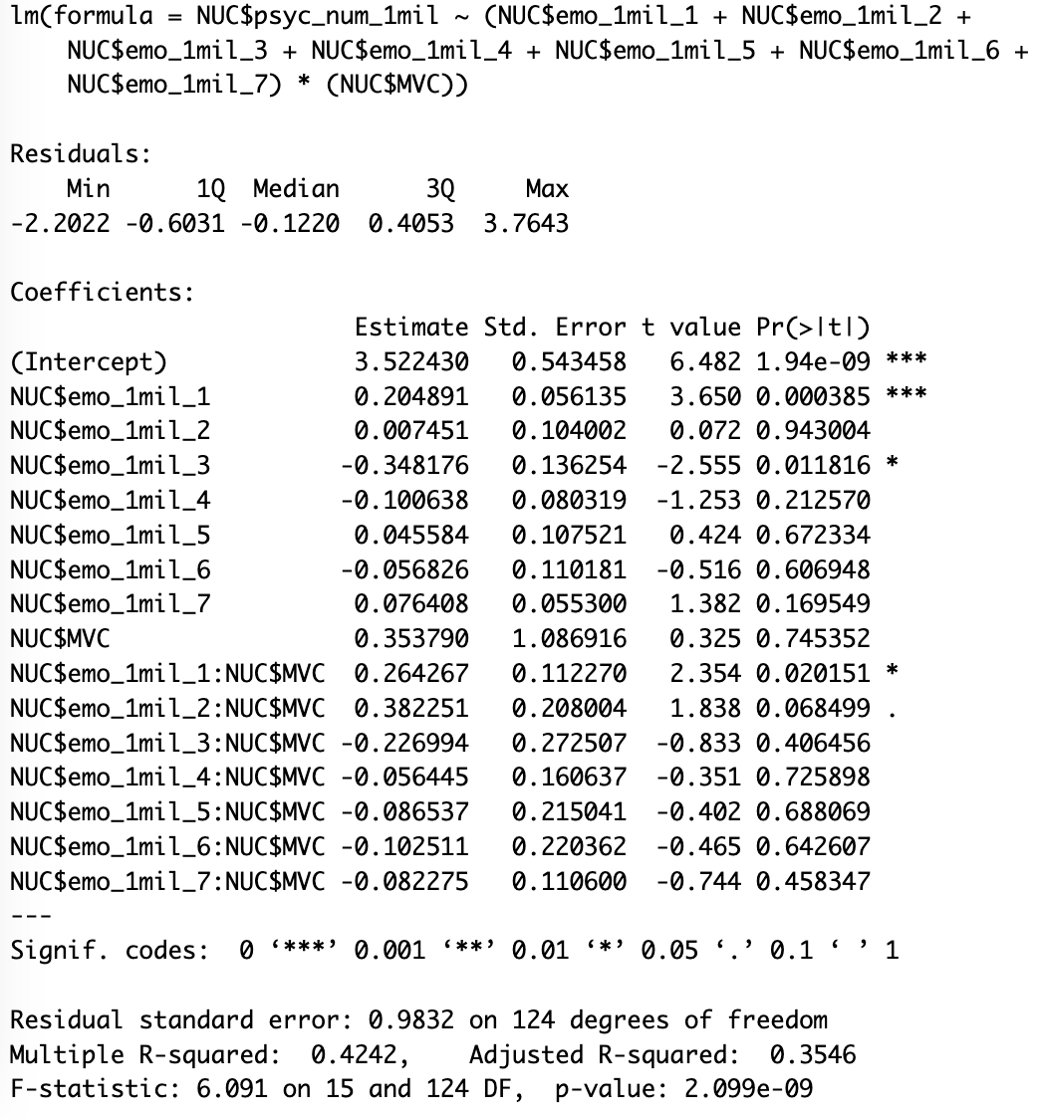

**Figure 45.**

*Analysis demonstrating the effect between emotions and participants level of endorsement once controlled for by condition at the 20k casualty level.*

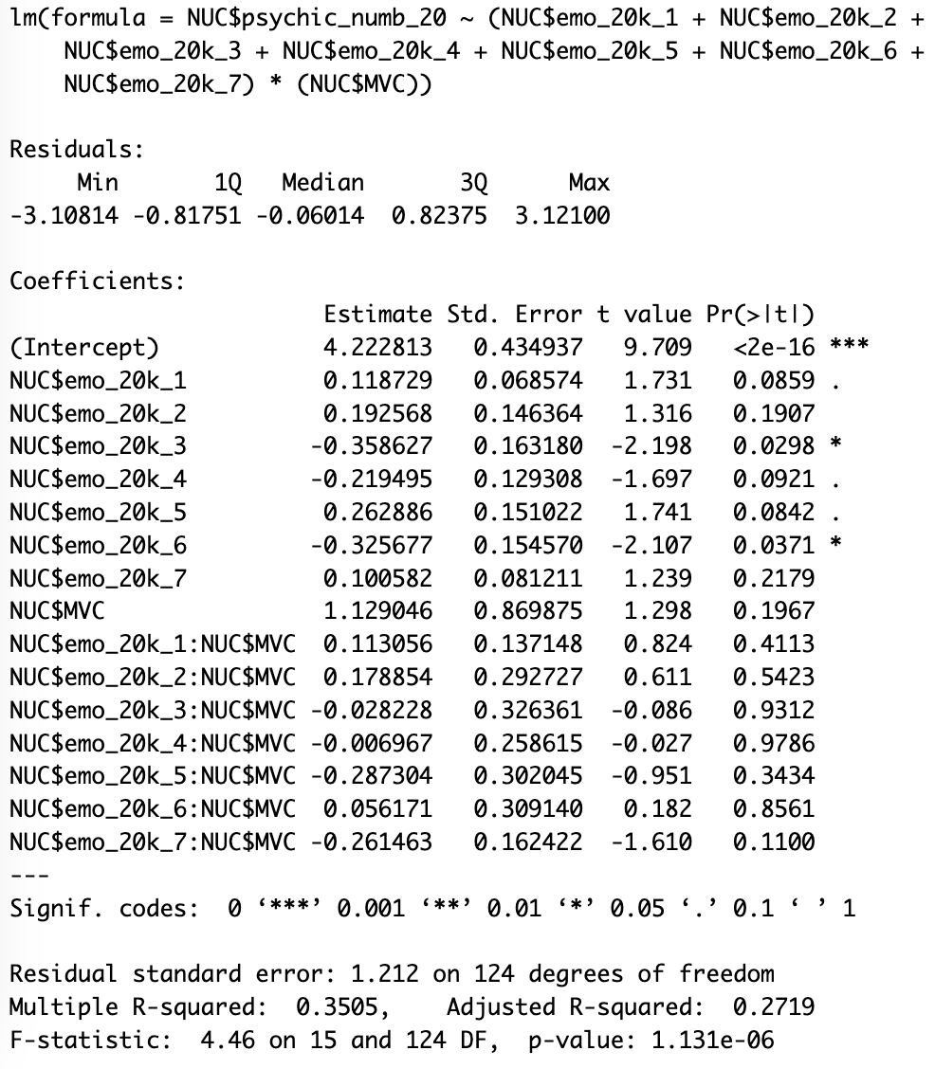

Figure 46.

*Analysis demonstrating the effect between participants level of endorsement once controlled for by condition at the 100k casualty level.*

**Figure 47.**

*Analysis demonstrating the effect between participants level of endorsement once controlled for by condition at the 20k casualty level.*

**Figure 48.**

*Analysis demonstrating the effect between participants level of endorsement once controlled for by condition at the 1 million casualty level.*

