**Tracking rare earth elements in an acid mine drainage stream: Lion Creek, Empire, Colorado**

By:

**Andres Reyes**

Department of Geological Sciences

University of Colorado Boulder

Defense Date: April 5, 2024

April 2024

Thesis Advisor:

**Dr. Thomas M. Marchitto, Jr.**

Department of Geological Sciences and

Institute of Arctic and Alpine Research (INSTAAR)

Defense Committee:

**Dr. Diane M. McKnight**

Department of Environmental Engineering and

INSTAAR

**Dr. Brian Hynek**

Department of Geological Sciences

# Abstract

Acid mine drainage, or acid rock drainage, poses a significant threat to both ecosystems and human communities due to boosted levels of acidity and toxic metal concentrations. Within these systems, dissolved rare earth elements are often found in elevated concentrations, potentially to an economic level. To better understand the mobility and fate of rare earth elements within acid mine drainage systems, Empire, Colorado was chosen as a study site for trace metal analysis. Both in-situ and laboratory measurements were conducted, revealing a strong dependence on Fe and Al concentrations for the sorption of rare earth elements onto the riverbed at this site. More specifically, Al-precipitates present a strong forcing on rare earth element sorption onto the riverbed, while Fe-precipitates don’t, and the formation of these precipitates are largely dependent on the pH of the water. At pH levels greater than 3, the Al-precipitates dominate, leading to much higher concentrations of rare earth elements found sorbed onto the riverbed. This is consistent with previous laboratory experiments and provides more data to an ever-expanding catalog of study in acid mine drainage systems.

# Table of Contents

Abstract 2

Table of Contents 3

1.0. Introduction 5

1.1. Acid mine drainage and sulfide weathering 5

1.2. Rare earth elements 5

1.3. Dissolved organic matter in river settings 6

1.4. Environmental impacts of AMD 6

1.5. Trace element behavior in river settings 7

1.6. Purpose of investigation 7

2.0. Methods 8

2.1. Sampling location 8

2.2. Sample collection and field measurements 10

2.3. Sample preparation 12

2.4. Sample analysis 12

2.5. Cerium anomaly 12

Equation 1. REE normalization 12

Equation 2. Ce* calculation 13

3.0. Results and Discussion 14

3.1. Field data 14

3.2. Water chemistry 16

3.3. Flocculant chemistry 26

4.0. Conclusion 34

5.0. References 35

6.0. Appendix and Supplementary Materials 37

6.1. Table 1. In-situ Field Measurements 37

6.2. Table 2. Water Trace Metal Concentrations 38

6.3. Table 3. Water REE Concentration 39

6.4. Table 4. Water Metal R2 Calculations 40

6.5. Table 5. Water Ce* 43

6.6. Table 6. Flocculant Trace Metal Concentrations 44

6.7. Table 7. Flocculant REE Concentrations 45

6.8. Table 8. Flocculant Metal R2 Calculations 46

6.9. Table 9. Flocculant Ce* 49

# 1.0. Introduction

## 1.1. Acid mine drainage and sulfide weathering

Acid mine drainage (AMD) is a well-studied process by which exposed rock material is converted via a series of aqueous chemical reactions into ferric (Fe3+) and ferrous (Fe2+) iron, sulfate (SO42-), and, most significantly, protons (H+). The high yield of protons generates prominent acidity, leaving waters at low pH. This increased acidity enhances the water's ability to leach out metals from within the parent rock body. AMD is found extensively within abandoned mining sites, where it gets its name, but the process can occur in natural outcrops, in which case it is referred to as acid rock drainage (ARD).

AMD stems from the oxidation of sulfide minerals, which are commonly found in conjunction with economically viable mineral veins and ores, like gold, silver, and coal. Minerals in this group include pyrrhotite (Fe1-xS), sphalerite (ZnS), and galena (PbS) among others, but the most commonly occurring, and thus most prominent in AMD, is pyrite (FeS2). The process begins with pyrite oxidation via 1) elemental oxygen (O2) in circumneutral pH systems or 2) Fe3+ in acidic pH environments (Stinger & Stumm, 1970), releasing protons and ferrous iron (Fe2+) as products. The Fe2+ is then oxidized into Fe3+. This step, referred to as the rate-determining step, is mediated by the gram-negative chemoautotroph lithophage bacteria *Acidithiobacillus ferrooxidans*, which use ferric iron as an energy source (Leduc & Ferroni, 1994). Without the presence of this bacteria, the rate-determining step proceeds much slower, in some cases by a factor of 106. From this point, the Fe3+ may precipitate as ferrihydrite (Fe(OH)3) via a hydrolysis reaction, yielding some protons, furthering acidification. However, the Fe3+ may instead react with the pyrite from which it originated, producing a massive quantity of protons and Fe2+, which, as stated above, is the energy source of choice for the acidophilic bacteria. Now, the cycle is self-propagating and generates massive quantities of protons.

## 1.2. Rare earth elements

The rare earth elements (REEs) consist of 15 economically important metals found in trace concentrations on the Earth’s surface. REEs are used extensively in modern technological applications, more so with each passing year. They are sought after for their unique magnetic and optical properties. These metals are Yttrium, Scandium, and the lanthanide metals. They are rarely found in viable mining concentrations, although they tend to be deposited together. Scandium and promethium do not often share this pattern with the other REEs, so they are often left out of the discussion. While REEs are indeed “rare,” they are more common than the likes of gold, silver, and platinum, with the exception of promethium. During the igneous mineral crystallization process, the REEs preferentially remain in magma. This leads to the highest concentrations of REEs in deposits that have either experienced intensive fractional crystallization or are derived from such deposits. These deposits are typically carbonatites, alkaline igneous systems, and monzanite-xenotime-bearing placer deposits.

The REEs are mostly trivalent, with the exceptions of Eu and Ce. Eu is divalent (+2) and Ce, which has two redox states, can be found in both +3 and +4 charge states (Verplanck et al, 2004). All REEs share similar ionic radii. Generally, the concentrations of dissolved REEs in water decrease with increasing pH (Elderfield et al., 1990). At low pH, REEs behave conservatively, making them viable tracers in some systems. They are often associated with high levels of dissolved organic carbon (DOC) due to their tendency to form complex organic ions (Tanizaki et al., 1992; Viers et al., 1997; Dupre et al., 1999; Ingri et al., 2000). They may also form complexes with fluorides, sulfates, phosphates, carbonates, and some hydroxides.

Ce, as previously mentioned, has two redox states in nature, a +3 and +4 form. While Ce3+ is soluble, Ce4+ is not. As a result, Ce may find itself depleted or enriched relative to its REE siblings depending on the oxidation potential of the environment. By standardizing observed Ce concentrations to a known standard, it is possible to obtain the Cerium anomaly (Ce*). More positive values of Ce* are indicative of more reducing conditions and higher dissolved Ce concentrations, and vice versa (Thomas et al., 2003). More positive values indicate Ce-enrichment relative to other REEs and vice versa.

## 1.3. Dissolved organic matter in river settings

Dissolved organic matter (DOM), or DOC, comprises one of Earth’s largest carbon pools. While the definition of “dissolved” is operational, in the geosciences, DOM is typically referred to as any suspended organic matter that is smaller than 0.5 μm in diameter. This consists of a wide variety of chemical substances, including colloids, viruses, some bacteria, nanogels, macromolecules, and truly dissolved molecules. In terrestrial waters, humic substances make up a majority of the DOM population, typically originating from degraded OM-rich soils.

DOM can behave in a number of ways in fluvial settings. When consumed, DOC is oxidized via elemental oxygen and converted into carbon dioxide (CO2), lowering the pH (Tranvik & Wachenfeldt, 2014). DOM may also form colloids, which play a large role in overall river chemistry. It has been shown that, although they make up a fraction of the total particulate volume and mass in a river, they harbor a significant portion of the available surface area for pollutant adsorption (Perret et al., 1994). DOM is capable of binding trace metals, largely impacting their bioavailability. At low pH, the capacity for binding of DOM decreases for several cations, increasing the toxicity in a system. In regions with both high acidity and high cation concentrations, like AMD systems, DOM flocculation to surfaces becomes a prominent behavior (Kupka & Gruba, 2022). It has been suggested that flocculation is enhanced by UV and short-wavelength visible light radiation. In waters with enriched levels of iron, humic substances may co-precipitate with iron oxides.

## 1.4. Environmental impacts of AMD

There are an estimated 20,000-50,000 mining sites producing AMD on US Forest Service lands alone, with worldwide remediation costs reaching into the tens of billions of dollars (Weatherell et al., 1993). These systems, as noted above, produce intense acidity, with the worst cases reaching pH levels as low as -3.6 (Nordstrom et al., 2000). With the consequent increase in metal ions, AMD systems are potently toxic. While ecologically diverse systems typically possess the capacity to counter the introduction of individual pollutants, pollution introduced by AMD is so complex that ecosystems collapse quickly (Gray, 1997). In some instances, river ecosystems are declared biologically “dead.” The water draining out of AMD may infiltrate groundwater systems (USDA, 1993) and migrate to manmade wells.

## 1.5. Trace element behavior in river settings

Regions of intensive sulfide oxidation, like AMD settings, are extremely favorable to the mobilization of trace elements. Trace elements may form complexes with inorganic and organic ligands, like carbonates, sulfides, and fulvic acids. Because these ligands have higher solubilities than their components alone, their formation enhances the inherent solubility of trace metals. Trace metals may instead form hydrous oxides via hydrolysis reactions, which, as stated above in 1.1., contributes to the acidification of the system. They may also be incorporated into colloids. Because colloids are small enough to be considered dissolved, this incorporation enhances the apparent solubility of trace metals. If necessary, this may be accounted for via ultrafiltration. Again still, trace metals may adsorb onto surfaces downstream, decreasing pH. This adsorption has the opposite effect of colloid incorporation, reducing the apparent solubility of the trace elements. It is unclear whether organic complexation and adsorption to sediments play a larger role in trace metal concentrations, as nature seems to conflict with experimentation (Sholkovitz and Copland, 1980). Trace metals may find themselves incorporated into flocculant, a material that encourages the aggregation of suspended particles into larger particles that may settle out of suspension. In AMD systems, Fe and Al commonly play the role of flocculants, forming red and white coatings, respectively, on the riverbed. In AMD settings, these minerals are commonly schwertmannite (Fe8O8(OH)6SO4) and felsőbányaite (Al4(SO4)(OH)10·4H2O). Terrestrial river settings are extremely complex, and much is being done to better understand the processes by which trace elements abide in these systems.

## 1.6. Purpose of investigation

I aim to characterize the REE load both dissolved in stream water and accumulating on the streambed in an AMD system that has yet to be characterized for such. A second objective is to investigate how REEs are removed from AMD systems by Al, Fe, and Mn oxides, including their relative importance. This study aims to further the general understanding of REE behavior within AMD systems and to compare with other studies of similar nature (Rue and McKnight, 2021; Brooks, 2023). To accomplish this, the stream system found in Empire, Colorado was chosen as the site of investigation due to its relative ease of access and known AMD conditions.

## 

# 2.0. Methods

## 2.1. Sampling location

Empire is a town located in Clear Creek County, Colorado, just north of Georgetown. It sits at an elevation of 8,577’ and has a population of less than 500 people. Empire has a rich mining history, with gold, silver, and molybdenum mines being commonplace there for over 150 years. The lithology of the region is defined by a mixture of biotite gneiss and granodiorite, both rock types being known for their ore potential. As mentioned above, pyrite is commonly associated with ore deposits, making Empire an ideal location for AMD production. Indeed, AMD conditions are observed in the two creeks discharging from the mine-populated mountains to the north of Empire: North Empire Creek (NEC) and Lion Creek (LC). These streams meet at a confluence just north of town, where they flow south and join together with the eastbound West Fork Clear Creek (WFCC). River water is clear, but riverbeds are intensely red, taken as an indication of Fe-dominance within the system (Figure 1). Sampling was done on November 18, 2023, when stream flow is near its annual minimum.

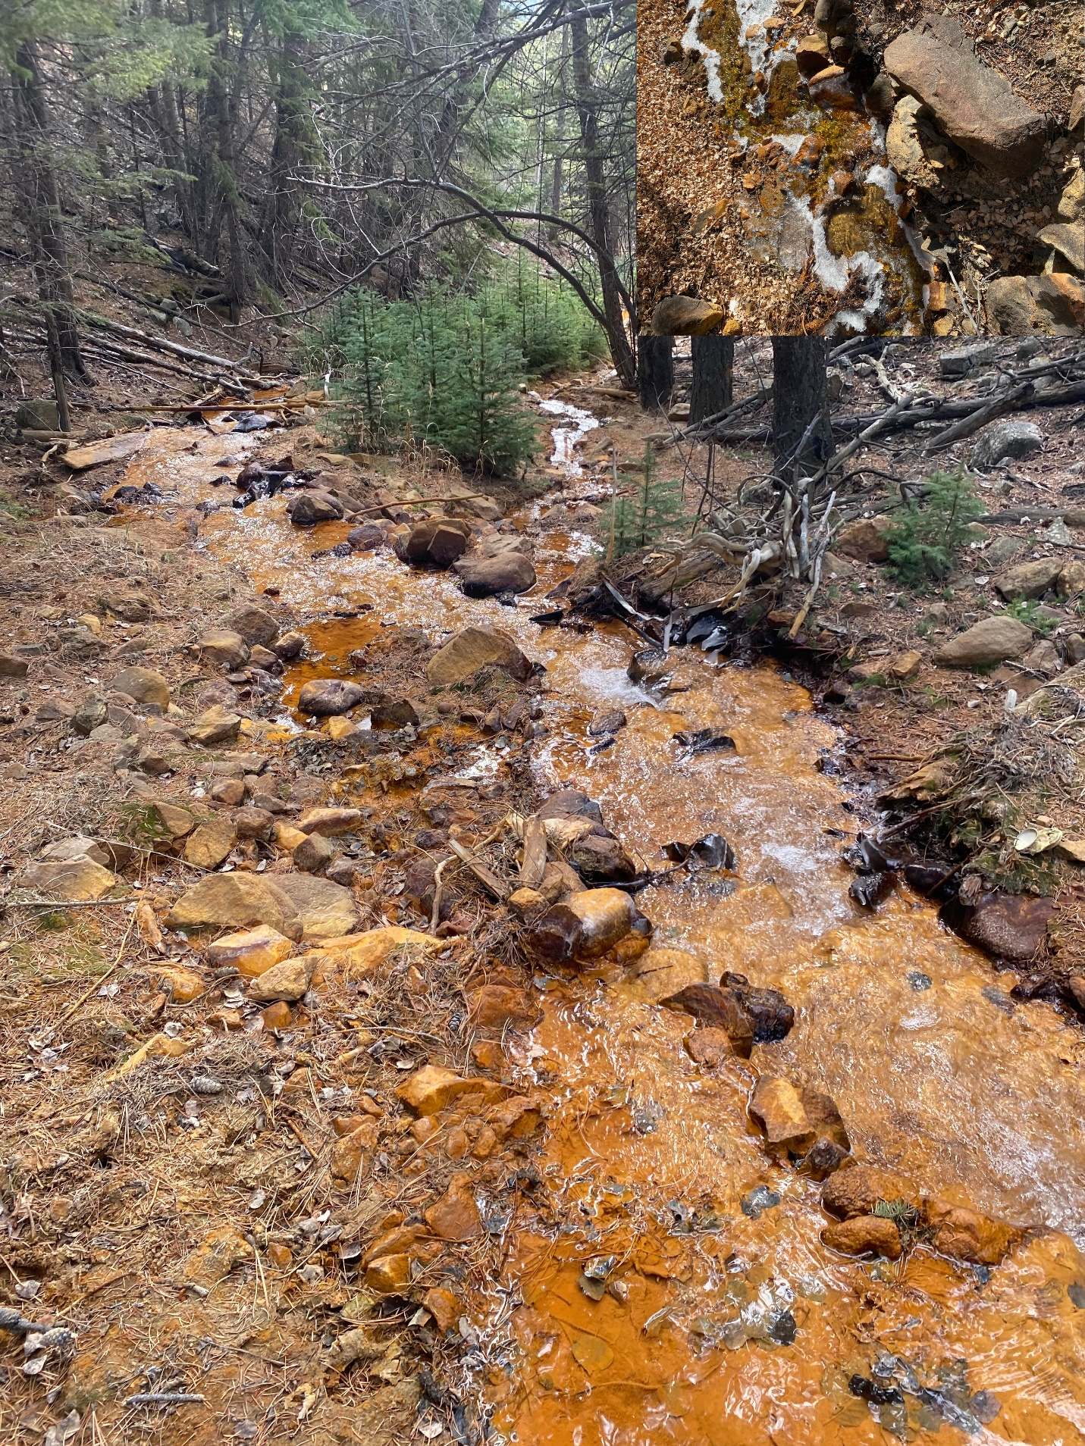

Figure 1. Image of LC, just south of Sample 3's location, facing southward towards Empire. The red color is far more dominant than in sample 1 (top right).

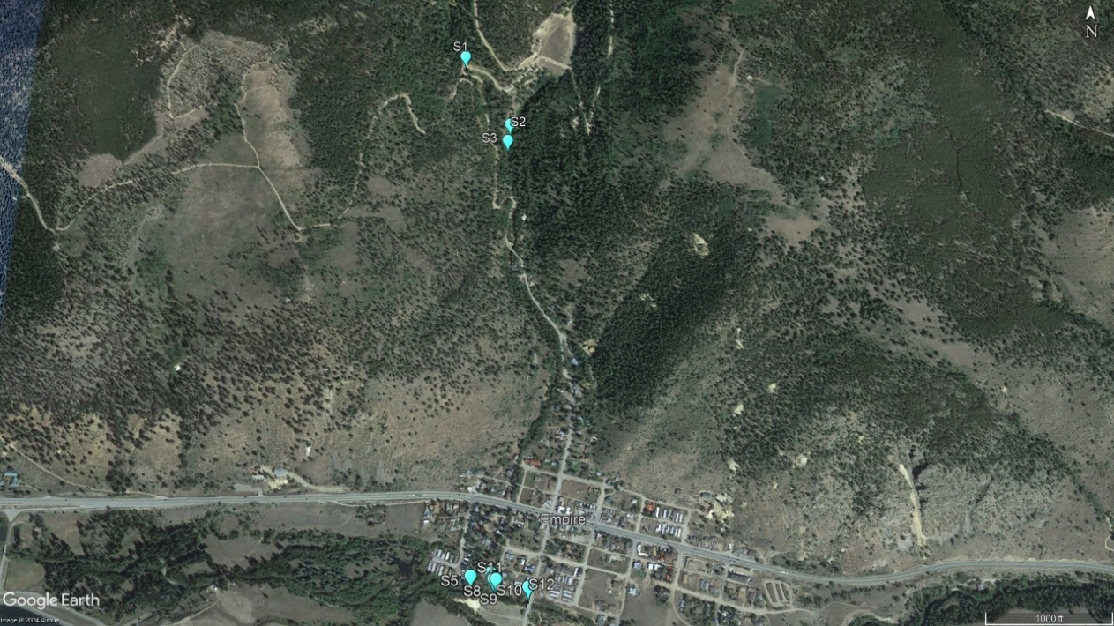

Figure 2. Large-scale map view of site sampling locations at Empire, CO. Samples are designated by an “S,” followed by the sample number. Samples 1-3 were taken north of Empire on LC and NEC. Samples 4-12 were taken on the southern end of Empire near the confluence.

## 2.2. Sample collection and field measurements

To characterize REE mobility in the system, several stations were chosen in the region for sample collection. The starting point was determined by road access availability to stream water. It was determined that a series of samples collected from LC to WFCC would be the best route. Samples 1 and 3 were collected in LC, north of Empire. Sample 2 was collected in NEC upstream of the LC-NEC confluence. Sample 5 was collected in WFCC upstream of the main confluence as a baseline for the larger river body. Samples 4 and 6-11 were collected along a gradient as LC flows into WFCC (Figure 4). Samples 4, 6, 7, 9 and 10 were collected on or near the north riverbank of NWCC. Samples 8 and 11 were collected at the same locations as samples 9 and 10, respectively, but were instead collected at the middle of the WFCC river channel. Sample 12 was collected farther downstream of the main confluence to gauge for any longer-lasting legacies of the AMD-impacted waters. For the purposes of this study, samples 1, 3, 4, and 6-12 can be treated A rock and water with a wire
as a sequence, where 8 and 11 correspond to the same distance downstream as 9 and 10, respectively. Samples 2 and 5 stand on their own because they are not a part of the main flow path of study (Figures 2 and 3).

Figure 3. Zoomed-in map view of samples, designated by an “S,” followed by the sample number, collected in proximity near the West Fork Clear Creak confluence, south of Empire.

Figure 4. View looking south into WFCC from the north riverbank, standing on the confluence of LC and WFCC. As water flows into WFCC and is pushed downstream (left), precipitates form close to the riverbank. This effect is dampened with distance across WFCC, producing a color gradient in the riverbed.

Water samples were collected at each station in 125 mL acid-washed low-density polyethylene (LDPE) bottles,which were rinsed with local stream water 3 times before sample collection. Flocculant samples were collected by scrubbing streambed rocks with a toothbrush into a tray using local stream water, which was then transferred into 1 L LDPE bottles. Rocks were retained for surface area normalization (Dudley et al., 2001). Flocculant samples were collected at stations 3, 4, 6, 7, 9, and 10. All samples were kept in a cold room prior to analysis. Conductivity, pH, and dissolved oxygen (DO) were collected at each station with a ProDSS Multiparameter Digital Water Quality Meter.

## 2.3. Sample preparation

After returning to the lab, water samples were filtered through 47 mm diameter 1.2 μm pore size Whatman GF/C microfiber filters that had been combusted at 450 °C for 4 hours, using a hand vacuum pump and plastic filtering unit. Filters were stored for potential future analysis. Samples were then divided into 3 designated containers: 1) 30 mL acid-washed LDPE bottles for REE and trace metal analysis, 2) 60 mL bottles for anion analysis, and 3) 60 mL brown glass bottles for DOC analysis. Samples designated for REE analysis were spiked with 1 mL of 2% v/v ultra trace metal grade (Fisher Optima) nitric acid (HNO3-). Anions and DOC are to be measured at a later date.

Flocculant samples were allowed to settle out of suspension over the course of several months. Excess water was then decanted, and the remaining sediment was loaded into plastic weighing boats and allowed to dry overnight in an oven at 70°C. Dried flocculant was weighed, and approximately 25 mg of each sample was placed in an acid-washed 50 mL Falcon tube with 1 mL of concentrated Optima-grade nitric acid. Samples were then loosely capped and set to rest in a hot water bath for 4 hours, after which they were tightly sealed and allowed to sit at room temperature for 4 days. Following this, the samples were diluted to the 50 mL mark with ultrapure (18.2 MΩ) water and centrifuged at 5000 rpm for 10 minutes.

## 2.4. Sample analysis

Both water and digested flocculant samples were further diluted 1:1 with 2% Optima grade nitric acid and analyzed by high-resolution magnetic-sector inductively-coupled mass spectrometry (ICP-MS) on a ThermoFinnigan Element2 at INSTAAR. A total of 28 elements were measured per sample, and isotopes and mass resolution (low, medium, or high) were chosen to avoid mass interferences and/or to reduce the beam intensity for abundant elements. Quantification was made versus five external standards with drift and blank corrections. Detection limits were sub-ppt for most of the REEs, and at ppb levels for the major elements.

## 2.5. Cerium anomaly

This calculation is done following Equations 1 and 2. Typically, Ce* is calculated using either the Post-Archaean Australian Shales (PAAS) or the North American Shale Composite (NASC). However, this study is a follow-up to Brooks (2023), where they found it more appropriate to standardize to the Paradise Portal (PREE1) standard from the upper Animas Basin, Colorado, due to the location of study. As such, this study will follow suit so as to provide a more direct comparison. Calculations using the PAAS are included in the appendix.

### Equation 1. REE normalization

$$Standardized sample (La, Ce,Pr)= \frac{Sample element concentration}{Standard element concentration}$$

### Equation 2. Ce* calculation

$${Ce}^{*}=\frac{2*{Ce}_{standardized sample}}{{La}_{standardized sample}+{Pr}_{standardized sample}}$$

# 3.0. Results and Discussion

## 3.1. Field data

Figure 5. In-situ measurements conducted by sample number. Sample numbers are illustrated such that moving left to right is equivalent to moving downstream from LC into WFCC, with the exceptions of samples 2 and 5, which were not collected in the direct flow path.

There were several observed trends in in-situ measurements following LC downstream of sample 1. pH ranged from 2.7-6.9 (Figure 5a), tending to increase with distance downstream. Temperatures ranged from 0.9 °C to 3.3 °C (Figure 5b), also with a tendency to increase downstream. Specific conductance shows the opposite trend, decreasing downstream, ranging from 981 μS/cm to 434.2 μS/cm (Figure 5c). Dissolved oxygen ranged from 9.94 mg/L to 10.64 mg/L (Figure 5d), appearing to mirror the temperature profile, in an inverted manner.

Not included in the ranges listed above are samples 2 and 5, which, as previously mentioned, were collected outside of the flow path of study. Sample 5, perhaps intuitively, resembles the other central WFCC samples 8, 11, and 12 in every measured metric. Because sample 5 is taken to be representative of WFCC before the LC-WFCC confluence, this suggests rapid mixing of LC waters as they flow into the larger river body. In contrast, sample 2 stands out in every metric measured. Sample 2, taken as representative of NEC before the LC-NEC confluence, is quite different from sample 1, being warmer, less acidic, less conductive, and less oxic. Sample 3 lies in between samples 1 and 2, although it resembles sample 1 more than sample 2, suggesting that LC may have a larger impact in downstream river chemistry.

## 3.2. Water chemistry

Figure 6. Distribution of dissolved trace metal and REE concentrations found in sampled waters. Stations are color-coded by pH, with arbitrarily chosen symbols added to aid in distinguishing individual samples.

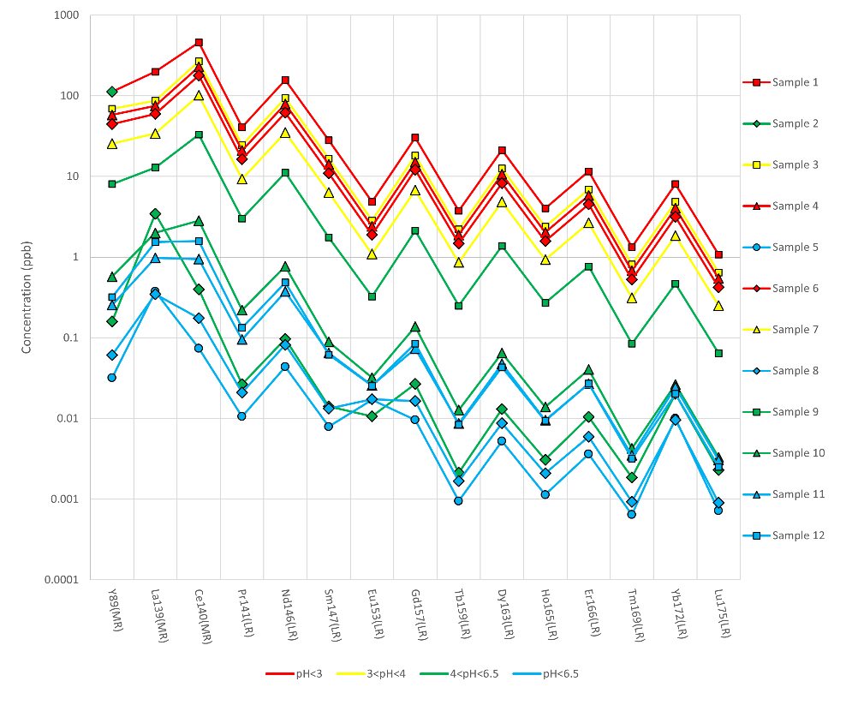

Figure 7. Distribution of dissolved REE concentrations found in sampled waters. Stations are color-coded by pH, with arbitrarily chosen symbols added to aid in distinguishing individual samples.

Most dissolved metal concentrations are inversely correlated to both pH and distance downstream of LC (Figures 6, 7, and 8). In almost all cases, the concentration of dissolved metals decreases as pH and distance downstream both increase, which is to be expected. Downstream position seems to be a stronger determinant than pH in these concentrations, suggesting a continuous loss of metals to the streambed due to oxide formation as flow continues. Several major elements show little variation with pH (Figure 8): K and Ca behave conservatively, Mg decreases modestly as pH rises, 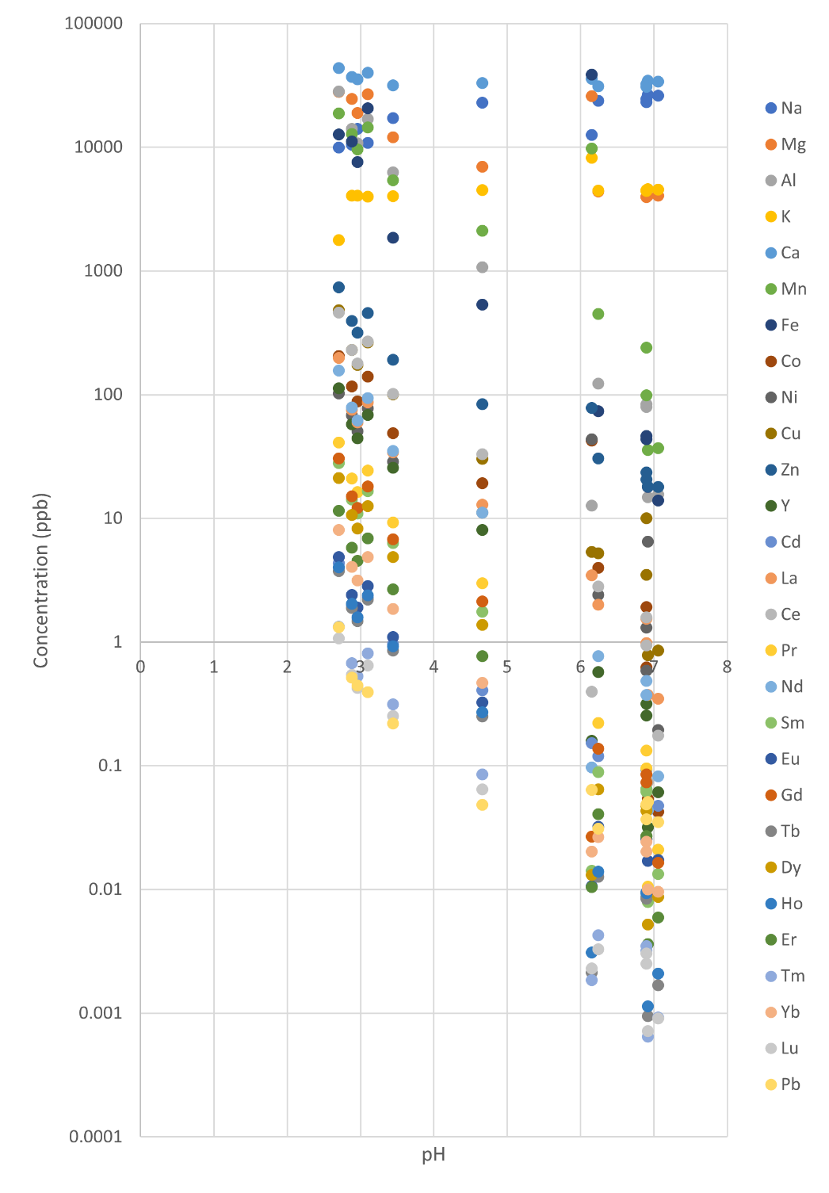and Na increases slightly with pH (Figure 8). These observations rule out water dilution as a cause for dissolved metal behavior downstream. Elemental patterns broadly reflect their abundance on Earth: lighter elements were typically more abundant than heavier elements, and elements with even numbers of protons were typically more abundant than similar elements with odd numbers of protons. This is believed to be due to the higher stability yielded from pairing of atomic particles (Wu 2020). Sample 2 from NEC again shows its nonconformity here, with irregular concentrations across the board, and with a notably high concentration of iron for its pH.

Figure 8. pH vs dissolved cation concentration.

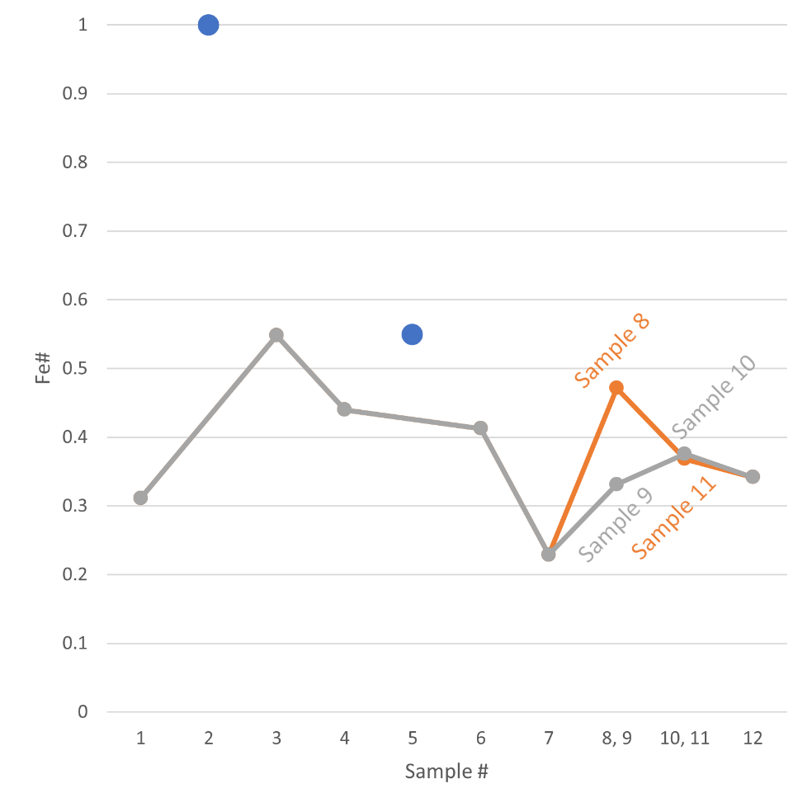Sample 2’s behavior as an outlier is further accentuated by looking at its iron number (Fe#) (Figure 9). Fe#, calculated as [Fe]/([Fe]+[Al]), is a ratio out of 1 that describes the amount of dissolved iron relative to dissolved aluminum. An Fe# closer to 1 denotes a sample that contains more dissolved Fe than Al (by mass) and vice versa. This was chosen to mimic Brooks (2023), where they related the dominance of either dissolved Fe or Al to classify the behavior of REEs in AMD systems. Throughout the Empire study site, the average Fe# was 0.45, indicating a slight dominance of dissolved Al over Fe. Sample 2, however, showed an Fe# of >0.999, indicating an extreme dominance of dissolved Fe over Al. This suggests that Al must have been lost somewhere upstream in NEC, likely due to remediation (Kielty & Holm, 2019). Removing sample 2 from the calculation yields a new average Fe# of 0.40, revealing that the dominance for dissolved Al over Fe within the LC system is more so than initially apparent.

Figure 9. Fe# by sample.

Taking a closer look at the relationship between the log-transformed dissolved REE concentrations and pH levels reveals that there is indeed a strong correlation (Figure 10). The average R2 value of this relationship amongst the REEs is 0.90. The REEs showed a large range of concentrations throughout the site, ranging from 0.8 ppt to 459 ppb, but they all displayed an overall decrease in concentration with an increase in pH, reflecting precipitation along the LC flow path.

Figure 10. pH vs dissolved REE concentration.

The three most abundant oxide-forming metals found dissolved in samples were Fe, Al, and Mn, all in relatively similar concentrations. An R2 analysis of the relationship between the log-transformed cation concentrations and Fe, Al, and Mn reveals that all three metals are well correlated to the concentrations of most dissolved metals (Figures 11, 12, 13, and 14). K and Ca were both poorly correlated to the metals, and Na was inversely correlated, which is consistent with previous observations of Na behaving in opposition with the rest of the metals. Sample 2 was not considered in this calculation because of its irregularities when compared with the rest of the samples. Against the REEs, Al was the most well correlated, with an average R2 of 0.99, followed 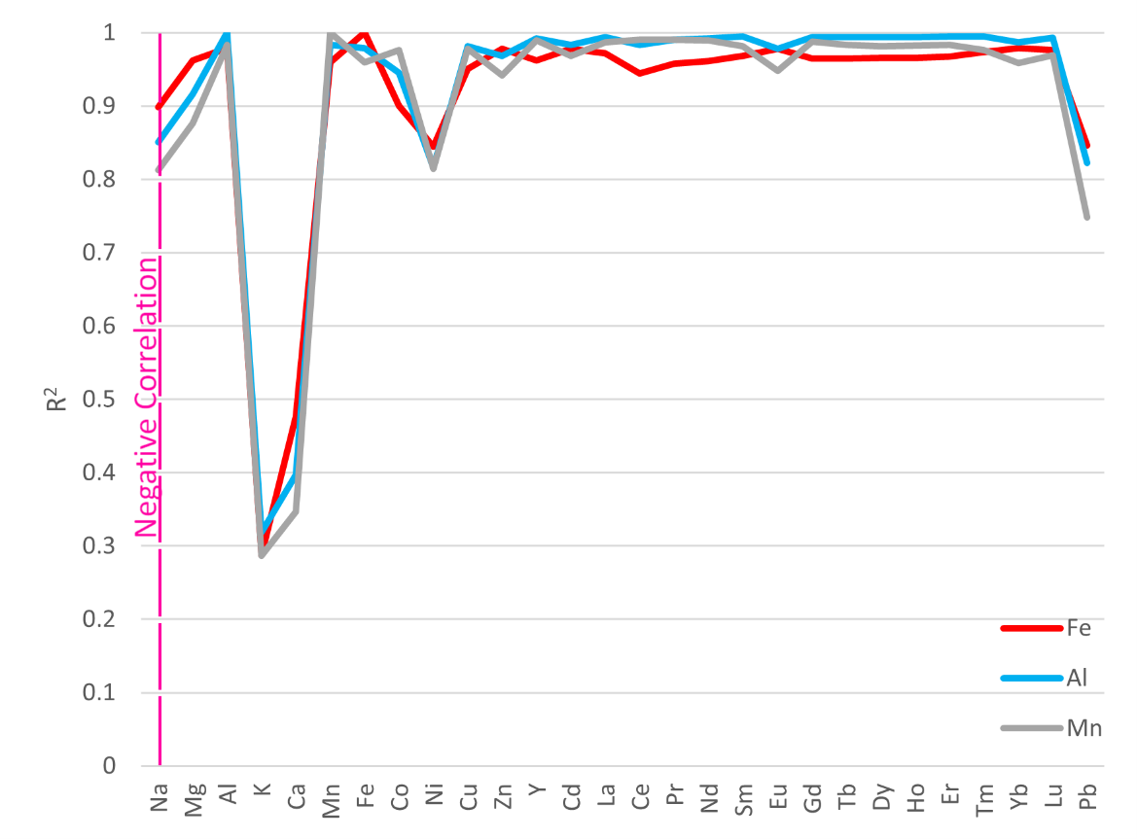by Mn with an average R2 of 0.98. Fe was the least well correlated with an average R2 of 0.97. Although these three averages are very similar, they are significantly different from each other at the 95% confidence level (pairwise Student’s 2-tailed t-test). This suggests that dissolved Al is the best determinant of REE behavior in the system, though clearly all three metal oxides are operating in tandem. Here, sample 2’s nonconformity plays a supporting role. Sample 2, as previously shown, has very low Al and REE concentrations, but extremely high Fe concentrations, suggesting that Al oxides are likely dominating the removal of REEs there. It is possible that the Lower North Empire Creek Restoration Project, conducted by the Colorado Department of Public Health and Environment and completed in 2019, is responsible for this observed deviation in NEC’s behavior.

Figure 11. Calculated R2 values for each dissolved element relative to a chosen metal, across all samples except NEC Sample 2. Values were calculated as a function of log([cation]):log([X]), where X is Fe (red), Al (blue), or Mn (gray). Na, which displayed a negative correlation, is emphasized on this figure with a pink line.

The REE patterns observed in the waters of LC are comparable to the findings of Brooks (2023), which produced similar profiles (Figure 15). Sample 1 is in the same order of REE abundance as the highest sampled REE concentrations found by Brooks (2023). Heavier REEs are found in lower abundances than lighter REEs, and REEs with even atomic numbers are found in higher abundances than REEs with odd atomic numbers. Sample 1 most similarly resembles Brooks (2023) California Gulch and Little Sayers Gulch locations, in both concentrations and element pattern. Y is the only REE to behave somewhat inconsistently, sometimes occurring in unique relative concentrations.

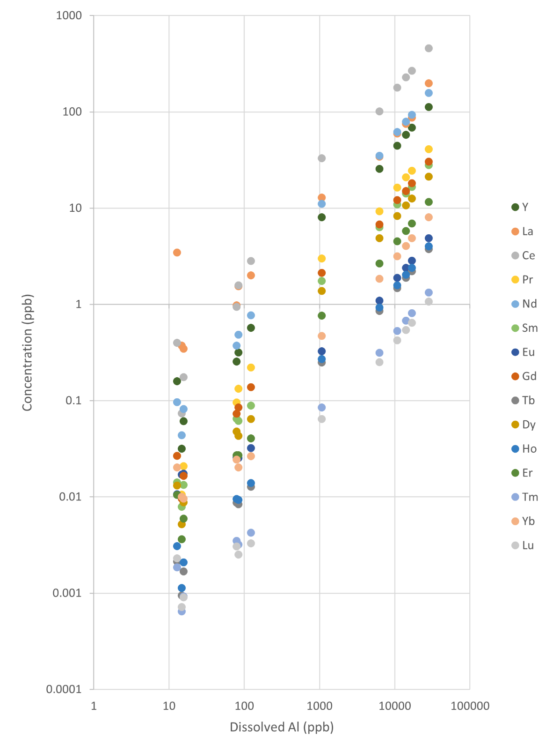

Figure 12. Dissolved Al concentration vs dissolved REE concentration. The lowest Al sample is NEC Sample 2.

The water Ce* demonstrates that dissolved Ce was almost always enriched relative to other REEs in the Empire AMD system (Figure 16). However, the Ce* became gradually less positive with position downstream of LC, indicating that water conditions became less reducing, and Ce became less enriched. This could be explained by the increase in pH.

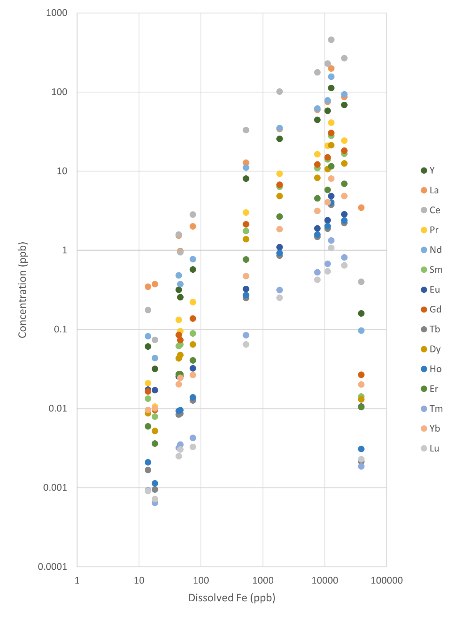

Figure 13. Dissolved Fe concentration vs dissolved REE concentration. The highest Fe sample is NEC Sample 2.

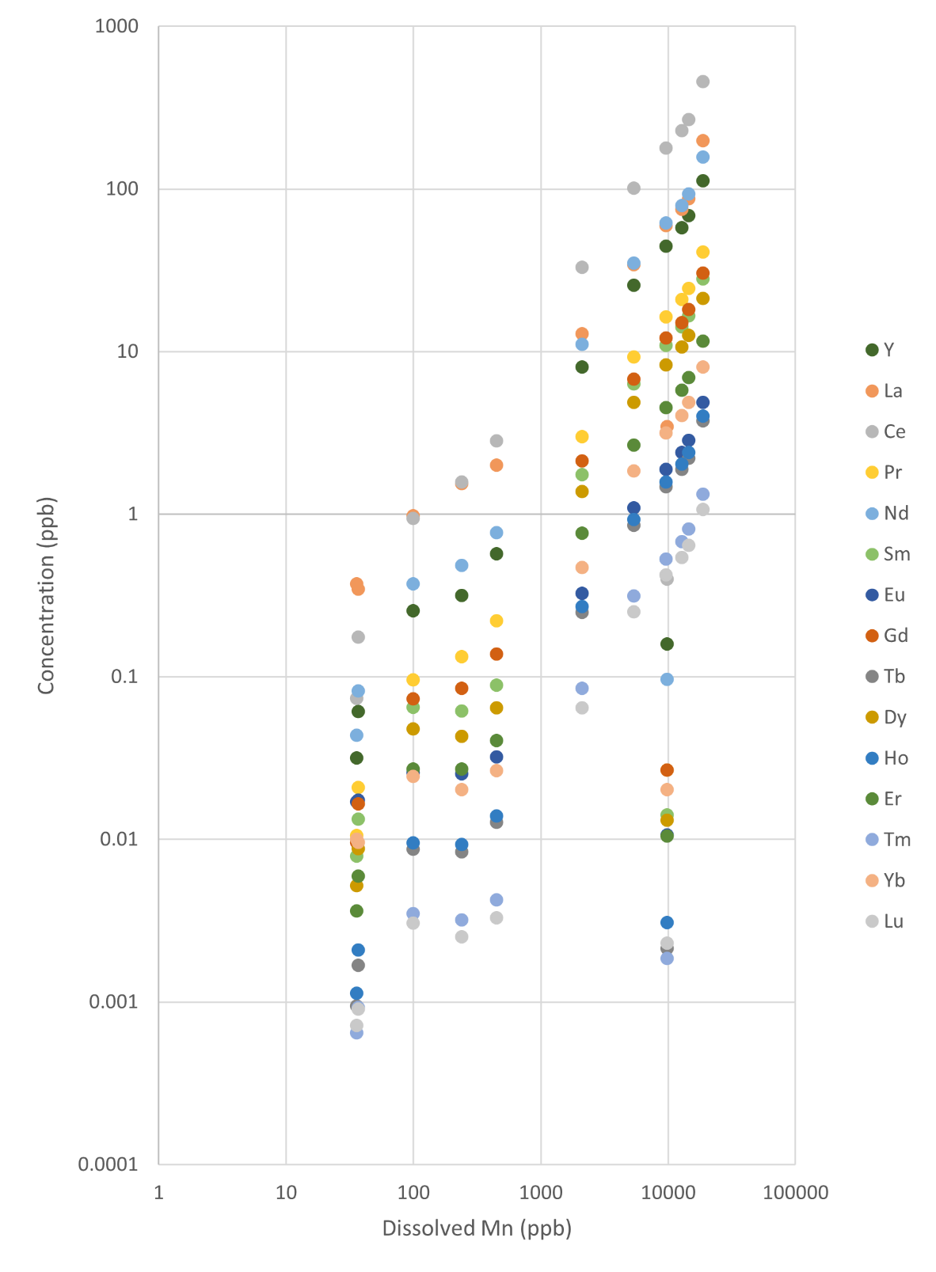

Figure 14. Dissolved Mn concentration vs dissolved REE concentration. The sample with anomalously low REEs for its Mn is NEC Sample 2.

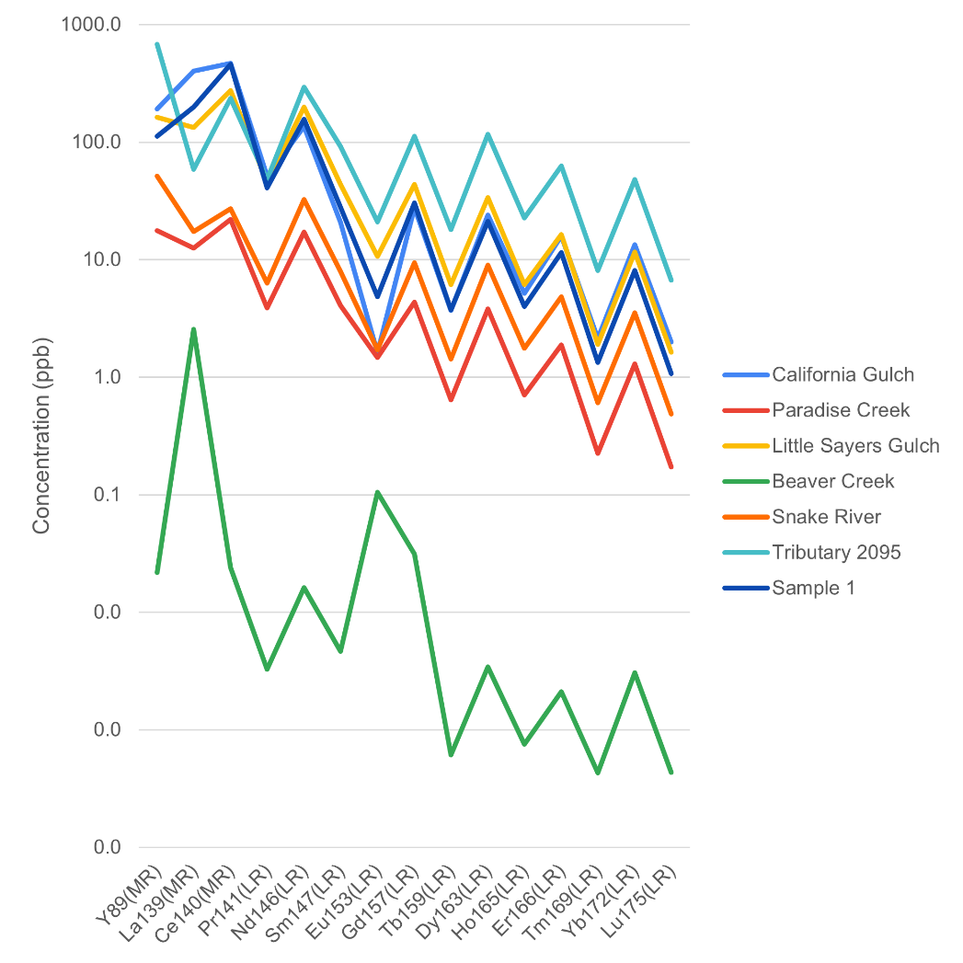

Figure 15. Comparison between the highest sampled concentrations of dissolved REEs at each of six study sites in Brooks (2023) and the highest sampled concentration of dissolved REEs from this study (Sample 1).

Figure 16. Cerium anomaly observed in water chemistry samples using the PREE1 standard.

## 3.3. Flocculant chemistry

The flocculant displayed a clear color gradient from orange-red to light tan with position downstream, especially at the confluence of LC with WFCC (Figure 17). This reflects a shift in Fe dominance to Al dominance in the flocculant chemistry (Figure 18). This suggests that aluminum minerals became the dominant flocculant surface as waters moved downstream of LC, at pH’s higher than roughly 3. In opposition to the dissolved data, flocculant REEs and other metals generally increased in abundance downstream, with a notable jump in REE and Al (and decrease in Fe) concentrations between samples 6 and 7. This is consistent with a loss of dissolved metals to Al-oxide flocculants.

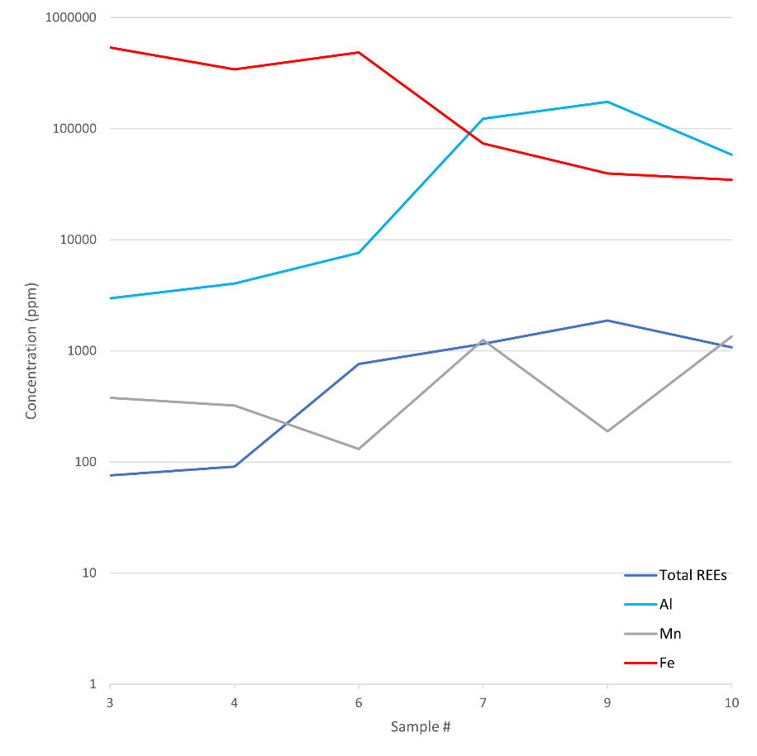

Figure 18. Profile of Al, Mn, Fe, and total REEs in flocculant across the study site.

Figure 17. Image of dried flocculant samples. Samples 3, 4, 6, 7, 9, and 10 are represented by vials A, B, C, D, E, and F, respectively.

To first order, the flocculant displayed several orders of magnitude higher concentrations of all metals than what was observed in the water (Figures 19 and 20). Elemental relationships shifted, however, between water and flocculant. While the REEs remained positively well correlated to Al, Mn lost its correlation and Fe switched to an inverse correlation, with average calculated R2 values of 0.88, 0.09, and 0.72, respectively (Figures 21 and 22). La concentrations appear to be anomalously inflated in sample 6. A second calculation excluding La provides new average R2 values for Al, Mn, and Fe of 0.94, 0.08, and 0.77, respectively. This observation may be explained by the potential for felsőbányaite, sometimes called basaluminite, to sorb REEs onto its surface above pH’s of around 3.5, as shown in experiments by Lozano et al. (2019). Felsőbányaite is often present in AMD systems (Carrero et al., 2017). While schwertmannite precipitates at lower pH values than felsőbányaite, it does not retain REEs well (Lozano et al., 2019). As one might expect, the highest observed concentrations of REEs in the flocculant at Empire were in sample sites with the highest water pH values, where felsőbányaite precipitates more than schwertmannite. It should be noted that these are not the highest pH values found throughout the study site, but rather the highest pH values found throughout the flocculant sample set. The mass contribution of Fe for the flocculant is consistent with this interpretation, showing an abrupt shift from around 98% to 30% as samples shift into the felsőbányaite precipitation range (Figure 23). This shows that Fe accounted for 98% of the total measured cations by mass found in flocculant prior to the felsőbányaite-schwertmannite switch, and only 30% of the total cations afterwards. In contrast, Al shows the opposite pattern. Al accounted for 1% of the total cations in flocculant before the switch and 66% of the total cations after. Combined with REE concentrations by site, this illustrates the large dependence on Al for REE sorption to the riverbed. Because sample 6 possesses an environmental pH of 2.96, it is possible that the anomalous La concentrations found there are a result of preferential La incorporation into felsőbányaite as the mineral begins to precipitate.

Figure 19. Profile of all measured cations in each flocculant sample.

These findings are consistent with the highest sampled REE concentrations found in flocculants by Brooks (2023). Sample 9 is used for comparison as this study’s representative for high REE concentrations, and is most similar to Brooks (2023) California Gulch (Figure 24). Y, again, shows some inconsistency, with its relative concentrations shifting from site to site.

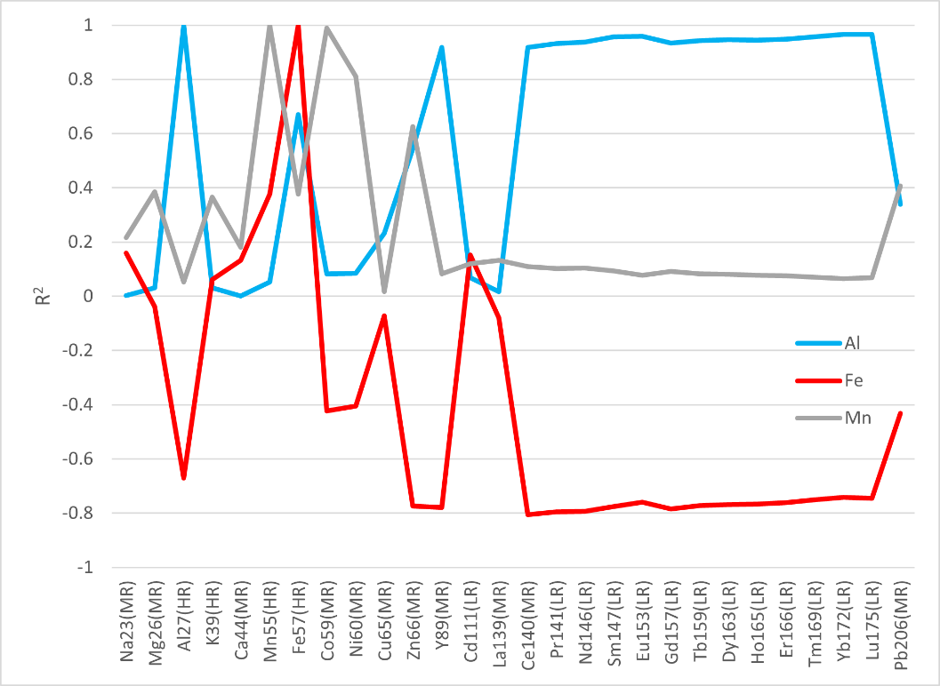With the exception of sample 6, the Ce* profile for the flocculant chemistry exhibits a generally increasing trend downstream (Figure 25). This is consistent with what was observed in the water chemistry Ce*, which showed a generally decreasing trend downstream. This suggests a relative enrichment in Ce in the flocculant compared to other REEs with distance downstream of LC. This can be explained by Ce being preferentially removed from the water and into the flocculants as pH increases. The anomalously high La concentration found in sample 6 is skewing the Ce* at that site.

Figure 21. Calculated R2 values for each log-transformed cation against Al (blue), Fe (red), and Mn (gray). Negative values indicate an inverse correlation.

Figure 20. Distribution of REEs throughout the collected flocculant samples.

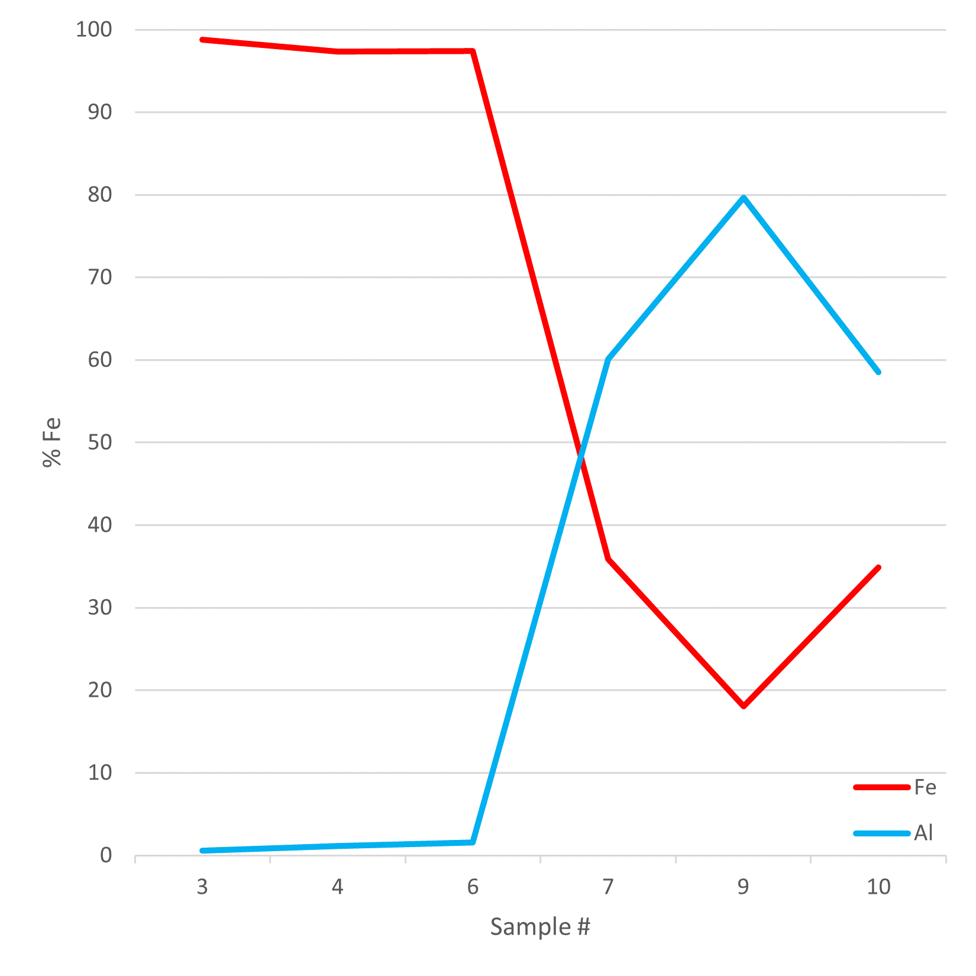

Figure 22. Percent Fe and Al relative to total cation concentration in flocculant samples. Sample 7 marks the shift in dominance from schwertmannite to felsőbányaite.

Figure 23. Al vs REE concentration found in flocculant.

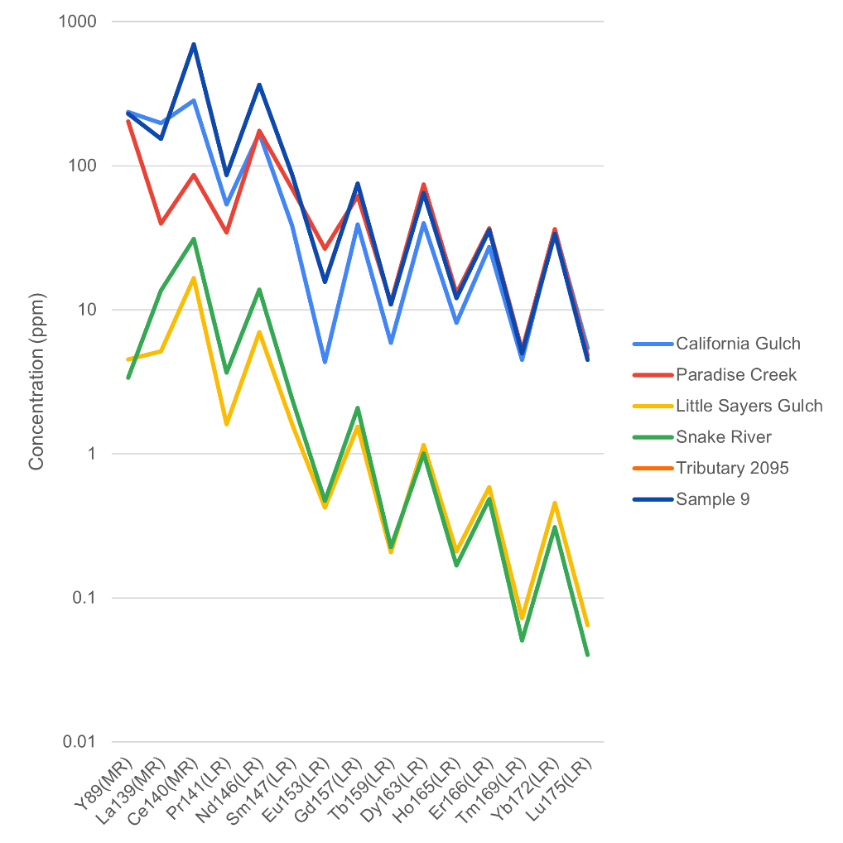

Figure 25. Cerium anomaly profile in flocculant collected over the study site using the PREE1 standard.

Figure 24. Comparison between the highest sampled REE concentrations in flocculant found by Brooks (2023) and the highest sampled REE concentrations in flocculant found in this study (Sample 9).

# 4.0. Conclusion

At Empire, it was found that LC boasted elevated levels of REEs in both the stream water and the flocculant on the riverbed. Within the water, there was a clear correlation between dissolved REEs and pH (inversely), Al, Fe, and Mn. Within the flocculant, Al remained positively correlated to REEs while Fe became inversely correlated, and Mn lost its correlation.

This study is consistent with the idea that Fe and Al concentrations play a key role in conjunction with pH in REE sorption onto the riverbed. At low pH, Fe-precipitates form, which allow REEs to mobilize further downstream, where, at higher pH, the Al-precipitates scavenge them. It is assumed that the precipitating minerals responsible for this effect at this site are schwertmannite and felsőbányaite, but X-ray diffraction or Raman spectroscopy analysis of dried flocculant may provide a more concrete description of stream mineralogy.

There is still much to be done in regards to this site: anion analysis, specifically sulfate, and surface area normalization of flocculant:rock will both provide valuable insight into what else is going on behind the scenes.

# 5.0. References

Brooks, N. (2023) Climate-induced mobilization of rare earth elements in high altitude streams Colorado: potential role of complexation in hydrous metal oxide precipitation (Publication No. 30424790) [Master’s thesis, University of Colorado, Boulder]. ProQuest Dissertations and Theses Global.

Carrero, S., Fernández-Martínez, A., Pérez-López, R., and Nieto, J. (2017) Basaluminite Structure and its Environmental Implications. *Procedia Earth and Planetary Science* 17, 237-240.

Ding, Z., Han, G., Qu, R., Liu, J., and Wang, P. (2023) Review on Zinc Isotopes in River Systems: Distribution and Application. *Water* 16, 87.

Dudley, J., Arthurs, W., and Hall, T. (2001) A Comparison of Methods Used to Estimate River Rock Surface Areas. *Journal of Freshwater Ecology* 16, 257-261.

Dupré, B., Viers, J., Dandurand, J., Polvé, M., Bénézeth, P., Vervier, P., and Braun, J. (1999) Major and trace elements associated with colloids in organic-rich river waters: ultrafiltration of natural and spiked solutions. *Chemical Geology* 160, 63-80.

Elderfield, H., Upstill-Goddard, R., and Sholkovitz, E.R. (1990) The rare earth elements in rivers, estuaries, and coastal seas and their significance to the composition of ocean waters. *Geochemica et Cosmochimica Acta* 54, 971-991.

Gray, N.F. (1997) Environmental impact and remediation of acid mine drainage: a management problem. *Environmental Geology* 30, 62-71.

Ingri, J., Widerlund, A., Land, M., Gustafsson,  Ö., Andersson, P., and Öhlander, B. (2000) Temporal variations in the fractionation of the rare earth elements in a boreal river; the role of colloidal particles. *Chemical Geology* 166, 23-45.

Kielty, D. and Holm, J. (2019) Lower North Empire Creek Restoration Project. U.S. Environmental Protection Agency.

Kupka, D. and Gruba, P. (2022) Effect of pH on the sorption of dissolved organic carbon derived from six tree species in forest soils. *Ecological Indicators* 140.

Leduc, L.G. and Ferroni, G.D. (1994) The chemolithotrophic bacterium *Thiobacillus ferrooxidans. FEMS Microbiology Reviews* 14, 103-119.

Lozano, A., Ayora, C., and Fernández-Martínez, A. (2019) Sorption of rare earth elements onto basaluminite: the role of sulfate and pH. *Geochimica et Cosmochimica Acta* 258, 50-62.

Nordstrom, D., Alpers, C., Ptacek, C., and Blowes, D. (2000) Negative pH and Extremely Acidic Mine Waters from Iron Mountain, California. *Environmental Science and Technology* 34, 254-258.

Perret, D., Newman, M., Nègre, J., Chen, Y., and Buffle, J. (1994) Submicron particles in the rhine river – I. Physio-chemical characterization. *Water Research* 28, 91-106.

Sholkovitz, E.R. and Copland, D. (1981) The coagulation, solubility and adsorption properties of Fe, Mn, Cu, Ni, Cd, Co and humic acids in a river water. *Geochimica et Cosmochimica Acta* 45, 181-189.

Singer, P.C. and Stumm, W. (1970) Acid mine drainage rate determining step. *Science* 167, 1121-1123.

Tanizaki, Y., Shimokawa, T., and Nakamura, M. (1992) Physiochemical of trace elements in river waters by size fractionation. *Environmental Science and Technology* 26, 1433-1444.

Thomas, J.B., Bodnar, R.J., Shimizu, N., and Chesner, C.A. (2003) Melt Inclusions in Zircon. *Reviews in Mineralogy and Geochemistry* 53, 63-87.

Tranvik, L.J. and von Wachenfeldt, E. (2014) Interactions of Dissolved Organic Matter and Humic Substances in Freshwater Systems. *Reference Module in Earth Systems and Environmental Sciences.*

United States. Forest Service & United States. Bureau of Mines. (1993). *Acid drainage from mines on the national forests: A management challenge*. Forest Service.

Verplanck, P., Nordstrom, D., Taylor, H., and Kimball, B. (2004) Rare earth element partitioning between hydrous ferrous oxides and acid mine water during iron oxidation. *Applied Geochemistry* 19, 1339-1354.

Verplanck, P., Nordstrom, D., and Taylor, H. (1999) Overview of Rare Earth Element Investigations in Acid Waters of U.S. Geological Survey Abandoned Mine Lands Watersheds. *U.S. Geological Survey Toxic Substances*, 83-92.

Viers, J., Dupré, B., Polvé, M., Schott, J., Dandurand, J., and Braun, J. (1997) Chemical weathering in the drainage basin of a tropical watershed (Nsimi-Zoetele site, Cameroon) : comparison between organic-poor and organic-rich waters. *Chemical Geology* 140, 181-206.

Weatherell, C.J., Feasby, D.G., and Tremblay, G. (1993) The Mine Environment Neutral Drainage (MEND) Program – A Model of Cooperative Research for Technology Development. *PROJECT MANAGEMENT INSTITUTE 28th Annual Seminars & Symposium Chicago, Illinois, 19-25.*

Wu, Z. (2020) Study on the Odd-Even Periodic Table of Chemical Elements. *Tehcnium BioChemMed* 1, 38-45.

# 6.0. Appendix and Supplementary Materials

## 6.1. Table 1. In-situ Field Measurements

|  |  |  |  |  |  |
| --- | --- | --- | --- | --- | --- |
| **Sample** | **pH** | **Temperature (°C)** | **Specific Conductance (μS/cm)** | **DO (mg/L)** | **DO (%)** |
| 1 | 2.7 | 0.9 | 981 | 10.08 | 71.2 |
| 2 | 6.15 | 5 | 621 | 9.17 | 71.9 |
| 3 | 3.1 | 2.2 | 791 | 9.88 | 72.1 |
| 4 | 2.88 | 1.4 | 803 | 10.64 |  |
| 5 | 6.92 | 3 | 437.5 | 10.03 |  |
| 6 | 2.96 | 1.9 | 801 | 10.27 | 74.2 |
| 7 | 3.44 | 2.4 | 624 | 10.16 | 74.4 |
| 8 | 7.06 | 3.2 | 435.3 | 9.98 | 74.6 |
| 9 | 4.66 | 2.9 | 502 | 10.01 | 74.4 |
| 10 | 6.24 | 3.3 | 442.6 | 9.95 | 74.5 |
| 11 | 6.9 | 3.3 | 434.2 | 9.94 |  |
| 12 | 6.9 | 3.3 | 436.2 | 10.05 |  |

## 6.2. Table 2. Water Trace Metal Concentrations

|  |  |  |  |  |  |  |  |  |  |  |  |  |  |
| --- | --- | --- | --- | --- | --- | --- | --- | --- | --- | --- | --- | --- | --- |
|  | ppb | | | | | | | | | | | |  |
| Sample # | Na | Mg | Al | K | Ca | Mn | Fe | Co | Ni | Cu | Zn | Cd | Pb |
| 1 | 9962 | 27970 | 28150 | 1767 | 43700 | 18754 | 12710 | 205.2 | 102.5 | 481.8 | 740.2 | 4.818E02 | 1.321 |
| 2 | 12550 | 25840 | 12.73 | 8221 | 35650 | 9757 | 38600 | 42.52 | 43.59 | 5.349 | 78.30 | 1.528E-01 | 6.412E-02 |
| 3 | 10840 | 26840 | 16960 | 3978 | 40130 | 14460 | 20550 | 140.4 | 77.10 | 263.3 | 456.1 | 2.275 | 3.945E-01 |
| 4 | 10480 | 24570 | 14110 | 4054 | 36960 | 12740 | 11080 | 116.6 | 67.97 | 229.0 | 394.6 | 1.998 | 5.161E-01 |
| 5 | 26480 | 4062 | 14.76 | 4562 | 34570 | 35.77 | 17.96 | 5.403E-02 | 6.510 | 7.820E-01 | 18.10 | 4.733E-02 | 5.114E-02 |
| 6 | 14080 | 18990 | 10780 | 4041 | 35250 | 9626 | 7565 | 88.05 | 50.61 | 174.1 | 316.6 | 1.580 | 4.435E-01 |
| 7 | 17200 | 12000 | 6262 | 4021 | 31710 | 5388 | 1857 | 48.97 | 28.73 | 100.9 | 191.0 | 9.667E-01 | 2.206E-01 |
| 8 | 26030 | 4059 | 15.65 | 4551 | 33830 | 36.97 | 13.96 | 4.259E-02 | 1.952E-01 | 8.540E-01 | 17.92 | 4.733E-02 | 3.494E-02 |
| 9 | 22980 | 6981 | 1074 | 4489 | 33030 | 2110 | 531.9 | 19.18 | 11.13 | 30.26 | 83.45 | 4.068E-01 | 4.848E-02 |
| 10 | 23750 | 4387 | 122.7 | 4469 | 31170 | 450.6 | 73.74 | 3.980 | 2.411 | 5.238 | 30.48 | 1.191E-01 | 3.098E-02 |
| 11 | 24660 | 3961 | 79.36 | 4493 | 32340 | 99.13 | 46.23 | 6.265E-01 | 5.873E-01 | 3.482 | 20.58 | 6.492E-02 | 4.885E-02 |
| 12 | 23180 | 3981 | 83.96 | 4420 | 60670 | 239.9 | 43.56 | 1.915 | 1.312 | 9.981 | 23.60 | 9.328E-02 | 3.678E-02 |

## 6.3. Table 3. Water REE Concentration

|  |  |  |  |  |  |  |  |  |
| --- | --- | --- | --- | --- | --- | --- | --- | --- |
|  | ppb | | | | | | | |
| Sample # | Y | La | Ce | Pr | Nd | Sm | Eu | Gd |
| 1 | 112.5 | 198.6 | 458.8 | 40.98 | 156.8 | 27.98 | 4.857 | 30.39 |
| 2 | 1.596E-01 | 3.457 | 3.988E-01 | 2.666E-02 | 9.669E-02 | 1.414E-02 | 1.064E-02 | 2.680E-02 |
| 3 | 68.74 | 87.01 | 268.1 | 24.43 | 93.53 | 16.63 | 2.843 | 18.17 |
| 4 | 57.82 | 75.09 | 229.0 | 20.97 | 79.00 | 14.15 | 2.404 | 15.04 |
| 5 | 3.182E-02 | 3.744E-01 | 7.401E-02 | 1.059E-02 | 4.364E-02 | 7.922E-03 | 1.705E-02 | 9.596E-03 |
| 6 | 44.47 | 59.50 | 178.0 | 16.34 | 61.79 | 10.95 | 1.895 | 12.12 |
| 7 | 25.62 | 34.15 | 101.4 | 9.293 | 35.04 | 6.331 | 1.095 | 6.758 |
| 8 | 6.100E-02 | 3.471E-01 | 1.754E-01 | 2.089E-02 | 8.202E-02 | 1.334E-02 | 1.738E-02 | 1.649E-02 |
| 9 | 8.067 | 12.86 | 33.03 | 2.997 | 11.12 | 1.755 | 3.251E-01 | 2.129 |
| 10 | 5.729E-01 | 2.002 | 2.823 | 2.211E-01 | 7.701E-01 | 8.907E-02 | 3.219E-02 | 1.378E-01 |
| 11 | 2.556E-01 | 9.810E-01 | 9.426E-01 | 9.546E-02 | 3.741E-01 | 6.483E-02 | 2.568E-02 | 7.344E-02 |
| 12 | 3.178E-01 | 1.540 | 1.578 | 1.329E-01 | 4.833E-01 | 6.186E-02 | 2.538E-02 | 8.493E-02 |

|  |  |  |  |  |  |  |  |
| --- | --- | --- | --- | --- | --- | --- | --- |
|  | ppb | | | | | | |
| Sample # | Tb | Dy | Ho | Er | Tm | Yb | Lu |
| 1 | 3.752 | 21.24 | 4.011 | 11.56 | 1.333 | 8.061 | 1.073 |
| 2 | 2.136E-03 | 1.310E-02 | 3.089E-03 | 1.047E-02 | 1.854E-03 | 2.022E-02 | 2.298E-03 |
| 3 | 2.212 | 12.56 | 2.391 | 6.920 | 8.105E-01 | 4.857 | 6.453E-01 |
| 4 | 1.885 | 10.66 | 2.030 | 5.811 | 6.769E-01 | 4.043 | 5.419E-01 |
| 5 | 9.474E-04 | 5.217E-03 | 1.135E-03 | 3.620E-03 | 6.451E-04 | 1.005E-02 | 7.195E-04 |
| 6 | 1.476 | 8.272 | 1.579 | 4.525 | 5.282E-01 | 3.156 | 4.247E-01 |
| 7 | 8.577E-01 | 4.859 | 9.265E-01 | 2.670 | 3.138E-01 | 1.850 | 2.516E-01 |
| 8 | 1.678E-03 | 8.742E-03 | 2.093E-03 | 5.967E-03 | 9.252E-04 | 9.595E-03 | 9.062E-04 |
| 9 | 2.495E-01 | 1.382 | 2.708E-01 | 7.662E-01 | 8.484E-02 | 4.699E-01 | 6.446E-02 |
| 10 | 1.271E-02 | 6.470E-02 | 1.391E-02 | 4.052E-02 | 4.255E-03 | 2.649E-02 | 3.289E-03 |
| 11 | 8.682E-03 | 4.766E-02 | 9.545E-03 | 2.710E-02 | 3.497E-03 | 2.443E-02 | 3.049E-03 |
| 12 | 8.380E-03 | 4.321E-02 | 9.344E-03 | 2.708E-02 | 3.191E-03 | 2.028E-02 | 2.514E-03 |

## 6.4. Table 4. Water Metal R2 Calculations

|  |  |  |  |
| --- | --- | --- | --- |
|  |  | R2 | |
| Trace Metal | Correlated Metal | Including Sample 2 | Excluding Sample 2 |
| **Na** | Fe | 0.886 | 0.899 |
| Al | 0.513 | 0.851 |
| Mn | 0.824 | 0.812 |
| **Mg** | Fe | 0.963 | 0.962 |
| Al | 0.475 | 0.917 |
| Mn | 0.878 | 0.876 |
| **Al** | Fe | 0.444 | 0.979 |
| Al | 1.000 | 1.000 |
| Mn | 0.613 | 0.983 |
| **K** | Fe | 0.015 | 0.287 |
| Al | 0.423 | 0.318 |
| Mn | 0.060 | 0.287 |
| **Ca** | Fe | 0.434 | 0.477 |
| Al | 0.299 | 0.397 |
| Mn | 0.345 | 0.346 |
| **Mn** | Fe | 0.936 | 0.960 |
| Al | 0.613 | 0.983 |
| Mn | 1.000 | 1.000 |
| **Fe** | Fe | 1.000 | 1.000 |
| Al | 0.444 | 0.979 |
| Mn | 0.936 | 0.960 |
| **Co** | Fe | 0.849 | 0.900 |
| Al | 0.665 | 0.946 |
| Mn | 0.970 | 0.976 |
| **Ni** | Fe | 0.823 | 0.844 |
| Al | 0.524 | 0.816 |
| Mn | 0.823 | 0.814 |
| **Cu** | Fe | 0.627 | 0.951 |
| Al | 0.940 | 0.981 |
| Mn | 0.793 | 0.978 |
| **Zn** | Fe | 0.789 | 0.979 |
| Al | 0.839 | 0.968 |
| Mn | 0.867 | 0.942 |
| **Y** | Fe | 0.546 | 0.962 |
| Al | 0.980 | 0.992 |
| Mn | 0.724 | 0.990 |
| **Cd** | Fe | 0.682 | 0.978 |
| Al | 0.925 | 0.983 |
| Mn | 0.812 | 0.968 |
| **La** | Fe | 0.715 | 0.972 |
| Al | 0.912 | 0.994 |
| Mn | 0.859 | 0.987 |
| **Ce** | Fe | 0.508 | 0.945 |
| Al | 0.978 | 0.983 |
| Mn | 0.700 | 0.990 |
| **Pr** | Fe | 0.476 | 0.958 |
| Al | 0.990 | 0.991 |
| Mn | 0.662 | 0.991 |
| **Nd** | Fe | 0.473 | 0.961 |
| Al | 0.992 | 0.992 |
| Mn | 0.656 | 0.989 |
| **Sm** | Fe | 0.475 | 0.968 |
| Al | 0.994 | 0.995 |
| Mn | 0.648 | 0.982 |
| **Eu** | Fe | 0.465 | 0.978 |
| Al | 0.981 | 0.978 |
| Mn | 0.609 | 0.948 |
| **Gd** | Fe | 0.682 | 0.965 |
| Al | 0.925 | 0.994 |
| Mn | 0.812 | 0.988 |
| **Tb** | Fe | 0.485 | 0.965 |
| Al | 0.992 | 0.994 |
| Mn | 0.661 | 0.983 |
| **Dy** | Fe | 0.498 | 0.966 |
| Al | 0.991 | 0.994 |
| Mn | 0.672 | 0.982 |
| **Ho** | Fe | 0.504 | 0.966 |
| Al | 0.990 | 0.994 |
| Mn | 0.678 | 0.983 |
| **Er** | Fe | 0.517 | 0.968 |
| Al | 0.989 | 0.995 |
| Mn | 0.689 | 0.983 |
| **Tm** | Fe | 0.543 | 0.974 |
| Al | 0.985 | 0.995 |
| Mn | 0.704 | 0.977 |
| **Yb** | Fe | 0.569 | 0.979 |
| Al | 0.972 | 0.987 |
| Mn | 0.710 | 0.959 |
| **Lu** | Fe | 0.574 | 0.977 |
| Al | 0.976 | 0.993 |
| Mn | 0.725 | 0.970 |
| **Pb** | Fe | 0.588 | 0.847 |
| Al | 0.780 | 0.822 |
| Mn | 0.624 | 0.748 |

## 6.5. Table 5. Water Ce*

|  |  |  |
| --- | --- | --- |
|  | Cerium Anomaly | |
| **Sample #** | **PREE1 Standard** | **PAAS**  **Standard** |
| 1 | 1.293 | 1.167 |
| 2 | 0.112 | 0.106 |
| 3 | 1.488 | 1.331 |
| 4 | 1.477 | 1.321 |
| 5 | 0.178 | 0.168 |
| 6 | 1.462 | 1.308 |
| 7 | 1.458 | 1.305 |
| 8 | 0.410 | 0.382 |
| 9 | 1.360 | 1.223 |
| 10 | 0.991 | 0.910 |
| 11 | 0.700 | 0.645 |
| 12 | 0.770 | 0.711 |

## 6.6. Table 6. Flocculant Trace Metal Concentrations

|  |  |  |  |  |  |  |  |  |  |  |  |  |  |
| --- | --- | --- | --- | --- | --- | --- | --- | --- | --- | --- | --- | --- | --- |
|  | ppb | | | | | | | | | | | |  |
| Sample # | Na | Mg | Al | K | Ca | Mn | Fe | Co | Ni | Cu | Zn | Cd | Pb |
| 3 | 324.7 | 1033 | 2976 | 733.9 | 853.0 | 377.2 | 539600 | 3.526 | 3.059 | 119.3 | 25.19 | 8.719E-02 | 4.500 |
| 4 | 266.3 | 1881 | 4032 | 1774 | 810.1 | 321.6 | 342700 | 3.745 | 5.247 | 130.6 | 37.34 | 7.838E-02 | 8.214 |
| 6 | 753.0 | 467.9 | 7662 | 484.4 | 1505 | 131.0 | 485600 | 2.030 | 2.092 | 994.2 | 49.96 | 2.474 | 15.96 |
| 7 | 443.1 | 1857 | 123300 | 1587 | 1101 | 1254 | 73550 | 13.95 | 8.782 | 636.3 | 199.0 | 3.980E-01 | 28.18 |
| 9 | 393.4 | 388.2 | 175000 | 362.0 | 970.0 | 188.4 | 39600 | 2.743 | 3.154 | 834.1 | 119.9 | 2.848E-01 | 14.77 |
| 10 | 160.5 | 1418 | 58160 | 1352 | 623.0 | 1347 | 34660 | 13.64 | 6.928 | 451.8 | 151.9 | 2.539E-01 | 17.51 |

## 6.7. Table 7. Flocculant REE Concentrations

|  |  |  |  |  |  |  |  |  |
| --- | --- | --- | --- | --- | --- | --- | --- | --- |
|  | ppb | | | | | | | |
| Sample # | Y | La | Ce | Pr | Nd | Sm | Eu | Gd |
| 1 | 112.5 | 198.6 | 458.8 | 40.98 | 156.8 | 27.98 | 4.857 | 30.39 |
| 2 | 1.596E-01 | 3.457 | 3.988E-01 | 2.666E-02 | 9.669E-02 | 1.414E-02 | 1.064E-02 | 2.680E-02 |
| 3 | 68.74 | 87.01 | 268.1 | 24.43 | 93.53 | 16.63 | 2.843 | 18.17 |
| 4 | 57.82 | 75.09 | 229.0 | 20.97 | 79.00 | 14.15 | 2.404 | 15.04 |
| 5 | 3.182E-02 | 3.744E-01 | 7.401E-02 | 1.059E-02 | 4.364E-02 | 7.922E-03 | 1.705E-02 | 9.596E-03 |
| 6 | 44.47 | 59.50 | 178.0 | 16.34 | 61.79 | 10.95 | 1.895 | 12.12 |
| 7 | 25.62 | 34.15 | 101.4 | 9.293 | 35.04 | 6.331 | 1.095 | 6.758 |
| 8 | 6.100E-02 | 3.471E-01 | 1.754E-01 | 2.089E-02 | 8.202E-02 | 1.334E-02 | 1.738E-02 | 1.649E-02 |
| 9 | 8.067 | 12.86 | 33.03 | 2.997 | 11.12 | 1.755 | 3.251E-01 | 2.129 |
| 10 | 5.729E-01 | 2.002 | 2.823 | 2.211E-01 | 7.701E-01 | 8.907E-02 | 3.219E-02 | 1.378E-01 |
| 11 | 2.556E-01 | 9.810E-01 | 9.426E-01 | 9.546E-02 | 3.741E-01 | 6.483E-02 | 2.568E-02 | 7.344E-02 |
| 12 | 3.178E-01 | 1.540 | 1.578 | 1.329E-01 | 4.833E-01 | 6.186E-02 | 2.538E-02 | 8.493E-02 |

|  |  |  |  |  |  |  |  |  |
| --- | --- | --- | --- | --- | --- | --- | --- | --- |
|  | ppb | | | | | | | |
| Sample # | Tb | Dy | Ho | Er | Tm | Yb | Lu |
| 1 | 3.752 | 21.24 | 4.011 | 11.56 | 1.333 | 8.061 | 1.073 |
| 2 | 2.136E-03 | 1.310E-02 | 3.089E-03 | 1.047E-02 | 1.854E-03 | 2.022E-02 | 2.298E-03 |
| 3 | 2.212 | 12.56 | 2.391 | 6.920 | 8.105E-01 | 4.857 | 6.453E-01 |
| 4 | 1.885 | 10.66 | 2.030 | 5.811 | 6.769E-01 | 4.043 | 5.419E-01 |
| 5 | 9.474E-04 | 5.217E-03 | 1.135E-03 | 3.620E-03 | 6.451E-04 | 1.005E-02 | 7.195E-04 |
| 6 | 1.476 | 8.272 | 1.579 | 4.525 | 5.282E-01 | 3.156 | 4.247E-01 |
| 7 | 8.577E-01 | 4.859 | 9.265E-01 | 2.670 | 3.138E-01 | 1.84964 | 2.516E-01 |
| 8 | 1.678E-03 | 8.742E-03 | 2.093E-03 | 5.967E-03 | 9.252E-04 | 9.595E-03 | 9.062E-04 |
| 9 | 2.495E-01 | 1.382 | 2.708E-01 | 7.662E-01 | 8.484E-02 | 4.699E-01 | 6.446E-02 |
| 10 | 1.271E-02 | 6.470E-02 | 1.391E-02 | 4.052E-02 | 4.255E-03 | 2.649E-02 | 3.289E-03 |
| 11 | 8.682E-03 | 4.766E-02 | 9.545E-03 | 2.710E-02 | 3.497E-03 | 2.443E-02 | 3.049E-03 |
| 12 | 8.380E-03 | 4.321E-02 | 9.344E-03 | 2.708E-02 | 3.191E-03 | 2.028E-02 | 2.514E-03 |

## 6.8. Table 8. Flocculant Metal R2 Calculations

|  |  |  |
| --- | --- | --- |
| Trace Metal | Correlated Metal | R2 |
| **Na** | Fe | 0.160 |
| Al | 0.003 |
| Mn | 0.217 |
| **Mg** | Fe | 0.038 |
| Al | 0.031 |
| Mn | 0.385 |
| **Al** | Fe | 0.671 |
| Al | 1.000 |
| Mn | 0.052 |
| **K** | Fe | 0.061 |
| Al | 0.031 |
| Mn | 0.366 |
| **Ca** | Fe | 0.133 |
| Al | 0.001 |
| Mn | 0.181 |
| **Mn** | Fe | 0.376 |
| Al | 0.052 |
| Mn | 1.000 |
| **Fe** | Fe | 1.000 |
| Al | 0.671 |
| Mn | 0.376 |
| **Co** | Fe | 0.423 |
| Al | 0.082 |
| Mn | 0.990 |
| **Ni** | Fe | 0.405 |
| Al | 0.085 |
| Mn | 0.812 |
| **Cu** | Fe | 0.072 |
| Al | 0.233 |
| Mn | 0.017 |
| **Zn** | Fe | 0.774 |
| Al | 0.545 |
| Mn | 0.626 |
| **Y** | Fe | 0.778 |
| Al | 0.918 |
| Mn | 0.083 |
| **Cd** | Fe | 0.153 |
| Al | 0.068 |
| Mn | 0.120 |
| **La** | Fe | 0.080 |
| Al | 0.018 |
| Mn | 0.134 |
| **Ce** | Fe | 0.805 |
| Al | 0.918 |
| Mn | 0.110 |
| **Pr** | Fe | 0.796 |
| Al | 0.932 |
| Mn | 0.103 |
| **Nd** | Fe | 0.793 |
| Al | 0.937 |
| Mn | 0.104 |
| **Sm** | Fe | 0.775 |
| Al | 0.958 |
| Mn | 0.094 |
| **Eu** | Fe | 0.759 |
| Al | 0.959 |
| Mn | 0.078 |
| **Gd** | Fe | 0.784 |
| Al | 0.935 |
| Mn | 0.092 |
| **Tb** | Fe | 0.771 |
| Al | 0.943 |
| Mn | 0.083 |
| **Dy** | Fe | 0.768 |
| Al | 0.946 |
| Mn | 0.081 |
| **Ho** | Fe | 0.766 |
| Al | 0.944 |
| Mn | 0.078 |
| **Er** | Fe | 0.761 |
| Al | 0.949 |
| Mn | 0.075 |
| **Tm** | Fe | 0.751 |
| Al | 0.957 |
| Mn | 0.070 |
| **Yb** | Fe | 0.741 |
| Al | 0.967 |
| Mn | 0.066 |
| **Lu** | Fe | 0.745 |
| Al | 0.966 |
| Mn | 0.069 |
| Pb | Fe | 0.431 |
| Al | 0.339 |
| Mn | 0.407 |

## 6.9. Table 9. Flocculant Ce*

|  |  |  |
| --- | --- | --- |
|  | Cerium Anomaly | |
| Sample # | PREE1 Standard | PAAS Standard |
| 3 | 1.094 | 0.974 |
| 4 | 0.939 | 0.843 |
| 6 | 0.133 | 0.125 |
| 7 | 1.430 | 1.254 |
| 9 | 1.445 | 1.268 |
| 10 | 1.473 | 1.294 |