High Level Plan
Introduction (3-4 mins total)
- Force (1.5 mins)
- Civil engineering force (1 min)
- Social science force - what is seen in communication (1 min)
- What does the class think about force? (0.5 min)
First Discussion - as a whole (3 mins total)
  - Open floor for discussion for those that want to speak (2 mins)
    - Note: if class gets lost in topic/discussion, steer them back
  - After this dialogue, class might be confused about force and power
- Clarify our shared differences between force and power (eng. & soc. sci.) (1 min)
Second Discussion - in smaller groups (5-6 minutes)
- Further discussion
  - Grouping
    - Introduce 3 themes (1 minute) - break the class into three groups, each will have their own theme
      - Society,
      - Career discipline,
      - One Marginalized LOCAL Community based on your group’s shared interests (Micro/Marginalized (local) voices) (micro)
    - Force mapping (4-5 minutes)
    - With music, think about materials
Wrap-up (6.5 minutes)
- entire group debrief from individual groups - share force mapping (4.5 mins)
  - Each group share their conversations for ~90s (1.5 mins x 3 groups)
- Conclusion (2min)

Facilitation Plan

Greetings? 10-20 Seconds (xiaodong)
Hi, everyone, my name is Xiaodong, my name is Zach, welcome to today’s dialogue, before we kick off the dialogues, we would like to introduce one agreement to make sure our dialogue more “effective” in the limited time, we have a buzzer today, which means we probably will playfully “buzz” you if you goes too way from our collective focuses. But we greatly welcome everyone’s voices, yet we just hope we can do dialogues together. Ok, now I turn to my colleague Zach.

1. Introduction – “Force” (1.5 minutes), Zach
Purpose: Frame dialogue + build container (Stage I energy)
Speaker Notes:
- “Today we’re exploring the concept of force. Not just as a technical term, but as something that shapes how we experience the world.”
- “In this dialogue, we’re not trying to debate definitions or arrive at a single correct answer. Instead, we’re exploring how force operates across disciplines and in our lived experiences.”
- “Force can be physical, structural, emotional, institutional, relational. It can act on materials, on systems, and on people.”
- “Rather than starting with examples, we want to begin with the concept itself — and allow some space for ambiguity.”
- “Our goal is to notice how different frameworks shape what we see when we think about force.”
Transition:
- “I’ll briefly introduce force from a civil engineering perspective, and then we’ll widen the lens.”

2. Civil Engineering Force – Equilibrium (1 minute) - Zach
Purpose: Provide grounding concept without dominating space
Speaker Notes:
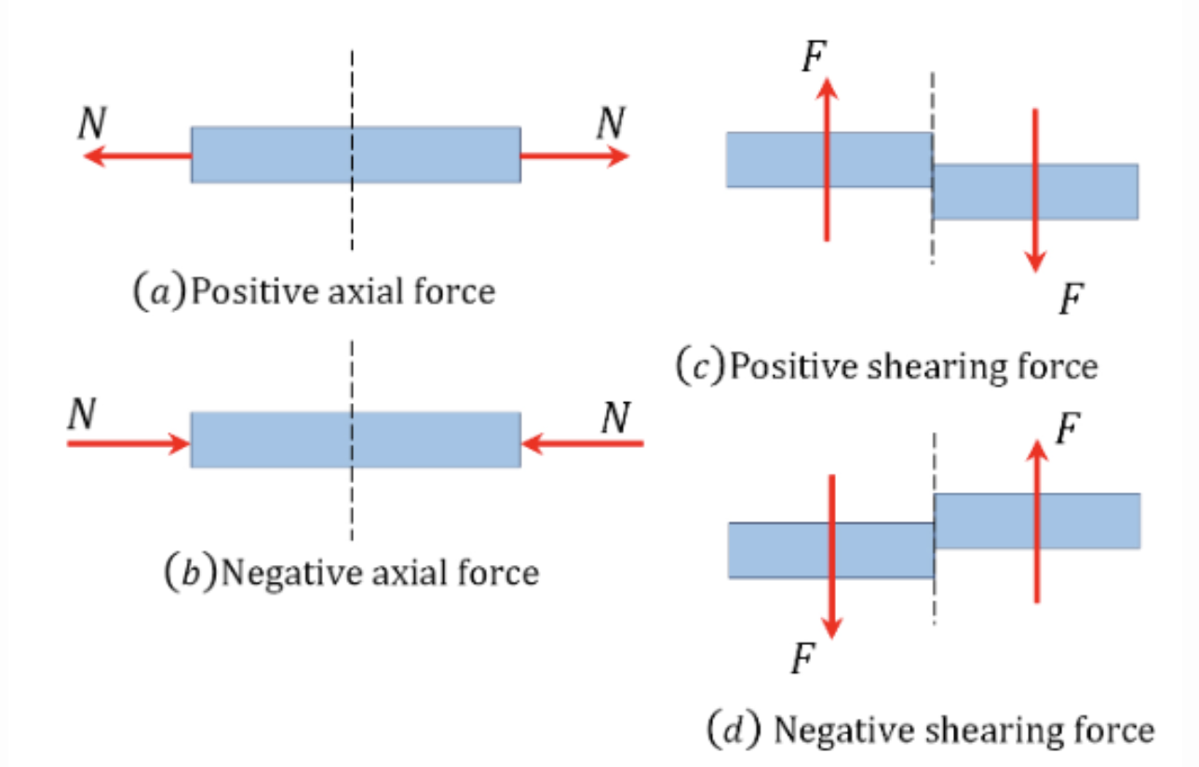
- “In civil engineering, force is foundational. At its simplest, force is something that causes a body to accelerate or deform.”
- “We often think in terms of applied forces and reaction forces.”
- “For example, when a load is applied to a beam, the supports provide reaction forces so the structure remains in equilibrium.”
- “Equilibrium means the sum of forces and moments equals zero — the system is stable.”
- “We also categorize forces: axial forces like tension and compression, shear forces, and moments that cause rotation.”
- “So in engineering, force is measurable, directional, and part of a balance.”
Pause slightly.
- “That’s one way of seeing force.”
Transition:
- “But that’s not the only way.”
INTRODUCE SOCIAL SCIENCE FORCE - XIAODONG

However, Force in my “social science” brain, Force is not really about physical factors, even though I do agree the force is an action exerted on the object or interaction among 2 objects from definition offered by civil engineering, but what kind of actions, on what “objects” during what specific interaction? Among who and who?, that is, these factors seem more important to my ends.

Based on my understanding, Force, we call as the formats of, not limits to coercion, compulsion, strength, violence, pressure, imposition.

(With GRAPHIC)
We are bringing Force to our table, rather than power,

Here we go, I would introduce one graphic, I cite from Saso Klekovski and others published Analytical Report: entitled as Civic Engagement – Long Road to Go in Jan, 2011

Force drawn from different sectors, also various intersectionality, connection, entanglement, hierarchy here. Now I turn to my colleague Zach.
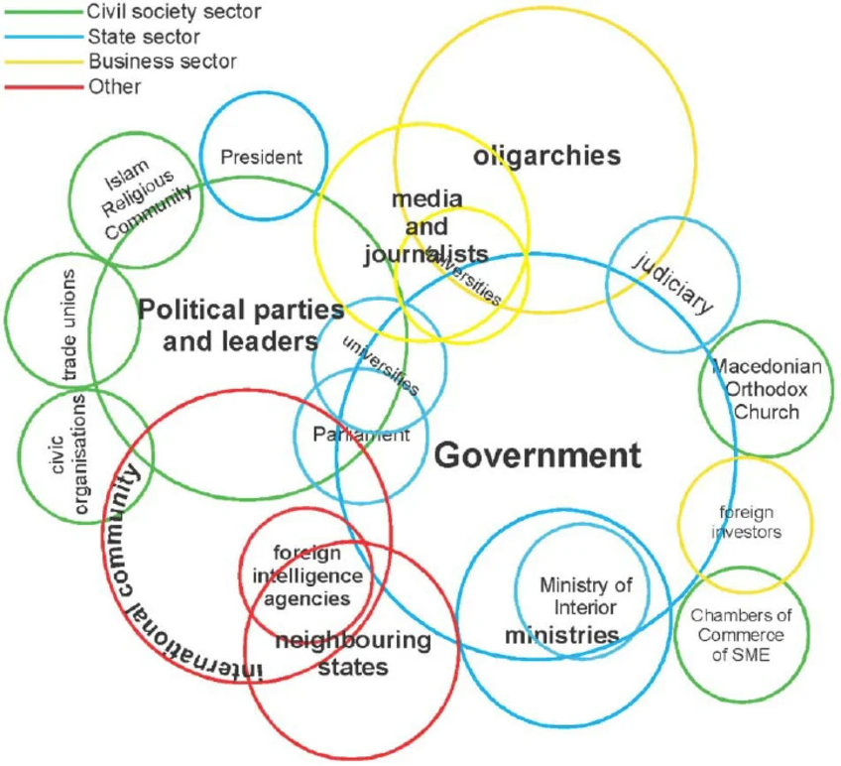

3. What Does the Class Think About Force? (0.5 minute prompt) XIAODONG
Purpose: Open Stage I – personal associations and meaning-making
Speaker Notes (Prompt):
- “When you hear the word force, what comes to mind?”
- “You don’t need a polished answer — just your first association.”
- “Is it physical? Emotional? Social? Personal?”
- “Where have you experienced force in your own life?”
Then
- “Let’s open the floor.” - ZACH
(Allow dialogue to unfold. If needed, gently redirect to lived experience rather than abstract theorizing.)
If conversation drifts:
- “Can we ground that in a personal experience?”
- “Where have you felt that kind of force?”

4. Clarification: Force vs. Power (1 minute) - Zach (first 3), Xiaodong (second 3)
Purpose: Reduce confusion without shutting down ambiguity
Speaker Notes:
- “I want to pause briefly because sometimes force and power get used interchangeably.”
- “In engineering, force is an interaction — a push or pull — that can be quantified.”
- “Power, in engineering, is the rate at which work is done. It’s related, but different.”

- “In social sciences, power often refers to the ability to influence systems, people, or outcomes — sometimes visibly, sometimes invisibly.” Power refers to authority, influence, capacity, sway, dominance, capability, persuasion. , force always moves people against their will. From the perspective of resistance, force and power represent two distinct methods of interacting with the world, leading to different levels of opposition and sustainability. Force is characterized by coercion, control, and harshness, which inherently produces resistance, counter-force, and conflict. Power, in contrast, is rooted in integrity, inner strength, and alignment, which generates little to no resistance and is sustainable
- “One way to think about it: force can act within a system, while power can shape the system itself.”
- “But that boundary isn’t fixed. And that tension is part of what we’re exploring.”
Transition: XIAODONG
- “So as we move into smaller groups, I invite you to notice: Where do you see force? Where do you see power? And how do they interact?
  - (No answers required)

ACTIVITY (We will be going around in classroom) - Zach
- Introduce activity
  - More direct approaches, for next 5 minutes, 3 groups, focus on different theme, think about force, in your life, how relate to each other,
    - Think about level, (macro, meso, micro)
      - More detailed,
  - Now we are gonna…
  - Explain o
  - “There are some ways (show some examples, find some graphics,) you can build a force map, but you have free to choose what kind of force map you would like to draw, to visually show how forces are connected with each other, try to tell us how you see, feel, force in your life.”

- Questions design forces-mapping XIAOODNG GROUPING PEOPLE
    - 1. Society (Macro)
    - 2. Career/Discipline (Meso)
    - 3. One Marginalized LOCAL Community based on your group’s shared interests (Micro/Marginalized (local) voices) (micro)
POSSIBLY ADD ANOTHER SECTION HERE FOR THE SECOND DISCUSSION

5. Conclusion (2 minutes)
Purpose: Stage IV reflection + ethical grounding + integration
Speaker Notes:
Zach
- “As we wrap up, I want to return to the idea of equilibrium.”
- “In engineering, equilibrium is stability — forces balancing one another.”
- “But in society, equilibrium doesn’t always mean justice. Sometimes it just means the system is holding.”
- “So one question I’m leaving with is: What forces are we reinforcing? And what forces are we resisting?”
- “As future professionals — engineers, communicators, social scientists, educators — we participate in systems of force.”
- “For me, thinking about the American Society of Civil Engineers Code of Ethics reframes force. It reminds engineers that our responsibility is to hold paramount the safety, health, and welfare of the public.”
- Xiaodong: “For me, thinking about the Engaged Scholarship, the awareness of “Force” also how to resist it, would be crucial entry/start pitch to remind academia that our responsibility is to make as much efforts as we can to Engaged Outreach & Research with local communities, to engaged pedagogy within classrooms, to Engaged Scholarship Infrastructure in Higher Ed.

- “So we argue that force is not neutral. How we design, communicate, or act can stabilize inequities — or redistribute force toward equity.”
- “I invite you to reflect: What forces shape you? And how do you want to apply force — or interrupt it — moving forward?”
Pause.

- “Thank you for engaging in this exploration.”
IF STILL HAVE TIME
Book recommendation, very briefly. Power vs. Force

