Selling Speed and Style: The Rise of Influencer Marketing on TikTok

By Eliza Rose Travelstead
University of Colorado Boulder
College of Media Communication and Information
Department of Advertising, Public Relations, and Media Design
Defense Date: March 31st, 2025

Thesis Advisor
Dr. Deepti Khedekar, Department of Advertising, Public Relations, and Media Design

Honors Committee
Dr. Jolene Fisher, Department of Advertising, Public Relations, and Media Design
Outside Committee Member: Lori Poole
March 31st, 2025

Abstract
This thesis explores how fast fashion brands leverage influencer marketing on TikTok to drive consumer engagement, urgency, and impulse purchasing behavior. Through a qualitative content analysis of 320 TikTok videos related to Zara, Brandy Melville, and Shein, this study identifies the visual, textual, and emotional strategies used by influencers to promote fast fashion. The findings reveal that scarcity marketing, aspirational storytelling, and sensory-driven content - especially in haul and unboxing videos - are central tactics for triggering consumer desire and encouraging frequent, often impulsive purchases. Influencers also serve as brand intermediaries, shaping audience perceptions through personal narratives and trust-based relationships, blurring the lines between entertainment and advertising. TikTok’s algorithm and commerce tools further amplify these strategies, creating a seamless environment for trend-driven consumption. While influencer marketing is shown to be highly effective in cultivating brand loyalty and social proof, viewer comment sections also reveal tensions around body image, financial burden, and inclusivity. This study contributes to emerging conversations around the psychological and societal effects of fast fashion advertising on digital platforms, offering insights for scholars, marketers, and ethically minded consumers. Future research should further investigate the neurological and behavioral effects of sensory and urgency-driven influencer content, particularly among Gen Z audiences.

Acknowledgments
Writing this thesis has been one of the most academically challenging - and undoubtedly most rewarding - experiences of my undergraduate career. I’m immensely grateful to the amazing group of inspiring women who supported and inspired me throughout this journey.
First, I want to thank my advisor and mentor, Dr. Deepti Khedekar, whose guidance was the foundation of this project. Her thoughtful feedback, encouragement, and belief in my work pushed me to grow not just as both a writer and a researcher.
I’m also incredibly thankful to Mia Wang, my research writing professor, who helped our honors class build the groundwork for our theses in the fall. From revising my (very rough) first draft to helping me find my first source, her early support was invaluable in setting me on the right path.
To Dr. Jolene Fisher, thank you for being such a positive and encouraging presence throughout this process. Your warmth and insight meant the world to me. And to Dr. Lori Poole, my outside committee member, I so appreciated your enthusiasm for research and education - your energy was exactly what I needed on my panel.
I also want to thank my friends for listening to me vent (a lot), offering support, and even staying up with me during the late-night writing marathons while I worked through my analysis. Your patience and presence meant everything.
This process has taught me that research is not linear. It’s messy, surprising, and transformative. I’ve gained more resilience, curiosity, and confidence than I ever expected - and I’m grateful for every moment of it.

Table of Contents
Chapter One: Introduction, Literature Review, and Research Questions
Introduction 5-6
Literature Review 6-14
Research Questions 14
Chapter Two: Methods 15-17
Chapter Three: Analysis 18-64
Chapter Four: Discussion 65-68
Chapter Five: Conclusion and Future Opportunities For Research, References 69-77

Chapter One: Introduction, Literature Review, Research Questions
The global fashion industry has undergone a significant transformation, marked by the rapid rise of fast fashion. Fast fashion refers to a business model that emphasizes the quick and high-volume production of low-cost, trend-driven clothing, which allows consumers to engage with the latest styles at an unprecedented pace (Binet, 2019). In recent decades, researchers have increasingly focused on the detrimental impacts of fast fashion, examining its effects on the environment, labor conditions, and broader societal implications (Kowzlowski, 2012). Fast fashion's ability to foster consumer loyalty through influencer advertising strategies needs to be explored more thoroughly. The model's appeal is heavily driven by tactics emphasizing immediacy and exclusivity, creating a sense of urgency among consumers. While studies such as Su and Chang (2018) have examined brand perception within the fashion industry, there is still an insufficient understanding of the societal pressures and micro trends that drive brand loyalty and purchasing behavior, even in the face of growing criticism. Influencer marketing has amplified FF's reach despite recent criticism of the industry, effectively engaging consumers through social proof and aspirational messaging. Thus, their role in sustaining brand loyalty needs to be explored further.
The literature on fast fashion advertising reveals several themes that are relevant to understanding how fast fashion brands like Zara, Brandy Melville, and Shein engage with their consumers. A key focus in the existing research is on how these brands have built a loyal audience by capitalizing on fast-moving micro-trends, a model they internally design and propagate, which amplifies societal pressure on consumers to adopt new styles to stay fashionable and relevant constantly (Tung, 2024). Each study contributes to a more nuanced understanding of how these companies foster engagement through emotional and psychological mechanisms, even as criticisms of the industry persist. Existing research has extensively documented the ethical concerns surrounding the fast fashion industry, such as its environmental impact, exploitative labor practices, and the promotion of overconsumption. For instance, Phillips and McQuarrie (2010) examine the psychological disconnect between consumer values and purchasing decisions. Similarly, Peters, Li, and Lenzen (2021) discuss the effectiveness of corporate social responsibility messaging in mitigating brand criticism. These studies often overlook the advertising strategies that allow brands to maintain consumer engagement and loyalty despite widespread criticism. This gap in the literature highlights the need to explore how fast fashion marketing not only attracts but sustains consumer loyalty through psychological and emotional mechanisms. In particular, the role of social media, influencer marketing, and the propagation of micro-trends in shaping consumer behavior remains underexplored. To address these gaps, this project examines the influencer advertising strategies employed by Zara, Brandy Melville, and Shein, focusing on how these tactics influence consumer loyalty, purchasing behavior, and self-identity among young women. The following literature review delves into these nuances, exploring how these brands utilize rapid trend cycles, social media, influencers, and to cultivate a sense of identity and belonging among their target audiences.
Literature Review
Trend-Driven Fast Paced Advertising
Fast fashion's reliance on trend-driven, rapid advertising has revolutionized consumer behavior, creating a constant demand for new and unique styles. Brands such as Zara and Shein have adopted operational and marketing strategies to introduce fresh collections weekly, contrasting with traditional seasonal cycles of 2-4 releases per year (e.g., see Aftab, Yuanjian, Kabir, & Barua, 2018). Zara, for instance, leverages its "Rapid-Fire Fulfillment" system to reduce production lead times to as little as 15 days, ensuring its ability to adapt to evolving trends and consumer demands nearly instantaneously (Ferdows et al., 2004). This approach fosters a perception of scarcity, encouraging impulse purchases driven by fear of missing out (Byun & Sternquist, 2008).
The speed and agility of fast fashion marketing directly appeal to consumers' psychological desires for immediacy and trend participation. Gazzola et al. (2020) highlight how this rapid turnover aligns with consumer expectations for constant novelty, significantly increasing shopping frequency and brand engagement. Retailers achieve this by closely monitoring consumer preferences through data analytics and customer feedback loops, enabling them to refine and introduce trend-aligned products swiftly (Ferdows et al., 2004).
Additionally, fast fashion advertising integrates storytelling and visual engagement, creating a narrative around each collection. Digital platforms and multimedia campaigns further amplify the emotional connection, enhancing consumer loyalty. As Zambrano (2018) notes, incorporating interactive storytelling in advertising strategies builds stronger brand-consumer relationships, fostering both engagement and repeat purchases.
Despite these successes, the rapid trend cycles driven by fast-paced advertising also contribute to overconsumption and environmental degradation. Gazzola et al. (2020) argue that while brands financially benefit from increased consumer turnover, this strategy exacerbates unsustainable practices, raising critical questions about the industry's long-term viability. Unlike traditional brands, which often emphasize brand heritage, product quality, and long-term consumer relationships, fast fashion brands prioritize immediacy, affordability, and trend responsiveness.
Fast Fashion Practices Exhibited by Zara, Brandy Melville, and Shein
The Spanish fast fashion retailer Zara, part of the Inditex group, has significantly disrupted and pioneered traditional retail practices by shifting away from the conventional two-season model of spring/summer and fall/winter collections. Unlike the industry norm of 2–4 planned seasonal product launches, Zara pioneered a model that produces smaller, more frequent collections, totaling up to 20 "seasons" annually. This unprecedented approach has been made possible through Zara's implementation of a super-responsive supply chain strategy known as "Rapid-Fire Fulfillment" (Tung, 2024), which reduces the product design-to-delivery cycle to as little as 15 days. This supply chain strategy has been adopted by numerous retailers, creating a fast-paced and highly competitive industry that thrives on constant turnover (e.g., see Aftab, Yuanjian, Kabir, & Barua, 2018).
Brandy Melville has successfully cultivated brand loyalty among teenage consumers through the strategic use of social media and exclusivity. By creating a distinct brand identity centered around the Brandy Girl aesthetic - characterized by casual, minimalist clothing and a slim, conventionally attractive body type - the company appeals to its target demographic's aspirational desires (Roller, 2023). Brandy Melville's marketing strategy capitalizes on social media platforms to showcase relatable, unpolished images of young women that align with their audience's ideals while subtly reinforcing traditional beauty standards (Tolentino, 2020). Furthermore, the brand's exclusive "one-size-fits-most" policy limits accessibility, creating a sense of desirability and status for those who can fit into its clothing (Macedo, 2021). This approach, while criticized for promoting harmful body image ideals, has proven highly effective in fostering a devoted following among teenagers.
Shein has strategically leveraged social media and influencer marketing to establish a dominant position in the fast fashion industry and cultivate strong brand loyalty among its primarily Gen Z audience. By partnering with Key Opinion Consumers (KOCs) rather than high-profile influencers, Shein fosters a sense of authenticity and relatability, connecting its products to everyday life and creating trust among young consumers (Chen et al., 2023). The brand employs user-generated content (UGC) to amplify its reach, encouraging customers to share their outfits online, often spontaneously and without direct compensation, thereby fueling viral marketing campaigns (Munajat et al., 2023). Additionally, Shein's collaborations with platforms like TikTok, Instagram, and Pinterest, combined with targeted digital campaigns, have cultivated billions of views, allowing the brand to maintain visibility and engagement in a highly competitive market (Chen et al., 2023). This comprehensive social media strategy, coupled with its data-driven approach to trend forecasting and cost-effective manufacturing, has enabled Shein to attract and retain a devoted customer base while redefining fast fashion marketing.
Influencer Celebrification and Its Impact on Fast Fashion
The impact of influencers and celebrity partnerships on fast fashion is increasingly prominent in digital marketing literature. Brooks, Drenten, and Piskorski (2021) introduce the concept of 'influencer celebrification,' a process by which social media influencers (SMIs) acquire celebrity capital within the social media advertising ecosystem. Their study highlights how influencers, unlike traditional celebrities, develop their celebrity capital through generative, collaborative, and evaluative practices. Generative practices, such as attention labor and platform agnosticism, emphasize the entrepreneurial efforts influencers undertake to build their audiences across platforms. Collaborative practices, including audience portability and creative ideation, showcase how influencers co-create content with their followers, fostering a sense of community and engagement. Evaluative practices, such as community-centric Key Performance Indicators (KPI) and content traversal, highlight the methods by which influencers' impact and reach are assessed across digital platforms.
This process of influencer celebrification directly impacts fast fashion marketing strategies, where influencer partnerships are often leveraged for rapid consumer engagement and product turnover. Influencers' ability to cultivate devoted online communities enables fast fashion brands to reach niche audiences quickly and authentically. Moreover, the collaborative nature of influencer content creation, such as sponsored hauls and styling videos, seamlessly integrates brand promotions into platforms like TikTok and Instagram. Brooks et al. (2021) argue that the authenticity perceived in influencer endorsements, driven by audience-centric practices, amplifies consumer trust and purchase intent. This is particularly critical for fast fashion brands that rely on high-volume, trend-driven purchasing behaviors.
Unlike traditional brands, which often emphasize heritage and curated campaigns, fast fashion brands prioritize immediacy and affordability. Their advertising strategies lean on influencer partnerships and algorithm-driven marketing to create urgency and promote real-time trends, highlighting their distinct, rapid-response approach to consumer engagement.
The Role of Social Media in Influencer-based Advertising for the Fast Fashion Industry
Social media has fundamentally transformed fast fashion advertising, enabling brands to connect with consumers in real time while leveraging digital tools to amplify engagement and drive sales. Platforms like Instagram, TikTok, Pinterest, and WeChat have become indispensable for brands like Zara and Shein to promote trends, drive consumer interaction, and build brand loyalty. Liu and Zhang (2019) highlight how integrating social media into fast fashion advertising creates an immediate feedback loop, where consumer preferences inform real-time adjustments to product offerings and marketing strategies.
The effectiveness of social media in fast fashion advertising lies in its ability to engage Generation Z and Millennials - digitally native demographics that value immediacy, interactivity, and aspirational content. Shein, for example, uses big data and micro-influencer partnerships to create hyper-targeted campaigns, leveraging platforms like TikTok and Instagram to showcase trendy, affordable clothing and foster a sense of community (Liu & Zhang, 2019). These platforms also encourage user-generated content (UGC), where consumers share their outfits and shopping experiences, effectively serving as brand ambassadors without formal endorsement deals.
Additionally, digital marketing strategies for fast fashion extend beyond social media platforms to include integrated tools such as big data analytics and e-commerce solutions. Liu and Zhang (2019) emphasize how brands like Zara utilize digital systems to collect and analyze customer data, allowing them to predict trends and manage inventory with unprecedented efficiency. This integration not only streamlines operations but also enhances the consumer experience by delivering personalized recommendations and tailored advertisements.
Social media also fosters emotional connections with brands through interactive content such as polls, live streams, and behind-the-scenes glimpses of product development. As Wang et al. (2019) suggest, elements like entertainment, trendiness, and electronic word of mouth (eWOM) are central to driving brand loyalty and preference on these platforms. Furthermore, visually driven platforms like Instagram amplify the appeal of fast fashion by showcasing aspirational lifestyles, encouraging consumers to emulate trends, and reinforcing the desirability of new collections (Fritzell, 2018).
However, the rapid growth of social media advertising in fast fashion is not without criticism. The emphasis on speed and affordability often promotes unsustainable consumer behaviors, as platforms incentivize frequent purchases and short-lived trend cycles. Moreover, as Fritzell (2018) points out, social media intensifies social comparison pressures, particularly among young consumers, exacerbating overconsumption and undermining efforts toward sustainability.
Social media has revolutionized the marketing strategies of fast fashion brands, offering unprecedented opportunities for engagement and growth. However, this digital transformation also underscores challenges related to ethical consumption and environmental impact. As the review progresses, subsequent sections will examine the role of influencers in amplifying these dynamics through the use of scarcity marketing techniques to trigger impulse buying cycles to sustain the fast fashion model.
Influencers Role in Fast Fashion Advertising
Social media influencers (SMIs) have become an indispensable component of fast fashion advertising, leveraging their relatability and broad reach to drive consumer engagement and purchase behaviors. Unlike traditional celebrity endorsements, influencers often build trust and authenticity through their direct connection with followers, making them particularly effective in shaping consumer preferences in the fast fashion industry (Sudha & Sheena, 2017). Authenticity is a critical factor in the success of influencer marketing. Influencers, especially micro and nano influencers, are perceived as more relatable and credible because of their consistent engagement and personalized content (Sudha & Sheena, 2017; Liu & Zhang, 2022). Research indicates that influencers who align their messaging with their personal values and maintain transparency about sponsorships generate stronger trust among followers. This authenticity not only fosters a deeper connection with consumers but also increases the likelihood of influencing purchase decisions, particularly among Generation Z and Millennials, who value genuine interactions over traditional advertising (Sudha & Sheena, 2017).
Influencers play a significant role in driving impulsive buying behaviors in fast fashion. Liang (2022) notes that the immediacy and visually stimulating nature of influencer content create a sense of urgency and exclusivity, prompting consumers to make unplanned purchases. Integrating in-app shopping features on platforms like Instagram and TikTok has further streamlined this process, allowing consumers to transition from inspiration to transaction in seconds. For instance, influencers often showcase limited-time offers or exclusive collaborations, capitalizing on fear of missing out (FOMO) to spur immediate action (Liang, 2022).
SMIs are also key drivers of micro-trends, often shaping and amplifying the fast fashion industry's rapid trend cycles. By endorsing specific styles or collections, influencers create demand for new products, further accelerating the industry's production and consumption rates (Liu & Zhang, 2022). As identified in the Swedish study on Generation Y and Z, influencers not only speed up the decision-making process but also play a pivotal role in determining what is considered fashionable, effectively shaping the aesthetic preferences of their audience. While influencers are highly effective in promoting fast fashion, their role has also been criticized for encouraging overconsumption and unsustainable practices. Liu (2022) highlights the ethical dilemma and hypocrisy of influencers promoting fast fashion while simultaneously advocating for sustainability, as their endorsements often lead to increased purchasing and disposal rates. This duality underscores the need for a more critical examination of influencer marketing strategies and their long-term impact on consumer behavior and the environment. In conclusion, influencers have become powerful agents in the fast fashion industry, driving trends, encouraging impulse buying, and fostering brand loyalty through authenticity and relatability.
Research Questions
RQ1: How is TikTok as a social media platform structured to facilitate advertising?
RQ2: What strategies do fast fashion influencers on TikTok use to create a sense of urgency among consumers and increase impulsive purchasing behavior among viewers?
a. What types of visual and textual cues are most used?
b. What emotional and psychological appeals are employed?
RQ3: How do these influencer advertising strategies affect viewers?

Chapter Two: Methods

This study examines how fast fashion brands, Zara, Brandy Melville, and Shein utilize influencer marketing and user-generated content on TikTok to shape consumer emotions, behaviors, and perceptions. Specifically, the research aims to answer two key questions: (1) What strategies do fast fashion influencers on TikTok use to create a sense of urgency among consumers and increase impulsive purchasing behavior? (2) How do these influencer advertising strategies affect viewers?

Data Collection and Preparation
Data for this study was gathered from TikTok videos related to Zara, Brandy Melville, and Shein. There were 320 videos analyzed. The TikTok content was divided into two primary categories:
- Branded Sponsored Content – Officially sponsored TikTok videos created in partnership with the brands.
- User-Generated Branded Content – Videos made by influencers that did not explicitly display sponsorship but still promoted these brands.
Branded TikTok videos were selected based on hashtags and brand mentions, while user-generated videos were chosen based on their organic promotion of these brands.
Units of Analysis
The primary unit of analysis included:
- TikTok Video Transcripts – Analyzing verbal narration, brand messaging, and persuasive language.
- Visual and Physical Cues – Examining outfit styling, product showcasing, and non-verbal expressions.
- Comment Sections – Assessing audience reactions, signs of impulse purchasing, and engagement with brand messaging.

Analyzing Video Content and Consumer Expression
This study employs a content analysis approach to identify and categorize themes across video content, user engagement, and discourse. Content analysis is a research tool used to determine the presence of certain words, themes, or concepts within some given qualitative data.
The analysis focuses on:
- Verbal and Physical Cues in Branded Content – How influencers use speech patterns, persuasive language, humor, and call-to-action phrases to drive consumer engagement.
- Themes in User-Generated Content – How influencers who are not explicitly sponsored by brands still encourage purchasing behavior.
- Audience Engagement and Consumer Behavior – How comment sections reflect consumer reactions, discussions of impulse purchasing, and brand influence.

Coding and Analysis Approach
A content analysis method was applied to identify recurring themes, patterns, and storytelling techniques used by both influencers and consumers. The research process included:
- Identifying Advertising Strategies – Open coding to categorize types of visual and textual cues that create urgency and drive impulse purchasing.
- Psychological and Emotional Appeals – Examining themes such as scarcity marketing, aspirational messaging, and authenticity cues.
- Audience Impact – Analyzing comment sections and Reddit threads to assess how these advertising strategies affect consumer sentiment and purchasing behavior.
- Axial Coding for Thematic Relationships – Refining themes to determine patterns in marketing influence across different content types.

Drawing Conclusions
With the dataset fully coded, I will draw conclusions by exploring the relationships between identified themes. This study will assess how fast fashion brands leverage influencer marketing to foster consumer behavior and shape self-identity, particularly among young women. The findings will provide insights into how advertising strategies contribute to impulse buying, emotional engagement, and brand perception in the fast fashion industry.

Chapter Three: Analysis
This section presents the findings from the content analysis of TikTok videos centered on Zara, Brandy Melville, and Shein. In this study, branded influencer content refers to the videos and social media posts created by fashion influencers that incorporate brand messaging - whether through explicit sponsorship or implicit promotion - into their content. The focus is not on the sponsorship arrangement itself but on the influencer-based strategies they employ. Specifically, the research investigates how these influencers use visual and textual cues, along with emotional and psychological appeals, to create a sense of urgency and trigger impulsive purchasing behavior among consumers. Additionally, the study examines user-generated critiques to assess how viewers’ emotions, brand perceptions, and purchasing behaviors are influenced by these practices. Lastly, the study will interpret how speech patterns, body language, and tone of voice used by influencers in their TikTok videos contribute to audience engagement and shape consumer attitudes. The insights derived from this analysis aim to provide some understanding of how influencer strategies promoting fast fashion products support the creation of narratives and sentiments that at least partially drive consumer behavior within the fast fashion industry. Ultimately, this research contributes to the growing discourse on the need for accountability, inclusivity, and sustainability in the fashion industry.
Distinction Between Branded and Organic Influencer Content
This section of the thesis aims address the first research question - how is TikTok as a social media platform structured to facilitate advertising? In order to answer this question, I explored how the social media platform TikTok allowed influencers (sponsored and unsponsored) to promote the three fast fashion brands of interest under review in this thesis – Zara, Brandy Melvill, and Shein. It is essential to unpack TikTok as an advertising platform to better understand the tools and avenues it offers to content creators – such as influencers – to enable them to promote branded products.
TikTok’s advertising ecosystem encompasses both organic influencer posts and paid advertisements. When influencers collaborate with brands for promotional purposes, they can publish sponsored content directly on their personal account. Based on my observation, this content is sometimes labeled with hashtags like #ad, #sponsored, or #partner to ensure that the audience understands it is a video that has been sponsored by brands. TikTok also allows influencers to use branded content tool, which permits them to tag posts with a business partner label. Often, this information is paired with an on-screen "Paid Partnership Badge" visible to viewers, further clarifying the promotional nature of the post. In addition to traditional sponsorships, TikTok allows brands to establish affiliate marketing partnerships with influencers. In this case, influencers provide unique links or promotional codes for specific clothing items on the platform, allowing their followers to make purchases directly through those links. Influencers earn a commission based on the sales generated from these referrals, creating a performance-based incentive to promote the brand and its products.
As a platform, TikTok strengthens the bond between influencers and consumers, offering a benefit many advertising avenues (such as T.V.) cannot. As consumers of content created by influencers (in this case, videos), the viewers on this platform are more likely to engage with influencer content that offers direct benefits, such as discounts, promotions, or other special offers. Viewers of influencer videos are thus often the buyers of branded products that these influencers promote through their content on TikTok. While some influencer videos do not display clear indication of sponsorship, it’s important to note that organic and unsponsored posts still often yield intense influence because they may come across as more authentic. For example, popular influencer Alix Earl has a track record of causing items to sell out almost immediately after mentioning them in her posts, whether her posts are sponsored or not.
Additionally, not all sponsored content is distributed in the same manner on TikTok. Like on many other social media platforms, such as Facebook and X, advertisements can also appear on this platform’s feeds through paid advertisements bought by different brands. These types of ads are sponsored by brands and promoted through TikTok’s targeted advertising tools, which enable specific demographics and audiences to be reached based on user data, interests, and behaviors. These types of ads are referred to as “In-Feed Ads,” and often look like organic posts but are inserted into the feed by the platform’s algorithm. This means that viewers can come across branded content even if they are not following any influencer personally.
This analysis helps us understand how TikTok works to the advantage of influencers and the brands they promote. As an advertising platform, TikTok enables promotional material to be distributed through sponsored and unsponsored influencer-created content and strategically placed advertisements. This distinction helps contextualize the advertisement strategies used by fast fashion influencers and underscores how their endorsement of products impacts viewers’ consumption behavior and opinions about fast fashion brands like Zara, Brandy Melville, and Shein. To analyze the advertising strategies employed by fast fashion influencers, I began by searching for sponsored content. I chose this approach because I wanted to determine whether brands such as Zara, Brandy Melville, and Shein imposed specific patterns or requirements in their contracts with influencers. Since sponsored content requires contractual agreements, I wanted to see if there were consistencies in the assumed asks based on similar visual and textual cues, along with emotional and psychological appeals employed. To my surprise, I found a great deal of variability among the sponsored content. Although all the influencers selected for paid partnerships were fashion content creators, they varied significantly in content style and follower count. For the purposes of my analysis, it is important to note that all the sponsored videos I examined did not appear on my feed organically. I believe this is because my past purchasing behavior and the type of content I typically consume do not align with the content that is posted by fast fashion brands or the influencers who promote their products. Consequently, I was unable to analyze any advertisements through TikTok’s “In-Feed” advertisements. This outcome is understandable given that I am not a direct target for these brands.
To my surprise, I found it very challenging to locate officially sponsored content on TikTok for Zara and Brandy Melville. Given the size and influence of these brands, I initially expected to find an abundance of sponsored content. However, advertising has evolved over the past few decades and has been blurring the lines of the boundaries with content that used to be typically recognized as entertainment or even information. The scarcity of sponsored content suggests that these brands may be allocating their advertising budgets differently, potentially favoring “In-Feed” advertisements or working with influencers in ways that do not require direct sponsorship disclosure. Additionally, since TikTok's algorithm curates content based on user behavior, it is possible that I may not be falling within these brands’ primary target demographics, which could explain why I was not served these ads organically.
Ultimately, I was unable to find any officially sponsored content from Brandy Melville, but I was able to analyze 42 influencer videos that included branding messaging. This was surprising, as I did come across videos discussing how to become a Brandy Melville ambassador. There is a possibility that the ambassador program no longer exists or that it never required ambassadors to create TikTok content. Although I was unable to find sponsored content, my searches led me to videos featuring discussions about the hiring process at Brandy Melville, highlighting themes of exclusivity marketing. Contrarily, it was easy to find an abundance of Shein-sponsored content - Shein has robust ambassador and partnership programs. Based on the themes analyzed, Shein gives the influencers they work with creative freedom over their posts but also sets directions they must follow.
To find sponsored videos created by various influencers, I used the same search queries across all three brands, swapping the brand names accordingly. For instance, the search queries for Brandy Melville included the following: Brandy Melville partner, Brandy Melville sponsorship, Brandy Melville paid partnership, Brandy Melville influencer collab, Brandy Melville, #brandymelvillead, #brandymelvillepartner, #brandymelvillepartnership, #brandymelville, and #brandymelvilleambassador. Despite the difficulty in finding sponsored videos for some brands, there were clear patterns in the data collected that highlighted some recurring themes. These are mentioned in the sub-sections below.
Theme One: Styles of Showcasing Clothing
In analyzing branded influencer content across Zara, Brandy Melville, and Shein, I identified three primary ways influencers showcased the clothing they have either purchased or received from brands: haul-style videos, unboxing videos, and try-on videos. While these formats share similarities, particularly in their tendency to display a large quantity of clothing in a short time, they differ in important ways based on structure, purpose, and consumer influence tactics. Haul videos focus on showcasing multiple clothing items acquired in a single shopping session, emphasizing quantity and the overall shopping experience rather than individual product details. Unboxing videos capture the initial process of opening a package from a brand, offering raw, first impressions that add a sense of authenticity. Since these videos document genuine reactions, they enhance credibility and trust among viewers. Try-on videos, on the other hand, involve influencers wearing and evaluating the clothing, providing insights into fit, style, and overall look. These videos help viewers decide whether to purchase an item, especially when the creator shares their sizing details for reference. After analyzing 320 branded influencer videos, I identified several key themes, which are outlined in the following subcategories.
Haul-Style Videos
I analyzed 32 officially sponsored haul-style videos from Shein and found an abundance of similar content. Although I was unable to find officially sponsored content and explicitly sponsored haul-style videos or Brandy Melville or Zara, I did analyze 15 haul-style influencer videos created for Zara and 12 for Brandy Melville. It was clear based on my analysis of these videos that influencers used various implicit promotion strategies to endorse their fast-fashion branded products in the haul-style format. I found that the primary focus of haul-style videos is to highlight both the quantity of clothing purchased and the variety of styles showcased. The tone of the influencers was most often excited and enthusiastic, reinforcing the appeal of abundance and excess. Across all 59 haul videos, two recurring characteristics stood out: scarcity marketing and excessive consumption appeal. This section of the study will focus on excessive consumption appeal, as a later theme will discuss scarcity marketing – including its presence in haul-style videos.
Excessive Consumption Appeal. Across all 59 haul-style videos analyzed, the average number of clothing items per haul was 10. Smaller hauls typically featured 5-10 items, mid-sized hauls ranged from 10-15 items, and large hauls showcased more than 15 items, with the largest haul analyzed including 19 pieces of branded apparel. While some influencers briefly mentioned the prices of a few individual items, there was no consistent way to determine the total cost of each haul. However, given that Zara, Brandy Melville, and especially Shein are known for moderate to low price points, it can be inferred that medium to large hauls could become quite expensive for the average consumer. The most expensive haul analyzed that mentioned pricing was a $700 Brandy Melville haul.
A key takeaway from haul-style videos is the underlying message that having more clothing equals having more style options, and by extension, better style and greater happiness. This idea was reinforced both verbally and visually throughout the videos. In 72% of haul-style videos I analyzed, influencers began by holding multiple large shopping bags, dropping them onto the floor, or showcasing their weight and size, emphasizing the sheer volume of their purchases. These exaggerated displays glamorize large-scale shopping, making it appear aspirational rather than excessive or wasteful. Combined with the influencers’ energetic tones and visible excitement, it becomes challenging for a viewer not to be drawn into the appeal of these large-scale hauls. Images are included below:
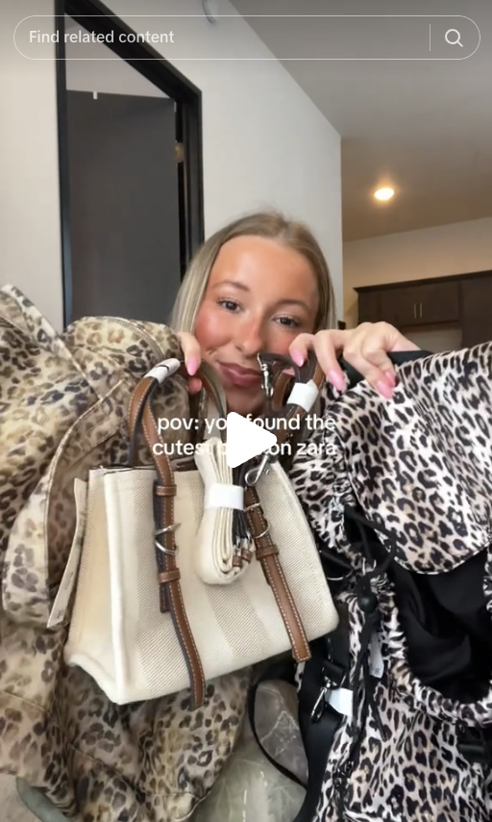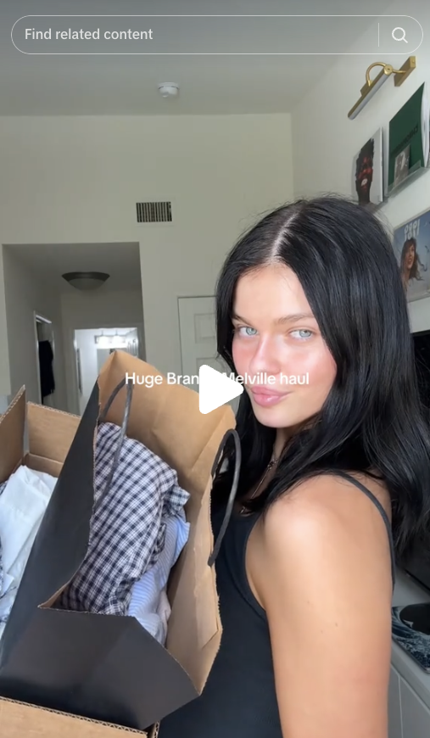
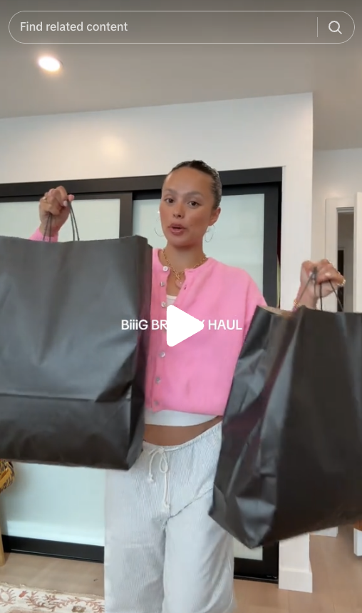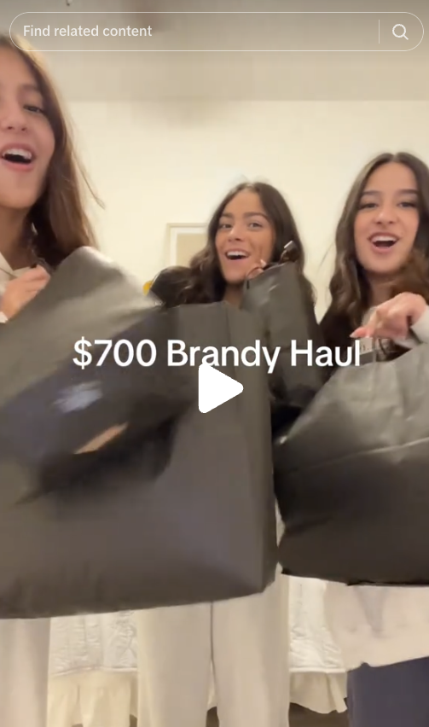
The normalization of bulk purchasing in haul-style videos is closely tied to the rapid cycle of micro-trends, particularly within brands like Zara and Shein, which specialize in fast production and trend adoption (Tung, 2024). The psychological component behind this trend-driven consumption is notable - Gazzola et al. (2020) argue that fast fashion’s rapid turnover aligns with consumers’ expectations for constant novelty, ultimately increasing shopping frequency and brand engagement. This argument is supported by the comment sections of these haul videos, where viewers frequently express urgency and desire for the items shown. While there is no way to track whether viewers purchase the items featured in these hauls or if they browse the store’s website afterward - since TikTok’s backend data and store analytics are inaccessible - the videos do drive engagement and brand awareness. The abundance of comments asking for product codes, and links, and stating “I need everything” illustrates the effectiveness of these videos in fueling consumer desire to purchase excessively. A few examples of comments that reflect this sentiment are below:
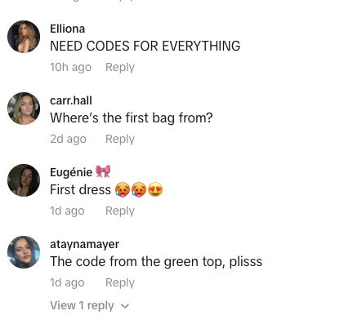

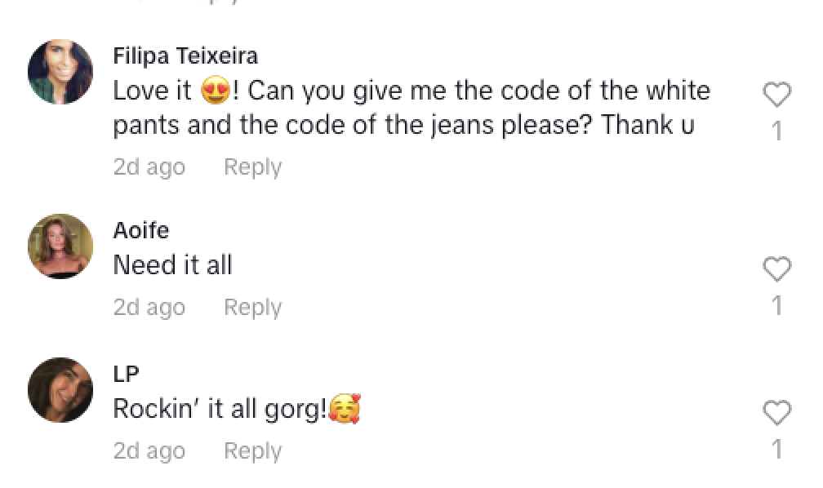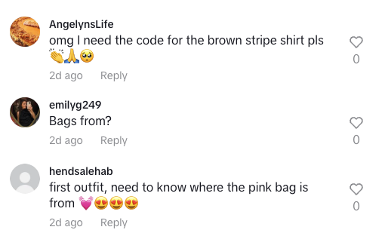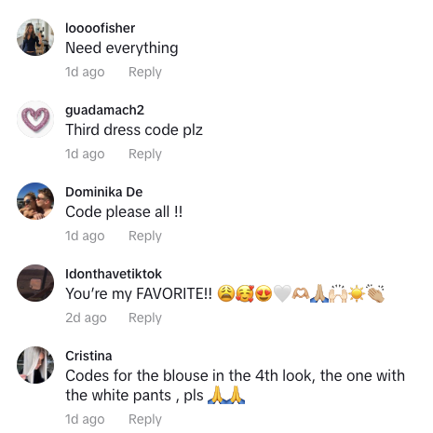
These comments exemplify how haul videos not only showcase clothing but also create a shopping culture rooted in excess and continual trend participation. Based on my analysis, one can claim that there is evidence of a hedonic treadmill effect in which consumers continuously seek new purchases to maintain excitement.
Unboxing-Style Videos
Unboxing videos, as described by Gangadharbatla & Khedekar (2021), share similarities with haul-style videos, as they typically showcase multiple items in a single session. However, unboxing videos are distinct in that they focus primarily on revealing and reacting to new items as they are taken out of their packaging. Through the influencer videos I analyzed, I could see that these videos placed a strong emphasis on first impressions, making them particularly effective in building anticipation and excitement around a brand. A key finding from my analysis of 22 unboxing videos is how first reactions contribute to a sense of authenticity. Because influencers experience the items in real-time, their facial expressions and verbal responses help create an unscripted and genuine feel as well as a sense of expectancy and elation. Additionally, the limited try-on component of these videos often seemed to leave viewers wanting more, frequently leading to comments requesting a follow-up try-on haul. This suggests that unboxing videos serve as an initial phase of product exposure, enticing viewers but also encouraging further engagement with the influencer’s content. Examples of these comments are below:
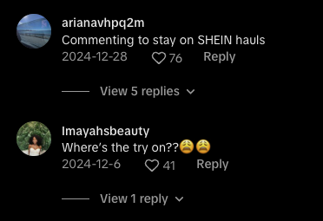
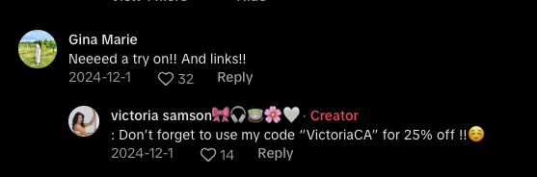

It is important to note that, in sponsored content, influencers are typically required to disclose when a brand has sent them products, often in the form of a PR haul. However, within the 22 videos analyzed, I was only able to identify two officially sponsored unboxing hauls from Shein. Despite this, as previously discussed, the influencer marketing landscape is increasingly blurred, making it difficult to distinguish between pure entertainment and subtle advertising. Many of the influencers in the analyzed unboxing videos likely received products from brands, even if they did not explicitly disclose sponsorship. This ambiguity creates an element of exclusivity, making viewers feel as though they are missing out on something special, which in turn could increase consumer demand. When influencers casually “unbox” new pieces without clear sponsorship disclosure, it reinforces the illusion of organic discovery, making the products seem even more desirable.
Since influencers open the packages on camera, their facial expressions and tone of voice convey excitement, surprise, or sometimes mild disappointment, which adds to the genuineness of the experience. This real-time reaction enhances credibility, as viewers feel they are witnessing a frank assessment of the products. One of the most frequently observed verbal and non-verbal cues in these videos was the use of sensory engagement, particularly through ASMR (Autonomous Sensory Meridian Response). Many unboxing videos intentionally amplify sounds such as the ripping of tissue paper, opening plastic packaging, handling soft or textured fabrics, and slicing open the tape sealed on boxes with a knife. This leads me to ask the question: do influencers purposefully incorporate ASMR into their videos to hook viewers? Is this a conscientious choice because the effects of watching this style leads to a sense of relaxation and pleasure for viewers?
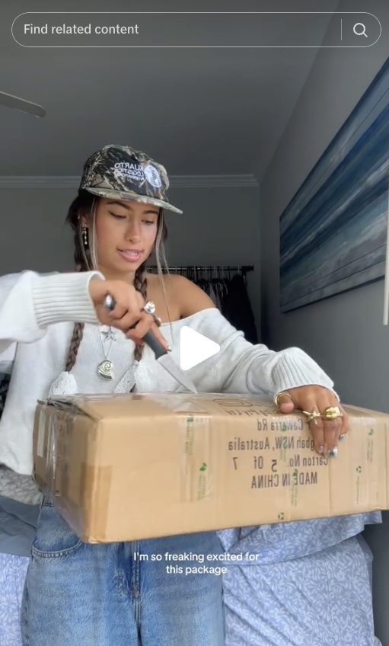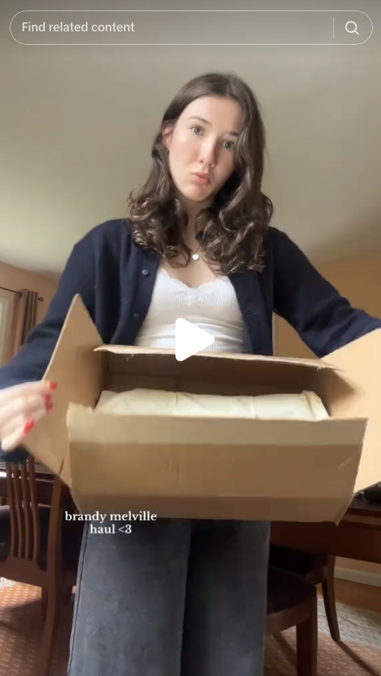
These subtle yet intentional sound effects heighten sensory appeal, making the video feel more immersive and satisfying to watch. While one cannot confirm this theory based on the comment sections alone, one would make an educated guess that this is a psychological tactic used to evoke an emotional high, mimicking the feeling of receiving a package and triggering instant gratification shopping. Additionally, unboxing videos capitalize on the exclusivity effect, making viewers feel as if they are getting a sneak peek into a special shopping experience. This fear of missing out (FOMO) (Liang, 2022), combined with the influencer’s genuine excitement and sensory-driven engagement tactics, makes unboxing videos a powerful marketing tool that subtly encourages impulse purchasing.
Try-on-Style Videos
As the name suggests, the try-on videos I analyzed featured influencers wearing and showcasing the clothing they purchased in a haul. These videos often include full outfit styling, where influencers pair newly purchased items with pieces from their existing wardrobe to create a cohesive look. In cases where influencers bought many items, they typically showcased multiple outfits in succession, emphasizing versatility and styling options. Among the 16 try-on videos analyzed, there was an even split between those that included verbal narration and those that relied solely on visual presentation. This suggests that influencers take different approaches to try-on content, either focusing on aesthetic appeal and styling or providing detailed feedback and personal commentary.
For the videos that did not include verbal commentary, influencers relied on physical cues to display the garments effectively in the following manner:
- Presenting at least three different outfits per video, showcasing variety.
- Walking in a catwalk-like manner, mimicking a fashion show to highlight fabric movement and fit.
- Using upbeat, playful background music to create an engaging, high-energy feel.
- Alternating between various poses when a full walking sequence was not included, ensuring that the audience could see the garments from multiple angles.
In the eight videos that incorporated verbal narration, influencers provided additional context about their purchases:
- Three videos included elements of storytelling, where influencers explained why they purchased specific clothing items (e.g., for an event, a vacation, or to try out a new trend). This approach made the videos feel more personal and relatable, giving viewers insight into the influencer’s thought process and lifestyle.
- The remaining five videos focused on product descriptions, where influencers evaluated the fit, feel, and quality of the garments. Most commonly, influencers noted whether:
  - The items fit true to size.
  - The fabric felt soft, stretchy, or structured.
  - There were any quality issues, such as sheer fabric or loose stitching.
Interestingly, in videos that did not include verbal narration, there were frequently viewer comments asking for sizing details and fabric descriptions. This suggests that even without verbal cues, viewers were still engaged enough to seek out additional information before making a purchase. This level of audience interaction reinforces brand engagement, as potential consumers are being influenced by their visual senses, prompting them to ask clarifying questions before deciding to buy.
One of the key consumer persuasion tactics I observed in try-on videos was the ability to reduce uncertainty in online shopping. Seeing an influencer - a real person - try on an outfit - seemed to make the shopping experience feel more trustworthy than simply relying solely on product images from a website. Additionally, influencers frequently engaged with their audience in real-time, prompting peer influence and social validation. Common phrases included:
- “What do you guys think of this?”
- “Should I keep this?”
- “Do I need this in another color?”
These types of questions encouraged engagement, prompting viewers to comment, like, and share their opinions, which not only boosts post visibility but also strengthens the relationship between the influencer and the brand. By blending authentic reactions, audience interaction, and styling versatility, try-on videos served as an effective digital equivalent of an in-store shopping experience, helping convert viewers into consumers while reinforcing brand loyalty and community influence. Examples of consumer engagement are available in the screenshots below:

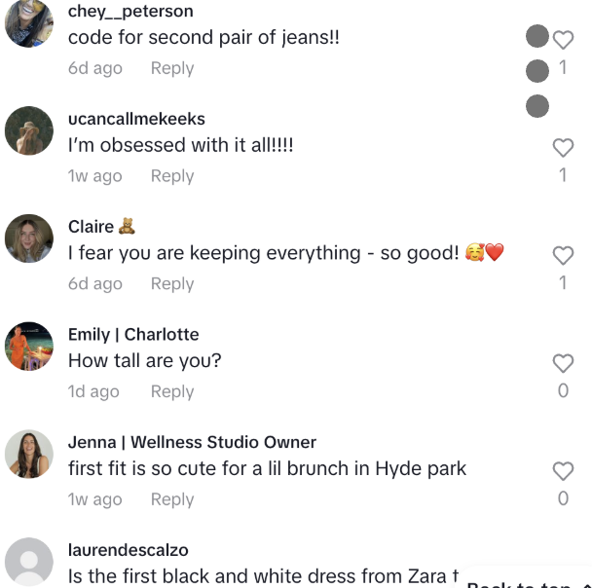

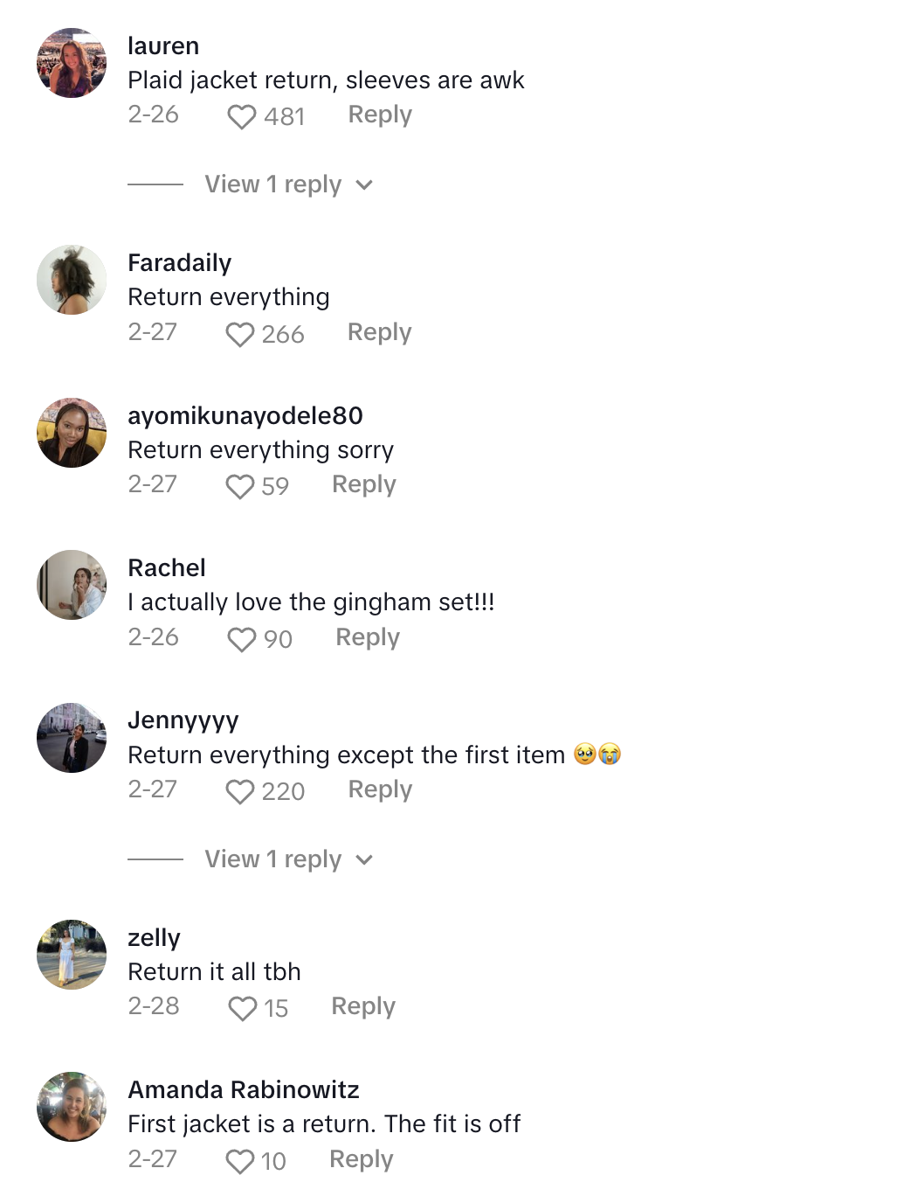

Theme Two: Influencer Storytelling to Connect with Viewers
The second theme identified in the analysis is storytelling as a tool for authenticity and trust-building. As Zambrano (2018) notes, incorporating interactive storytelling in advertising strengthens brand-consumer relationships, increasing engagement and repeat purchases. Among the 12 videos analyzed that featured storytelling, influencers commonly employed inclusivity narratives, romanticized shopping experiences, and emotional justifications for their purchases. They also made disclaimers like “If you’ve been following me for a while, you know I love this brand,” further reinforcing credibility. Additionally, many influencers referenced “retail therapy” to frame shopping as an emotionally fulfilling experience (e.g., “It’s been a long week, so I treated myself”), aligning with fast fashion’s marketing strategies that tie consumption to self-care and personal happiness.
A strong example of this theme is a TikTok video by an influencer who goes by the handle @ellapccobb, in which she romanticizes her upcoming trip to Portugal by justifying a large Zara shopping haul. The caption reads, “@ZARA is having a moment. Need everything!!!!!! Everything is linked on my LTK!!! Find me at ELLAPCOBB :) #zarahaul #zara #zaraoutfit.” This caption suggests a potential sponsorship or ambassador program partnership, as she provides affiliate links. The video itself follows a structured yet informal format, blending aspirational lifestyle marketing with real-time outfit decision-making, making the content both relatable and desirable. There are five key themes in Ella’s video, which can be seen in other videos as well, that are outlined below:
- Romanticizing Shopping & Travel - opening videos using statements like, “I might be the only one that does this, but whenever I have a big trip planned, I always put in a really big, massive clothing order just to really romanticize my life.” This positions shopping as an experience rather than a necessity, reinforcing fast fashion’s appeal through frequent wardrobe updates and aspirational living.
- Descriptive Language & Emotional Connection - using emotionally charged adjectives to enhance the appeal of the items:
  - “Chic” – 3x (“They are so chic,” “This set feels very special and chic”).
  - “Cute” – 4x (“Look how cute this necklace is,” “This is another look that’s very cute”).
  - “Cool” – 3x (“They feel so effortless and cool,” “This set feels very special and chic and cool”).
  - “Effortless” – 1x (“So effortless and cool”).
  - “Fancy” / “Sexy” – Used to describe a lacey top, reinforcing versatility for both casual and upscale occasions.
  - “Comfy” / “Neutral” – Used to emphasize functionality and mix-and-match potential.
  - “Baggy and Oversized” – Suggests trendy yet comfortable styling, aligning with current fashion preferences.
- Real-Time Outfit Experimentation & Authenticity – Unlike traditional fashion ads, the videos feels spontaneous. For instance, Ella reacted to outfits in real time, displaying genuine excitement and decision-making. A clear example is when she put on a jacket, checked herself in the mirror, and exclaimed, “Oooo okay… this is cute.” Her widened eyes and slight head nod visually reinforce excitement, making the reaction feel more authentic.
- Encouraging Audience Engagement – Many influencers ended their videos with, “Alright guys, I don’t know what to keep and what to return.” This strategic uncertainty makes their videos feel less like an overt sponsorship and more like a natural shopping experience. By leaving the decision open-ended, she encourages viewers to engage in the comments and offer opinions, increasing audience interaction.
- Fast Fashion’s Mix-and-Match Appeal – Throughout the video, influencers emphasized the versatility of Zara’s pieces. For instance, Ella noted in a video, “This is comfy and neutral; I can mix and match all of these pieces,” reinforcing the fast fashion strategy of interchangeable, trend-driven wardrobe-essentials.
Looking at the comment section of Ella’s video to determine their influence on impulse shopping behavior, one can see engagement patterns that suggest consumer interest and, in some cases, immediate purchasing behavior.
Two key themes emerged in these videos:
- Positivity & Brand Reinforcement – Most comments were overwhelmingly positive, praising both the influencer’s styling and the brand (which, in the case of Ella’s video, was Zara).
- Indicators of Purchase Intent – Several comments directly referenced purchasing behavior. For instance, in the case of Ella’s video:
  - 12 comments included the word “need,” signaling an immediate urge to buy.
  - 16 comments asked for product codes, showing active efforts to locate and purchase the items.
  - 7 comments inquired about sizing, indicating a serious consideration of buying.
  - 5 comments explicitly stated that viewers had already added the items to their cart or made a purchase.
These high-engagement interactions to influencers’ narrative-style videos on TikTok demonstrate how influencer marketing on TikTok creates urgency, making the shopping process feel seamless and immediate. The use of verbal narration, product recommendations, and aspirational storytelling played a key role in motivating viewers to act on impulse. However, it is important to note some anomalies. For instance, while most comments were positive and purchasing-driven, there were three notable comments under a video by another influencer – Chelsea – that expressed frustration with Zara’s size inclusivity:
- “My Zara has nothing over XL, and if they do, it’s rare 😫 this definitely isn’t all locations.”
- “I never find anything my size at Zara.”
- “See, and you presented proof buttttt my proportions make it impossible for me to find anything, so I hate Zara 😭😭😭 I’m 5’11 for reference.”
These comments highlight an important limitation of influencer marketing. While influencers can enhance a brand’s appeal and drive sales, they cannot resolve long-standing brand criticisms (in Zara’s case, their lack of inclusivity in relation to body sizes). This analysis demonstrates how TikTok influencers use storytelling to create urgency, drive engagement, and encourage purchasing behavior through psychological and emotional cues. The positive reinforcement and purchase intent in the comment sections suggests that these videos were effective in stimulating consumer interest and prompting impulse buying. However, negative comments reveal that while influencer marketing boosts brand desirability, it does not necessarily resolve accessibility and inclusivity concerns.
Theme Three: Developing Awareness for and Positioning Fast Fashion Brands in the Minds of Viewers
One of the most strategic ways fast fashion brands establish a presence on TikTok is through messaging that reinforces their brand identity and distinct positioning (Liu & Zhang, 2019). While this study did not try to ascertain whether or how brands provide influencers with direct guidelines on how to describe their products, clear patterns emerged in the influencers’ videos that indicated how each brand was marketed. Influencers frequently highlight key differentiators that set one brand apart from the others, creating specific brand associations in viewers' minds. These key sub-themes are outlined below:

Zara: Professionalism, Chic Styling, and Sustainability
Compared to Shein and Brandy Melville, Zara’s positioning focused heavily on chic, business casual outfits, professional wear, and vacation-ready styles. Several influencers framed their Zara hauls as a way to elevate their wardrobe, often showcasing structured blazers, tailored pants, and polished basics that could be worn in an office setting or styled casually. A particularly interesting deviation from Zara’s typical brand identity was its sponsored influencer campaign promoting Zara Pre-Owned, a secondhand shopping platform that allows customers to resell, donate, or repair Zara clothing. The influencer Elizabeth (@elizabethanneventer) posted a sponsored video explaining the platform's features, emphasizing Zara’s newfound interest on sustainability. In her video, Elizabeth repeatedly used the term “pre-owned” (five times) to reinforce the sustainable and environment-conscious element of their branding and legitimize the platform. Her messaging also focused on ease of use and accessibility, stating, “I just had to scan the barcode that was on the tag, and it pulled up all the information for me.”
By emphasizing convenience and functionality, Elizabeth’s content framed secondhand shopping as both a personal lifestyle choice and an easy, hassle-free experience. Her video also incorporated personal wardrobe storytelling, making her endorsement feel more authentic:
- “Honestly, it's so cute, it's just not really in my rotation anymore, but for somebody else, it could be.”
Rather than framing her Zara clothing as disposable or unwanted, Elizabeth subtly maintained its desirability, thus reinforcing the idea that Zara’s Pre-Owned marketplace is a way to extend the life of stylish, high-quality pieces.
Zara also tapped into inclusive branding by partnering with Chelsea (@itschelseaj), a plus-size African American influencer, to create content addressing common concerns about Zara’s sizing. Chelsea’s videos followed a simple format. For instance, one video captioned “Can a plus-sized woman fit @ZARA?” showcased Chelsea walking through a Zara store, selecting an outfit, and later trying it on at home. In her videos, she frames her content as answering questions many plus-size shoppers have, making it feel like a community-driven discussion rather than a corporate ad. Finally, instead of discussing pricing or specific product details, Chelsea’s messaging focuses entirely on demonstrating that plus-size individuals can shop at Zara. Both Elizabeth’s and Chelsea’s videos seemed to serve as brand reputation management tools (one reframing Zara as eco-conscious and the other working to expand its inclusivity narrative).

Shein: Trend-Driven Global Influence & App-Focused Marketing
Influencers branding Shein branding differed in their approach from those branding Zara. Shein influencers leaned into its global reach, trend-driven nature, and digital-first shopping experience. Out of all the brands, Shein had the highest number of international influencers, with nine influencers from different countries appearing among the videos I analyzed. I’m sure there are more that exist, but for the purposes of this analysis I was able to identify nine. These influencer videos hammered in Shein’s position as a brand that has widespread accessibility which taps into micro-trends across multiple cultures.

Shein App & Hidden Shops. Another most notable way Shein’s influencers differentiated the brand was through their tutorials on how to use their app. Unlike Zara and Brandy Melville, which rely more on aesthetic branding and organic content, Shein’s marketing strategy is highly integrated into its digital shopping platform. A key example of this is an influencer video by @emilyhayhurst, showcasing Shein’s “Hidden Shops” in their app. This example effectively represents the common patterns observed across all 10 videos analyzed of influencers promoting Shein’s app. The influencer narrates while scrolling through Shein’s app, pointing out different collections designed to resemble high-end brands.
- “If you like Zara, if you like Anthropologie, Free People, they have a hidden shop for it.”
- “Misguided comes in as a close number two because everything’s so good, and they even put a little metal tag on all of their pieces, which makes everything feel more elevated.”
- “This next shop, Majia, is like everything Zara.”
- “Glowmode is anything Lululemon or Alo.”
- “This last shop is Shein Aloruh - it’s everything Meshki.”
This verbal narration and direct app demonstration serve multiple functions. It helps educate users on how to shop smarter within Shein’s platform. It also leverages brand association by linking Shein’s items to well-known, high-end competitors. Lastly, it creates an aspirational appeal by making Shein products seem like budget-friendly versions of luxury fashion. Shein’s app-focused marketing further distinguishes the brand from competitors by reinforcing the idea that Shein is not just a store, but an entire shopping ecosystem. This digital-forward branding approach makes Shein stand out as a fast-paced, trend-heavy platform that is constantly evolving and offering new shopping experiences.
A recurring theme in these videos was the emphasis on "dupes", a term used to describe affordable alternatives to high-end or designer products. As seen in the comments above, many influencers explicitly compared Shein items to popular luxury brands like Zara, Free People, Reformation, and Lululemon, positioning Shein as a budget-friendly option for trendy fashion. By highlighting hidden Shein shops that mimic the styles of well-known brands, influencers reinforced Shein’s value proposition of offering stylish, on-trend pieces at a fraction of the cost. This tactic appeals to cost-conscious shoppers who want the look and aesthetic of designer fashion without the high price tag. The use of direct brand name comparisons in these videos suggests that Shein strategically markets itself as an accessible alternative to premium retailers, tapping into the growing demand for affordable fashion dupes.
Physical & Visual Cues in Shein’s App Videos. In Shein’s influencer videos that feature how to use their shopping app, both physical and visual cues were used to enhance viewer engagement and understanding. The videos often included screen recordings of the app interface that showcase key features such as functions, filters, and collections. Influencers frequently point at different parts of the screen while discussing various shops, creating a sense of interactivity and guiding the viewer’s attention. Additionally, zoom-ins on product details, price comparisons, and category names highlight Shein’s affordability and trend-driven offerings, reinforcing the brand’s appeal to budget-conscious, style-savvy consumers.
Brandy Melville: Minimalism, Basics, & Employee-Created Content
Influencers who showcased Brandy Melville products had the most distinct branding approach, emphasizing simplicity, everyday wear, and exclusivity. A consistent theme across Brandy Melville try-on videos was the repeated emphasis on their clothing as high-quality “basics.” Among the 16 try-on videos analyzed, five specifically mentioned how Brandy Melville’s clothing consists of staple pieces that will “get frequent use.” A key theme that influencers repeated in their videos for Brandy Melville’s was the brand’s strong focus on wardrobe essentials - clothing that is marketed as versatile, timeless, and designed for everyday wear. Influencers promoting Brandy Melville frequently emphasize that their pieces are "high-quality basics" that can be worn repeatedly and styled in multiple ways. This messaging aligns with the brand’s reputation for offering staple items rather than trend-heavy fashion. Unlike Shein and Zara, which thrive on rapid trend cycles, influencer marketing for Brandy Melville suggested exclusivity and longevity, appealing to consumers who seek simple, effortlessly stylish clothing that integrates seamlessly into their existing wardrobe. This emphasis on quality over quantity helps reinforce the brand’s aspirational yet minimalist identity, positioning its pieces as essential investments rather than impulse purchases.
Brandy Melville also employed a unique influencer marketing tactic: relying on employee-generated content – or content generated by Brandy Melville employees - rather than traditional sponsorships. Unlike Shein, which clearly invested in influencer partnerships, Brandy Melville had no identifiable officially sponsored content in the dataset I created. Instead, branding efforts were largely carried by: “Day in the life of a Brandy Melville employee” videos and “Get ready with me to work at Brandy Melville” videos.
Brandy Melville’s Exclusive Brand Identity. As noted in the literature review, Brandy Melville is widely recognized for its distinct “Brandy Girl” aesthetic, characterized by minimalist, neutral-toned clothing, a slim, conventionally attractive body type, and a Eurocentric, Caucasian, beauty standard (Tolentino, 2020). Not surprisingly, all the influencers featured in Brandy Melville employee videos fit this aesthetic, reinforcing the brand’s exclusivity and aspirational appeal. This raises an important question: Were these employees encouraged to post these videos as an internal form of influencer marketing? Since Brandy Melville has faced controversy for its “one-size-fits-all” approach and hiring practices, this organic-looking employee content may have been curated to serve as a way to maintain exclusivity while avoiding direct brand involvement in influencer marketing.
In conclusion, each fast fashion brand strategically positioned itself on TikTok through specific messaging and influencer-driven branding techniques. Influencers positioned Zara primarily using chic, professional styling and sustainability-focused content to appeal to an aspirational yet eco-conscious audience. Their videos for Shein leaned into trend-driven global influence, affordability, and app-focused tutorials to position Shein as a global, all-in-one fashion marketplace. Brandy Melville reinforced its exclusive, minimalist aesthetic through employee-generated content that subtly promoted its brand identity. These distinct branding approaches show how fast fashion companies leverage influencer marketing not just to sell products, but to shape consumer perceptions of their brand identity and positioning. Below are images that visually illustrate the discussed branding strategies for Zara, Shein, and Brandy Melville, showcasing Zara’s Pre-Owned platform and inclusivity efforts, Shein’s app features and dupe marketing, and Brandy Melville’s employee-driven content and emphasis on quality basics.
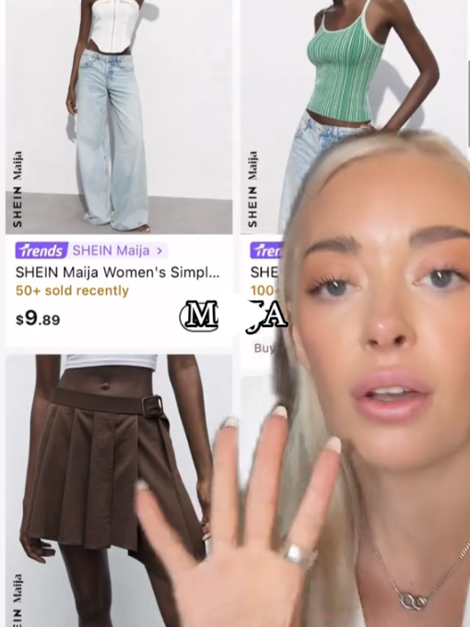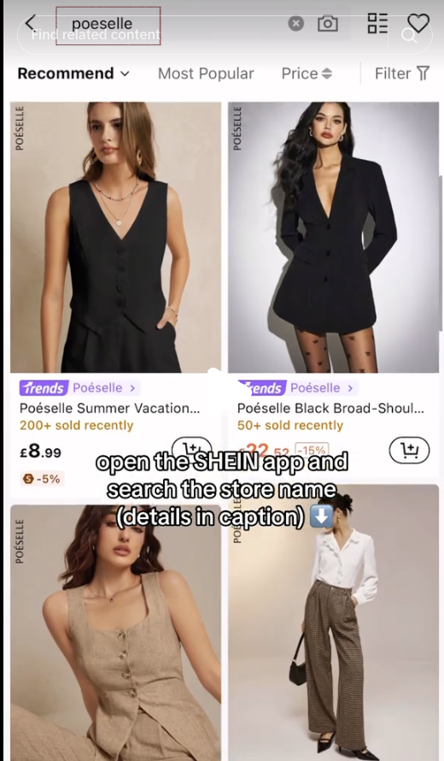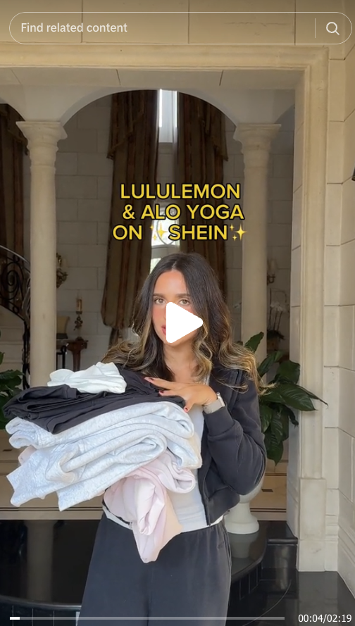
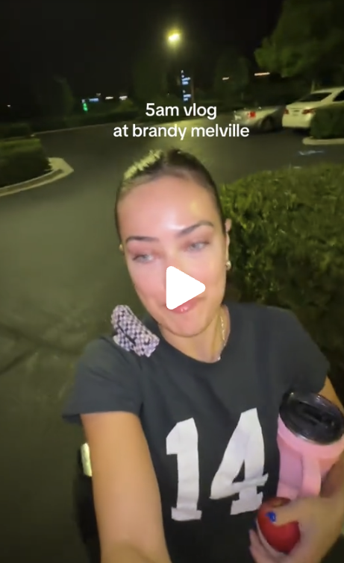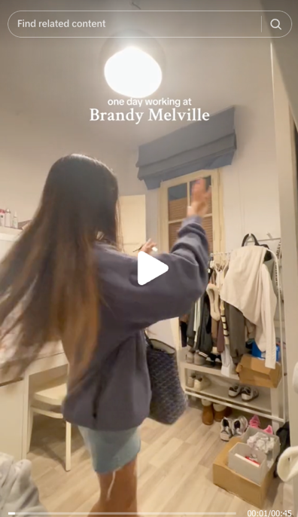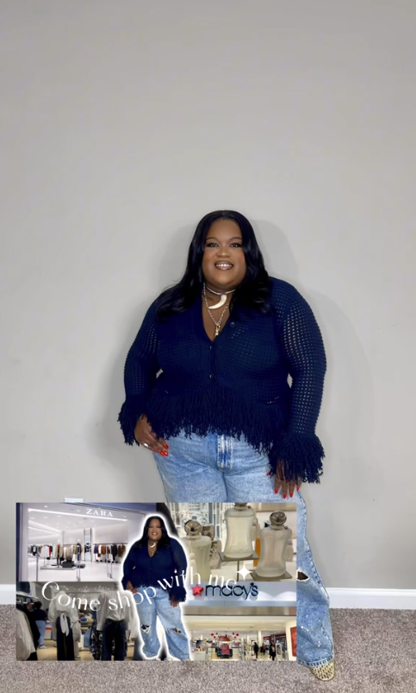
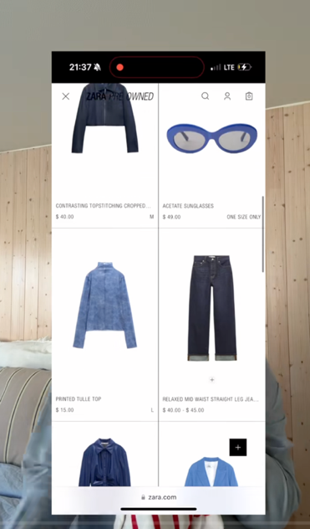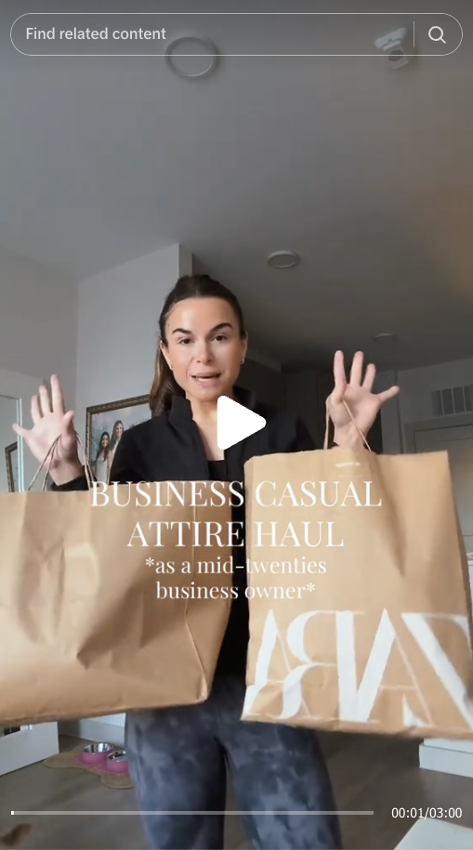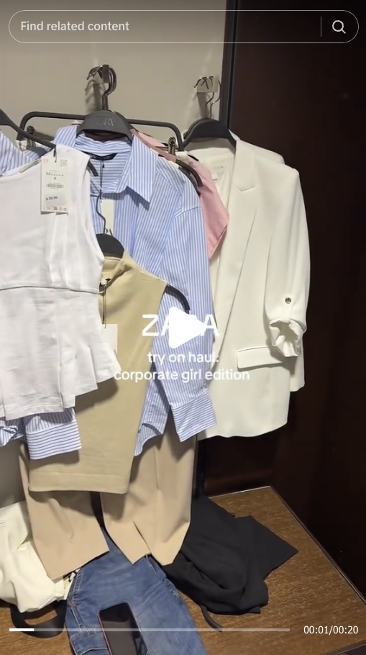
Theme Four: Urgency Messaging Related to Seasonality and Sales
Urgency messaging about seasonality and sales was prevalent across multiple video categories, demonstrating how influencers create a sense of immediacy to encourage purchases. Among the 52 videos that employed urgency-driven messaging, 32 were haul-style videos, 9 were unboxing videos, and 11 were try-on videos. These videos utilized urgency messaging, time-sensitive promotions, limited-time collections, and seasonal cues to drive engagement and impulse buying. Videos that did not include verbal narration tended to generate more comments from viewers requesting product details or reviews. This suggests that influencers who rely solely on visual storytelling - without explicit endorsements - still create an environment where audiences seek validation before making a purchase.
Urgency-related Factors in Fast Fashion Advertising
Haul-Style Videos. Out of the 59 haul-style videos I analyzed, 32 utilized language that emphasized scarcity and time sensitivity to create a sense of urgency around purchasing decisions. This marketing tactic is closely tied to the Fear of Missing Out (FOMO) phenomenon, where the highly stimulating nature of influencer content heightens consumer urgency, often leading to impulse purchases (Liang, 2022). The frequent use of scarcity-driven language reinforces the idea that fashion trends are fleeting, and viewers must act quickly to secure desirable pieces before they are no longer available.
To illustrate the specific language used, among the 32 videos that employed scarcity messaging, 16 directly referenced trends, and influencers in these videos used the phrase "you need" an average of twice per video. A few common ways influencers framed this messaging at the start of their videos to hook their audience included phrases such as:
- “I ran to Zara the second I saw this was trending!”
- “This piece has been all over my FYP—if you want it, act fast!”
Below are a few more quotes from influencer videos using scarcity and trend-driven messaging:
- “There was one shirt left on the rack and I snatched it”
- “This is such an ‘it girl’ top”
- “I scrounged their website to find these pants”
- “Next up was the most incredible find”
- “I was unsure about the long-short trend, I tried this pair on in-store and loved them”
- “This dress has been blowing up on TikTok, I was lucky to get my hands on it!”
- “They only had one left in my size, so obviously I had to grab it.”
Although Liang’s research highlights how verbal urgency cues from influencers drive consumer impulse purchases, I argue that this effect extends beyond just the words used - it is also deeply connected to the personal brand and influence of the creator. When influencers have a strong, engaged fan base, viewers are not just making purchases based on the urgency cues alone - they are buying into the curated brand image of the influencer. For influencers with a loyal following, their purchasing decisions carry weight with their audience. When an influencer receives PR packages or selects clothing themselves, there is an element of positive reinforcement that signals to their followers that the items are worth buying. Additionally, if a trusted influencer engages with a trend or mentions they bought an item because it was trending on their FYP, then that trend is perceived as legitimate and worth participating in. In essence, the scarcity appeal of a product is heightened when an influencer expresses their urgency and excitement about securing it. This phenomenon is further reflected in the comment sections of the videos that used trend-driven scarcity messaging, as shown in the examples below:

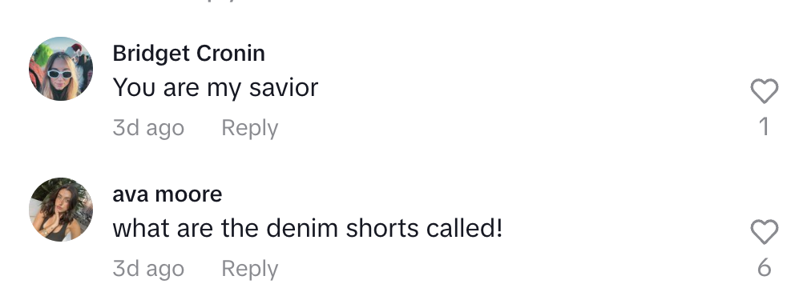
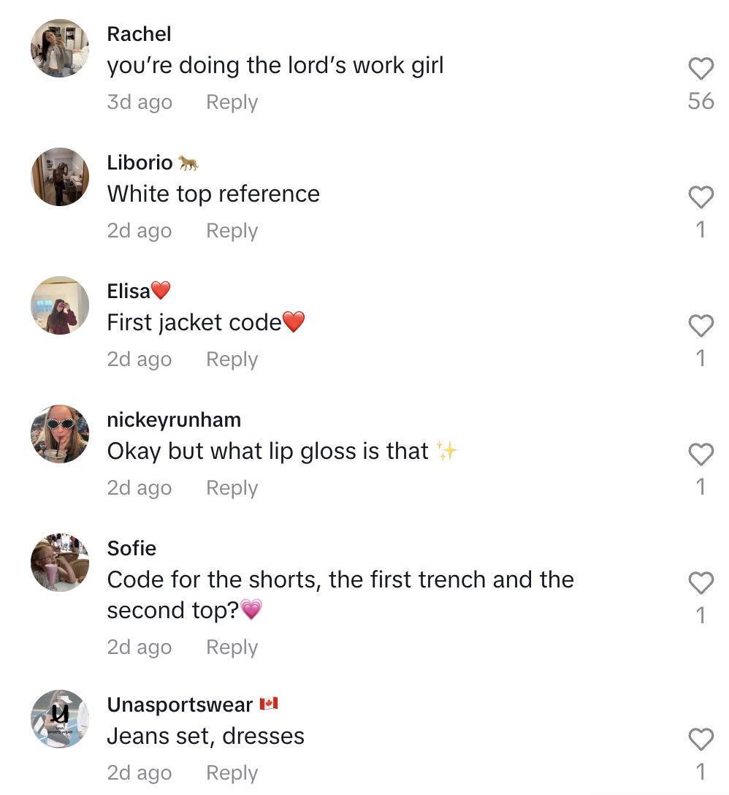
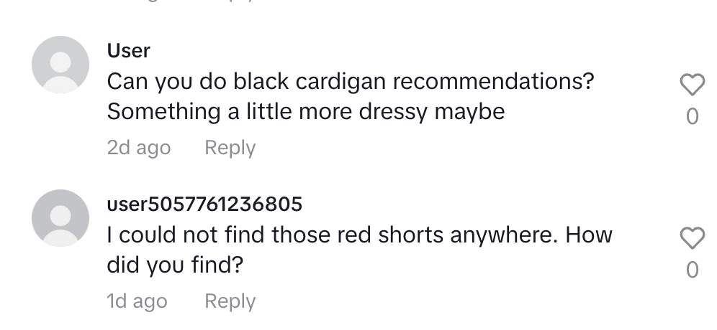
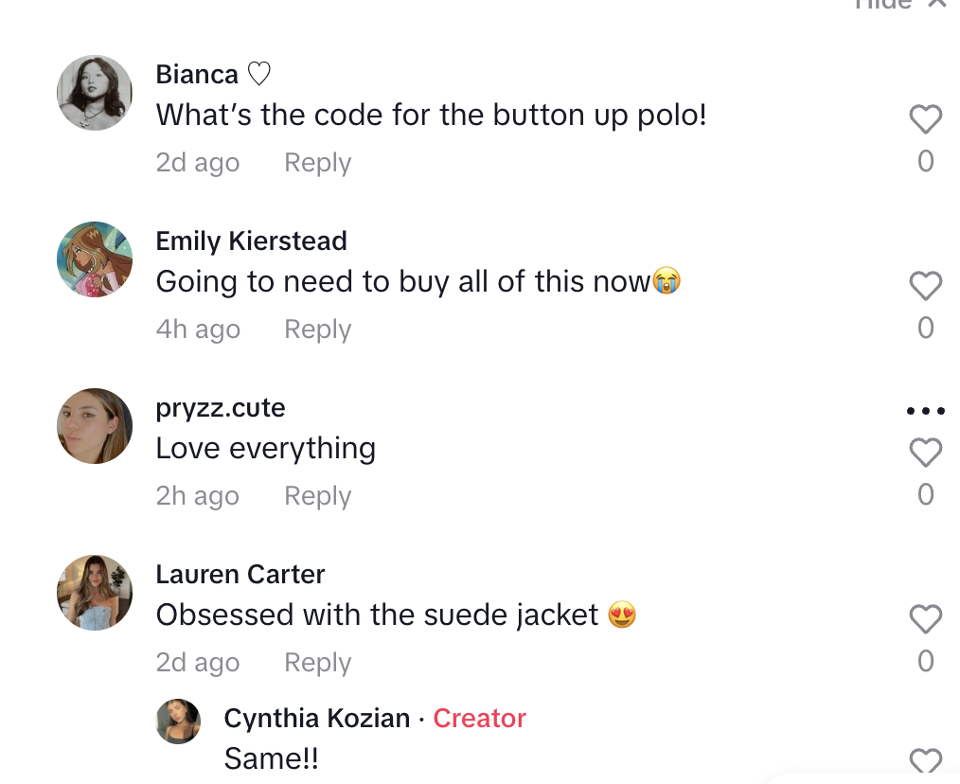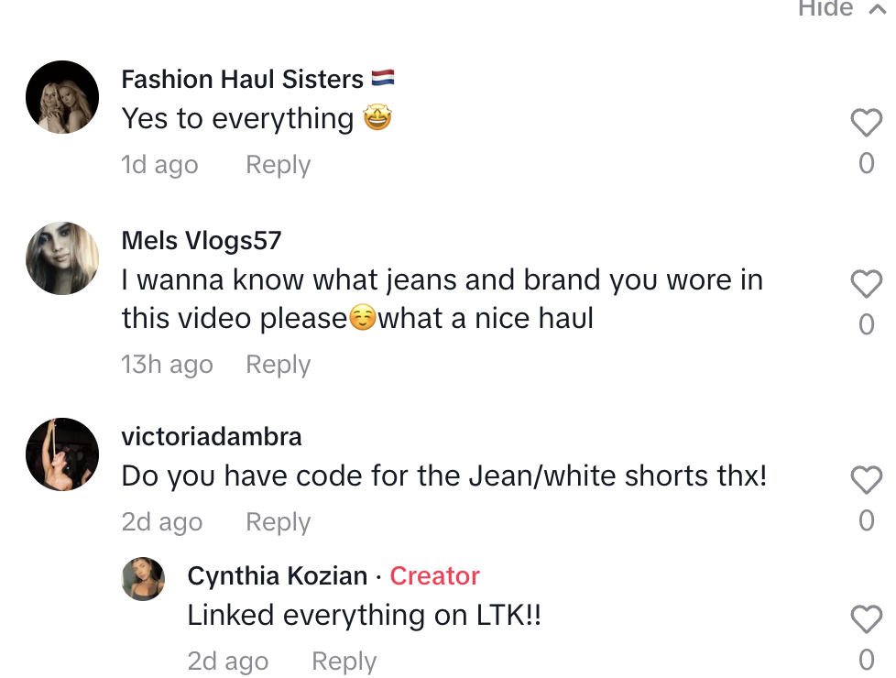
These six comment threads highlight the most common recurring themes among haul-style videos using trend-driven scarcity messaging. The comments demonstrate viewer engagement in multiple ways, including:
- Purchase Intent - Many viewers expressed a desire to buy items by asking for specific product codes, making it easier to locate the exact pieces shown in the haul.
- Admiration for the Clothing - Several comments simply praised the clothing or specific items showcased, reinforcing positive sentiment toward the brand and the influencers’ haul.
- Gratitude and Social Sharing - Comments such as “Sharing this post is doing God’s work” suggest that viewers deeply appreciate the influencer for revealing these fashion trends, framing the video as a helpful or exclusive insight.
- Influencer as a Trusted Fashion Source - Multiple viewers asked the influencer for personalized recommendations, indicating a high level of trust and admiration. This suggests that influencers are not just showcasing clothes but are also acting as style guides in a sense. This helps shape purchasing decisions based on their credibility.
These comment sections reinforce the persuasive power of haul videos, where influencers not only spark impulse purchases but also cultivate trust and engagement with their audience, further fueling the trend-driven shopping cycle.
Seasonality. One of the most striking observations from the videos analyzed was how different brands incorporated seasonality into their messaging. Influencers who created Shein and Zara videos frequently used visual cues to signal the relevance of their clothing to a particular season. For example, fall-themed hauls often showcased earthy tones such as browns, reds, oranges, and warm neutrals. These videos also featured heavier fabrics like wool, knitwear, and layering pieces, reinforcing the association between clothing and colder weather.
Timeless. Contrarily, Brandy Melville’s approach to seasonal marketing was notably different. Unlike Shein and Zara, where seasonal cues were immediately apparent in the clothing selections, Brandy Melville’s videos often lacked strong visual indicators that tied their collections to a particular time of year. In many instances, the only seasonal reference came from the video’s caption - such as “Brandy Melville Spring Haul” - rather than from the clothing itself. This is likely a strategic decision by the brand, as Brandy Melville positions itself as having a minimalist aesthetic that transcends traditional seasonal trends.
Interestingly, Brandy Melville' videos tended to reference spring and summer more frequently than fall or winter. This aligned with the brand’s established “West Coast, beachy” aesthetic, which emphasizes lighter wardrobe staples for warmer climate. Within these videos, 63% included language that framed the clothing as “basics,” “essentials,” or “staples,” reinforcing the brand’s emphasis on simplicity, versatility, and long-term wearability rather than trend-driven purchases.

Trendy vs. Timeless. In contrast to videos uploaded by Brandy Melville employees that emphasized on basics, Shein and Zara videos overwhelmingly focused on trendy, must-have items. For instance, of the Shein videos analyzed, 67% featured buzzwords such as “trendy,” “it-girl,” “cool-girl,” and “neutral aesthetics.” These terms align with Shein’s rapid product turnover and ability to capitalize on micro-trends that frequently emerge on social media platforms like TikTok. While traditional fashion brands release collections tied to the four seasons, Shein’s business model is built around continuous drops that reflect real-time consumer demand. Additionally, Shein videos featured more direct calls to action than Brandy Melville or Zara videos. Influencers frequently used engagement-driven language, such as:
- “Keep or return?” - Encouraging viewers to weigh in on purchasing decisions, increasing interaction and influencing potential buyers.
- “I saw this all over my FYP, so I had to get it!” - Leveraging social proof and FOMO (Fear of Missing Out) to drive urgency.
- “Limited stock - don’t wait!” - Implying scarcity to prompt impulse buying.
This frequent use of trend-driven language underscores how Shein relies on hype culture and social validation to fuel its sales cycles. Unlike Brandy Melville, which markets its clothing as timeless investments, influencers promoting Shein’s products encouraged rapid turnover and constant wardrobe refreshes.

Sales-Driven Urgency and Shopping Behaviors
The videos promoting sales events followed distinct visual and structural patterns. Among the 52 videos that featured urgency messaging, 12 followed a “Come Shop with Me” format. These videos were filmed in a vlog-like style, with influencers capturing their shopping trips in real time. The videos included shots of influencers walking into stores, browsing racks, and reacting to in-store promotions. Captions often reinforced the urgency with text overlays such as:
- “Come shop with me - Zara winter sale edition!”
- “RUN, do not walk! #brandymelville #springoutfit #springshopping”
- “I went crazy at the sale - haul coming soon!”
This format not only makes the content feel immersive and participatory, but it also mimics the thrill of in-person shopping, encouraging viewers to act quickly before the sale ends.

Music, Social Cues, and Consumer Influence
Another unique finding in the analysis was the role music played in reinforcing urgency messaging. Shein videos, in particular, were more likely to feature trending TikTok sounds, including popular background music like Good Graces by Sabrina Carpenter. This aligns with TikTok’s algorithmic nature, where trending audio can increase a video's visibility and contribute to it going viral. By pairing sales-driven messaging with high-energy, upbeat songs, influencers created an exciting atmosphere that heightened the sense of immediacy and impulse.
Additionally, Shein’s use of side-by-side comparisons in its videos played a crucial role in shaping consumer expectations. A common format was the “What I Ordered vs. What I Got” trend, where influencers would display a screenshot of a product listing alongside footage of themselves trying on the item. These videos functioned as a form of social proof, reassuring viewers that the item was true to size, worth the price, or aligned with website photos.
Urgency messaging, particularly in relation to seasonality and sales, is a dominant strategy in fast fashion influencer marketing. Whether through direct calls to action, seasonal color palettes, or real-time shopping vlogs, influencers effectively create a sense of scarcity and immediacy that encourages rapid purchasing. Examples of viewers reactions to these types of videos are showcased below:
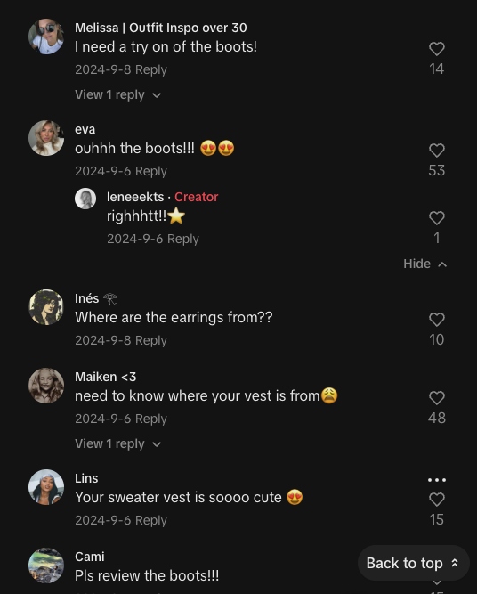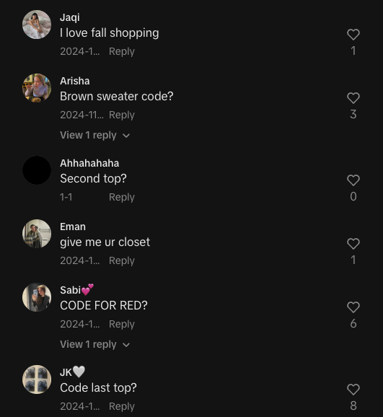

Theme Five: Financial Burdens and Negative Comments Impacting Self-Perception

Consumer Frustrations with Pricing and Affordability. When I began my content analysis, I expected to find a substantial number of comments discussing the financial strain of keeping up with fast fashion trends. My goal was to explore whether influencer marketing led to a tangible impact on viewers' spending habits and financial well-being. While I did uncover instances of viewers expressing concern over pricing, it was difficult to pinpoint whether these frustrations stemmed directly from the videos themselves or broader anxieties surrounding fashion consumption. Through a comprehensive review of the comments, I identified 35 instances in which users directly complained about the cost of items featured in haul-style, try-on style, and unboxing-style videos. These price-related complaints accounted for 11% of the total videos analyzed. Notably, Zara received the highest volume of price-related complaints (72%), whereas Brandy Melville and Shein had fewer mentions of affordability concerns. Interestingly, Brandy Melville’s pricing was often defended by commenters, with ten instances acknowledging that while they could find similar pieces for a lower price elsewhere, they preferred Brandy Melville because of the fit. The image provided is a prime example of this sentiment: 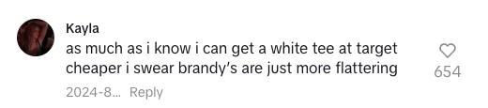
This preference for fit over affordability was a recurring theme among Brandy Melville shoppers. In contrast, Zara's pricing faced more scrutiny, with commenters frequently expressing confusion or frustration about why a fast fashion brand had such high prices. A few representative comments included:
- “I love Zara, but the prices are getting out of hand. $50 for a basic top??”
- “Fast fashion shouldn’t be this expensive… Zara is acting like it’s designer.”
- “I NEED this, but my wallet won’t let me.”
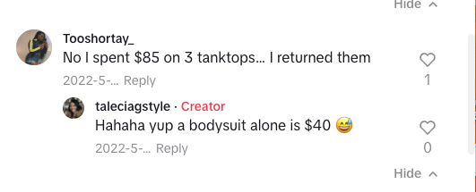
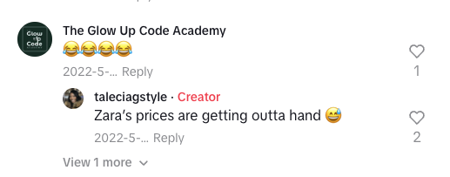

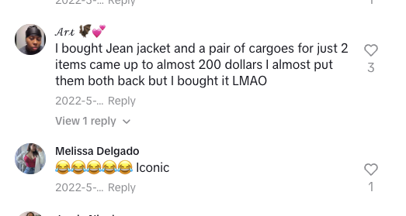
These types of comments suggest a tension between Zara’s branding as an affordable yet aspirational retailer and consumer expectations for fast fashion pricing. Although Zara’s price points are generally higher than Shein’s or Brandy Melville’s, shoppers seemed to struggle with the perceived value-to-cost ratio, particularly when items were seen as “basic” essentials.
Another theme that emerged in the comments was the discussion around clothing quality, particularly about Shein. Despite Shein’s reputation for producing low-cost, lower-quality garments due to its ultra-fast production cycles and inexpensive materials, there were seven instances in which influencers in haul and try-on videos made a point to emphasize that certain pieces “felt expensive” or “did not feel cheap.” This is notable because Shein’s affordability is often associated with lower quality, yet influencers appeared to actively counteract this perception. It raises the question of whether Shein provides direction to influencers to highlight quality aspects of certain pieces to shift consumer perceptions and position the brand as more than just a budget retailer. Unlike Zara and Brandy Melville, which are generally perceived as having higher quality than Shein, the emphasis on quality in Shein videos suggests a strategic effort to combat preconceived notions about the brand’s materials and construction.

Negative Comments and Issues of Body Image

Beyond financial concerns, another significant theme in the comments sections revolved around body image frustrations and how these brands cater to (or exclude) different body types. Through my analysis, I identified 65 comments in which viewers expressed dissatisfaction or frustration with how fast fashion brands fit their bodies. The majority of these comments were directed at Zara and Brandy Melville, with Shein receiving fewer body image-related critiques.
For Zara, the most common complaints centered around fit inconsistencies and a perception that the brand’s clothing was not designed for a wide range of body types. Many commenters expressed frustration that Zara’s styles catered primarily to tall and slim individuals, leaving others struggling to find flattering pieces. A few examples include:
- “Zara’s sizing makes no sense… I’m a medium everywhere else but an XL here??”
- “Cute outfits, but Zara is NOT for short girls.”
- “I swear Zara clothes are only made for models.”
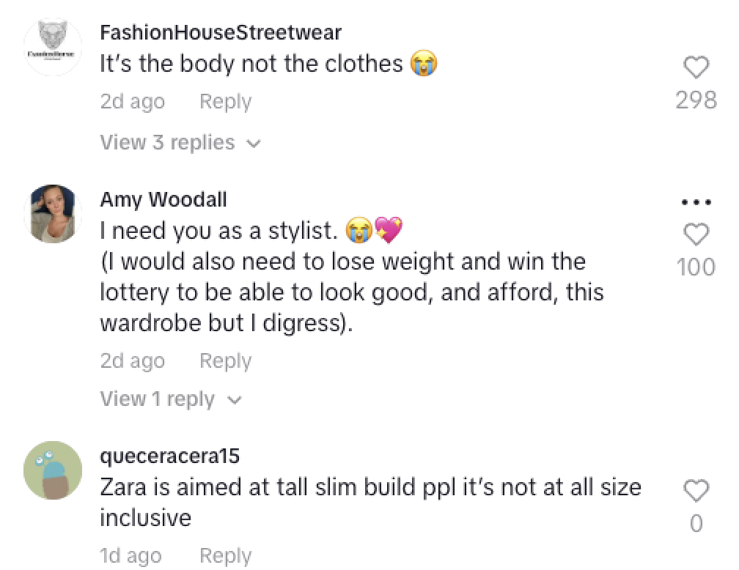
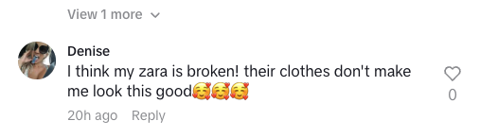
For Brandy Melville, the one-size-fits-all model was the primary source of frustration. I identified 10 direct mentions of this issue, with commenters expressing their dissatisfaction over the brand’s lack of inclusivity. Some of the most frequent grievances included:
- “Brandy Melville ‘one size’ is a joke. Who does it even fit??”
- “Brandy makes you feel bad for being anything other than a size 2.”
- “Every time I see a Brandy haul, I’m reminded that I’ll never fit into their clothes.”
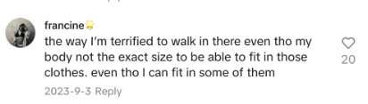
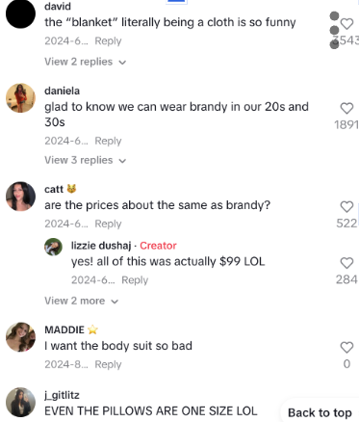
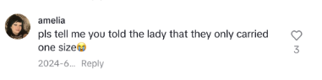
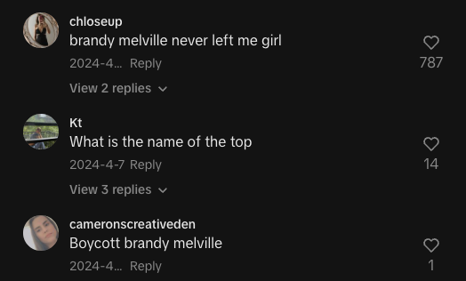
The fact that 90% of the videos where negative body image comments appeared were try-on style videos is particularly noteworthy. This suggests that viewers are more likely to experience body-related frustrations when they see the clothing worn on a real person rather than just displayed in a haul or unboxing video. A key factor could be that most influencers featured in these try-on videos were slim and fit conventional beauty standards, making it difficult for some viewers to see themselves represented in the content.

Chapter Four: Discussion and Other Potential Areas for Research
The findings of this study align with existing research that highlights the fast fashion industry’s reliance on trend-driven marketing and its impact on consumer behavior, while also revealing critical gaps that merit further exploration. It is important to acknowledge the direction this project took, the limitations posed by TikTok's algorithm, and the potential TikTok ban in the United States posed significant concerns to this study. As a result of the impending ban, I initially focused on collecting data from TikTok as quickly as possible before the ban was initiated, sometimes without ensuring that it aligned with my intended research objectives. The potential ban led me to consider relying on Reddit discourse, which would have provided broader insights into consumers’ discussions. However, using Reddit to gather consumer responses to how influencers affected them proved to be harder than I thought. Nonetheless, my analysis based on data derived from the TikTok videos and viewer comments confirmed that the use of influencer advertising strategies by brands like Zara, Shein, and Brandy Melville has created a digital marketplace where immediacy, scarcity, and social validation shape purchasing decisions and clearly affect the viewers. This discussion expands on these findings by linking them to prior literature while pinpointing areas where additional research is needed.
Dopamine Responses and Sensory Appeal in Unboxing Videos
Unboxing videos emerged as a distinct marketing tool in this study, leveraging sensory engagement and anticipation-building to enhance consumer excitement. These findings align with research by Gangadharbatla & Khedekar (2021), who argue that unboxing content creates a sense of emotional investment in products, reinforcing brand attachment. A particularly interesting finding of this study is that unboxing videos often amplify sensory cues, such as the sound of ripping paper, handling fabric, and the crinkle of packaging materials. This mirrors the Autonomous Sensory Meridian Response (ASMR) effect, which has been associated with dopamine release and increased emotional engagement (Poerio et al., 2018).
While prior research has explored ASMR’s effects on relaxation and emotional well-being, there is limited research on how ASMR-driven sensory marketing affects impulse purchasing. Future research should explore the neurological and psychological effects of unboxing videos on shopping behavior. Measuring dopamine levels in response to sensory cues in TikTok videos could offer groundbreaking insights into the neurochemical relationship between social media advertising and impulse purchasing. Using fMRI or EEG scans, researchers could track how the brain reacts to different advertising strategies on TikTok, providing deeper insight into the neuroscience of digital consumerism.

The Psychological Impact of Fast Fashion Marketing

While it is challenging to establish direct psychological effects from the comments alone, the patterns of frustration surrounding body image and pricing suggest that fast fashion influencer marketing plays a role in shaping consumer self-perception and purchasing anxieties. This aligns with previous research indicating that social media-driven fashion content can heighten comparison culture, reinforce exclusivity, and contribute to feelings of inadequacy (Fardouly et al., 2018). Additionally, the presence of price-related concerns suggests that fast fashion marketing, while positioned as “affordable,” may still lead to financial pressure among consumers who feel compelled to keep up with trends and influencer recommendations. Though I was unable to fully measure the impact of these concerns on purchasing behavior, the comment sections reveal that viewers are actively thinking about their spending habits, affordability, and the emotional implications of fast fashion. Overall, this theme highlights the complex relationship between fast fashion advertising, consumer expectations, and personal self-worth. While influencers create aspirational content that drives engagement and sales, they also contribute to a culture of comparison, financial strain, and body image insecurities. Addressing these issues in future research will be essential in understanding the broader implications of TikTok-driven fashion marketing on consumer well-being.
Fast-Paced Advertising and Purchasing Behavior
As previously discussed, fast fashion brands no longer adhere to traditional seasonal collections; instead, they use high-speed production cycles to introduce new products on a near-weekly basis (Aftab et al., 2018; Ferdows et al., 2004). Zara’s “Rapid-Fire Fulfillment” system, which delivers new collections in as little as 15 days, exemplifies how brands use supply chain agility to capitalize on fleeting fashion trends. This aligns with Byun and Sternquist’s (2008) research on scarcity-driven marketing, which argues that limited product availability triggers a fear of missing out (FOMO), pushing consumers toward impulse purchasing. One of the key limitations of this study was the inability to track actual purchasing behavior from influencer videos. While data derived from the comment sections of the TikTok videos I analyzed for this study provided some indication of purchase intent - such as viewers asking for product codes or mentioning that they had added items to their carts - there was, unfortunately, no direct way to confirm whether these engagements translated into completed sales. Therefore, future research could benefit from using a quantitative, big-data approach to gain access to TikTok’s back-end store analytics to analyze how influencer content directly translates to sales. This would provide quantifiable data on the effectiveness of influencer marketing in fast fashion.
Another gap in the existing literature is the direct impact of social media-driven trend cycles on consumer well-being. While I was able to identify instances in the comment sections where viewers expressed negative reactions to a video or voiced concerns about the fast fashion industry, I was unable to make definitive claims about how influencer marketing and the constant flux of trends affect viewers’ psychological well-being. A potential approach to exploring this further would be through qualitative interviews, allowing researchers to gain deeper insights into how individuals emotionally and cognitively respond to fast-paced trend cycles and influencer-driven advertising.
Influencer Storytelling and Emotional Engagement in Advertising
Zambrano (2018) discusses how interactive storytelling in advertising enhances consumer loyalty by creating an emotional bond between the brand and the consumer. This study confirms that influencer marketing thrives on storytelling. Influencers use narrative-driven content to seamlessly integrate promotional messaging, positioning their purchases as essential to personal transformation, lifestyle enhancement, or emotional well-being. For example, Ella’s packing haul for her Portugal trip demonstrated how influencers often romanticize shopping as an aspirational act rather than a transactional necessity. The influencer’s use of descriptive, enthusiastic language (e.g., “This is so chic” and “I need everything”) reinforces consumer desire and subtly shifts the focus from product quality to trend participation.
This aligns with Zambrano’s (2018) work on brand storytelling to create deeper engagement. However, this study allowed me to gain additional insight to this process: rather than brands controlling their narratives, I noticed that social media influencers now act as intermediaries, blurring the lines between personal content and strategic advertising. Future research would benefit from exploring the long-term effects of influencer storytelling on purchasing behaviors. While it is evident that storytelling fosters emotional engagement, there is limited research on whether this method creates stronger brand loyalty in fast fashion compared to traditional advertising methods.
Scarcity Marketing and the Power of Urgency
Scarcity marketing has long been a driver of impulse purchasing behaviors (Byun & Sternquist, 2008), and this study provides further evidence that TikTok influencers leverage urgency as a psychological tactic. As seen in this study’s content analysis, influencers frequently employ phrases that convey product scarcity and trend dominance for by using phrases like, “I ran to Zara the second I saw this was trending!”, “this piece has been all over my FYP, if you want it, act fast!”, or “this is such an ‘it girl’ top.”
While Byun and Sternquist (2008) examined scarcity tactics in traditional retail spaces, this study suggests that social media platforms intensify this phenomenon by making urgency-driven messaging more widespread and instantaneous. Unlike in-store shopping, where scarcity is physically evident, TikTok influencer-created content generates a digital sense of urgency by repeatedly reinforcing limited availability through influencer endorsements.
A significant gap in research remains: To what extent does this urgency-driven messaging translate into actual purchases? Future studies could analyze TikTok analytics and fast fashion retailer data to quantify the correlation between urgency-based advertising and conversion rates. Additionally, eye-tracking or neurological studies on consumer responses to scarcity cues in TikTok videos could provide biological insights into the effectiveness of urgency-driven influencer marketing.

Chapter Five: Conclusion
This study explored how TikTok is structured to facilitate advertising and how fast fashion influencers employ advertising strategies to shape consumer behavior, create urgency, and encourage impulse purchases. Through a qualitative content analysis of 320 TikTok videos created by influencers featuring Zara, Brandy Melville, and Shein, several themes emerged that provide insight into how social media marketing operates within the fast fashion industry. The findings indicate that TikTok, as a platform, is highly structured to facilitate advertising for the fast fashion industry through its algorithmic amplification of engaging content, the seamless integration of influencer promotions, and the use of visual and verbal cues that drive consumer desire. Additionally, this study revealed that fast fashion influencers utilize psychological and emotional appeals, such as scarcity marketing, trend-driven urgency, and aspirational storytelling to influence purchasing behavior.
Though the findings of this study offer valuable insights, future research could benefit from analyzing an even larger sample size of TikTok videos. While 320 videos provided ample data to identify recurring themes, a more extensive dataset could further solidify patterns and additional nuances in influencer marketing tactics. A larger sample could also allow for a more detailed breakdown of trends over time, revealing potential shifts in advertising strategies based on seasons, platform changes, or consumer sentiment.
The first key finding from this study was that scarcity marketing and trend-driven urgency were dominant advertising techniques used by influencers. In 59 haul-style videos, influencers frequently emphasized the need to purchase items quickly before they sold out, reinforcing a sense of exclusivity and social pressure to participate in micro-trends. Many influencers referenced seeing specific pieces “all over their FYP” (For You Page), which played into the psychological phenomenon of fear of missing out (FOMO). This strategy aligns with past research on consumer impulse buying, demonstrating that perceived product scarcity increases consumer urgency and willingness to spend.
Another critical finding was the use of storytelling as a tool to build authenticity and trust. Many influencers framed their purchasing decisions within personal narratives, whether through justifications for impulse shopping, romanticizing their lives through fashion, or referencing their long-standing loyalty to a brand. This technique was particularly effective at making influencer-sponsored content feel organic rather than overtly promotional. Ella’s Zara packing haul was a prime example of this, as she structured her video around preparing for a trip while subtly encouraging viewers to shop the looks she showcased. This type of interactive storytelling fosters brand affinity and engagement, making the influencer’s content feel more relatable and aspirational.
The third major theme identified in this study was how brands strategically position themselves through influencer content to create distinct identities. Zara videos frequently highlighted business casual and chic fashion, sometimes incorporating sustainability messaging through promotions of Zara’s Pre-Owned platform. In contrast, Shein content leaned heavily on fast-changing trend cycles, affordability, and influencer-led discovery of “hidden gems” within the brand’s vast inventory. Meanwhile, Brandy Melville’s influencer content repeatedly reinforced its identity as a provider of high-quality, everyday basics, with a notable emphasis on its exclusive, West Coast-inspired aesthetic. These positioning strategies demonstrate how brands leverage influencer marketing not just to sell products but to curate distinct brand identities that resonate with their target audiences.
Additionally, this study identified the impact of seasonality and sales-related urgency messaging. Many influencers framed their content around seasonal wardrobe updates and limited-time sales, reinforcing the notion that fashion is disposable and requires constant refreshing. Brandy Melville’s reliance on captions rather than visual indicators of seasonal clothing stood out as a unique approach, aligning with its minimalist, staple-based aesthetic. Meanwhile, Shein’s use of trending sounds, call-to-action phrases, and frequent references to TikTok-driven aesthetics like “It Girl” and “Cool Girl” exemplified how the brand capitalizes on hyper-fast trend cycles.
Finally, an essential theme in this study was consumer frustration, particularly regarding financial burdens and consumer perception of lack of body inclusivity. While the comment sections across all videos reflected enthusiasm and product interest, there were also numerous instances of financial concerns. Viewers frequently complained about Zara’s rising prices, with some expressing frustration that a known fast fashion brand was charging prices that felt too high. Brandy Melville, on the other hand, sparked discussion about its controversial one-size-fits-all model, with multiple comments indicating that consumers felt excluded by the brand’s sizing limitations. This aligns with previous critiques of Brandy Melville’s exclusivity, reinforcing how certain fast fashion brands maintain desirability through restricted accessibility.
Overall, this study highlights the powerful role of influencer marketing in shaping fast fashion consumption on TikTok. Influencers act as both trendsetters and intermediaries between brands and consumers, using urgency-driven messaging, storytelling, and brand positioning to encourage purchasing behavior. TikTok’s algorithm-driven platform structure further amplifies these strategies, making influencer marketing an exceptionally effective tool for fast fashion brands. However, consumer discourse in comment sections suggests that while these marketing tactics are highly persuasive, they are not without their critiques, particularly regarding financial strain, brand exclusivity, and ethical concerns. By analyzing a larger dataset in future research, scholars could further explore the evolving impact of TikTok-driven influencer marketing, particularly how consumer sentiment shifts over time. While this study provides valuable insights into the advertising strategies employed by Zara, Brandy Melville, and Shein, a broader examination could strengthen our understanding of the long-term effects of social media-driven fast fashion consumption.

References
Aftab, M. A., Yuanjian, Q., Kabir, N., & Barua, Z. (2018). Super Responsive Supply Chain: The Case of Spanish Fast Fashion Retailer Inditex-Zara. International Journal of Business and Management, 13(5), 212. https://doi.org/10.5539/ijbm.v13n5p212
Alba, J. W., & Williams, E. F. (2013). Pleasure principles: A review of research on hedonic consumption. Journal of Consumer Psychology, 23(1), 2–18.
https://doi.org/10.1016/j.jcps.2012.07.003
Baron, N. S. (2016). Only Connect: What the Internet Might Be Doing to Us. The American Journal of Psychology, 129(3), 337–343. https://doi.org/10.5406/amerjpsyc.129.3.0337
Binet, F., Coste-Manière, I., Decombes, C., Grasselli, Y., Ouedermi, D., & Ramchandani, M. (2019). Fast Fashion and Sustainable Consumption. In S. S. Muthu (Ed.), Fast Fashion, Fashion Brands and Sustainable Consumption (pp. 19–35). Springer. https://doi.org/10.1007/978-981-13-1268-7_2
Brooks, G., Drenten, J., & Piskorski, M. J. (2021). Influencer Celebrification: How Social Media Influencers Acquire Celebrity Capital. Journal of Advertising, 50(5), 528–547. https://doi.org/10.1080/00913367.2021.1977737
Cachon, G. P., & Swinney, R. (2011). The Value of Fast Fashion: Quick Response, Enhanced Design, and Strategic Consumer Behavior. Management Science, 57(4), 778–795. https://www.jstor.org/stable/25835736
Casadei, P., & Lee, N. (2020). Global cities, creative industries and their representation on social media: A micro-data analysis of Twitter data on the fashion industry. Environment and Planning A: Economy and Space, 52(6), 1195–1220.
https://doi.org/10.1177/0308518X20901585
Chen, D., Su, S.-I. I., & Chen, Z. (2023). Quick response in fast fashion omnichannel: Exploring cost sharing effect. RAIRO - Operations Research, 57(4), Article 4. https://doi.org/10.1051/ro/2023071
Cheng, S. (2018). The Interdependence between the Demand of Fashion Industry and the Function of Fashion Education. American Journal of Industrial and Business Management, 08(04), 1065–1072. https://doi.org/10.4236/ajibm.2018.84073
Cook, S. C., & Yurchisin, J. (2017). Fast fashion environments: Consumer’s heaven or retailer’s nightmare? International Journal of Retail & Distribution Management, 45(2), 143–157. https://doi.org/10.1108/IJRDM-03-2016-0027
Crofton, S., & Dopico, L. (2007). Zara-Inditex and the Growth of Fast Fashion. Essays in Economic&BusinessHistory,25,41–54. https://www.ebhsoc.org/journal/index.php/ebhs/article/view/181
George, B. P., & Yaoyuneyong, G. (2010). Impulse buying and cognitive dissonance: A study conducted among the spring break student shoppers. Young Consumers, 11(4), 291–306. https://doi.org/10.1108/17473611011093925
Kozlowski, A., Bardecki, M., & Searcy, C. (2012). Environmental Impacts in the Fashion Industry: A Life-cycle and Stakeholder Framework. The Journal of Corporate Citizenship, 45, 17–36. https://www.jstor.org/stable/jcorpciti.45.17
Mackinney-Valentin, M. (2013). Trend Mechanisms in Contemporary Fashion. Design Issues, 29(1), 67–78. https://www.jstor.org/stable/24267103
Peters, G., Li, M., & Lenzen, M. (2021). The need to decelerate fast fashion in a hot climate—A global sustainability perspective on the garment industry. Journal of Cleaner Production, 295, 126390. https://doi.org/10.1016/j.jclepro.2021.126390
Poerio, G. L., Blakey, E., Hostler, T. J., & Veltri, T. (2018). More than a feeling: Autonomous sensory meridian response (ASMR) is characterized by reliable changes in affect and physiology. PLOS ONE, 13(6), e0196645. https://doi.org/10.1371/journal.pone.0196645
Phillips, B. J., & McQuarrie, E. F. (2010). Narrative and Persuasion in Fashion Advertising. Journal of Consumer Research, 37(3), 368–392. https://doi.org/10.1086/653087
Pop, R.-A., Hlédik, E., & Dabija, D.-C. (2023a). Predicting consumers’ purchase intention through fast fashion mobile apps: The mediating role of attitude and the moderating role of COVID-19.TechnologicalForecastingandSocialChange,186,122111. https://doi.org/10.1016/j.techfore.2022.122111
Reyes Jr, R. V., Balazon, M. A. M., Benavente, M. J. E., Concepcion, S. M. S., Cruz, J. E. D. D., Tolentino, J. T., & Abad, M. A. H. (2024). Best Practices of Clothing Businesses in Talavera, Nueva Ecija, A Foundation for Strategic Business Advancement. International Journal of Advanced Engineering, Management and Science, 10(5), 112–126. https://doi.org/10.22161/ijaems.105.7
Roller,C.(2023).BrandyMelville:AnAnalysis.Intertext,31(1).
https://surface.syr.edu/intertext/vol31/iss1/7
Royo‐Vela, M., & Casamassima, P. (2011). The influence of belonging to virtual brand communities on consumers’ affective commitment, satisfaction, and word‐of‐mouth advertising. Online Information Review, 35(4), 517–542.
https://doi.org/10.1108/14684521111161918
Nurfadila, S. (2020). Impact of Influencers in Consumer Decision Process: The Fashion Industry. INTERDISCIPLINARY JOURNAL ON LAW, SOCIAL SCIENCES AND HUMANITIES, 1(2), 1. https://doi.org/10.19184/ijl.v1i1.19146

Trieu, D. T. (2024). Decoding the Fast Fashion Phenomenon in Vietnam: A Multidimensional Analysis of Impulse Buying Dynamics and Price Sensitivity in Consumer Purchase Behavior. International Journal of Economics, Business and Management Research, 08(10), 314–339. https://doi.org/10.51505/IJEBMR.2024.81020 (N.d.).

