Views of Climate Change: how the news influences climate change denial in rural America.

Anna Mary Scott

University of Colorado Boulder

# Abstract

Climate scientists believe that humanity has just about twelve years to solve climate change. As the second largest polluter in the world, this leaves the United States in a position of power and global responsibility. However, the United States has seen a rise in climate change denial since the late 1980s, when scientists discovered what the media dubbed an “ozone hole.” Previous research suggests that some abstract messaging on climate change in the media — as well as polarized news choice, objectification of natural phenomena and growing distrust in mainstream news — is in part responsible for growing skepticism about the validity of climate science on the part of both the general population and powerful governmental figures. This project uses interviews and a nationwide survey to help examine which factors affect individual climate opinion and trust in the news. Using a long-form multimedia journalism piece, this project also profiles individuals in rural West Virginia with skeptical views on climate change and media professionals with experience covering environmental issues in these areas. This project aims to provide journalists with context for better, more effective climate change communication that can appeal people of all social, economic, educational and political backgrounds in the United States.

*Keywords:* news media, climate change, climate change denial, rural America, news choice, West Virginia

# 

# 

# Introduction

In October 2018, the United Nations Intergovernmental Panel on Climate Change released a report which said that based on current levels of greenhouse gas emissions, the planet will reach the crucial threshold of 1.5 degrees Celsius above pre-industrial levels as early as 2030. This means that the world must work as an intergovernmental unit to solve the climate change problem. The report suggests that, if we do not work quickly, the effects will be irreversible. This makes it imperative that the human race swiftly, efficiently and unequivocally overcomes the particular obstacles that the scientific community has been battling for years: misinformation, public apathy and climate change denial.

Climate change denial is the denial, negotiation or dismissal of the current scientific consensus accepted by approximately 97 percent of actively publishing scientists (Cook et. al, 2016) that says human activity is causing overall warming of the planet and that this warming will contribute to an increase in natural disasters and environmental crises such as drought, flood and famine. Factors affecting an individual’s opinion on the validity of climate change may include: political alignment (including both ideology and labeled identity), personal experience with extreme climate events, levels and quality of education and media habits. Some climate change denial is outright denial of any evidence that Earth’s climate is changing, but this is not the most prevalent discourse among climate change deniers. Instead, the most common point of contention is with the assertion that climate change is caused by humankind rather than the Earth’s natural cycle (Dunlap & McCright, 2011).

Climate denial could easily be brushed off by environmentalist media as a fringe movement. If it represents a small percentage of the general population, they claim, there is no point in attempting to educate or persuade these people to believe in climate change. The Yale Program on Climate Communication uses the model of Six Americas to demonstrate that only nine percent of the U.S. population is dismissive of climate change, while 12 percent are doubtful of it and seven percent are disengaged from it. However, while the relative proportion of climate change deniers in the United States is small, there are a few deniers that hold a tremendous amount of power in the government.

One particularly influential climate denier is the former head of the Environmental Protection Agency, Scott Pruitt. His public dismissal of climate change from the highest position of environmental policy in the U.S. government made him dangerous to the furthering of environmentalist efforts to keep climate change under control.

Within President Trump’s administration, he was far from alone. Trump himself continuously and categorically dismisses the validity of climate science whenever possible. During his election campaign, he pushed a false narrative about climate change being “created by and for the Chinese in order to make U.S. manufacturing non-competitive” (@realDonaldTrump, 2012). When the latest National Climate Assessment was released on Nov. 23, the president told *The Washington Post* on the subject of climate change: “One of the problems that a lot of people like myself — we have very high levels of intelligence, but we’re not necessarily such believers” (Blake, 2018).

When any climate denier holds that much power and influence, it validates the denialist movement and emboldens propaganda and conspiracy around climate science. Whether people like Pruitt or Trump genuinely doubt the validity of climate change or simply hold vested interests in environmentally unsound practices like oil and gas (Park, 2018) can most likely not be conclusively determined by a study such as this. However, we can study how media consumption affects the trustworthiness of science to those most susceptible to harmful rhetoric perpetuated by them and other climate change deniers in positions of power.

The most important predictor of climate change denial is political ideology (Bolin & Hamilton, 2018). Reason states, therefore, that identifying patterns in political behavior helps us to understand the occurrence of climate change denial. Since dismissal of climate change is prevalent in conservative messaging and media (Feldman, 2016), it is likely that the rate of climate change denial is higher in more politically conservative areas.

Climate change denial is built upon and accommodated by the oversimplified, image-based and exotic fantasies of nature and the environment portrayed in the mainstream media (Howard-Williams, 2011). Howard-Williams claims that, when the media presents the environment as separate from the lived human experience, it reinforces assumptions that humankind does not carry responsibility for climate change. Meanwhile, a lack of empathy on the part of those that do not experience certain environmental changes may affect one’s ability to conceptualize climate change as a real and present threat (Kirilenko, Molodtsova, & Stepchenkova, 2015).  
 The following project seeks to understand the relationship between the news media coverage of climate issues and the occurrence of climate change denial in rural communities in the United States.

The term “climate change” is defined by Encyclopaedia Britannica as “periodic modification of Earth’s climate brought about as a result of changes in the atmosphere as well as interactions between the atmosphere and various other geologic, chemical, biological, and geographic factors within the Earth system” (2018) For the purposes of this project, I will assume credibility of the overall scientific consensus on climate change, which asserts that climate change is caused mostly by human activity (Cook et. al, 2016).

The Encyclopaedia Britannica also defines “skepticism” as “the attitude of doubting knowledge or claims set forth in various areas.” This will be used mostly in reference to climate change skepticism, the preferred self-identifying term for climate change deniers. This term carries some controversy, however, as it should be noted that the scientific community is based on a philosophy of skepticism that should not be confused with any denial of scientific consensus.

**Significance**

This project is important to research because the rise of climate change denial to prominence in mainstream political discourses has been especially pronounced in recent years. This is particularly concerning for the scientific community because of the subsequent prevalence of climate change denial in powerful political spheres. To consider climate change denial as a fringe social movement without acknowledging their disproportionate levels of power and influence forsakes hope for any of the radical changes to environmental policy demanded by the Intergovernmental Panel on Climate Change (IPCC) report of 2018. If we can learn to understand what causes skeptical discourse on climate change to emerge, we can more effectively work as journalists and media professionals to avoid the patterns that reproduce it.

Past research on this topic focused primarily on media influence on public opinion, social media effects on climate change discourses, or the effectiveness of specialized media in communicating climate change concepts. However, no research thus far has focused specifically on media messaging on climate change in specific areas of the country. For example, rural areas like Kentucky and West Virginia are important areas to study this messaging in because those who live and work in those areas are less likely to personally experience grand consequences of climate change like hurricanes, wildfires, flooding or other natural disasters and, therefore, must rely more heavily on media reports about these phenomena. Some past research also focused on the long-term effects of certain closely-held ideals of journalistic integrity and trustworthiness, such as objectivity and balance. As news trustworthiness is likely to affect how audiences interpret climate change coverage, this project seeks to extend upon this research. I will also apply it to media distributed towards rural communities in West Virginia, where I interviewed local residents to report on their perspectives surrounding climate change in a long-form, multimedia piece focusing on the coal community.

**Media Influence**

Commonly-held journalistic standards dictated by central ideals of objectivity and balance often inadvertently foster the spread of scientific misinformation, either intentionally or unintentionally (Park, 2018). The widely-held belief that journalism’s value lies in its function as a trustee for the public and a neutral observer to weigh all perspectives equally leads to the oversimplification of complex scientific concepts and/or *false balance* between scientists and climate change deniers. These two factors work together to create confusion and spread misinformation about the facts of climate change. Therefore, they give a voice to a small minority group within the American public and equating that voice to those of established climate scientists.

Although climate change can serve as an unfortunate exemplar for journalism’s well-meaning attempts to be fair and balanced leading to unintended consequences in the form of misinformation, it is only one example from a media landscape that frequently repeats this behavior. Currently, digital journalistic mediums do not allow for the same level of trustworthiness that newspapers, radio or television broadcasts once did (McCombs, Wanta & Kiousis, 2011). Journalism in the present day is a balancing act; maintaining relevance and securing funding while remaining unbiased in their coverage is a nearly impossible feat for the modern journalist.

There are three main models that we can use to examine both motivations of news media and trustworthiness of journalists through the eyes of the public. These are the *Market Model*, the *Advocacy Model* and the *Trustee Model (*McCombs, Holbert, Wanta & Kiousis, 2011).

**The Market Model** of journalism encourages news organizations to choose programming based on what will cause the greatest spectacle (McCombs, Holbert, Wanta & Kiousis, 2011). This model is susceptible to content flood, as audiences are likely to lose interest in a topic once they hear about it for too long, especially if the topic is complex. Modern-day journalism, which is driven by clicks and engagement, must keep up with audience demand and may therefore be discouraged from covering important environmental issues.

**The Advocacy Model**, meanwhile, plays directly into political interest, which often means that the press is less free to cover certain subjects that may upset certain viewers or shareholders (McCombs, Holbert, Wanta & Kiousis, 2011). This is particularly important to special interest groups, which means that this model can often be intertwined with The Market Model.

**The Trustee Model**, while the most trusted and least sensational, can be used as a facade to cover up a news source that is truly acting through the advocacy or market model (McCombs, Holbert, Wanta & Kiousis, 2011). This becomes truly dangerous when these sources use their trustee status to discredit other news sources. It is not uncommon for broadcast news outlets to assert themselves as being inherently more trustworthy than others.

**Political Identity**

The term “self-efficacy” is defined in social cognitive theory to mean “the degree of certainty with which an individual expects to successfully execute a behaviour.” Extended to political ideology, McCombs, Holbert, Wanta & Kiousis (2011) argue that “political self-efficacy” — in other words, an individual’s confidence in their political beliefs and political power — can be used to determine whose opinion will be most influenced by media messaging. This term will be used to discuss the importance of media in shaping public opinion, as political ideology is the main predictor of climate change views (Bolin & Hamilton, 2018).

**Reinforcing spirals of ideology** allow biased sources to amplify political differences in climate views by undermining the trustworthiness of competing news networks (Bolin & Hamilton, 2018). McCombs, Holbert, Kiousis and Wanta (2011) also argue that these “reinforcing spirals” shape the use of traditional news media over time by continually overinflating credibility of some sources and simultaneously discrediting others.

**Partisan-influenced advocacy news** is becoming more common and those with low political self-efficacy are likely to only trust one news source (McCombs, Holbert, Wanta & Kiousis, 2011). While those with high levels of political self-efficacy are more likely to gravitate towards more traditional news based on the trustee model. They are also less susceptible to persuasion by satirical news sources. If an individual gets their news exclusively from one source, what messages are being amplified through reinforcing spirals?

**Special interest groups** (eg. gas & oil) can prevent climate from being shown or properly explored in the news (Park, 2018). Thanks to the advocacy model for news distribution, oil and gas industries can easily manipulate the messages, implicit or explicit, being portrayed on climate change in the news. This can mean that they can prevent any unseemly language about oil and gas, or they can discourage any story about climate change airing at all.

**Coverage of climate change**

Climate change coverage in general is focused mostly on visual framing and does not include many in-depth discussions of climate science (Howard-Williams, 2011). The term “narrative framing,” specifically in the context of climate communication, is defined by Pezzullo & Cox (2018) as “the ways in which media organize the bits and facts of phenomena through stories to aid audiences’ understanding and the potential for this organization to affect our relationships to the phenomena being articulated.” This project will use this term as a central concept for critically examining media portrayals of climate change and natural disasters.

Howard-Williams (2011) identified ways the natural environment is portrayed using one of four *narrative framings* in television news in New Zealand:

* **The Threatened Environment,** “made up of local and planetary systems under threat from human activity” (Howard-Williams, 2011).
* **The Pristine Environment,** “a wilderness that is home to unfamiliar plants and animals, innocent in its disconnection from human society, a curiosity to be admired” (Howard-Williams, 2011).
* **The Savage Environment,** “the primal forces of nature that stand in opposition to the order of human society (most often seen in terms of *extreme weather*)”(Howard-Williams, 2011).
* **The Recreational Environment,** “a place for fun and to get away from the routine of urban life” (Howard-Williams, 2011).

Although these themes were identified within the context of New Zealand television, they can be applied internationally to other television programs, including those in the United States. The biggest takeaway from these findings is that nature is represented in the media as something entirely separated from humanity, often even in opposition to humanity. This removes responsibility for environmental harm from humans and could potentially establish a foundation for climate change skepticism (specifically skepticism surrounding human-caused climate change).

The term “objectification” is defined by Jaspal & Nerlich (2012) as “the process whereby unfamiliar and abstract objects are transformed into concrete and ‘objective’ common-sense realities.” Jaspal and Nerlich also hold this term against “anchoring,” which refers to “categorisation of unfamiliar objects through their comparison with an existing stock of familiar and culturally accessible objects.” They argue that anchoring the concept of climate change to an already objectified concept of the ozone hole “[facilitates] communication and discussion about [climate change].” These terms will be used mainly in reference to media portrayals of the ozone hole in the 1980s, but they also apply to modern-day coverage of climate change phenomena.

The so-called “ozone hole” is still regularly referenced in the media. The newer term “greenhouse effect” has a similar purpose as an objectified concept that tends to be oversimplified to simply connote the dangers of greenhouse gases like carbon dioxide, often while ignoring the other complexities of Earth’s energy balance.

The term “condensation symbol” is defined by Pezzullo & Cox (2018) as an image or entity designed to hold connotations with or exemplify complex concepts so that the public can easily understand them. One classic example of a condensation symbol in climate change communication is the polar bear, which has represented both global warming and climate change for decades.

Climate change coverage in the 1980s focused on *objectification* of scientific natural phenomena (Jaspal & Nerlich, 2012). Using the *condensation symbol* of a physical hole in the atmosphere (Pezzullo & Cox, 2018), journalists were able to communicate the gravity of ozone depletion in a way that the public found easy to understand.

The foundation of the “ozone hole” as a narrative frame and an early exemplar for climate change communication caused a continually over-simplified doomsday narrative to occur in media. “Starting with conceptual anchors for framing information, the gaining of knowledge in a field tends to follow a spiral model, with new bits added to prior accumulation,” (Ungar, 2000).

This concept of the “ozone hole” as a tool for discussing climate change phenomena was as uninformed and confusing as it was effective. There was no “hole” being formed by ozone depletion and there is no single “ozone layer” to poke a hole into. Still, the phrase became central to messaging in environmentalist media and is still widely used today (Rich, 2018). Therefore, by creating a foundational story for climate change to follow (that of the wounded environment), science journalists of the 1980s garnered worldwide attention towards environmental issues, but they also ultimately negatively impacted climate change as a concept in the media for decades to come. After the apocalypse never came (in part due to the initial effectiveness of the messaging), people got burnt out on the sense of urgency that climate change messaging relies on.

**Lived Experience**

Coverage of climate change is most effective when it is specialized in some way. Some research suggests that specialized coverage is more vital to action-based climate change awareness than any coverage focused on a broader context. Asplund, Hjerpe & Wibeck (2012) analyzed two Swedish farming magazines for climate change content over the time period of 2000-2009, during which they were able to identify several patterns in narratives and bias about climate change and then compare those to broader coverage found in mainstream media. These patterns showed that, although specialized media stayed away from exposing any uncertainty about the science of climate change, it was actually more balanced in representing climate change perspectives. That is, specialized framing often focused just as much, if not more, on the positive possibilities on climate change than on doomsday scenarios. This was combined with an emphasis on the concrete consequences of climate change over the more theoretical and abstract to build an effective, action-based message on climate change.

Asplund et al. (2012) assert that an increase in specialized coverage of this nature is necessary to raise climate change awareness. While farmers may be an effective group to focus on given the influence of agriculture on greenhouse gas emissions, climate change is affected by most human activities, and not all vocations can easily translate into effective climate change coverage. In fact, it can sometimes be counterintuitive to the goal of one's vocation. For example, a coal miner may not have the same personal connection to climate change that a farmer does, so discussions of climate change may be dismissed on the basis that policy decisions may be detrimental to those working in this field. Therefore, it is important to also consider other kinds of personal connections to climate change phenomena. This includes the geographic location of an individual or community.

The most common direct experience with climate change in North America is noticeable temperature differences. People talk more about climate change if they can sense drastic temperature changes in their area (Kirilenko, Molodtsova & Stepchenkova, 2015). In this sense, news media is not necessarily more important than lived experience. Paired with the findings of Asplund, Hjerpe & Wibeck (2012), these results point to personal connection having a substantial effect on public opinion about climate change. It could be argued, therefore, that geographic location is a significant factor in determining one’s perspective on climate change. However, for phenomena that cannot be personally experienced, the news must fill in the gaps. Establishing the importance of personal connection as precedent for future climate change coverage could aid the media in creating effective content that informs the public on issues associated with climate change and the true cause of natural disasters.

**Conclusion**

Image-based coverage of climate change and the persistence of the market model in broadcast journalism has led to sensationalist doomsday-messages about climate change. In turn, feelings of isolation and distrust on the part of people who do not have access to more accurate information tends to rise. Meanwhile, the trustee model and the journalistic standard of balance have led to increased visibility of climate change deniers in the media. Both of these standards are rooted in ideologies which assume that the news should be catering to the “lowest common denominator,” or the population that we assume will not understand or be interested in any complexity in information or in presentation. Instead of rewriting scientific concepts to appeal to people without a formal education, journalists instead often oversimplify these concepts to the point that they are easily misconstrued and often weaponized to misinform. I wish to test whether or not the “lowest common denominator” could be better informed by hearing clearer, less politically-conflated details about climate change and natural disasters. Given that people in the American Midwest often do not have personal experience with coastal disasters like hurricanes (which often receive relatively heavy media coverage compared to other natural disasters), specifically focusing this study on hurricanes could lend valuable insight to the value of clear wording.

# Method

This project involves a survey on media choice and climate change opinion that I will distribute nationwide. The nationwide distribution was intended to allow for a larger sample size and also demonstrate differences in climate perspectives according to physical location. In addition, I traveled to rural West Virginia to interview climate change skeptics of various socio-political influence. I then combined all of my findings into a multimedia long-form journalism piece for the creative portion of my project.

The creative project is a long-form print piece, around 1300 words. The piece itself is a look at the different complexities of attitudes about climate change in West Virginia, using a Lyft driver named Richard Dean as the main profile subject. Other perspectives from journalists, coal industry workers, environmentalists and community members also inform the piece, creating a well-rounded portrait of coal mining communities in West Virginia.

I chose to travel to West Virginia because studying Yale Climate maps allowed me to pinpoint districts with fewer people who believe in climate change. Originally, I wanted to put out my own survey to find participants, but I didn’t have time to get IRB approval by the time I had to buy plane tickets and reserve lodging. The Yale Climate Opinion map turned out to work just fine for finding the information I need.

My survey, meanwhile, is on climate opinion and news choice and also includes one of two video clips of a hurricane: one personifies the storm, using its given human name and using words like “destruction” to give the storm itself agency. The other speaks of the storm not as a singular entity but as a predictable weather pattern that does cause damage, but is not actively choosing to do so. One of the clips played for each participant. The purpose of this section of the survey was to find any differences between audience perceptions of climate and weather through word choice in coverage of the same event. The findings of the survey have been worked into the creative project as well. Given the fairly limited scope of my survey, my data is a tentative sample of United States climate opinion, but this has been made clear to readers.

Initially, I planned on filming each interview and including video clips in the print piece for each subject. However, since I do not own my own film equipment, I decided not to risk losing or damaging rented property of that value. I hope that pairing my writing with a portrait of each source will still give the audience a sense of intimacy with the subjects. The overall goal of this piece is to inspire empathy, which I hope will help journalists understand the best way to get through to people of all backgrounds.

I was concerned that this format would not be quite as engaging as a series of video clips. However, for some audience members, this could be more digestible, as it allows the reader to take in however much they would like to in one sitting. It also allows for better comfort of my interviewees. Since this subject is complex, I want to use the creative project to lean into the storytelling itself. I hope that this will make the subject compelling enough to keep the attention of a wide audience. I am also tying this story into the broader issue of climate change denial and its place in national policy. While I would prefer to avoid a Trumpian framing as much as possible, his administration’s withdrawal from the Paris Climate Accord in 2017 makes this an issue that many environmentalists in the United States (and around the world) could find interest in.

However, I want to avoid giving legitimacy to anti-climate arguments, which is another reason I want to focus on the individual person instead of doing a broader story on the overall philosophy of climate deniers. I know that past journalists’ attempts to represent all sides of a conversation has created a culture of false balance in the media, particularly when it comes to climate change. I want to make sure that my story does not fall into this trap. As such, I aim to maintain objectivity while still keeping in the minds of my audience that this philosophy goes against all scientific evidence. I also try to briefly address the role that the media plays in polarizing attitudes. This will involve discussions about newsroom funding and competition for ratings and viewership. I hope that my creative piece can provide audiences with a brief history of environmental journalism as well as an intimate look into present-day implications of past actions and environmental communication strategies taken by early journalists.

**Creative Project**

These materials are available by contacting the author.

# 

# 

# 

# 

# 

# 

# 

# 

# 

# 

# 

# 

# 

# 

# 

# 

# 

# 

# 

# 

# 

# Analysis

The data derived from this survey is limited due to the small number of responses gathered. A total of 43 responses to the survey were recorded in one week of distribution. Five of these responses were determined to be from bots and will not be included in this analysis.

The survey provided a definition of “climate change” from the Encyclopedia Brittanica — “periodic modification of Earth’s climate brought about as a result of changes in the atmosphere as well as interactions between the atmosphere and various other geologic, chemical, biological, and geographic factors within the Earth system” — and then asked a series of questions about belief in climate change consensus and trust in news media.

Distribution of this survey snagged slightly due to misunderstandings of the survey’s purpose, specifically on Reddit. Some users accused the researchers of inherent bias for asking about whether or not respondents believed in climate change. The complaint from Reddit user PerceivedShift is recorded below, edited for spelling errors:

“[It’s] like they are attempting a "gotcha" by mis-representing the meaning of climate change in politics. Nobody can deny the climate changes day to day, week to week, and year to year...etc. But we all know they mean man made climate change...because their beloved global warming failed so they need to change their words to make it sound like they have a [consensus].”

There are more politically liberal respondents than politically conservative.

Still, within this small data set, certain patterns can still be observed. These results can still lend to the larger discussions included in this paper, even if they cannot stand alone as conclusive.

**Belief vs. Social Issues**

There is an observed relationship between respondents who do not believe in climate change and those who align on the liberal side of the political spectrum when it comes to social issues. All 3 respondents who said they did not believe in climate change at all identified as socially liberal.

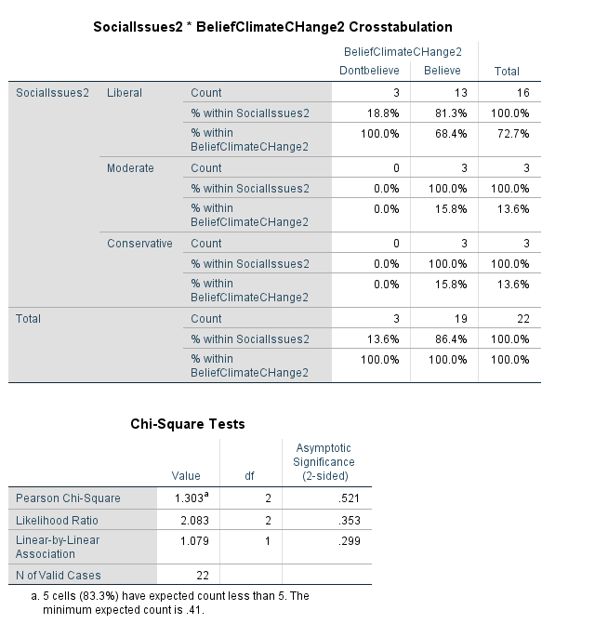

*Figure 1. Belief in climate change in general vs. political alignment with social issues.*

**Belief vs. Fiscal Issues**

There is a statistically significant pattern between those who identify either as liberal or moderate in regards to fiscal issues and those who do not believe in climate change in general. 100 percent of the respondents who identified as fiscally moderate said that they did not believe in climate change according to the provided definition while 10 percent of respondents that identified as fiscally liberal said the same.

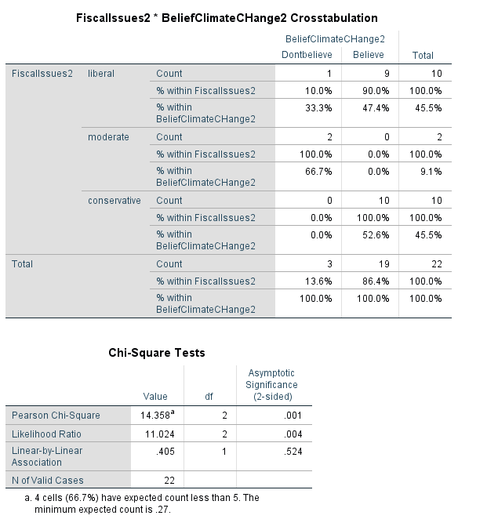

*Figure 2. Belief in climate change in general vs. political alignment with fiscal issues.*

These results have some interesting implications. However, they are also limited because the survey did not include a definition of liberal or conservative in relation to fiscal issues. This could be interpreted as either “liberal-aligning” in the sense that liberal politics tend to favor social welfare programs, but it could also be “liberal” as in a “hands-off” government approach to taxes and finance. Despite the statistical significance of this cross-tabulation, the ambiguity of the terms renders this set largely inconclusive.

**Trust in Climate Change Coverage vs. Trust in Preferred Media**

There is no statistically significant correlation between levels of trust in climate change news coverage in general and trust in the respondent’s preferred media outlet. However, certain patterns are still observable from this data.

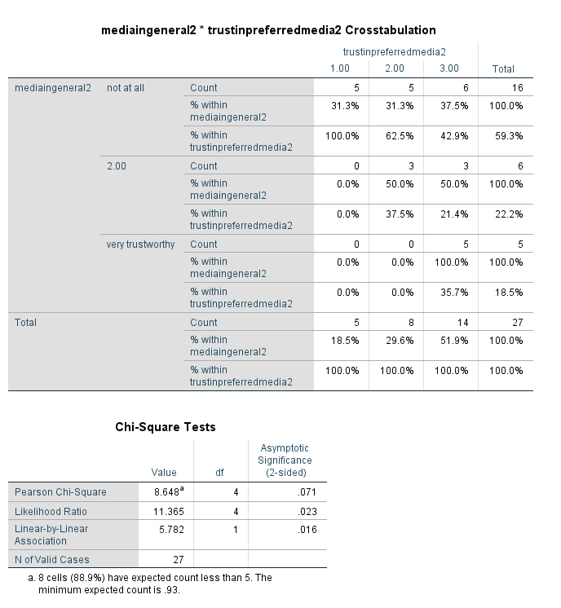

*Figure 3. Trust in climate change media in general vs. trust in personal preferred media outlet.*

A respondent reporting less trust in their preferred media outlet tends to correlate with scoring general media portrayals of climate change lower. Alternately, this could be interpreted as certain respondents not trusting the media in general, but making a slight exception for their preferred source for news media.

**Human Activity vs. Social Issues**

There is a statistically significant correlation between more socially conservative respondents and respondents who do not believe that climate change is influenced by human activity. This implies that social conservatives are slightly more likely to doubt human responsibility for climate change.

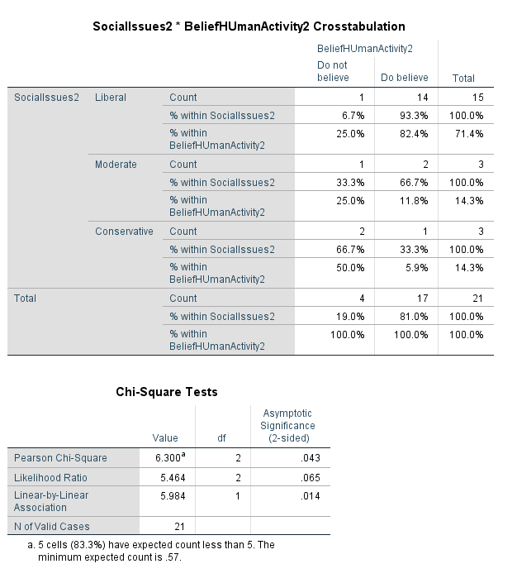

*Figure 4. Belief in human-caused climate change vs. political alignment with social issues.*

**Human activity vs. fiscal issues**

There is another statistically significant correlation between respondents who align with fiscal conservatism and those that are skeptical about human activity being responsible for climate change. This follows roughly the same pattern as Figure 2.

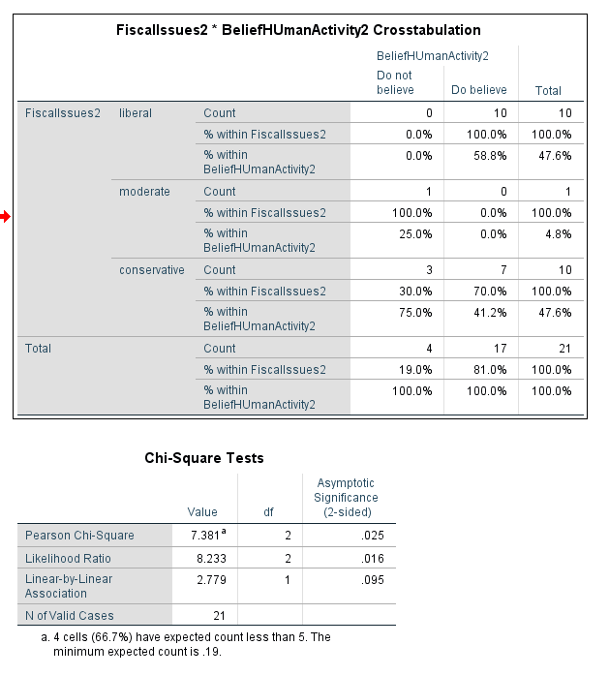

*Figure 5. Belief in human-caused climate change vs. political alignment with fiscal issues.*

**Trust in climate coverage vs. frequency of climate change coverage**

The observed pattern between these two variables is that respondents who said climate change was infrequently covered in the media in general were more likely to rate media in general as “not at all” trustworthy when it comes to climate change coverage.

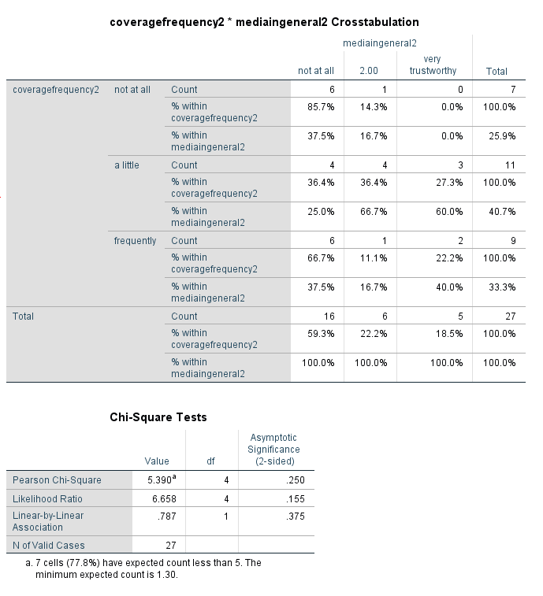

*Figure 6. Frequency of climate change coverage vs. trust in climate change coverage in general media.*

**Trustworthiness and credibility of climate change coverage**

Respondents were shown one of two short clips which narrated a fictional incoming hurricane. One clip used personified terms and dramatic language to talk about the hurricane (1) while the other used purely scientific language (2). Respondents were then asked a series of questions on the credibility of the information in their clip and the trustworthiness of the “newscaster” narrating it.

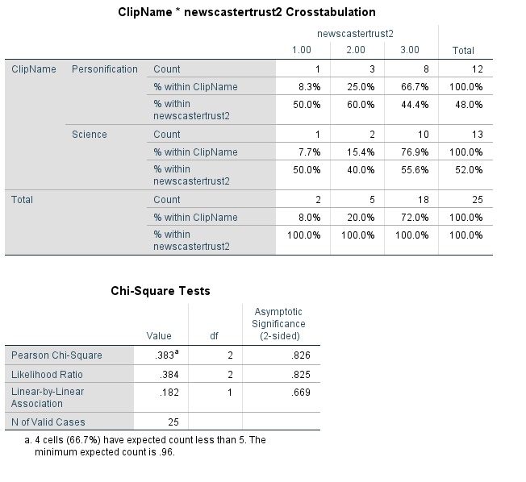

*Figure 7. Clip shown to respondent vs. trust in newscaster.*

There is very little correlation between the clip shown to respondents and the perceived trustworthiness of the narrator. This implies that respondents likely form their opinions on the trustworthiness of a media source before consuming news content.

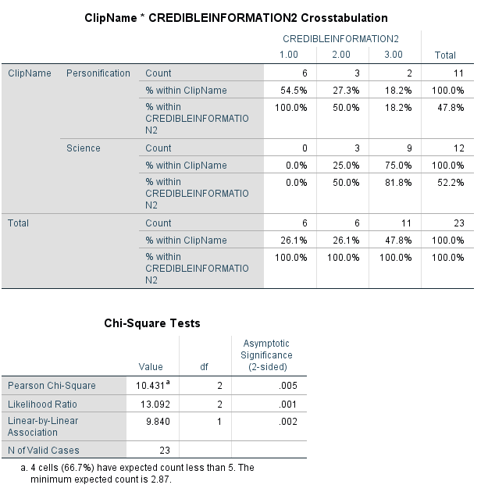

*Figure 8. Clip shown vs. perceived credibility of presented information.*

There is a statistically significant correlation between the clip shown and how credible respondents found the presented information on climate change. A majority of respondents that were shown the science and likelihood clip found the information trustworthy, while respondents presented with the personification and objectification clip were much less likely to find the information credible. This implies that the audience is more likely to take information seriously when it is focused on the scientific.

**Fiscal issues and trust in news clip**

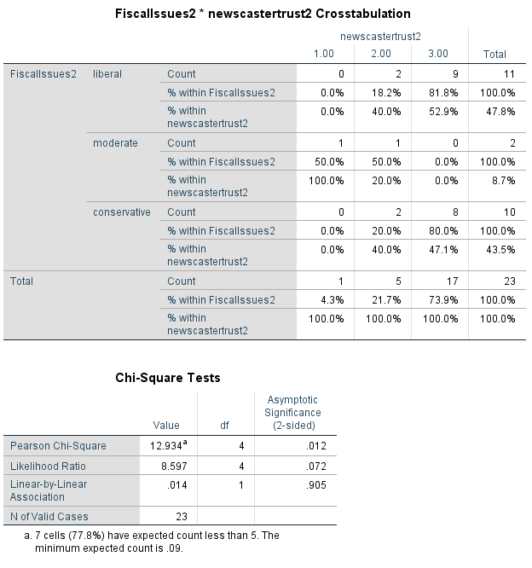

*Figure 9. Political alignment with fiscal issues vs. perceived trustworthiness of clip narration.*

About the same number of fiscal conservatives and fiscal liberals found the newscaster to be trustworthy. The only respondent that found her untrustworthy identified as more fiscally moderate.

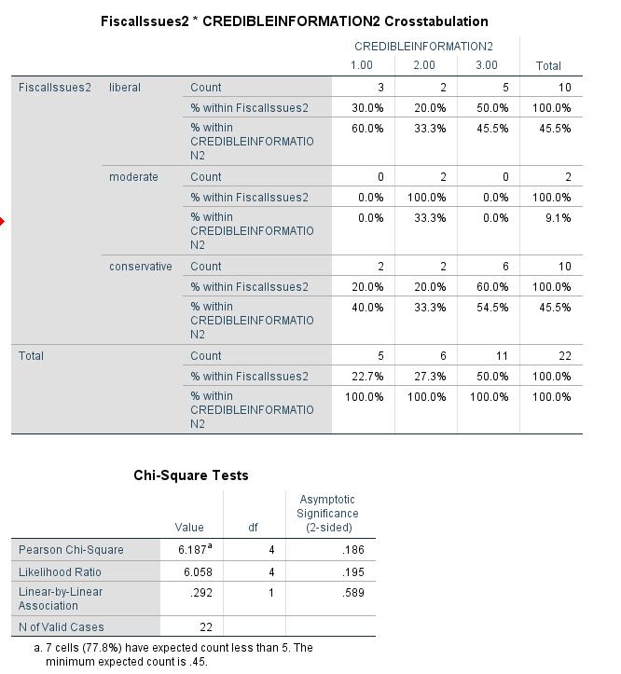

*Figure 10. Political alignment with fiscal issues vs. perceived credibility of information presented in clip.*

Once again, about the same number of fiscal conservatives and liberals found the clip credible. These two results together suggest that political alignment does not affect how people consume news media. However, it should be taken into account that this piece of “news” did not carry any reputation with its coverage, political or otherwise.

**Takeaways**

Although the conclusivity of the data is limited by the small sample size and uneven distribution of political ideology (most survey respondents were democratic and/or liberal), some patterns can still be acquiesced from the data present and tentative conclusions can be drawn that could be further studied at a later date:

1. People who identify as fiscally liberal and/or moderate are slightly more likely to express skepticism on climate change.
2. People who do not trust most media tend to also put very little trust in their own preferred media outlets. Alternately, those who do not put their full trust in their preferred media also tend to distrust media in general.
3. People who identify as socially and fiscally conservative and/or moderate are more likely to display skeptical attitudes about human-caused climate change.
4. People that report seeing infrequent climate change coverage in the media are less likely to find climate change coverage trustworthy.
5. Climate change coverage that uses more scientific and specific language is more likely to be seen as credible and trustworthy.

It is expected that, should this survey be re-distributed to a larger audience, the results would be more or less the same. However, a larger pool of respondents would likely lend more nuance to the data. It would therefore be beneficial to re-distribute this survey at a later date, hopefully through channels with wider reach.

**Conclusion**

# Climate change is a complicated subject, and one that requires a thorough understanding in order to cover. If coverage is not personalized for the audience, nobody will pay attention when they need to. However, the findings of this survey imply that audiences are willing to listen to specific scientific language in relation to climate change. Dumbing the material down only serves to further alienate the material from its audience.

# As journalists, it is our responsibility to understand our audience enough to know what they will want to read about, but it is also our responsibility to shape our coverage so that people will want to read about things they need to know. Science coverage can be credible without being boring, and conflating those two qualities can lead to journalists underestimating their audience.

# We can learn from West Virginia that one’s sense of community runs deeper than anything. Even if you do not work in the coal industry, you likely know someone who does. Regardless of political affiliation, every time I brought up the coal industry, whomever I was speaking to showed me that they considered themselves personally invested. Some people got defensive and assumed I was trying to make the industry look bad. Others were prideful of their heritage and recognized that coal is a central part of community life. And others still expressed an almost anguished ambivalence as they tried to reconcile their passion for environmental causes with the legacy surrounding their community. In every case, it was clear that the community was more important than anything.

But it is not as simple as focusing coverage on only what your audience wants to hear. Journalists will need to resist the appeal of journalism under the market model as much as possible and continue covering tough topics. An audience not wanting to focus on a certain topic simply means that the journalist must take on a new perspective to make them want to listen.

In order for climate change news coverage to be successful, it needs to separate from party affiliations, yes, but it also needs to realize that people are smarter than we give them credit for. There is nothing wrong with presenting just the facts of a story and you do not need jargon or complex terminology for your content to be scientifically accurate.

There is no question that environmental coverage is imperative as global communities struggle to adapt to our changing climate. It is time to find collaborative solutions removed from partisan influence. It is time to consider not just the wants, but the needs of our communities. People care more than we think they do. They care about the people they know. Environmental journalism should focus on bringing those people into the forefront of all environmental discussion.

# References

Asplund, T., Hjerpe, M., & Wibeck, V. (2012). Framings and coverage of climate change in Swedish specialized farming magazines. *Climatic Change*, *117*, 197-209. doi:10.1007/s10584-012-0535-0

Blair, J., Czaja, R., & Blair, E. (2014). Data Collection 1: Selecting a Method. *Designing surveys: A guide to decisions and procedures,* 48-82*.* Thousand Oaks, CA: Sage Publications.

Blake, A. (2018, November 27). President Trump's full Washington Post interview transcript, annotated. Retrieved from https://www.washingtonpost.com/politics/2018/11/27/president-trumps-full-washington-post-interview-transcript-annotated/?noredirect=on&utm_term=.a313d2e13527

Bolin, J. L., & Hamilton, L. C. (2018). The News You Choose: News media preferences amplify views on climate change. *Environmental Politics,* *27*, 455-476. doi:10.1080/09644016.2018.1423909

Campbell, D. T. (1963). *Experimental and quasi-experimental designs for research*. Estados Unidos: Rand McNally.

Cook, J., Oreskes, N., Doran, P. T., Anderegg, W. R., Verheggen, B., Maibach, E. W., . . . Rice, K. (2016). Consensus on consensus: A synthesis of consensus estimates on human-caused global warming. *Environmental Research Letters,11*(4), 048002. doi:10.1088/1748-9326/11/4/048002

Corner, A., Whitmarsh, L., & Xenias, D. (2012). Uncertainty, scepticism and attitudes towards climate change: Biased assimilation and attitude polarisation. *Climatic Change,114*, 463-478. doi:10.1007/s10584-012-0424-6

Donner, S. D., & Mcdaniels, J. (2013). The influence of national temperature fluctuations on opinions about climate change in the U.S. since 1990. *Climatic Change,* *118*, 537-550. doi:10.1007/s10584-012-0690-3

Dunlap, R. E., & Mccright, A. M. (2011). Organized Climate Change Denial. *Oxford Handbooks Online*. doi:10.1093/oxfordhb/9780199566600.003.0010

Gallup & Knight. (2018). American Views: Trust, Media and Democracy (p. 3, Rep.). Gallup.

Howard-Williams, R. (2011). Consumers, crazies and killer whales: The environment on New Zealand television. *International Communication Gazette,* *73*, 27-43. doi:10.1177/1748048510386740

Jaspal, R., & Nerlich, B. (2012). When climate science became climate politics: British media representations of climate change in 1988. *Public Understanding of Science,* *23*, 122-141. doi:10.1177/0963662512440219

Jylhä, K. M. (2016). *Ideological roots of climate change denial: Resistance to change, acceptance of inequality, or both?* (Order No. 10780245). Available from ProQuest Dissertations & Theses A&I; ProQuest Dissertations & Theses Global. (2002490775). Retrieved from https://colorado.idm.oclc.org/login?url=https://search.proquest.com/docview/2002490775?accountid=14503

Kirilenko, A. P., Molodtsova, T., & Stepchenkova, S. O. (2015). People as sensors: Mass media and local temperature influence climate change discussion on Twitter. *Global Environmental Change*, *30*, 92-100. doi:10.1016/j.gloenvcha.2014.11.003

McCombs, M. E., Holbert, R. L., Wanta, W., & Kiousis, S. (2011). Trust in the News. *The news and public opinion: Media effects on civic life,* 41-57. Cambridge: Polity.

Park, D. J. (2018). United States news media and climate change in the era of US President Trump. *Integrated Environmental Assessment and Management,* *14*, 202-204. doi:10.1002/ieam.2011

Pezzullo, P. C., & Cox, J. R. (2018). *Environmental communication and the public sphere*. Thousand Oaks, CA: SAGE

realDonaldTrump. (2012, Nov. 6). The concept of global warming was created by and for the Chinese in order to make U.S. manufacturing non-competitive. [Twitter post]. Retrieved from https://twitter.com/realdonaldtrump/status/265895292191248385?lang=en

Rich, N. (2018, August 01). *Losing Earth: The Decade We Almost Stopped Climate Change.* Retrieved from https://www.nytimes.com/interactive/2018/08/01/magazine/climate-change-losing-earth.html

Sue, V. M., & Ritter, L. A. (2012). Writing Survey Questions. *Conducting online surveys*, 51-75. Thousand Oaks, Calif: Sage.

Ungar, S. (2000). Knowledge, ignorance and the popular culture: Climate change versus the ozone hole. *Public Understanding of Science,* *9*, 297-312. doi:10.1088/0963-6625/9/3/306