Uintatherium anceps from the Uinta Formation, Piceance Creek Basin, Colorado
With Implications on the morphological variation in Uintatherium anceps
By
Geoffrey W. Flora
Geological Sciences, University of Colorado at Boulder

Defense Date (November 1st, 2021)

Thesis Advisor:
Dr. Jaelyn Eberle, Geological Sciences
Defense Committee:
Dr. Jaelyn Eberle, Geological Sciences
Dr. Lon Abbott, Geological Sciences
Dr. Christy McCain, Ecology and Evolutionary Biology

Abstract
Uintatheres are an early Paleogene group of large-bodied herbivores recognizable by their bizarre knobby cranial horn-like protuberances and saber-tooth canines. The uintatheres represent one of the earliest lineages of mammals to obtain a large body size and were the biggest land animals of their time during the Middle Eocene (ca. 49 - 39 Ma)
Herein I describe a skull and fragmentary postcrania of a uintathere that was discovered on a construction site in the Piceance Creek Basin near Meeker, Colorado in 2009. The skull UCM 102271 represents the most complete uintathere fossil described to date from the Piceance Creek Basin. UCM 102271 was compared with uintathere skulls held in the collections at the University of Wyoming and the Utah Field House of Natural History State Park Museum.
Distinguishing characters of UCM 102271 include a dorsally elevated parietal horn, a temporal fossa without typical posterodorsal expansion, and an M3 with a molar fossa at the lingual base of the metacone. Measurements of the skull are smaller than average for Uintatherium anceps. The skull length and upper tooth row length are is 15% and 6% smaller than the average for Uintatherium anceps.
The size and morphology of the skull confidently places it within the genus Uintatherium. The addition of UCM 102271 increases the morphologic variation observed in Uintatherium anceps. These findings further support the need for the reevaluation of species level taxonomy for Uintatherium anceps and other uintatheres.

Acknowledgements
I would like to thank my undergraduate honors thesis committee members, Dr. Jaelyn Eberle, Dr. Lon Abbott, and Dr. Christy McCain, for their time and support required. Thank you to Dr. Jaelyn Eberle for her tireless mentorship and countless revisions on this research endeavor. Thank you for the opportunity to ponder such a strange group of fossil mammals. Thank you to Dr. Laura Vietti for access to the University of Wyoming Geological Museum fossil collection and your hospitality during my stay at the University of Wyoming in Laramie. Thank you to Dr. John Foster and Dr. Steve Sroka for access to the Utah Field House of Natural History State Park Museum’s fossil collection and for their generous hospitality during my stay in Vernal. Thank you to vertebrate paleontology collections manager Jacob Van Veldhuizen for your help accessing the University of Colorado Museum of Natural History (UCM) collections, moving fossils, and providing space in the Paleo Prep Lab. Thank you to Heather FInlayson for her help developing supports for the specimen during this research and for her preparation work of the skull. Thank you to Peter Robinson and Sue Ann Bilbey for sharing their knowledge of the specimen’s discovery. Thank you to my parents and family who have remained supportive throughout the duration of this endeavor.

Table of Contents

- Introduction 1
  - Statement of Purpose 2
  - Taxonomic and collecting history of North American uintatheres 3

- Geological Setting 8
  - Piceance Creek Basin 8
  - Uinta Formation 9

- Materials and Methods 15
  - Comparative Methods 15
  - Principal Component Analysis (PCA) 16
  - Institutional Abbreviations 17
  - Dental and Anatomical Terminology Abbreviations 17

- Systematic Paleontology 21

- Description 22

- Comparisons to Uintatherium anceps, Tetheopsis, and Uintatherium? Insperatus 25
  - FHPR 1151 Uintatherium anceps 25
  - UW 13644 Tetheopsis sp. 25
  - YPM 11036 (FHPR 50501) Uintatherium anceps 26
  - UCM 51406 Uintatherium anceps 27
  - IVPP V6379 Uintatherium? insperatus from China 27

- Results 31
  - Principal Component Analysis: Exploring the Usefulness of Uintathere
Morphometric Measurements 34
- Discussion 40
  - Distinguishing the genera of Uintatheres 40
  - Intraspecific Variation in Uintatherium anceps 42
  - Biostratigraphic Implications of UCM 102271 46

- Conclusion 49

- References 51

List of Figures
Figure 1. Distribution of uintatheres 4
Figure 2. Large North American uintathere genera 5
Figure 3. YPM 11030, Holotype Uintatherium anceps 6
Figure 4. Wheeler’s 1961 skull ratios 7
Figure 5. Paleogene intermontane basins of Rocky Mountain region 11
Figure 6. Composite stratigraphic column of the northern Piceance Creek Basin 12
Figure 7. Outcrop of Tongue 9 of the Uinta Formation 13
Figure 8. Map of the study area 14
Figure 9. Turnbull 2002 skull length measurements 18
Figure 10. Turnbull 2002 tooth measurements 19
Figure 11. Turnbull 2002 tooth row measurements 20
Figure 12. Lateral and ventral view of UCM 102271 29
Figure 13. Right cheek tooth row UCM 102271 30
Figure 14. PCA of tooth row measurements 36
Figure 15. PCA of tooth measurements 37
Figure 16. Bivariate plot of M1L vs M1AW 38
Figure 17. Bivariate plot of M3L vs M3AW 39
Figure 18. Comparison of the Uintatherium and Tetheopsis skulls 41
Figure 19. UCM 102271 Right M3 43
Figure 20. Comparison of small Uintatherium anceps skulls 45
Figure 21. Composite stratigraphic columns of the Uinta, Piceance Creek, Bridger, Washakie, and Sand Wash Basins 48

List of Tables
Table 1. Cheek Tooth Row Measurements of UCM 102271 31
Table 2. Individual Tooth Measurements of UCM 102271 32
Table 3. Skull Measurements of UCM 102271 33

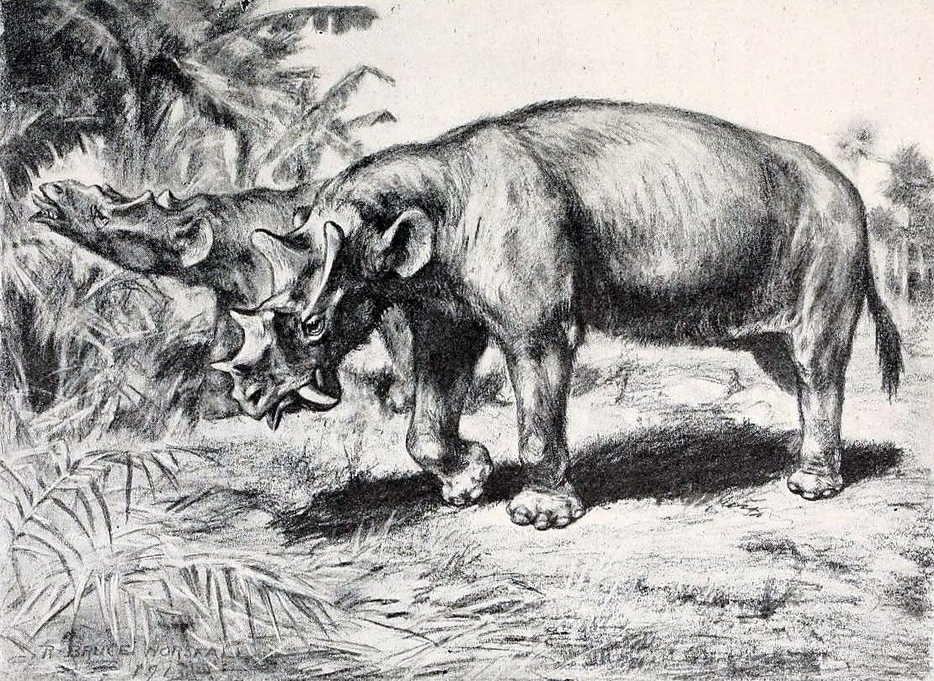
Restoration of Uintatherium anceps by Bruce Horsfall – 1913 (Public Domain)

“No animal is there, that possess both tusks and horns…”
-Aristotle, Historia Animalium Book II (1), 350 BCE

Introduction
The Dinocerata (uintatheres) are an order of large-bodied primitive eutherians of bizarre appearance that lived between the late Paleocene and early Eocene. The North American forms of the middle Eocene were elephantine in proportions and distinctive for their three pairs of bony horn-like protuberances crowning the skull and their saber-tooth canine tusks protected by large flanges on the lower jaws. Uintathere fossils have been discovered in the U.S. western interior and the Gobi Desert of Asia (Figure 1). The earliest uintatheres appeared in the Late Paleocene (Tiffanian) of North America and Asia (ca. 59 Ma) (Simpson, 1929; Patterson, 1939; Dorr, 1958). These early uintatheres were relatively unspecialized plantigrade, pig-sized (175 kg, 385 lbs), omnivorous mammals (Flerov, 1952; Lucas & Schoch, 1998). By the late middle Eocene (ca. 49 to 38 Ma), uintatheres were elephant-sized digitigrade forms and the largest land animals of their time. The geologically youngest genus Eobasileus weighed up to 4,500 kg (9,900 lbs) (Turnbull, 2002). These large North American forms belong to the genera Uintatherium, Tetheopsis, and Eobasileus (Figure 2) (Lucas & Schoch, 1998). There are four species of uintathere typically recognized (Lucas and Schoch, 1998). The most well-known is Uintatherium anceps. There are two species of Tetheopsis, T. speirianus, a long-nosed form, and T. ingens, a short-nosed form (Wheeler, 1961). Eobasileus cornutus is the final species recognized for its gigantic skulls. All three genera bore the iconic three pairs of horn-like protuberances (nasal, maxillary, parietal) and saber-like canine tusks. These genera were herbivorous and well adapted to browsing, with a rhinoceros-like mobile upper lip, procumbent shearing lower incisors, a horny pad in place of upper incisors and a long flexible giraffe-like tongue (Flerov, 1952; Wheeler, 1961). Uintatheres went extinct just prior to the beginning of the late Eocene (ca. 38 – 37 Ma) (Lucas & Schoch, 1998).
The origin of the Dinocerata is unclear. Many relationships have been proposed including with the Proboscidea (Marsh 1871; Leidy 1872; Cope 1872), Pantodonta (Cope, 1882), Ungulata (Marsh, 1886), Leptictida (Flerov, 1952), Xenungulata (Schoch & Lucas, 1985), and Perrisodactyla (Burger, 2015). However, none of these relationships have been thoroughly evaluated. In the summer of 1872, discoveries of these strange mammals in the badlands of the Greater Green River Basin, Wyoming, sparked the infamous Bone Wars. A period of competitive fossil discovery leading to life-long bitter feud between the early American paleontologists Othniel C. Marsh (Yale College) and Edward D. Cope (Academy of Natural Sciences of Philadelphia).

Statement of Purpose
The aim of this research project is to describe the skull of a large uintathere (UCM 102271) from the middle Eocene of the Uinta Formation in the Piceance Creek Basin (PCB) of western Colorado. UCM 102271 represents the most complete uintathere remains described thus far from the PCB. Schoch & Lucas (1985) described the first uintathere remains from the PCB, which included a pair of broken canines associated with an incomplete skull (UCM 51406). An additional undescribed skull and skeleton was sold to the Gunma Prefecture Museum in Japan and could not be compared during this study. Although uintathere fossils are famous from the middle Eocene deposits of the western United States, they remain exceptionally rare finds, with the majority of fossils being too fragmentary for confident species level identifications. The description of UCM 102271 provides an opportunity to compare an unusually complete skull from the PCB of Colorado to the other uintathere specimens of the Bridger and Washakie Basins of Wyoming. Below, I will describe UCM 102271’s size and morphological characters, to further expand the observed variation within the already highly variable Uintatherium anceps.
Taxonomic and collecting history of North American uintatheres
In 1871, Marsh unknowingly described the first uintathere, erroneously attributing the fragmentary fossils (YPM 11030, Figure 3) to a new species of brontothere, Titanotherium? anceps (Marsh, 1871). The following year, American vertebrate paleontologists Joseph Leidy, Othniel Marsh, and Edward Cope descended on the Tertiary strata of the Wyoming Territory. All three parties collected numerous remains of uintatheres. On August 1st, Leidy (1872a,b) was first to publish, establishing the first uintathere genus Uintatherium robustum. On August 19th, Cope (1872a) and Marsh (1872a) would report their uintathere fossils. Furious, fast-paced, and at times vindictive publication between Marsh and Cope ensued. Marsh and Cope’s feud centered on the uintatheres, with both authors refusing to acknowledge the work of the other. For detailed accounts of this important and fascinating era in American paleontology, the reader is referred to Wheeler (1960), Romer (1964), and Thompson (2008) Their rivalry left uintatheres in a state of taxonomic chaos, establishing nine genera with 42 poorly diagnosed species (Wheeler, 1961).
Wheeler (1961) reevaluated the historical collection of the Bone Wars uintatheres, concluding that three genera (Uintatherium, Tetheopsis, and Eobasileus) could be discerned based upon horn ratios of the skull (Figure 4). Wheeler’s (1961) ratios compare three skull length measurements based on the regions defined by the three pairs of horns. Wheeler’s contribution significantly improved the taxonomic understanding of uintatheres, he did not morphologically justify the species level synonymies for Uintatherium or Eobasileus. For example, Wheeler (1961) synonymized 28 species named during the Bone Wars (Leidy, 1872a,b; Marsh, 1886; Scott, 1886) with Uintatherium anceps stating only that “all specimens of Uintatherium apparently belong to a single variable species.” Recent workers have been critical Wheeler’s work. Lucas & Schoch (1998) stated “we believe this synonymy bears critical reevaluation”, although no study has addressed the issue to date. Turnbull (2002) was the most recent to publish on the North American uintatheres, producing an extensive monograph describing specimens collected from the Washakie Basin of Wyoming housed at the Field Museum in Chicago. Turnbull (2002) recognized just two genera and two species Uintatherium anceps and Eobasileus cornutus based upon differences in skull length. While the generic synonymizing of Tetheopsis with Eobasileus appears appropriate, Turnbull (2002) did not provide any morphological justifications to support this idea, nor did he explain his reason for synonymizing the two species of Tetheopsis (T. speirianus and T. ingens) into Eobasileus cornutus.
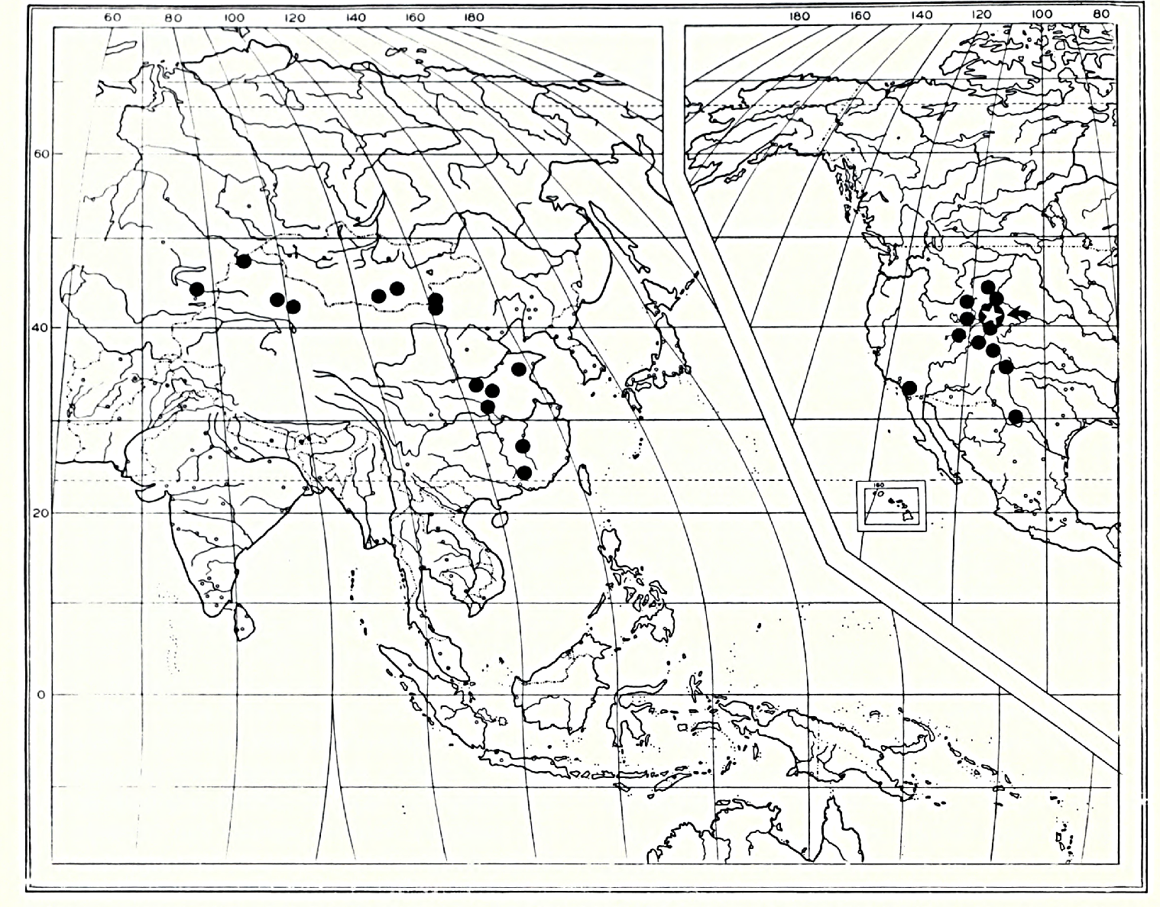

Figure 1. The global distribution of the DInocerata (uintatheres). Each locality that has produced a uintathere fossil is represented by a black circle. The red star is the general location of interest in this study within the Piceance Creek Basin, Western Colorado. (From Turnbull, 2002).

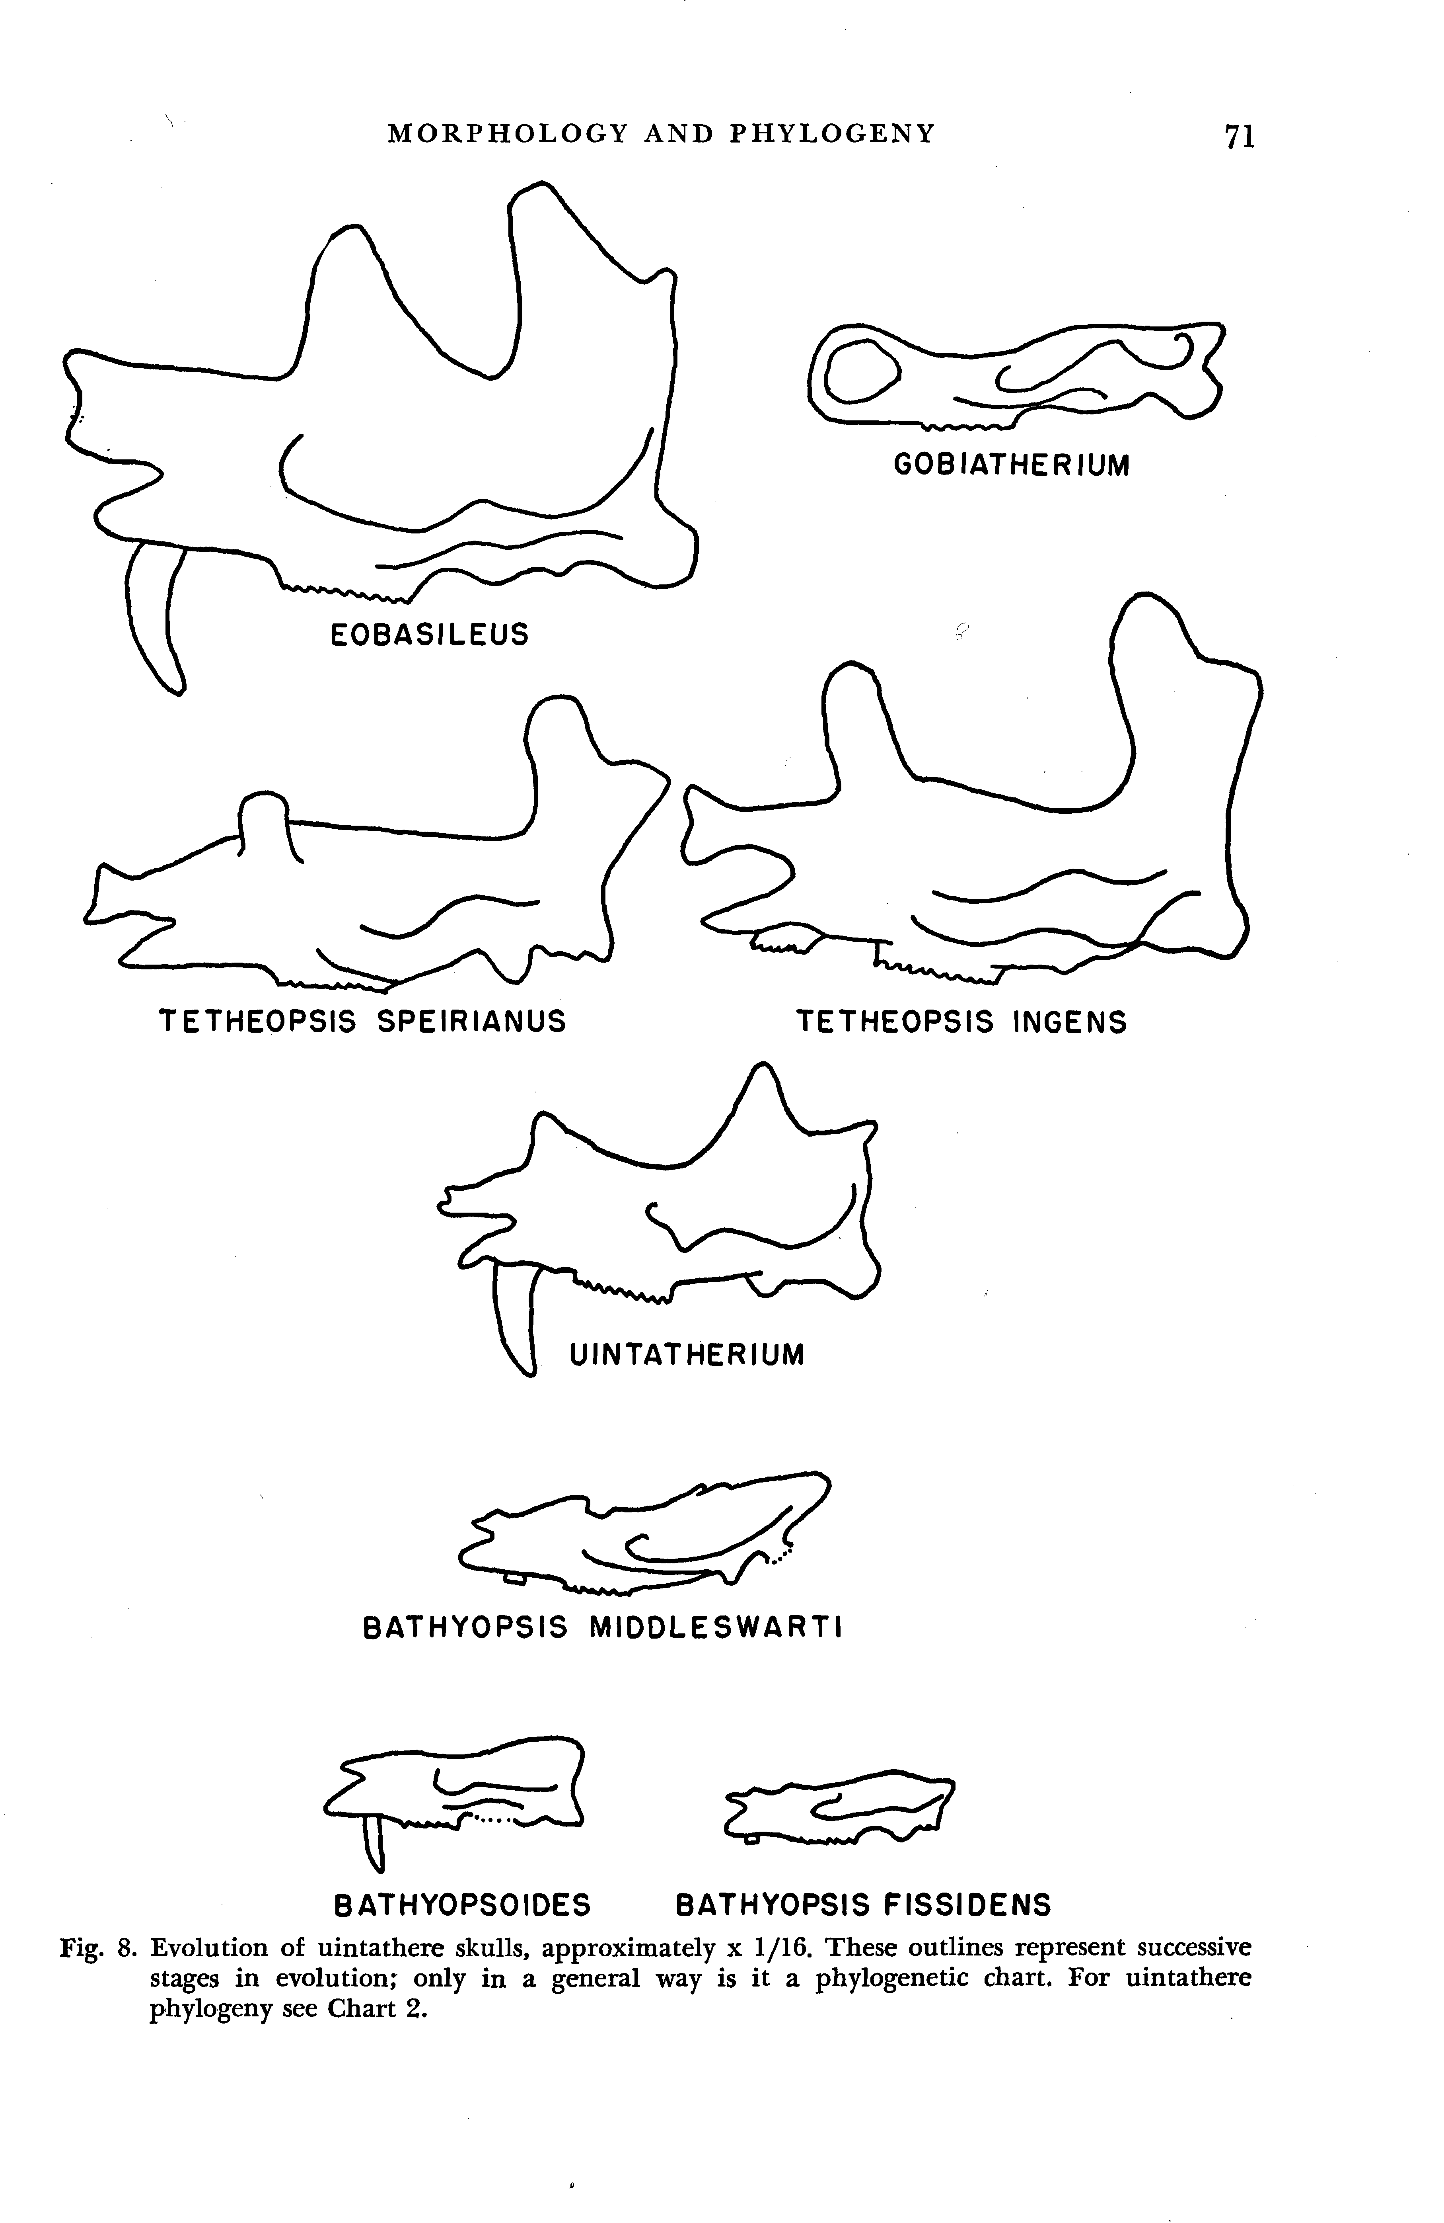

Figure 2. The three large middle Eocene North American uintathere genera. Outline drawing of skulls are scaled to relative size. (From Wheeler, 1961)

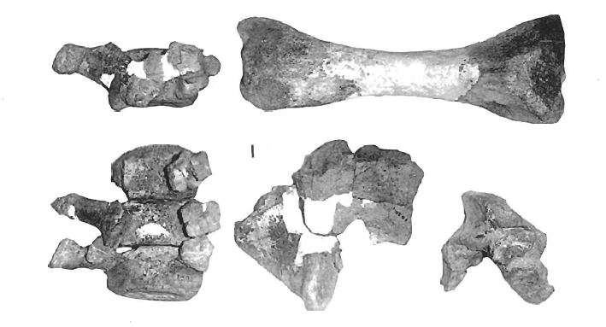
D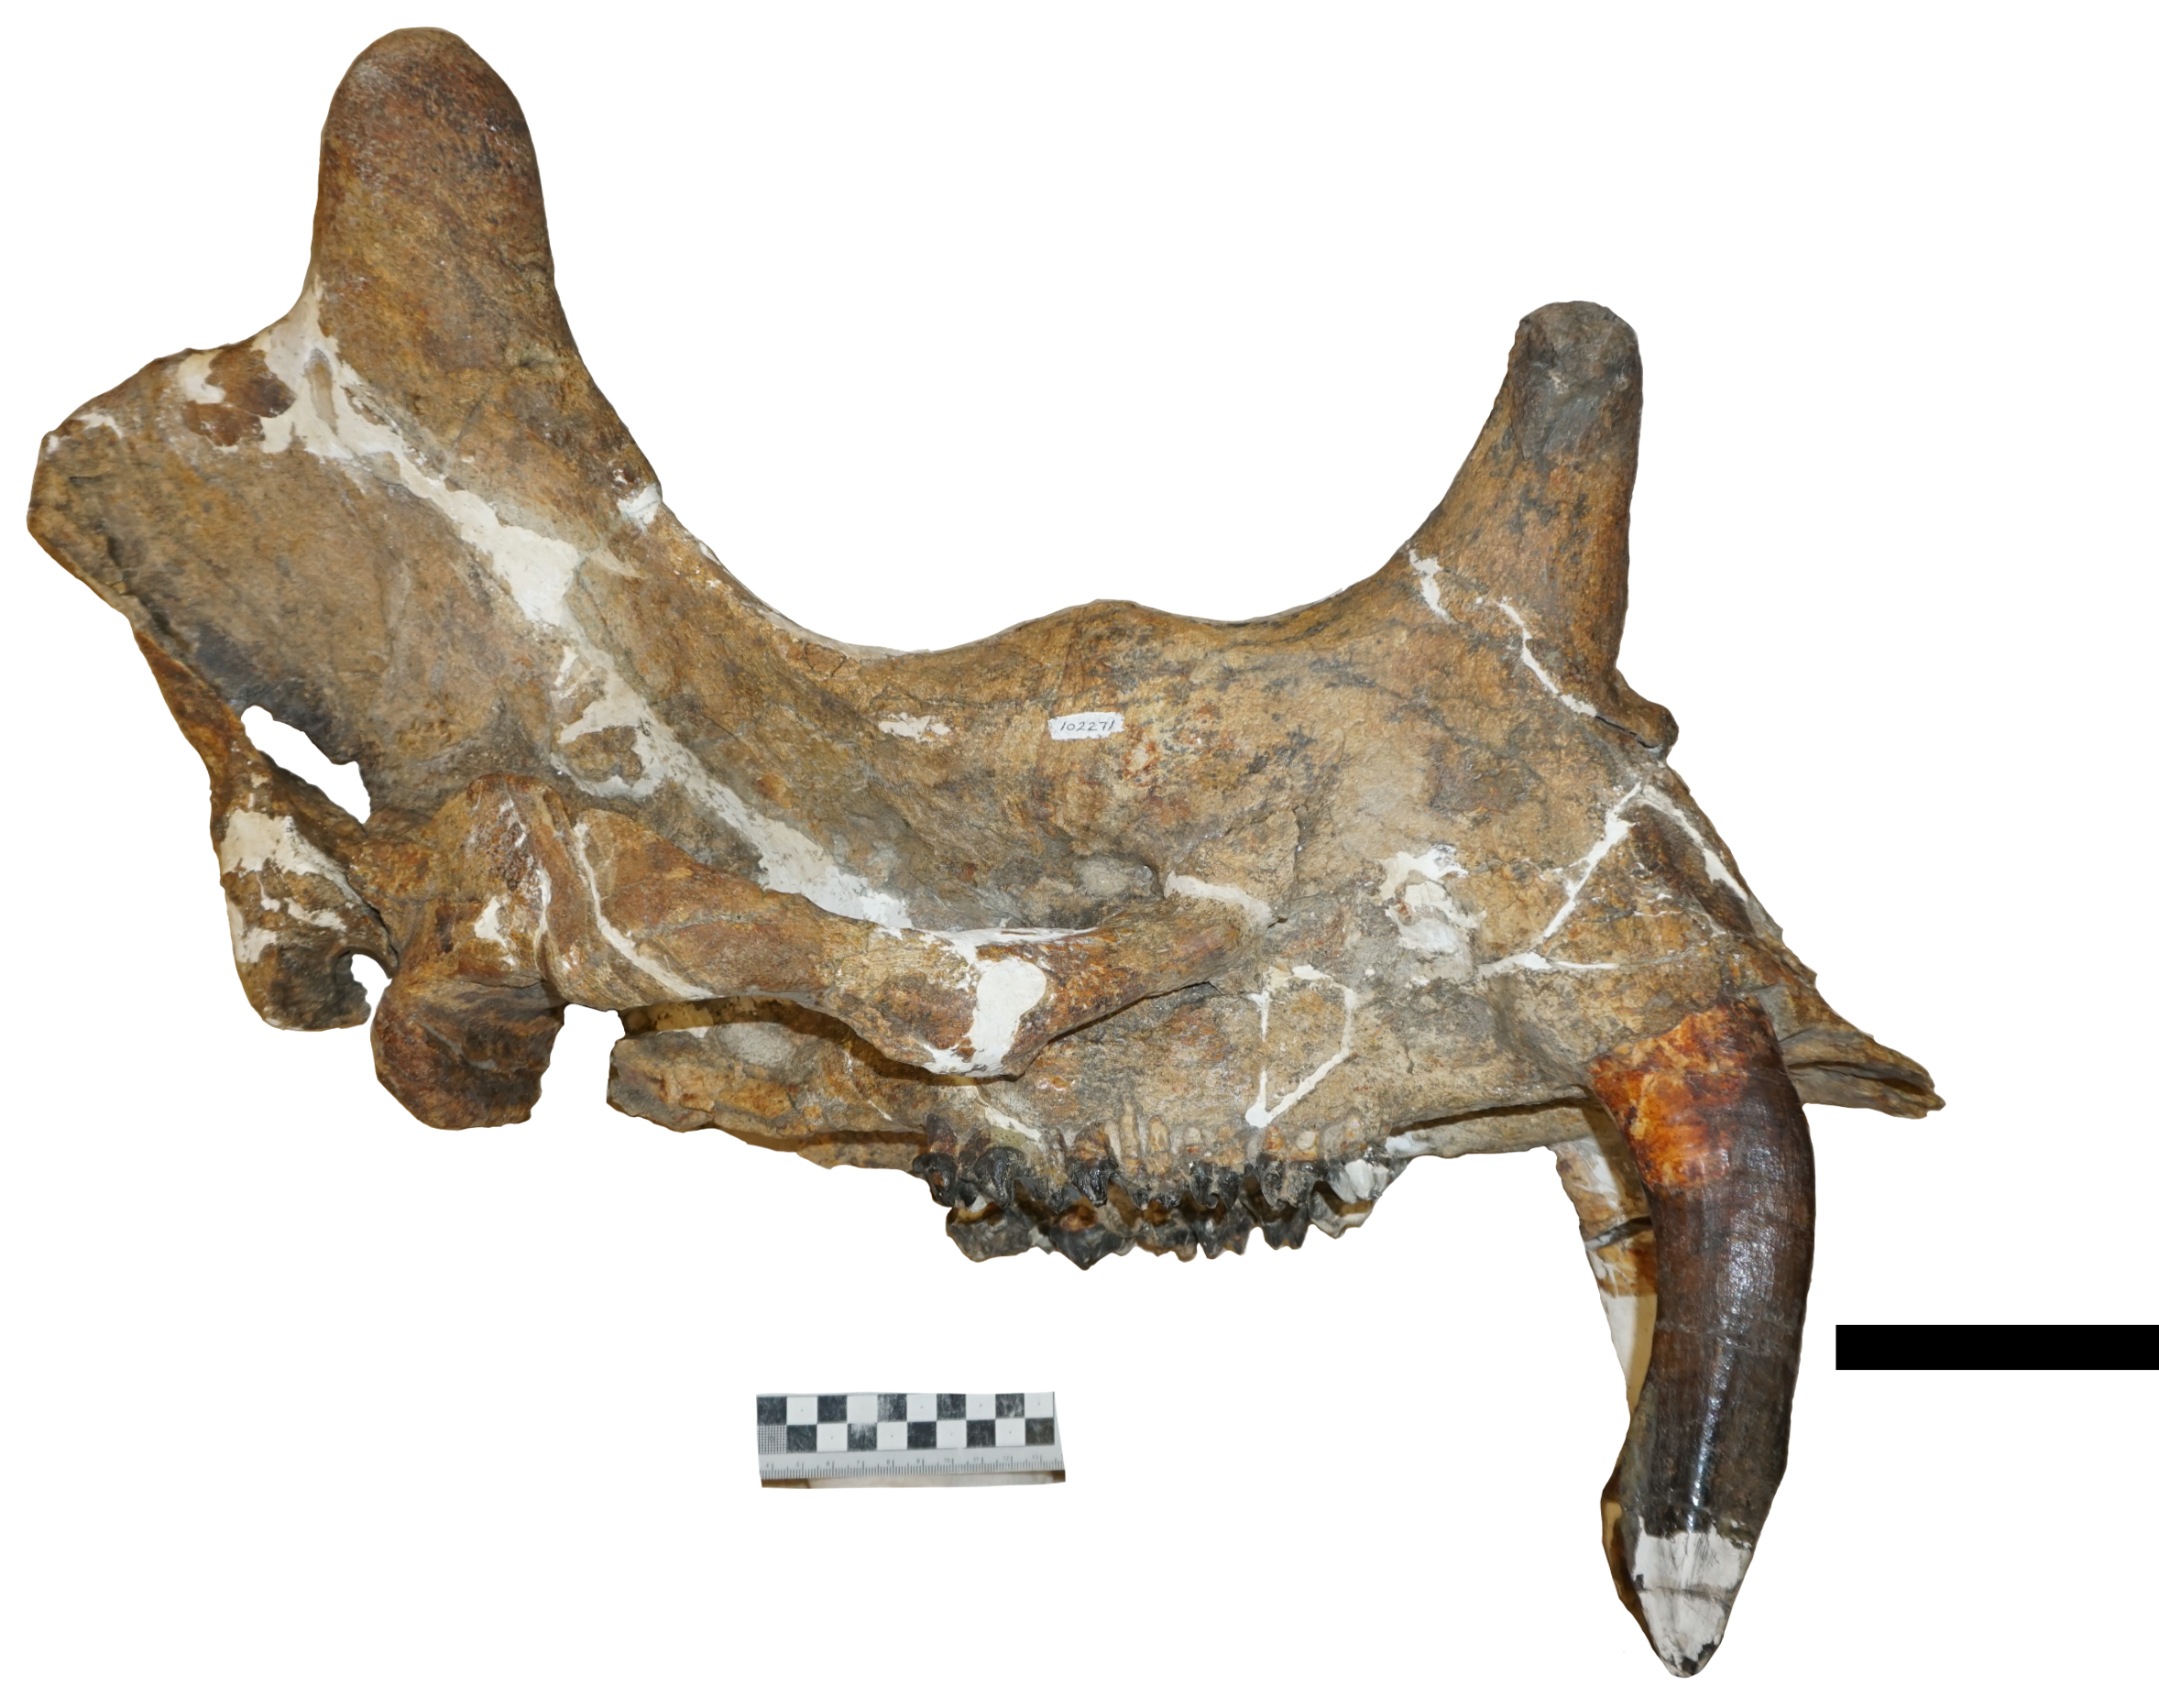
A
C
B
Figure 3. YPM 11030, holotype for Uintatherium anceps (=Titanotherium? anceps, Marsh, 1871). Four thoracic vertebrae (a), restored left tibia (b), partial right parietal horn with partial occipital (c), left glenoid fossa with partial zygoma (d). (From Wheeler, 1961). Scale bar = 10 cm.

Figure 4. Wheeler’s (1961) skull ratios. A – distance between nasal horn and maxillary horn. B – Distance between maxillary horn and parietal horn. C – Distance between parietal horn and occipital crest. (From Wheeler, 1961)

Geological Setting
Piceance Creek Basin
The Piceance Creek Basin (PCB) of northwestern Colorado is an asymmetric structural and depositional basin which formed during the Laramide Orogeny, within the broken foreland province along the eastern margin of the Cordilleran fold-and thrust region (Smith et al. 2008, Johnson, 2010). Laramide-age uplift divided the foreland basin with chains of strongly emergent anticlinal basement-cored uplifts forming the Piceance Creek Basin, Uinta Basin, Greater Green River Basin, and Washakie Basin (Dickinson et al., 1988; Smith et al., 2008; Täanavsuu-Milkeviciene & Sarg, 2015). The PCB is bounded by the Douglas Creek Arch to the west, the Uinta Mountains to the northwest, the Axial Arch to the north, the White River uplift to the east, and the Uncompahgre and Gunnison uplifts to the south (Figure 5). Throughout most of their depositional history during the early to middle Eocene (ca. 57-43 Ma), both the Uinta Basin and PCB were occupied by Lake Uinta, a large saline body of water (Johnson et al., 2019). Lake Uinta deposited one of the world’s largest oil shale resources in the PCB during its greatest transgressive phase approximately 49 Ma (1.53 billion barrels of oil equivalent) (Johnson, 2010). Following Laramide structural isolation, ancient lakes formed thick sequences of carbonates and evaporites while the surrounding uplifts provided orogenic clastic sediment that intermittently filled the basins from the early to mid-Eocene (ca. 53 to 46 Ma; Täanavsuu-Milkeviciene & Sarg, 2015). These sedimentary deposits are divided into three formations, from oldest to youngest, the Wasatch Formation (DeBeque Formation locally; Burger, 2009) (early Eocene, ca. 54 Ma), Green River Formation (early to middle Eocene, ca. 54 - 49 Ma), and Uinta Formation (middle Eocene, ca. 48.5 Ma) (Figure 6 & 7). The uintathere skull of interest comes from the Uinta Formation.

Uinta Formation
Upper Eocene strata of the Uinta Basin (northeastern Utah) and PCB (northwestern Colorado) have a long history of complicated, and often confusing, application of stratigraphic nomenclature (Cashion & Donnell, 1974). The early application of the name ‘Uinta Formation’ was reviewed by Bradley (1931) who applied the name to strata overlying the Green River Formation only within the Uinta Basin and assigning the similar upper Eocene strata in the PCB to the Evacuation Creek Member of the Green River Formation and Bridger Formation. Stratigraphic analysis by Cashion and Donnell (1974) subsequently concluded that the Evacuation Creek Member in the PCB was equivalent to the type section of the lower Uinta Formation in the Uinta Basin, thus applying the name to the PCB.
In the PCB, the Uinta Formation reaches a maximum thickness of 250 meters (820 ft) within the northern portion of the basin. The formation consists of deltaic, turbidite, and alluvially derived sandstones and volcaniclastic conglomerates that locally interfinger with lacustrine marlstones and siltstones (Trudell et al., 1970; Hail, 1987; Cole & Picard, 1989; Hail & Smith 1994). The sediment originated from infilling streams that formed large wedges of volcaniclastic debris originating from the Absaroka and Challis volcanic fields of Wyoming (Johnson, 1985; Surdam & Stanley, 1979; Johnson et al., 2019). These prograding wedges intertongue with the lacustrine deposits of the upper Green River Formation along the fluctuating shoreline of Lake Uinta in the northern portion of the PCB (Donnell, 2009). Nomenclature and delineation of the intertonguing units has varied through the years, with Donnell (2009) providing the most recent overview of the formally and informally named Green River Formation tongues and sequentially-numbered tongues of the Uinta Formation. The Wavy Tuff located just below the lowest Uinta Formation tongue has an age of 47.04 ± 0.18 Ma based on ⁴⁰Ar/³⁹Ar dating, and provides a lower bounding absolute age for the formation (Smith et al., 2008; Johnson et al., 2019).
UCM locality 2010002, the site that produced the uintathere skull described below (Figure 8), occurs in Tongue 9 of the Uinta Formation (Figure 7) or Tu Zone 9 (Donnell, 2009), based upon the locality’s stratigraphic position above the Black Sulphur Member of the Green River Formation (Bilbey et al., 2010). The skull was found in association with a uintathere femur, fragmentary pelvis, and a nearly complete baenid turtle Baena arenosa (P. Robinson, personal communication, 2020; Bilbey et al. 2010). All fossils were discovered in a light gray, well-lithified, fine-grained calcareous sandstone. This lithology occurs sporadically as discontinuous lenses within a 30- meter-thick, mudstone rip-up conglomerate (Bilbey et al. 2010). Previously, Duncan (1976) recorded miacid and brontotheriid material from the Tongue 9 of the Uinta Formation. Tongue 9 appears to be a productive layer that has produced other undescribed fossil localities housed at the UCM that contains, turtles, crocodilians, brontotheres, and uintatheres. No formal biostratigraphic age assignment has been applied to the Uinta Formation in the PCB. Personal communication with Peter Robinson (2020), suggests the undescribed fossils compare favorably with other classic Bridgerian age localities.

Bridger
Figure 5. Paleogene intermontane basins of Rocky Mountain region, United States Western Interior. Red star represents the approximate locality of interest. (From Täanavsuu-Milkeviciene & Sarg, 2015)

Figure 6. Composite stratigraphic column of the northern Piceance Creek Basin. Abbreviations: Fm – Formation, Mb – Member, W – Wasatch. The new locality of interest lies to the northeast near the top of the Uinta Formation. (From Täanavsuu-Milkeviciene & Sarg, 2012; Masterson 2016)

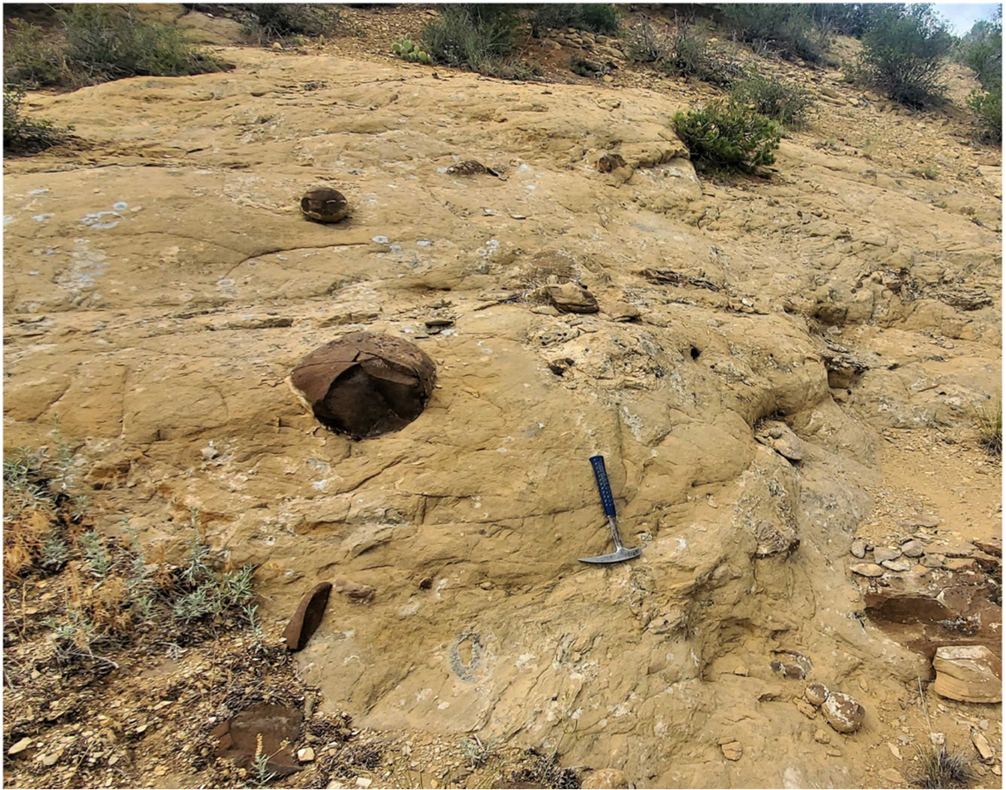
Figure 7. Exposure of brown weathering sandstone and conglomerate from Tongue 9 of the Uinta Formation, Greasewood Gulch Quadrangle, Rio Blanco County, Colorado. Picture Credit: Geoff Flora

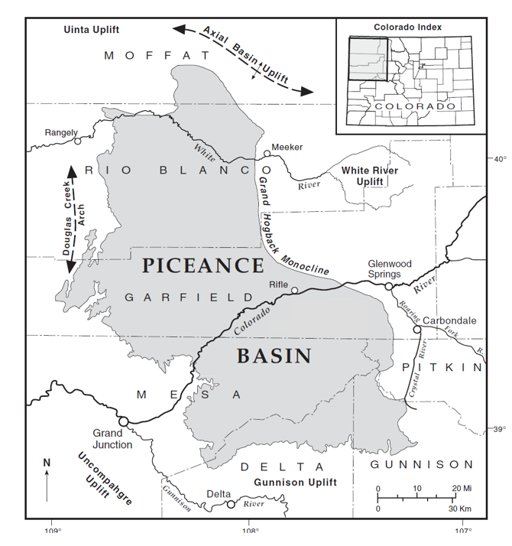
Figure 8. Relative location of study area (indicated by red star) within the northern portion of the Piceance Creek Basin. (From Madole & Streufert, 2003)

Materials and Methods
The skull of interest in this study is UCM 102271. The skull is housed in the fossil vertebrate collection at the University of Colorado Museum of Natural History (UCM), in Boulder, Colorado. UCM 102271 was discovered in 2009 during mitigation monitoring performed by Uinta Paleontology, Inc. The skull was discovered by Pat Monaco and collected and initially prepared by Uinta Paleontology. The discovery site UCM locality 2010002 is in the northern portion of the Piceance Creek Basin in Rio Blanco County, Colorado. The land is administered by the Bureau of Land Management. More complete locality information is available to qualified researchers at the University of Colorado Museum of Natural History (UCM).

Comparative Methods
Measurements were taken on UCM 102271, and comparisons were made to two previously described skulls housed at the Utah Field House of Natural History State Park Museum and University of Wyoming FHPR 1151 (Uintatherium anceps) and UW 13644 (Tetheopsis sp.). A cast of YPM 11036, FHPR 50501 (Uintatherium anceps = Dinoceras mirabile) on exhibit at the Field House Museum was additionally used for comparison. Dental nomenclature follows Wheeler (1961) and Turnbull (2002) (Figure 9). Skull and dental measurements follow Turnbull (2002) (Figure 9, 10 & 11). Turnbull (2002) developed different dental measurements than previous workers, arguing that two width measurements, which differ from most mammal studies were “necessary” and offers “better functionality” for the two major lophs of uintatheres. Turnbull (2002) developed 15 tooth row measurements hoping they would successfully identify fragmentary uintathere skulls to the genus and possibly species level. Turnbull (2002) additionally compiled and documented the skull measurements used by Marsh (1886) and Wheeler (1961). Only 14 of the 24 skull measurements could be applied to UCM 102271 due to the skull’s incompleteness at the occipital and nasal portions of the skull. A total skull length was estimated by measuring the length of the skull from occipital crest to the break in front of the maxillary horn. Four images of complete skulls of Uintatherium anceps (YPM 11036, AMNH 1663, AMNH 1664, FMNH 53933; Wheeler, 1961; Turnbull, 2002), were uploaded into ImageJ (Schneider et al., 2012). The total length of each skull (from occipital crest to nasal horn). An additional measurement was taken of the skull from the anterior portion of the maxillary horn to the anterior tip of the nasals. This missing portion of UCM 102271 comprised an average of 20% in the other skulls. An additional 20 percent was added to the length of UCM 102271’s to estimate its total skull length. Measurements less than 15 cm were made using a digital caliper with a measurement precision of +/- 0.02 mm. Measurements greater than 15 centimeters were taken using a standard tape measure. Tooth row length measurements (Figure 11) were taken along the lingual side of the tooth row. Anatomical terminology follows Marsh (1886). Additional comparisons for taxonomic identification were made using descriptions, images, and measurements published in the literature. Taxonomic classification follows Wheeler (1961).

Principal Component Analysis (PCA)
PCA is a multivariate statistical analysis whose primary function is to reduce the dimension of multivariate datasets (Jolliffe, 2002). PCA was chosen as a means to sort through the 74 measurements compiled by Turnbull (2002) for uintatheres, explore the relatedness (correlation between) each measurement, and determine which measurements show the greatest amount of variance within uintatheres. The level of variance can then be checked within its biological context to determine its taxonomic usefulness. All PCAs were performed in the Paleontological Statistic Software Package (PAST) (Hammer et al. 2001).

Institutional Abbreviations
American Museum of Natural History (AMNH), Academy of Natural Sciences, Philadelphia (ANSP), Carnegie Museum of Natural History (CMNH), Denver Museum of Nature & Science (DMNH), Field Museum Chicago (FMNH), Princeton University Museum (PUM) - housed in the Yale collection (YPM, University of Colorado Museum (UCM), University of California Museum of Paleontology (UCMP), Utah, Field House (FHPR), University of Michigan Museum of Paleontology (UMMP), United States National Museum (USNM), Collection of Fossil Vertebrates, Department of Geology and Geophysics, University of Wyoming (UW), University of Washington, Burke Museum (UWBM), Yale, Peabody Museum of Natural History (YPM)

Dental and Anatomical Terminology Abbreviations
Upper-case letters, designate teeth from upper jaws; Lower-case letters, designate teeth from lower jaws; P, Upper/lower premolar; M,

Upper/lower molar; AP length, Anteroposterior length; AW, greatest width through protoloph (PL); PW, greatest width through metaloph (ML); L, greatest length of tooth crown; Cusps: PR, protocone; PA, paracone; ME, metacone; MS, metastyle; HY, hypocone; AC, anterior cingulum; PC, posterior cingulum.

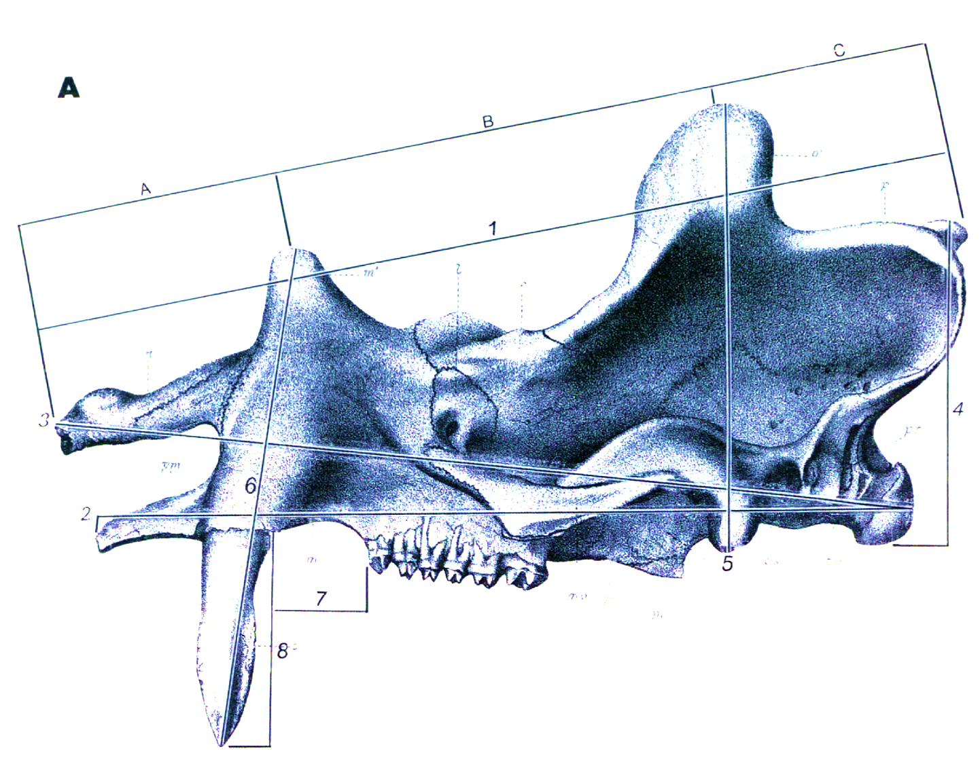

Figure 9. Selected skull measurements compiled by Turnbull (2002) which are shown on Uintatherium anceps (Form Turnbull, 2002).

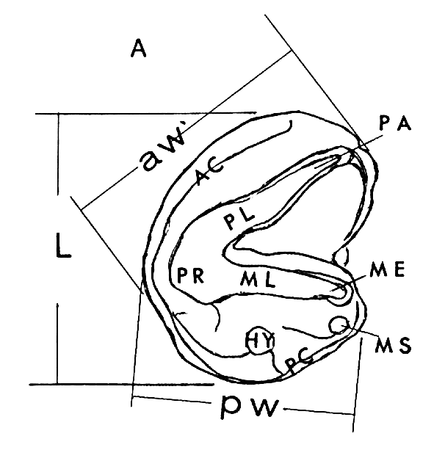

Figure 10. Three measurements: Length, Anterior Width, and Posterior Width applied to individual uintathere upper cheek teeth. Tooth Shown represents the general morphology of the upper molar 3 (M3). Abbreviations: aw greatest width through protoloph (PL); pw greatest width through metaloph (ML); L greatest length of tooth crown; cusps PR protocone, PA paracone, ME metacone, MS metastyle, HY hypocone, AC anterior cingulum, PC Posterior cingulum. (From Turnbull 2002).

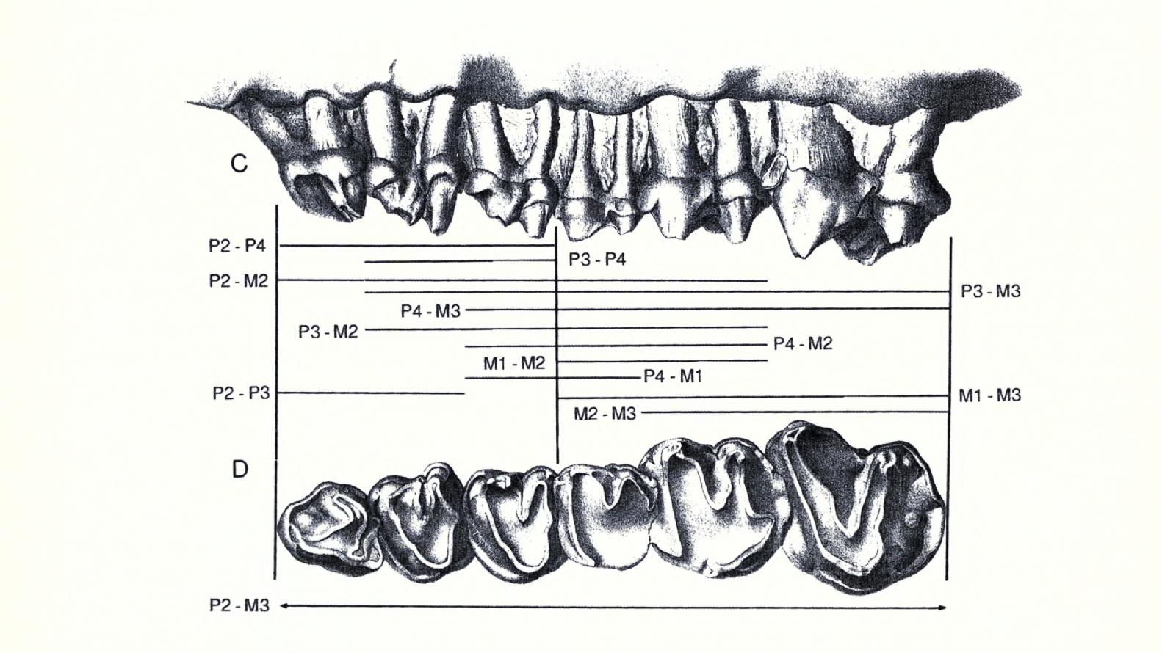
B
A
Figure 11. Tooth row measurements developed by Turnbull (2002) applied to the left upper cheek teeth of Uintatherium anceps shown in labial (A) and occlusal (B) views. (From Turnbull, 2002)

Systematic Paleontology
Order Dinocerata Marsh, 1872
Family Uintatheriidae Flower, 1876
Subfamily Uintatheriinae Wheeler, 1961
Uintatherium Leidy, 1872
Uintatherium anceps Marsh, 1871
Type species: Uintatherium robustum Leidy, 1872 = Titanotherium? anceps Marsh, 1871.
Synonyms: Titanotherium, Uintamastix, Loxolophodon, Tinoceras, Dinoceras, Eobasileus, Elachoceras
Holotype: (YPM 11030) Left glenoid fossa, partial squamosal, right parietal horn, partial parietal, partial occipital containing the posterodorsal wall of the braincase, left occipital condyle, four thoracic vertebrae, proximal end of left radius, and restored left tibia.
Distribution: Bridger Formation and Washakie Formation, middle Eocene of the Bridger and Washakie Basins, Wyoming. Uinta Formation, middle Eocene of the Piceance Creek Basin, Colorado. Questionably present in the lower part of the Sand Wash Basin, Colorado. Questionably present in the lower section of the Uinta Formation, middle Eocene, Uinta Basin, Utah. Questionably present in Santiago Formation, middle Eocene, of the Los Angeles Basin, California, questionably present in Devil's Graveyard Formation middle Eocene of the Tornillo Basin, Texas.
Revised Diagnosis: As in all uintatheres three pairs of horn-like protuberances on skulls, smallest of the large sized uintatheres, largest Uintatherium skull length may overlap with smallest Tetheopsis skull length, distinguished from other large uintatheres Eobasileus and Tetheopsis by position of protuberances. Parietal protuberance above or just anterior to postglenoid process. Parietal protuberance shifted anteriorly compared to Tetheopsis and Eobasileus. Maxillary protuberances positioned above diastema, just posterior pf the canine. Temporal fossa typically expanded posterodorsally. Premolars and molars with more developed and expansive anterior and posterior cingula Tetheopsis and Eobasileus.
Description
Skull – The nearly complete skull UCM 102271 (Figure 12) consists of a well-preserved right side containing the right maxillary and parietal protuberances and a complete zygomatic arch. The upper dentition is complete. The anterior portion of the skull is missing the nasals and a small portion of the anterior-most premaxilla. The ventral portion of the skull is broken near the pterygoid-basisphenoid boundary, missing the posterior basicranial region. The right side preserves the temporal fossa, which appears to extend to its most dorsoposterior point. The left side of the skull is incomplete, missing all three protuberances. Multiple bone fragments are associated with UCM 102271, including a portion of the right temporal preserving part of the external auditory meatus and ventral border of the temporal fossa. A distorted fragment contains the left postglenoid process and left occipital condyle. Other bone fragments may belong to the left temporal and parietal. Some of the associated fragments are far too large and thick to be pieces of the skull and are probably fragments of a limb bone. The skull contains many small fractures, a condition also observed in other uintathere skulls and may be the result of burial compression. The skull has been laterally compressed which is most evident on the dorsal side of the skull above the orbits. The lateral compression distorted the skull, moving the right side approximately a centimeter anterior relative to the left side. The lateral compression did not crush the dental palate, which has been slightly dorsally upturned from the rest of the skull. Nearly all uintathere skulls show some degree of distortion and that of UCM 102271 appears to be average amongst reported specimens.
The most noticeable feature of UCM 102271 is its small size. Its estimated skull length is 15% smaller than the mean for Uintatherium anceps skulls published in the literature. Whereas the tooth row length is about 6% smaller than the mean for Uintatherium anceps. The skull is confidently from a young adult specimen, given the fusion of skull sutures and early stages of dental waer. Following the skull ratios of Wheeler (1961) which are described in Materials and Methods, B/C is 2.5, and an estimated B/A is 2.4. The B/C ratio compares more favorably with Tetheopsis, while the B/A is much closer to the value observed in Uintatherium anceps.
The maxillary protuberance is well developed, circular in cross-section, and recurves posteriorly and slightly distally. The parietal protuberance is also well developed and rises vertically from the dorsal aspect of the skull. The dorsal apex of the parietal protuberance sits well above the maxillary protuberance and occipital crest. The high position of the parietal protuberance is mainly the result of the highly elevated occiput on UCM 102271, with only minor expansion of the parietal protuberance itself. The parietal protuberance is laterally elliptical in cross-section, and lacks the distinctive anterior ridge observed on most skulls of Uintatherium anceps. The temporal fossa of UCM 102271 is surprisingly shallow for Uintatherium and lacks the usually posterodorsal expansion diagnostic of the genus (Wheeler, 1961).
Dentition – The upper dentition (Figure 13) is complete, preserving both canines and cheek tooth rows. The labial margins of the left upper dentition are damaged. Both canines are long and protrude nearly 19 centimeters from the alveolus. It is possible the canine has been displaced about a centimeter out of the alveolus prior to fossilization. The damage on the left side of the skull reveals the alveolus of the left canine. The root of the canine terminates at the base of the maxillary protuberance, having a root length of 14 centimeters and an enamel crown length of 18 centimeters. The tips of the canines are lanceolate in shape and extend ventrally with minimal recurve.
The P2s are the smallest tooth and triangular in outline. The P3 and P4s are near equal in size are generally quadrate or slightly transversely rectangular in outline. The molars sequentially increase in size from the M1 to the M3 and are all quadrate in outline. In UCM 102271, the P2s are damaged and preserve no details of the occlusal surface. The P3s and P4s are subequal in length and width, with a slight transverse elongation. The molars (M1 – M3) are near equal in length and width. There are poorly developed hypocones posterior to the protocone on the P3 and P4. The anterior and posterior cingula are well developed except around the protocone where the cingulum nearly disappears. Slight wear facets have formed on the protoloph and metaloph of the P3 and P4.
The M1s are worn down to the dentine, leaving no trace of the protoloph and metaloph. Other uintathere researchers have noted far greater wear observed on the M1s of uintatheres compared to the other permanent dentition (Wheeler, 1961; Turnbull, 2002). Marsh (1886) suggested the unequal wear is the result of an earlier eruption of the M1s relative to the other permanent cheek teeth. Marsh’s assertion seems consistent with what other researchers have discovered in other large ungulates. For example, a similar unequal wear pattern matches the condition observed in fossil and modern Rhinocerotidae, where the eruption of the upper and lower molar M1 precedes the eruption of the other permanent premolars and molars (Böhmer et al., 2016). The morphology of the M2 and M3 are quite similar. The M3 does show an increase in anterior and posterior cingula width around the margins of the tooth compared to the M2. The M3 contains a molar fossa (Figure 19) at the lingual base of the metacone that borders the metaloph and causes a posterior deflection near the metacone. The M2s and M3s contain numerous small enamel crenulations, which form along the cingula, metacone, metaloph, and paracone. The M2 and M3 show only the slightest amount of wear.
Femur – A nearly complete left femur is associated with UCM 102271. A small dorsal portion of the greater trochanter is missing. The femur’s morphology matches that of the graviportal femora of other uintathere specimens, showing a robust femoral shaft, reduction of the greater and lesser trochanters, and a reduced neck of the femoral head. The overall morphology of uintathere femurs resembles that of the modern Elephantidae. The femur of UCM 102271 is 11% smaller in total length compared to the mean of Uintatherium anceps.
Pelvis - A fragmentary illium and left pubis also is associated with UCM 102271. The fragment contains the obturator foramen and pubic symphyseal region but is broken just anterior to the acetabulum. The fragment contains no features from which comparable measurements could be made with those published by Marsh (1886) and Turnbull (2002).

Comparisons to Uintatherium anceps, Tetheopsis, and Uintatherium? insperatus
FHPR 1151 Uintatherium anceps
FHPR 1151 is a nearly complete uintathere skeleton found in the Washakie Basin near Haystack Mountain south of Wamsutter, Wyoming (Turnbull, 2002). The associated skull has been significantly dorsoventrally flattened though adequate planar measurements from the dorsal and ventral side of the skull can be taken (Turnbull, 2002). The protuberances of the skull compare favorably with Uintatherium anceps as the maxillary protuberances are positioned above the canine-premolar diastema. FHPR 1151 differs in skull length and breadth considerably from UCM 102271, though FHPR 1151’s dorsoventral crushing may be exaggerating this feature. The skull length of FHPR 1151 matches the largest observed in Uintatherium anceps, whereas UCM 102271 matches the lowest observed skull length for the species. The region of the skull between the parietal horns and maxillary horns shows similar levels of anteroposterior elongation as UCM 102271. UCM 102271 differs from FHPR 1151 in having a much higher occiput, nasofrontal fossa, and small dome-like protuberances above the orbits. The estimated skull length of UCM 102271 is 26% smaller than FHPR 1151.

UW 13644 Tetheopsis sp.
UW 13644 is a skull identified as either Tetheopsis or possibly Eobasileus (Turnbull 2002). The skull was discovered from the lowest beds of the Upper Washakie Formation, Washakie Basin (Turnbull, 2002). UCM 102771 differs significantly in skull morphology from UW 13644. The skull of UW 13644 is anteroposterioly elongated and transversely shortened compared to UCM 102271 and other Uintatherium anceps (Figure 18). UCM 102271’s maxillary protuberances are positioned above the canine premolar diastema, well anterior of the orbits, while UW 13644’s maxillary protuberance is positioned above the orbits. The temporal fossa of UW 13644 is anteroposterioly shortened beyond that of UCM 102771. The postorbital region of UW 13644 is far more anteroposterioly elongated, moving the zygomatic-squamosal suture and post glenoid process further posterior relative to the M3. The dental measurements of UW 13644 exceed the maximum observed values of Uintatherium anceps supporting its placement in either Tetheopsis or Eobasileus. The estimated skull length and tooth row length of UCM 102271 is 11% and 16% smaller respectively than these measurements on UW 13644.

YPM 11036 (FHPR 50501) Uintatherium anceps
FHPR 50501 is a historic paper mâché cast of Marsh’s (1886) holotype of Dinoceras mirabile, which was synonymized with Uintatherium anceps by Wheeler (1961). This skeletal mount was given to the Field House Museum in Vernal, Utah by the Carnegie Museum. The skull of YPM 11036 is one of the most complete uintathere skulls known, and was a centerpiece in Marsh’s 1886 monograph on the Dinocerata. The specimen was collected from the Bridger D beds near Sage Creek Mountain in the Bridger Basin of Wyoming (Wheeler, 1961). The general morphology of the YPM skull, degree of anteroposterior elongation, and lack of transverse narrowing compare favorably with UCM 102771. However, UCM 102771 lacks the full extent of posterodorsal elongation of the temporal fossa observed in YPM 11036. Additionally, the occiput and parietal protuberances of UCM 102771 are expanded dorsally beyond that of YPM 11036. Further, UCM 102271 lacks the distinctive transverse ridge formed at the nasal-frontal suture and the anterior ridge of the parietal protuberance observed in YPM 11036. The zygomatic arch and postglenoid process are far more robust in UCM 102271. Lastly, UCM 102271 displays more anteroposterior elongation posterior to the orbits than YPM 11036. The estimated skull length and tooth row length of UCM 102271 is 14% and 5% smaller, respectively, than these measurements on YPM 11036.

UCM 51406 Uintatherium anceps
UCM 51406 is a fragmentary uintathere skull and the first uintathere fossil to be described from the Piceance Creek Basin (Schoch & Lucas, 1985). It was found in the lower Uinta Formation (Tu1) of Hail (1974). Schoch & Lucas (1985) identified the skull as Uintatherium anceps based on the position of the maxillary protuberances above the canine-premolar diastema. The maxillary protuberance of UCM 51406 is well developed, circular in cross section and recurves dorsally and is very similar in morphology and position to the maxillary protuberance observed in UCM 102271. Of interest is a diamond-shaped fossa between the maxillary protuberance and the nasal-frontal suture above the orbits. This small fossa was observed in UCM 102271, but was not present in the other specimens of Uintatherium anceps, YPM 11036 and FPHR 1151.

IVPP V6379 Uintatherium? insperatus from China
In 1978, a nearly complete uintathere skull IVPP V6379, identified as Uintatherium? insperatus, was discovered in the Lushi Formation of Hennan, China (Tong & Wang 1981). The position the skull’s protuberances compare favorably with UCM 102271 and other skulls of Uintatherium anceps. The protuberances of the Chinese uintathere are less developed than the average Uintatherium anceps and far less developed compared to UCM 102271. UCM 102271 and U.? insperatus share a shallow temporal fossa, and both skulls lack the posterodorsal expansion typically seen in Uintatherium anceps. However, UCM 102271 lacks the diagnostic arched nasofrontal ridge borne by U.? insperatus. Tong & Wang (1981) noted that a key feature of U.? insperatus is its small size, which is significantly smaller than Uintatherium anceps and more similar in size to Bathyopsis middleswarti, the potential predecessor of Uintatherium anceps from the lower Bridger Formation (Bridger A & B) of Wyoming (Wheeler, 1961). However, the horn development, horn positions and anteroposterior elongation of the skull more closely resembles the morphology of Uintatherium, and not Bathyopsis. The tooth row length of U.? insperatus is 13% smaller than UCM 102271 and 19% smaller than the mean of Uintatherium anceps; U.? insperatus is by far the smallest skull observed for Uintatherium. However, it is unclear if IVPP V6379 belongs in the genus Uintatherium and requires further study to support its generic placement.

10 cm
Diastema
Temporal Fossa
Occipital Crest
Postglenoid Process
Maxillary Protuberance (horn)
Parietal Protuberance (horn)
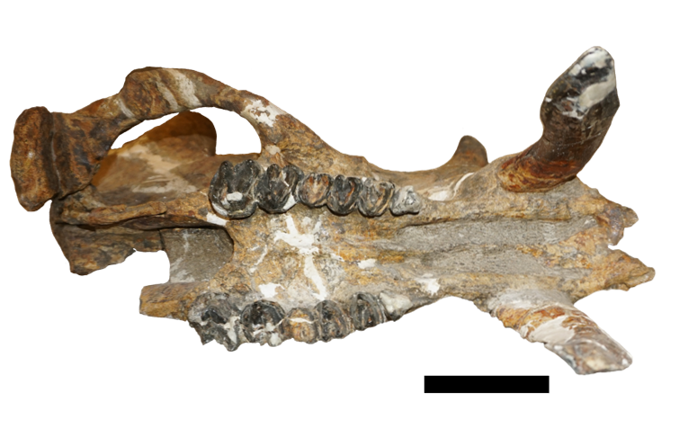
10 cm
Figure 12. Above: Right side lateral view of UCM 102271. Below: Ventral view of UCM 102271. Scale bars = 10 cm

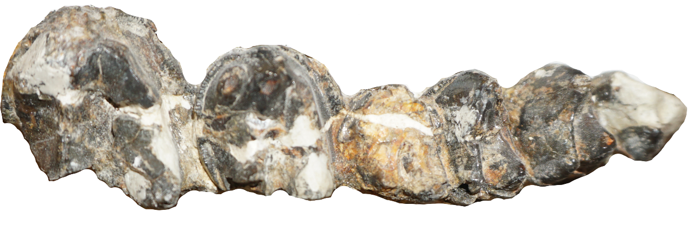
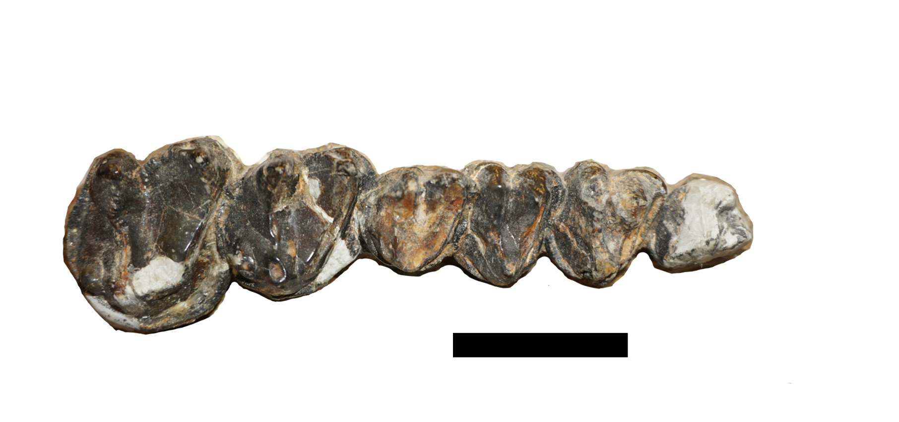
4 cm
Dentine
M3
M1
M2
P3
P4
P2

P2
P3
P4
M1
M2
M3

Figure 13. Upper right (above) and upper left (below) cheek tooth rows (P2 to M3), Anterior to the right. Scale bar = 4 cm.

Results
Table 1. Cheek Tooth Row Measurements of UCM 102271. P=premolar, M=molar, see Figure 11 in Materials and Methods for explanation on measurements and abbreviations.

Cheek Tooth Row Measurements (Cm) | Right | Left
P2 – M3 | 14.3 | 14.7
P3 – M3 | 12.5 | 12.8
P4 – M3 | 10.3 | 10.4
P2 – P4 | 6.1 | 6.6
P2 – P3 | 4.1 | 4.5
P2 – M1 | 8.2 | 8.3
P2 – M2 | 11.0 | 11.2
P3 – P4 | 4.3 | 4.3
P3 – M2 | 9.2 | 9.1
P3 – M1 | 6.4 | 6.2
P4 – M1 | 3.9 | 4.0
P4 – M2 | 7.1 | 7.1
M1 – M3 | 8.1 | 8.9
M1 – M2 | 5.2 | 5.1
M2 – M3 | 6.6 | 6.9

Table 2. Individual Tooth Measurements of UCM 102271. P=premolar, M=molar, L= length, AW= anterior width, PW=posterior width. see Figure 10 in Materials and Methods for explanation on measurements and abbreviations.

Tooth Measurements  (cm) | Right | Left
CL | 5.3 | 5.8
CW | 2.7 | 2.7
P2L | 2.2 | 2.3
P2AW | 1.8 | 2.3
P2PW | 2.0 | 2.2
P3L | 2.2 | 2.0
P3AW | 2.7 | 2.7
P3PW | 2.6 | 2.6
P4L | 2.1 | 2.1
P4AW | 2.7 | 2.8
P4PW | 2.6 | 2.8
M1L | 2.1 | 2.1
M1AW | 2.4 | 2.7
M1PW | 2.2 | 2.2
M2L | 2.9 | 2.9
M2AW | 3.3 | 3.2
M2PW | 2.8 | 2.9
M3L | 3.3 | 3.4
M3AW | 4.1 | 4.2
M3PW | 3.6 | 3.3

Table 3. Skull Measurements of UCM 102271, see Figure 9 in Materials and Methods for explanation on measurements and abbreviations. * Estimated.

Skull Measurements (cm)
Total length of skull from nasals to occipital crest | 64*
Width of palate between last molars | 5.7
Width of palate between first molars | 6.8
Width of palate between first premolars | 5.8
Width of palate across diastema | 6.6
Width of palate between canines | 7.5
AP diameter of zygomatic fossa | 16.8
Transverse diameter of zygomatic fossa | 7.8
Distance from top of parietal protuberance to end of postglenoid process | 36.4
Distance from top of maxillary protuberance to end of canine | 40.5
Diastemal length | 5.8
Length of canine from alveolar border to tip | 17.3

Discussion
Principal Component Analysis: Exploring the Usefulness of Uintathere Morphometric Measurements
Exploratory Principal Component Analyses (PCA) were performed on the morphometric datasets to evaluate the potential taxonomic usefulness of Marsh’ (1886) and Turnbull’s (2002) multitude of measurements. PCA was chosen to narrow down the high number of measurement variables defined by Turnbull (2002). UW 13644 (Tetheopsis sp.) and BMUW 592041 (Eobasileus cornutus) consistently fell well beyond the principal component value distributions of Uintatherium anceps for both tooth row and individual tooth measurement. Interestingly, the other specimen of Tetheopsis, YPM 11041 (Tetheopsis ingens) and PUM 10079 (Tetheopsis speirianus) fell within the principal component values distributions for Uintatherium anceps. However, the horn placement and anteroposterior elongation of the skull support the current taxonomic placement for these specimens in Tetheopsis. Given UCM 102271’s small size and maxillary horn placement above the diastema, as well as its grouping near the main distribution of other Uintatherium anceps specimens during PCAs, UCM 102271 is confidently placed within the genus Uintatherium. The specimens of Eobasileus and Tetheopsis were removed so further PCAs could focus solely on the variation within Uintatherium anceps. Preliminary analysis revealed canine measurements were far more variable than any other measurement, masking the distributions of the other variables. As canine variations are a well-known sexually dimorphic character in large ungulate mammals (Mihlbacher, 2008), they were removed for the final analysis of individual tooth measurements to enhance the analyses of variation amongst the cheek teeth.
The PCA of Uintatherium anceps tooth row lengths (Figure 14) revealed that the P2-M3 (total cheek tooth row), P2– M2, and P3 – M3 contained the most variance in the tooth row dataset. While large variance values do not necessarily correlate directly to characters of biologic significance, a reasonable hypothesis would expect high levels of variance between two or more groupings of distinctive taxa (Davis, 2002). The biplot directions of these three variables are nearly orthogonal, meeting at an angle of about 80 degrees. In PCA biplots, two variables which show no correlation will meet at an orthogonal angle in a biplot, and if the angle is less than 90 degrees they are positively correlated, while an angle greater than 90 degrees implies the variables are negatively correlated (Jolliffe, 2002). Little to no positive or negative correlation between these three measurements is surprising, as all three variables capture all of or a large portion of the tooth cheek tooth row length. As such, the three variables might be expected to be positively correlated based upon overall length. Such a relationship may be the result of space constraints of the uintathere’s distinctively small palate. Potentially either the premolar series or molars consistently fills the available space, when one or the other is smaller than expected. The vast majority of the variance in the dataset is explained by the P2 – M3 measurement. This is interpreted by the wide spread along the first component axis compared to the second component axis. This is evidence that size is the strongest driver of tooth row measurement variations within Uintatherium anceps. UCM 102271 received the most negative principal component score for the cheek tooth row length (P2 – M3). This result stems from UCM 102271 having the smallest observed value for the P2 – M3 measurement, thus producing the greatest amount of negative variance.
The PCA analysis for the individual tooth measurements (Figure 15) revealed that the third upper molar length (M3L) and third upper molar width (M3AW) contained the greatest variance within the total dataset. Since the M3 is not constrained by an additional posterior tooth, the high level of variance is expected given the tooth’s ability to expand posteriorly. I suspect the high variance in the anterior width of the M3 is derived from varying expansions of the anterior and posterior cingulum surrounding the M3. The anterior width measurements of Turnbull (2002) consistently showed higher levels of variance than the posterior width measurements. It is unclear what anatomical feature is driving this discrepancy, though the answer may lie again in variable amounts of cingula width expansion or that the protoloph varies in transverse width more than the metaloph. UCM 102271’s strong negative component scores are the result of its smaller measurements compared to other specimens of Uintatherium anceps. Two bivariate plots are presented below based upon the PCAs. The first bivariate plot (Figure 16) is of the first upper molar (M1) and the anterior width of this tooth (M1AW). These measurements shared a low variance in the dataset of Uintatherium anceps. The unusually small M1 of UCM 102271 is highlighted in this plot. The second bivariate plot (Figure 17) is of the most variable measurements, the upper molar 3 (M3) and the anterior width of the upper molar 3 (M3AW). The unexpectedly high value of UCM 102271’s M1AW is the result of the previously noted character, the anterior lingual expansion of the M3 anterior cingulum.

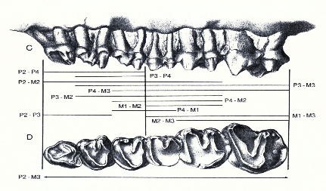
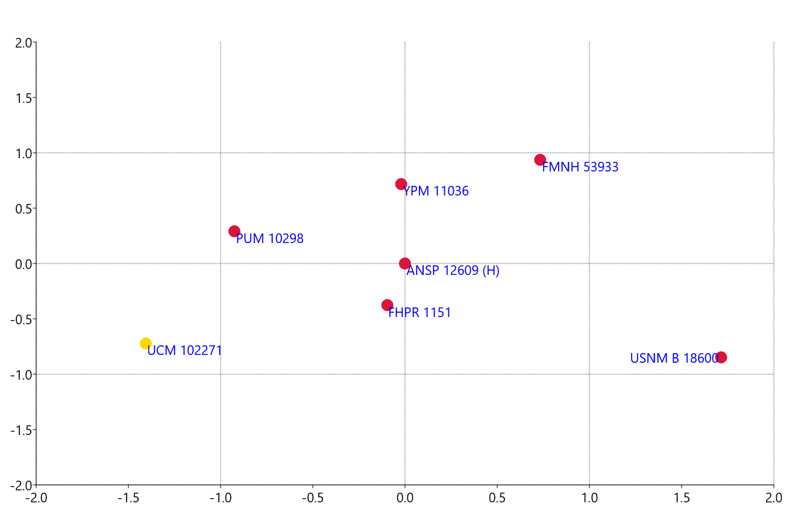
Component 2
Component 1
P2 – M3

P3 – M3
P2 – M2

Figure 14. PCA of Turnbull’s (2002) tooth row measurements. Principal Component 1: eigenvalue = 1.263, % Variance = 55.5. Principal Component 2: eigenvalue = 0.572, % Variance = 25.1. (H) – Holotype of Uintatherium robustum.

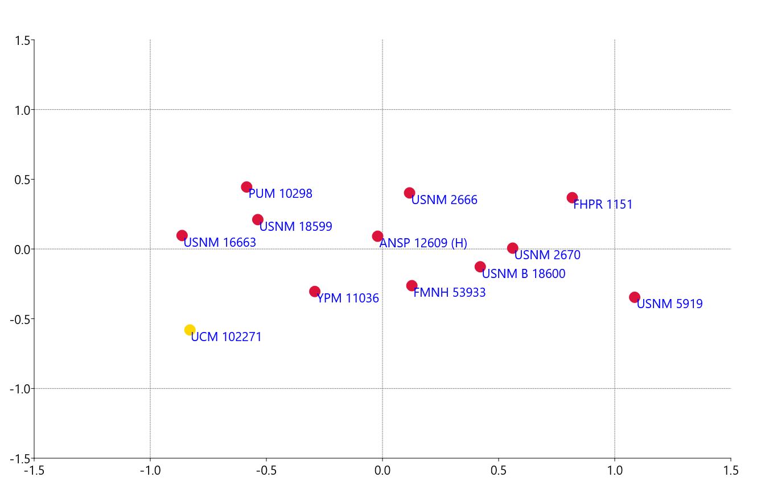
Component 2
Component 1
M3 AW
M3 L

Figure 15. PCA of Turnbull’s (2002) individual tooth measurements. Principal Component 1: eigenvalue = 0.411, % Variance = 51.6. Principal Component 2: eigenvalue = 0.108, % Variance = 13.6.

Figure 16. Bivariate plot of the M1 length (x-axis) and the M1 anterior width (y-axis).

Figure 17. Bivariate plot of the M3 length (x-axis) and the M3 anterior width (y-axis).

Distinguishing the genera of Uintatheres
Wheeler’s (1961) skull ratios (Figure 2 in Introduction) provided an excellent contribution towards the understanding of uintathere taxonomy, even if the ratios alone are a bit simplistic. The skull ratios successfully whittled down the chaos of nine genera named by Leidy, Marsh, Cope, Osborn and Cook to just three. Wheeler’s ratios captured the distinctive anteroposterior (AP) elongation of the skull observed in Tetheopsis and Eobasileus and differentiate the genera from Uintatherium (Figure 18). Size overlap among the genera makes measurement discrimination alone unreliable. UCM 102271 represents a case that begins to break down the ratios of Wheeler (1961), as the B/C ratio overlaps with both Tetheopsis and Eobasileus and is beyond the previous range observed for Uintatherium (Figure 2). It is worth noting that Wheeler’s B/A ratio does sufficiently discriminate between Uintatherium and Eobasileus, but does not discriminate consistently between Uintatherium and Tetheopsis. From my observations of UW 13644 identified as Tetheopsis sp. there is clear evidence of relative AP elongation and transverse shortening in the skull of Tetheopsis, particularly in the nasals, frontals, maxillae, and basicranial region (Figure 18). This condition was described by Lucas and Schoch (1998) as “skull long and narrow”. In addition, horn position distinguishes Uintatherium and Tetheopsis. In Uintatherium, the parietal horns are positioned above the postglenoid process and the maxillary horn is positioned above the diastema just posterior of the canine tusk. In Tetheopsis the parietal horns are positioned behind the postglenoid process. Identifying these morphological characters of the skull provides a more confident means to differentiate between Uintatherium and Tetheopsis than Wheeler’s (1961) ratios. No specimens of Eobasileus were available for comparison in this study, but descriptions from Turnbull (2002) and the phylogeny of Lucas and Schoch (1998) suggests that Eobasileus shares parietal horns positioned behind the postglenoid process and AP elongation with Tetheopsis.

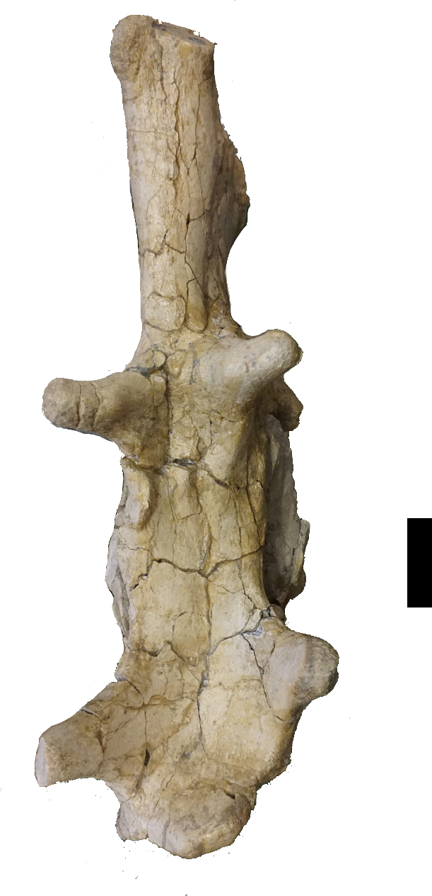
10 cm
Parietal Protuberance (horn)
Parietal Protuberance (horn)
Maxillary Protuberance (horn)
Nasal Protuberance (horn)

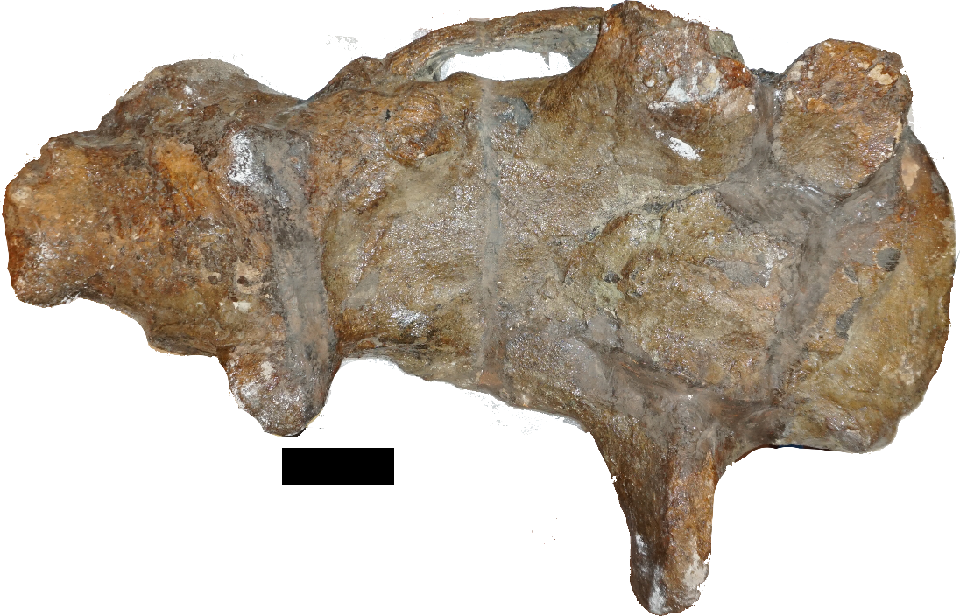
Maxillary Protuberance (horn)
Nasal Protuberance (horn)
Figure 18. Comparison of the Uintatherium and Tetheopsis skulls. Blue arrows point to anterior and posterior portions of the skull which displays AP elongation and transvers shortening in Tetheopsis and the relatively broad condition of Uintatherium. Above: UW 13644 Tetheopsis sp. in dorsal view. Below: FHPR 1151 Uintatherium anceps in dorsal view. Scale bar = 10 cm

Intraspecific Variation in Uintatherium anceps
In paleontology, species level taxonomy can be a subjective process, with authors establishing new species on the basis of size or minor morphologic differences, despite the expectation for variance in size and shape in all species. Comparing UCM 102271 with other Uintatherium anceps skulls identified a few potential species level characters that might be useful for determining the presence of a new species within Uintatherium anceps. The characters include: M3 with metacone molar fossa, M3 anterior lingual anterior cingulum expansion, temporal fossa without posterodorsal expansion, presence of a nasal-frontal fossa, and dorsal expansion of the occiput. These characters in combination with UCM 102271’s smaller than average or smallest observed measurement values might suggest the presence of another species of Uintatherium.
As no two fossils are alike, caution must be applied with species level characters and requires the differentiation of tokogenic character variation (sexual dimorphism, ontogeny, and natural population variations) and phylogenetic character variation (species differences) (Mihlbachler, 2008). Unfortunately, no locality has been discovered which contains more than one uintathere skull, which would potentially aid in the identification of tokogenic variation. Fortunately, multiple brontothere mass death assemblages, including the taxa Metarhinus sp., Duchesneodus uintensis, and Megacerops coloradensis, have been recognized (Mihlbachler, 2008; Turnbull and Martill, 1988). Brontotheres are an extinct group of large perissodactyl ungulate that lived during the Eocene Epoch, going extinct at the Eocene-Oligocene boundary (Mihlbachler, 2008). Similar to uintatheres, brontotheres are notable for their bony nasal protuberances and large body size, matching that of extant rhinos and elephants (Mihlbachler, 2008). The morphologic similarities between uintatheres and brontotheres suggests they may have shared a similar ecological niche, making brontotheres potentially useful evolutionary analogs. Mihlbachler (2008) examined the brontothere death assemblages and identified the following tokogenic characters: premolar morphology, the size and presence of the M3 hypocone, canine size, horn size and shape, and overall skull robusticity. These last three characters were primarily used in the early identification of uintathere species and should be considered unreliable indicators of interspecific variation (Marsh, 1886; Scott, 1886).
Mihlbachler et al. (2004) argued that canine size, horn size and shape, and overall skull robusticity represent sexually dimorphic characters in brontotheres. Wheeler (1961) and Turnbull (2002) similarly suggested these traits as sexually dimorphic indicators for uintatheres as well. UCM 102271’s well-developed horns, large canines and robust skull (enlarged zygomatic arch and postglenoid process) suggest it belongs to a male Uintatherium anceps. The larger skulls of U. anceps (largest values for total skull length) typically share these potential male tokogenic characters. This makes the small size of UCM 102271 intriguing. UCM 102271 shares morphometric similarity to the smallest observed skulls of Uintatherium anceps, AMNH 1693 and PUM 10298 (Figure 20). Wheeler (1961) and Turnbull (2002) interpreted both skulls as female given their smaller than average size and poor horn development. Based on horn morphology, UCM 102271 is similar skulls of Uintatherium anceps identified as male, but is smaller (about 10%) than those male skulls collected from the Washakie and Bridger Basins. This suggests the uintatheres of the Piceance Creek Basin are smaller than their Wyoming counterparts. What is needed to test this hypothesis is the discovery of an even smaller skull of Uintatherium anceps with characters suggestive of a female skull (e.g., smaller horns) from the Piceance Creek Basin.

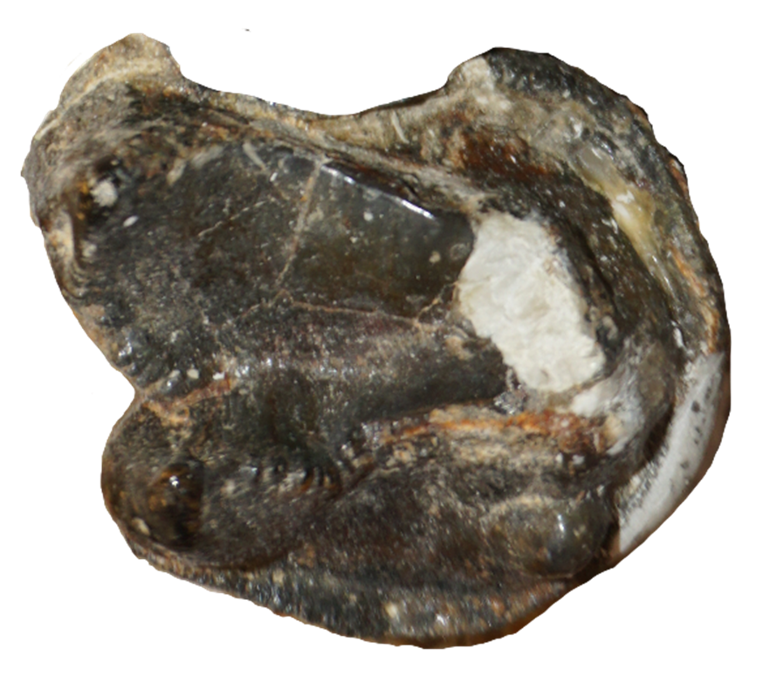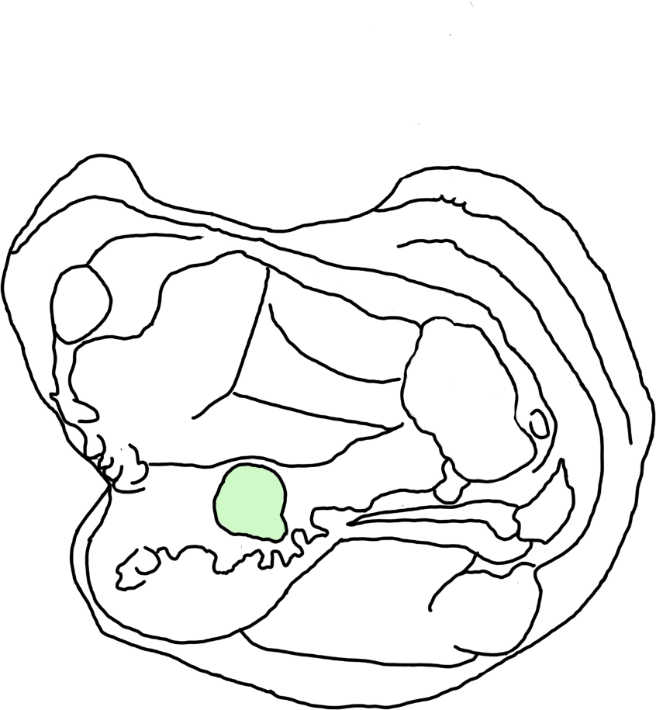
2 cm
Lingual expansion of anterior cingulum
Molar fossa
Figure 19. Above: UCM 102271, a right M3 showing the lingual expansion of the anterior cingulum and molar fossa at base of metacone. Below: Outline drawing of M3, molar fossa in green. Scale bar = 2cm
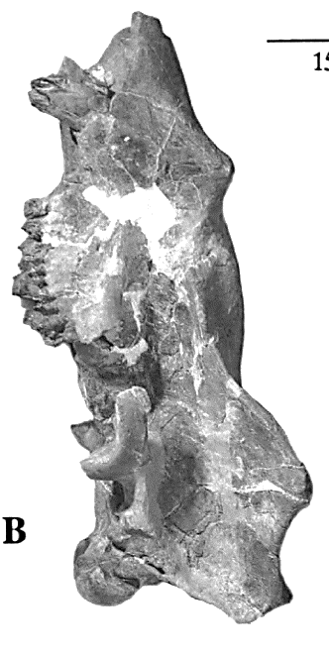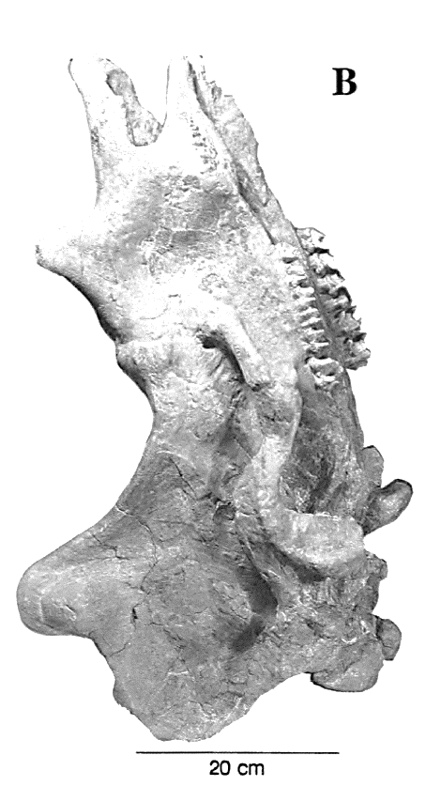
10 cm
10 cm
10 cm
Figure 20. Comparison of the three smallest Uintatherium anceps skulls. A: UCM 102271, a probable male with well-developed parietal and maxillary horns and thicken zygomatic arch and postglenoid process, TSL estimated = 64 cm. B: PUM 10298, a potential female skull with very poorly developed horns, TSL = 68 cm. C: AMNH 1693: another probable female given the smaller than average horn sizes, TSL = 69 cm. Scale bars = 10 cm

B

C

A
Biostratigraphic Implications of UCM 102271
The identification of UCM 102271 as Uintatherium anceps confirms the assertion of Schoch & Lucas (1985) of the species’ presence in the Piceance Creek Basin, Colorado. Gunnell et al. (2009) identified the earliest occurrence of Uintatherium anceps within the Bridgerian 3 (Br3) biochron interval (Bridger C and D of Matthew (1909) and Osborn (1929) (Figure 21) of the Bridger Basin. Gunnell et al. (2009) stated Uintatherium anceps ranges through the Uintan 1a (Ui1a) and the Uintan 1b (Ui1b), which are two late intervals of the middle Eocene. The final occurrence of Uintatherium anceps is less clear. The Uintatherium anceps fossils discovered higher in the section are fragmentary and lack key diagnostic skull elements (Wheeler, 1961). The appearance of the additional large uintatheres Tetheopsis spp. in the late Br3 and Eobasileus cornutus in the Ui1b further complicates correct taxonomic identification. Gunnell et al. (2009) marked the last occurrence of Uintatherium anceps within the Uintan 2 (Ui2) biochron. However, I was unable to find any described fossils of Uintatherium anceps in the literature from the Ui2 biochron. The stratigraphically highest described specimens of Uintatherium anceps by Wheeler (1961) are from Bridger D (questionably Bridger E), Washakie A, and Uinta A. Turnbull (2002) echoed this statement, adding Uintatherium anceps is only present in the lower section of the Washakie Formation (Br3 to Ui1a). It is possible that the stratigraphically highest occurrence of Uintatherium anceps occurs during the Ui1a, and the purported occurrences in Ui1b and Ui2 are misidentified fossils of Tetheopsis spp. or Eobasileus cornutus. Tetheopsis is known only from the Washakie Basin and occurs in both the upper and lower zones of the Washakie Formation (Twka1 and Twka2 respectively). Eobasileus cornutus occurs in only the upper zone of the Washakie Formation (Twka2) of the Washakie Basin, Uinta B of the Uinta Basin and the upper portion (Twka 2 equivalent) of the Sand Wash Basin (Wheeler, 1961; Turnbull, 2002). These occurrences suggest Uintatherium anceps temporally overlapped only with Tetheopsis. However, it is strange that no other Tetheopsis specimens have been found in the Bridger Basin or Piceance Creek Basin suggesting the local units pre-date the appearance of Tetheopsis. A review of the uintathere material from the Uintan biochrons would shed further light on whether Uintatherium anceps did coexist with both Tetheopsis and Eobasileus and provide clearer evidence for the last occurrence of Uintatherium anceps.
UCM 102271 and UCM 51406 indicate Uintatherium anceps is present between Tongue 1 and Tongue 9 of the 13 Uinta Formation tongues within the Piceance Creek Basin. These occurrences suggest correlation of the majority, or potentially all, of the Uinta Formation of the Piceance Creek Basin to the Bridger Formation C to E of the Bridger Basin, the lower section of the Adobe Town Member of the Washakie Formation in the Washakie Basin. To date there is no evidence of the other genera Tetheopsis or Eobasileus from within the Piceance Creek Basin, which suggest the local Uinta Formation in the PCB is older than their first appearances (Ui1 and Ui2 respectively). These findings are consistent with Smith’s et al. (2008) composite age model that suggests the Uinta Formation in the Piceance Creek Basin was deposited during the middle Eocene between the absolute age range of 48.5 Ma and 47.3 Ma (Smith et al. 2008).


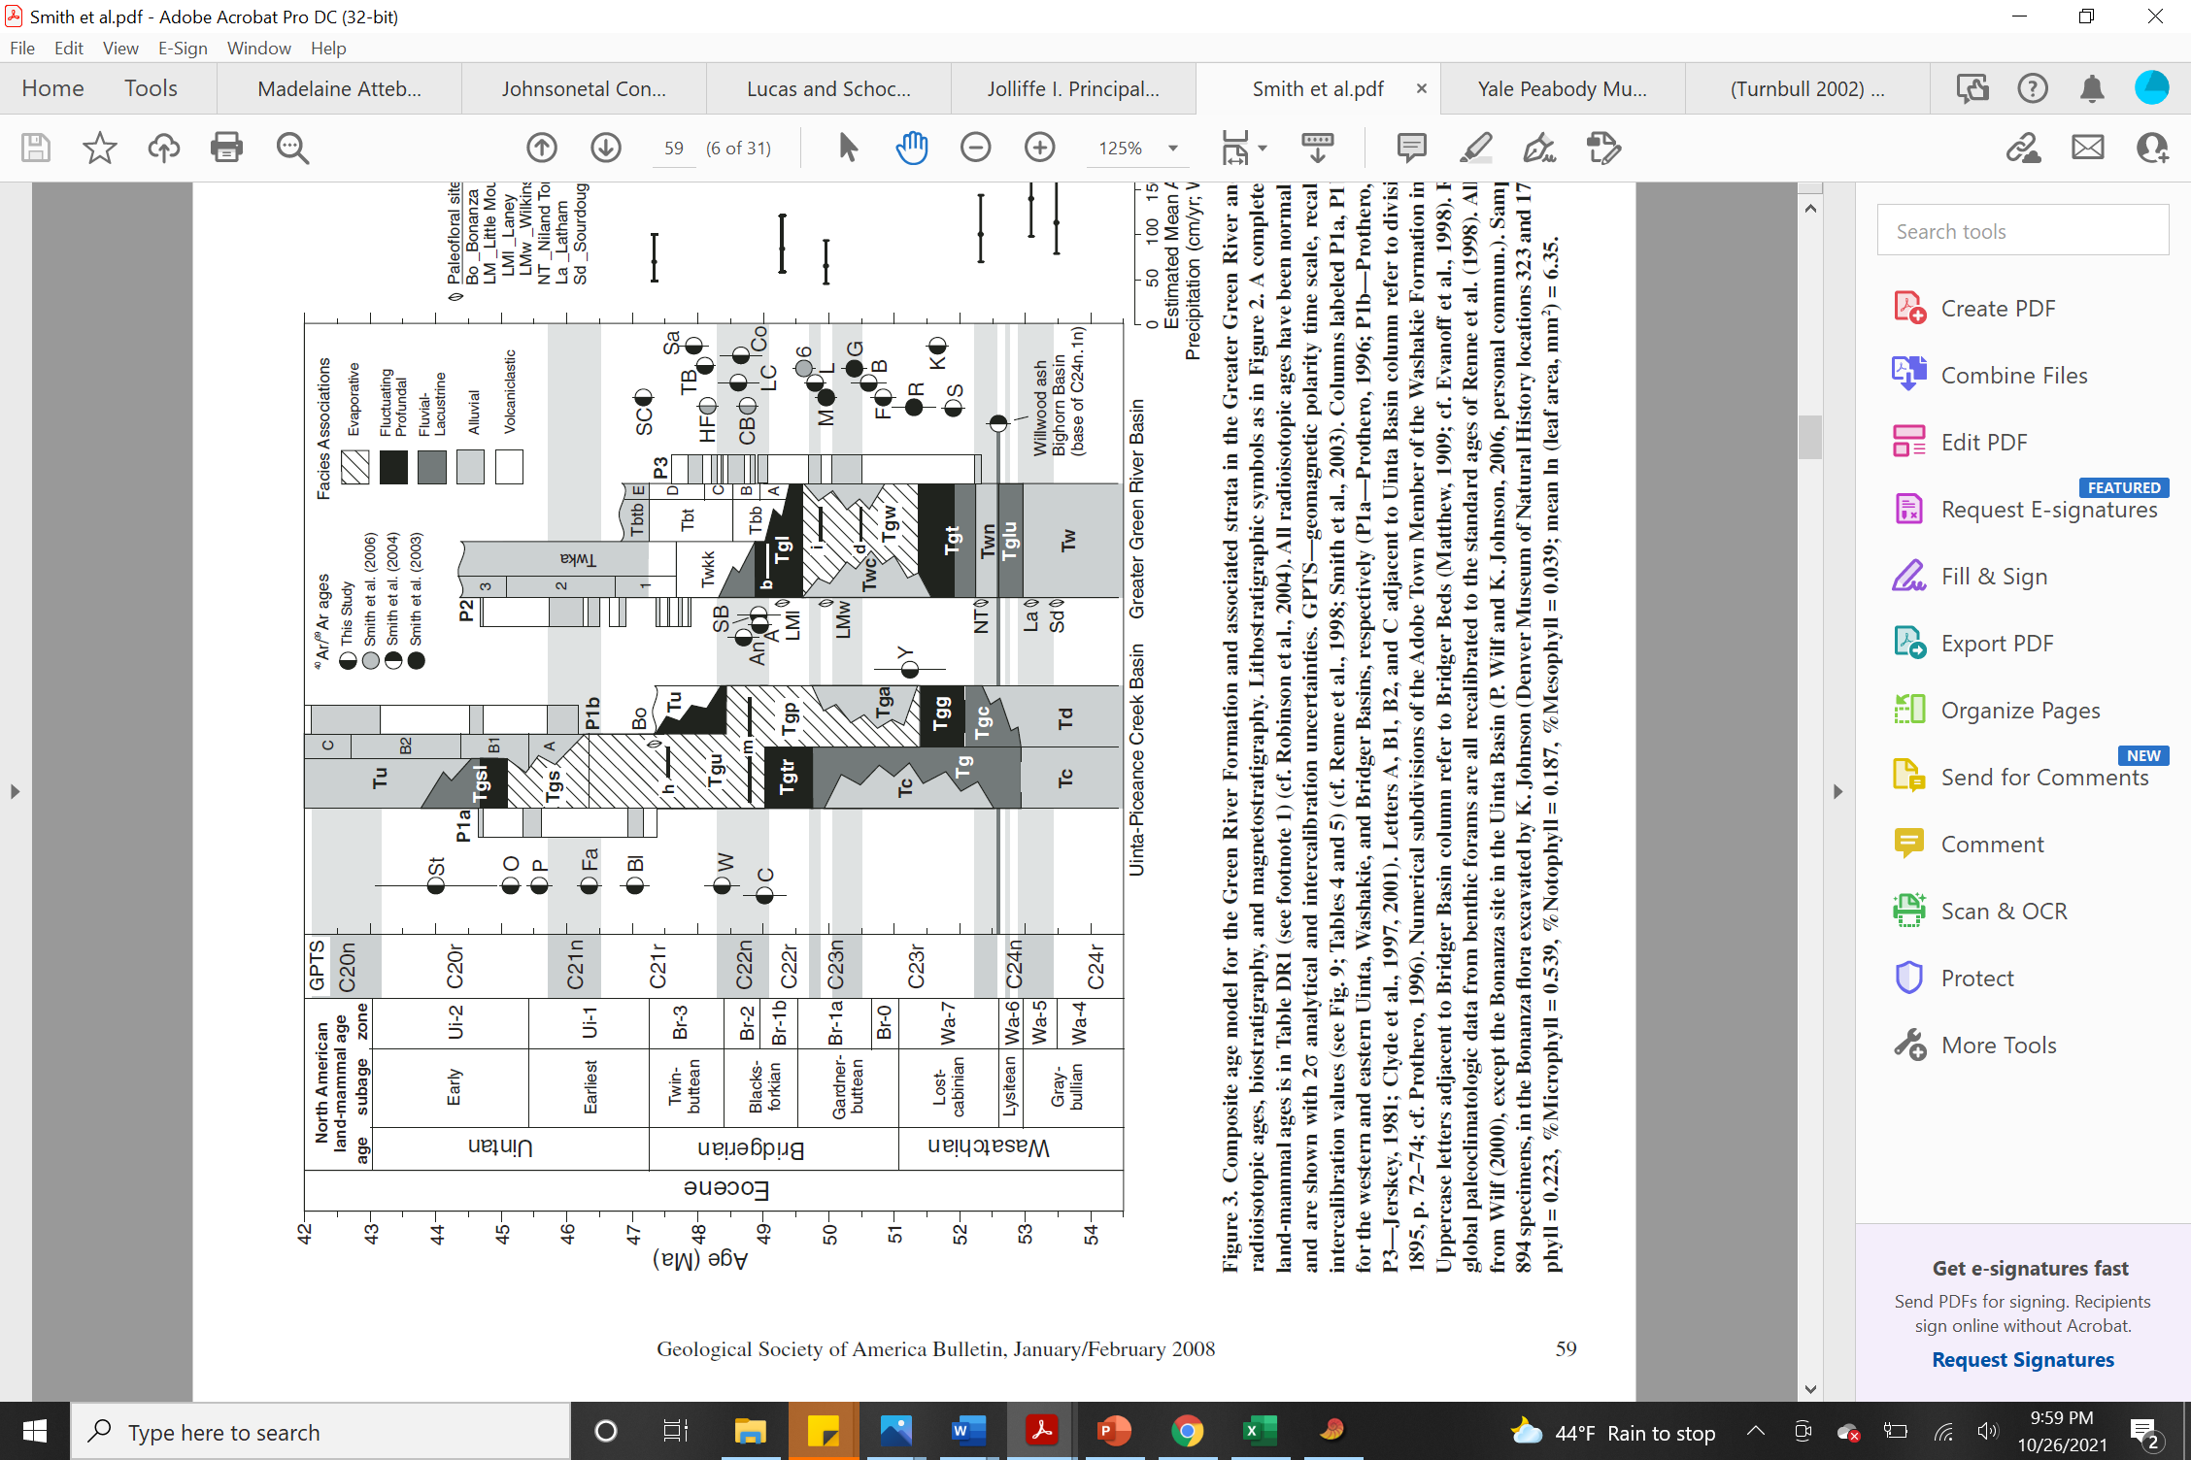
Figure 21. Composite Stratigraphic Columns for the four Laramide structural and depositional basins of the Rocky Mountain Region. Red arrow: relative stratigraphical position of UCM 102271. Yellow highlights mark the large uintathere bearing formations. Occurrence estimates: Blue – Uintatherium anceps, Orange – Tetheopsis spp., Green - Eobasileus cornutus. Tb – Bridger Formation, Twk – Washakie Formation, Tu – Uinta Formation (From Smith et al. 2008)
Conclusions
UCM 102271 is identified as Uintatherium anceps. Generic classification is based upon position of the maxillary horn above the diastema, parietal horns above the postglenoid process, lack of anteroposterior elongation and transverse shortening of the skull. These characters provide a more reliable generic identification compared to Wheeler’s (1961) skull ratios. Assignment to species follows the current acceptance of a single highly variable species Uintatherium anceps. The inclusion of UCM 102271 in Uintatherium anceps further increases the breadth of variation observed within this species. UCM 102271 represents one of the smallest known specimens of Uintatherium anceps. UCM 102271’s measurements compare more favorably with skulls identified by Marsh (1886), Wheeler (1961) and Turnbull (2002) as potential female and juvenile skulls. However, the well-developed horns and large canine tusks suggest that UCM 102271 is a male. The skull is of a young adult based upon a lack of visible sutures and early wear of the cheek teeth. This new skull indicates that Uintatherium anceps in the Piceance Creek Basin are smaller than the specimens known from the Washakie and Bridger Basins of Wyoming.
The variation in size and morphology within Uintatherium anceps appears to be greater than what is usually accepted for many fossil mammal species. However, no diagnostic characters have yet successfully established discrete taxa within Uintatherium anceps, although the group suffers from a general paucity of recent research studies. The fragmentary nature of the holotype specimen of Uintatherium anceps further complicates identifying and establishing diagnostic characters. A species-level revision and redescription of Uintatherium anceps is essential for future taxonomic studies of North American uintatheres.

References
Bilbey, S. A., Hall, J. E., Monaco, P. E., Robinson, P. R., and Hall, Q. W. (2010). Paleontological Final Report, Rio Blanco County, Colorado.
Birgenheier, L. and Vanden Berg, M. (2011). Core-Based Integrated Sedimentologic, Stratigraphic, and Geochemical Analysis of the Oil Shale Bearing Green River Formation, Uinta Basin, Utah. United States.
Böhmer, C., Heissig, K., and Rössner, G. (2016). Dental Eruption Series and Replacement Pattern in Miocene Prosantorhinus (Rhinocerotidae) as Revealed by Macroscopy and X-ray: Implications for Ontogeny and Mortality Profile. Journal of Mammalian Evolution.
Burger, B. J. (2009). Mammalian faunal change across the Paleocene-Eocene boundary in the Piceance Creek Basin, western Colorado (Doctoral dissertation, University of Colorado at Boulder).
___________(2015). The systematic position of the saber-toothed and horned giants of the Eocene: the uintatheres (Order Dinocerata). Society of Vertebrate Paleontology 75th Annual Meeting. Meeting Program and Abstracts p.99.
Cashion, W.B., and Donnell, J.R. (1974). Revision of nomenclature of the upper part of the Green River Formation, Piceance Creek basin, Colorado, and eastern Uinta basin, Utah, IN Contributions to stratigraphy: U.S. Geological Survey Bulletin, 1394-G, p. G1-G9.
Cook, H. J. (1926). A new genus of uintatheres from Colorado. Colorado Museum of Natural History
Proceedings, 6: 7-11.
Cope, E. D. (1872a). Notice of proboscidians from the Eocene of southern Wyoming. Proceedings of the American Philosophical Society, 12, 580.
_________(1872b). Notices of new Vertebrata from the upper waters of Bitter Creek, Wyoming Territory. Proceedings of the American Philosophical Society, 12, 487-8.
_________(1885). The genera of Dinocerata. American Naturalist, 19, 594.
Davis, J. C. (2002). Statistics and data analysis in geology (third edition). John Wiley and Sons, New York, 638 pp.
Dorr, J. A., Jr. (1958). Prounitatherium: new uintathere genus earliest Eocene, Hoback Formation, Wyoming, and the phylogeny of the Dinocerata. Journal of Paleontology, 32, 506-16.
Duncan, D.C. (1976). Preliminary geologic map of Greasewood Gulch Quadrangle, Rio Blanco County, Colorado. USGS Publications Warehouse. DOI: 10.3133/mf755
Flerov, K. K. (1952). New Dinocerata from Mongolia (in Russian). [Prodinoceratidae; Gobiatheriinae].
Doklady Akademiya Nauk SSSR, 86: 1029-1032.
Flower, W H. 1876 (1873). Professor Flower's Hunterian lectures on the relation of extinct to existing
Mammalia. Part IV Nature, 13: 387-388.
Franczyk, K.J., Fouch, T.D., Johnson, R.C., Molenaar, C.M., and Cobban, W.C. (1992). Cretaceous and Tertiary paleographic reconstructions for the Uinta-Piceance basin study area Colorado and Utah: U.S. Geological Survey Bulletin 1787–Q, 37 p.
Gunnell, G. F., Murphey, P. C., Stucky, R. K., Townsend, K. B., Robinson, P., Zonneveld, J. P., ... & Albright, L. B. (2009). Biostratigraphy and biochronology of the latest Wasatchian, Bridgerian, and Uintan North American land mammal “ages”. Museum of Northern Arizona Bulletin, 65, 279-330.
Hutchison, J. H. (1971). CF Uintatherium (Dinocerata, Mammalia) from the Uintan (Middle to Late Eocene) of Southern California. PaleoBios, 12: 1-8.
Leidy, J. (1872a). On some new species of fossil mammalia from Wyoming. Academy of Natural Science, Philadelphia, Proceedings, 1872: 169.
_______(1872b). The above reprinted in September 1872, American Journal of Science.
_______(1872c). Remarks on fossil mammals from Wyoming. Academy of Natural Science, Philadelphia, Proceedings, 1872: 240-242.
_______(1873). Contributions to the Extinct Vertebrate the camelid brain. American Naturalist, 105: 227-239. Fauna of the Western Territories: United States Geological (Hayden) Survey Territories Report, Part 1: 1- 358, Pis. 1-37. For uintatheres pp. 93-109; 331-334; Pis. XXV
Jolliffe, I. T. (2002). Graphical representation of data using principal components. Principal component analysis, 78-110.
Johnson, R. C. (1985). Early Cenozoic history of the Uinta and Piceance Creek basins, Utah and Colorado, with special reference to the development of Eocene Lake Uinta: in Flores, R.M., and Kaplan, S.S., eds., Cenozoic paleogeography of the west central United States: Rocky Mountain Section, Society of Economic Paleontologists and Mineralogists, Rocky Mountain Paleogeography Symposium 3, p. 247-276.Leidy, J. (1872). On some new species of Mammalia from Wyoming. Proceedings of the National Academy of Sciences, Philadelphia, 1872, 167-9.
Johnson, R. C., Mercier, T.J., Brownfield, M. E., Pantea, M. P., and Self, J. G. (2010). An Assessment of in-place oil shale resources in the Green River Formation, Piceance Basin, Colorado. Chapter 1 of 7, Oil Shale and Nacholite Resources of the Piceance Basin, Colorado, U.S. Geological Survey Digital Data Series DDS–69–Y.
Johnson, R., Birdwell, J., Brownfield, M., Mercier, T., Hansley, P. (2019). Connections between Eocene Lakes Uinta and Gosiute with emphasis on the infilling stage of Lake Uinta in Piceance Basin. Mountain Geologist. 56. 143-183.
Kay, J. L. (1934). The Tertiary formations of the Uinta Basin, Utah: Carnegie Museum Annals , v. 23 p. 357-371.
Lucas, S. G. and Schoch, R. M. (1998). Dinocerata. In C. M. Janis, K. M. Scott, and L. L. Jacobs (eds.), Evolution of Tertiary Mammals of North America, 1, 284-291.
Madole, R. F., and Streufert, R. K., 2003, Geology of the Gibson Gulch quadrangle, Garfield County, Colorado: Colorado Geological Survey Open-File Report 01-2, 18 p. Colorado Geological Survey.
Masterson, M. E. (2016). Hydrogeochemical Evaluation of the Uinta Formation and Green River Formation, Piceance Creek Basin, Northwestern Colorado, USA (Doctoral dissertation, Portland State University).
Matthew, W. D. (1909). The Carnivora and Insectivora of the Bridger Basin, middle Eocene: Am. Mus. Nat. History Memoirs, v. 9, pt. 6, p . 291-567(esp. p. 293-307).
Marsh, O. C. (1871). Notice of some new fossil mammals from the Tertiary formation. American Journal of Science (3rd series), 2, 35-44.
__________(1885a). The gigantic mammals of the order Dinocerata. United States Geological Survey Fifth Annual Report, 243-302
__________(1885b). Dinocerata, a monograph of an extinct order of gigantic mammals. United States Geological Survey Monograph, 10, 1-217.
__________(1886). Dinocerata, a monograph of an extinct order of gigantic mammals. United States Geological Survey Monograph, 10: 1-237. (Preprinted in 1884 and 1885.)
Mihlbachler, M. C., Lucas, S. G., Emry, R. J., & Bayshashov, B. (2004). A new brontothere (Brontotheriidae, Perissodactyla, Mammalia) from the Eocene of the Ily Basin of Kazakstan and a phylogeny of Asian “horned” brontotheres. American Museum Novitates, 2004(3439), 1-43.
Mihlbachler, M.C. (2008). Species taxonomy, phylogeny, and biogeographyof the Brontotheriidae (Mammalia: Perissodactyla): Bulletin of the American Museum of Natural History, v. 311, 475 p.
Osborn, H. F. (1881). A memoir of Loxolophodon and Uintatherium, two genera of the sub-order Dinocerata. Contributions from the E. M. Museum of Geology and Archaeology of Princeton College, 1, 5-44.
___________(1929). The titanotheres of ancient Wyoming, Dakota, and Nebraska: U. S. Geol. Survey Mon. no. 55, 2 v. (esp. v, 1., p. 78-97).
Patterson, B. (1939). New Pantodonta and Dinocerata from the upper Paleocene of western Colorado. Geological Series. Field Museum of Natural History, 87, 1-9.
Roehler, H.W. (1973). Stratigraphy of the Washakie Formation in the Washakie basin, Wyoming: U.S. Geological Survey Bulletin, 1369, p. 1-40.
Romer, A. S. (1964). Cope versus Marsh. Systematic Zoology, 13: 201-307.
Schneider, C. A., Rasband, W. S., & Eliceiri, K. W. (2012). NIH Image to ImageJ: 25 years of image analysis. Nature Methods, 9(7), 671–675.
Schoch, R. M. & Lucas, S. G. (1985). The phylogeny and classification of the Dinocerata (Mammalia, Eutheria). Bulletin of the Geological Institutions of the University of Uppsala, 11, 31-58.
Scott, W. B. (1886). On some new forms of the Dinocerata. American Journal of Science, 31: 303-307.
Simpson, G. G. (1929). A new Paleocene uintathere and molar evolution in the Amblypoda: Am. Mus. Novitates, no. 387, p. 1-9.
Smith, E.M., Carroll, A.R., and Singer, B.S. (2008). Synoptic reconstruction of a major ancient lake system: Eocene Green River Formation, western United States: Geological Society of America Bulletin, v. 120, p. 54-84.
Surdam, R. C., and Stanley, K. O. (1979). Lacustrine sedimentation during the culminating phase of Eocene Lake Gosiute Wyoming (Green River Formation): Geological Society of America Bulletin, pt 1, v. 90, no. 1, p. 93-110.
Tänavsuu-Milkeviciene K.& Sarg J.F. (2015). Sedimentology of the World Class Organic-Rich Lacustrine System, Piceance Basin, Colorado. In: Smith M., Carroll A. (eds) Stratigraphy and Paleolimnology of the Green River Formation, Western USA. Syntheses in Limnogeology, vol 1. Springer, Dordrecht.
Tong, Y. and Wang, J. (1981). A Skull of Uintatherium from Henan. Vertebrata PalAsiatica 19(3):208-213.
Tong, Y. & Lucas, S. G. (1982). A review of Chinese uintatheres and the Origin of DInocerata (Mammalia, Eutheria). Proceedings of the Third North American Paleontological Convention, 2. 551-6.
Turnbull, W D., and D. M. Martill. (1988). Taphonomy and preservation of a monospecific titanothere
assemblage from the Washakie Formation (Late Eocene), southern Wyoming: An ecological accident in the fossil record. Palaeogeography, Palaeoclimatology, Palaeoecology, 63: 91-108.
Turnbull, W. D. (2002). The mammalian faunas of the Washakie Formation, Eocene age, of southern Wyoming. Part IV. The Uintatheres. Fieldiana., Geology;, new ser., 47. Publication (Field Museum of Natural History), 1519.
Wheeler, W.H. (1960). The uintatheres and the Cope-Marsh war.Science, 131: 1171-1176.

____________(1961). Revision of the uintatheres. Yale University Peabody Museum of Natural History Bulletin, 14, 1-93.

Appendix
Right Femur Measurements of UCM 102271 (measurements in meters).
Length | 0.602
Diameters of Head (Transverse) | 0.115
Diameters of Head (Anteroposterior) | 0.107
Distance from top of head to trochanter minor | 0.155
Height of trochantor minor | 0.017
Transverse diameter through greater trochanter | -
Least diameter of shaft (Anteroposterior) | 0.062
Least diameter of shaft (Transverse) | 0.087
Transverse diameter of distal end | 0.174
Greatest AP diameter of distal end | 0.134
Least AP diameter of distal end | 0.084
Transverse diameter of inner condyle | 0.069
Transvers diameter of outer condyle | 0.071

