An Epistemological Genealogy of Neoliberalism

By Alec Tiger
Date of Defense: November 1st, 2020

Department:
Philosophy

Advisor:
Garrett Bredeson (Philosophy)

Honors Council Representative:
Iskra Fileva (Philosophy)

Committee Member:
Anthony Abiragi (Writing and Rhetoric)

Abstract:

This paper offers a genealogical analysis of Neoliberalism with reference to the broad category of the epistemic. It includes a focus and reflection on the methodology of genealogy, its unique effectiveness for philosophical analysis of history, and its importance for effectively understanding the present. The genealogy presented traces a distinct line of thought through three Austrian economists—Carl Menger, Ludwig von Mises, and Friedrich Hayek—revealing Neoliberalism’s views on the epistemic nature of human beings, government/state, and the market. Specifically, the analysis connects Neoliberalism’s epistemological understandings to a view of political individualism and explores the features and consequences of Neoliberalism as a way of knowing the world, or as a totalizing world view.

Introduction

Neoliberalism as Political Rationality
Despite the development of an expansive literature on Neoliberalism over the past 20 years, seemingly any paper on the subject must make some preliminary comment as to what the author is referring to. This literature has expanded across a dynamic array of fields: economics, sociology, philosophy, anthropology, history, etc. It is precisely this diversity of analysis that has made the exact reference to Neoliberalism so difficult to determine. However, this diversity is also telling of the complexity of the concept, and of the fact that only such a diverse field of inquiry could begin to satisfactorily characterize it. As such, I will move forward along a familiar analytical strand of Neoliberalism that I believe is the only conception which can account for the complexity and expansiveness of the issue.
The analytical framework I will embrace is that of political rationality. This framework derives from Michel Foucault’s work on Neoliberalism at the end of the 1970s and has been developed further by a number of modern thinkers, specifically Wendy Brown. Brown puts forth political rationality as ‘the condition of possibility and legitimacy’ of governmental practice, “the field of normative reason from which governing is forged” (Brown, 2016, p. 116). Brown says that political rationality was originally developed in Foucault’s work to understand how populations may be ruled intensively, yet indirectly; how a certain form of reason may disseminate through governing to bring about certain “qualities and relations of citizens, laws, rights, economy, society, and states” (Brown, 2016, p. 116). As it is a regime of normative reason which disperses through governing, it brings about its actualization through the ontological and epistemological qualities and relations of the world, and thus becomes integral to the way the world is ordered, humans act, and institutions rule. Political rationality can be understood not simply as only a form of normative reason, but the process of a normative reason becoming actual, “generating and relating specific kinds of subject, society, and state and as establishing an order of truth by which conduct is both governed and measured,” (Brown, 2016, p. 118). Thus, political rationality is a world-forming order of reason which disseminates and saturates the way people are, know, and interact. Neoliberalism is a political rationality and as such it becomes a way of approaching the world—a certain way of knowing the world—which becomes a part of both the individual and institution.
Influential voices such as Pierre Dardot, Christian Laval, Aihwa Ong, and others, generally support a model of Neoliberalism like the one presented above. The other prevailing narrative on Neoliberalism can be characterized as closer to, or directly under, a Marxist framework. This group may categorize Neoliberalism as a set of policies, a form of capitalism, a set of ideas, or some mixture of ideological and material factors. The main difference, however, is that the Marxist approach focuses on the intricacies of capitalism and capital accumulation, while the Foucauldian approach focuses on the way Neoliberal reason saturates institutions and individuals. The Foucauldian thinkers do not necessarily deny the existence of the factors of capitalism and capital accumulation, but rather emphasize the importance of the underlying regime of normative reason. While one goal of this paper is to seek a more complete conception of Neoliberalism, it is necessary to provide a basic conceptual framework. The following is not meant to be an exhaustive characterization, but instead is meant to provide context and a basic understanding of Neoliberalism. The first few points will define some essential notions of Neoliberalism, while the latter half will begin to distinguish Neoliberalism as a political rationality.
- Market Supremacy. The fundamental relationship that Neoliberalism focuses on is that of the individual and society to the market. Neoliberalism views the market as a supreme information processor. This means that market forces left to themselves can organize and communicate information more effectively than any centralized apparatus. Thus, for Neoliberalism, there should be no intervention with the market itself or the action of the market.
- Limited, Deregulated, Decentralized State. Following from the supremacy of the market in organizing information, the role of government and the state is bound by an inability to interfere with the market. The state provides a framework for the market but must not regulate it. The state can set up conditions for the spreading of market forces but privatizes its services to allow for this spread.
- Finance. In the realization of Neoliberalism since the 1980s, there has been an increasing focus on and growth of the financial industry, and the financialization of previously unanticipated sectors. As such, there is a twofold aspect of Neoliberal finance that scholars often point to: the global influence of financial markets and the way the institutional functioning of the world is being transformed by financial criteria (Cahill & Konings, 2019).
- Global Project. An important note in the study of Neoliberalism is the global character of its spread and effects, but also the global vision of its intellectual history. For example, Quinn Slobodian offers a rethinking of the history of Neoliberal ideas with a focus on the important global perspective which permeated their discussions: interconnected trade, foreign investment rights, Europe’s relation to Africa, etc. (Slobodian, 2020). Differently, an increasing number of thinkers are charting the origins and spread of Neoliberalism’s actualization from its beginnings in South America, well before it gained any political influence in North America or Europe (Dados & Connell, 2018; Appelbaum, 2020; Ong, 2006).
- Government vs. governance. To borrow Wendy Larner’s distinction: while Neoliberalism generally means less government (in the sense of privatization, budget cuts, deregulation, etc.) it does not mean less governance (Larner, 2000). While Liberalism hailed a laissez faire approach to government, Neoliberalism seeks an active governance through market forces and logic. Instead of a hierarchical organization of commanding and controlling programs/institutions, governance deploys norms, techniques, processes, practices, etc., to achieve a certain order or conduct (Brown, 2016, p. 124). In other words, to provide a framework for the market and spread its forces, the state deploys varying forms of governance, despite a general shift to a seemingly less involved government. An example of governance which Larner gives is welfare agencies. Instead of top-down control into the process of welfare administration, budgetary disciplines, accountancy, and audits reshape the service into a competitive sphere and specifies the citizen as a consuming agent (Larner, 2000). Further examples of governance will be explored at the end of this paper.
- Multiplicity not coherency. As Neoliberalism has spread across the political forces of the Global North and South, it has become clear that it cannot be characterized as a coherent single formula applied uniformly in all situations. Thinking of Neoliberalism as a form of reason allows one to analyze its saturation and actualization even when its forms vary. For example, Aihwa Ong points to policies throughout Asia, that while still under socialist or authoritarian regimes, are seeking to create self-governing competitive market subjects, much the examples of Neoliberal rationality that are more commonly given (Ong, 2006).
- Subject creation. It is helpful to think of Neoliberalism with Foucault’s usage of the subject. Neoliberalism’s logic, norms, and practices act in the world in a way that shapes a Neoliberal subject. The idealization of the Neoliberal subject is the competitive, self-entrepreneurializing, individual, constantly engaging with market processes to achieve the economic self-optimization.
- The Market Model. If there is a characteristic of Neoliberalism as political rationality, it is the pervasive spread of the model of the market throughout society, and onto areas, sectors, institutions, individuals, etc., which would have been considered non-economic. In Foucault’s conception of the Neoliberal homo-economicus, the human being is posed with a market model as a piece of human capital (Foucault, 2011). Wendy Brown’s narrative emphasizes the displacement of the political sphere with that of the economic (Brown, 2016). In any case, it seems that many critiques of Neoliberalism return to this displacement of something non-economic to the economic.
Another important note for the discourse on Neoliberalism generally—as Dieter Plehwe astutely noted in a recent article— is that there is a general disconnect between the social sciences analysis and the history of ideas analysis of Neoliberalism (Plehwe, 2018). The social sciences tend to focus on the economic and political realms—exploring changes in the make-up of economic relations in capitalism and globalization—with little attention to the dynamic history of Neoliberal thought (Plehwe, 2018). On the other hand, those who focus on the history of ideas have not paid enough attention to Neoliberal impacts on politics and economics. As the discussion of Neoliberalism continues, it is essential for thinkers to synthesize their advancements with other work. Although this paper will largely focus on the intellectual history of Neoliberalism, there will be an effort to connect the analysis with the more general issues initially motivated the project.

Genealogy, Foucault, Contingency
Before distinguishing my specific methods I will take on for the purposes of my analysis, a discussion of the more general tradition relied upon and the important recent developments for the methodology of genealogy is necessary. In continental philosophy, genealogy is perhaps most famously associated with Friedrich Nietzsche, who consistently worked through a historical lens to present his critiques of modernity and morality. Foucault followed along this Nietzschean project, and in his most famous works presented archaeologies and genealogies of madness, rationality, discipline, sexuality, and so on. In taking on this historical lens through the majority of his career, Foucault was able to develop a methodological framework for application in other areas and demonstrated the analytical power of genealogy in general. Collin Koopman’s recent book, Genealogy as Critique (2013), developed a clear methodological framework and powerful analytical tools for deploying the genealogical method. The method which Koopman outlines is a Foucauldian genealogy of problematization—as to be contrasted with genealogy of subversion or vindication. In what follows I will outline the key components of this method, and my purpose in attempting to use it.
A genealogy of problematization is a critical inquiry into the historical present, or an investigation into the historical conditions of the present. It is distinct from other historical analyses because it is invariably addressed to the present. As such, it is a mix of history and philosophy: it traces the past so as to better understand the questions of present. Genealogies start from the present problematization in order understand the emergence of who we are. This question of the individual is essential to the genealogical project because it constitutes an essential philosophical problem, but it is not just the question of who we are, it is the question of ‘who are we in the present moment?’ Genealogy seeks to provide insight into this question through tracing the emergence, or the conditions of possibility, for a problematization. A problematization is more a ‘constellation of problems’ than a single problem; it is, “to critically show the way in which certain practices, beliefs, and conceptions have become problematic in the history of thought,” (Koopman, 2013, p. 95). The concept of problematization allows the philosopher to analyze an issue across its multiplicities—across the expansive number of processes and mechanisms operating over various institutions over a period of time—and to reference, restructure, or shed light upon the modern problematization. To deem practices, beliefs, and conceptions as problematic is to call further attention to them, to insist that they require more thought and work, and to bring to light questions. It is essential to emphasize that while a problematizing genealogy is necessarily value laden, it seeks to be normatively unambitious: “Genealogy is not judgement, but critique.” (Koopman, 2013, p. 95). While it seeks to show how practices, concepts, and so on become problematic and demand attention, it does not seek to show that they are wrong or right. In itself, genealogy only seeks to ask questions of, or facilitate thought upon, a problematization, and to “provide us with materials that we will need if we are to engage in the difficult practice of reworking ourselves” (Koopman, 2013, p. 93). It is the critical practice of tracing the history of who we are today, why we are who are today, and why we face the specific problems we face today when we ask ourselves who we are, and in doing so discovering questions, tools, and ideas for the practice of reworking who we are and/or who we want to be.
A crucial note for the usage of genealogy is its emphasis on contingency and complexity. First, the multiplicities that make up a proper genealogy extend through a wide field of institutions, techniques, and apparatuses (Koopman, 2013, p. 102). Consider the multiplicities of Discipline and Punish (1975). Foucault analyzes the techniques of controlling the plague; the rise of population statistics in various forms and the increase of surveillance; discipline techniques in monasteries, schools, armies, and other institutions; the movement of intellectual thought in not only prisons, but in criminology more broadly. This is not an exhaustive list of the factors Foucault analyzes, but illustrates the complexity of forces at hand. Second, and one of the most powerful pieces of genealogy, is the demonstration of contingency. Genealogy works from the assumption of, but also seeks to show, the contingency of the intersection of these forces and the contingency of the modern problematization. Showing the complexity of the forces and the nature of their intersection also shows that they “are less stable and durable than often suggested: they are tenuous, reversible, heterogeneous, dependent upon a range of ‘relatively autonomous’ knowledges, knowledgeable persons and technical possibilities,” (Koopman, 2013, p. 102). There can be no one explanatory factor, the modern problematization is not fixed or necessary, and it is possible to engage in the process of changing it. This conclusion must not be undermined, for the most apathetic of attitudes results from viewing a way of being—whether a political subjectivity or otherwise—as necessary.
To provide a richer understanding of the genealogical method I have discussed, consider a brief example from Foucault’s History of Sexuality Vol I (1976). Foucault poses sexuality as the modern problematization: an infiltrating conception into the very way people understand who they are, infiltrating in the fact that sexuality is a point of analysis into the human being from a vast series of institutions in society: government, education, academia, religion, etc. It is a problematization in that the fact that it is so pervasive in our understanding of ourselves and offers a point of analysis for these institutions, demanding deeper consideration into the intricacies of the role sexuality plays in society. Employing the genealogical method then, Foucault begins to analyze the history of sexuality across various forces, such as religion, the biological sciences, the psychological sciences, economics, the family unit, etc. Foucault analyzes sexuality across its multiplicities, through its conditions of emergence, through the problems it created through history and the ways they were solved, and so on, to provide his modern problematization of sexuality as an apparatus for bio-power. The project of crafting a genealogy of sexuality became Foucault’s most important, but never completed, work. Even in this brief illustration, sexuality provides the perfect catalyst for understanding the method of genealogy.
The project I will be presenting in this paper would constitute a single piece, or a single strand, of a larger genealogy on Neoliberalism. Putting forward that the following project is meant to be a genealogy raises a number of questions: how does Neoliberalism constitute a problematization—that is, if it can constitute one at all? What about Neoliberalism will shed light on the question of who we are in the present? Is the concept of Neoliberalism something that is fit to be analyzed through the framework of genealogy? I will seek to answer some of these questions in the process of this project, but there are certain comments I must make from the outset.
I am setting out the goal of genealogy with full understanding that the product can never be completed as such. A proper genealogy would take much more space, time, and understanding than I possess at this time (Foucault’s genealogy of sexuality expands over 3 volumes and was never finished while his much earlier genealogy of madness was over 900 pages). As such, I am using the method of genealogy for this project partially for the purposes of providing a compelling characterization Neoliberal thought but am also working with the intention of having a conversation about genealogy itself, and its metaphilosophical grounding, through the engagement of the method. However, the project which follows does need not be discounted on the grounds that it is incomplete. The exploration of the epistemologies of Neoliberalism and the engagement in the process of discovering the corresponding problematization provide valuable insight into the relation of Neoliberalism and its effect on the individual in the 21st century.

Method, Objective, Epistemology
As mentioned above, this paper will be exploring a genealogy of Neoliberalism along the single strand of the epistemic. I will be focusing on the epistemological intellectual developments of Neoliberal thinkers and focusing on the epistemological issues they found to be the most pressing. Even a quick review of Neoliberal thought through the 1900s reveals that Neoliberal economists were keenly aware of the role that knowledge played in their thought. The question of knowledge in fact became a central issue to one of the most influential thinkers of not only Neoliberalism, but economics as a whole: Friedrich Hayek. The influence of his views on knowledge, and the role of knowledge in an economy, came to shape the development of economic thought throughout the 1900s (Mirowski, 2017, p. 196). In fact, as Mirowski’s The Knowledge We Have Lost in Information (2017) argues, the questions of knowledge, information, and truth were the driving force of the field of economics throughout the 1900s.
In modern political discussion, Neoliberalism has often become synonymous with free market economics. While this is not a true simplification, it does seem to capture the heart of Neoliberal thought for practical purposes. Neoliberalism calls for unfettered market competition, for the government to provide the space for unfettered market competition, for market solutions, and for decentralization and privatization. But why is the concept of a ‘free’ or ‘unfettered’ market so important? What is it about markets, or about human beings, that requires we do not tinker with its processes? This is the question at the heart of Neoliberal epistemology and at the heart of how Neoliberal thought conceives of the individual—of the human being’s ability to know—and in turn, their role in society.
To restate, the objective of this project is to restructure the intellectual movements, the recent history of ideas, of epistemology in Neoliberal thought. Epistemology here is meant to refer to the object of knowledge, how knowledge relates to truth, the role of the subject who knows, the role of knowledge in government, the market’s relation to knowledge and truth, and so on. Instead of seeking a theory of knowledge or justification, I am seeking characterizations of the epistemologies or epistemic of Neoliberalism, the different roles knowledge plays in Neoliberal thought, or the ways that Neoliberalism approaches the broad category of the epistemic. The reason for such an investigation is because there are many important implications to the individual and society in how a theory, especially a political or economic theory which is applied in some form, approaches the role of knowledge. As I will try to show, the fundamental way that Neoliberalism conceives of knowledge, and the human being’s ability to know, has had a broad influence on how we interact with the world, the market, each other, and ourselves.

Problematizing Neoliberalism

A Brief History
What is at issue with Neoliberalism is a political rationality: a saturating order of normative reason that is the condition of possibility and legitimacy of governing, which disseminates into a way of knowing and being in the world. As individuals in the present, it is nothing less than our identities that are being put into question here. It is the way that we interact with the institutions that make up our social world, it is the way we interact with our governing bodies, it is the way we function in our communities, and it is the way we understand ourselves. To begin working towards answers to these questions, it is first necessary to give a brief history of Neoliberalism in thought and practice. What follows will briefly overview the key points in the history of Neoliberalism, as well as provide a review of the literature on Neoliberalism.
Neoliberalism as an intellectual movement begins to take form around the time of The Great Depression and the debates on socialism. The Great Depression was a shock to the field of economics as a whole and seemed to provide the opportunity for interventionist solutions to the economic problems at hand. Central figures to the debate between interventionism/socialism and free market economics were Friedrich Hayek and Ludwig von Mises—two of the most influential Neoliberal thinkers. In 1937 the Lippmann Colloquium took place. This has been noted as the origins of Neoliberalism by some thinkers: the first gathering of supporters of the tradition of liberalism who saw the need for a fundamental rethinking in its doctrines (Dardot, 2014; Slobodian, 2020). Many economists who would go on to develop the intellectual line of Neoliberalism were in attendance: Ludwig von Mises, Friedrich Hayek, Alexander Rüstow, Karl Polanyi, and Wilhelm Röpke. While the onset of World War II kept the movement from sustaining coherence at this time, it does mark an important moment of recognition of the need for a reformulation of liberalism. This project was revisited again in this formal manner 10 years later with the first meeting of the Mont Pelerin Society. For academics who firstly constitute Neoliberalism as a thought collective, the Mont Pelerin Society represents the root of the network (Mirowski & Plehwe, 2015). Attendees of this meeting in 1947, and the members of the Mont Pelerin Society throughout its existence, illustrate the diversity and scale of Neoliberalism: Friedrich Hayek, Ludwig Von Mises, Karl Popper, Milton Friedman, George Stigler, James Buchanan, Wilhelm Röpke, Gary Becker, etc.
Another reason why the Great Depression and post-World War 2 period marks an important moment in the history of Neoliberalism, and economics overall, is the implementation of the New Deal. This is important primarily because it represented a general movement by United States policy toward interventionism, which was also reflected throughout much of Europe. This was not a Neoliberal movement, but the interventionist standard that would follow represented the antithesis to Neoliberalism. Secondly, the New Deal represented an adherence to Keynesian economics. Keynes had a huge economic influence in many governmental programs in a time where the status of the economic science was still very much in question. It would not be until much later in the century that economists would have such a strong governmental influence again. After World War II the influence of Keynesian economics and interventionism would last into the 1970s. While the United States was significantly removed from a socialist economy, the character of governmental intervention was much stronger than it is today. During this time, the United States economy experienced stable growth, inflation, and unemployment. Inequality also decreased during this time. The below image (Kotz, 2018, p. 439) shows percentage income growth of quintiles of national earners. From 1948-1973—the time period referred to as ‘regulated capitalism’ by researcher David Kotz—all quintiles of national earners saw increased growth in income.
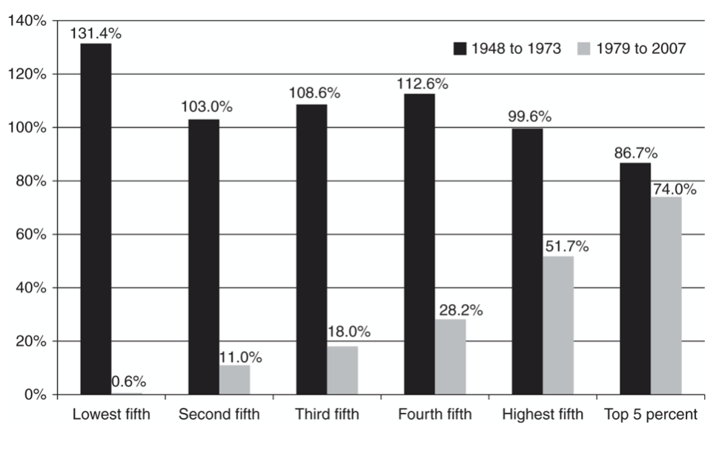
Percentage Income Growth of Quintiles of National Earners (Kotz, 2018, p. 439)
Along with the interventionist tendency of the time, this period was also revolutionary for the field of economics. The advancements made in statistics, information theory, and economic theory in general would define the trajectory of not only Neoliberalism, but economics and its role in society as a whole. Mirowski looks in depth at the advancements of this time period and the development of game theory, experimental economics, and market design—the most thriving focuses in economics today (Mirowski, 2017). These advancements not only propelled the field of economics but also gave economics clear practical applicability in running government. Theoretically, economics extended its analysis to increasingly wide aspects of society and human life. Foucault points to the theory of human capital—developed by Gary Becker in 1964—on this point: “the interest of this theory of human capital is that it represents two processes, one that we could call the extension of economic analysis into previously unexplored domain, and second… the possibility of giving a strictly economic interpretation of a whole domain previously thought to be non-economic.” (Foucault, 2011, p. 219, italics added). These movements, both from Neoliberal and Neoclassical economists, could be said to have been extending the analytical domain of economics to the entirety of social and human life, of extending the economic domain to the entire organization of government, society, and people.
While in the global North the mid-century economic world was defined by Keynesianism and an interventionist sentiment, Neoliberal economists found opportunities for the implantation of their ideologies in the global South. An often referenced example is the ‘Chicago Boys’ and the regime of Augusto Pinochet in Chile. The Chicago Boys were Chilean economists who were trained in the Chicago School starting in the late 1950s, and whose influence—along with many Chicago economists themselves—shaped, “the first substantially neoliberal regime” (Dados & Connell, 2018, p. 3), under Pinochet in the 1970s. Recent academic work has extended the global lens, showing how throughout its history Neoliberal thinkers were focused on the global scale. Dados and Connell point to the dispersion of Neoliberal ideologies through all of Latin America (Dados & Connell, 2018, 3). Quinn Slobodian’s book, Globalists (2020), argues that Neoliberalism must primarily be interpreted on the global scale. He shows how many of the main Neoliberal thinkers were constantly focused on the global scale of the economy, largely through legal rights of free trade and foreign investment protection.

The Neoliberal Era
If the intellectual developments of the 1930s-1970s laid the foundations for the extension of the economic domain to the organizing principles of society and life, then the 1970s, 1980s, and onwards represents the period of influence. Binyamin Appelbaum’s book, The Economists’ Hour (2020), traces the economists limited influence in government through the mid-century and the shift coming into the 1970s. Through the midcentury, economists were viewed as abstract theorizers or number crunchers working with little political influence. A sentiment from William McChesney on his last day as the FED chairman seems to capture the prevailing attitude. In referring to the FED’s staff economists, he said, “they don’t know their limitations, and they have a far greater sense of confidence in their analyses than I have found to be warranted.” (Appelbaum, 2020, p. 3). However, the 1970s represented ‘The Economists’ Hour’, in the sense that economics would become the most influential field for policy, government, and society as a whole. From 1970 to 2018, mainly PhD economists served as chairs of the FED. George Shultz became the first economist to serve as the Treasury Secretary in 1972 and would later become an integral member of the Reagan Administration. Congress created a new agency responsible for economic analysis in 1974, the Congressional Budget Office, led by economist Alice Rivlin. Economic tools such as cost-benefit analysis became central to policy making and legal analysis. These examples are limited only to the United States, but they illustrate the profound change in the status of the economist. This change paired with increase in support for Neoliberal economics—both within the field and politically—ushered in a new era of recent political and social history.
While the rise of the status of the economist was certainly a pre-condition of the Neoliberal era, the economic and political instability of the time was also integral to the shift to Neoliberalism. The 1970s saw more economic turmoil than the United States had seen in decades. Budget deficits increased as the national debt continued to grow, the mid-1970s recession witnessed the worst stock market crash since the Great Depression, and there was an extended period of stagflation. The rising strand of Conservatism had already begun the sentiment of limited government, but the spectacle created by the economic issues and Nixon scandal intensified this attitude.
The tenures of Thatcher and Reagan are the most common starting point for the implementation of Neoliberalism. The essential principles of Neoliberal ideologies seemed to run through political agendas, perhaps driven by a reservoir of ill-will towards New Deal economics. Regardless, and firstly, the attempts to decrease budget deficits resulted in the cutting of a mass of social and welfare programs. Services that experienced substantial cuts in the 1980s include: social security, food stamps, military retirement, public housing, and health services. Secondly, taxes were slashed at a striking rate: the highest bracket rate in 1981 was 70% and had fallen below 30% by 1989 (the end of Reagan’s term). The below image shows how substantial the changes in income taxes were, but corporate, business, and capital gains also experienced large cuts. Thirdly, the rollouts of deregulation in spheres/industries such as energy, health care, airlines, corporations, environmental, etc. These three poles of low government spending, low taxes, and less regulations, make up the fundamentals of conservative politics today, but are also very telling of the shift in the social and political landscape.
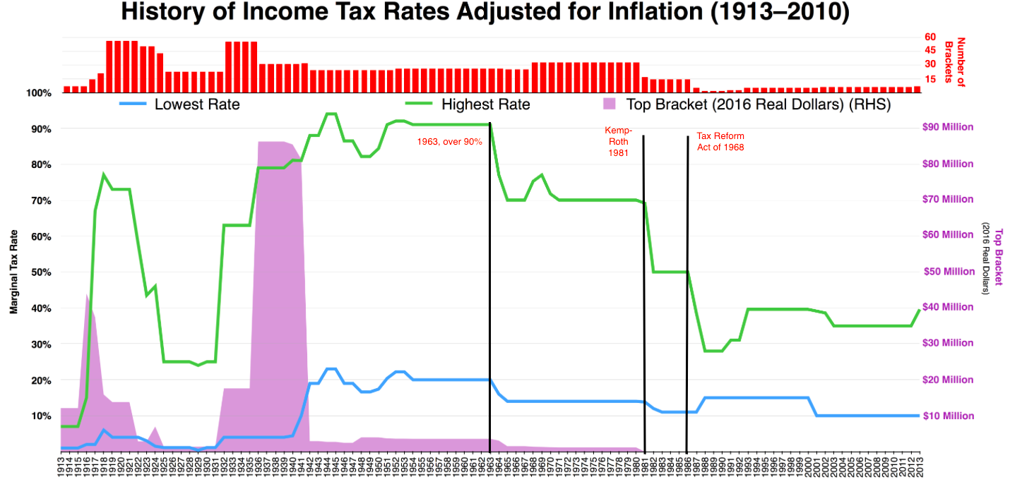
Figure 1
If the cutting of taxes, reduction in government spending (and thereby large cuts to social and welfare programs), and deregulation represented the initial tangible actions of Neoliberal implementation, then privatization, marketization, and financialization represent the long-term consequence. First, an increasing amount of public services are now distributed through private companies. Privatization has “taken the form mainly of contracting out public services to private companies rather than a sell-off of state-owned enterprises.” (Kotz, 2018, p. 5). Notable examples are education, health, prisons, housing, and social services. Second, a similar concept to privatization is marketization. Marketization is the restructuring, or refocusing, of an industry/service on the model of the market and competition. An especially potent example of this concept is higher education. William Deresiewicz captures the issue: “‘Efficiency’ in the transmission of knowledge, not the unscalable craft of teaching, has become the cardinal value… Academic units (that is, departments) are seen as ‘revenue centers’; the ones that can’t pull their weight… are slated for downsizing or outright elimination.” (Deresiewicz, 2015, pp. 67-8). As an increasing number of industries are administered through private companies, an increasing number of social, community, or public, services are being modeled on of the market and competition with the ‘cardinal value’ of efficiency. Third, an essential element of the Neoliberal economy is the increased role of finance. The financial boom over the past 40 years has created one of the largest industries in the economy, with increasing shares of national profits and GDP (Cahill & Konings, 2019, p. 67). The shift of company focus from stakeholder value to shareholder value, and the increase in investment from a widening portion of citizens, has played a fundamental role in the dispersion of Neoliberal effects to the working class.

The Present
The Neoliberal era has resulted in a dense network of issues surrounding government, inequality, the environment, globalization, and human being’s position in reference to their political and social reality. Making sense of this network of issues has been the object of study among a diverse field of researchers. The above brief history has reviewed much of the research on the historical movements of Neoliberalism, but a huge section of this literature has tried to make sense of what these movements have done to our present social landscape. Kim Moody’s article “The Neoliberal Remaking of the Working Class” (2018) provides an extensive statistical portrait of the changes that have taken place over the past 40 years. The essential dynamic that has taken place in developed nations is the increase in productivity, GDP, and profits, with a stagnation in wages and income. Figure 2 below illustrates the increasing gap between productivity/output, and compensation to workers. Figure 3 further illustrates the issue: the steady rise in GDP compared to the much more stagnant growth in household income. Kotz points to the decrease in real minimum wage, or the buying power of minimum wage, from its high of over 10$ an hour to under 6$ an hour by 2006 (Kotz, 2018, p. 7). It must be noted that this huge increase in income and wealth inequality has disproportionately affected people of color by a striking margin, as illustrated in Figure 4.
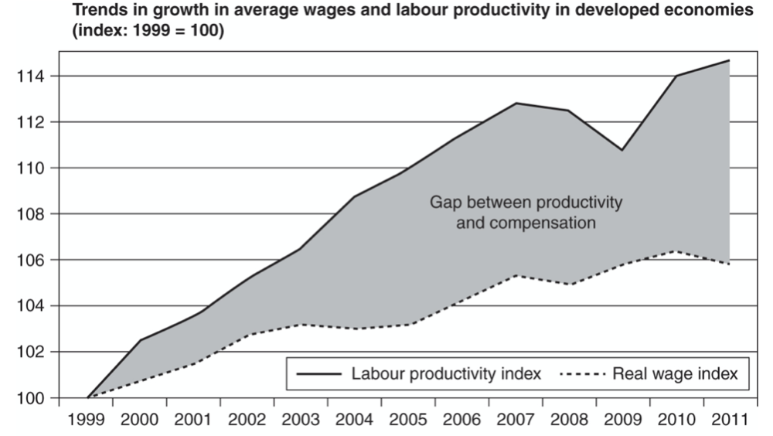
Figure 2 (Moody, 2018)
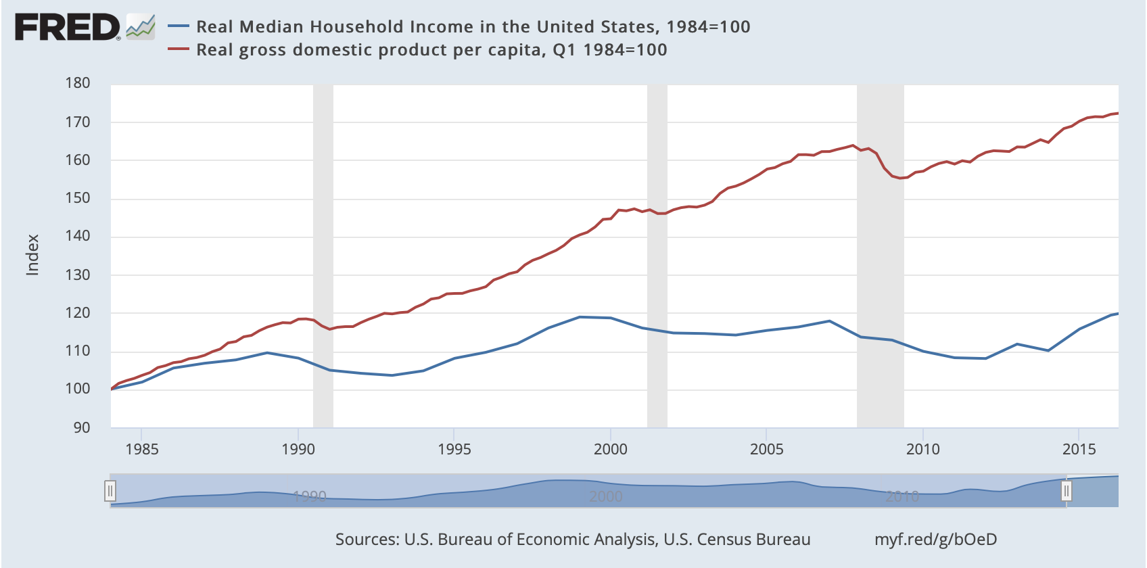
Figure 3; Real Median Household Income in the United States https://fredblog.stlouisfed.org/2016/12/the-puzzle-of-real-median-household-income/?utm_source=series_page&utm_medium=related_content&utm_term=related_resources&utm_campaign=fredblog
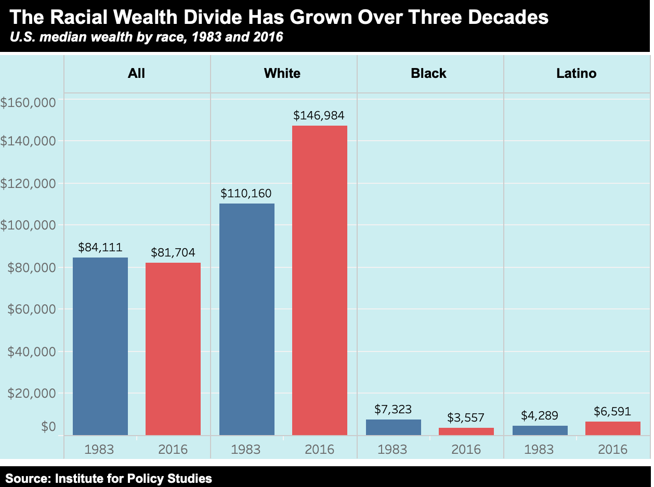
Figure 4; from https://inequality.org/facts/wealth-inequality/
Essential to these dramatic issues is the change in the makeup of the working class and the economic landscape. As developed countries have moved to service economies, and many manufacturing jobs have been outsourced, the available jobs are becoming more ‘irregular’. Irregular work is subject to some definitional and statistical controversy but broadly include jobs that are “non-standard or atypical due to their temporary nature,” (Moody, 2018, p. 7). Moody estimates that irregular employment ranges between 12-20% of the workforce, an increase from the estimate of under 10% before the 1980s (Moody, 2018). While a relatively small number, the increase in irregular work along with decreases in average job tenure seems to have a role in the disparity of income and capital accumulation. Combining these considerations with the boom of the financial industry, the wave of privatization, and the marketization of an increasing number of social services/industries, it is safe to conclude that the economic subject of today faces a much different social, political, and economic landscape than in the past.
The above has explored a basic history of Neoliberalism and presented a reference point of the present reality, both statistically and conceptually. But how are we supposed to make sense of this history and present reality? How are we to confront, question, and think about the problems associated with Neoliberalism? With this reference point and these questions in mind, I will now turn to the epistemological genealogy of Neoliberalism. The working assumption that this history and present conception has presented is that there is something about our social reality, something about the institutions, government, work, and people we interact with, that has fundamentally changed the way that human beings live their lives in the world today. The developments of the Neoliberal era have implemented institutions and tactics that have created new subjectivities: they have made people into subjects in ways that they haven’t been in the past. Importantly, they have changed the way that we know the world, and that we know ourselves.

Economizing Man
When one reflects upon the discussion of Neoliberalism thus far in the context of the genealogical question—the condition of existence in modernity, who we are in the present, and what it means to know, interact with, and engage with the present world—it seems there is something within Neoliberalism that is fundamental to the genealogical present. In an unclear way, it seems there is a relation between the present world’s fundamental norms, values, and goals, and Neoliberalism as a political rationality. Further, it seems that there is a fundamental relationship between Neoliberalism and the way that the individual in the present world forms their norms and values, and understands and interacts with the world. For if Neoliberalism is the defining Political Rationality of the present, then it seems to be no error when Dardot and Laval propose that at stake with Neoliberalism “is nothing more, nor less, than the form of our existence” (Dardot & Laval, 2014, 3, italics in original). The problematic in analyzing Neoliberalism is thus fundamental to understanding the relations of the state, the structures of society, and the condition of the individual.
A genealogy of Neoliberalism will seek to develop an understanding of these relations, structures, and conditions of existence. The conceptual shift that laid the foundations for the later epistemic discussions in Neoliberalism--and a nearly paradigmatic conceptual shift for all of economic thought—is the marginal revolution. Specifically, it was Carl Menger’s value theory which laid the foundations on which the earliest strands of Neoliberalism would be built, and the later developments would generalize. As such, I will take Menger’s value theory as the beginning node for my exploration of Neoliberal epistemology. In looking at Menger’s rethinking of the fundamental pieces of economic theory, two things become apparent. First, Menger’s theory separates completely from the epistemological and ontological character of the economic actor in previous theory. Second, Menger wanted to generalize his theory past strictly ‘economic’ actors and develop a completely universal theory of value.

Value Theory as the Foundation
Carl Menger came into an economic discourse that was on the verge of a fundamental reformulation. The Classical economists had developed an economic system that was meant to be made up of universal and immutable laws but had left fundamental categories of analysis completely unexplained. They had been unable to constitute a solid connection between a thing’s value and its price, exactly what value amounted to, and they struggled to articulate the precise role of demand in linking value and price (Salerno, 2014). Menger recognized these fundamental problems in Classical economics to be in their value theory, which applied only to the actions of economic actors working within the realm of exchange and seeking profit. The Classicals had positioned the economic actor as the businessman—the rational profit-seeker—and focused their analysis on production costs and exchange values. This left a twofold gap in their theory: where goods receive their fundamental value and the nature of demand. The nature of demand meaning the essential qualities of actors who make up demand, and their impact on the economic process. Menger sought to solve these issues by positing the economic actor as all individuals in a market and founding a value theory upon the preferences of these individuals: the subjective valuations of all human beings.
While the Classical economists had analyzed the economic being as the businessman seeking a profit in a system of exchange, Menger revolutionized the analysis by constituting all individuals as economic beings. Menger’s observation in all human beings was the action of economizing: the deployment of limited means to more ends than can be accomplished through those means. This concept, so fundamental to economic thought today, comes from the basic observation that people have limited resources, abilities, time, etc. (means), and a greater set of desires, values, goals, etc. (ends) than these means are able to achieve. Menger took this observation—an observation of a state of being—and developed it into an action: economizing. When someone makes use of a limited mean towards any end, they are economizing said mean. This essentially means they are making a valuation, calculation, and decision against other possible uses of the limited mean, or other means at their disposal. It is through this observation and this action that Menger formulates the rest of his value theory. At the beginning of Menger’s analysis, then, is the definition of economic actors through the bounds of their limited state: the economizing man.
It is the engagement in the action and the perception of the relationship within economizing that gives rise to another phenomenon: value (Menger, 2007, p. 114). Value is grounded in the action of economizing: a things value is imputed onto the thing when a person disposes it to a certain end. A things value is determined by the decision that a person makes, the calculation of desires and deployment to an end. Value is grounded through the condition of a limited ability in, or quantity of, means to dispose towards exceeding ends, and the awareness that they are doing such: “Value is thus the importance that individual goods or quantities of goods attain for us because we are conscious of being dependent on command of them for the satisfaction of our needs.” (Menger, 2007, p. 115). Separating from the value theories of the past, value is not an inherent property of any thing. It is instead a relationship between things and the subjective importance of the ends it will be used for. Value is imputed onto individual things from the importance of the satisfaction which it can achieve. Any given thing’s value is imputed from the least important satisfaction which that individual thing can achieve.
The solution to the diamond-water paradox—given by Adam Smith and troubling many afterwards—may provide the clearest understanding of the intricacies of Menger’s value theory. The paradox is that despite water being essential to the sustenance of human life and diamonds having very little importance to the functioning of human life, the market value of water is nearly nothing and the market value of diamonds is extremely high. Under Menger’s framework, when individuals approach the goods of diamonds and water, they take part in the action of economizing. As such, they deploy the amount of each good at their disposal towards the exceeding ends which they can achieve. Water is available in such abundance that an economizing actor can achieve nearly all ends which it would be able to achieve. Diamonds however are available in such scarcity that an economizing individual’s ability to deploy diamonds towards its exceeding ends is much more limited. Thus, the imputed value of the least important satisfaction which water can achieve is very low, while the imputed value of the least important satisfaction which diamonds can achieve is very high. In understanding this example, we see how Menger was able to solve the gaps in the Classical economists’ theory. Value is fundamentally derived from the subjectively ordered preferences of the economizing man, and demand is now defined through the economizing man as an integral piece of the economic process.

Menger’s Contribution to Neoliberalism
While this conception of value was revolutionary for developing a precise systematic account of value, marginal utility, demand, and the market processes, there are a few more subtle points to its importance for Neoliberal thought.
First, the extension of the economizing man. While centralizing the concept of economizing grounded Menger’s value theory, it is the extension of analysis past what the Classical economists had done which would echo through later Neoliberal thought. Posing all individuals in a society as economic actors brought all individuals within the domain of the economic analysis, opened the frontier of economic theory to new possibilities, and created further potential for an economic subjectivity. The extension of the domain of economic theory to further areas of human life is a trend which has continued not only in Neoliberal thought, but in economic thought more generally.
Second, the founding of value theory on subjective valuations by all individuals seems to foreshadow the importance placed on individualism in later economic thought. When one hears of the liberal sentiment that it is the values of individuals which must be given the most importance—values, goals, or ends which only an individual can know the importance of and which no collective or central force can control—there seems to be a presupposition of a Mengerian value theory. For if value is fundamentally and exhaustively a relation between individuals and their preferences, then there does seem to be a natural extension into holding that the preferences of individuals must be centralized and protected politically. This extension was made explicit by Neoliberal economists following Menger’s school of thought.
Third, the epistemological and ontological conditions became centralized and extended through Menger’s theory. Recall the ontological condition of limited means and ability formulated into the action of economizing, and the epistemological condition of the awareness of such a state in founding value. These conditions are tied together into the concepts of economizing, the economizing man, and marginal value theory. As such, it is clear that these conditions shape the human beings understanding of the world. It is through this relation of resources and desire, means and ends, or limitations and deployment, that we interact with the world. With the creation of the concept of economizing, Menger is viewing human beings as in this state, conditioned by the experience of economizing, and understanding the world through this relation. This recognition is of substantial importance to Neoliberal thought. It centralized the economic condition as a way of knowing and existing in the world, not just for profit-seeking businessmen but all human beings. Through the lens of economics, Menger looked critically at how every individual understands the world, clearing ground for later economists to continue on such a line.

Homo-Agens
If Carl Menger’s career represents the crux of a revolution in economic thought, then much of Ludwig von Mises’ career represents an articulation, defense, and legitimation of this revolution. The first half of the 20th century found economics, and the social sciences generally, under an existential analysis in the academic community. Questions such as ‘what do the social sciences amount to’, ‘can the social sciences ever be sciences in the same sense as the natural sciences’, and ‘what is the role of a social science in the academic, political, and social community’ bounded a strong methodological discourse through this time period. It is from these questions—central to the economic discipline—that Ludwig von Mises’ most important work arises.
One of Mises’ goals was to set the bounds, or to lay out the fundamental content and method, of the economic science in such a way as to ground its legitimacy and assert its importance. To do so, von Mises would take Carl Menger’s value theory as a foundation, articulate exactly what this foundation represented, and generalize upon this to build the framework of the economic science. For von Mises, the key to doing such was articulating Menger’s subjective theory of value as an a priori universal theory of human action. In doing so, all of economic theory would be pushed into an a priori universal category. It is important to note the universality of what Mises’ project was trying to achieve. The theory was trying to do nothing less than define the logic of all human action, to put all human action within the domain of economic study:
“It is much more than merely a theory of the ‘economic side’ of human endeavors and of man's striving for commodities and an improvement in his material well-being. It is the science of every kind of human action…Nothing that men aim at or want to avoid remains outside of this arrangement into a unique scale of gradation and preference. The modern theory of value widens the scientific horizon and enlarges the field of economic studies” (Mises, 1998, p. 3, italics added)

Defining Human Action
Central to Mises extension of Menger’s theory to a theory of all human action is the concept of choice. Action is purposeful behavior, and purposeful behavior must always involve some choice: “acting man chooses, determines, and tries to reach an end.” (Mises, 1998, p. 12). At any moment at which one acts, they are in a situation where they have means, ends, and a choice of what to do. It is the engagement with this situation that results in action. Importantly, it is this characteristic of humanity that Mises took to be the defining essence of human beings. The essence of human action is our limitations, our desires, and our engagement in choosing how to use these limitations to achieve our desires. Working from Menger’s value theory, human beings are essentially beings that subjectively value ends and try to achieve them. What does Menger’s value theory reveal about people being essentially acting beings? Mises believed this theory to constitute the framework of the logic of all human action: the framework of the logic of essentially acting beings. Mises also took this framework to follow a priori from the broad category of action. He believed that the following conditions of action followed necessarily from within the concept of action and choice:
First, a state of uneasiness. Underlying all human action is a state of unease or dissatisfaction, which gives the basic incentive for action: “The incentive that impels a man to act is always some uneasiness.” (Mises, 1998, p. 13). This is an important existential condition: humans are essentially acting beings, and action derives from a state of unease or dissatisfaction. Necessitated in this thesis is that a state of perfect satisfaction cannot result in action: “We call contentment or satisfaction that state of a human being which does not and cannot result in any action.” (Mises, 1998, p.13).
Second, an image of a more satisfactory state. Accompanying a state of unease, there must also be the image of a more satisfactory state. This image is the potential goal: the end which action seeks to achieve through the deployment of means. “Acting man is eager to substitute a more satisfactory state of affairs for a less satisfactory. His mind imagines conditions which suit him better, and his action aims at bringing about this desired state.” (Mises, 1998, p. 3).
Third, the expectation that purposeful behavior—action—could remove or alleviate the state of dissatisfaction. This expectation is essential for if there were no expectation that one could do something about their state, there would be no action—man would have to ‘submit to destiny’ (Mises, 1998, p. 14).
To Mises, these are the fundamental conditions under which human beings live: “Man is the being that lives under these conditions. He is not only homo sapiens, but no less homo agens.” (Mises, 1998, p. 14, italics added). The human being is the active being. The active being who lives out their life under the condition of dissatisfaction compelling them to action, compelling them to organize their means for their end. It is important to reiterate the gravity of the project that Mises is attempting to put forward. He starts with the goal of articulating Menger’s value theory, but in doing so is extending it past what Menger had formulated. Menger had observed the state and action of economizing and grounded the concept of value in the subjective preferences of the individuals who are doing the economizing. Menger had extended economic analysis to all individuals who economize means to exceeding ends. Mises on the other hand extends his articulation of Menger’s value theory to the essence of human beings. Mises takes the concept of economizing and formulates the underlying conditions of economizing—a state of dissatisfaction, an image of a better state, and an expectation that action could alleviate the dissatisfaction—and founds this as the essence of human beings. Any distinction between economic and non-economic action has been dissolved. Action, economic and otherwise, is about Mises’ given conditions of existence, and as such, human beings become homo-agens.
This generalization of engagement and action—engagement into the process of alleviating unease or disposing means to end—as the essence of being also becomes the essential characteristic of how to think about the organization of human beings. The market emerges as the process of the engagement of individuals interactions: “The market is not a place, a thing, or a collective entity. The market is a process, actuated by the interplay of the actions of the various individuals,” (Mises, 1998, pp. 258-9). Instead of exchange, production, or consumption, it is engagement at the heart of the economic processes: “Production and consumption are different stages in acting.” (Mises, 1998, p. 312). The market emerges as individuals engaged into the conditions of being, as they act in the conditions of homo-agens, as they seek to alleviate uneasiness. The essence of the market, and the economic actor, is now very far removed from that of the Classical economists, and very far generalized in comparison with Menger’s work. This development in Mises’ work serves as another foundational piece for Neoliberalism: the conception of man as acting and engaging, with invariably subjectively valued ends, and the market as the space in which these beings engage with each other to compete for their ends. This development provides a foundation of economic thought in which human beings must engage in a space of competition, in which a thing or end’s value can only be derived subjectively from individuals’ preferences, and the free market as space in which these interactions take place. This is the foundation from which later Neoliberal thinkers are able to further develop. The in-depth articulation of the role, nature, and epistemic intricacies of the market itself comes out of Mises’ once student, Friedrich Hayek. Understandings Hayek’s conception of the market is the key to relating market logic to Mises’ underlying theory of human action:
“This system is steered by the market… The market directs him and reveals to him in what way he can best promote his own welfare as well as that of other people. The market is supreme. The market alone puts the whole social system in order and provides it with sense and meaning.” (Mises, 1998, p. 258)

Market Rule
In moving from Menger’s economizing man to Mises’ homo-agens, we saw a centralization and extension of the basic concepts of limited means being disposed to greater ends. The choice facing human beings of how to dispose of limited means, and the engagement into the conditions of action defined the essence of humanity and character of the economic process. There may be a number of epistemic implications from these theories, generalizations, and characterizations, but to return the focus to the genealogy of Neoliberal epistemologies, it is more helpful to turn to the work of Friedrich Hayek. Hayek comes directly from this line of Austrian economists, but his impact extends far beyond that of only the Austrian line. Importantly, Hayek’s work in the epistemological domain is essential to understanding the intricacies of his work in general, but also was an essential development to this history of economic ideas in general.. In comparison with the line of Menger and Mises, Hayek gives knowledge a more central role in his discussions, and it becomes the key to connecting economizing man and homo-agens to knowledge and the market.
In looking at Hayek’s epistemic work, there is a threefold distinction to take into consideration: the subject/individual, the planner/government/economists, and the market. Firstly, what can the individual person know? This knowledge is directly related to what human beings can know, what human rationality can achieve, what knowledge is important, what human beings are unable to know, etc. Secondly, what can the central planner, or planning apparatus, know? How well can we organize the glut of information available? This is a question of the validity of collective knowledge and the ability to use it. Importantly, this is also a question for the economist. What ability does the economist have to observe something in a market process and change something for a better outcome? Finally, what can the market ‘know’? What is the relation of the market and truth? In analyzing Hayek’s discussion of the market, and market competition, it seems that the market processes information in a way that relates to knowledge and produces outcomes that constitute truth.

The Problem of Dispersed Knowledge
The natural starting point in looking at Hayek’s epistemological work is his paper, “The Use of Knowledge in Society” (1945). This paper emerges out of an especially potent controversy between free market and socialist economics, a controversy that would motivate Hayek’s thought throughout his career. In this paper, Hayek puts forth the problem of constructing a rational economic order: what problem do we face in trying to organize optimal economic activity? If one were to command all the relevant knowledge and information in a society and start from a given set of preferences, then the constructing (or planning) of an economic order would purely be a question of logic and calculation. This is, however, not the problem that society faces because, “the ‘data’ from which the economic calculus starts are never for the whole society ‘given’ to a single mind which could work out the implications and can never be so given.” (Hayek, 1945, p. 519). From the outset of this paper and Hayek’s career, then, he is emphatically holding a thesis of limitation of central planning, or the economist’s, abilities.
The first reason for this is dispersed knowledge. The knowledge needed to plan an economy is dispersed throughout the economy in the sense that it is possessed by many individual economic actors and never by anyone in a concentrated form (Hayek, 1945, p. 519). It is unorganized, circumstantial, fleeting, and of relative importance only known to those who possess it. Hayek continually refers to “knowledge of particular circumstances and place” (Hayek, 1945, 522), and “of the fleeting moment not known to others” (Hayek, 1945, p. 522). It is knowledge which, “by its nature cannot enter into statistics” (Hayek, 1945, 525). It is the sort of knowledge which would only be relevant to a certain fleeting circumstance, and of which the relative importance could only be valued by the individuals involved.
With the focus on dispersed knowledge there is an important continuity with Mises’ homo-agens. One could say that dispersed knowledge is knowledge of the limited means at the disposal of an individual, or some individuals, and the ends which those individuals conceive of achieving with said ends. These ends can only be valued by the individuals, and only they can decide how, or if, to act upon it. This knowledge is the knowledge of homo-agens, and Hayek puts it forward as the essential knowledge for the operation of an economy. Potential examples could be localized inefficiencies in a shipping method, changing preferences in a community, the ability to arbitrage an overpriced supplier, one’s own preferences or desires in consumption, etc. Not only is it a nearly inconceivable prospect to collect this knowledge but organizing it into an economic order would be just as inconceivable due to the nature of its subjective valuations and relative importance.
While collecting or organizing dispersed knowledge is presented as nearly an impossibility, the market and price system is presented as a mechanism that already achieves rational economic order. Through the market processes, all the relevant information to the individuals that make up the market is transferred: “in a system in which the knowledge of the relevant facts is dispersed among many people, prices can act to coordinate the separate actions of different people in the same way as subjective values help the individual coordinate parts of his plan.” (Hayek, 1945, p. 527). In this conception, the inputs of a market are all the information and knowledge in a society, and it is processed into a single output of price. It relays only that which is relevant: a single price which you can act upon in a form that is easily understood. “The whole acts as one market, not because any of its members survey the whole field, but because their limited individual fields of vision sufficiently overlap so that through many intermediaries the relevant information is communicated to all.” (Hayek, 1945, p. 527). In thinking of the threefold distinction given above, the important knowledge of the individual is that of homo-agens—limited means and subjectively valued ends, the knowledge of a central planner is entirely limited beyond any practicality, and the market is that which organizes and communicates this knowledge.

Tacit Knowledge and Limitations
While the conversation thus far has been about dispersed knowledge, its forms, and its properties, there are two important categories of knowledge to introduce in analyzing Hayek’s later views: tacit, unconscious, or underlying knowledge; and epistemic limitations. Knowledge of the tacit realm can be thought of as the framework of thought that your mind has, or the underlying rules of thinking that we are not aware of: “for Hayek, it was rationality that was largely unconscious, with conscious perception and drives constituting the veneer of intentionality and desires floating on top of the sea of obscure and inaccessible rule structures.” (Mirowski, 2017, p. 68). Tacit knowledge is distinct from dispersed knowledge in that it is unconscious and completely inaccessible, but it is still invariably attached to the individual. In the fact that tacit knowledge is inarticulate or unconscious, it can be hard to understand what it is meant to be, but it can be understood as the rules, framework, or conditions of thought and rationality itself. It is the underlying structure of the mind which individuals still ‘know’ in a certain sense, but unconsciously. Epistemic limitations on the other hand are those things which people cannot know and define the limits of human knowledge and rationality. The epistemic limitation which constitutes the defining factor of the economic problem is the inability to know or predict future events, outcomes, or developments.
With the categories of tacit knowledge and epistemic limitations, Hayek poses the market processes and competition as the mechanism which accesses these epistemic categories. In his lecture “Competition as a Discovery Procedure” (2002), these themes permeate through the work. Competition is a process which discovers facts about the world, facts that would otherwise have not been known. Competition is needed and justified by our epistemic limitation of not knowing the essential circumstances that determine the behavior of others, and not knowing what the future events or outcomes will be (Hayek, 2002, p. 9). Competition discovers and communicates facts through the engagement of its participants. When participants engage into this process, all of knowledge is also engaged: knowledge of circumstance, skills, abilities, and also that which, “consists to a great extent of the ability to detect certain conditions an ability individuals can use effectively only when the market tells what kinds of goods and services are demanded.” (Hayek, 2002, p. 13).
Here, one should understand exactly what Hayek is saying takes place in the activity of the market. Individuals participate in the market through consumption, production, working, seeking profits, seeking better opportunities, etc. Recall here that with Mises’ formulation of the homo-agens, all human action is economic action. In the process of participation and engagement with the market, individuals are engaging their preferences, their dispersed conditional knowledge, their underlying tacit knowledge, and their epistemic limitations. The market processes all of this knowledge and information, communicates prices or conditions, and produces an outcome. Much of the knowledge and information that the market accesses is dispersed, tacit, or unknown to individuals, but is communicated through conditions which individuals can detect. The reference to these conditions feels abstract in Hayek’s writing. However, he is referring to the conditions as those that only market processes can access, use, and communicate these conditions. In this way, it seems that he is referring to something that is not conscious knowledge, but more of a psychological or behavioral, tacit, knowledge. Considering this also answers the question of what the discovered facts do: inform individuals of conditions which they can detect, less so than know. These facts relay essential information which can be acted upon. Competition, “can use the knowledge of all participants, and the objectives it serves are the particular objectives of all its participants in all their diversity and polarity.” (Hayek, 2002, p. 14).
It is important to give close attention to Hayek’s late abstract considerations of knowledge because within the Neoliberal strand of thinkers, he pays the closest attention to the question of knowledge in economic and political theories. It also reveals something of the epistemic character of the modern subject. Throughout Hayek’s thought, it is the knowledge of homo-agens, the knowledge of competitive advantage, or the knowledge which can be used for comparative advantage, which is pointed to as the conscious knowledge that is essential to the operation of the market. With the introduction of tacit knowledge, there is an entire category of unconscious and inaccessible knowledge which can only be accessed through the market processes that also is essential to optimal operation of the market. An important note herein is that tacit knowledge is not only pointed to as the most important knowledge of the market, but the market is in turn pointed to as the system of society: the spontaneous order or catallaxy. This point is important for three reasons.
First, the engagement of individuals into competition becomes a matter of social order. The usage of individuals’ dispersed and tacit knowledge through market processes is not only the path to optimal economic outcomes, but the spontaneous social order of the whole—the whole that is the collection of individuals seeking their own diverse ends. The end of market processes is not an economic equilibrium, optimum, or maximum, it is an order of a certain degree in which contributes to the realization of an unknown number of individual objectives (Hayek, 2002, p. 14). It is a process which engages dispersed and unconscious knowledge that we cannot understand and spontaneously produces an order which we cannot grasp. Essential to the operation of spontaneous order is the engagement of this dispersed and unconscious knowledge: the engagement of all individuals into competition.
Second, spontaneous social order can only be achieved through the usage of knowledge which is inaccessible and unknowable to any centralized source. As such, the state has no ability to plan market processes, nor interfere with its operation. The state can provide the structure for the market to operate, but any market process itself must be left to its own operation. Any interference by the state into market processes only interferes with the system of communication and hinders the emerging spontaneous order.
Third, the conception of the market processing all of this information, dispersed knowledge, and tacit knowledge, and producing an outcome of an ambiguous but essential spontaneous order, begins to relate the market process to something of a truth or knowledge producer: a ‘site of veridiction’, as Foucault formulated it. Market outcomes are prices, labor divisions, production and consumption levels, wealth distributions, etc., but the conglomerate of a market order in Hayek’s mind is the spontaneous social order. It is unknowable in its entirety and unable to be produced through human calculation or organization. It is processing all information and knowledge in a society and producing an order which otherwise would not have been achieved. In this way, it seems that the market outcomes are equated to worldly truths. The market system seems to ‘know’ things through its processing, and its outcomes are the result of this processing or knowing. The market in this conception is a sort of knower, a supreme information processor, a knowledge and truth producer. Conditions, outcomes, and communications that the market produces have gone through the process of the market, gone through the ‘site of veridiction’, and begin to constitute a worldly truth.
These considerations—the importance of engaging individuals in competition, the inability of the state to produce a social order, and the market as a truth producer—provide the three poles of the Neoliberal epistemic. The knowledge that matters for the individual is the engagement into the competition. It is knowledge of advantages and desires, means and ends. This knowledge is engaged by the market to produce a spontaneous social order; an order whose outcomes and structures are a sort of ‘true’ social outcome and ‘true’ social structure. The state is inherently limited epistemically, but not paralyzed. Governance is bounded through the end of competition. The state cannot interfere or plan any piece of a market process, but it can provide structures which engage individuals into competition. It can create the space for the market processes throughout society. In short, the state has the ability to act on a rule of competition: it may act on individuals, laws, or institutions in ways which create greater competition or more market ability.

Homo Economicus
If we take Friedrich Hayek’s thought as the end node of this genealogy, we have an image of the Neoliberal order on three fronts: the idealized subject, the rule of governance for political bodies, and the information-processing market. Firstly, we have a subject defined through an essence of the homo-agens. However, it is a subject whose dispersed knowledge, tacit knowledge, and epistemic limitations are emphasized. It is a subject who must be engaged into the market, or compelled to market activity, in order to allow for the access and use of these epistemic categories. Secondly, we have a rule of the market for political bodies or states. Working underneath the power and order of the market, states can only act as to spread and strengthen market forces. States can create the framework for the market by putting individuals into competitive situations, deploying market forces into new areas, or strengthening the ability for existing forces to act, but under no circumstances can directly impede onto the actual forces themselves. Governance is therefore defined through and bounded by the forces, or rule, of the market. Thirdly, we have a conception of the market as an information processor, a communicative device, and organizational system. The market accesses otherwise inaccessible dispersed knowledge, tacit knowledge, and epistemic limitations. It communicates only information which matters to individuals in a form which they can quickly detect and act upon. If the market process is able to occur freely and completely, spontaneous order emerges. It is an order which cannot be achieved through any calculation, but rather emerges from the operation of the market.
There are two concluding strands of thought that I would like to pull from the Neoliberal order which this genealogy has explored. Firstly, the absolute inability for there to be any sort of social or collective goal. The market produces a spontaneous order from the values and knowledge of all individuals within it, and it can only operate as such. Hayek was very clear on this point throughout his career, and often wrote directly against the idea of any collective or socialist goal.
Hayek’s view on this does seem to cohere with the considerations above. He holds that if there were to be collective goals, calculations, or values ordering the operation of the market, “it is only the knowledge of the organizers or managers alone that can have an impact.” (Hayek, 2002, p. 14), and that in the operation of the free market outlined above, the market, “can use the knowledge of all participants, and the objectives it serves are the particular objectives of all its participants in all their diversity and polarity.” (Hayek, 2002, p. 14). If the market accesses, communicates, and processes the inaccessible knowledge of its actors, then the social collectives attempt to impute goals or outside values to this process will limit the markets ability to access and process this inaccessible knowledge. Further, the freely operating market accesses all knowledge and values of its participants, so the order of the market reflects the values, goals, or ends of all the individuals within it. Thus, there is no outside social goal, no outside collective end which could be placed over and above that which the free market reflects: the market necessarily produces the values, goals, or ends of all individuals. The outcome of the market is the reflection of its inputs: a reflection of the values, goals, or ends of the individuals which participate in it. If there were to be an impedance of a social or collective goal, then, it would not reflect the values of all individuals within.
This necessity of political individualism which follows from the considerations above seems to be in tension with the concepts or desires of social goals, social justice, and social equality. As was analyzed in the Problematizing Neoliberalism section of this paper, there seems to have emerged a number of undesirable consequences from the realization of Neoliberalism since the late 1900s. The concepts of marketization/economization, privatization, deregulation, and financialization of our economy and social body has produced vast inequality in wealth distribution, a pervasive focus on economic ends, and a subversion of the political realm to the economic. There seems to be space for a legitimate questioning as to whether the deployment of free market forces throughout the social body or a focus strictly on the economic realm in the organization of society truly produces a desirable social order. However, if Hayek’s considerations are true—or the picture of the world that Neoliberalism produces more generally—then the order which emerges from the spread of, and focus on, the purely economic ends has reflected the values, goals, and knowledge of all individuals in society, as well as the level of inaccessible or unknowable dispersed knowledge, tacit knowledge, and epistemic limitations. If these considerations are correct, then it seems correct when Hayek holds that social justice is a meaningless concept, and further that the idea of a social goal over and above that which the market would produce is simply inconsistent or contradictory (Buckley, 2012).
However, there is a further concluding strand than that of the necessity of political individualism that emerges from the above genealogy. The implication that can be drawn from the Neoliberal conception of individual, state, and market is the Neoliberal epistemic. In this sense, an epistemic is a way of knowing the world. It is a sort of defining world view which shapes how one interacts and understands. It is a way of knowing that conditions how one lives. Notice that the picture that has emerged is that of a market supremacy, a state which must spread and strengthen the markets forces, and the individual which must engage into the process of the market. It is an order in which market forces are so pervasive that individuals are constantly confronted with them, constantly compelled to engage with the market, constantly incentivized to be an economic actor. It is an order in which market forces are conceived of as the greatest use of information and most efficient social order, which in turn relays the logic of the market throughout the social order. The ends and values of the market—optimal use of inputs, efficient organization of resources, and the perpetual final end of profit and growth—become the values disseminated to all institutions and individuals. That is to say that the state, private firms, education, policing, non-profits, etc., are to be run through the logic of the market and through the ends of the market. What is the result of this if realized? It is the epistemic of a familiar theorization: homo-economicus. Homo-economicus is the basic unit of the Neoliberal order. It is the unit of the enterprise being. It is the individual conceptualized as an enterprise, an enterprise of themselves. It is not simply the individual who is a part of a market, but whose entire existence is articulated through market values and market logic.
The essential movement explored through this work is from homo-agens to homo-economicus. Homo-agens is the being whose essence is defined through the deploying of means towards the alleviation of varying dissatisfactions. It is the individual whose essence is action and engagement into the conditions of being which Mises defined. With the addition of Hayek’s discussion of knowledge and the extension of the market forces, homo-economicus emerges. The subject is pervasively engaged in market forces, viewed as a market being, and compelled to act as an enterprise, “as self investing human capital.” (Brown, 2016, p. 177). The interests of the individual recede or are conditioned into the interests of enterprise, of competitive advantage, of optimal economic growth, performance, or profit. If homo-agens is the being whose essence is defined through the deploying of means to alleviating dissatisfaction, homo-economicus is the being whose essence is that of homo-agens but invariably engaged into the values, ends, and logic of the market. The Neoliberal homo-economicus which was first theorized by Michel Foucault again emerges from this genealogy as the engagement of Mises’ homo-agens into Hayek’s conception of the market. It is from the idea of this version of homo-economicus that the totalizing world view, the way of knowing and being in the world, or the Neoliberal epistemic comes out of.

The Neoliberal Epistemic
To conclude, I would like to recall the purpose of a genealogy and to consider features, consequences, or actualizations, of the Neoliberal epistemic. A genealogy is a history of the present. It traces the past with reference to the problem of understanding who we are in the present. In this genealogy of the epistemological ideas of Neoliberalism, I have sought to understand Neoliberalism further and to problematize the Neoliberal epistemic. While I cannot provide a systematic account of the Neoliberal epistemic, nor would such be the proper outcome of a genealogy, the literature on Neoliberalism reviewed in the Problematizing Neoliberalism section of this paper indicates that there is something true in the Neoliberal epistemic to the individuals experience of the present. Further, the impact of the ideas of Menger, Mises, and Hayek in modern politics further indicates the relevance of the Neoliberal epistemic. As such I would like to prod at certain features of this totalizing world view: the way pervasive market logic shapes the way one understands, interacts, approaches, moves through, or reflects upon the world. I would like to explore features of this epistemic which may have found actualization in the world today: the way that Neoliberalism may shape a person’s understanding of what it means to be an individual existing in the world, or existing in a Neoliberal order.
Marketizing or economizing. Often thought of as the process of marketization, or economization, of certain industries, sectors, or firms which were previously run through non-economic or non-market models, these concepts can also be thought of through the epistemic conditions of these processes. When one thinks of the world through the Neoliberal epistemic, the logic of the market is the rule of organization. The ultimate end is that of the market’s spontaneous order, and alternative ends or values are simply incoherent. As such, the way in which we understand the role of institutions and how individuals interact with institutions becomes epistemically bound to the economic. To use education as an example, its end is economized into the development of human capital and the serving of a market for individuals to invest in themselves. As such, educational institutions are run off of the market model, and students enter the market as investors into the self. Once the understanding of education is shifted into the investment into personal human capital, the way in which education is approached becomes oriented towards the economic realm and the ends of the economic realm. It becomes incoherent to approach education on the basis of values of democratic citizenship, the rigorous enrichment of individual life, or the rewards of seeking knowledge as an end in itself. We see here how the Neoliberal epistemic economizes the way that subjects know the world: the world is known through the domain of the economic. We also see here how the Neoliberal epistemic economizes knowledge: “knowledge is not sought for purposes apart from capital enhancement, whether that capital is human, corporate, or financial. It is not sought for developing the capacities of citizens, sustaining culture, knowing the world, or envisioning and crafting different ways of life in common.” (Brown, 2016, pp. 177-8). A twofold distinction, then: the way the individual and institution know the world, understand their place in it, and order their actions as such, is through the domain of the economic; and knowledge itself is bound to the ends and values of market logic.
Governance and Practices. The Neoliberal epistemic is disseminated through the institutions which come to govern through it. Through this process of governance and dissemination, the structures of institutions and individuals within them are conditioned by market logic. This changes the way that individuals interact with these institutions and other individuals, as well as how they understand themselves and their place in the world. This dissemination spreads ways of thinking and acting and incentivizes individuals towards them. To recall the definition of governance from the introduction, it is meant to capture the way that Neoliberalism spreads through practices and techniques. Instead of agents or apparatuses exerting direct control over individuals, institutional governance focuses on spreading norms, incentivizing action, creating standards, encouraging individual entrepreneurializing, etc. (Brown, 2016, p. 126). To give a better understanding of this process, consider Brown’s example of devolution. Devolution is the devolving of authority by larger units to smaller units, which often involves the pushing large scale problems to these smaller units. When authority on issues is devolved to smaller units, and these units are continually slated into a competitive sphere, they are forced to entreprenuerialize in order to solve issues which they are not prepared for. Brown gives the following illustration of devolution, “Thus, state funding cuts in education or mental health devolve responsibility for these undertakings to municipalities, which in turn devolve them to individual schools or agencies, which devolve to individual departments,” (Brown, 2016, p. 132). Once this authority is devolved to individual departments, or even individual people, they are simply not equipped to satisfactorily handle issues like education or mental health, and are instead forced to find cost reducing, efficient, ways to handle the issues in order to keep their competitive standing in the field. They become isolated units, responsible for themselves and increasing their own competitive standing, and yet are still invariably tied to the project of the higher authorities who devolved the authority in the first place. Here we see a prime feature in the deployment of Neoliberal governance, and the way it spreads the Neoliberal epistemic: it binds individuals to isolated projects and incentivizes them to entreprenuerialize, while still being bound to a greater project, and a greater set of values, outside themselves.
Disseminating Values. The Neoliberal order is claimed to be a space in which all individuals can pursue their own subjective values in a rational way that results in spontaneous order. Recall, throughout Mises’ and Hayek’s work we see claims of how the free market allows for the pursuit of all individual values, while centralized organizations prescribe values which may conflict with or hinder the individual’s values. The spreading of market forces throughout society, or the ordering of society on of market logic, is supposed to create a greater ability for the pursuit of subjective values. However, as can be seen with the analysis of governance, the pervasive spread of market forces conditions subjective values: they condition the individual themself. The values and ends of market logic and the subjectivity of homo-economicus are disseminated through the pervasive deployment of market forces and condition any number of subjective values into values of the economic. So, while there is a claim of the emergence of an order in which a multitude subjective values may be sought, the Neoliberal epistemic subtly remakes the institutions and individuals within it, conditioning the multitude of values into the single strand of the economic.
The Truth of the Market. Foucault’s lectures on Neoliberalism (2011) recognized the aspect of the Neoliberal epistemic which connects the market to truth, and Mirowski’s (2017) recent book explored this connection further. In Foucault’s conception of Neoliberalism, the market becomes the site of veridiction, the site which processes, circulates, produces, and verifies truth: “When you allow the market to function by itself according to its nature, according to its natural truth, if you like, it permits the formation of… the true price.” (Foucault, 2011, p. 31). A reflection on Hayek’s conception of knowledge, the market, and spontaneous order pushes the relationship between the market and truth even further. The free market accesses, processes, and organizes a mass of dispersed knowledge, tacit knowledge, and other information, and produces a communicative outcome. If operating freely, within the proper framework of society and without hinderance, a spontaneous order emerges which is optimal and could not be achieved through the collective organization of the market. This processing of a mass of various forms of knowledge and production of optimal outcomes gives a certain power to the markets organizations, prices, labor divisions, wealth distributions, etc. As the outcome is a function of the processing of a mass of knowledge, it is a verified, true, outcome. To give an example to illustrate, consider a Nash equilibrium outcome in game theory. There may be a huge number of potential outcomes from a given game, or a given auction, but the Nash equilibrium which the free market produces is propounded as the true outcome. It is true because it is that which emerges from the information that the market accesses and communicates between players; it is that which emerges from the process of the market. As the outcome is the product of the process of the market, it is equivalent to truth. Market outcomes are not looked at as just or good outcomes; rather they surpass the just or the good and became truth.
The Individual. In the above discussion, the focus has been on the abstracted level of the market, or the institutions being remade on the basis of and disseminating market logic and values. It is important to end with an emphasis on the individual, for there is something acutely personal which should come through in a genealogy. In a dominated by the Neoliberal order, or a world in which the Neoliberal epistemic finds some actualization, it is human beings who are affected. It is people whose way of knowing the world is conditioned, whose knowledge, agency, creativity, or meaning may be subverted to the supremacy of the market. If there is any essential reflection which must come through from a genealogy of Neoliberalism, it is that the individual person’s relation to the market demands further questioning and thought. For what happens to the human being when they are remade into homo-economicus? What happens to the power of the individual when they are reduced to an input in the supremacy of the market information processor, compelled to constant market activity, placed into the perpetual ends of economic growth? These are questions which demand particular attention in the modern world, and they are questions which ought to be intensely personal to an individual in the present. These are the questions which the modern thinkers on Neoliberalism are so desperately trying to have the public consider. These too are the questions we must continue to ask in order to not only understand the genealogical question of who we are, but the further question of who we want to be.

Works Cited
Appelbaum, Binyamin. The Economists' Hour: How the False Prophets of Free Markets Fractured Our Society. Picador, 2020.

Brown, Wendy. Undoing the Demos: Neoliberalism's Stealth Revolution. Zone Books, 2016.
Buckley , William, and Friedrich Hayek. “F A Hayek - Social Justice .” YouTube.com, 2012, www.youtube.com/watch?v=RnMd40dqBlQ. Accessed 2020.
Cahill, Damien, and Martijn Konings. Neoliberalism. Polity Press, 2019.

Dados, Nour, and Raewyn Connel. “Neoliberalism in World Perspective: Southern Origins and Southern Dynamics.” The SAGE Handbook of Neoliberalism, by Damien Cahill et al., SAGE, 2018, pp. 28–39.

Dardot, Pierre, et al. The New Way of the World: on Neoliberal Society. Verso, 2014.

Davis, Gerald F. Managed by the Markets. ; How Finance Re-Shaped America. Oxford University Press, 2011.

Deresiewicz, William. Excellent Sheep: the Miseducation of the American Elite and the Way to a Meaningful Life. Free Press, 2015.

Foucault, Michel, and Michel Senellart. The Birth of Biopolitics Lectures at the College De France, 1978-1979. Palgrave Macmillan, 2011.

Foucault, Michel. Discipline and Punish. Vintage Books, 1975.

Foucault, Michel. The History of Sexuality. Vintage Books, 1976.

Hayek, Friedrich August von. “Competition As A Discovery Procedure.” Quarterly Journal of Austrian Economics , 2002.

Hayek, Friedrich August von. “The Use of Knowledge in Society.” American Economic Review , 1945, pp. 519–530.

Hayek, Friedrich August von., and William Warren. Bartley. The Fatal Conceit: the Errors of Socialism. Routledge, 1988.

Koopman, Colin. Genealogy as Critique: Foucault and the Problems of Modernity. Indiana University Press, 2013.

Kotz, David. “Neoliberalism, Inequality, and Capital Accumulation.” The SAGE Handbook of Neoliberalism, by Damien Cahill et al., SAGE, 2018, pp. 427–445.

Larner, Wendy. “Neo-Liberalism: Policy, Ideology, Governmentality.” Studies in Political Economy , 2000.

Menger, Carl. Principles of Economics. Ludwig Van Mises Institute, 2007.

Mirowski, Philip, and Dieter Plehwe. The Road from Mont Pèlerin: the Making of the Neoliberal Thought Collective. Harvard University Press, 2015.

Mirowski, Philip, and Edward M. Nik-Khah. The Knowledge We Have Lost in Information: the History of Information in Modern Economics. Oxford University Press, 2017.

Mises, Ludwig von. Human Action: a Treatise on Economics. Ludwig Von Mises Institute, 1998.

Moody, Kim. “The Neoliberal Remaking of the Working Class.” The SAGE Handbook of Neoliberalism, by Damien Cahill et al., SAGE, 2018, pp. 399–410.

Ong, Aihwa. “Neoliberalism as Mobile Technology .” Transactions of the Institute of British Geographers, 2006.

Plehwe, Dieter. “Neoliberal Thought Collectives: Integrating Social Science and Intellectual History.” The SAGE Handbook of Neoliberalism, by Damien Cahill et al., SAGE, 2018, pp. 85–97.

Salerno, Joseph. “Carl Menger.” Mises Institute, Mises Daily Article , 20 June 2014, mises.org/profile/carl-menger.

Slobodian, Quinn. Globalists: the End of Empire and the Birth of Neoliberalism. Harvard University Press, 2020.

“Wealth Inequality in the United States.” Inequality.org, 2016, inequality.org/facts/wealth-inequality/.

Yohanna, Daniel. “Deinstitutionalization of People with Mental Illness: Causes and Consequences.” AMA Journal of Ethics , 2013.

Some of their intellectual output from this time became central to the foundations of Neoliberal political rationality—such as the dispersed knowledge theory.
For example, game theory and the designing of auctions became the model for the FCC electromagnetic spectrum licenses. Game theory and market design were also employed in the 2007 finical crisis in an attempt to raise the value of toxic assets (Mirowski, 2017).
Arthur Burns became the first PhD economist to serve as the chair of the FED in 1970. The recent appointment of Jerome Powell represents only the second time since 1970 that a non-academically trained economist has been appointed.
For a strong illustration of this point, see Appelbaum’s outline of the cost-benefit analysis leading to a rejection of an automobile safety regulation due to the cost of the regulation exceeding the value of lives saved (Appelbaum, 2020).
Notably, Reagan’s commitment to removing direct federal funding of mental hospitals led to a wave of ‘deinstutitonalization’. The current mental health crisis is often traced back to the budgetary and legal movements of this time (Yohanna, 2013).
It should be added here that the focus on cutting government spending was in the social/welfare/domestic spheres, while spending on defense and other areas were consistently increased.
Those who have interest in the company’s performance.
Those who own part of the company, and therefore have interest in the company’s monetary value.
“The portion of households invested in the stock market increased from 20% in 1983 to 52% in 2001” (Davis, 2011, 213)
Generally taken to be the British and Scottish economists of the 18th and 19th centuries: Adam Smith, David Hume, Thomas Malthus, David Ricardo, etc.
For the Classicals, value was split in value categories was that of exchange value and use value. Exchange value is the price that something sells in the market, while use value was the inherent value of a thing taken as an unexplained given.
For example, the development of human capital theory, and more recently behavioral economics.
Mises defines action as conscious and purposeful behavior. This is to be sharply distinguished from unconscious reactions, instincts, or impulses.
See Mirowski’s chapter, “Hayek and the Schools of Design” for an illustration of Hayek’s direct impact on the most prevalent schools of economic thought today (Mirowski, 2017).
Hayek addressed this controversy as late as his book The Fatal Conceit: The Errors of Socialism (1988).
The Neoliberal homo-economicus has been theorized by thinkers such as Michel Foucault, Wendy Brown, and Pierre Dardot, among others.
As examples of direct control, Brown would point to hierarchal structures with top-down mandates, command and control, and direct enforcement (Brown, 2016, p. 126).

