MHA Collaborative Film Project

Handouts for Workshop Participants

MHA Collaborative Film Project | VIDEO WORKSHOP SCHEDULE AT-A-GLANCE | Day 1: Pre-Production
 |  | Introduction to the workshop
 |  | Introductions to each other
 |  | Analyze sample videos
 |  | Introduction to crew positions and equipment
 |  | BREAK – LUNCH
 |  | Break into groups and brainstorm
 |  | Make a list of locations and potential interviewees
 |  | Off site: Scout locations and contact interviewees
 | Day 2: Production Begins
 |  | Review of yesterday’s work and ideas
 |  | Recording tips and notes
 |  | Lighting, Interview Tips and Consent
 |  | Review individual group’s equipment
 |  | BREAK - LUNCH
 |  | Film Shoot Scavenger Hunt
 |  | Review Scavenger Hunt Footage together
 | Day 3: Production Wrap-Up and Begin Post-Production
 |  | Introduction to Editing
 |  | Edit Scavenger Hunt Footage
 |  | Review Scavenger Hunt edited videos
 |  | BREAK - LUNCH
 |  | Begin shooting films
 |  | Create “pickups” list of what needs to be done on project tomorrow
 | Day 4: Post-Production – Editing, voice over, and B roll
 |  | Advanced editing techniques (on screen text, b-roll, voice over, etc)
 |  | Each group works with a mentor to do what’s needed for their individual project. Each group determines the best use of their time today between gathering additional film and editing.
 |  | Review work, create “pickups” list of items left to be done to complete the project
 | Day 5: Final Edits and Projection Party
 |  | Review of yesterday’s work and questions
 |  | Continue editing
 |  | BREAK -LUNCH
 |  | Complete editing, save final file to USB and upload to Vimeo
 |  | BREAK and set up screening party
 |  | Screening party! Invite family and friends

Crew Positions

There are many different jobs and titles in filmmaking, these are the basic responsibilities to make a film and the roles we will be trying on in this workshop:

Producer – makes things happen, like a project manager

Director – calls the shots as they’re happening, person who has the vision and makes decisions

Camera Operator – recording the image

Sound – records the sound (may be same as camera operator)

Editor – reviews and decides which footage to use and what order it should go in to tell the story; they bring it all together at the end, with director’s guidance

Do any of these positions appeal to you more than others? Think about which ones you might like to try.

WORKSHEET: DEVELOPING story ideas

Develop your Ideas
What is the goal/purpose of the video?
Who is your intended audience?
What is it about?
What is the content/information you want to convey?
What is the creative approach you want to take?
Narrative Style: Voice over with pictures explaining the story
Documentary Style: Let others tell the story with testimonials, interviews, etc.
Drama Style: Use actors with directed action to tell the story
What do we have to work with - what are resources, places, people do we have access to in the next few days?
What should the video accomplish?
What would you like the viewer to think or feel afterwards?

After some discussion, list below:
Goal of your Film:
Audience:
Creative Concept:
Length: 5-10 minutes
Production Schedule: Video should be ready to play in five days
Responsibilities: (roles can be shared; it’s just important that each role is filled, and that everyone knows who is responsible for each)
Producer(s):
Director(s):
Camera/Sound:
Editor(s):

Worksheet: Potential Locations and Contacts
Subject matter of film:

Intended audience:

Potential locations/events for capturing footage:

Potential people to interview:

Interview Tips

Some things to Consider:

Asking Permission
Is the interview location quiet, and comfortable?
Pauses and silence are ok (allow for some silence, let the interviewee time to think or add more)
Respectful listening (don’t worry about your next question – keep listening!)
Taking notes (up to you: some interviewers like to make a quick not for an idea for a follow up question)
What makes a good question? Avoid questions that can be answered with a yes or a no. Consider questions that ask someone to “tell me about,” or “tell me a story about.”

Be sure to ask at the end of the interview:
- Is there anything else you’d like to add?
- Would you like a copy of this recording?
- Would you like to be notified where to find the finished film online?

Remember to get their contact information (address, phone, email) and the proper spelling of their first and last name.
This is for both your records and so that you display their name properly on screen or in the credits. If you plan to have a “title” on screen when they are talking, ask what it should be (are you interested in displaying their job title, their role in the community, or some other way they want to be identified - like perhaps their tribal affiliation?).

Q: What other things might be important to consider when conducting an interview so that the person is comfortable, and the experience a positive one?

Worksheet: Interviewer Preparation
How I will explain my project and ask permission:

After you turn on the camera, ask interviewee to state their name and (again) ask if it is ok to record so it is captured on film.

Discuss and write down some sample interview questions:
1
2
3
4
5
6
7
8
9
10 | Is there anything else you’d like to add? … Would you like a copy?

Video Recording Tips
You can draw the audience’s attention to something and make them feel a certain way simply through how you frame the image (no dialogue needed to communicate your idea!).
“Subject” here can refer to a person, animal, object, etc. – whatever is the main character in the shot.

Framing Your Shot: How you frame your shot communicates to the audience what is important and how they should feel about the subject.
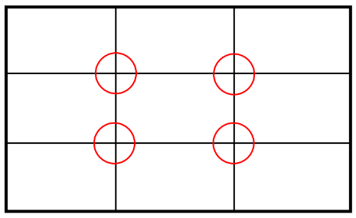
Rule of Thirds
When framing a shot, keep your subject off center – the circles represent good positions for the subject.

Head Room
Ok… Much Better!

The first has too much room above the head. If you stick to the rule of thirds, and make sure there is not too much head room, you will naturally draw your audience’s eyes to your subject.

Framing Your Shot
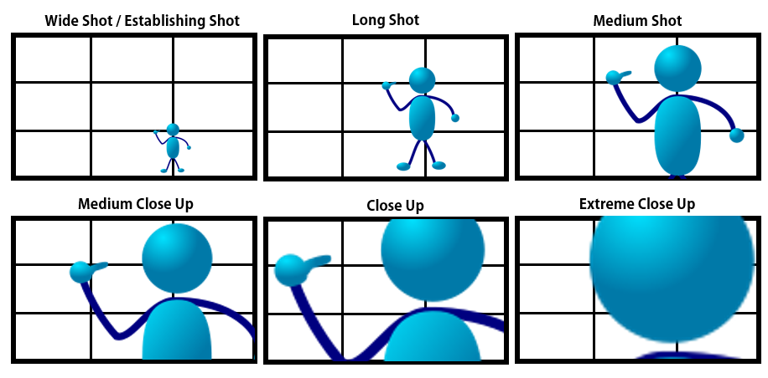

Video Recording TIPS, Continued

Shot Angle: Determined by where camera is placed. Angle really affects what an audience feels when viewing the film. Most shots are done at eye level, which is a basic, neutral angle.
High Angle – the camera looks down on subject; appear less powerful, insignificant.
Low Angle – the camera looks up at subject; appear more powerful.
“Dutch” Angle – the camera is tilted, increases tension and uneasiness for audience.
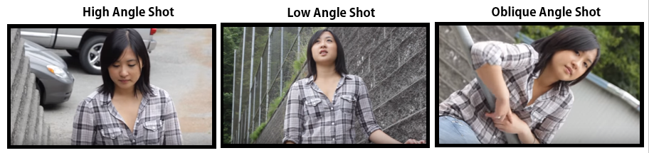
Dutch

Using the Zoom
If you want that sharp foreground, fuzzy background effect, it’s a little more difficult with basic video cameras we are using. Go as far away as the camera will allow for you to frame your shot. With a basic video camera, move the camera really far away from the subject and zoom all the way in.

Following a Subject in Motion: How to move the camera
Tilt: tilt camera lens upwards and downwards while fixed on tripod; tilt vertically
Pan: swivel camera left to right, or vice versa; move horizontally while on tripod
Handheld: hold it in your hand; it can dramatize, make viewers feel excited, unsettled
Tracking: follow subject as they move, often at the same pace
Keep in Mind:
- Frame your shot using the rule of thirds, avoid too much head room.

- Have more or less of your subject filling the frame depending on whether it is an “establishing shot” to provide context and how “intimate” you want the audience to feel with the subject.

- Consider how you want to angle the camera and how you want to follow motion in any given scene – without words, you can communicate powerful, powerless, frantic, calm, etc.

Video shot Scavenger Hunt!

Scavenger Hunt! Basic shots and camera motions. Apply rule of thirds to each shot. Stop and start recording again for each list item. Record each for ten seconds. Use a tripod when possible. Check off each item as you complete it:

LOCATION 1: ___________________________

TYPES OF SHOTS:

TYPES OF ANGLES:
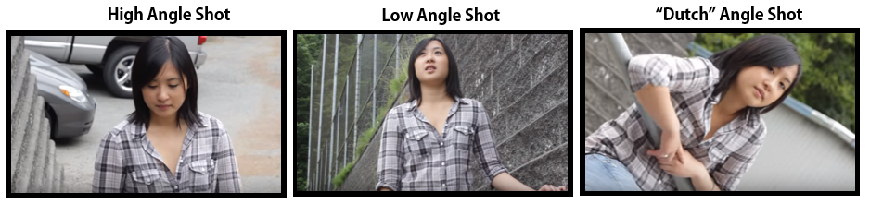

Tilt: tilt camera lens upwards and downwards while fixed on tripod; tilt vertically

Pan: swivel camera left to right, or vice versa; move horizontally while on tripod

Handheld: hold it in your hand; it can dramatize, make viewers feel excited, unsettled

Tracking: follow subject as they move, often at the same pace

Questions or need assistance? Ask a workshop mentor!
Chris Justin Elijah Sophia Jen

Remember: 10 seconds per shot
- ES - Wide/Establishing Shot
- LS - Long Shot
- MS - Medium Shot
- MCU - Medium Close Up (ask your subject to explain or describe the location)

- CU - Close Up (do the close up of something they described in the location)

- ECU- Extreme Close Up

LOCATION 2: ___________________________
Remember: 10 seconds per shot
- Medium Shot, from High Angle
- Close Up, from Low Angle
- Medium Close Up, from Dutch Angle

Choose a different type of shot for each:
- Tilt
- Pan
- Handheld
- Tracking

AUDIO and LIGHTING Tips
When possible it’s best to use microphones and lighting that are external/in addition to the camera. This is not always possible; sometimes you just use what the camera provides and improvise on the lighting!

SOUND – good sound quality is essential!
Types of Microphones with our gear
On camera – it is best to avoid relying on the on-camera microphone when possible.
Lapel, wireless – great for interviews or when you are following someone around. Be sure when placing the mic on someone that you hide the cord between the mic and the battery pack. You may have to slip the cord down their shirt and attached it to the pack as it comes out the bottom of their shirt.
Shotgun Mic – great for on the go, following the action around you. Keep in mind – it will only pick up sound from the direction you are pointing the camera in. So if someone is talking behind you and your camera is pointed away from them, it will not adequately capture their voice.
Always test the microphone! (test while recording, stop, listen to test recording, then start official recording)

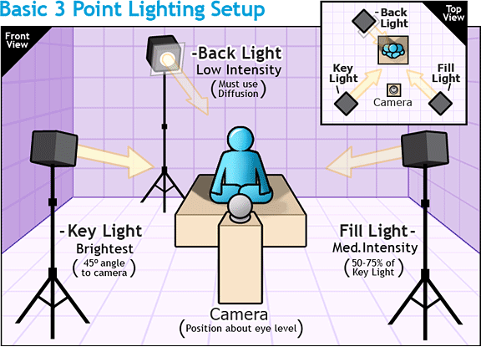
LIGHTING
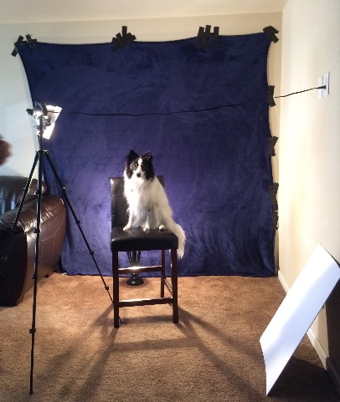
Ideally when you are interviewing, you want Three Point Lighting (see illustration to the left). For our purposes, it’s important that you are aware of lighting and do the best you can. Try to avoid heavy shadows on one side of a person’s face, for instance.
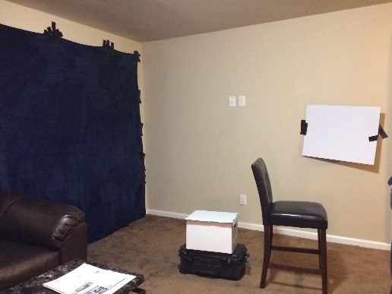
from lifeofmike.com
Be Creative, Improvise!
Windows, sunlight, reflectors made out of white poster board, etc. See our recently improvised setup:

Worksheet: Making a plan -Shots and scripts
Script/Story Outline

Shot List
IMAGE/SHOT DESCRiPTION/Video | TEXT/Audio
Wide shot of castle, zoom in slowly | Once upon a time, a long time ago...

Saving and Editing YOUR Video Files

SAVING your video files: The video files are saved on the camera and must be downloaded.
- Saving from the camera: connect the video camera to a computer via a USB cord and download to where you want to save them (USB drive, external hard drive, computer desktop).

- Saving from SD Card: remove the SD Card from the camera, and plug it into the slot on the computer. It will open on the computer like an external drive, drag files to where you want to save them.

PLEASE NOTE: when downloading the raw film, select the highest level folder (usually labeled “Private”) and include all files that are within it.

ACCESSING your video files:
- Click on the folder that says "Private." Then click through these file folders to get to playable video: PRIVATE --> AVCHD --> BDMV --> STREAM.

The raw files are in the folder called "STREAM" so you have to find that folder, and that's where you can click on them and play. The other folders include associated information, but the playable files are in the "Stream" folder.

- If your computer (PC/Windows) does not see, recognize, or play those files when you click on them (0000, 00001, 00002, etc) - or plays but you hear no sound, you need to download a media reader. VLC is a standard, free downloadable program that does that. You can download VLC here: http://www.videolan.org/vlc/index.html

Once you install it, then open the program. Go to the far left of the menu on top and select MEDIA, Open file/multiple files/folder -- however you want to do it, and they will queue up and play in VLC.

EDITING: iMovie Quick Start Guide

- Start a New Project [plus (+) button at top], choose “Movie,” name and save it to your USB/removable drive

- Choose “no theme” and name your Movie

- Import your footage to the iMovie library from where you have saved your footage or from the camera
  - Click the import button (a downward facing arrow)
  - Import from the camera directly via USB cable or the SD Card placed in the computer, or from files you have saved to the computer or a drive.

- Select clips from your iMovie library and place them in the Timeline Area
  - From the iMovie Library at top left, double click the clip so that a yellow border appears around it. Use the “handles” at the sides of the yellow border to shorten or lengthen clip. Then drag the clip into the New Project area (you will see dotted outlines). YELLOW BOX INDICATES WHERE YOU’RE CURRENTLY WORKING in the library or on the timeline.

- The “Title” button is located in the Content Library at the lower left of the screen.

- Select transitions to place between clips by highlighting “Transitions” in Content Library.

- Add audio by using “Sound Effects,” importing from iTunes, or recording your voice (or other sound) over the clip:
  - Place cursor over location in project where you want to begin recording. You will have a white vertical line on the place it begins to record. Click the microphone at the lower left of the Viewer, Click the Record button (red circle), click it again to stop the recording.

- To lengthen or shorten a video or sound clip, simply grab and drag the left or right edge.

- To Export an MP4 file, click the Share button at the top right of the toolbar, and then click File.
  - Set the title of the shared movie. You can adjust quality by clicking the arrows (choose “High” for mp4). Click Next. Navigate to the location where you want to save the file, and click Save. Saving takes a long time...

Worksheet: “PICKUPS”
List here the remaining things that need to get done:
 | Task | Person Responsible

Worksheet: “PICKUPS”
List here the remaining things that need to get done:
 | Task | Person Responsible

Worksheet: Film Title and Summary
Brain storm some possible film titles here – circle the one you like most.
As you complete the editing process, be sure to add the title to the start of your film.

In a few sentences, describe what your film is about:

Worksheet: Credits to be Included in Your film
Credits are important! Be sure to include them at the end of your film.
Name your team and roles (more than one person can have the same role, ex. co-directors)
Director
Editor
Camera
Sound
Additional roles?, list here:

Interviews: list the names of people you interviewed and were included in the film

Film, Music, Photos: sources from which you obtained materials included in your film

Thank yous: names of organizations or people you want to thank for their support
(ex., you might include somebody you interviewed but who did not make it in the final cut of your film)

Please fill this out and hand it in before you leave!

Name: Address:

Phone: Email:

Can we contact you through Facebook? (please circle one) YES NO

Do you want to continue work on your film with a mentor after the workshop has ended? YES NO

Please check which venues you would like to share your work.
You will be credited for your contribution at each site:

- On community access cable tv in Bismarck-Mandan
Dakota Media Access will air your film on the free cable station.

- Vimeo.com
In order to share your video on our project website and Facebook, it has to be available online. Vimeo is a website like YouTube but with better protections regarding the sharing and long term storage of your video. You can decide whether people can download and save it, and if you remove it from the site it is no longer stored there or accessible to the public.

- Mhacollaborativefilm.weebly.com
This is our project’s website; this will require your film to be uploaded at Vimeo.com.

- MHA Collaborative Film Project Facebook page
We share news about the workshops and film project here; it requires your film to be on Vimeo.

- Public Venues like theaters in Bismarck or at Northern Lights
- Our longer form documentary film(s)
If you are willing to share your short film and/or raw footage with the workshop mentors, we will download your files onto an external drive in a folder labeled with your name. Any use of your footage will be shown to you for your approval and will include your name in the credits.

Contacts and Resources

The project website is http:// http://mhacollaborativefilm.weebly.com/
You can find us on Facebook: https://www.facebook.com/mhacollaborativefilm/
And contact us by Email: mhacollaborativefilm@gmail.com

You can also contact us directly:
Justin Deegan: 701-421-3290; justin@thunderrevolution.com
Elijah Benson: 612-708-8459; elijah.benson89@gmail.com
Jen Shannon: 303-919-5022; jshannon@colorado.edu
Chris Hammons: 626-590-0907; christian.hammons@colorado.edu

To view your video online, go to https://vimeo.com/mhacollaborativefilm

What if I want to keep making films?
Talk to a workshop mentor about continuing to develop your film, or about how you can shoot and edit film on a smart phone. You are welcome to call, email, or Facebook message us! If you choose to expand on the film you made in the workshop, let us know – we are here and would be happy to keep working with you beyond the workshop.

If you have a passion for filmmaking, we will be happy to help guide you to additional resources and opportunities!

FilmMAKing with smart phones

I don’t have a video camera... how can I keep making films?
Today, you or someone you know may have a video camera – in their phone! If you have a smart phone with video, you can use that to make great films. All the roles are the same, and so are the techniques of framing your shots, storytelling, interviewing, camera angles, sound, and editing. You can shoot with your phone and edit on a computer, or you can edit right on your phone with video editing apps.
For a video workshop on filmmaking using your phone, see “Mobile Devices: Pro Options Within Reach” (53min) by Dakota Media Access at https://www.youtube.com/watch?v=p8_lnBIn0fQ&feature=youtu.be

FILMING

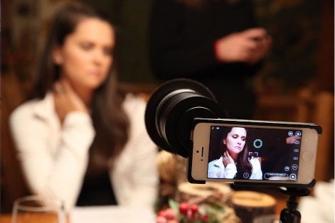
When recording on a mobile device it's very important to:
1) Record horizontally, holding the phone sideways instead of vertically. Do your best to keep it steady (there are tripod adaptors for phones).
2) Check the recording settings and make sure it is set to record in full HD 1920x1080 (29.97fps)

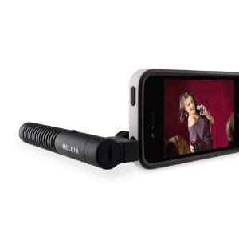
If you want to go all professional, you can purchase accessories:
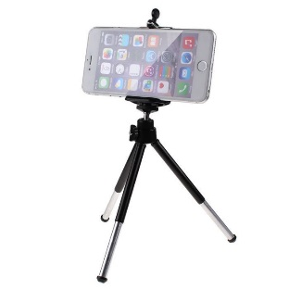
3) If possible, use external microphones: use something like an iRig device to enable yourself to get professional mics with XLR cables into your mobile device. (Dakota Media Access in Bismarck has one if you'd like to borrow it...Having professional sounding audio is absolutely essential!)
4) There are also tripod adapters and lens add ons you can purchase to get a clean shake-free image as well as long lenses or different optics.

Editing
You can download the footage/video files from your smart phone to your computer, and use editing software on your computer. If you want to edit on your phone:
iPhone– use the free iMovie app, just like the software we used in this workshop!
Android – use something like the free FilmoraGo app

On a computer, if you want to invest in a more powerful editing program, the pros use Adobe Premier and Final Cut Pro. For more workshops videos by Dakota Media Access, see https://www.youtube.com/playlist?list=PLADwRP9Hw3MnQgYAw5o1Qy3ByXPZViOnJ

